MENTAL HEALTH USERS NETWORK OF ZAMBIA (MHUNZA) SUBMISSIONS TO THE DRAFT GUIDELINES ON DE- INSTITUTIONALISATION

The Mental Health Users Network of Zambia (MHUNZA) was established in 2000. Since its establishment MHUNZA has become one of the lead organisations advocating for the rights of persons with mental disability in Zambia. MHUNZA works with persons with mental disability and assists in identifying their needs and priorities, participates in the planning, implementation and evaluation of services and measures concerning the lives of persons with psychosocial disability and contributes to public awareness of mental health and advocates for change. In order to realize its vision and mission MHUNZA champions the following core values in all the work that it does:

* 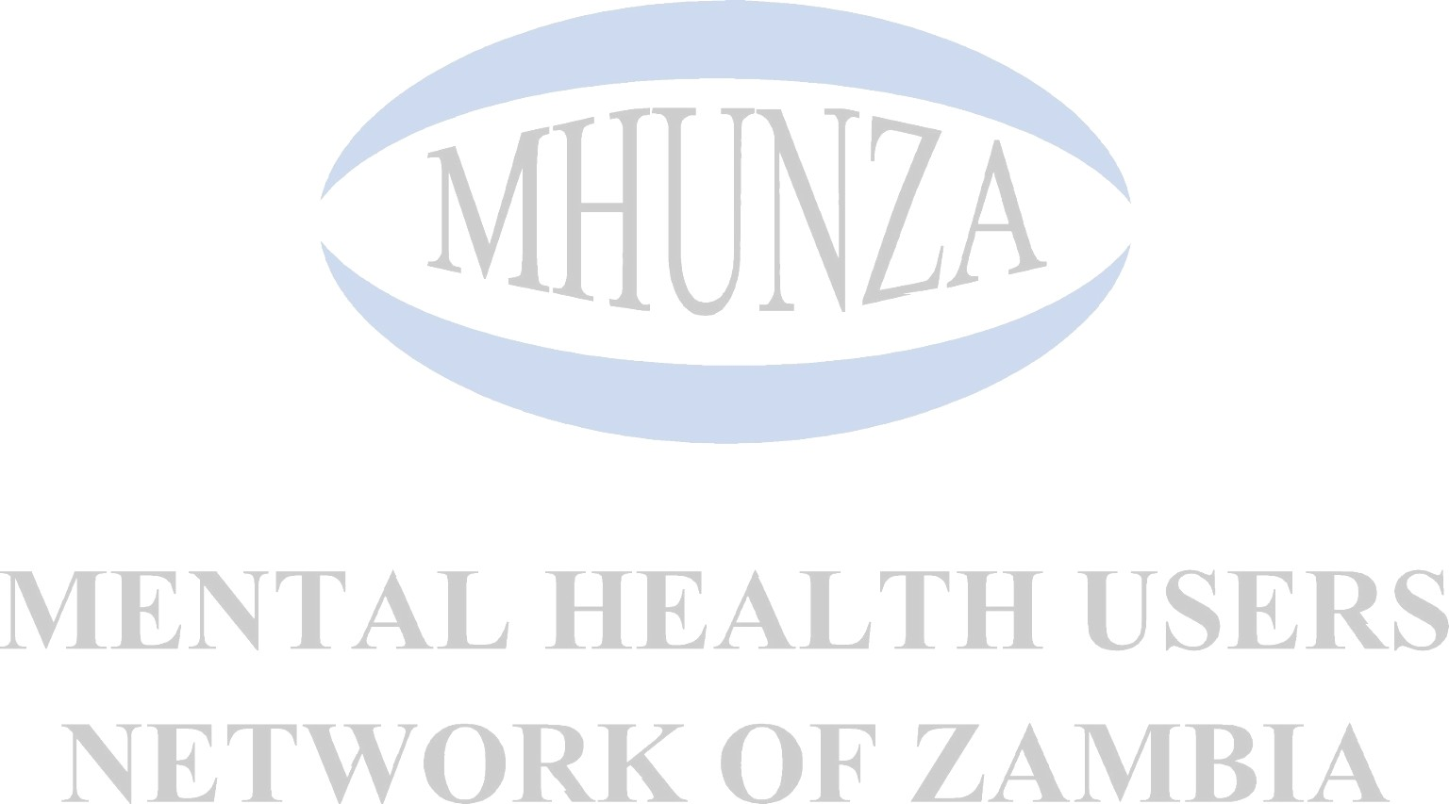**Equity:** The Network is an equal opportunity institution which believes in participation of both men and women in development and works towards ensuring equitable distribution of opportunities;
* **Transparency:** The network commits itself to ensuring persons with mental health problems; Board members and Secretariat remain transparent in all their functions.
* **Accountability:** The network reaffirms its commitment to be accountable for their actions and decisions and for the financial resources received from members donors, government and other partner organisations or self generated activities;
* **Justice:** The Network believes that persons with mental disability will receive justice in their undertakings;
* **Commitment:** The Network is committed to excellence in service delivery to persons with mental disability , Caregivers and Community members;
* **Acceptance:** the fundamental acceptance of one’s condition is critical to mitigation of stigma and discrimination;
* **Integrity:** Accountable to persons with mental disability and other stakeholders and transparency in the delivery of services.

Against the above background, MHUNZA with the support of Validity Foundation held national consultation in Zambia to raise awareness of the Guideline among its members in Lusaka and Ndola. As a result, MHUNZA submissions is as follows:

1. **Awareness raising** – The guidelines are welcomed by MHUNZA as a good step in ensuring that de-institutionalisation is successful. However, majority of our members indicated that the Guidelines should have a focus on how raising awareness of mental health within the community should be a priority. The rationale for this is because people with mental disability will be required to go back to the community and stay with other member of the society. These members of the society were at the core of sending people with mental disability to institutions in the first place and that if they are not properly told about the mental health, the community will not be safe for people with mental disability. For instance, the

report titled *Human Rights and Mental Health in Zambia1* demonstrated how the community plays a big role for people with mental disability in Zambia. In the report a young mother with mental disability stated that neighbours would laugh at them because of their condition.2 It was also noted in the report that women would be beaten by their husbands and in laws because of their mental disability. In fact, one of the psychiatric nurses mentioned that most people with mental disability who end up in hospitals usually have psychical injuries.3

It is our submission that the Draft Guidelines takes into consideration having a section that focuses on awareness raising within the communities.

1. **Abuse and/or Support of Traditional healers** – mental disability in Zambia understood as possession by evil spirits. They are “disturbances in the relationship between people and divinity, divine punishment for past actions, or an unbalance due to social issues”.4 Compared to psychiatric services, traditional healers are readily available and thus more accessible to the general population. Many traditional healers promise effective solutions. Unfortunately, the Draft Guidelines as they are right now does not take into consideration the impact and role those traditional healers play in institutionalisation of people with mental disability in Zambia.

It is our submission that, the Guidelines comes up with a section that appreciates the role those traditional healers play within the community. Frequently people go to traditional healers before accessing mental health services. Most people with mental disability in Zambia have seen a traditional healer *(“Ng’anga”*) for support. People may also see a traditional healer at the same time as a mental health professional, or – particularly in cases of relapse – afterwards. The *Human Rights and Mental Health in Zambia* report noted that due to the scarcity in rural areas of conventional medicine, people, “tend to rely on traditional healers and sometimes they take advantage of the vulnerability of the patient”.5 In fact, the Zambian 2005 Mental Health Policy records that 70-80% people with mental health issues consulted traditional healers before seeking help from conventional health

1 *Human Rights and Mental Health in Zambia* by MHUNZA and MDAC found here https:[//w](http://www.mdac.org/en/where-we-work/zambia)ww[.mdac.org/en/where-we-work/zambia](http://www.mdac.org/en/where-we-work/zambia)

2 *Human Rights and Mental Health in Zambia* pg 25.

3 *Human Rights and Mental Health in Zambia* pg 26.

4 See, for example, Sorsdahl et al, “Explanatory models of mental disorders and treatment practices among traditional healers in Mpumalanga, South Africa” (African Journal of Psychiatry, 13(4) (Sep 2010): 284–290); Human Rights Watch, “Like a Death Sentence”: Abuses against persons with mental disability in Ghana (2012), available online at https:[//w](http://www.hrw.org/report/2012/10/02/death-sentence/abuses-against-persons-mental-disabilities-)ww[.hrw.org/report/2012/10/02/death-sentence/abuses-against-persons-mental-disabilities-](http://www.hrw.org/report/2012/10/02/death-sentence/abuses-against-persons-mental-disabilities-) ghana

practitioners.6 For instance, it was noted by a person with mental disability in the above mentioned report that ‘a traditional healer will try to beat a patient, because always they associate any kind of ailment, like you know, [with] demon possession, and sometimes like a spirit has gotten into you, so you have to be beaten.’7

1. **Accessibility** – the Guidelines are glaringly lacking accessibility provisions for people with disabilities. Through our national consultations our members especially those in rural areas told us, that in order to live in the community without any problem, there is need for the Draft Guidelines to have provisions on how accessible the society should be. The members indicated that majority of the time people with disabilities who are in rural areas have had challenges accessing their houses. The roads toward their places are either with potholes or not wide enough for wheelchairs users.

Our submission is that the Guidelines as currently drafted will lock out a group of people with disabilities that need physical accessibility in order for them to live in the community.

It is our hope that our views will be considered in the final submissions.

6 Republic of Zambia, Mental Health Policy 2005, 5.