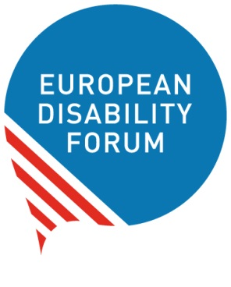

**To:**

Ms. Rosemary Kayess

Chairperson of the UN Committee on the Rights of Persons with Disabilities

**Brussels, 29 June 2022**

Ref. EDF-22-32-YV-AC

**Re: Draft Guidelines on Deinstitutionalisation, including in emergencies**

Dear Chair,

I am contacting you on behalf of the European Disability Forum, independent organisation that advocates for the rights of 100 million Europeans with disabilities in the European Union, in relation to the Draft Guidelines on Deinstitutionalisation that the Committee is developing, currently in the consultation phase.

Deinstitutionalisation is one of the main challenges our societies face these days regarding the implementation of the CRPD. Hence, it is the focus of some of the principal advocacy we lead in Europe.

EDF welcomes the work undertaken by the Committee to support States Parties’ implementation of the CRPD through General Comments and guidelines. General Comment No. 5 on the right to independent living is a good starting point to understand the obligations required under article 19 of the Convention.

To support the deinstitutionalisation process, we believe it is also necessary to have practical guidelines for public authorities at the national and local level. These guidelines should both highlight the final objectives, while also giving pragmatic information and recommendations on how to reach them. They should contain examples and good practices, national successful cases, specific applicable steps, and targets taking into consideration different economic, regional and cultural realities.

Unfortunately, we believe the draft Guidelines presented for the consultation, in their current format and approach, do not yet provide the necessary support for governments to undertake a realistic and swift transition from institutional to community-based independent living.

The draft guidelines include very positive elements such as the adoption of a holistic perspective taking into account the access to services, employment, education or intersectionality, as well as the importance of ensuring the participation of persons with disabilities.

However, EDF found some gaps and issues in the current draft guidelines and their development, among which we would like to highlight the following:

* Some organisations have raised concerns about the participation in the consultation process, including to give input, believing it has not been optimal. The document is not easily understandable for self-advocates and there were not possibilities for face-to-face discussions with the people most concerned by institutionalisation.
* Some concepts create confusion- for example, the partial inclusion of institutions such as prisons, refugee camps or shelters for homeless people set in the paragraph 14, do not seem to be core to the mandate of the CRPD if it is not focused on persons with disabilities placed in these settings.
* The catalogue of contents that a social protection package to be provided to persons with disabilities leaving institutions, in order to cover immediate and mid-term needs for resettlement – as listed in the paragraph 103 - is a paramount topic that should be further detailed.
* Certain legal implications expressed in the guidelines – such as sections 54 and 55, or 85 to 87, among others - anticipate reflections which usually are part of the General Comments yet to be drafted and adopted. While these reflections are important, it should be stressed that the Committee, so far, has not published general comments on these Articles (13 and 28). It should, therefore, be mentioned that some of the observations are temporary, and that it is necessary to specify them through the General Comments yet to come.

Therefore, we offer our full support for the reformulation of a practical and operational set of guidelines that can help us achieve the complete fulfilment of the Article 19, as expressed in the General Comment No. 5 (2017).

We thank you for your kind consideration and remain at your disposal to discuss this matter in more detail.

Yours sincerely,



**Yannis Vardakastanis**

President of the European Disability Forum