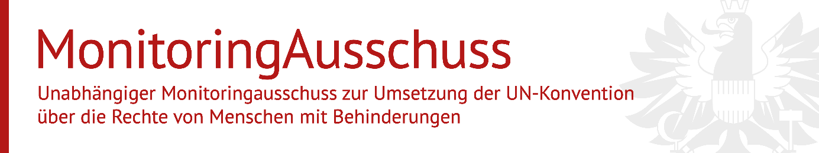Juni 2022

**Draft Guidelines on Deinstitutionalization,** **including in emergencies**

**from the Committee on the Rights of Persons with Disabilities**

The Independent Monitoring Committee is responsible for monitoring compliance with the UN Convention "Convention on the Rights of Persons with Disabilities" (UN CRPD)[1] of 13 December 2006 in matters that are federal in legislation and execution. It is the responsibility of the Independent Monitoring Committee pursuant to § 13g para. 2 no. 1 and 2 BBG[2] to obtain statements from organs of the administration with regard to the implementation of the UN Convention on the Rights of Persons with Disabilities and to issue recommendations and statements concerning the implementation of the UN CRPD.

The Independent Monitoring Committee would like to thank for the transmission of the Draft Guidelines on Deinstitutionalization, including in emergencies, and expressly welcomes the draft. It is necessary that inclusion takes place in society and separation of people with disabilities is no longer passed off as a necessary protective measure. The present draft guidelines represent a comprehensive understanding of deinstitutionalization and will make a significant contribution in Austria. The Independent Monitoring Committee will work to ensure that these guidelines are also implemented in Austrian practice.

For the Committee

Mag.a Christine Steger

(Chairwoman)

1. Convention on the Rights of Persons with Disabilities (CRPD); UN-Generalversammlung, A/RES/61/106; BGBl III 2008/155 ratifiziert mit 26. Oktober 2008 BGBl III 2008/155, neue Übersetzung: BGBl III 2016/195.
2. idFd BGBl I 2018/59.