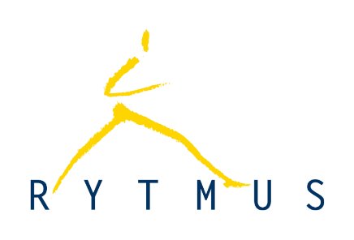 

**Written Submission**

**to the UN Committee on the Rights of Persons with Disabilities**

**on the Draft Guidelines on Deinstitutionalization,**

**including in emergencies**

Submitted by:

**Mr. Karel**

With the support of

[RYTMUS](https://rytmus.org/)

[Validity Foundation – Mental Disability Advocacy Centre](https://validity.ngo/)

Email: [validity@validity.ngo](mailto:validity@validity.ngo)

1. June 2022

Mr. Karel is a 40-year-old man who grew up with his father and lived in an institution for 10 years as an adult. He also had his legal capacity restricted. In 2022, Mr. Karel has lived in a studio apartment for 12 years and uses social services 3-4 hours a week. He has two jobs and enjoys going into town to watch hockey.

Mr. Karel was surprised by the information in the guidelines that there is something called "the United Nations" and that the Czech Republic should follow "that agreement" (the Convention on the Rights of Persons with Disabilities). This was important information for him; he thought that no one had addressed this and that the Czech Republic had done nothing to abolish institutions. The introductory text was difficult for Mr. Karel, and the assistant had to explain several times different terms (United Nations, etc.). Mr. Karel responded to the text that "in some institutions, the staff treat some people badly."

Mr. Karel agrees with how the disadvantages of the institutions are described in the Guidelines.

As for Mr. Karel, the problematic issues include:

* the regime (in the morning at seven o'clock they put a kettle of coffee in the dining room and in the evening at six o'clock they took it away, I couldn't have the kettle in my room)
* I couldn't have outings when I wanted
* various prohibitions (to buy one beer)
* the impossibility of leaving the institution (the social worker said that even the president couldn't get me out...)
* decisions made without people's knowledge (they changed my insurance company, gave me an extra pill ...)
* there are a lot of people in one place (it's difficult, noise in the corridor, smell).

At the same time, Mr. Karel raised concerns in relation to some aspects of the Guidelines:

* I didn't have to go to the activities offered by the institution, but at the same time, no one offered me anything else to do
* There is the possibility of meeting or finding friends or a girlfriend
* I wouldn't abolish all the institutions. Some people are comfortable with being surrounded by many people and having a set program; some people are used to living in institutions, and in fact, it is their only home. Moving out could be very difficult and sometimes sad for them.

The most important information was that it depends on the government of the Czech Republic, what laws they will make and where they will put the money. Mr. Karel thinks it would be helpful if all people with disabilities could vote and help change the current situation.

**NOTE: The views presented in this submission are of Mr. Karel and do not necessarily reflect the opinions of the organisations that made it possible for Mr. Karel to participate in the consultation process.**