

And

Network of Independent Experts – NIE

**Written submission**

From Luydmila Borisova[1]

to the Committee on the Rights of Persons with Disabilities (CRPD)

The statement is provided to Network of Independent Experts – NIE (NGO based in Bulgaria) as a written document. It had been translated by the organization with support from the Validity Foundation. No other editorial changes (except the translation) are made in the statement.

Opinion:

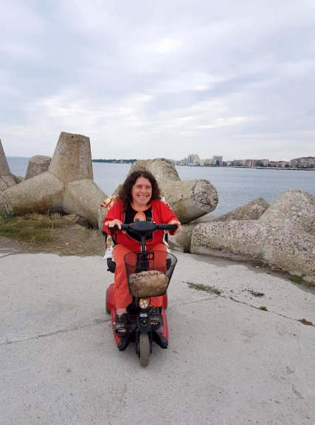Luydmila Borisova, from Stara Zagora, 48 years old – currently living in a Home for Adults with Physical Disabilities. I work in a library named “Rodina” (“Homeland”) since 2002. I like my job even though it is not very well paid. I am mainly responsible for the digitalization of old book editions, which could be useful to teachers, students, and the civilians as a whole.

I went to high school where I studied economics as a major. I wanted to study to become an animation artist but it wasn’t possible back then because my disability apparently “scared” the management of the school. So, I studied accounting and economics instead of art. This shows how the system treats the people with visible disabilities. Years later, I got bachelor’s degree in Social Services and my goal was to use my knowledge in the people with disabilities field. After that, I got a master’s degree in Library Science and Technologies because I like my job.

I love reading books, especially psycho-thrillers, I love to paint, and to endure in extreme travels and experiences. I like and I love challenges – to ride a horse, fly a paraglider, a motorcycle, etc.☺ I like to have a small glass of snaps and to try different foods. I love partying with friends, to listen to music loudly, especially alternative music.

***

For the last 15 years the termination of the institutionalization process simply did not take place in Bulgaria. People were still being placed in institutions, with the consent of many of them because they did not have any other alternative. Bulgarian legislation is not compliant to the international law concerning the termination of institutionalization.

1. Institutionalization deprives people from their right to personal space – 2, 3, 4 or more people are being placed together in one room depending on the capacity of the institutional setting and the decision of the so called management. A person goes into an institution due to different reasons, such as a lack of a roof over their head, being in an institution since childhood, incapability of the person to live at home, etc.;
2. Some of the people lose their sense of self responsibility, they become, sorry to say it, but a bit of “complain-about-all” kind of people. These are people who have lived in institutions since childhood and do not know what it means to take responsibility for your own life (it even took me a while to realize that, especially when I once lived in a rented place and was feeling hopeless). Others were raised in families that cannot take care of them anymore, so they place them in an institution – neither the family, nor the person with disability receives an adequate support by the State. There are also those who, due to the protective function of the State, do not look for a job or some kind of a training, but are satisfied with the pensions they receive from the State (what I have in mind is only concerning people with physical disabilities, who need support in the form of accessible environment, personal assistant, etc. It is different when we talk about people with mental disabilities who need another type of support, so they could live in a normal environment).
3. It is wrong to build new institutions, instead of being guided towards receiving adequate services and towards places where people prefer to live. There is another thing – even people who live in their homes, due to the inadequate support they receive, face the inability to make independent decisions and it is like they are in a small institution, because they are not recognized as independent decision-makers, even though they only have physical disabilities. The parents and relatives who are forced to take care after a person with disability often assume the care-givers role (like in an institution) and it happens because of the politics around people with disabilities that is wrongly understood, because of some people’s mentality and the lack of information in this field. The overprotection deprives a person from its abilities to make independent decisions. It is wrong to assume that “today’s child” will not become a “tomorrow’s grownup” with an ability to assume responsibility (whether it is with the help of guardian or another assistance, if he/she is with mental disability). It is very important to have an adequate support for the whole family.
4. It is appropriate to provide support for affordable housing, a place, which is tailored to the capabilities of the individual (In Bulgaria it is considered enough if the State just provides housing, without caring if this housing is accessible or whether the person might need provision of special support. There are many cases of people who want to live on their own, but they are quickly forced by the circumstances either to go back to the institution or there is lethal end.) The provision of social services in Bulgaria is always assumed as “closed circle services”, even the Social services Act is not written right, because it says that they provide community based services but those so called “community based services” are in fact residential services and are not tailored to the needs of every person. (There is a lot to be said in this regard but the Guidelines cover it thoroughly enough).
5. Another important reason for entering an institution is when there is discrimination, the person itself does not feel good in its living environment and prefers to be among "like-minded" (sounds awful, but I've heard it dozens of times, even it had happened that I did not like someone with a similar disability to mine, and he immediately reacted like I was ashamed of that "like-minded" person, and accordingly my answer was that I just do not like him and I do not want to communicate with him). Discriminatory practices are common and the possibility of legal protection is negligible
6. Another vicious practice, dressed in a legal framework, is when it is considered that a person with a disability must be socially weak. In short, in the eyes of lawmakers, all people with disabilities are automatically socially disadvantaged. The income criterion, for example, for renting municipal housing is the most important, the person with a disability is on an "equal footing" with other social groups, also necessarily socially disadvantaged. In a country like ours, you have to study, work and look for your place under the sun despite the system. My personal life experience has taught me many things, including living as independently as possible, regardless of the circumstances and the situation around me. This is another case in which I prove that in Bulgaria there isn’t individual approach to the individual, no respect for the human being, no respect for the dignity of such a person who despite his/her disability studies, works, creates a family - and all with the help of its friendly circle, not the State. You cannot compare one person with a motor disability and another with a hearing impairment, for example - if one can climb 5 or 50 stairs, for the other this is impossible. You must also be socially disadvantaged in order to receive mobility aid or have a disability decision (ТЕЛК) which says that you need to receive that mobility aid. I, for example, need to provide my own mobility aid because in the eyes of the decision makers and the ubiquitous doctors I must be able to walk, but I know how far the limits of my motor abilities go and how much I want to be as mobile as possible. (I can talk about this a lot, but it doesn't matter…, in my opinion, the guidelines also clearly indicate the topic of providing aids). Finally, I will add to this point that it is another nonsense to think that a medical device and a mobility aid are one and the same thing and that they should go to one ministry – the Ministry of Health - a parody of the subject of aids.
7. There is so much to be said about so many things, but the most important thing is that the person with disability must have a choice. There shouldn’t be even one child placed in institution. Families must be provided with adequate support. Services must be organized around the person, meaning that there should individual approach towards each person. There is a reason why the world is so colorful, because it is full of myriad of individuals, each of them hiding unique opportunities.

P.S.: I still live in an institution but unlike many other people, my perception of it is of a place where I could go back to, eat and sleep. That doesn’t mean that I didn’t try to acquire my own place, on the contrary. There are facts to testify for that. I sincerely hope that this is not just another “make a wish” document.



Л. Б.

**NOTE: The views presented in this submission are of Luydmila and do not necessarily reflect the opinions of the organisations that made it possible for Luydmila to participate in the consultation process.**

1. The author is a person with disability.