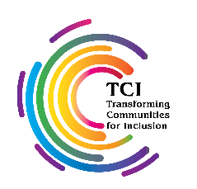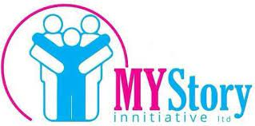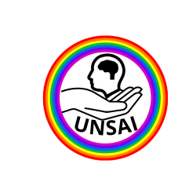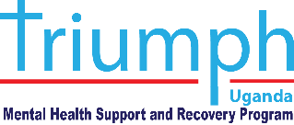

**FEEBACK REPORT ON "DRAFT GUIDELINES ON DEINSTITUTIONALISATION, INCLUDING IN EMERGENCIES" FOR UGANDA 2022**

**PART ONE**

**INTRODUCTION AND BACKGROUND:**

* 1. **BACKGROUND:**

The United Nations Committee on the Rights of Persons with Disabilities published the **"*Draft Guidelines on Deinstitutionalisation, including in Emergencies*"** and launched the process of public consultation on the 20th day of May 2022. The guidelines have been developed pursuant to Article 19 of the United Nation Convention on the Rights of persons with Disabilities. In this regard, the purpose of the Draft Guidelines is to assist States Parties in fulfilling their obligations under article 19 of the CRPD, on living independently and being included in the community.

In order to materialize the contribution of Ugandan Organisations of Persons with Disabilities specifically working in the area of psychosocial disabilities. With the support of Transforming Communities for Inclusion(TCI), Uganda National Self Advocacy Initiative(UNSAI), Mental health for all – a Peer – led organization of persons with psychosocial disabilities led the National level public consultations in partnership with Triumph Mental Health Support(TRIUMPH) and MY Story Initiative(MSI)with support from Transforming Communities for Inclusion (TCI). The purpose of the consultation process was to engrave a wholistic appreciation of the Guidelines to persons with psychosocial disabilities through their organisations. This report presents the input of the public consultation that was undertaken by UNSAI in June 2022 with the view of highlightingthe concerns, proposals and Best practices to inform the Committee on the Rights of Persons with Disabilities in development of DI guidelines.

* 1. **CONTEXT OF THE CONSULTATION**
  2. The Uganda Bureau of Statistics Census Report (UBOS 2016)[1] indicated that **12.4%** of the Ugandan population lives with some form of disability implying that approximately 4.5 million Ugandans are persons with disability hence a development concern.

Uganda is ranked among the top six countries in Africa in rates of depressive disorders (4.6%; Miller et al., 2020), while 2.9% live with anxiety disorders (WHO, 2017). About 5.1% of females and 3.6% of males are affected.

The estimated incidence of mental illnesses is massive: 35% of Ugandans suffer from a mental illness, and 15% of Ugandans require treatment. It is likely that the incidence of mental illnesses and the need for treatment is much higher ([Molodynski, Cusack, & Nixon, 2017](https://www.ncbi.nlm.nih.gov/pmc/articles/PMC5663025/)). The number of people affected by mental health disorders greatly varies from source to source as well, as there is little pre-existing research on mental health in Uganda.

Molodynski et al. (2017) found that Uganda spends 9.8% of its gross domestic product on healthcare, or US$246 annually per person, but just 1% of this goes into mental healthcare. The majority of national mental health funding goes to the national mental health referral hospital, Butabika Hospital- **Psychiatric institution for persons with psycho social disabilities**. Established in 1955, Butabika hospital now with frequent overcrowding, and has limited staff. Despite Butabika Hospital being the only nationally funded mental hospital, many severe criticisms have surfaced in the last couple of years. Butabika Hospital detains without assessment, houses patients in seclusion rooms without toilets, fails to distinguish between compulsory and voluntary admissions, offers no separate facilities for children, and relies heavily on pharmacological treatment, which often results in heavy side-effects.

There is need for a Paradigm shift brought about by the on the Convention on the Rights of Persons with Disabilities(CRPD) for persons with psycho social disabilities to live independently and being included in the community (Article 19 CRPD).

There is limited doubt that the Government of Uganda has prioritised the protection, promotion and fulfillment of the human rights of persons with disabilities. It is important to note that Uganda is a signatory to the United Nations Convention on the Rights of Persons with Disabilities (UNCRPD). The UNCRPD imposes several obligations on state parties which inter alia include taking legislative measures like modifying or abolishing existing laws, regulations, customs and practices that constitute discrimination against persons with disabilities.[2]As a result of this obligation Uganda has a duty to streamline all its laws in light of the Convention’s provisions. Uganda has developed a comprehensive legal framework that seeks to protect and promote rights of Persons with disabilities. The government has also taken an extra step of enacting laws specifically designed to cater for PWDs in general and particular kinds of disabilities specifically. These laws include the Mental Health Act of 2019, The Persons with Disabilities Act of 2020, and The Children’s (Amendment) Act, 2016

* 1. **THE METHODOLOGY:**

This Consultation process was mainly qualitative, given the nature of the subject matter. It involved a detailed analysis of the DI Guidelines, general international law relevant to the rights of persons with disabilities as far as deinstitutionalization is concerned, domestic law as well as policy initiatives was considered. In some respect, views from experts at both local and national levels in the field of disability rights and deinstitutionalization were sought to triangulate the analysis of the provisions under scrutiny.

There were three strands to the consultation:

* In-person Focus group 18th June,2022. This mainly targeted peers with psycho social disabilities including survivors of institutions especially those living in the rural who may not be able to engage online.
* Online consultation through webinar 22nd June, 2022. This was at a National level targeting all persons with disabilities in Uganda.
* Interviews conducted 7th -20th June,2022. Interviews only targeted survivors of institutions especially persons with psycho social disabilities.

Hard copies and soft copies of the DI guidelines were distributed, Sign Language interpretation and real-time captioning was provided for the on-line consultation event.

* 1. **THE SCOPE:**

The Consultation process surveyed a wide range of issues recognized and guaranteed under the Guidelines necessary for the protection of human rights of persons with disabilities juxtaposing them with the provisions in laws of Uganda. In order to avoid duplication from other Organisations of Persons with Disabilities, much concentration was placed on persons with psychosocial disabilities based on the area of expertise of the coalition members herein.

Most participants were persons with psycho social disabilities in particular women with psycho social disabilities including youth female with psycho social disabilities. Other persons with disabilities included persons with Person with Person with cerebral palsy, Person with intellectual disability, Person with low vision, Blind person, Person who are hard of hearing, Deaf person,Person with albinism,Family member of a person with disability.

**PART TWO**

**THE RESULTS FROM THE CONSULTATIONS**

* 1. **Introduction:**

This part notes the specific as well as general observations about the guidelines in regard to deinstitutionalization by advocates of human rights of persons with psychosocial disabilities. The specific issues pertaining to our constituency is noted hereunder.

* 1. **Specific Observations:**
     1. **The Right to freedom from torture, inhuman and degrading treatment:**

The Guidelines advocate for the free will of the persons with disabilities to choose where they can live. This eliminates issues of coercion that comes with physical and mental torture that goes against the right to freedom from torture, inhuman and degrading treatment provided under UNCRPD[3] and the Uganda Constitution.[4] Most of the respondents consulted on during the process noted that the guidelines shall enhance enjoyment of human rights such as freedom from torture, inhuman and degrading treatment which is prohibited in all respects.

* 1. **General Observations:**
     1. Concerns:
* The guidelines on Deinstitutionalization should be well explained to all stakeholders including persons with disabilities. For example a participant miss understood the meaning of New admissions to mean medical admissions for treatment in any case someone is ill in paragraph 14 of the guild lines and raised concern of what happens when someone is ill and needs medical attention and medical admission is required. This calls for conducting trainings on these guidelines.
* Paragraph 18 Processes of deinstitutionalization should not be led by management or those involved in the maintenance of institutions is not clear to us as we thought that those maintaining the institutions would be made aware of the dangers of institutionalization so that they support the process of Deinstitutionalization.
* First, in the Ugandan context, we are grappling with the uncultured principles under the Mental Health Act, 2019 which falls short of the UNCRPD.
* We need the good will of government to act as it has the duty to respect, protect and fulfill the rights of persons with disabilities.
* The degree of readiness of our respective communities to accept persons with disabilities and treat them with dignity. There is need to prepare the communities where person with disabilities especially persons with psycho social disabilities chose to live after institutions.
* There are some OPDs which run facilities that directly fall in the categories you listed in the definition of institutions, It would be good that they should lead the process and set the example of phasing out such institutions.
* First, in the Ugandan context, we are grappling with the uncultured principles under the Mental Health Act, 2019 which falls short of the UNCRPD. It also hints on vulnerable groups which u think youth and the older persons who are often victims of institutionalization. these should be considered critical in the guidelines. The need to harmonize the national and international initiatives is critical for the clear understanding of the guidelines. Most importantly, there is need to critically understand context of their use like the approach used in coming up with the Africa disability protocol to better benefit persons with disabilities

**2.3.2 The role of OPDs in the implementation of this DI guidelines.**

* OPDs should pilot community based supports projects for persons with disabilities.
* Conduct massive campaigns on CRPD article 19 Independent living and being included in the community for persons with disabilities including persons with psycho social disabilities.

**2.3.3 The kind of support does the Government of Uganda needs to implement the DI guidelines**

Technical support in the implementation of the DI guidelines.

Government of Uganda needs international cooperation (CRPD article 33) to finance the Deinstitionalization process.

Government needs support in training/ capacity building of all civil servants on the rights of persons with disabilities in particular right to independent living and being included in the community. Starting with the Ministry of Gender and Social welfare and Community Departments at the Local Governments.

Government needs support in Policy formulations and Program designs as regards to DI

**2.3.4 What we need as persons with psycho social disabilities:**

* Inclusive communities; a youth female with psycho social disabilities said she need and loves to remain in her community
* Provision of Community based mental health care in addition to the community based support services
* Provide financial and other psychosocial support to the families with people living with psychosocial disabilities
* Accurate disaggregated data persons with disabilities generally and persons with psychosocial disabilities specifically and also those in institutions across the country. The data on institutionalization both in hospitals and prisons must also speak to the duration of institutionalization.
* Need to support coordination and consultation of persons with psychosocial disabilities and through their organizations and Ministry Departments and Agencies(MDAs) in the design of deinstitutionalization programmes and policies  within the State
* Guarantee/ Ensure access to economic empowerment initiatives like Youth Livelihood Programmes, Uganda Women Entrepreneurship Programme, Special Disability Grant and  Senior Citizenship Grant, Parish Development Model etc (in the case of Uganda) to even persons with psycho social disabilities and their caregivers/ families in order to alleviate the economic burdens.
* Provide for effective monitoring and evaluation of the deinstitutionalization process. Also inspection of all prison, police cells and hospitals to ensure there is no institutionalization beyond period required for treatment or when serving a prison sentence.
* Develop and Adequately resource the Probation and Social Welfare System (Officers) with the mandate to protect the welfare of all children and powers to inspect and supervise children in homes or other institutions to avoid abuse. Need to cause a systems change in these offices to Deinstitutionalization of children with disabilities.
* Establish and adequately resource the Mental Health Advisory Boards to execute their mandate (in accordance to the Mental Health Laws of the specific country. For Uganda, Mental Health Act 2019.

2.3.5 Best Practices

This consultations exercised was able to identify a good practice of “ Reintegrating” children with disabilities into their communities by Ekisa Ministries supporting children with disabilities in Jinja Uganda who have successfully deinstitutionalized 20 children with high support needs.

This organization work with the child with disabilities as a case referred to as case management and also work with the family and the community where this child with disabilities is going and they developed two major tools that is Needs of the child tool and the Capacity to care tool respectively.

Never the less, they have also facing challenges while reintegrating children back to their communities which they work hard to solve like: few failed reintegration, Deinstitutionalizations require adquent funding/ resources, negative community perceptions about persons with disabilities living independently.

These consultations also picked good practice from survivors of institutions especially from persons with psycho social disabilities like support from their immediate families, access to main stream support services, being active participants to development of their communities and country at large. All these have supported them to live independently and be included in the community.

* 1. **The Conclusion:**

**Persons with disabilities especially persons with psycho social disabilities are looking forward to being active participants in the Deinstiotutionalization process.**

Organizations of persons with Disabilities which participated in these consultations in Uganda:

Uganda National Self Advocacy Initiative (UNSAI) Mental health for all – a Peer – led organization of persons with psycho social disabilities

Triumph Mental Health Support(TRIUMPH)

My Story Initiative

East Africa Centre for Disability Law and Policy

disability inclusive Development resource.

Praxeda UPPID

HOPE JUNIOR INCLUSIVE SCHOOL NYANAMA

Kayunga District Union of Persons with Disabilities

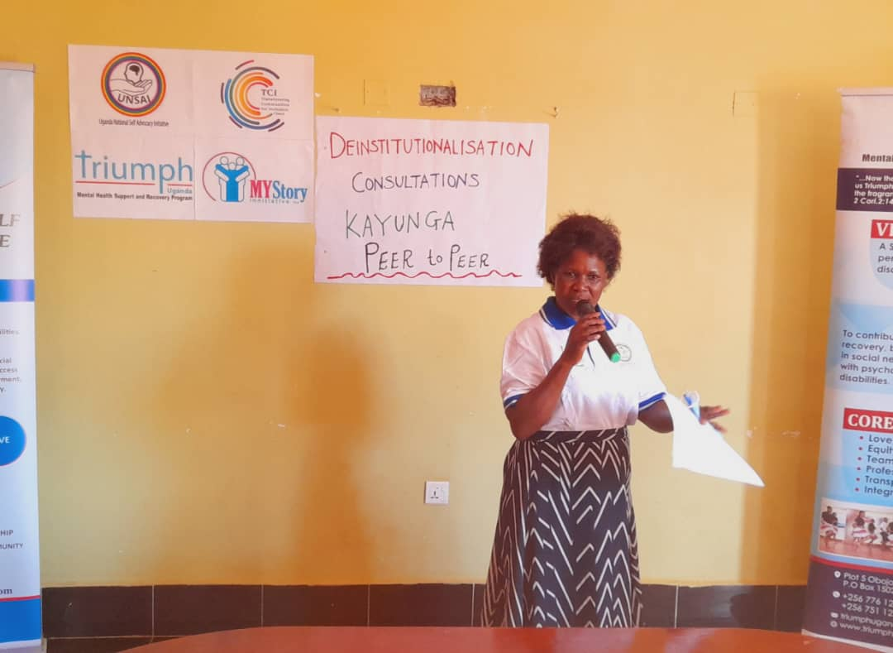

**TCI Fellow Dorothy Nakato woman with psycho social disabilities facilitating consultative in person meeting on the DI draft con**

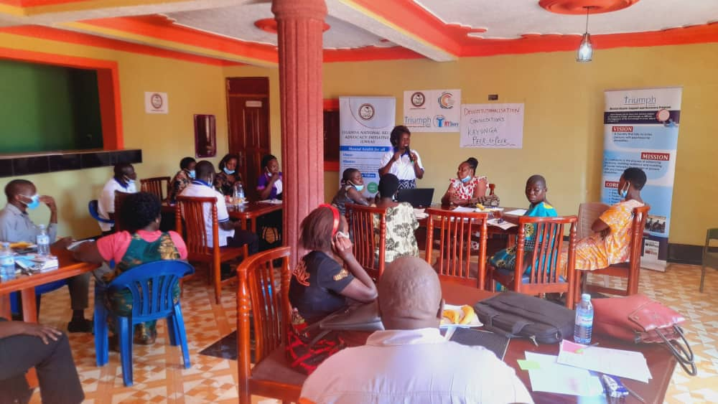

**TCI Fellow Dorothy Nakato woman with psycho social disabilities facilitating consultative in person meeting on the DI draft con**

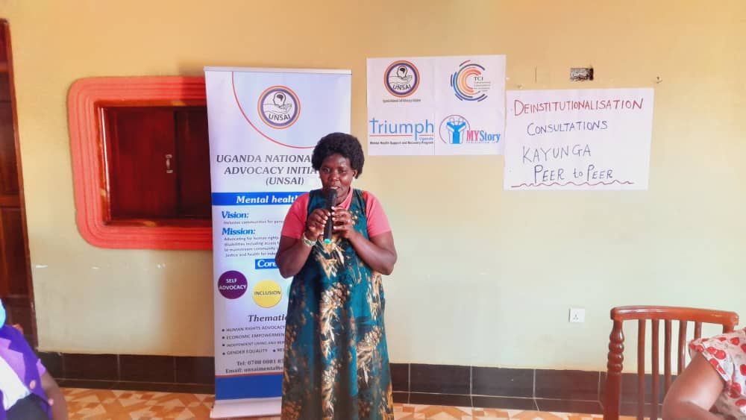

**TCI Presedent and Survivor of insititutions gives a key note speech.**

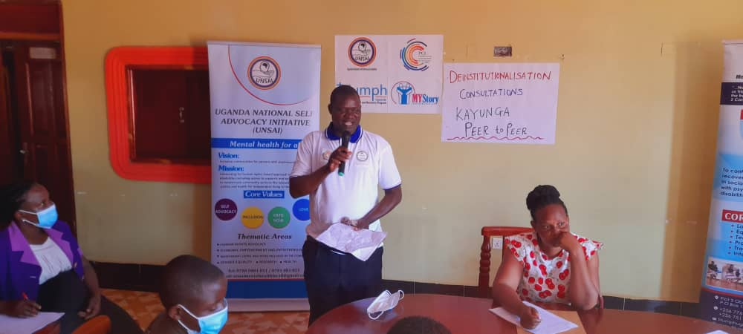

**UNSAI Executive Director- Emmanuel and Survivor of institutions welcomes participants to the consultative meeting**

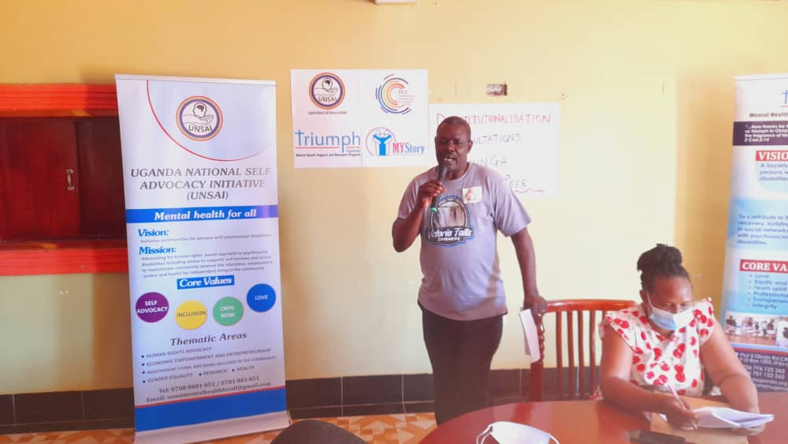

**Daniel a resilient leader with psycho social disabilities and survivor of institutions gives his experience as a traumatized child at 13 years of age in psychiatric institutions**

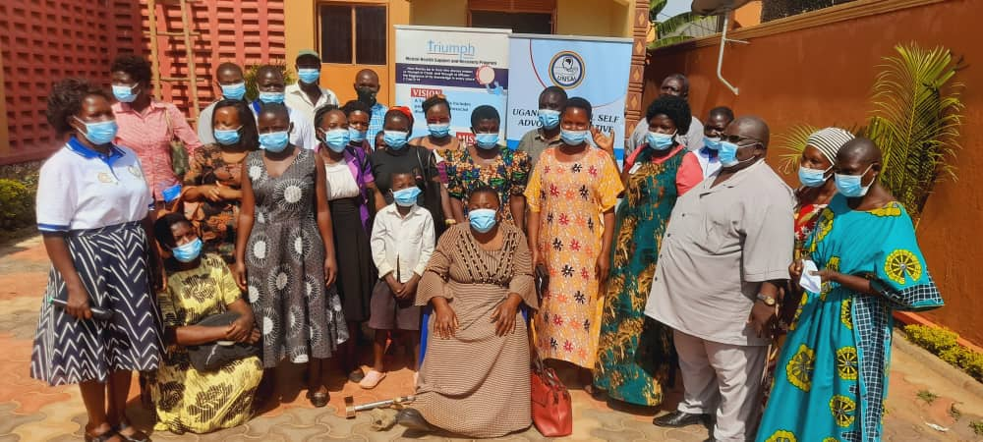

**Group photo of all participants after the DI draft consultative meeting in Kayunga District.**

1. Uganda Bureau of Statistics 2016, *The National Population and Housing Census 2014 – Main Report*, Kampala, Uganda
2. See Article 4(1)(b) and (c) of the United Nations Convention on the Rights of Persons with Disabilities.
3. See Article 15 of the UNCRPD.
4. See Article 24 of the Constitution.