**Step-by-step guide on the submission of Oral Statements on the new online registration platform “EVENTS”**

Contents

Introduction 1

**STEP 1 Selecting the relevant event and action point from the “List of Open Events” page** 2

**STEP 2 Creating your Oral statement request(s) on the “EVENTS” platform** 2

**CONFIRMATION OF SPEAKING SLOTS:** 4

**STEP 3: Registering your online co-sponsoring of NGO statements** 5

Introduction

On a **pilot basis** to be implemented at the 56th regular session of the Human Rights Council (18 June 2024 to 12 July 2024), non-governmental organizations (NGOs) with ECOSOC status will be requested to register for oral statements through the **new online registration platform “EVENTS”**, which is accessible at the following link:<https://events.ohchr.org> .

**IMPORTANT:**

* For more information on the process of creation of NGO accounts on the platform, you are encouraged to consult the guidelines on the process of account creation on the new online registration platform “EVENTS” which is available on the [HRC information page for NGOs](http://www.ohchr.org/EN/HRBodies/HRC/Pages/NgoParticipation.aspx) .

**Step-by-step description of the oral statement submission procedure**

**STEP 1:** Selecting the relevant event and action point from the “List of Open Events”

**STEP 2:** Creating your Oral Statement request(s) on the “EVENTS” platform

**STEP 3**: Registering your Online co-sponsoring of NGO statements

**STEP 1 Selecting the relevant event and action point from the “List of Open Events” page**

* Only **primary accounts** are able to inscribe on any list of speakers.
* **Secondary accounts can edit a registration** (adding a speaker, uploading the statement or the video), co-sponsoring other statements or cancelling requests, but have **no inscription rights.**
* Once successfully logged in, a list of events will appear on your welcome screen. Select the action point “**Oral statement**”. Please make sure that you choose the right event namely the respective session of the Human Rights Council.

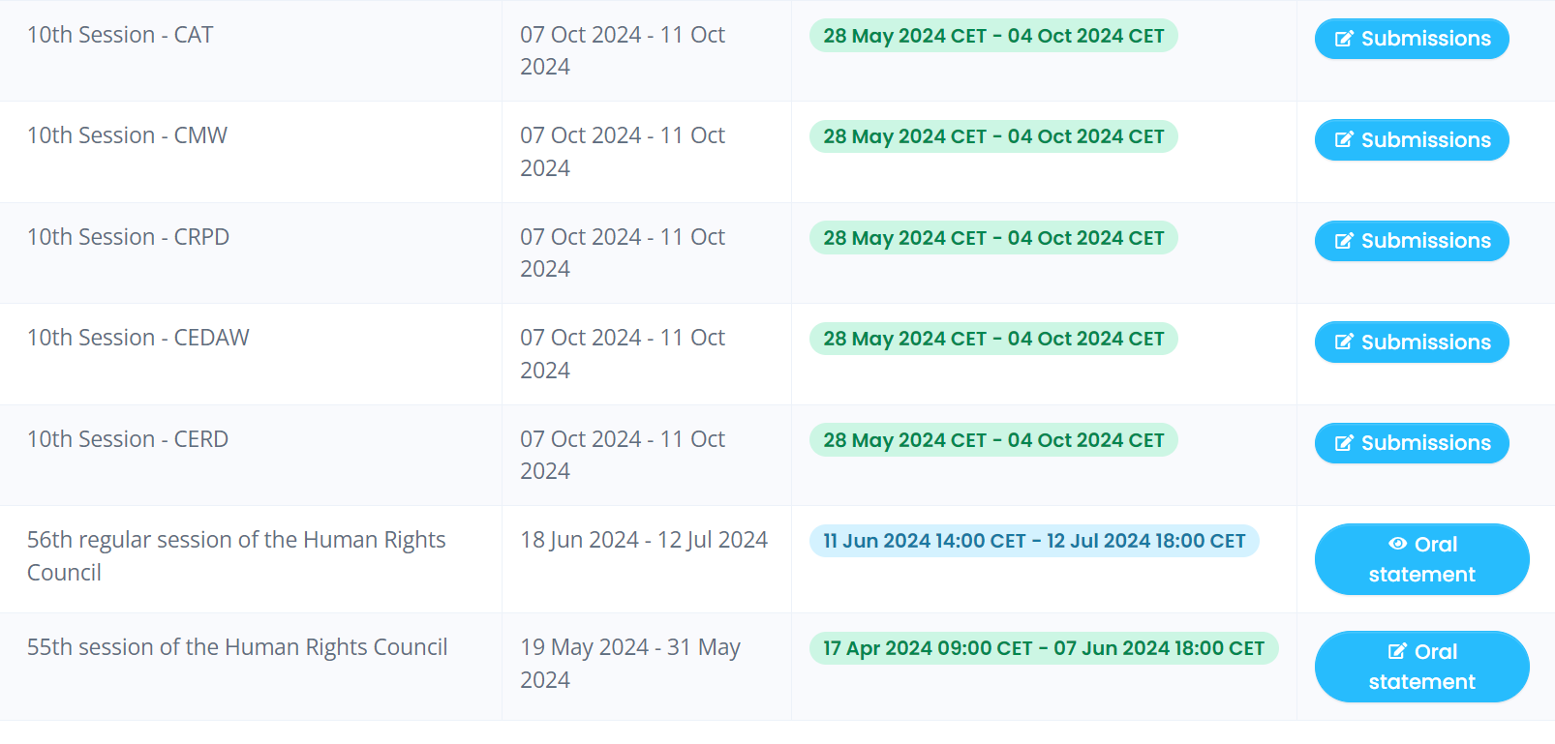

**STEP 2 Creating your Oral statement request(s) on the “EVENTS” platform**

* Once you have clicked on “**Oral Statement**”, the screen as in the below image will appear. Please make sure to read the relevant information.
* Click on “**Register to a debate**” available at the bottom of the screen:

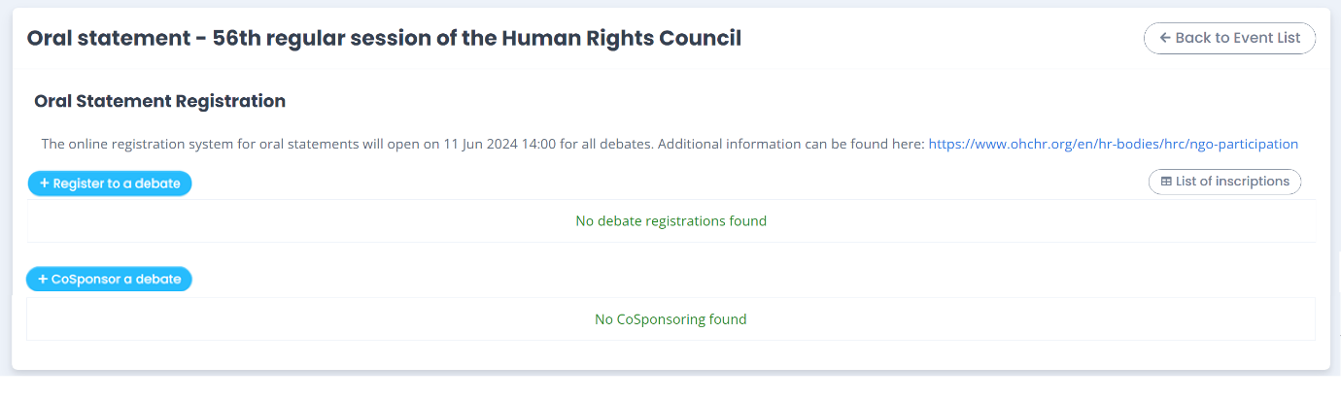

* To register a new **oral statement**, you must indicate the priority and the attendance type by filling all the relevant information from the drop-down list.
* Click on the “**Save**” button.

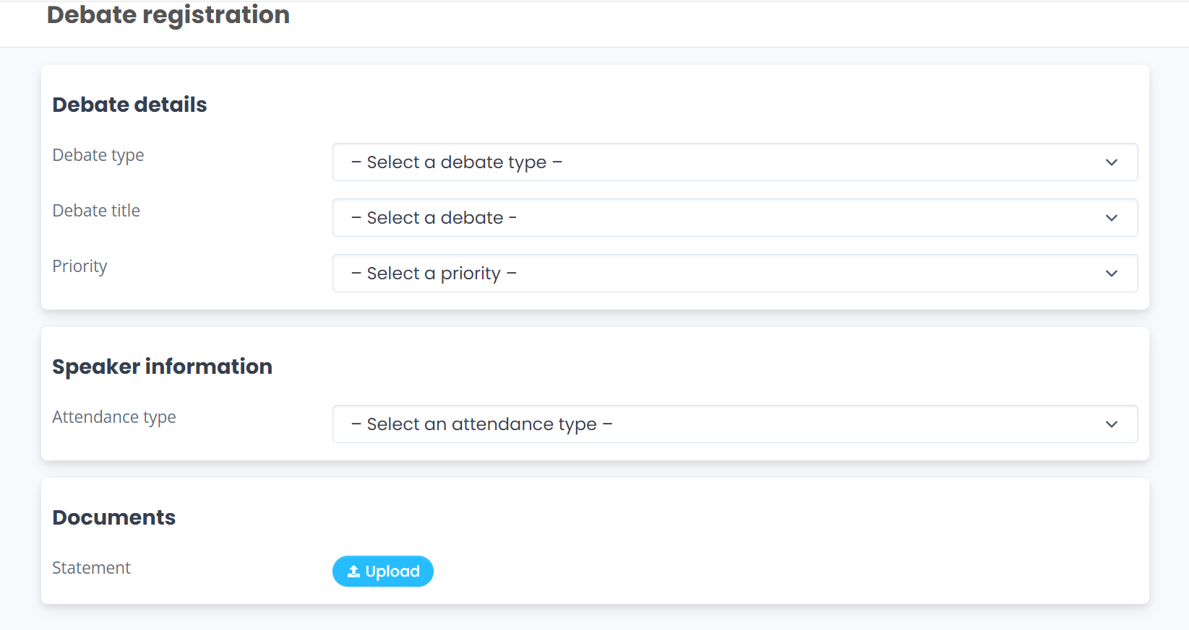

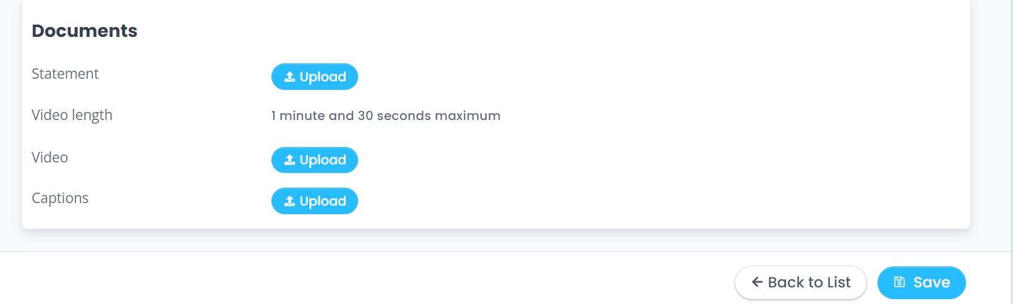

* Your statement will appear as shown below, with the option of modifying it by clicking on “Edit/Upload” or deleting it by clicking on “delete”:

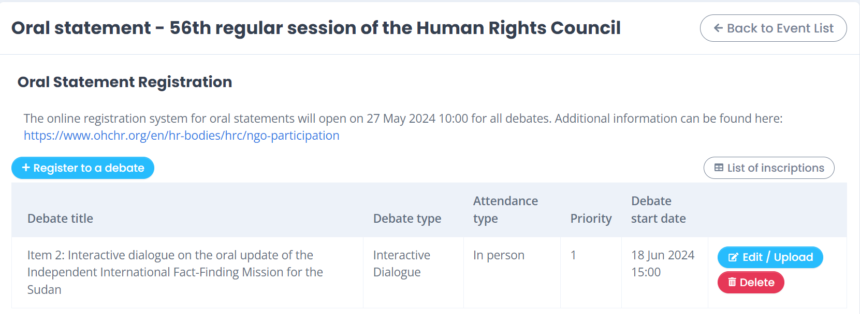

* To upload your video-statement or your oral intervention, click on “Edit / Upload” and upload the relevant file(s) under “Documents”.
* You will be able to **upload your statement and other documents at a later stage**, not necessarily at the same time of inscription. Please bear in mind that **uploading a statement (or transcript) is mandatory for both in-person and video messages.** Failure to comply before the deadline will result in the exclusion of the NGO from the list of speakers.
* Once you upload a statement, you will be required to provide the name of the speaker.
* For video interventions, upload your video file (max 250MB) in the dedicated space. **Please note that video messages that do not comply with the speaking time limits or exceed the maximum weight of the file (250MB) will not be accepted by the system.**
* Please note that both steps mentioned above are mandatory. A video uploaded without the transcript will not be processed by the HRC Secretariat and the NGO will be removed from the list of speakers.



* As recalled by the Bureau of the Human Rights Council, with the exception of an official representative of a UN Member State speaking in front of the national flag and/or the official picture of the Head of State/Government, **the background of video-statements should be neutral without any flag, banner, flyer, picture or symbol.** Failure to comply will result in the exclusion of the NGO from the list of speakers.
* **The full official name of the NGO should be displayed within the video**. Please note that the name displayed should be **the one of the NGO delivering the statement only** (no co-sponsors or non-ECOSOC NGOs), and it should be in accordance with that registered in the database of NGOs in consultative status with ECOSOC.
* **Captioning of the video is strongly encouraged** in order to ensure accessibility of persons with disabilities. In order to facilitate this procedure, NGOs are able to upload a specific file for subtitles directly in the Events registration system. This is not a mandatory field, and it can be left empty.

## **CONFIRMATION OF SPEAKING SLOTS:**

* All NGOs are requested to confirm their speaking slots.
* In-person participants are required to confirm their participation by **uploading the transcript of their statement(s) on EVENTS** as per the deadline set (6 p.m. on the working day before the debate is scheduled to start). Please note that the speaking slots of those NGOs that have not confirmed their participation before the deadline will be removed from the list of speakers.

For participants through a video message, **their participation will be confirmed once both their transcript and the video statement are uploaded on EVENTS** as per the deadline set (6 p.m. on the working day before the debate is scheduled to start). Please note that the speaking slots of those NGOs that have not uploaded a video statement before the deadline will be removed from the list of speakers.

**STEP 3:** **Registering your online co-sponsoring of NGO statements**

* In order to **co-sponsor** the statement of other ECOSOC NGOs, you will have to click on the “**CoSponsor a debate**” button in the main menu.

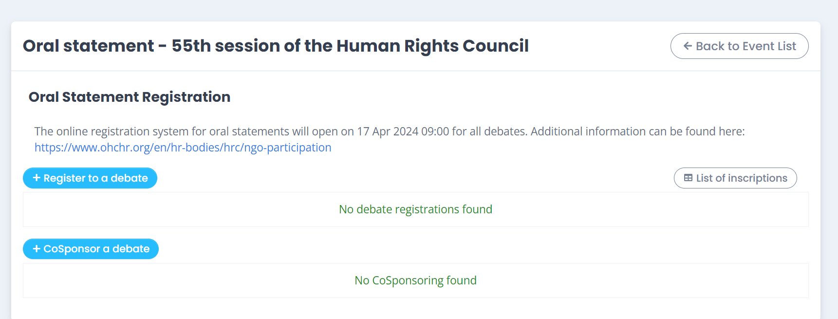

* 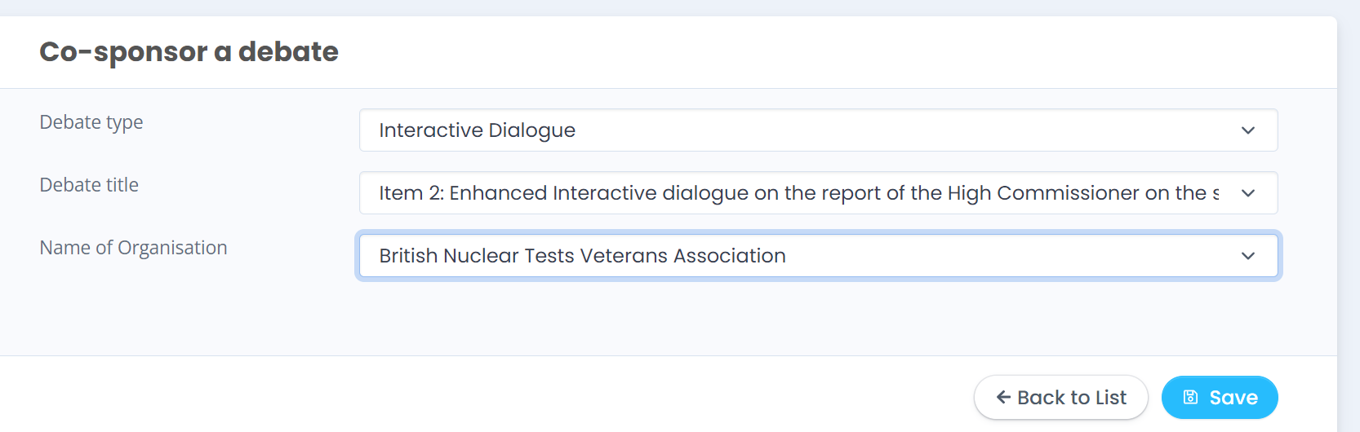You must fill all the relevant information of your cosponsor ship statement from the drop-down list and click on the “**Save**” button:
* The new “EVENTS” system will also allow you to see which NGOs have co-sponsored your statement. This will appear under the name of the debate.