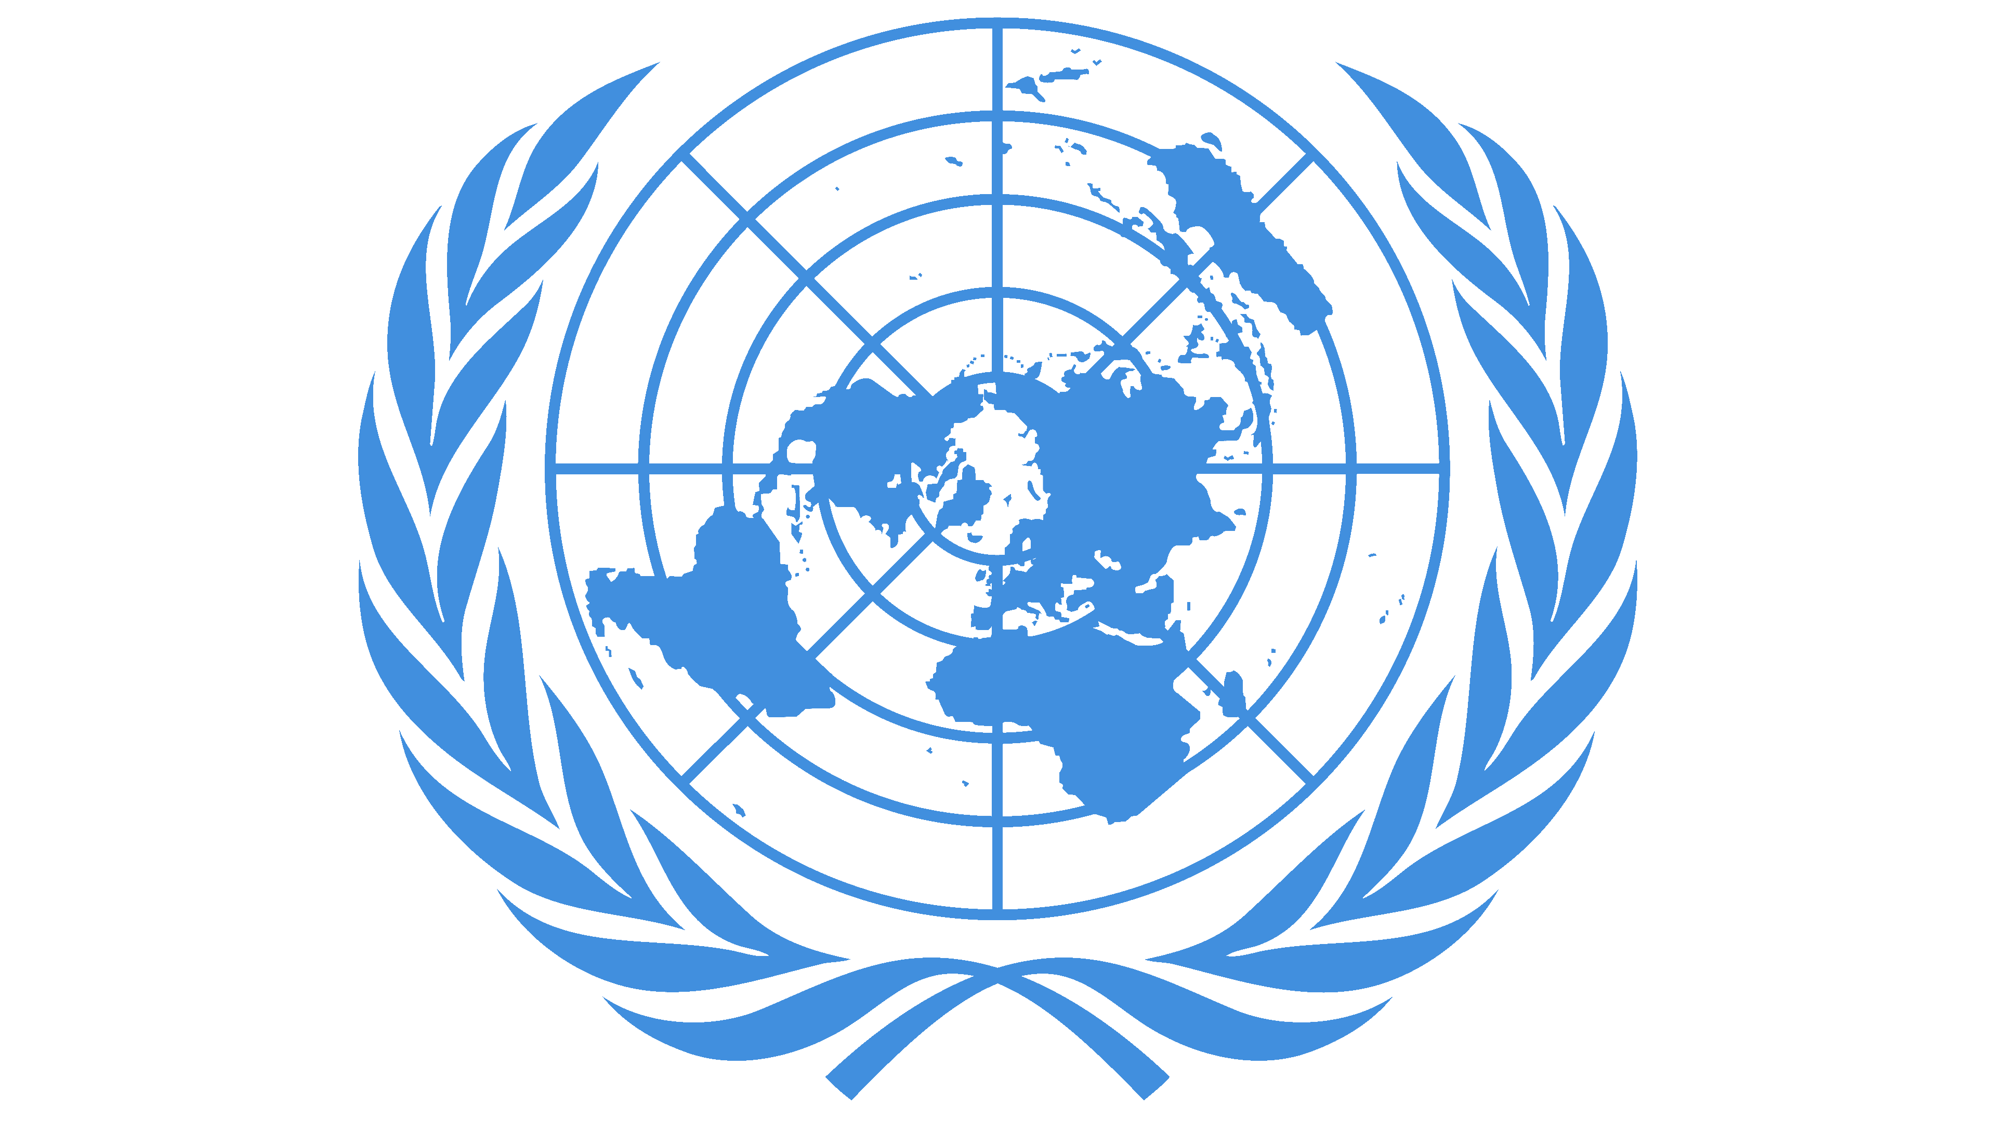

**United Nations Independent International Fact-Finding Mission  
on the Islamic Republic of Iran**

E-mail: [ffmiran@un.org](mailto:ffmiran@un.org)   
Webpage: <https://www.ohchr.org/ffmiran>

Instagtam.com/iranffm

**FACT SHEET**

***Torture and ill-treatement in the context of the “Woman, Life, Freedom” movement***

This fact sheet summarizes the FFM on Iran’s findings on torture and ill-treatment committed in the context of the September 2022 protests in Iran, and the “Woman, Life, Freedom” movement that followed. Pursuant to Human Rights Council Resolution S-35/1, the FFM outlined its findings in its first report presented to the Human Rights Council ([A/HRC/55/67](https://www.ohchr.org/sites/default/files/documents/hrbodies/hrcouncil/sessions-regular/session55/a-hrc-55-67-en.docx), translated into Persian can be found [here](https://www.ohchr.org/sites/default/files/documents/hrbodies/hrcouncil/sessions-regular/session55/advance-versions/ffmi-mandated-report-unofficial-persian-translation.pdf)). The Mission presented a detailed legal, factual, and contextual analysis of its findings in a subsequent conference room paper ([A/HRC/55/CRP.1](https://www.ohchr.org/sites/default/files/documents/hrbodies/hrcouncil/ffmi-iran/20240318-CRP-Combi.docx)).

During its investigations, the Mission established that State officials intentionally inflicted severe pain and mental suffering on women, men and children arrested and detained in connection with the September 2022 protests, in acts amounting to torture. Such treatment consisted of beating, flogging, burning, electrocution, suspending detainees by their arms, and forcing detainees into stress positions, as well as various forms of psychological torture including mock executions and death and rape threats. These acts were perpetrated for purposes of extracting confessions about victims’ links to the protests, and intimidating and punishing them for their support to the “Woman, Life, Freedom” movement. Torture was perpetrated during arrest, transfer, or during interrogations in official and unofficial detention facilities across 16 provinces of Iran. Torture and ill-treatment was perpetrated in the custody of police forces, Islamic Revolutionary Guard Corps (IRGC), the Ministry of Intelligence, and prisons operated by the State Prisons Organization.

Torture was committed in the context of broader patterns of gross human rights violations in detention. The Mission established patterns of lengthy interrogations with detainees being blindfolded during interrogations, resulting in officials conducting the torture almost never being identified.

Victims, including children, were held in solitary confinement for prolonged periods of time in conditions amounting to cruel, inhuman, or degrading treatment or torture. Some were also held in conditions amounting to enforced disappearances. Detainees were also systematically subjected to verbal abuse, insults of a sexual nature, threatened, and mocked and ridiculed based on their ethnicity and religion. Medical care was routinely denied by security officers.

Like adults, children were held in both official and unofficial detention facilities, deprived of contacting their families or a lawyer. Parents or guardians were not or belatedly notified of their children’s arrests. Detained girls and boys were subjected to severe forms of physical, psychological and sexual abuse, including rape.

Rape and other forms of sexual violence perpetrated against women, men, and children arrested and detained in connection with the September 2022 protests, amounted to torture. Sexual and gender-based violence was mostly used against women to humiliate and punish them for their support for gender equality and non-discrimination in the context of the “Woman, Life, Freedom” movement.

The Mission remains concerned that the Iranian domestic legal framework lacks a definition of torture consistent with international law and standards. Prosecutorial officials and judges, moreover, rely on evidence obtained under torture for purposes of meting out sentences.

The Mission found that victims’ rights not to be subjected to torture or cruel, inhuman or degrading treatment or punishment were grossly violated. Such conduct is in violation of Iran’s obligations under the ICCPR to which it is a state party. It is also in violation of the right not to be subjected to arbitrary arrest and detention and to the right to the highest attainable standards of health protected respectively by the ICCPR and ICESCR, to which Iran is a state party.

Beyond custodial torture, the Mission also recalls its findings that summary proceedings without fair trial and due process guarantees, also violate the prohibition against torture and ill-treatment.

The Mission, moreover, found that torture constituted a crime against humanity as committed as part of a widespread and systematic attack against a civilian population, namely women, girls and others protesting for human rights.

Torture survivors continue to suffer the physical and psychological effects of the torture they endured, particularly in detention. Survivors battle flashbacks, nightmares, suicidal thoughts, anxiety, self-isolation, lack of concentration, low mood, and recurrent panic attacks. Children have been exposed to brutal violence, whether as victims or witnesses, the trauma of which may affect generations to come.

**The FFM reiterates its call on the Government of the Islamic Republic of Iran to:**

1. Immediately place a moratorium on the use of the death penalty;
2. Cease and desist from any practices that amount to torture or cruel, inhuman, and degrading treatment, and to repeal provisions of the Islamic Penal Code which sanction punishments amounting to torture, including flogging;
3. Define torture as a crime in national legislation in line with international law and standards, and ratify the CAT and its Optional Protocol, the CEDAW, and the Second Optional Protocol to the ICCPR;
4. Provide due process, including access to a lawyer of one’s own choosing from the time of arrest and during interrogations, and prompt access to medical examinations by an independent doctor upon being taken into custody, during transfers, and periodically during detention;
5. Allow unimpeded access to and monitoring of detention centres by international and independent organizations and observers, including impromptu visits. Also allow regular consular visits for foreign citizens and for Iranian citizens with dual nationality; and
6. Unequivocally condemn sexual and gender-based violence and bring the definition of rape in Iranian law in line with international law and standards: repeal laws that deter victims from reporting SGBV, that contain discriminatory standards of proof or that lead to impunity for SGBV.

**The FFM calls on the international community to support victims of torture in Iran and abroad by:**

1. Prosecuting and punishing those engaged in acts amounting to torture;
2. Providing safe passage, asylum and care for victims and survivors;
3. Granting asylum and humanitarian visas to those fleeing persecution; and
4. Providing medical and other life-saving assistance, to victims, especially those fleeing persecution in the context of the protests in the Islamic Republic of Iran.