Intersessional panel discussion on human rights challenges in addressing and countering all aspects of the world drug problem

(as of 24 January 2024)
Monday, 5 February 2024, 10:00 a.m. – 12:00 p.m.
Palais des Nations, Room XX, Geneva
(will be broadcast live and archived on https://media.un.org/en/webtv)
BIOGRAPHIES

Panellists: | 1. Ms. Christine Stegling, Deputy Executive Director of the Policy, Advocacy and Knowledge Branch and Assistant Secretary General of The Joint United Nations Programme on HIV/AIDS (UNAIDS)  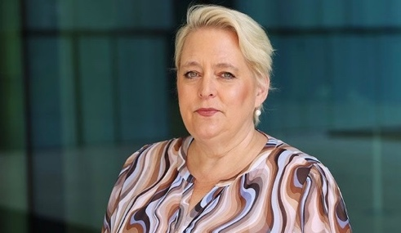  Prior to joining UNAIDS in January 2023, Christine Stegling was the Executive Director of Frontline AIDS and previously an Executive Director of both the International Treatment Preparedness Coalition and the Botswana Network on Ethics, Law and HIV/AIDS (BONELA). A passionate leader, committed manager and effective problem-solver, Ms. Stegling brings a vast experience in - and deep, nuanced knowledge of - the AIDS pandemic. She is known for expertly spearheading initiatives capable of changing policy, law and fiscal environments to accelerate and expand progress toward ending AIDS. Her policy and advocacy work at global, regional and country levels has helped increase access to HIV prevention and treatment, expanded sexual and reproductive health and rights, and supported marginalized people through community-based programs.  2. Mr. Jean-Luc Lemahieu, Director of the Division for Policy Analysis and Public Affairs of the United Nations Office on Drugs and Crime (UNODC)  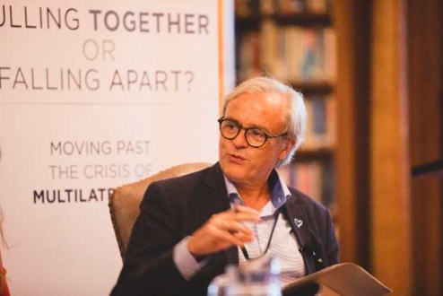  Jean-Luc Lemahieu was appointed as a Director of the Division for Policy Analysis and Public Affairs at UNODC in December 2013. Before taking up this position, he gained 20 years of field experience serving in various countries challenged by political economies influenced by the illicit economy, including Afghanistan and Myanmar, and in drug transit regions, such as the Caribbean. His first appointment with the UN dates back to 1990, as a Junior Professional Officer with the United Nations Industrial Development Organization (UNIDO) assigned to the Republic of Korea. Mr. Lemahieu is a licensed jurist with a postgraduate degree in international law.  3. Ms. Ann Fordham, Executive Director of The International Drug Policy Consortium (IDPC)  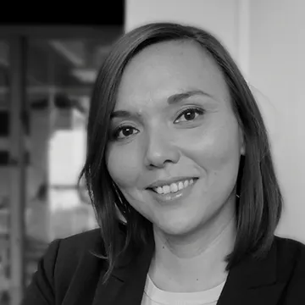  Ann Fordham was appointed as Executive Director of IDPC in 2011 and currently leads the coordination and development of the network. Ann implements international advocacy efforts on drug policy and human rights, specifically calling for reform of laws and policies that have proven ineffective in reducing the scale of the drug market and have negatively impacted marginalised population groups, such as people who use drugs and growers of illicit crops. She represents IDPC at international events and works with policy makers and civil society partners around the world to review and shape drug control policies towards more humane and effective approaches that are based on principles of human rights and public health. Ann was also the Chair of the Strategic Advisory Group to the United Nations on drug use and HIV from 2017 to 2023.  4. Ms. Adeeba Kamarulzaman, Commissioner of the Global Commission on Drug Policy (GCDP)  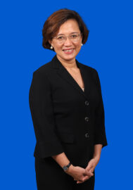  Adeeba Kamarulzaman is a Professor of Medicine and Infectious Diseases and Pro Vice Chancellor and President of Monash University, Malaysia. Prior to this appointment, she served as Dean of Medicine at the University of Malaya. She is the Immediate Past President of the International AIDS Society, and currently Co-Chair of the WHO Science Council. Dr. Kamarulzaman has dedicated her career to the prevention, treatment and research of infectious diseases and HIV/AIDS and is a strong advocate for HIV prevention, treatment and care programs. In 2007, Dr. Kamarulzaman established the Centre of Excellence for Research in AIDS (CERiA) at the University of Malaya (Malaysia). She has served on numerous technical and advisory committees for UNAIDS, WHO and UNODC and is a member of the Malaysian Health Advisory Council. She joined the Global Commission on Drug Policy in 2022.

