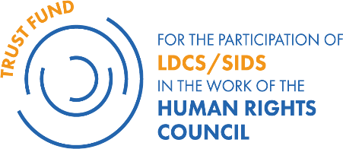 

# **LDCs/SIDS BENEFICIARY DELEGATES AND FELLOWS SUPPORTED BY THE TRUST FUND AT THE 56th SESSION OF THE HUMAN RIGHTS COUNCIL (HRC56)**

**(****18 June – 12 July 2024)**

**Delegates programme at HRC56:** 18 June – 12 July 2024

|  |  |  |
| --- | --- | --- |
| 1 | **Angola** | **Ms. Domingas Lumbo Mucuta** |
| 2 | **Antigua and Barbuda** | **Ms. Annetta Deborah Jackson** |
| 3 | **Bangladesh** | **Mr. Mohammad Irfan Chowdhury** |
| 4 | **Barbados** | **Ms. Latoya Felicia Archer** |
| 5 | **Belize** | **Ms. Melissa Rodriguez** |
| 6 | **Benin** | **Mr.** **Bessanh Brice Baudouin Gbessi** |
| 7 | **Burkina Faso** | **Ms. Ines Bakio** |
| 8 | **Gambia** | **Ms. Sainabou Jahateh** |
| 9 | **Guyana** | **Mr. Jason Fields** |
| 10 | **Maldives** | **Ms. Aishath Rifga Mohamed** |
| 11 | **Mali** | **Mr. Habou Coulibaly** |
| 12 | **Somalia** | **Mr.** **Halimo Muse Mayow Sayidali Hassan Alim** |
| 13 | **Suriname** | **Ms. Varsha Sujata Ramratan** |
| 14 | **Vanuatu** | **Mr. Albert Nalpini** |

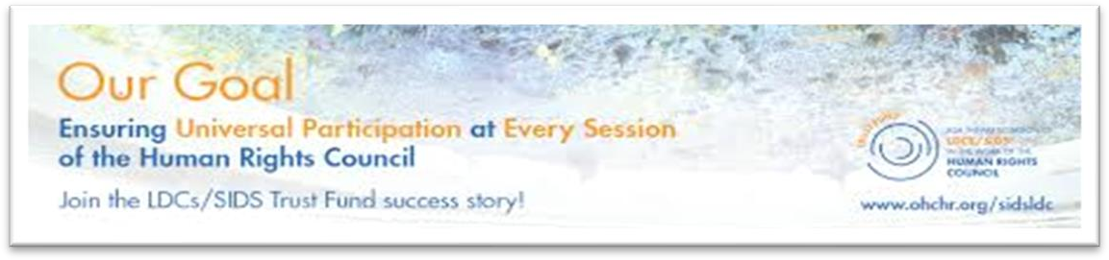

**Angola**

**Domingas Lumbo Mucuta**  
**Human Rights Officer**

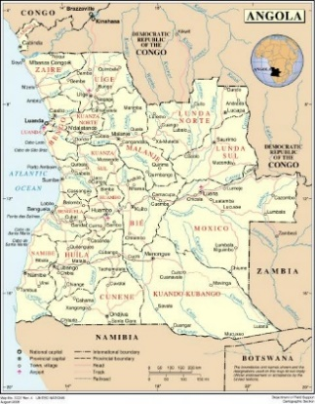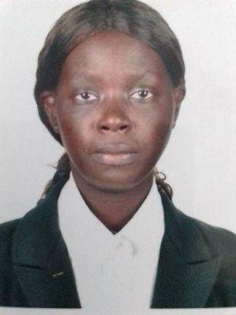

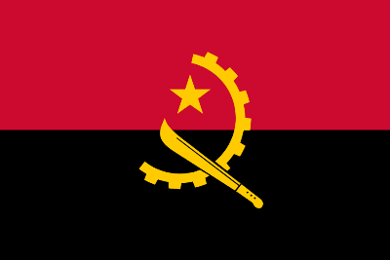

Ms. Domingas Lumbo Mucuta holds a degree in International Relations from the University of Belas in Angola. She joined the Ministry of Foreign Affairs in 2016 and has worked in several departments. Since 2021, she has served as a Human Rights Officer in the Directorate of Multilateral Affairs, UN Department. Currently, she is a member of the Intersectorial Commission on the Elaboration of National Reports on Human Rights (CIERNDH) in Angola. Prior to joining the Ministry, she worked as an English teacher at the private school Carpe Diem in Angola for over four years.

**Antigua and Barbuda**

**Annetta Deborah Jackson**  
**Crown Counsel at the Attorney General's Chambers**

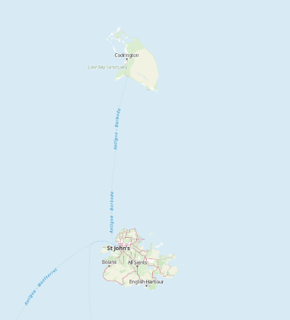





Annetta D. Jackson is an Attorney-at-Law and creative passionate about Gender Equity and Social Protection. She holds a Bachelor of Laws with First Class Honours from the University of West London and was awarded a Very Competent in her Postgraduate Bar Professional Training.

She works as Crown Counsel within the Attorney General’s Chambers and previously served as a Programme Officer in Antigua and Barbuda’s National Gender Machinery, responsible for Gender Mainstreaming in Legal and Institutional Frameworks.

Having technical experience in Gender Development, Annetta serves on Antigua and Barbuda’s Department of Environment Gender and Environment Social Safeguards Advisory Committee and on the Labour Department’s Work Place Harassment Reform Taskforce.

For the past 4 years Annetta has been involved in Gender Justice Advocacy through her work with the NGO Intersect Antigua and has experience with Feminist Philanthropy through work with the Black Feminist Fund as a Fellow.

***This is her first time attending a regular session of the Human Rights Council and her first time in Geneva.***

## Bangladesh

## Mohammad Irfan Chowdhury

## Assistant Secretary (UN Wing), Ministry of Foreign Affairs

## Drapeau du Bangladesh, Drapeaux du pays Bangladesh

Mr. Mohammad Irfan Chowdhury is a career diplomat from Bangladesh who is currently working as an Assistant Secretary at the United Nations Wing of the Ministry of Foreign Affairs. Apart from Bangladesh’s engagement with different UN bodies, his portfolio includes multilateral organizations and human rights issues.

Owing to his current assignment at the United Nations desk, he possesses a keen interest in the United Nations and the relevant bodies including their operative procedures and mechanisms, humanitarian diplomacy and human rights. He was actively involved in formulating the documents regarding the 4th cycle of UPR of Bangladesh in November 2023 in Geneva.

Mr. Mohammad Irfan Chowdhury joined the Ministry of Foreign Affairs, Bangladesh in 2021. Besides carrying out his duties in the Ministry, he is currently pursuing a Professional Master's in International Relations & Diplomacy from the Department of International Relations of the University of Dhaka. Mr. Irfan holds a Bachelor of Medicine and Surgery (M.B.B.S.) degree from Dhaka Medical College

***This is his first time attending a regular session of the Human Rights Council and his first time in Geneva.***

## Barbados

## LaToya Felicia Archer

**Foreign Service Officer, Human Rights and Multilateral Relations Unit, Ministry of Foreign Affairs and Foreign Trade**

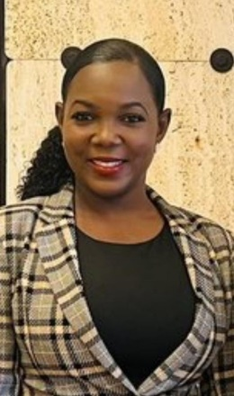

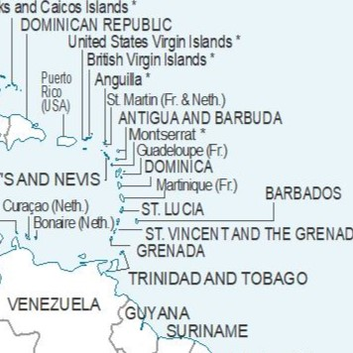

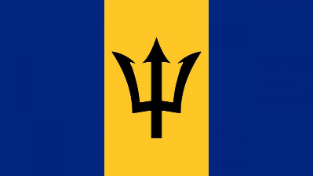

## 

Ms. LaToya Archer is a Foreign Service Officer in the Ministry of Foreign Affairs and Foreign Trade of Barbados. She holds a Master’s Degree in Business Administration and a collection of specialized work-related certificates which has formed the foundation for her role. LaToya has a diverse background in the Public Service having served in varied capacities prior to her current position. Since entering the Foreign Ministry in 2018 she has navigated through different sections and is currently assigned to the Human Rights and Multilateral Relations Unit. Her role is multifaceted, focusing on advancing Barbados' foreign policy objectives, particularly regarding social, humanitarian, and cultural issues aligned with the mandates of the United Nations Third Committee.

Top of Form

Additionally, her involvement in the preparation and participation in Barbados' Fourth Cycle of the Universal Periodic Review of the Human Rights Council, in May 2023, ignited a profound interest in human rights advocacy. During a brief stint as Second Secretary at the Permanent Mission of Barbados to the United Nations in New York, for the 78th Session of the UN General Assembly, she refined her diplomatic skills through engagement in negotiation processes within the Third Committee. Moreover, during that period, she provided support to her colleagues by lending assistance with transacting business in other areas of national significance.

***This is her first time attending a regular session of the Human Rights Council.***

## 

## Belize

## Melissa Rodriguez-Gill

**Foreign Service Officer , Ministry of Foreign Affairs and Foreign Trade**

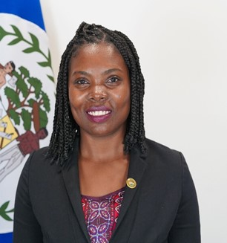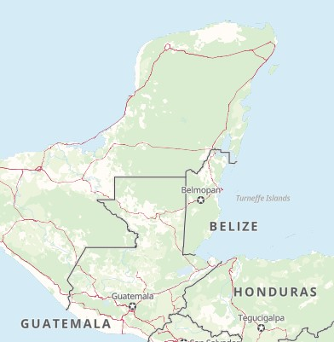

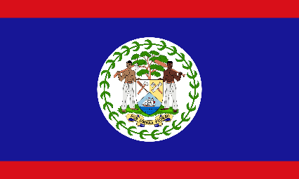

Mrs. Melissa Rodriguez-Gill is a Foreign Service Officer at the Ministry of Foreign Affairs and Foreign Trade. Since 2017, she has served with the Government of Belize, where she leads the Human Rights Treaty Reporting Desk. In this role, Mrs. Rodriguez Coordinates the Universal Periodic Review (UPR) process and coordinates the implementation of a National Monitoring, Reporting, and Follow-up Mechanism for treaty body compliance.

Her extensive portfolio also includes handling migration and refugee issues, energy policies, matters related to the International Atomic Energy Agency (IAEA), support for efforts to combat human trafficking, and managing targeted financial sanctions desk related to terrorism and its financing.

***This is her first time attending a regular session of the Human Rights Council.***

## Benin

**Bessanh Brice Baudouin Gbessi**

**Head of the Service of Human Rights Protection Associations and Agencies at Human Rights Department of Ministry of Justice and Legislation**

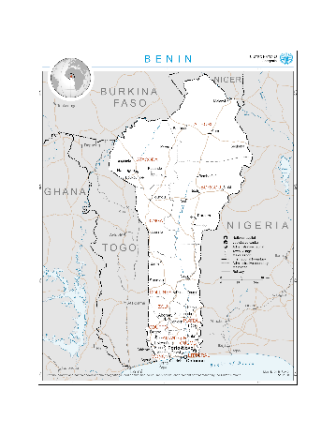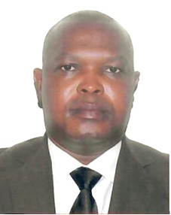



Project manager, Mr Brice Gbessi has real skills in Human Rights, Humanitarian emergency, entrepreneurship and sustainable development areas. Current Head of the Service of Human Rights Protection Associations and Agencies, he is in charge of the Coordination and the monitoring of the implementation of Benin’s recommendations for the fourth round of the Universal Periodic Review. As such, he is also involved in all processes of Treaty Bodies reports and lists of items responses Development.

His aim at this position is to enhance the implementation of the recommendations, commitments and comments of regional and international human rights mechanisms by addressing four main challenges : i) develop a national plan for the implementation of Benin’s recommendations of fourth round of Universal Periodic Review, ii) update and restructure the national mechanism for monitoring the application of international human rights instruments, iii) develop an integrated national system for the production, storage and dissemination of human rights data and iv) promote a human rights-based approach of development from national to local levels. He thinks that this programme can help him to identifiy opportunities to reach these objectives for his country.

Before this position, he was in charge of the Department of Prospective and data analysis at Civil Society Promotion Center, where he managed, among others, the processes of draft law on freedom association in Republic of Benin and database on associations and NGOs.

Mr Brice Gbessi holds a Master 2 degree in entrepreneurship and project management. He detains also a Professional Master’s in Local development. He is preparing a Master 2 research in human rights and democracy.

## Burkina Faso

**Inès Bakio  
Directrice des organisations internationales/Ministère des Affaires Etrangères, de la Coopération Régionale et des Burkinabè de l‘Exterieur**

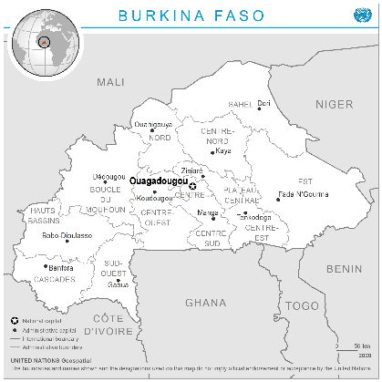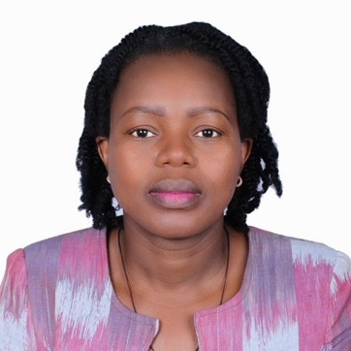



Madame BAKIO Inès est juriste de formation et diplomate de carrière. Après avoir obtenu une maitrise en Droit à l’Unité de formation des Sciences juridiques de l’Université Joseph KI-ZERBO de Ouagadougou en 2002, elle est admise au concours de Conseillers des Affaires Étrangères en 2003. A la suite d’une formation sanctionnée par le Diplôme de l’École nationale d’administration et de magistrature, option Diplomatie, elle intègre le corps des conseillers des Affaires Étrangères en 2006.

Après avoir occupé de nombreuses responsabilités notamment Chargée d’études, Directrices des affaires consulaires et servi en qualité de Ministre conseiller à l’Ambassade du Burkina Faso au Japon, elle est nommée Directrice des organisations internationales depuis avril 2023 au Ministère des affaires étrangères de la coopération régionale et des burkinabè de l’extérieur. La Direction des organisations internationales assure le suivi et le traitement de toutes les questions concernant les relations entre le Burkina Faso et l'Organisation des Nations Unies.

Conscient des enjeux du multilatéralisme, elle s’intéresse aux mécanismes de fonctionnement des organisations des nations unies et des institutions spécialisées en vue d’une participation efficace et fructueuse de son pays au sein de ses différentes instances internationales. Mettant à profit, sa formation et sa carrière, elle apporte sa contribution aux sessions d’élaboration, de négociations et de suivi des accords et conventions impliquant son pays.

Dans cette dynamique, les travaux du Conseil des droits de l’hommes constituent une opportunité, en tant que cadre par excellence de la question des droits de l’homme, de visiter le corpus légal et juridique de toute la matière humanitaire et de s’imprégner des expériences des différents pays membres en matière de la mise en œuvre des droits de l’homme.

***Elle participe pour la première fois à une session ordinaire du Conseil des droits de l’homme.***

## Gambia

**Sainabou Jahateh**

**Senior State Counsel**

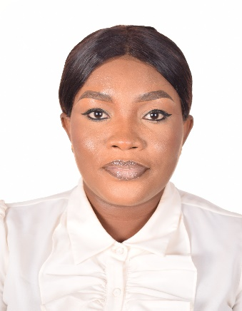

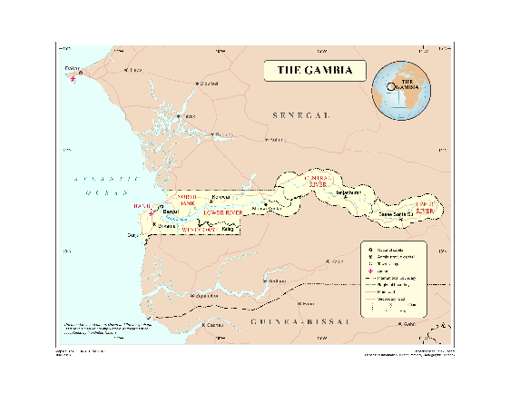



Sainabou Jahateh started her career at the Ministry of Justice in 2014 as a Public Prosecutor. In 2016 she was promoted to the position of a State Counsel and in 2022 she became Senior State Counsel. She is currently the Deputy Chairperson of the Human Rights reporting Committee of the Ministry, as well as a member of the Sexual and Gender Based Violence Unit of the Ministry of Justice.

As a Senior State Counsel, she works under the Criminal Division of the Ministry where she prosecutes cases from the Magistrate Court to the Supreme Court of The Gambia. Her responsibilities also include reviewing agreements and assisting the Head of the Human Rights Unit in the coordination of the reporting obligations of The Gambia with Treaty Bodies.

Ms Jahateh is currently posted to the office of the Curator of Intestate Estates to assist the head of that unit in the day-to-day administration of that office.

Ms. Jahateh obtained her LLB at the University of The Gambia in 2013, her BL in 2016 at the Gambia Law School and subsequently obtained an LLM at the University of The Gambia in 2023. Currently, she is pursuing a PhD in Diplomacy and Consular Relations from the University of The Gambia.

***This is her first time attending a regular session of the Human Rights Council and her first time in Geneva.***

**Guyana**

**Jason Fields**

**Senior Foreign Service Officer II in the Ministry of Foreign Affairs and International Cooperation attached to the Multilateral and Global Affairs Department**

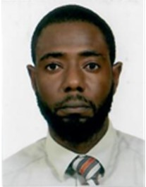

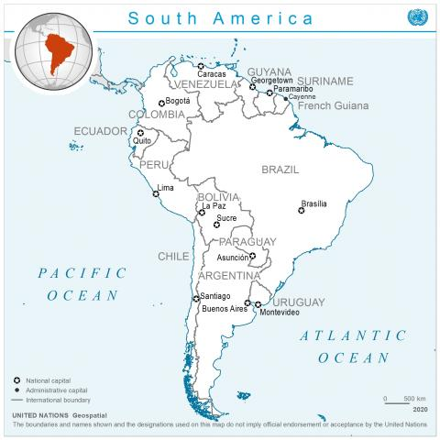

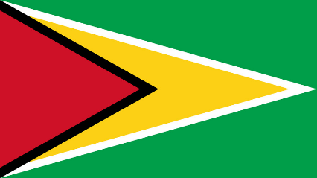

Mr. Jason Fields is a career Foreign Service Officer and began working at the Ministry of Foreign Affairs and International Cooperation on January 2, 2008, in the Multilateral and Global Affairs Department (MGAD).

His promotion to FSO III in 2013 marked a milestone in his career and provided him with the invaluable opportunity to be mentored by a Senior FSO tasked with Guyana’s human rights portfolio within the MGAD, which included the Third Committee of the United Nations General Assembly. Mr. Fields served in Guyana’s Embassy in Washington, D.C., from (2017-2023). While serving at the Mission, he held the human rights portfolio on bilateral and multilateral matters, as it pertained primarily to the Organisation of American States and, by extension, the Inter-American Commission on Human Rights (IACHR).

Mr. Fields' professional focus lies in the realm of human rights, particularly within the OHCHR. His extensive expertise and dedication to this crucial area of international affairs are further demonstrated by his role as an alternate representative for the Ministry of Foreign Affairs and International Cooperation on the National Mechanism for Reporting and Follow-up on Guyana’s Human Rights Treaty Obligations.

***This is his first time attending a regular session of the Human Rights Council and his first time in Geneva.***

## 

**Maldives**

**Aishath Rifga Mohamed**

**Chief General Service Officer at the ministry of Foreign Affairs**

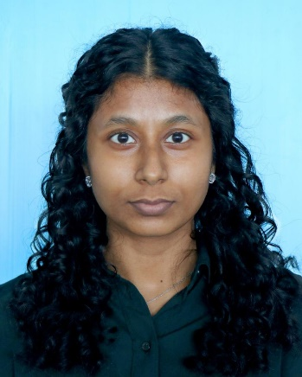

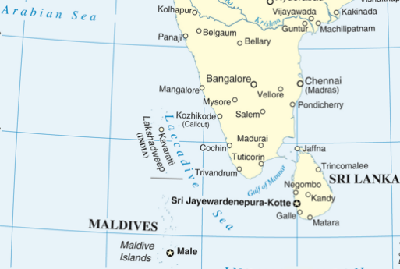

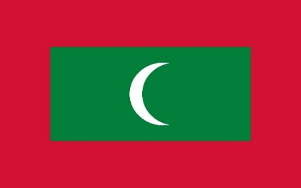

Aishath Rifga Mohamed is currently a Chief General Service Officer at the Ministry of Foreign Affairs of the Republic of Maldives. Since joining the Ministry in December 2021, she has been responsible for facilitating the Maldives’ participation in and engagement with international organisations including the Commonwealth, Organisation of Islamic Cooperation (OIC), Non-Aligned Movement (NAM), Organisation of African, Caribbean and Pacific States (OACPS) as well as United Nations specialized agencies. This includes exploring new opportunities for enhanced cooperation, preparing for visits, preparing brief papers, statements, talking points, and reports. She has also overseen Maldives’ participation in important and prestigious international conferences such as the World Economic Forum’s meetings and the Munich Security Conference. With practice-based learning being an integral part of the Foreign Service, she has had the opportunity to experience first-hand the art of diplomacy, which has been instrumental in polishing her soft skills such as effective communication. Her diverse experience has also enabled her to gain insights and further understanding into topics such as peace and security, sustainable development and human rights. Previously, she worked as an intern at the Economic Cooperation Department and Protocol Department of the Ministry.

Working with inspiring career diplomats in the Ministry, has renewed her interest to learn more and advance in this field to take on a leading role in implementing the nation’s foreign policy goals and objectives. She holds a Bachelor of Arts in International Relations from the Asia Pacific University in Malaysia.

***This is her first time attending a regular session of the Human Rights Council and her first time in Geneva.***

**Mali**

**Habou Coulibaly**   
**Conseiller des Affaires étrangères, Chargé de dossier à la Section droit international de la Direction des Affaires juridiques du Ministère des Affaires étrangères et de la Coopération internationale du Mali.**

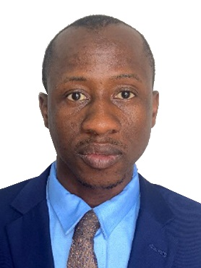

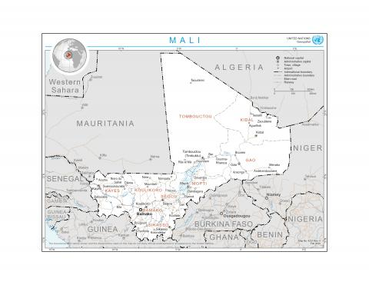



En septembre 2014, Monsieur Habou COULIBALY arrive en France pour ses études supérieures en Droit, à l’Université Clermont Auvergne où il obtient une Licence en droit public en 2017, puis un Master 2 Carrières Internationales en 2019.

La même année en décembre, il est candidat heureux au concours d’entrée à l’Ecole Nationale d’Administration (ENA) du Mali, dans le Corps des Conseillers des Affaires étrangères.

De 2021 à 2023, il effectue la formation au sein de cette Ecole en tant qu’élève fonctionnaire. De juillet à décembre 2022, il effectue son stage de qualification au Ministère des Affaires étrangères et de la Coopération internationale, Direction Asie et Océanie, Département Moyen-Orient. En mars 2023, il soutient son mémoire de fin de formation à l’Ecole Nationale Administration (ENA) sur « la Coopération entre le Mali et les pays du Golfe arabo-persique ».

En septembre 2023, il a été affecté à la Direction des Affaires juridiques, Département de la « Recherche et des Etudes générales », Section : « Droit International » du Ministère des Affaires étrangères et de la Coopération internationale du Mali.

Il surveille ainsi la mise en oeuvre des conventions internationales, en particuliers celles relatives aux droits de l’Homme, ratifiées par le Gouvernement du Mali ; et participe activement à l’élaboration des rapports de mise en oeuvre de ces Conventions. Il communique régulièrement sur l’actualité du Droit internationale et rédige des notes visant à aider les hautes autorités à la prise de décision.

Monsieur Habou COULIBALY est particulièrement intéressé par les questions de droits de l’Homme, du droit international humanitaire et la justice pénale internationale.

***Il participe pour la première fois à une session ordinaire du Conseil des droits de l’homme et il s’agit également de sa première visite à Genève.***

**Somalia**

**Halimo Muse Mayow SayidAli Hassan Alim**

**Division Head of Department of Human Rights at Ministry of Women and Human Rights Development**

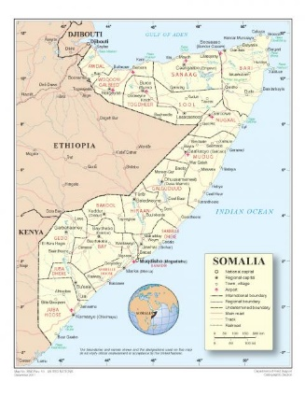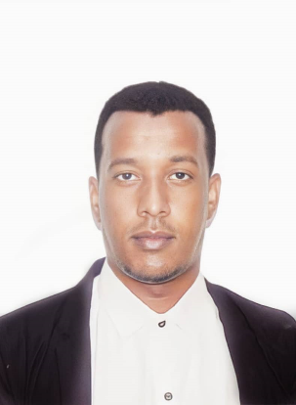



Mr. SayidAli Hassan Alim joined the Ministry of Women and Human Rights Development since 2019 and served in several positions at the Ministry including special secretary, protocol officer to the State Minister, as well as the position of division Head Department of Human Rights Development At Ministry of Women and Human Rights Development of the Federal Republic of Somalia. Prior to joining the Ministry, he had the opportunity to attend various seminars and meetings related to Human Rights and Humanitarian issues which let him to acquire a strong knowledge and skills in those fields.

Mr. SayidAli pursues his interest in child, women and People with special needs’ rights, and committed advocate for the promotion of human rights principles and values in Somalia within the framework of the policy and action plan of the Ministry of Women and Human Rights Development.

Mr. SayidAli holds a Bachelor of Information Communication Technology and the University of Admas University and is currently pursuing an MA in project Management from the University of Acourd University.

***This is his first time attending a regular session of the Human Rights Council and also his first time in Geneva.***

## Suriname

**Varsha Sujata Ramratan**

**First Secretary of the Mission of Suriname to the United Nations**

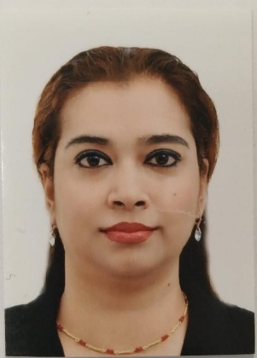

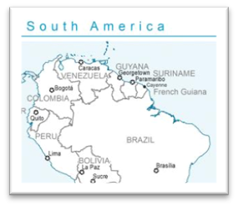

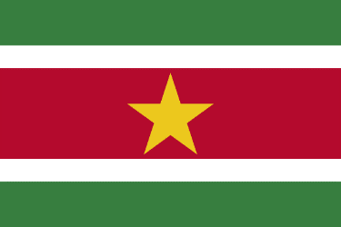

Ms. Varsha Ramratan is a diplomat, who currently works at the Mission of the Republic of Suriname to the United Nations in New York. She did her Legal Law Masters (LLM) degree in the following subject: ***“Guaranteeing accessibility of public buildings and public places to improve the legal position of persons with disabilities”.***

She is currently focused on the main issues of The United Nations General Assembly Second Committee which is one of the six main committees of the United Nations General Assembly. This Committee deals with global finance, economic matters and other relevant regional or international forums, to combat illicit financial flows in all their forms. Her portfolio also includes enhancing trade and investment initiatives and organizing high-level visits.

She has functioned as presenter at radio and tv programs focusing on general topics regarding the rights of women and the youth. She was engaged in a lot of social projects and in youth organizations. Because of her pro-active engagements she was recognized to be on the elections list in her country in 2015. Due to a lot of competition in the political field, she was placed as an alternative candidate. In 2020, she was finally selected to be on the official list for the elections for the parliament in her country Suriname. She was one of the youngest women candidates for the election for the parliament in Suriname in 2020 via the political party VHP. She was not chosen as an official candidate in the parliament but according to the election rules and procedures she is the next in line if a candidate from her district decides to withdraw his or her position.

After the elections Ms. Varsha joined the Ministry of Foreign Affairs, International Business and International Cooperation in Suriname in 2020 and is active in the diplomatic world and developed skills in the fields of human rights and multilateral negotiations.

She was selected as one of the young professionals of Suriname during the launch of the book in Suriname “Wan Tamara De!”

This book is an inspiration for anyone who is interested in pursuing a career, entrepreneurship or doing business in beautiful Suriname. Suriname has a lot to offer, also to our new generation of professionals.

***This is her first time attending a regular session of the Human Rights Council and her first time in Geneva.***

## Vanuatu

**Albert Nalpini**

**National Human Rights Coordinator – Ministry of Justice and Community Service**

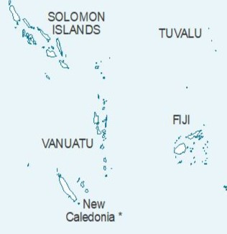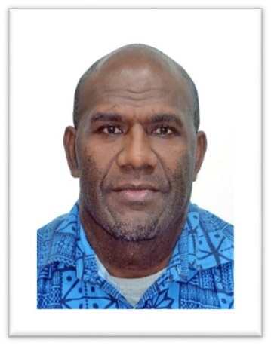

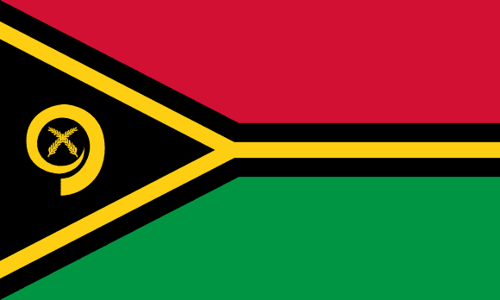

Mr. Albert Nalpini is the National Human Rights Coordinator under the Ministry of Justice and Community Services of the Government of the Republic of Vanuatu since 2021. This unit is responsible to look after the following UN Conventions, CRC, CRPD, CAT, UNCAC, ICCPR including reports and implementation. Secondly, to working with government agencies, different stakeholders NGOs/CSOs for the promotion and protection of human rights for all citizens.

Before joining the Ministry of Justice and community services, Mr. Nalpini has been working as a Police Officer from 1997 until occupying the office of the Commissioner of Police in 2016 to 2019. He furthered completed the following programs at the University of the South Pacific (USP) Diploma in Prosecutions (DIPRO), Bachelor of Laws (LLB), and Professional Diploma in Legal Practice (PDLP).

Mr. Nalpini expresses sincere gratitude for the opportunity which will highly strengthen the capacity and will contribute immensely in addressing human rights issues in Vanuatu into the future.

***This is his first time attending a regular session of the Human Rights Council.***

***