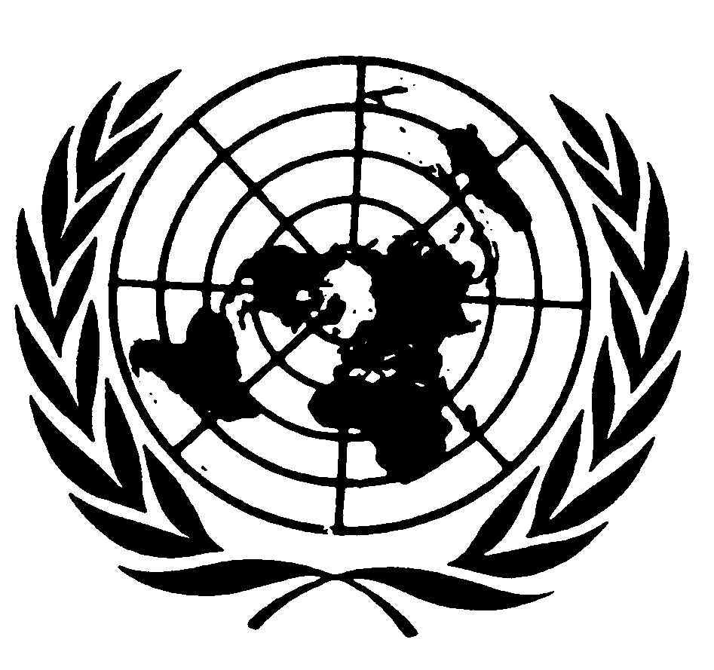

**Oral Statement by Ms Attiya Waris**

**Independent Expert on the effects of foreign debt and other related international financial obligations of States on the full enjoyment of all human rights, particularly economic, social and cultural rights**

49th session

Human Rights Council

**Panel discussion on ensuring equitable, affordable, timely and universal access for all countries to vaccines in response to the COVID-19 pandemic**

Geneva, 10 March 2022

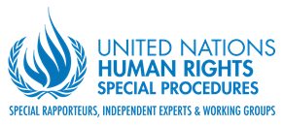

**Excellencies,**

**Distinguished panellists,**

**Distinguished delegates, participants**

I am grateful for the invitation to join this panel. At the same time, I am disheartened by the need to continue having this conversation about inequalities in access to COVID-19 vaccines.

When I took up this function, in August last year, access to vaccines was the main concern of many low and middle-income countries. In numerous discussions Government authorities and other actors worried about heavy debt burdens while their populations required vaccines, doctors and social protection measures. It was an impossible dilemma, they said. The common demand was for international cooperation to ensure timely, affordable and fair access to COVID-19 vaccines.

Yet, instead of improving, vaccine inequality has widened. While most high-income countries have ensured booster vaccines for all those who wanted them, as of 7 March, only 13.6% of people in low-income countries has received at least one dose[1]. Most low vaccinated countries are in my continent, Africa.

This gap is hard to explain if we consider that the **financial resources exist and could have been deployed more effectively, more equitably and faster**. After the successful development of vaccines over a year ago, much more could have been done to ensure health care workers or persons at risk of developing a serious form of disease were swiftly vaccinated around the world. The most successful tool to avoid the loss of thousands of lives and the grave socio-economic impacts we continue to see across the world was available- yet out of reach of the majority.

As the Peoples Vaccines Campaign has said, “The science and the economics are crystal clear. The majority of the world’s people must have access to a vaccine”.

Despite this, we continue to see delays in lifting intellectual property rights protections, and in sharing technologies and know-how with manufacturers in the global south to ensure faster access.

These delays have benefitted a few in detriment of the many. They have ensured billions of dollars in profits for a handful of pharmaceutical companies. They have deterred the development of more localized, effective manufacturing responses that could have reached those in need faster.

In a recent report [by Amnesty International,](https://www.amnesty.org/en/wp-content/uploads/2022/02/POL4051402022ENGLISH.pdf) the organization reports that of all vaccine developers analysed, only Johnson & Johnson and AstraZeneca had made more than 50 % of their stock available to low and lower middle income countries, mostly as donations from upper-income countries rather than sales. All other companies included in this report have prioritized profits and sold to the highest bidders.

One possible solution would have been and could be in the future **to combat illicit financial flows**, which includes tax evasion and tax abuse. According to the [State of Tax Justice 2021,](https://taxjustice.net/reports/the-state-of-tax-justice-2021/) published by a coalition of civil society organizations in November last year, “countries are losing a total of US$ 483 billion in tax a year to global tax abuse committed by multinational corporations and wealthy individuals”. This amount of money would suffice to fully vaccinate the global population against COVID-19 more than three times over. Importantly, a large portion of these capital flows leave low and middle income countries in urgent need of resources.

This pandemic has shown us that addressing IFF is essential not only because it depletes national coffers but also because national health systems require public funding to have the capacity to protect and fulfil the rights to health and to life.

**Distinguished delegates,**

In closing, let me recall that in November 2021, over 35 of us, Independent Experts of the Human Rights Council, issued a public statement calling for States to use all available means to facilitate faster and more equal access to vaccines worldwide, including the introduction of a temporary waiver of relevant intellectual property rights under the TRIPS Agreement.

We stressed, and I quote, that

…. “Every person must have access to a COVID-19 vaccine that is safe, effective and timely,"... "The priority should be to ensure that all people everywhere can enjoy the benefits of scientific progress and the highest attainable standard of health."

1. [Our World in data](https://ourworldindata.org/covid-vaccinations).