United Nations logo **United Nations Human Rights Council**

**Easy to read**

**How to make sure that climate change does not stop people from getting the food they need**

**Climate change is about the earth getting warmer and the problems that it is causing for people and the planet we live on.**

# A picture containing logo Description automatically generatedAbout us

We are from the United Nations (UN).

The United Nations is a group of countries that work to make the world better and safer.

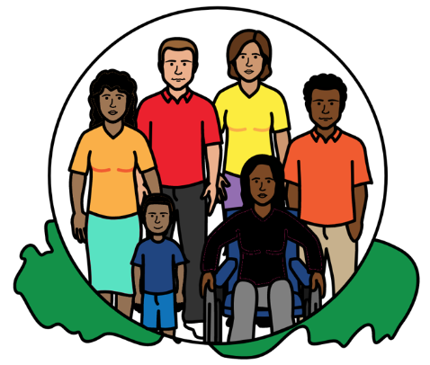

Our job is to make sure that

everyone in the world is treated fairly and gets their human rights.



Everyone has human rights.

For example, everyone has the right to food, water and a healthy world to live in.

That is what should happen in everyone’s lives.

# A bowl of soup with vegetables Description automatically generatedAbout this report

This report is about how to make sure that everyone in the world can get the food they need now and in the future.

That means stopping and fixing any food problems because of climate change.

It also means changing how we grow and make food to help stop climate change.

**About climate change**

Climate change is about the earth getting warmer.

This is causing big problems for people, animals and plants.

For example, climate change is causing more big weather problems like floods, too much heat, bad storms and big fires.

**Climate change and food problems**

**Food problems because of climate change**

Many people in the world still do not have enough to eat.

Climate change is one of the main reasons for that.

For example, it can be hard to grow food when there are big weather problems, like floods, bad storms or too much heat.

**Climate change problems because of the way we grow and make food**

The way that we grow and make food is also a problem.

This is because it is causing climate change.

The way that we grow and make food can be unsafe for people, plants and animals now and in the future.

For example, we often use things that are bad for the earth when we grow food. Like chemicals.

They damage the soil that food grows in. That means less food can grow in the future.

A lot of food is sold in other countries.

But moving the food can use a lot of gas, oil and coal that is bad for the planet.

**Extra problems for people in poorer countries**

There are extra problems for people in poorer countries.

For example, many people need land so they can grow food to eat or sell.

But many people do not have enough land to grow food on.

Or their land has been taken away from them to be used for other things.

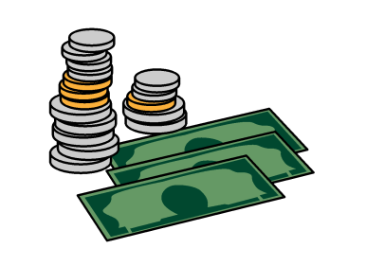

Food can also cost too much for many people in poorer countries.

This is because of unfair rules in the world about buying and selling things.

Climate change can also make food cost more.

Poorer countries often have the worst climate change problems.

And they often have less money to spend on climate change and food problems.

But this is unfair because richer countries are causing most climate change problems.

And they are not doing enough to help poorer countries.

**What countries should do now**

Everyone has a right to food.

Everyone has the right to a healthy world to live in.

Everyone has the right to get extra money to get food if they need it.

For example, if they cannot work.

Countries should make sure that **everyone** in the world gets these human rights now and in the future.

There are laws in the world about that.

Countries should follow the laws when they make decisions.

For example, decisions about climatechange, food and money.

That means countries should not make decisions that are bad for people’s human rights.

Countries should work with people in communities to make decisions about climate change and food.

That includes people who have the most climate change and food problems.

Countries should listen to people and use their ideas.

That is because people often know how to grow food in a better way to keep their community safe and to stop climate change.

**Changing how we grow, make and eat food**

The way that we grow and make food is making climate change worse.

That means countries must change the way that they grow and make food.

Or how they catch fish from the sea.

That is to help stop climate change.

And to keep people, plants and animals healthy and safe.

For example, countries should start doing things like:

* Eating less meat. This is because the way we produce meat is bad for climate change.

* Making more food from plants.
* Supporting people to grow food for themselves or for people in the community.

People could grow different healthy foods from the local area.

* Using less chemicals to grow food.

Countries should also get support to make and get food if they need it when there are climate change problems.

**Making sure that everyone has enough money to buy food**



Countries should give people some extra money to buy food if they do not have enough.

For example, people may need extra money if they cannot grow food or earn money because of climate change.

**Making sure that companies do what they need to**

Companies need to also think about people’s human rights in their work.

They should not do anything that might cause human rights problems.

Like stopping people from getting or growing food.

For example, local farmers should not have to buy seeds from big companies to grow food.

This is because big companies may charge a lot of money for the seeds.

Companies must also work to solve any human rights problems they cause.

For example, companies that do bad things for climate change should pay for the damage.

Countries should make sure that companies do what they need to.

They should make good laws and rules about that.

Countries should also make sure that:

* Food does not cost too much.
* People can speak up in a safe way about bad things that companies do.

**Making sure that countries work together to give everyone enough food**

Countries must work together to make sure that everyone in the world has enough to eat.

That means changing unfair rules about how countries buy and sell food to each other.

For example, poorer countries should be able to grow food in the best way for them.

They may want to support local farmers to grow food in a better way to stop climate change.

Or they may want to grow more food themselves instead of buying it from other countries.

The rules should not stop poorer countries from doing that.

Richer countries should also give more money to poorer countries.

That is to help poorer countries to deal with climate change and food problems.

The money should be used for people who need most support.

**Making sure that people get their rights to their land**

Countries should make sure that people have enough land and other things they need to grow food.

That includes people who often have the worst climate change problems.

Like women, local farmers and people who catch fish.

All of these things will help to make sure that everyone has enough to eat.

And that everyone has a healthy world to live in.

**More information**

We wrote another report about how climate change is making it hard for people to get the food they need and how we can help the people.

The report is on our website at:

https://www.ohchr.org/en/documents/thematic-reports/ahrc5537-measures-minimizing-adverse-impact-climate-change-full

You have to move down the page a bit to find the easy to read report.

**Pictures by The Picture Communication Symbols ©1981–2016 by Mayer-Johnson LLC a Tobii Dynavox company. All Rights Reserved Worldwide. Thousands of resources available for free at** [**www.boardmakeronline.com**](http://www.boardmakeronline.com/)