|  |  |  |  |
| --- | --- | --- | --- |
|  |  | A/HRC/56/CRP.1 | |
|  |  | | 3 July 2024  English only |

**Human Rights Council**

**Fifty-sixth session**

Situation of human rights in Ukraine: 1 March to 31 May 2024

**Office of the United Nations High Commissioner for Human Rights**

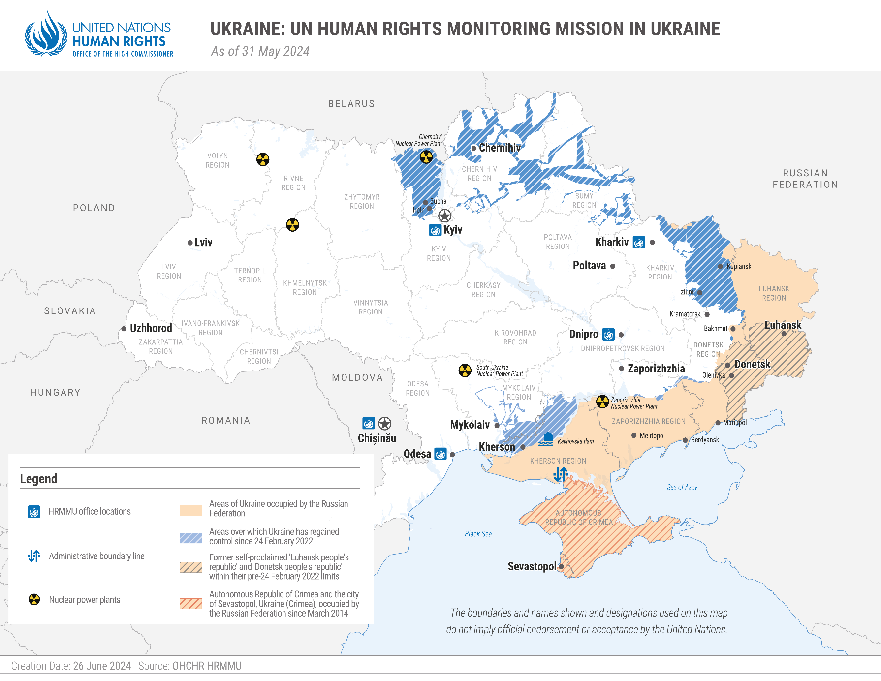

I Executive summary

1. The full-scale invasion of Ukraine by the Russian Federation and subsequent hostilities continued to have a devastating impact on the civilian population in the period between 1 March and 31 May 2024.

2. Intensified military operations by Russian armed forces seeking to capture further Ukrainian territory resulted in increased civilian casualties and damage to civilian property and infrastructure, particularly near the frontline. The Office of the High Commissioner for Human Rights (OHCHR) documented that the cross-border offensive by Russian armed forces in Kharkiv region alone resulted in 78 civilians killed and 305 injured between 10 and 31 May. Increased use of powerful air-dropped bombs with a larger range by Russian armed forces was a significant reason for the rise in civilian casualties and massive destruction of civilian infrastructure in frontline communities.

3. Russian armed forces resumed attacks against energy infrastructure in the reporting period – the most extensive since the winter of 2022-2023. Five waves of such attacks resulted in civilian casualties and significant power cuts for millions of people across the country, with cascading effects on water supply, mobile and internet connectivity, and public transportation. The cumulative impact of these sustained attacks on energy infrastructure could potentially deprive the civilian population of services necessary for its survival, particularly when the winter season starts.

4. OHCHR documented five instances where high-precision munitions struck the same location or target in Government-controlled territory twice within a short interval of time, resulting in the death or injury of emergency workers, police officers, paramedics, and other civilian first responders aiding victims of the first impact, raising specific concerns under international humanitarian law (IHL).

5. Russian authorities in occupied territory appeared to increase pressure on residents to obtain Russian citizenship, despite the prohibition against compelling people to swear allegiance to an occupying Power under IHL. In the reporting period, dozens of people who had left occupied, many of them older persons, cited lack of access to medical care without Russian citizenship as one of their main reasons for leaving. Parents also described increased pressure to obtain Russian citizenship for school-aged children. Most people interviewed by OHCHR linked this development to a decree issued by the President of the Russian Federation in 2023, which asserted that any person without Russian citizenship in the occupied territory would be considered a “foreigner” from 1 July 2024.

6. OHCHR continued to document the widespread use of torture and ill-treatment, including sexual violence, against civilians and Ukrainian prisoners of war (POWs) held by the Russian Federation. OHCHR also documented the continued efforts of family members to obtain information about the fate and whereabouts of civilian detainees and POWs in Russian captivity.[1] The lack of response to such inquiries or the denial of detention by Russian authorities raise concerns of enforced disappearance.

7. OHCHR also documented that 22 Russian POWs in the hands of Ukraine were subjected to torture and ill-treatment in the initial stages of captivity, while conditions in official places of internment continued to improve. Ukrainian authorities continued to prosecute and convict people on charges of “collaboration activities” for activities that, in principle, could be lawfully compelled by the occupying Power. However, in the reporting period, the Government took steps to improve compliance with international human rights law (IHRL) and IHL in this respect.

II. Methodology

8. This thirty-ninth report by OHCHR on the human rights situation in Ukraine covers the period from 1 March to 31 May 2024.[2] It is based on the work of the United Nations Human Rights Monitoring Mission in Ukraine (HRMMU).[3]

9. Information in this report was gathered during 90 field visits, 35 visits to places of detention and 26 visits to care institutions and shelters, 34 trial hearings, and 1,125 interviews[4] with victims and witnesses of human rights violations, as well as their relatives and lawyers, Government representatives, members of civil society, and other interlocutors. It also draws from court documents, official records, and other relevant material, including from open sources.

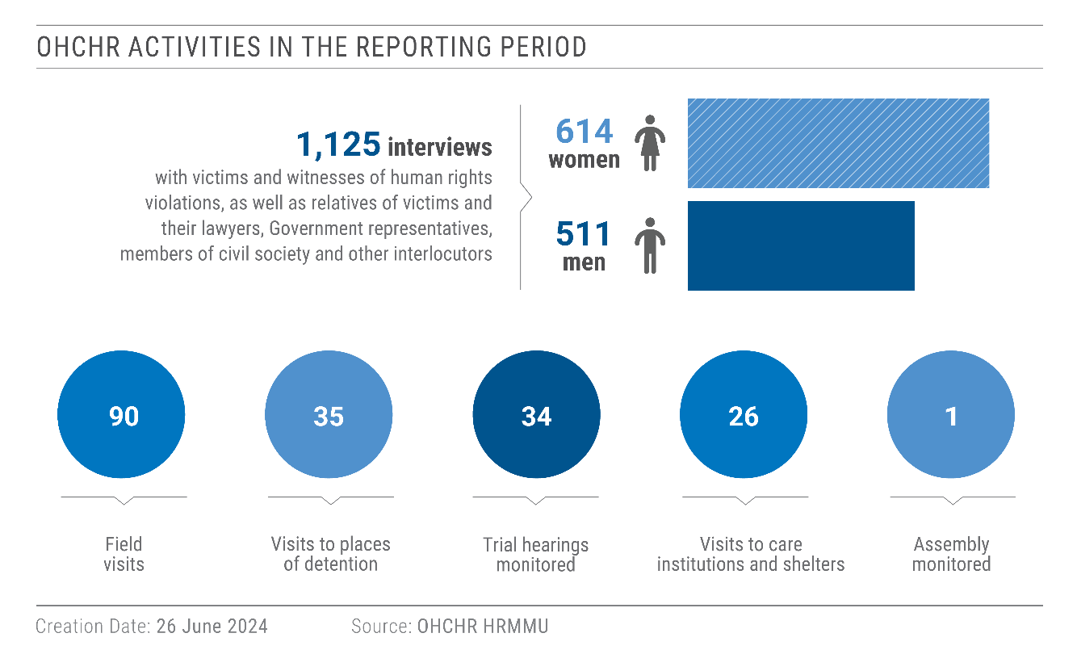

10. Verification of alleged violations in occupied territory, where possible, was often delayed because of multiple challenges: the Russian Federation has not granted OHCHR access for independent monitoring; individuals faced difficulty in moving from occupied territory to territory controlled by Ukraine due to the absence of crossing points, the necessity to travel vast distances through the Russian Federation, and the presence of numerous internal checkpoints in occupied territory; and many people were hesitant to share accounts via telephone or electronic messaging services out of concern that conversations may be overheard or intercepted.

11. Findings are included in the report where they meet the “reasonable grounds to believe” standard: namely where, based on a body of verified information, an ordinarily prudent observer would have reasonable grounds to believe that the facts took place as described, and where legal conclusions are drawn, that these facts meet all the elements of a violation.

12. Information in this report is used with the informed consent of all sources as to its use. At all stages, OHCHR strictly adhered to the “do no harm” principle and took all appropriate measures to prevent re-traumatization and protect individuals.

13. Prior to publication, OHCHR shared the draft report with the concerned States for factual comments, as per standard practice.

III. Impact of conduct of hostilities on civilians

*“We have nothing left, only the walls!”*

– an older woman in Dnipro whose house was damaged by a missile attack on 14 April 2024

A. Overall civilian harm

14. At least 436 civilians were killed (257 men, 156 women, 12 boys and 11 girls) and 1,760 injured (939 men, 704 women, 66 boys and 51 girls) between 1 March and 31 May 2024 as a result of conflict-related violence.[5] Casualties included 6 media workers, 26 employees of healthcare institutions, 5 humanitarian workers, and 28 emergency service workers.

15. The vast majority of civilian casualties (96 per cent) were caused by the use of explosive weapons with wide area effects in populated areas, such as artillery shells and rockets, bombs, missiles, loitering munitions and other explosive munitions dropped by unmanned aerial vehicles. About four per cent of the casualties resulted from incidents involving mines and explosive remnants of war.

16. As in previous reporting periods, the majority (91 per cent; 391 killed and 1,616 injured) of casualties occurred in territory controlled by Ukraine. Nine per cent (45 killed and 144 injured) occurred in territory occupied by the Russian Federation.

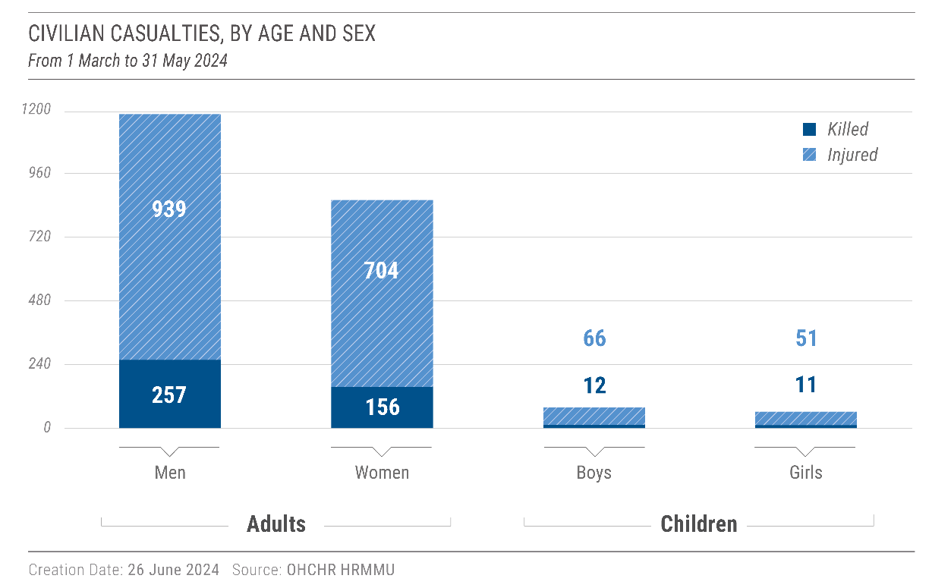

17. In the reporting period, Russian authorities reported that 91 civilians were killed and 455 injured in the Russian Federation from attacks launched by Ukrainian armed forces, primarily in Belgorod, Briansk, and Kursk regions. With regard to the incident with the highest reported number of civilian casualties, local Russian authorities claimed that falling debris from an intercepted missile had killed 17 and injured 32 when it struck an apartment block in Belgorod. OHCHR has not been able to verify these reports in line with its standard of verification.[6]

18. At least 174 civilians were killed and 690 injured in Ukraine in May 2024, the highest monthly number of civilian casualties OHCHR has documented since June 2023. The main reason for this increase was the launch of a new ground offensive by Russian armed forces in Kharkiv region (see below).

19. Hostilities also damaged or destroyed at least 110 educational facilities and 35 medical facilities during the reporting period. For example, in Chernihiv city, the blast wave from a missile attack on 17 April 2024 damaged a hospital and injured 6 staff members and killed one woman in her car on the way to the hospital. In Kharkiv city, a missile hit near a psychiatric hospital on 27 April, damaging several buildings of the hospital while at least 198 patients and medical workers were inside. One patient – a civilian woman – sustained injuries.

20. Damage to educational and medical facilities significantly hindered children’s access to education and health care. As a result of hostilities, many children living in frontline areas had to attend classes online or in underground classrooms. Children experienced significant disruptions to their learning process due to air raid sirens, electricity blackouts, and limited availability of equipment such as phones or tablets to connect to online classes.[7] Families in areas with ongoing hostilities faced challenges accessing primary health care services since the number of family doctors in these areas is limited. Pregnant women and babies were particularly affected, given the low availability of maternal and newborn care services.[8]

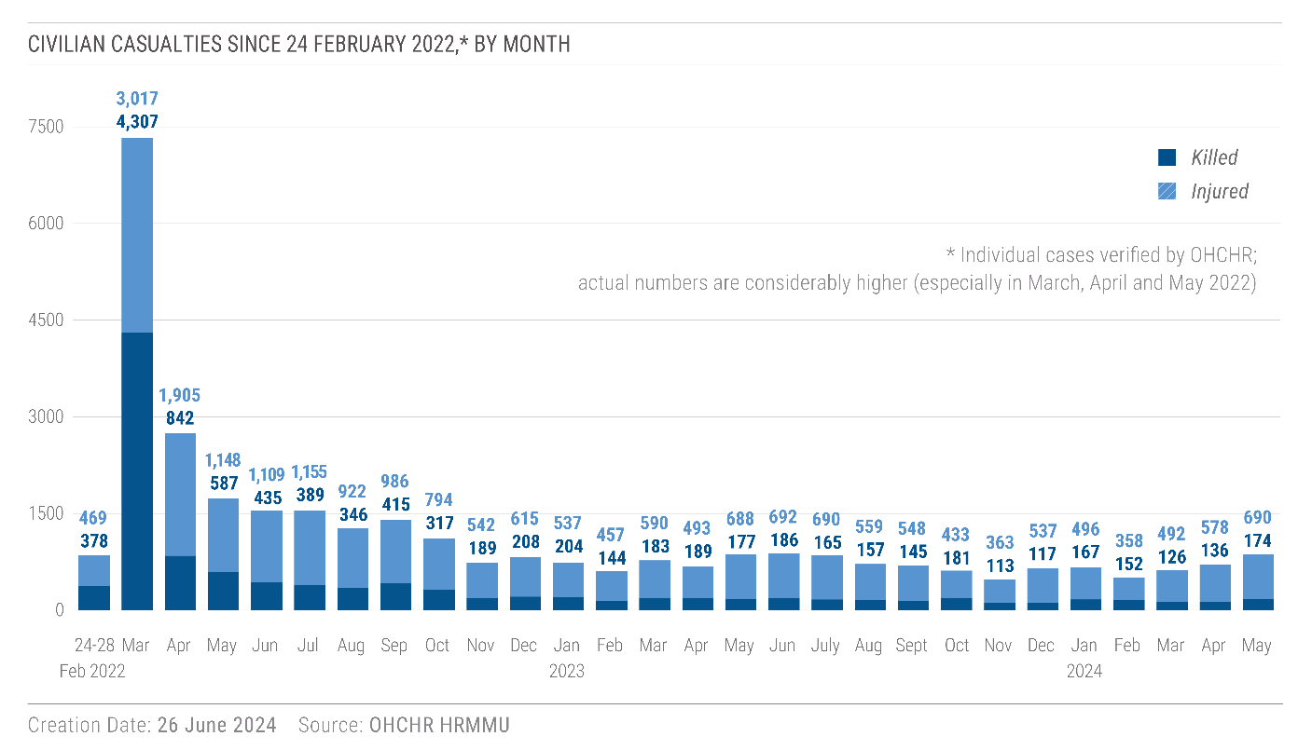

B. Increased civilian harm near the frontline

21. In the reporting period, Russian armed forces intensified offensive operations to capture territory along the frontline. Fighting became particularly heavy in the northern part of Kharkiv region after Russian armed forces launched a new cross-border offensive into the region on 10 May 2024, eventually taking control of several settlements on the Ukrainian side of the border. The fighting particularly affected the town of Vovchansk and its surrounding settlements.

22. In the context of this offensive in Kharkiv region, the Russian Federation also increased its attacks on Kharkiv city, resulting in high numbers of civilian casualties. For example, on 23 May, missiles struck a printing house, killing seven employees and injuring at least 21 civilians, mainly women. On 25 May, two air-dropped bombs struck Epitsentr, a large home improvement centre, killing 19 civilians and injuring 54, including many employees. On 31 May, multiple missiles hit a residential area of the city, including a multi-story building, killing nine civilians and injuring at least 15.

23. The intensification of hostilities along the frontline resulted in an increase in civilian casualties. In Kharkiv region alone, at least 78 civilians were killed and 305 injured by shelling, missile attacks, aerial bombardments and mine-related incidents between 10 and 31 May.

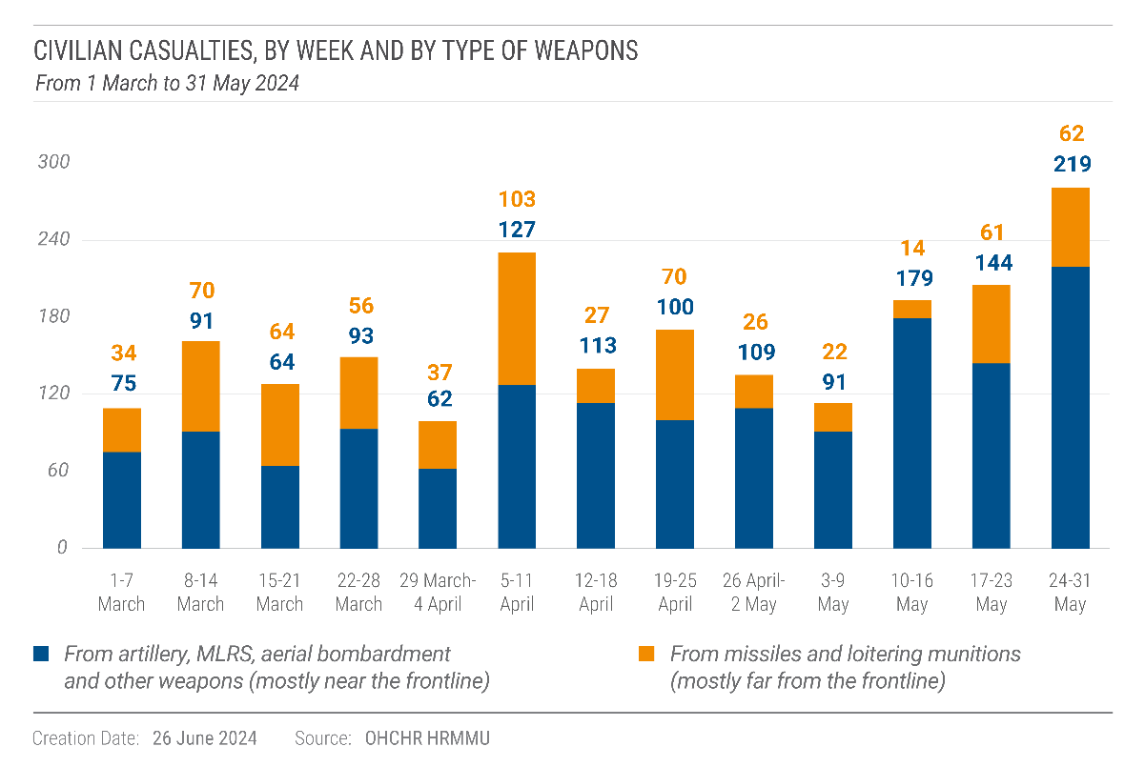

24. The intensification of hostilities near the frontline also led to the destruction of humanitarian facilities. For example, on 5 April 2024, a missile struck and completely destroyed the Médecins sans Frontières (MSF) office in Pokrovsk. The building was exclusively rented by MSF and clearly identified with the MSF logo on the facade. An MSF security guard (man) was injured as well as two men, two women and one boy in the houses nearby. On 24 April 2024, a missile struck near a Danish Refugee Council (DRC) office in Kharkiv city, damaging the office and over a dozen DRC vehicles used for humanitarian services.

25. The increased use of guided and unguided air-dropped bombs by the Russian armed forces also contributed to the rise in both civilian casualties and the destruction of civilian property and infrastructure along the frontline. Recent reported modifications to standard Russian air-dropped glide bombs enable them to glide further, thus extending their operational range and allowing them to reach more densely populated areas farther from the frontline. The massive explosive power of these bombs causes substantial destruction and harm when striking populated areas. In the reporting period, air-dropped bombs, including modified glide bombs, killed and injured 462 civilians (222 men, 200 women, 25 boys and 15 girls), a 336 per cent increase in comparison with the previous reporting period.[9] For example, the attack on the home improvement center in Kharkiv city on 25 May 2024 mentioned above was carried with two guided glide bombs. Air-dropped bombs also damaged or destroyed at least 36 educational facilities and 10 medical facilities in the reporting period. For example, on 10 April, an air-dropped guided bomb destroyed a hospital building in Vovchansk, Kharkiv region, injuring a technician (a man) of the medical facility.

26. While the majority of civilian casualties (88 per cent) near the frontline occurred in Government-controlled territory, 12 per cent occurred in villages, towns and cities in territory occupied by the Russian Federation, particularly in the cities of Donetsk and Horlivka. For example, on 18 April, shelling damaged a blood transfusion station in Horlivka, injuring at least three women medical workers. On 13 May, artillery shelling killed an older couple in the Petrovskyi district of Donetsk, the closest district to the frontline. Three days later, on 16 May, two women were killed and a 5-year-old girl sustained injuries, also from artillery shelling, at a bus stop one kilometre from the place of the 13 May attack.

27. Older persons were disproportionately affected.[10] Forty-one per cent of the civilians killed or injured near the frontline were over age 60 (250 women and 243 men),[11] although they represent only 25 per cent of the Ukrainian population.[12] One explanation for this disparity is that many families with children and younger individuals have fled areas near the frontline while older residents have often stayed behind due to limited financial means, low mobility and health issues, attachment to the land, or responsibilities such as caring for livestock or gardens, elevating their risks of harm.

28. The intensified hostilities also led to new internal displacement. Ukrainian authorities issued evacuation orders in several areas, including Sumy and Kharkiv regions, and Government-controlled areas of Donetsk region. Authorities evacuated 11,436 people from Kharkiv region after the start of the 10 May military incursion. Many also left on their own.

C. Attacks on energy infrastructure

29. During the reporting period, Russian armed forces launched the largest campaign of attacks against critical energy infrastructure since the winter of 2022-2023, with the impact of such attacks affecting millions of people across the country.[13]

30. Between 22 March and 31 May 2024, Russian armed forces launched five waves of large-scale coordinated attacks on energy facilities across 15 regions of Ukraine, each involving dozens of missiles and loitering munitions. While Ukrainian air defenses intercepted some of the weapons, many struck critical power generation plants, substations, and electricity distribution systems across Ukraine, causing severe damage and destruction. In total, ОНСНR recorded 78 attacks on energy infrastructure during the reporting period. Most of these attacks (65) occurred in Government-controlled territory. As a result, the electricity generation capacity of Ukraine has been significantly reduced.

31. The attacks caused significant power outages for millions of people, with cascading effects on water supply, mobile and internet connectivity, and public transportation in affected areas. Rolling power cuts were eventually initiated across the country, with daily power outages of up to 12 hours in several regions, including Kyiv.

32. In one example, a power plant visited by OHCHR in western Ukraine was struck with multiple missiles during two of the attack waves between 22 March and 8 May.[14] The attacks caused massive destruction and fire to all sections of the power plant, shutting down all energy production. In addition to exacerbating the need for rolling power cuts across the country, the shut-down also directly impacted nearly 7,000 households that were receiving hot water and heating from the power plant. Alternative sources of heating for affected households will be needed if power production cannot be resumed by winter.

33. OHCHR recorded 13 attacks on energy infrastructure in Russian-occupied territory. The International Atomic Energy Agency (IAEA) also announced that drone attacks had struck the occupied Zaporizhzhia Nuclear Power Plant three times between 7 and 18 April, raising concerns about nuclear safety.[15] Ukrainian and Russian authorities each attributed the attacks to the other party. OHCHR has not been able to attribute responsibility for these attacks.

34. Energy companies and national authorities in Ukraine have cautioned that the cumulative impact of repeated strikes on infrastructure decreases the likelihood that necessary repairs can be made in time for winter. The large-scale destruction of critical energy infrastructure could have an immense impact this winter, potentially depriving people of services essential for their survival, including heating. This would particularly affect certain groups in situation of vulnerability, such as older persons, persons with disabilities, children, and persons living in poverty. Persons with low mobility may additionally face challenges to move around, find shelter, or seek warmer environments, especially those living in high-rise buildings and needing elevators. Finally, rationing of energy and rolling electricity cuts are likely to affect industry and business, with a compounded negative impact on employment, tax revenues and social protection. The potential price increases are also likely to negatively impact the standard of living of groups in situation of vulnerability, especially older persons with low pensions or persons living in poverty.

D. Successive strikes causing civilian casualties

*“The colleagues who work now accept and are willing to take risks. They know that they may lose their life on duty.”*

– a representative of an ambulance station in Kharkiv city

35. Between 1 March and 31 May, OHCHR documented that the Russian armed forces had conducted at least five attacks during which high-precision weapons struck the same location or target twice within an interval of 15 and 70 minutes, causing civilian casualties, particularly among those who had arrived to help people injured in the first strike. These attacks, sometimes referred to as “double-tap” attacks, killed at least nine emergency workers, paramedics, and police officers (all men), and injured 19 members of these same professions (18 men and 1 woman) in the Government-controlled areas of Kharkiv, Donetsk, and Odesa regions.

36. For example, on 4 April, two loitering munitions struck the same location in Kharkiv city within an interval of 55 minutes, killing three emergency workers and injuring an emergency worker, a paramedic, a police officer and two civilian men. The police officer died from his injuries in the hospital several weeks later. In another case, on 15 March, two emergency workers and one paramedic were killed and seven emergency workers and an ambulance driver injured when a ballistic missile struck a location in Odesa city 15 minutes after a first strike hit the same location.

37. Emergency response workers and members of civilian police enjoy protected status as civilians under IHL.[16] Conducting a new attack on the same location or target during the timeframe in which medical and other emergency response workers would be known or foreseeably expected to be on scene to assist victims raises serious concerns, at the very least, as to a lack of sufficient precaution required under IHL to minimize harm caused to civilians.[17] If the documented attacks were conducted with the purpose of killing or injuring first responders or other civilians, they would constitute deliberate attacks on civilians, a war crime.

E. Civilian casualties from mines and explosive remnants of war

38. Mines and explosive remnants of war (ERW) killed 17 civilians and injured 62 more in the reporting period (71 men, 5 women, and 3 boys). This represents an 84 per cent increase compared to the preceding three months.[18] ERW and mine-related incidents disproportionately affected men and boys (94 per cent of all cases). The majority of civilian casualties occurred in Donetsk, Kharkiv and Kherson regions, mostly in areas of the last two regions over which Ukraine regained control in the fall of 2022. Eighteen per cent of mine-related incidents occurred while civilians were working their land during the spring agricultural season.

39. For instance, on 29 March, a 50-year-old man was killed when his tractor triggered what appeared to be an anti-tank mine buried in a field near a village in the northern Kherson region. A resident who arrived at the scene shortly after the incident reported that the explosion dismembered the man and ignited the tractor. Deminers found another anti-tank mine in the vicinity following the incident.

40. In addition to causing casualties among civilians, the prevalence of mines and ERW in territory occupied by the Russian Federation, and later regained by Ukrainian armed forces, has negatively impacted the agricultural sector as significant tracts of land cannot be safely cultivated.

IV. Human rights in territory of Ukraine occupied by the Russian Federation

A. Obligations as occupying Power

*“You are nobody here, you are immigrants. You can refuse to apply for Russian passports. Here is a rubber boat, we’ll deport you with it.”*

– a resident from occupied territory reporting what members of the Russian armed forces said to her family

41. Since the beginning of the occupation of the Autonomous Republic of Crimea and the city of Sevastopol (Crimea) in 2014 and of other parts of Ukraine after 24 February 2022, OHCHR has documented that the Russian Federation has violated several of its obligations as an occupying Power, including by imposing wholesale its legal and administrative systems in occupied territory,[19] and by compelling residents to obtain Russian citizenship.[20] In the reporting period, these violations continued to affect residents of the occupied territory.

42. On 27 March 2024, the UN Human Rights Committee found that the automatic naturalization of Ukrainian citizens who permanently resided in Crimea at the beginning of the occupation of the peninsula by the Russian Federation in March 2014 also constituted discrimination on the grounds of national origin. The Committee held that “a person’s nationality constitutes an important component of one’s identity, and that the protection against arbitrary or unlawful interference with one’s privacy includes protection against forceful imposition of a foreign nationality.”[21]

43. While Russian authorities have not automatically imposed Russian citizenship on residents of the regions of Ukraine occupied after 24 February 2022 in the same manner as they did in Crimea in 2014, the systems imposed in newly occupied territory have, as a practical matter, effectively compelled people to obtain Russian citizenship in order to access necessary services.

44. During the reporting period, dozens of people interviewed by OHCHR who had recently left the occupied territory described what appears to be increased pressure to obtain Russian passports as one of the main reasons for their departure. Many, particularly older persons, cited difficulties in accessing health care without Russian citizenship. For example, an older man in a wheelchair and his wife from a village in Luhansk region told OHCHR that without Russian passports, it was no longer possible for them to undergo medical examinations and surgeries in the occupied territory. A paramedic who refused to obtain a Russian passport said that she was allowed to provide some medical care to non-Russian passport holders, but for more specialized care and hospitalization, a passport was needed.

45. Parents also cited increased pressure to obtain Russian citizenship for their school-age children. One woman from Donetsk city told OHCHR that the teacher of her six-year-old daughter demanded in April that she obtain a Russian birth certificate for her daughter, the only child in the class without Russian citizenship. Another woman from Kalanchak, Kherson region, told OHCHR that some of her neighbors were threatened that if they did not obtain Russian passports and did not send their children to school, their children could be taken away.

46. Many of those interviewed linked the timing of their departure to a 1 July 2024 deadline by which people without Russian citizenship living in the occupied territory would be considered “foreigners.” According to a decree signed by the President of the Russian Federation on 27 April 2023, [22] Ukrainian citizens not registered in the occupied territory must apply for a residence permit or face risks of deportation or forcible transfer out of the occupied territory, starting from 1 July 2024.The decree also provides that all residents without Russian passports, regardless of the place of their residence registration, must comply with various administrative procedures and reporting requirements to continue residing and working in occupied territory.[23] Those interviewed by OHCHR cited fears of additional bureaucratic barriers to employment, deportation or confiscation of property if they did not become Russian citizens. In April, the deadline was extended to 31 December 2024.

47. Under IHL, an occupying Power must not compel persons living in occupied territory to serve in its armed forces, nor may it use pressure or propaganda to secure their voluntary enlistment.[24] Yet, on 1 April 2024, Russian authorities launched an annual spring military conscription campaign, including in Crimea and the occupied areas of Donetsk, Luhansk, Kherson, and Zaporizhzhia regions. The Military Commissariat of the occupying authorities in Crimea announced its aim to enlist at least 2,500 residents from Crimea alone, marking the nineteenth such campaign in the peninsula since the beginning of the occupation in 2014. While nominally aimed at Russian citizens, this conscription campaign could be tantamount to compelling persons living in occupied territory to serve in the Russian armed forces, given the broader pressure exerted on residents of occupied territory to obtain Russian citizenship. In the reporting period, Russian authorities also continued applying pressure on forcibly mobilized men from Donetsk and Luhansk regions by opening criminal investigations against those who left their military units and placing them on wanted lists.[25]

1. Private property

48. Under IHL, an occupying Power must respect private property and cannot seize it except if required by imperative military necessity.[26] New laws adopted in some parts of occupied territory could effectively result in the illegal seizure of private property.

49. Russian-appointed “people’s assemblies” in occupied Donetsk, Luhansk, and Kherson regions adopted new laws which set out a process for confiscating “unused” residential property.[27] Under these laws, non-payment of utilities or lack of record in the Russian registry of properties are evidence that the residential property is “unused”. If no one claims the property within 30 days of it being announced as “unused”, a court decides on transfer of ownership of the property to local councils.

50. According to these laws, owners can confirm their ownership of the property only in person, a requirement which presents significant difficulties and risks for those who have left occupied territory. Access to occupied territory is possible only through the Russian Federation, which allows entry of Ukrainian citizens through two international border crossings only, where they risk being detained and questioned given the well-documented practices of Russian security forces towards persons suspected of having pro-Ukrainian views.[28] Another significant barrier is the requirement to have a Russian passport to register the property, rendering it almost impossible for those who have left occupied territory to claim and register their property.

B. Rights to life, physical and mental integrity, liberty and security

51. As documented in past reports, the occupation of Ukrainian territory by the Russian Federation has been accompanied by widespread violations of residents’ rights to life, physical and mental integrity, liberty and security.[29] Because of challenges in documenting violations such as torture and sexual violence, the sections below also include information about violations that OHCHR documented during the reporting period, but which occurred earlier.

2. Killings of civilians

52. On 23 April 2024, two Russian soldiers killed at least six persons, including four civilians (three women and one man) and two off-duty Russian servicemen in Podo-Kalynivka and Abrykosivka, two villages in Kherson region. According to local residents, the two soldiers were trying to break into at least two houses when they killed those who were trying to stop them. Russian military police arrested two alleged perpetrators hours after the incident and, in May, according to reports of the Russian media provider “Kommersant”, the Russian Investigative Committee indicted them.

53. OHCHR also verified during the reporting period the summary execution of four civilians (all men) in four incidents that occurred in March 2022 in Kyiv and Chernihiv regions. These cases are consistent with previously documented patterns. [30] In total, since 24 February 2022, OHCHR has verified the summary execution of 163 civilians (136 men, 22 women, 3 boys and 2 girls) in areas controlled by Russian armed forces.

3. Torture and ill-treatment

54. OHCHR continued to document cases of torture and ill-treatment that took place in occupied territory before the reporting period. In line with previously documented patterns, [31] most of the 20 released civilian detainees (14 men, 6 women) interviewed by OHCHR in the reporting period described being subjected to torture and ill-treatment. They reported severe beatings, including with batons and plastic sticks, pistol shots with rubber bullets, electric shocks, deprivation of water and food, mock executions, and threats. They also described dire conditions of detention that amount to ill-treatment and may, in some cases, amount to torture.

55. OHCHR also interviewed during the reporting period five military medics (all men) who were released during prisoner exchanges in early 2024 after more than 20 months in captivity.[32] The medics described appalling conditions of internment and provided detailed accounts of torture during captivity that were consistent with previous OHCHR findings.[33] One of them, for example, described severe beatings, including while being hung upside down from the ceiling, and forced so-called “stretching” (standing with arms and legs spread wide, causing severe tension and extreme pain in muscles) within the internment facility to compel him to confess to allegations in Russian media that Ukrainian medics had “castrated Russian POWs” and committed other war crimes.

56. Consistently with previous OHCHR findings, torture in detention often included forms of sexual violence. Seven civilian men and three civilian women reported being subjected to sexual violence during their detention in Kherson, Donetsk, Luhansk, Kharkiv and Zaporizhzhia regions in incidents that took place before the reporting period. In one case, guards repeatedly kicked an older man in his testicles during his four-day detention in Kherson in September 2022. As a result, his genitals were so swollen that he could hardly walk. In another case, a former member of the Ukrainian special forces who spent twenty months in detention in four different facilities was tortured repeatedly for two weeks in August 2022 with electric shocks to his genitals.

57. Three of the five medics mentioned above were also subjected to sexual violence, comprised of beatings to the genitals and forced nudity. One medic reported that the guards in an internment facility in the occupied territory of Ukraine forced all the POWs in a barrack, including him, to strip and squat naked outdoors for two to three hours.

4. Arbitrary detention

58. OHCHR documented 15 instances of arbitrary detention of civilians that occurred in the reporting period (involving 11 men and 4 women). For example, in Crimea, the Russian occupying authorities continued applying pressure on Crimean Tatar activists. OHCHR recorded the arbitrary arrest of ten Crimean Tatar activists, including two citizen journalists for ‘Crimean Solidarity’, in Bakhchysarai and Dzhankoi districts on 5 March 2024 (all men). These individuals were mostly suspected of terrorism and membership in the banned religious organization “Hizb ut-Tahrir”. At the time of the arrest, law enforcement officers failed to inform the victims of the reasons for their arrest and the charges against them. Courts held *pro forma* closed hearings to extend the period of pre-trial detention without notifying the defendants or their lawyers, and no grounds or justification for extended detention were evident from the court’s reasoning.

5. Enforced disappearances

*“My son was seven months old when his father disappeared. He doesn’t remember his father. I show him photos and tell him this is ‘father’ but my son calls him ‘a man’.”*

– the wife of a civilian detainee about the impact of the disappearance of her husband on their child

59. Many of the cases of detention of civilians documented by OHCHR may also amount to enforced disappearances. The Fourth Geneva Convention contains specific provisions and procedural safeguards that contribute to clarifying the fate and whereabouts of protected persons, including the right of internees to inform their families[34] and to maintain communication with the outside world on a regular basis.[35] During the reporting period, OHCHR interviewed relatives of 33 civilian detainees who, for prolonged periods of time, had no information about the whereabouts or fate of their loved ones. In many cases, family members approached occupying authorities or even sometimes authorities in the Russian Federation, typically without success. Thirteen have not received any official confirmation of the detention or internment from the Russian authorities at all.

60. For example, after Russian armed forces detained a civilian man from the Kharkiv region in September 2022, his mother approached a wide range of institutions both in the occupied territory and in the Russian Federation, including the police, military administration, penitentiary authorities and facilities. Russian authorities only confirmed his detention in the summer of 2023, eight months after he was taken away. When she finally managed to speak with her son in the fall of 2023, he told her that he had been detained in one of the detention facilities that she had approached, and which had denied that he was detained there.

61. In a more recent case, in Crimea, Russian occupying authorities detained three women from their home in March 2024. As of 31 May 2024, the women’s family members had still not received any official information about their whereabouts, despite multiple inquiries to the occupying authorities, including by their lawyers.

6. Execution of Ukrainian POWs

62. OHCHR documented the execution of two Ukrainian servicemen by Russian armed forces in the reporting period. According to detailed information obtained by OHCHR, the men were executed near the village of Buhruvatka, Kharkiv region, on 21 May 2024 by order of the unit commander after they were injured in an attack on their vehicle.

63. During the reporting period, several Russian public figures continued calling for unlawful treatment of Ukrainian POWs. For instance, the commander of the Russian paramilitary group “Rusich”, part of the Russian armed forces, gave an interview during which he admitted to having committed and called for the execution of Ukrainian POWs. Such statements, as well as the absence of prosecution for the alleged execution of Ukrainian POWs committed during previous reporting periods, are inconsistent with IHL.[36]

64. Since 24 February 2022, OHCHR has documented the execution of 28 Ukrainian servicepersons *hors de combat* and the deaths of 11 POWs in detention. In addition, OHCHR received in 2024 credible allegations of 25 other executions of Ukrainian servicepersons *hors de combat* by Russian armed forces during the previous reporting period.[37]

65. On 22 May 2024, the chief editor of three Russian State media outlets published on her social media accounts the names and dates of birth of 500 Ukrainian POWs, whom the Russian Federation had reportedly offered Ukraine to exchange for Russian POWs. Exposure of POWs to intimidation and public curiosity, including dissemination of their private data, is prohibited under IHL.[38]

7. Contact of Ukrainian POWs with the outside world

66. During the reporting period, Russian authorities continued to deny OHCHR access to Ukrainian POWs. Since there was only one reported exchange of POWs on 31 May 2024, OHCHR was unable to obtain updated information on the treatment and conditions of internment of Ukrainian POWs.[39]

67. However, OHCHR interviewed 20 relatives of POWs and six relatives of missing servicepersons who described their daily struggles to find information about their loved ones. Relatives of four POWs reported that they had not received confirmation of their captivity by the Russian Federation for more than 14 months despite receiving accounts from released POWs that they had seen the latter in captivity.

68. Regular communication between POWs and their relatives also continued to be denied in violation of the Third Geneva Convention.[40] Thirteen relatives interviewed by OHCHR had received no letters from their loved ones, while seven had received only one letter or a short phone call during the past 18 months. All interviewees described spending hours searching for information about their loved ones on social media, inquiring with released Ukrainian POWs and civilian detainees, and visiting relevant Ukrainian authorities, which, in many cases, required long trips.

8. Impact of the lack of information and communication on families of POWs and civilian detainees

*“The worst is not knowing. All our lives are circling around the fact that our close ones are in captivity”.*

– mother of a Ukrainian POW who has been in captivity for almost two years

69. OHCHR spoke to 44 family members of POWs, missing servicepersons or civilian detainees about the impact of the lack of information and communication with their loved ones. They described how the uncertainty, lack of information and communication, and silence or denial of the Russian authorities caused them constant stress and agony, which often resulted in depression, anxiety, sleep disorders, panic attacks, migraines, weight changes, a worsening of chronic conditions, and problems with their work, social and family life. Details from returning POWs and civilian detainees about torture and the dire conditions in places of internment have further compounded their worry and anxiety. The wife and the sister of two Ukrainian POWs both suffering from late-stage cancer shared their distress with OHCHR. One only had one short phone call with her husband over two years, while the other had not been able to talk to her husband at all since he was captured two years ago.

70. Prolonged detention or enforced disappearances of civilians, as well as internment of POWs, negatively impacted the standard of living of the families, particularly women. As women became the sole head of their household (although they are traditionally not the primary income earner), some of the female partners of civilian detainees reported experiencing financial hardship. Women often also struggled balancing this with family duties, continuing to care for children or older members of the family. Mothers explained being worried about the negative impact of the separation and lack of communication on the development and mental health of their children. Despite numerous challenges, these women organized to establish non-governmental organizations and groups advocating for the rights of POWs.

71. OHCHR takes note of measures taken by the Ukrainian authorities to provide compensation and support for persons who were detained by the Russian Federation. On 15 March, Ukrainian authorities passed a resolution establishing a framework to coordinate support services, including medical and psychological assistance, to POWs and civilians after their return from detention.[41]

9. Conflict-related sexual violence

72. During the reporting period, in addition to the cases in detention described above, OHCHR documented 16 cases of conflict-related sexual violence (against 9 women, 6 girls, and 1 man) perpetrated by members of the Russian armed forces in residential areas under their control. The newly documented cases occurred in 2022.

73. In five cases, Russian soldiers raped or gang-raped six girls between the ages of 13 and 17 in Kherson, Kyiv and Mykolaiv regions. Four of the girls were also subjected to other forms of sexual violence. In one case, Russian soldiers threatened a man to subject his wife and daughters to sexual violence unless he provided food and alcohol to soldiers stationed in their village. In another case, Russian soldiers sexually harassed three adult sisters at a checkpoint while they were trying to leave for Government-controlled territory, eventually forcing them to turn back.

74. In total, since 24 February 2022, OHCHR has documented 263 cases of sexual violence against 168 men, 83 women, 10 girls, and 2 boys perpetrated by members of the Russian armed forces, law enforcement authorities and penitentiary services. Of these, 208 cases occurred in a context of detention, against 81 civilian detainees, 124 POWs and 3 retained personnel, while 53 occurred against civilians in residential areas and 2 during processes of so-called “filtration”.[42]

10. Deportation and forced transfer of protected persons

75. Under IHL, deportation of protected persons from occupied territory is prohibited regardless of motive.[43] Nonetheless, OHCHR continued to document deportations and forced transfers of protected persons in the reporting period.[44] For example, on 16 April 2024, the Federal Security Service of the Russian Federation in Zaporizhzhia region announced that a woman from Melitopol would be “deported” and her entry to the Russian Federation prohibited for 20 years for alleged attempts to gather information about movements of Russian forces. On 16 April, a Russian-appointed court in Mariupol, Donetsk region, also ordered the deportation of a Ukrainian citizen for allegedly distributing Islamist literature on a list of prohibited extremist publications of the Russian Ministry of Justice.

76. In other cases documented in the reporting period, Russian authorities brought at least four people (three men and one woman) initially detained in the occupied territory to the border between the Russian Federation and Georgia in late 2023 and early 2024, threatening them with prolonged detention or physical violence if they did not leave the Russian Federation. They had initially been detained for expressing pro-Ukrainian views in private conversations, singing Ukrainian songs in public, and wearing Ukrainian-style clothing, which may amount to arbitrary detention and unlawful infringement on the freedom of expression and opinion.

C. Civic space and fundamental freedoms

77. During the reporting period, Russian occupying authorities continued to use various legal provisions to restrict civic space in occupied territory.[45]

78. According to publicly accessible court records, courts in Crimea convicted 149 people (75 men and 74 women) in the reporting period for the administrative offence of “discrediting the Russian armed forces”,[46] and 88 people (66 men and 22 women) for “displaying Nazi symbols or showing disrespect for the Russian state”.[47] The number of convictions was higher than the one recorded in the previous three-month period.[48] In many cases, the alleged offenses were legitimate exercises of freedom of expression such as posting on social media pictures with the Ukrainian State emblem or Ukrainian flag, using the words “attack” or “aggression” to describe the full-scale invasion on 24 February 2022, expressing support for the Ukrainian armed forces or criticizing the occupying authorities.[49] Freedom of expression, as guaranteed by article 19 of the ICCPR, includes the right of individuals to criticize politicians, governments, and policies without fear of interference or punishment.[50] Since the introduction of the administrative and criminal offences of “discrediting the Russian Armed Forces” on 4 March 2022, OHCHR has documented 739 cases of prosecution under these charges. Additionally, OHCHR documented 172 cases of prosecution under charges of “displaying Nazi symbols or showing disrespect for the Russian state” since February 2022.[51]

79. Russian occupying authorities also used other legislative provisions to restrict freedom of expression. In the reporting period, occupying authorities in Crimea fined a prominent lawyer 30,000 rubles for “abuse of freedom of media” after he criticized conscription procedures in a chat group.[52] In another case, on 17 April 2024, a court in Simferopol fined a journalist and activist 2,000 rubles for her social media posts because *inter alia* she had mentioned the media outlet “Radio Liberty” without specifying it had been designated a “foreign agent” under Russian law.[53]

80. Russian occupying authorities also targeted members of specific religious groups. On 5 March 2024, they detained ten Muslim residents of Crimea (all Crimean Tatars) after searching their houses. The following day, the Kyivskiy district court of Simferopol remanded nine of the men in the pre-trial detention centre in Simferopol and ordered house arrest for the tenth on suspicion of membership in the “Hizb ut-Tahrir” group*.*[54] In April 2024, a court in Crimea convicted and sentenced a man to two years of forced labor for being a member of Jehovah’s Witnesses, which is under a blanket prohibition as an “extremist organization” in the Russian Federation.

D. Administration of justice and accountability

1. Criminal liability for violations committed by Russian servicemembers

81. A new law signed into force by the President of the Russian Federation on 23 March 2024[55] expanded the exemption from criminal accountability for persons enlisting in the Russian armed forces provided by law No. 270-FZ “On peculiarities of criminal liability of individuals participating in the special military operation” of June 2023. [56] By introducing the relevant provisions of law No. 270-FZ into the Criminal Code and Criminal Procedure Code of the Russian Federation,[57] the new law further weakened the legal framework for accountability, including for gross violations of IHRL and serious violations of IHL, and contributed to an enabling environment for further violations and harm against both civilians and POWs. It runs directly contrary to the obligations of the Russian Federation under international law to investigate war crimes and gross violations of IHRL, and prosecute the alleged perpetrators.[58]

2. Prosecution of Ukrainian servicemembers

90. Between 1 March and 31 May, Russian-appointed courts in occupied territory convicted at least 24 Ukrainian POWs for various crimes, including ill-treatment of civilians, (attempted) murder, and intentional destruction of property, and sentenced them to prison terms, including life imprisonment. Accounts from released Ukrainian POWs indicated widespread use of torture to extract confessions in criminal cases related to the conflict in Ukraine. OHCHR did not document any acquittals of Ukrainian POWs tried during the reporting period.

V. Human rights in territory controlled by the Government of Ukraine

A. Right to physical and mental integrity

1. Treatment of Russian POWs

83. Between March and May 2024, OHCHR interviewed 31 Russian POWs (all men) held in pre-trial detention facilities in Dnipro, Kharkiv and Kyiv and in two POW camps in Lviv and Vinnytsia regions. The majority of those interviewed reported beatings during interrogations in transit places, such as in cellars of private houses and administrative buildings used by Ukrainian armed forces, and at checkpoints during transportation between transit places or to official places of internment. While in transit places, they reported being punched, kicked, and beaten with wooden mallets, bats and sticks. Four Russian POWs reported being subjected to electric shocks. Eight of these cases of torture and ill-treatment occurred in 2024, in Donetsk and Zaporizhzhia regions. Torture documented by OHCHR ceased when these POWs arrived at official places of internment.

84. Three of the interviewed Russian POWs reported being subjected to forms of sexual violence in transit places or during transportation from transit places to official places of internment. These cases, which occurred before the reporting period, consisted of forced nudity, beatings to genitals, and threats of rape or threats of other forms of sexual violence.

85. In POW Camp “Zakhid-2” in Vinnytsia region, Russian POWs reported improved access to communication with their families, as they were allowed one phone call per month after February 2024. The State Penitentiary Service told OHCHR that it encouraged POWs to use their right to send letters and cards, which the interviewed POWs confirmed.

86. Videos of Russian POWs continued to be published online, exposing them to humiliation and public curiosity in violation of IHL.[59] In many videos, those filming asked the POWs to apologize, complain about their commanders and warn Russian nationals from participating in hostilities. During confidential interviews, seven Russian POWs stated that they were made to record videos after being subjected to torture or ill-treatment in transit places. Some alleged that the videos made in transit places were used to extort money from their families. Moreover, representative of mass media continued to post interviews of Russian POWs in places of internment, which were often humiliating for POWs or their families. POWs explained to OHCHR that they had agreed to such interviews only because the journalists offered to contact their relatives.

2. Conflict-related sexual violence

87. In the reporting period, in addition to the cases of sexual violence against Russian POWs, OHCHR documented three cases of sexual violence against three civilian men arrested by Ukrainian law-enforcement agencies on conflict-related charges in Government-controlled territory. These cases, which happened in 2022 and 2023, involved forced nudity, beating to genitals, threats of rape or threats of other forms of sexual violence.

88. In total, since 24 February 2022, OHCHR has documented 30 cases of sexual violence perpetrated by members of the Ukrainian armed forces, law enforcement authorities and penitentiary services against 24 men and 6 women, including 9 POWs and 21 civilians. These cases consisted mainly of threats of rape or threats of other forms of sexual violence.[60]

B. Freedoms of religion or belief and expression

89. In the reporting period, Ukrainian authorities continued to take actions against individuals associated with the Ukrainian Orthodox Church (UOC).[61] On 13 March, the Security Service of Ukraine (SBU) arrested a clergyman of the UOC as well as three people associated with an internet media outlet reporting on developments related to the UOC, which had expressed critical opinions about the Government of Ukraine.[62] In court, the prosecution argued that the defendants were members of an organized crime group as they had disseminated subversive news messages while the media outlet was not formally registered according to Ukrainian laws. In another case, on 25 April, the abbot of the UOC monastery Sviatohirsk Lavra was taken into custody on charges of disclosing information about the location of units of the Ukrainian armed forces (article 114-2) during a sermon delivered in the monastery. OHCHR continues to follow these cases, including respect for fair trial rights and procedural guarantees. As of 31 May 2024, all of them remained in pre-trial detention without bail.

C. Economic and social rights

90. Low pensions limited older people’s ability to secure adequate standards of living, including housing, and kept many (and older women in particular) in a situation of economic precarity. As of May 2024, social pensions amounted to a monthly 2,361 UAH (ca. 60 USD). Although the Government has not published calculations of actual subsistence minimum levels since January 2022,[63] costs of living have been estimated at twice the amount of social pension received by older persons.[64]

91. Displaced older persons and persons with disabilities continued to remain in collective centres for prolonged periods due to limited financial means and a shortage of long-term housing solutions in regions receiving internally displaced people. For instance, in a collective centre in Dnipropetrovsk region, several older women told OHCHR that they had been there for over eight months and did not have any prospects of moving to a place more suitable for their needs because they could not afford to rent private apartments.

D. Administration of justice and accountability

1. Prosecution for “collaboration activities”

92. During the reporting period, the Office of the Prosecutor General of Ukraine reported opening 652 new cases of “collaboration activities,” along with over 100 cases on other conflict-related charges.[65] Ukrainian courts issued verdicts in 322 cases of “collaboration activities” in the same period, finding the defendants guilty in all cases. As of 31 May 2024, the Office of the Prosecutor General of Ukraine reported opening a total of 8,091 criminal cases for “collaboration activities” since March 2022.[66]

93. In line with previous OHCHR findings, 40 out of 218 individuals charged with “collaboration activities” were prosecuted or convicted for conduct that could, in principle, be lawfully compelled by the occupying Power, such as restoring gas supply, or distributing wood for heating or cooking to the local population.[67]

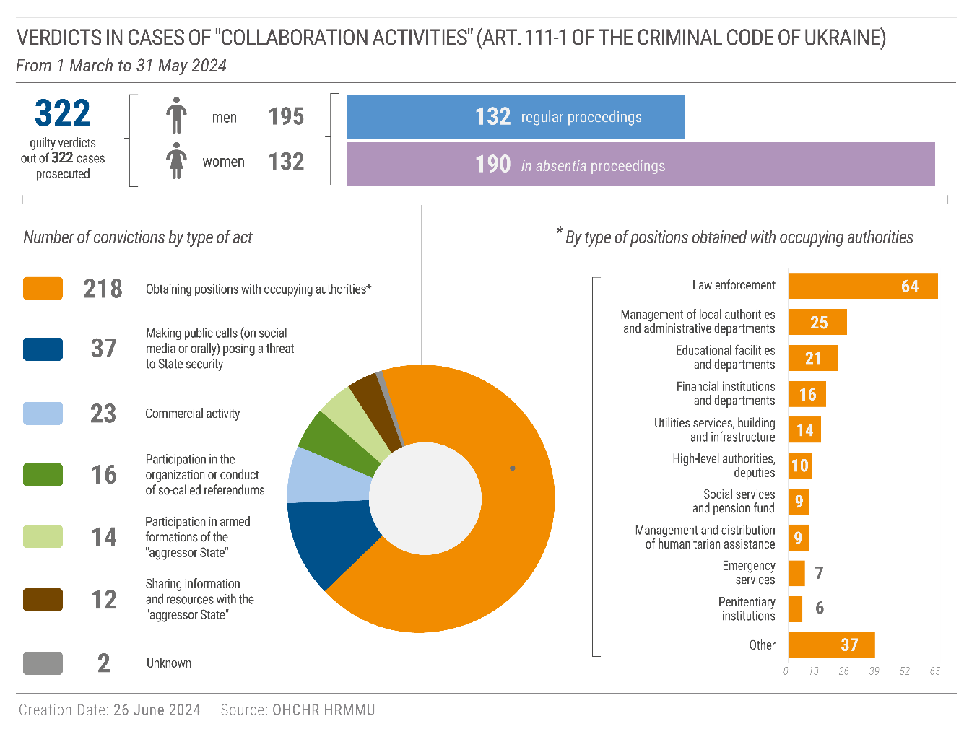

94. In some cases, defendants stated that they had performed work for the Russian occupying authorities due to fear for their lives, often after having received direct or indirect threats, or because of the dire humanitarian situation. For example, one police officer from Izium, Kharkiv region, stated in court that members of the Russian armed forces had detained and tortured him for several hours. A few weeks later, they came to the man’s house and threatened him with violence if he did not resume his work as a police officer. The man felt he had no effective choice and continued to perform his duties following up on minor offences and domestic violence, as before occupation.

95. In another example, Ukrainian authorities are prosecuting for collaboration activities two men and one woman who briefly performed functions of watchtower guards in Kherson penal colony No. 90 in 2022.[68] Two stated that they had agreed to work as penitentiary staff because they had no other means of survival, while the third reported receiving threats from members of the Russian armed forces to take the job.

96. On 15 May 2024, the Prosecutor General of the Government of Ukraine instructed his office to comply with IHRL and IHL during pre-trial investigations in cases of “collaboration activities”. The instructions referenced IHL provisions that specify that certain activities can, in principle, be lawfully compelled by the occupying Power and also the need to assess whether “collaboration activities” were undertaken under physical or mental coercion.

2. Prosecution of Russian servicemembers

97. Between 1 March and 31 May 2024, Ukrainian courts rendered 17 verdicts against 34 members (all men) of the Russian armed forces for war crimes (art. 438 of the Ukrainian Criminal Code), with sentences ranging from 10 years to life imprisonment.

98. In all cases except one, however, the defendants were tried *in absentia,* including 15 Russian servicepersons who were tried together and sentenced to 12 years of imprisonment each for detaining civilians in inhumane conditions in the basement of the Yahidne village school, Chernihiv region, in March 2022, resulting in the deaths of 10 older persons.[69] The high number of *in absentia* trials raises concerns about proper the notification of defendants of proceedings, which usually takes place through official websites of the court and prosecutor and Government-owned newspapers, and whether they waived the right to be present, consistent with due process and fair trial rights.

VI. Technical cooperation

99. In the reporting period, OHCHR provided technical assistance on a range of topics through engagement with representatives from different branches and levels of the Government of Ukraine.

100. Among other steps, OHCHR provided advice to the Ministry of Reintegration of Temporary Occupied Territories of Ukraine regarding the integration of a human rights approach into its draft strategy of restoration of State authority and reintegration of the population of occupied territories. OHCHR also participated in discussions on laws on private property adopted by the Russian occupying authorities, contributing to a decision of the Office of the Commissioner for Human Rights of the Ukrainian Parliament to develop guidelines for people affected by these laws.

101. OHCHR engaged with the Ministry of Defence to establish a regular dialogue on how to prevent civilian casualties. It also continued its practice of providing feedback to administrations of internment facilities for Russian POWs following visits and interviews. In the past, such feedback resulted in concrete improvements of the conditions in these facilities, such as revoking the practice of using physical exercise as a punishment.

102. With regard to Ukrainian POWs in Russian captivity, OHCHR continued its regular engagement with civil society organizations, providing, for example, information about how to use various relevant UN human rights mechanisms.

103. Additionally, at the request of the Government, OHCHR reviewed the draft law ‘On the Institute of Registered Partnerships’ to ensure its compliance with international human rights norms and standards.[70]

VII. Recommendations

**104. In past reports, OHCHR provided numerous recommendations, most of which are still relevant and require implementation. The violations recorded in the current reporting period have highlighted the need to implement the following recommendations in particular:**

**105. To all parties:**

**(a) Respect and ensure full compliance with IHL, in particular, in the conduct of hostilities and the treatment of protected persons;**

**(b) Take all feasible precautions to avoid or at the very least minimize civilian harm, including through the careful selection of means and methods of warfare;**

**(c) Cease the use of explosive weapons with wide-area effects in populated areas and rigorously map the location of mines so that affected areas can be promptly cleared;**

**(d) Ensure timely and effective investigations into all alleged violations of IHL and IHRL; ensure that alleged perpetrators, including members of the security forces and persons in positions of command, are duly prosecuted; and provide reparations and support to victims and survivors, including medical, psychological and legal support services, with particular attention to the specific needs of women, girls, men and boys; and**

**(e) Ensure that POWs are not exposed to any form of public curiosity.**

**106. To the Russian Federation:**

**(f) Immediately cease its use of armed force against Ukraine and withdraw its military forces from the territory of Ukraine, as per United Nations General Assembly Resolution ES-11/1 on the “Aggression against Ukraine”, adopted on 2 March 2022, and the binding order of the International Court of Justice on provisional measures of 16 March 2022;**

**(g) Immediately cease attacks on critical energy infrastructure;**

**(h) Immediately cease summary execution, torture, ill-treatment and sexual violence against POWs and civilian detainees, and end all unlawful practices relating to detention;**

**(i) Provide independent and impartial monitors full access to all places where Ukrainian POWs and civilian detainees are held;**

**(j) Ensure that all prosecutions of POWs fulfil essential guarantees of fair trial; respect the right of Ukrainian POWs to communicate with their families; and take all necessary measures for the establishment of mixed medical commissions with a view to facilitating repatriation of the severely wounded and sick;**

**(k) Fulfil its obligations under IHL in the territory under its occupation and cease interfering with the public order and civil life that existed prior to occupation, including by respecting Ukrainian laws and institutions unless absolutely prevented from doing so; and**

**(l) Strengthen cooperation and dialogue with OHCHR, including by providing OHCHR meaningful access to the occupied territory.**

**107. To the Ukrainian authorities:**

**(m) Ensure that POWs are treated in full compliance with IHL, including by protecting them from torture or ill-treatment at every stage of captivity;**

**(n) Ensure that all prosecutions of POWs respect all due process and fair trial guarantees provided for in IHL and IHRL; and**

**(o) Align the law ‘On Collaboration Activities’ with international law; refrain from prosecuting individuals for collaboration when their cooperation with the occupying authorities was in line with what can be required under IHL.**

**108. To the international community:**

**(p) Urge the parties to the conflict to respect IHRL and IHL, and work collectively to ensure respect for IHRL and IHL, including through provision of remedy, redress and reparation for violations, and prevention of further violations;**

**(q) Call for OHCHR to have the fullest possible access to all areas of Ukraine occupied by the Russian Federation to facilitate comprehensive monitoring, which is critical to ensuring accountability;**

**(r) Assist in enhancing the capacity for safe, efficient, and effective demining operations and support programs to educate civilians to the risks posed by mines and explosive remnants of war;**

**(s) Assist actors providing support to victims and survivors of grave human rights violations, inclusive of sexual violence, with attention to the respective needs of women, girls, men and boys; and**

**(t) Sustain attention and humanitarian assistance to people impacted by the war, including those internally displaced.**

1. Most of the newly documented cases occurred before the reporting period.
2. For past periodic reports, see https://www.ohchr.org/en/countries/ukraine.
3. HRMMU was deployed on 14 March 2014 to monitor and report on the human rights situation throughout Ukraine, with particular attention to the Autonomous Republic of Crimea, eastern and southern regions of Ukraine, and to propose recommendations to the Government and other actors to address human rights concerns. For more information, see A/HRC/27/75, paras. 7-8.
4. With 614 women and 511 men.
5. The actual figures are likely higher as some reports of civilian casualties are still pending corroboration. The lack of access of OHCHR to occupied territory and limited access to areas close to the frontline render full verification difficult in some instances. For OHCHR monthly updates on the protection of civilians in Ukraine and the total number of civilian casualties since 2014 and 24 February 2022, see https://ukraine.un.org/en/resources/publications.
6. Reported civilian casualties that OHCHR has not been able to verify are not included in the overall numbers of verified civilian casualties. See para. 11 above.
7. Information provided by UNICEF. See also UNICEF, *Catch-up classes help children in Ukraine recover lost learning, news release*, 14 May 2024.
8. UNHCR and WHO, *UNHCR alarmed at growing humanitarian needs around Kharkiv, Ukraine*, press briefing, 21 May 2024. See also WHO, *Refining primary health care financing in Ukraine: examining provider costs and impact of war*, news release, 21 May 2024.
9. From 1 December 2023 to 29 February 2024, aerial bombardments killed and injured 54 men, 47 women, 3 girls, and 2 boys.
10. HRMMU, *Update on the Human Rights Situation of Older Persons in Ukraine in the Context of the Armed Attack by the Russian Federation*, May 2023, paras. 14-16.
11. The percentage is calculated based on records for which age is known.
12. State Statistics Service of Ukraine, *Distribution of the permanent population of Ukraine by sex and age*, 2019, at https://ukrstat.gov.ua/druk/publicat/kat_u/2019/zb/07/zb_rpnu2019.pdf (last accessed on 13 May 2024).
13. Large-scale attacks against energy infrastructure took place on 22 and 29 March, 11 and 27 April, and 8 May. OHCHR previously reported that from October 2022 to January 2023, 14 large-scale attacks damaged or destroyed at least 76 objects of energy infrastructure in 19 regions of Ukraine and Kyiv city. See OHCHR, *Report on the Human Rights Situation in Ukraine, 1 August 2022 to 31 January 2023*, March 2023, paras. 39 and 40.
14. The power plant was also struck several times during the 2022-2023 winter season, resulting on two occasions in complete disruption of energy production and heating provision lasting for one to two weeks. The plant was able to resume energy production relatively quickly after repairs.
15. . International Atomic Energy Agency, *United Nations Security Council Update*, 15 April 2024, at <https://www.iaea.org/newscenter/statements/united-nations-security-council-update> (last accessed on 26 June 2024).
16. Additional Protocol I of the Geneva Conventions, art. 50; Customary International Humanitarian Law, ICRC, Rule 1.
17. Additional Protocol I of the Geneva Conventions, art. 57; Customary International Humanitarian Law, ICRC, Rule 15.
18. From 1 December 2023 to 29 February 2024, mines and ERW killed 9 civilians and injured 34 (32 men, 7 boys, 3 women, and 1 girl).
19. Under IHL, the occupying Power is responsible for restoring and ensuring, as far as possible, ordinary life, public order, and safety, and has a duty to respect, unless absolutely prevented, the laws in force in the country. Regulations respecting the Laws and Customs of War on Land of 1907 (the Hague Regulations), art. 43; Fourth Geneva Convention, art. 64.
20. OHCHR, *Human Rights Situation during the Russian Occupation of Territory of Ukraine and its Aftermath*, March 2024, and OHCHR, *Ten Years of Occupation by the Russian Federation: Human Rights in the Autonomous Republic of Crimea and the City of Sevastopol, Ukraine,* February 2024.
21. Human Rights Committee, *Bratsylo, Golovko and Konyukhov v. Russia*, CCPR/C/140/D/3022/2017, paras. 8-10.
22. Russian presidential decree № 307 of 27 April 2023 “On the peculiarities of the legal status of certain categories of foreign citizens and stateless persons in the Russian Federation”, at <http://publication.pravo.gov.ru/Document/View/0001202304270013?index=1> (last accessed on 4 June 2024).
23. OHCHR, *Update on the Human Rights Situation in Ukraine, 1 February to 30 April 2023*, June 2023, pp. 2 and 3.
24. Fourth Geneva Convention, art. 51; the Hague Regulations, art. 52. Compelling a protected person to serve in the armed forces of the occupying Power constitutes a grave breach of the Geneva Conventions. Fourth Geneva Convention, art. 147.
25. The armed groups of the self-proclaimed ‘Donetsk people’s republic’ and the ‘Luhansk people’s republic’ forcibly mobilized thousands of men in February 2022 at the beginning of full-scale invasion of Ukraine. OHCHR, *Report on the Human Rights Situation in Ukraine, 1 August 2023 to 30 November 2023*, December 2023, para. 45.
26. The Hague Regulations, art. 46; and Customary International Humanitarian Law, ICRC, Rule 51 (c).
27. Authorities in the Zaporizhzhia region adopted similar legislation in September 2023.
28. OHCHR, *Ten years of occupation by the Russian Federation*, paras. 23-24.
29. OHCHR, *Ten Years of Occupation by the Russian Federation*.
30. OHCHR, *Killings of Civilians: Summary Executions and Attacks on Individual Civilians in Kyiv, Chernihiv, and Sumy Regions in the Context of the Russian Federation’s Armed Attack against Ukraine*, 7 December 2022.
31. OHCHR, *Detention of Civilians in the Context of the Armed Attack by the Russian Federation against Ukraine, 24 February 2022 to 23 May 2023*, June 2023.
32. Medical personnel, including military, who are exclusively engaged in the treatment of wounded and sick are not considered POWs, but can be retained only in so far as the state of health and the number of prisoners of war require. First Geneva Convention, arts. 24 and 28. The medics interviewed by OHCHR had not been involved in treating wounded or sick POWs at least since October 2022 and their retention was therefore a violation of IHL.
33. See for instance OHCHR, *Report on the Human Rights Situation in Ukraine, 1 August 2023 to 30 November 2023*, December 2023; and OHCHR, *Treatment of Prisoners of War and Persons Hors de Combat*, March 2023.
34. Fourth Geneva Convention, art. 106.
35. Fourth Geneva Convention, arts. 107 and 117. These rights can be restricted in line with article 5 of the Fourth Geneva Convention. See also art. 9 of the Convention of the Rights of the Child on the obligation to inform children or family members with essential information concerning the whereabouts of the absent member(s) of the family.
36. See also Additional Protocol I of the Geneva Conventions, art. 40, and Third Geneva Convention, art. 121.
37. OHCHR, *Report on the Human Rights Situation in Ukraine, 1 December 2023 to 29 February 2024*, March 2024, paras. 54-56.
38. Article 13 (2) of the Third Geneva Convention states that “prisoners of war must at all times be protected, particularly against acts of violence or intimidation and against insults and public curiosity”. In modern conflicts, the prohibited acts include the disclosure of photographic and video images, recordings of interrogations or private conversations, personal correspondence or any other private data, irrespective of the public communication channel used. See Commentary to the Third Geneva Convention, 2020, paras. 1623-1624.
39. Interviews were underway in the month of June and updates will be included in the next periodic report.
40. Article 71 of the Third Geneva Convention provides that POWs shall be allowed to send normally at least two letters and four cards monthly. Article 72 also provides for the right of POWs to receive by post or by any other means individual parcels. The right to correspondence is ensured, in particular, by transfer of the capture cards as defined in Article 70 of the Convention. Information in the capture card allows the person’s whereabouts to be monitored and POWs to exchange correspondence with family members. See Commentary to the Third Geneva Convention, 2020, para. 3149.
41. . Resolution of the Cabinet of Ministers, no. 296 (15 March 2024), See: https://zakon.rada.gov.ua/laws/show/296-2024-%D0%BF%23Text
42. A system of security checks and personal data collection during which many civilians were detained for periods ranging from several days to several months.
43. Fourth Geneva Convention, art. 49.
44. Russian Federation Presidential Decree No. 307 of 27 April 2023 “On peculiarities of the legal status of certain categories of foreign citizens and stateless persons in the Russian Federation”. The decree provides for the deportation of Ukrainian citizens under grounds of “constituting a threat to state security”. OHCHR, *Human Rights Situation during the Russian Occupation of Territory of Ukraine and its Aftermath*, para. 151.
45. More comprehensive information about such restrictions is available for Crimea due to the accessibility of court records. In other parts of occupied territory, OHCHR also documented a climate of fear that severely limits fundamental freedoms and all expressions of Ukrainian identity and culture. See OHCHR, [*Human Rights Situation during the Russian Occupation of Territory of Ukraine and its Aftermath,*](https://www.ohchr.org/en/documents/country-reports/human-rights-situation-during-russian-occupation-territory-ukraine-and) paras 46-56.
46. Russian Federation Code of Administrative Offenses, art. 20.3.3; Russian Federation Criminal Code, art. 207.3 and art. 280.3.
47. Russian Federation Code of Administrative Offenses, art. 20.3 (1) “Propaganda or public display of Nazi paraphernalia or symbols, or paraphernalia or symbols of extremist organizations, or other paraphernalia or symbols, the propaganda or public display of which is prohibited by federal laws” and art. 20.1 (3).
48. OHCHR recorded 105 convictions between 1 December 2023 and 29 February 2024.
49. See also OHCHR, *Ten Years of Occupation by the Russian Federation*.
50. *Marques de Morais v Angola* (CCPR/C/83/D/1128/2002), paras. 6-7.
51. Although those charges were introduced as administrative offences in March 2019 and November 2014 respectively, OHCHR started monitoring these prosecutions after the full-scale invasion and their more extensive application of charges to Crimean residents.
52. The lawyer was prosecuted for “abuse of freedom of the media” under article 13.15 (9) of the Code of Administrative Offenses of the Russian Federation.
53. The activist was prosecuted for “abuse of freedom of the media” under article 13.15 (2) of the Code of Administrative Offenses of the Russian Federation.
54. A religious group considered a terrorist organization under Russian law but not under Ukrainian law.
55. Federal Law 64-FZ of 23 March 2024 “On Amending the Criminal Code of the Russian Federation and the Criminal Procedure Code of the Russian Federation”, at <http://publication.pravo.gov.ru/Document/View/0001202403230018> (last accessed on 12 June 2024).
56. OHCHR, *Report on the Human Rights Situation in Ukraine, 1 February to 31 July 2023*, September 2023, paras. 128-129.
57. The June 2023 law was a *lex specialis* act that did not formally introduce any amendments to the Criminal Code or Criminal Procedure Code of the Russian Federation.
58. See First Geneva Convention, art. 49, Second Geneva Convention, art. 50, Third Geneva Convention, art. 129, and Fourth Geneva Convention, art. 146, which all stipulate that the High Contracting Parties to the Geneva Conventions “undertake to enact any legislation necessary to provide effective penal sanctions for persons committing, or ordering to be committed, any of the grave breaches”. See also Customary International Humanitarian Law, ICRC, Rule 158. States must investigate war crimes allegedly committed by their nationals or armed forces, or on their territory, and, if appropriate, prosecute the suspects. They must also investigate other war crimes over which they have jurisdiction and, if appropriate, prosecute the suspects.
59. See footnote 38.
60. In addition, OHCHR has documented 11 cases of conflict-related sexual violence in Government-controlled territory against 9 men and 2 women, perpetrated by civilians or members of territorial defence forces in February and March 2022, consisting of forced public stripping of persons considered to be “lawbreakers”.
61. The Ukrainian Orthodox Church (UOC), often informally referred to as “Moscow Patriarchate”, is one of the largest Orthodox Christian religious organizations currently active in Ukraine. After the armed attack by the Russian Federation, leaders of the UOC declared complete autonomy and independence from the Russian Orthodox Church and formally changed the organizational charter.
62. All were charged with the creation of, and participation in, a criminal organization (art. 255 of Criminal Code of Ukraine), hate crimes (art. 161) and combinations of different conflict-related crimes, including state treason (art. 111), collaboration activities (art. 111-1) and denial or glorification of armed aggression by the Russian Federation (art. 436-2).
63. Previously, the Ministry of Social Policy regularly published calculations of actual subsistence minimum to better reflect the dynamics of costs of living.
64. HRMMU, *Update on the Human Rights Situation of Older Persons in Ukraine*, para. 28.
65. During the same period, cases were initiated under other conflict-related charges, including state treason (article 111 of the Criminal Code), aiding and abetting the aggressor state (article 111-2), trespassing against territorial integrity (article 110).
66. On 3 March 2022, the Parliament of Ukraine amended the Criminal Code by introducing article 111-1 on “collaboration activities”. The law defines the offence of collaboration with the occupying authorities in broad terms and with imprecise language, causing uncertainty for individuals residing in occupied territory.
67. Article 51 of the Fourth Geneva Convention provides that the occupying Power may compel protected persons to work for public utility services, or for the feeding, sheltering, clothing, transportation or health of the population of the occupied country.
68. The ICRC Commentary to article 54 of the Fourth Geneva Convention says that “[a] whole series of persons holding public posts ... also fulfil an essential role in the life of the public, for example, ... prison staff”.
69. For further details on the case, see OHCHR, *Detention of Civilians in the Context of the Armed Attack by the Russian Federation against Ukraine,* para. 76.
70. The draft law is a response to *Maymulakhin and Markiv v. Ukraine* (Application No. 75134/14, Judgment, 01 September 2023) in which the European Court of Human Rights found that Ukraine had violated the right to non-discrimination (article 14) in conjunction with the right to respect for family life (article 8) of the European Convention on Human Rights, by denying to the applicants, a same-sex couple, any form of legal recognition and protection as compared with different-sex couples.