4th session of the Open-ended intergovernmental working group to elaborate the content of an international regulatory framework, without prejudging the nature thereof, relating to the activities on private military and security companies

(17-21st April 2023 I 10am – 12pm & 3pm – 5pm CET)

Guidance note to register for the list of speakers and for sending video statements
(for general comments only)

This guidance note is for States, specialized agencies, intergovernmental organizations, national human rights institutions and non-governmental organizations (with ECOSOC status) intending to register for the list of speakers for general comments. Please note that:
Participants must register for the event via Indico: https://indico.un.org/event/1001730/
Only those registered will receive the link to join the event, shortly before it starts.
During each segment of the programme of work, there will be time for discussion, during which States, specialized agencies, intergovernmental organizations, national human rights institutions, and non-governmental organizations (with ECOSOC status) will be allowed to intervene, in that order.
Oral intervention can be made either by:
- In-person delivery
- Making a live statement through the online Zoom platform; or
- Sending a pre-recorded video message for the general comments segment (refer to Annex I below on submitting video)

All stakeholders who would like to make a general statement should let the Secretariat know as soon as possible, by sending an email to ohchr-igwg-pmsc@un.org, copying speeches@un.org, with the following information:

- The means through which the oral intervention (general comments) will be made: remote intervention through Zoom, remote intervention through the sending of a pre-recorded video message, or in-person delivery;

- The type of stakeholder speaking: e.g., State, specialized agency, IGO, NHRI, or NGO (with ECOSOC status);

- Name of the State or organization; Name of the speaker;

- A copy of the oral statement, which will be part of the public session’s documents and also aid the interpreters and report writers.

Due to the constraints linked to the format of the meeting, a time limit for each intervention will need to be imposed for each category of stakeholders, as follow:

- States and regional organizations: 5 minutes maximum

- Other Stakeholders: 2 minutes maximum

Please note:
Only NGOs with ECOSOC consultative status may make an oral statement. Where the speaker is not from the inscribing NGO, an authorized representative from the latter must authorize this in writing.

In order to allow for the largest possible number of substantive contributions, participants are kindly requested to limit their interventions to be as concise and succinct as possible.

Abusive or disrespectful language or derogatory and inflammatory remarks by any participant will not be tolerated during the session. All participants should ensure that a sense of respect and tolerance permeates the discussion.
All statements received will be posted as received on OHCHR’s website and as soon as possible following the conclusion of each meeting. If the statement delivered is substantially different from the document initially received by the secretariat or if you do not wish the statement to be published online, please inform the secretariat. In line with the OHCHR disability policy, oral interventions without written scripts cannot be shared on the website.

Sending a pre-recorded video message (possible only for general statements)

For participants or stakeholders sending a pre-recorded video message, please:
- Register for the list of speakers (as indicated above),
- Carefully read the guidance for submitting your video file to the Secretariat via WeTransfer in Annex I below.
- Consider including captioning for the video statement in order to enhance participation of persons with disabilities. Guidance on creating captions using YouTube is available in Annex II below.
- Be mindful of the audio and video quality.
- Send your video message, together with a transcript of your message in Microsoft Word or accessible PDF format to ohchr-igwg-pmsc@un.org and unog-rsi-moderation@un.org at least 24 hours before the session for which it is submitted.
Note that the video file must not exceed 5 minutes for States and regional organizations, and 2 minutes for other stakeholders.

Requesting the floor during the event

To request the floor during the event, online participants may use the ‘raise hand’ function on the online platform and participants in the room may raise their placards.

ANNEX I

GUIDELINES ON SENDING VIDEO MESSAGES VIA WETRANSFER

1) | Open a browser on the computer where the files you want to | In order to enhance
 | send are located. Go to https://wetransfer.com/. | In order to enhance
 | send are located. Go to https://wetransfer.com/. | participation of persons
2) | Click on “Add your files” and select the following files: | with disabilities, all
2) | Click on “Add your files” and select the following files: | stakeholders are
 | a. Your video message (see below for specifications); | encouraged to include
 | b. A transcript of your statement in Word or accessible PDF | captioning on the video
 | formats. | statement, as well as to
 |  | consider including sign
3) | On the “Email to” field, add: ohchr-igwg-pmsc@un.org | language.

- On the “Your email” field, add your own email.

- On the “Message field”, include:

  - The stakeholder/organization on behalf of which you will be speaking;

  - The panel for which you are sending the video message.

- Click on “Transfer”. You will be prompted to enter a verification code, which will be sent to your email a few moments later (remember to check the spam folder). Copy the verification code, paste it in the transfer windows and hit verify.

- Once the verification code has been entered, your files will be uploaded. This might take a few minutes. After that, your files will be sent to us automatically. You will receive an email confirming that your files were sent successfully. You will also receive a confirmation email once we have downloaded your files.

Please note that all video statements should be sent at least 12 hours before the session for which it is submitted

ANNEX II

GUIDELINES ON CREATING VIDEO CAPTIONS USING YOUTUBE (FOR PRE-RECORDED VIDEO MESSAGES)

The purpose of these guidelines is to explain how to use YouTube to caption video messages. We recommend its use as an example of a quick, simple and free solution to increase the accessibility of events, but stakeholders are encouraged to use any means of their choosing to add subtitles to video messages.

These guidelines only address how to create subtitles when a transcript of the video is available. YouTube also generates automatic captions, but this falls beyond the scope of these guidelines.

- Go to www.youtube.com and log in or sign up using a Google account.
- In the upper-right corner, click on the camera icon and select “Upload video”.

- Select the video file.

- The following screen appears. As the video will not be made public on YouTube, most details are not relevant. The only required fields are the title and the indication that the video is not meant for children. Complete them and click “Next”.
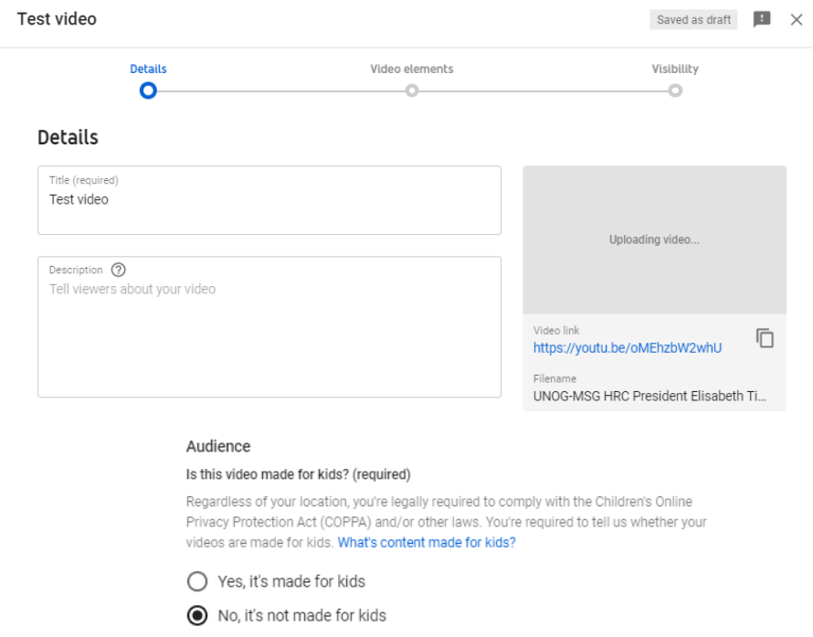

- Click “Next” on the “Video elements” tab. On the “Visibility” tab, select “Private” and click on “Save”.

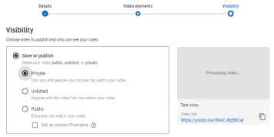

- After the video has finished uploading, it might be necessary to wait some minutes while it is being processed (capture

below). Processing time depends on several factors, such as the format and size of the original file, as well as

YouTube’s own upload traffic.

As a rule of thumb, it can take
aroundoneminuteof

processing for each minute of video – and more than that for higher-resolution video. The progress bar is usually not linear: 0% takes a long time, and from there it jumps to almost completion. A few minutes at 0% does not mean that the processing is frozen.
- Go back to the dashboard by clicking on the icon on the upper-left side. On the
left-hand column, select . Click on “Details” next to the video to caption. After that, select “Subtitles”.
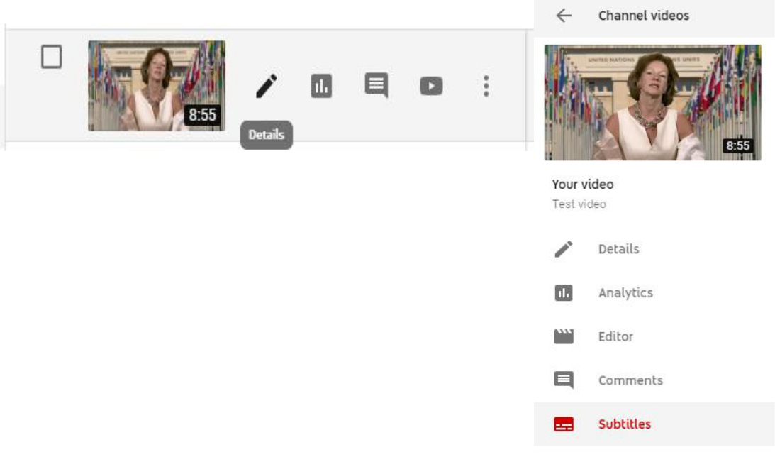
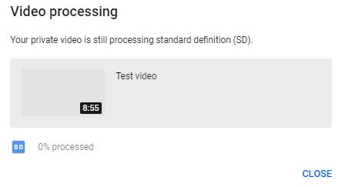

- Select “add” and then “Upload a file”. On the next screen, select “Transcript” as the file type. There might be a warning mentioning that “Uploading a file will overwrite this

version of English”. This means that YouTube has already generated automatic captions for this video, which will now be overwritten.
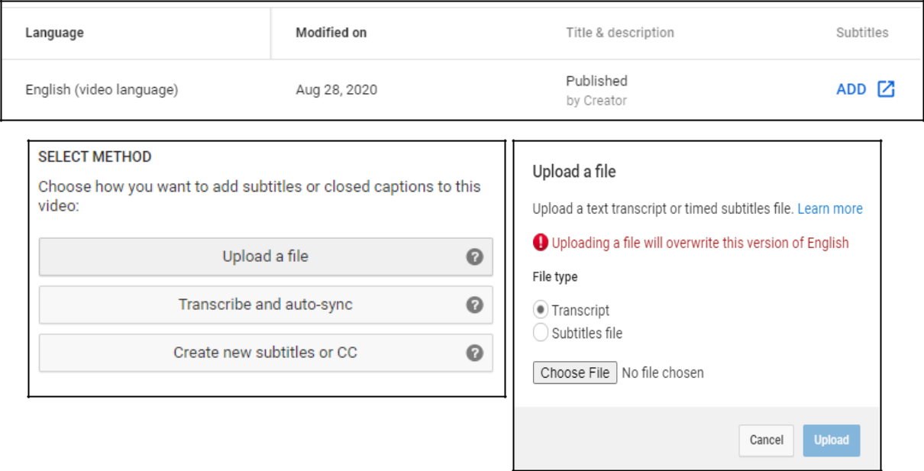

- Upload the transcript as a plain text (.txt) file. Using a Word document will not work properly. Before uploading it, edit the file so as to include only what is actually said in the video, without bullet points, headers or footnotes.

- The transcript will appear in the following box. Click on “Set timings”.
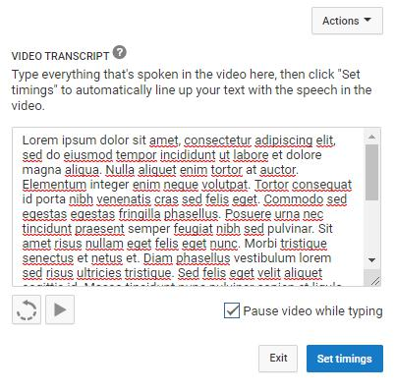

- YouTube will now transform the transcript in timestamped subtitles. For a 7-minute video, this takes 2 to 3 minutes on average. YouTube does not refresh the page automatically when this process has finished; so refresh the page after a few minutes to check whether it is finished (refreshing the page before it is complete does not reset the progress). When it is done, click on the draft.
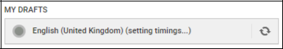

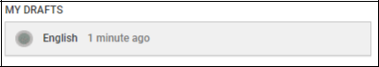

- It is possible to check and edit the subtitles at this stage, changing the wording or timing if needed. After this, click on “Save changes”.
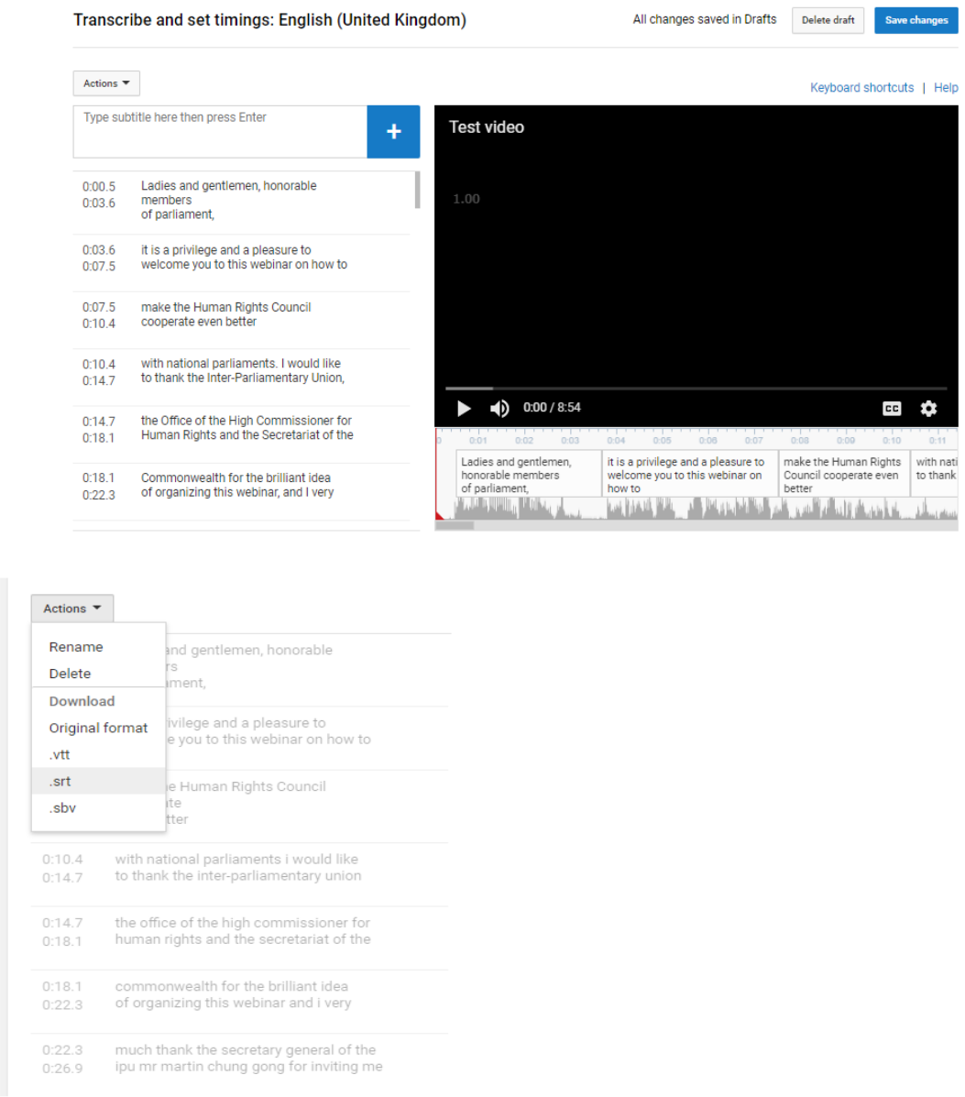

- Select again the edited subtitles. Click on

“Actions” and download the captions as a .srt file. Save it with the same file name as the video, as shown in the capture below.
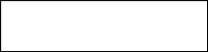
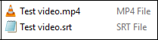

- To test it, open the video file using a player that supports subtitles, such as VLC Media Player. Provided that both files have the exact same name and are saved on the same folder, captions should be displayed automatically.

- Kindly upload the .srt subtitle file when uploading the video and related files on WeTransfer.

