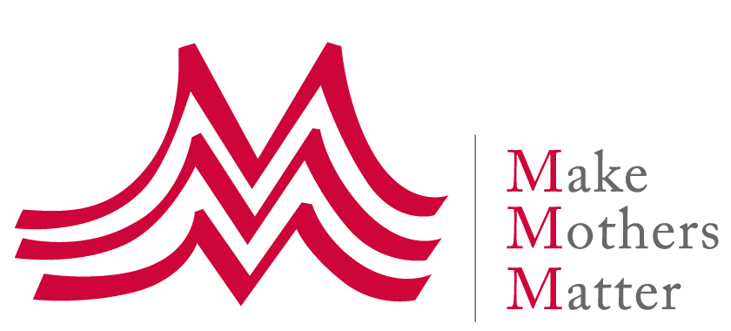

**Oral Statement**

**HRC 5th intersessional meeting**

**on human rights and the 2030 Agenda  
Overcoming multiple crises: realising the SDGs   
through a human-rights enhancing economy**

Make Mothers Matter welcomes the theme of this 5th meeting: we agree that transforming our economic system is key to addressing the multiple crises we face and realizing the SDGs.

It is time to recognize the inadequacy of GDP as a measure of well-being and progress, to move away from the growth mantra, and to understand that our economy should care for its people and planet, not prosper at their expense.

Care. Care is at the heart of well-being, both human and environmental. And this is at the heart of human rights, including the right to development. Economies depend on care work to survive and thrive. As we care for our children, we invest in the future.

Unfortunately, our current economic system does not factor in unpaid care work, the cause of much economic hardship and injustice for women, in particular when they are mothers[1]. The same goes for environmental damage, which is at the root of so many human rights violations.

We believe an economic system that works for everyone should therefore recognize, value, and support the work of caring for each other and for the planet.

The UN Secretary-General rightly emphasized this when he said: ‘The pandemic has shown us who is doing the work that really matters: nurses, teachers, care workers. As we recover, we need to remember this. It is time to end the inequities of unpaid care work and create new economic models that work for everyone’[2].

A few governments, including Finland, Iceland, New Zealand, Scotland and Wales, are also showing us the way by transforming to wellbeing economies[3]. And many similar initiatives exist at the local level[4].

Thus, we are calling on Member States to collectively ‘move beyond GDP’ and put this issue on the UN agenda, and to accelerate the transformation of our economic system so that it is driven by human rights and the wellbeing of people and the planet – with care at its heart.

1. 2013 Report of the Special Rapporteur on poverty to the UN GA on unpaid care work and women’s human rights - <https://www.ohchr.org/en/special-procedures/sr-poverty/annual-reports-1999-2014>
2. Antonio Guterres, UN Secretary-General, Town Hall with Young Women from Civil Society Organizations on 31 August 2020
3. See the work of the Wellbeing Economy government partnership (WEGo) and the wellbeing economy alliance (WEAll): <https://weall.org/>
4. See in particular the Doughnut Economics Action Lab (DEAL) <https://doughnuteconomics.org/>