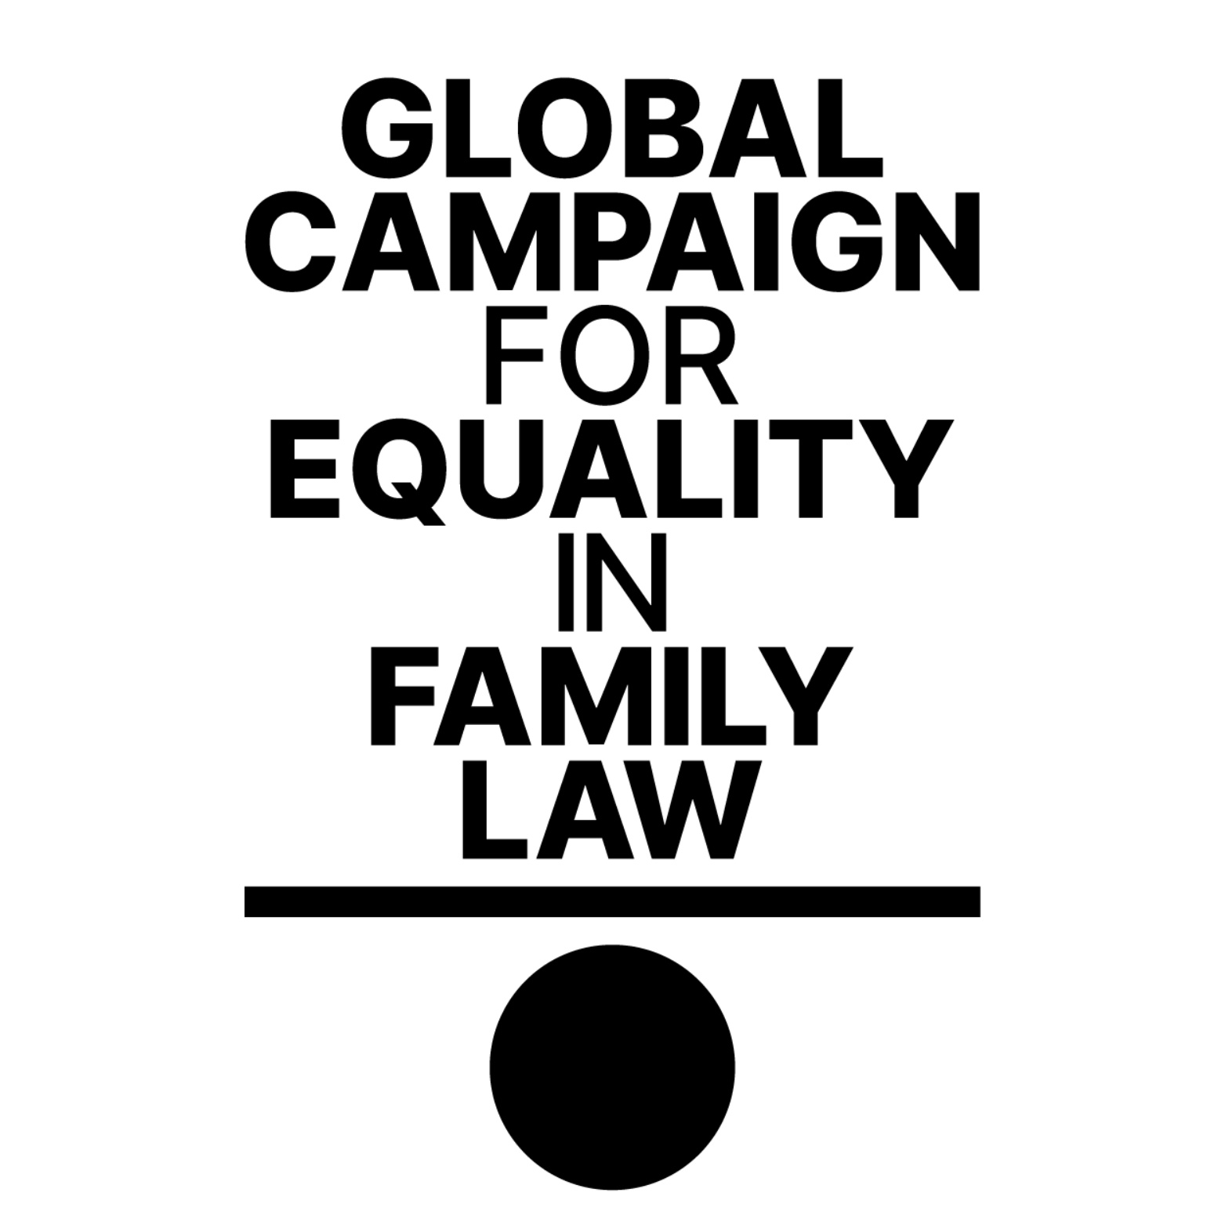 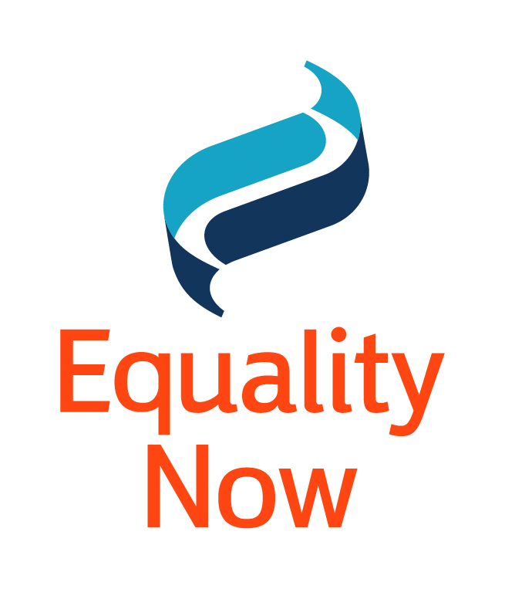

Office of the High Commissioner for Human Rights

Palais des Nations

1211 Geneva 10, Switzerland

[ohchr-registry@un.org](mailto:ohchr-registry@un.org); [ohchr-wohchr@un.org](mailto:ohchr-wohchr@un.org)

26th April 2024

**Input to the UN Secretary General’s report on child, early and forced marriage, pursuant to GA resolution 77/202**

1. In response to the call for input by the Office of the High Commissioner for Human Rights (OHCHR), Equality Now and the Global Campaign for Equality in Family Law submit this input to the report of the United Nations Secretary-General on progress towards ending child, early, and forced marriage worldwide, which will be submitted at the 78th Session of the UN General Assembly. Equality Now is an international human rights organization with ECOSOC status founded in 1992 working to promote the equality of women and girls worldwide. The Global Campaign for Equality in Family Law (GCEFL) is led by a coalition of 8 women’s rights, human rights and faith-based organisations including Equality Now, Act Church of Sweden, CLADEM (Latin American and Caribbean Committee for the Defense of Women’s Rights), Musawah, Muslims for Progressive Values, SOAWR (Solidarity for African Women’s Rights) network represented by FEMNET, Women’s Learning Partnership, and UN Women.[1]
2. Child, early, and forced marriage and unions (CEFMU) are some of Equality Now’s key thematic areas of focus under our End Harmful Practices program. Our submission will focus on key developments in laws and jurisprudence on CEFMU since the last progress report of the Secretary-General in 2022; provide examples of case studies of recent high-profile cases of child and forced marriage; and will focus on the role of unequal family laws in promoting CEFMU and restricting the rights of married girls and their ability to leave marriages and access services.

***Some Developments in Laws and Policies related to CEFMU since 2022***

1. There have been positive steps towards improving laws on CEFMU since 2022 in a number of countries, including efforts to raise the minimum age of marriage to 18 without exception, in accordance with international human rights standards. For instance, in **Zambia**, the Children’s Code Act of 2022 prohibited marriage under 18 for both boys and girls[2]; though child marriage was still permitted under the Marriage Act. This loophole was further closed through the passage of the Marriage (Amendment) Act 2023, which raised the minimum age of marriage to 18 without exceptions. Crucially, the law removed the exception for customary marriages, which was earlier in place.[3] Similar amendments were passed in **Zimbabwe** through the Marriages Act No. 1 of 2022, which set the minimum age of marriage at 18 without exceptions for all marriages, including customary marriages.[4]
2. In the **United States of America**, at least 300,000 minors under the age of 18 were legally married between 2000 and 2018[5]- mostly girls wed to adult men. Since 2022, six states - Massachusetts, Vermont, Connecticut, Michigan, Washington and Virginia - have passed laws raising the minimum age of marriage to 18 without exceptions. However, child marriage remains legal in 38 out of 50 US states.
3. Progressive jurisprudence on CEFMU has also been established by national and regional courts. In **Uganda**, in February 2023, the Constitutional Court of Uganda in *Kirya Martins & Aboneka Michael v. Attorney General,*[6] in a ground-breaking decision, held that the provisions of the Customary Marriage Act, Hindu Marriages and Divorce Act and the Marriage and Divorce of Mahommedans Act, insofar as they contradicted the minimum age of marriage set out in Article 31 of the Constitution, were null and void. However, the Ugandan Parliament has yet to implement this decision and pass the necessary amendments.
4. At the regional level, the African Committee of Experts on the Rights and Welfare of the Child (ACERWC) issued a landmark decision in 2022 on the communication in ***Legal and Human Rights Centre and Centre for Reproductive Rights v. Tanzania***.[7] The Committee found that Tanzania’s policies, which banned pregnant and married girls from attending school, violated international and regional human rights treaties to which Tanzania was a party. However, there are still serious concerns about the access to education for pregnant and married girls in Tanzania and the lack of implementation of the Committee’s decision. The Education Act of Tanzania, enacted through Government Notice No. 295 under Regulation 4 (Expulsion and Exclusion of Pupils from Schools), still stands and authorises the permanent expulsion of pregnant and married girls from public schools.
5. In November 2021, the Government of Tanzania, through the Ministry of Education, Science, and Technology (MoEST), issued the ‘Education Circular No. 2 of 2021’ that allows the re-entry of school dropouts due to any reasons, including pregnancies, back to the formal system of education. in February 2022, the Government, through the Ministry of Education, Science, and Technology (MoEST), issued a ‘Guideline to reinstating students who dropped out of primary and secondary education for various reasons’ which was a guideline to enforce the provisions of the ‘Education Circular No. 02 of 2021’ described above. However, these re-entry guidelines fall short of human rights standards as they are still discriminatory and vague and have been irregularly enforced from one school to another due to limited dissemination and understanding by education officials. There are cases where school officials decide what happens with a pregnant girl’s education without necessarily following the guidelines. Further, the guidelines have not addressed the drivers of teenage pregnancies, school-related sexual and gender-based violence, mandatory pregnancy testing, and the expulsion of girls from school when they become pregnant. The guidelines have also not provided recourse for all girls expelled from school because only students who dropped out within two years are allowed re-entry. Therefore, there is still a need to comprehensively review the education laws and policies to ensure all children attend school and are safe from school-related sexual and gender-based violence.

***The Impact of Discriminatory Family Laws***

1. Family laws and practices around the world, which govern marriage and unions, continue to be highly discriminatory against women and girls. Many family laws, particularly in some faith-based communities in the Middle East, Africa and Asia, condone and promote the practice of the male guardianship system under which even adult women are treated as minors who require the permission of male guardians to marry. Laws that uphold the male guardianship system are likely also to allow child and forced marriage, as the male guardian has the primary decision-making power to give a woman/girl in marriage. The rights of women and girls are severely restricted by such discriminatory family laws, especially in decision-making around family planning, access to sexual rights and reproductive health, and economic and educational opportunities.
2. Unequal family laws also negatively impact a married woman/girl’s right to equal divorce, which impacts their ability to leave a marriage when they wish to. Family and civil courts with family law jurisdictions also pose serious access to justice issues regarding delayed procedures, accessibility, and high cost. Women and girls who have experienced gender-based violence (e.g. domestic violence) within marriages and unions are doubly affected by unequal family laws.

***Challenges and Areas of Concern***

1. Equality Now notes with concern the recent rollbacks on the rights of women and girls; and the global phenomenon of shrinking space for civil society at national, regional, and international levels, including UN mechanisms and the impact of these rollbacks on measures to prevent and address CEFM. In particular, rollback on sexual and reproductive health and rights (SRHR), including access to abortion,[8] can have an impact on CEFMU, as pregnant girls who are unable to access abortions are at greater risk of being coerced or pushed into marriage. Lack of adequate access to SRHR services, such as contraception and abortion, is also a serious concern for married girls, who face high health risks from early pregnancies.
2. Climate change and climate shocks, especially droughts and floods, continue to exacerbate the drivers of child marriage. Over 50 million girls in Eastern and Southern Africa - nearly one third (32 per cent) of the region’s young women - were married before the age of 18.[9] In the southern African region, Zimbabwe, Malawi and Zambia have declared El Niño-induced drought a national disaster in March 2024. Child marriage is disturbingly perceived as a potential means and source of family livelihood in such crises. Disruptions of infrastructures due to flood induced displacements affect access to education, thereby removing some of the protection mechanisms against child marriage.
3. In **Malawi**, in Karonga district, for example, one of the causes of child marriages was lack of household income due to either droughts or excessive river floods, which left families without food to survive. This situation influenced parents and guardians to force their girl children into marriage to avoid their care responsibilities. Men who had better income took advantage of the families who were suffering from the impact of climate change to convince a girl for a marriage even when the man already had another wife.[10] In some communities, parents would force their boys to marry to have an energetic girl who could help them with such chores as collecting water and firewood. In **Kenya**, families in Kajiado County face severe consequences from prolonged drought. Extreme weather can lead to economic hardship, prompting families to marry their daughters off at a young age as a coping mechanism.[11] Poverty is a great motivator of early marriage and, in dire circumstances, families may see it as a way to reduce economic burden.

***Case Study of Forced Marriage by Abduction - Aitaj’s case (Georgia)***

1. In October 2023, the murder of 14-year-old Aitaj Shakhmirova by her 27-year-old “husband”, Alim Sadikov, spotlighted critical issues surrounding child and forced marriage in Georgia. Several months earlier, Sadikov had abducted Aitaj (both members of the ethnic Azerbaijani minority community in Georgia) when she was 13, forcing her into marriage against her will. Although she briefly escaped, her family pressured her to return to Sadikov, where she faced ongoing physical and sexual violence. Sadikov purchased a firearm, registered it in his name, and lured Aitaj to a location associated with her initial abduction, where he shot her after asking her to reenact her earlier escape attempt. NGO Social Justice Center represented Aitaj’s interests in the initial stages of the case.
2. Sadikov was charged with premeditated murder and, ultimately, as a result of the motion of Aitaj’s lawyers, also with rape of a minor. Charges of forced marriage were also brought against Aitaj's family members - her mother and uncle, who forced Aitaj to return to Sadikov after her escape. The case is now pending at the first instance court.
3. The case revealed broader institutional shortcomings in Georgia's response to child and forced marriage. The police and educational institutions allegedly had prior knowledge of Aitaj's forced marriage but failed to intervene effectively. This case demonstrates the need for stronger enforcement of laws against child marriage, enhanced support for victims, and improved prevention measures.

1. More info: [www.equalfamilylaws.org](http://www.equalfamilylaws.org)
2. Children Code Act No. 12 of 2022; https://www.parliament.gov.zm/sites/default/files/documents/acts/ACT%20No.%2012%20OF%202022%2CThe%20Children%27s%20Code%20FINAL.pdf
3. Marriage (Amendment) Act No. 13 of 2023 https://www.parliament.gov.zm/sites/default/files/documents/acts/Act%20No.%2013%20of%202023%2C%20The%20Marriage%20%28Amendment%29%20Act.pdf
4. Marriages Act No.1 of 2022, https://www.veritaszim.net/sites/veritas_d/files/MARRIAGES%20ACT%20No.%201%20of%202022.pdf
5. Reiss, Fraidy, *Child Marriage in the United States: Prevalence and Implications,* online at: <https://doi.org/10.1016/j.jadohealth.2021.07.001>
6. Constitutional Petition No. 135 of 2021; judgment dated 20th February 2023. https://ulii.org/akn/ug/judgment/ughccd/2022/1/eng@2022-01-10
7. Communication No: 0012/Com/001/2019 Decision No 002/2022; https://www.acerwc.africa/sites/default/files/2022-10/ACERWC%20Decision%20final%20Communication%20No-%200012Com0012019.Tanzania.pdf
8. Such as for example the decision of the Supreme Court of the US in *Dobbs v. Jackson Women’s Health Organization* 945 F. 3d 265 (2022), online at:<https://www.supremecourt.gov/opinions/21pdf/19-1392_6j37.pdf>

   <https://esaro.unfpa.org/sites/default/files/pub-pdf/child_marriage_and_environmental_crises_an_evidence_brief_final.pdf>
9. https://data.unicef.org/resources/child-marriage-in-eastern-and-southern-africa-a-statistical-overview-and-reflections-on-ending-the-practice/
10. [https://equalitynow.org/resource/malawi-42nd-session-acerwc-october-2023](https://equalitynow.org/resource/malawi-42nd-session-acerwc-october-2023/)
11. https://equalitynow.org/news_and_insights/prolonged-droughts-are-putting-girls-in-kenya-at-heightened-risk-of-child-marriage-and-other-human-rights-violations/