**AT Input to the report of the UN Secretary-General to the UN General Assembly on the issue of child, early and forced marriage**

* 1. **What efforts have been made or are planned to address the recommendations of the latest report of the Secretary-General on the issue of child, early and forced marriage (A/77/282)? Please, provide information, *inter alia*, on measures to:**

1. **address the root causes of child, early and forced marriage including social norms, gender inequalities and stereotypes;**

**--**

1. **ensure access to education, decent work, social protection, health services, including sexual and reproductive health, for girls and women who are affected or at risk, who are already married or in informal unions, who have fled such a marriage or union, whose marriage has dissolved, and widowed girls or women who were married as girls;**

**--**

1. **guarantee protection measures, remedies and support services for victims;**

Forced marriage - in other words, coercing a person into marriage - is punishable by a **prison sentence of six months to five years** in accordance with Section 106a of the Austrian Criminal Code.

* This specific criminal offense was created with the 2015 Criminal Law Amendment Act in implementation of the Istanbul Convention. Previously, forced marriage was punishable as aggravated coercion.

According to Section 39 (1) of the Austrian Marriage Act (EheG), a married person can request the **annulment of a forced marriage by filing a lawsuit** if he or she "was unlawfully forced to enter into the marriage by threat”.

* The annulment dissolves the marriage - as does the divorce - ex nunc. The effects of the marriage, such as the acquisition of a name or nationality, remain unaffected.
* The circumstances on the basis of which a residence permit was issued do not disappear retrospectively either.
* According to Section 42 of the Austrian Marriage Act (EheG), the consequences of annulment are the same as the consequences of divorce, whereby the married person by whom the threat was made or who knew of it is deemed to be at fault.

Since in case of a married minor (child) it can hardly be assumed that parents with power of representation who have arranged the forced marriage will bring an annulment action themselves, a judicial restriction of custody in accordance with Section 181 Austrian Civil Code and the appointment of another legal representative can be achieved.

If judicial intervention would be too late, child and youth welfare services can themselves take measures in the area of care and upbringing (including legal representation in this area) in the event of imminent danger in accordance with Section 211 (1) Austrian Civil Code, with effect until a court decision is made.

Under international civil law, the conditions for marriage, nullity or annulment are assessed for each person according to their personal statute, which is primarily based on their nationality (Section 17 Austrian Private International Law Act (IPRG)).

* Austrian courts and authorities can refuse to apply a foreign law and resort to Austrian law instead where the application of the foreign provisions would lead to a result that is contrary to the fundamental principles of the Austrian judicial order (Section 6 Austrian Private International Law Act; public policy clause). The Austrian Supreme Court on several occasions has emphasized that child marriage and forced marriage run counter to these fundamental principles.

1. **implement child- and gender-responsive budgeting to support effective measures to eradicate child, early and forced marriage.**

--

* 1. **What prevention mechanisms have proved effective to eradicate child, early and forced marriage? Please include examples of promising practices and challenges encountered on engaging family members, religious, traditional and community leaders, in raising awareness about, and countering child, early and forced marriage.**

Austria is taking a number of measures against forced marriage, ranging from raising awareness and funding of specialized counselling facilities to providing accommodation for affected women and girls.

**Specialized counselling facilities** providing support for girls and women affected or at risk of forced marriage are the association “Orient Express” in Vienna and “DIVAN” in Graz. In addition, a counselling center in western Austria, located in Innsbruck/Tyrol was established starting in 2021. Further regional expansion is planned for 2024.

A counselling facility which is specialized on abduction – including in the context of forced marriage - is the “National competence center against abduction and family violence” by the association “PeriFeri” located in Vienna. “PeriFeri” also **organizes a working group** on “Abduction and Family Violence" with the aim of promoting dialogue between all relevant actors – including ministries - in the field of forced marriage and abduction in Austria.

An **emergency shelter** for girls and young women affected or threatened by forced marriage is run by the association “Orient Express”. The shelter offers a safe space for eight young women (+ two emergency beds) through security measures including a secret address. In the shelter holistic and multilingual counselling as well as 24/7 care and support are provided. The shelter is financed by the Ministry of the Interior and the Directorate General for Women and Equality in the Federal Chancellery. Since 2019, “Orient Express” also runs a transitional apartment for this target group (up to 15 girls) which is financed by the city of Vienna.

* 1. **What kind of approaches and tools have been used to collect disaggregated data on child, early and forced marriages, as well as informal unions?**

There are no official statistics regarding the number of young people living in Austria, who have been forced into marriage or who entered into marriage as minors. According to a recent study report (ÖIF-Report Forced Marriage in Austria – Study on young people affected (2023)) the repeatedly cited figure of around 200 victims of forced marriage per year in Austria is probably a realistic estimate.

* 1. **Have digital technologies and tools been used to address child, early and forced marriage? If so, please share promising practices, challenges and possible solutions.**

In the field of prevention and raising awareness, the Federal Chancellery funded the digital project “Shirin Speaks” run by the association “Orient Express” which is specialised on forced marriage. The aim of the project is to prevent gender-specific violence, especially against girls and young women with a migration background. One focus of the project was the establishment of the Instagram account "Shirin Speaks" with postings – including about the topic of forced marriage - in several languages.

* 1. **Are digitalized birth and marriage registration systems being used in your country, requiring mandatory registration of all births and marriages, including childbirths at home and marriages under customary and religious laws?**

The Central Civil Status Register (ZPR) is a digital register which allows centralized capturing, storage and administration of all personal data concerning the civil status (birth, marriage, registered partnership and death), the name and the date of birth. The ZPR has been used nationwide since 2014. Civil status cases are available nationwide for all civil status authorities. Moreover, all authorities have the possibility to access the register to check the identity and the certificates that are presented.

After a child is born, it is mandatory to announce the birth within a week at a civil status authority, regardless of the child‘s citizenship. This announcement is to be made by the head of the hospital or the doctor/midwife who attended the birth. Alternatively, the parents can make the announcement. After the announcement, the birth of the child will be registered in the Central Civil Status Register (ZPR) and the birth certificate will be issued. This is a mandatory procedure for every birth that takes place in Austria; it does not matter if the child is born in an hospital or at home.

As far as marriages are concerned, they are subject to mandatory registration in the Central Civil Status Register (ZPR) for Austrian citizens, stateless people and recognised refugees. A marriage which is only performed in a church (denominational) ceremony is invalid under Austrian law. A valid marriage can only take place if a registrar conducts the ceremony. Therefore, marriages under customary and religious laws are not registered in the Central Civil Status Register (ZPR).

**Do these digitalized registration systems allow to verify digitally birth certificates, before registering any marriage?**

In order to register a marriage in Austria, it is required to submit various documents, including the birth certificates of both partners. Austrian civil status certificates (including birth certificates) allow a check of authenticity due to the fact that they contain a signature and a QR-code. There are two different types of signatures on Austrian civil status certificates:

* Type 1: certificate with electronic signature and QR-Code

Regarding certificates that contain an electronic signature, it is possible for civil civil status authorities to verfify the electronic signature online. Furthermore, the content of the certificate can be checked by means of a QR-code which leads to an electronic version of the certificate.

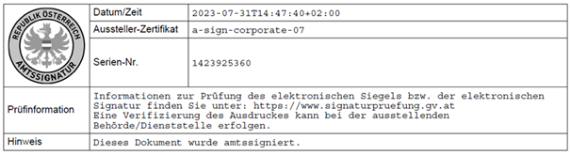

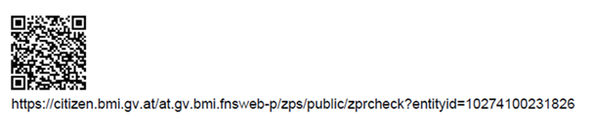

* Type 2: certificate with signature, seal of the registrar and QR-Code

The other type of certificate includes the seal of the registrar and signature. The certificate also includes a QR-Code.

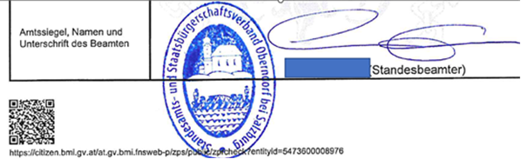

* 1. **What other innovative strategies have been used to address child, early and forced marriage, as well as informal unions and collect data on this practice in your country?**

**--**