Questionnaire in relation to Human Rights Council resolution 53/6 on human rights and climate change

Joint Submission by the Stockholm Environment Institute (SEI) and the Climate Justice Resilience Fund (CJRF)

Introduction

At the 26th UN Climate Change Conference in Glasgow (COP26), Scotland made history as the first Global North country to pledge bilateral finance specifically for addressing climate-related loss and damage (L&D). Last year, the Stockholm Environment Institute (SEI) published a report assessing and evaluating how the first GBP 1 million of Scottish government funding was disseminated and used, and how this can inform the operationalization of both the UNFCCC L&D fund and L&D finance more broadly.

Over the course of 2022, the Climate Justice Resilience Fund (CJRF) disseminated this funding as grants for locally led action to five non-governmental organizations (NGOs, henceforth referred to as “grant partners”): Young Power in Social Action (YPSA) in Bangladesh, Unitarian Universalist Service Committee (UUSC) for their work with their partner NGOs in the Pacific, Churches Action in Relief and Development in Malawi (CARD Malawi), HELVETAS Bangladesh, and the Loss and Damage Youth Coalition (LDYC).

Overall, we found that several of the losses and damages that the grants aimed to address infringed upon human rights, and that the locally led approach adopted by the grant partners was well suited to addressing L&D in a manner that also contributed to the protection of human rights. Here, we gather key learnings from our report to respond to the questionnaire in relation to Human Rights Council resolution 53/6 on human rights and climate change.

- Please describe through concrete examples and stories the impacts of loss and damage from the adverse effects of climate change on the full enjoyment of human rights in your country. Please indicate whether the impact was exceptional or whether an example of many similarly situated cases. Please estimate the number of cases that may be similar in your country.

Table 1 below provides examples of how losses and damages faced by communities within the projects assessed threatened fundamental human rights.
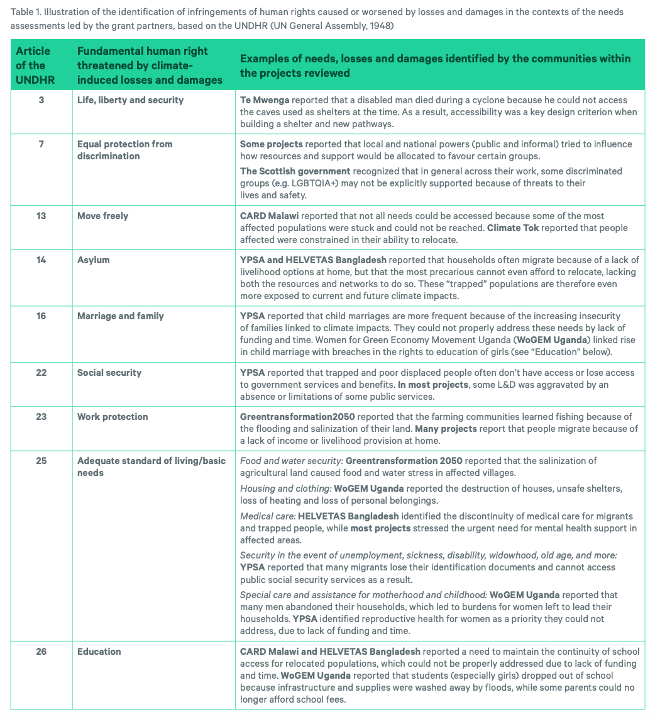

- Please describe any relevant quantitative and qualitative data as well as mechanisms and tools to measure, monitor, report on, and evaluate the impacts of loss and damage, including from extreme weather and slow-onset events, on the full enjoyment of human rights. Please take into account, inter alia, the disproportionate effects on women and girls, children, youth, older persons, persons with disabilities, Indigenous Peoples, migrants, persons living in poverty and others in vulnerable situations.

A. Locally led impact and needs assessments

All of the grant partners utilized participatory and locally-led approaches to assessing the losses and damages faced, identifying needs, and determining the activities that would be funded by the grants. Common approaches included conducting consultations or holding focus groups with affected communities to identify solutions, as well as shifting management and decision-making processes to be more community-driven. This enabled community members themselves to identify what actions would be necessary to contribute to the protection of their human rights, and led to greater local ownership of those actions.

We found that creating long-term partnerships with the communities allows funders to ensure truly inclusive processes, in which traditionally marginalized people are better identified, the local dynamics are known, and people are more likely to join since they feel this is a safe environment.

In several cases, however, individuals and groups within the communities faced social, economic and physical access barriers that prevented their meaningful contribution to the projects; the grantees had to offer alternative engagement options. For example, two of the subgrant partners reported difficulties in including women and disabled people in consultations due to informal power structures, as well as remote communities that are difficult to reach.

We also observed limits to community engagement. For instance, no project formally considered financial compensation of the local volunteers and other community members who were taking an active role in implementing the projects.

B. Using human rights as a framework to identify losses and damages

In the projects reviewed, we observed that the needs assessments did not necessarily follow the mainstream categories traditionally used to identify L&D and their associated actions (i.e. slow onset events, rapid onset events, economic and non-economic L&D). Instead, the grant partners followed an approach to identifying L&D and ways to address it that is more aligned with human rights, involving identifying what rights have been infringed by L&D and how L&D finance can support the protection of those rights.

We therefore mapped the needs identified in our assessment against the fundamental rights of Universal Declaration of Human Rights (UNDHR) to see if such a framework provides a better understanding of needs and how to address them (see Table 1 above). We observe that the human rights lens provides a more nuanced understanding of the local needs, and of the compounding and pre-existing factors of vulnerability that affect local needs, than the mainstream classification categories for L&D needs.

C. Monitoring, evaluation and learning approach and framework for systemic change developed by UUSC and their Pacific partners

One of the grant partners, UUSC, developed a monitoring, evaluation and learning (MEL) framework that centers justice and equity, recognizing the systemic nature of both the challenges faced and solutions needed in advancing climate justice and the need for affected communities to inform how any financial and technical investments impact their lives and livelihoods. Such a framework, presented in the table below, could also be well suited for assessing whether approaches to addressing L&D are also contributing to the protection of human rights through leading to overall systemic change.
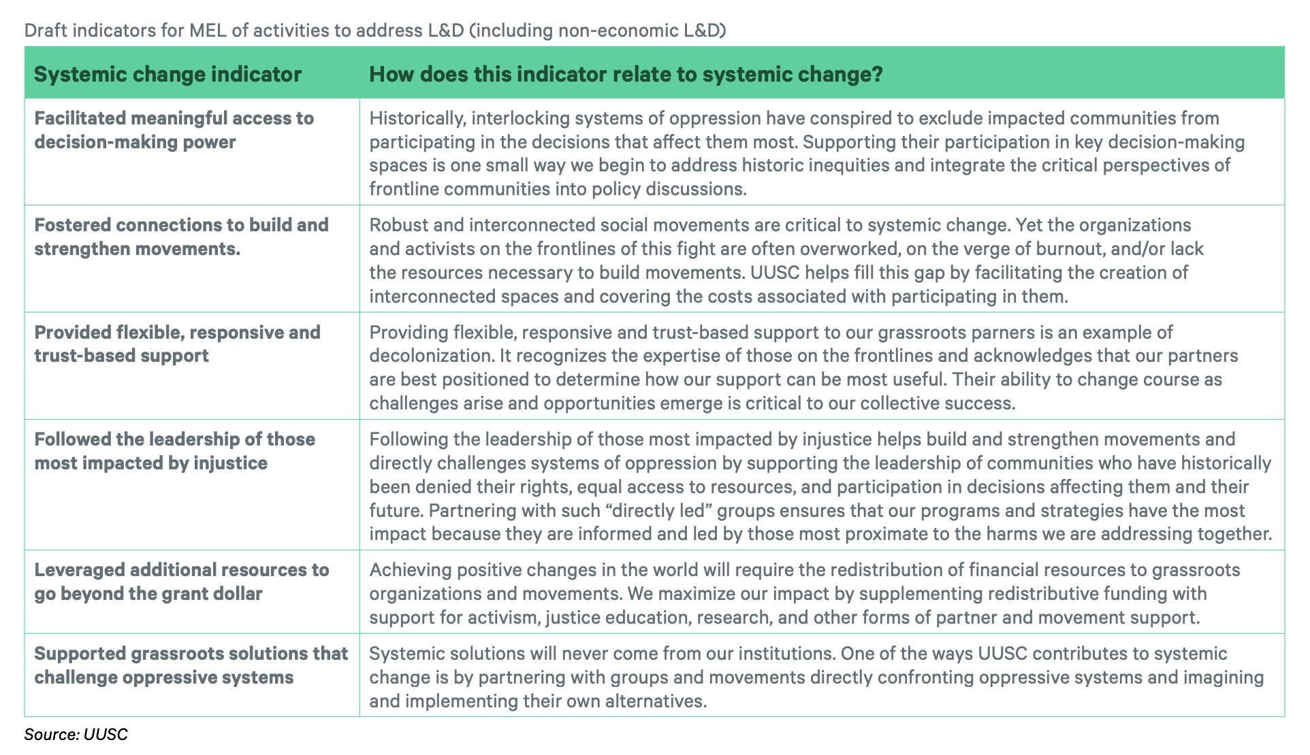

- Please describe any specific measures, including public policies, legislation, practices, strategies, or institutional arrangements that your Government has undertaken or plans to undertake at a national, sectoral or sub-national level, in compliance with applicable international human rights law, to avert, minimize and address loss and damage, including equity-based approaches and solutions. Please also identify any relevant mechanisms for ensuring accountability, including means of implementation.

N/A

- Please identify and share examples of promising practices and critical challenges in the promotion, protection, and fulfilment of the full enjoyment of human rights in the context of loss and damage, including examples that highlight multilateral cooperation and approaches, at global and regional levels, including equity-based approaches and solutions.

A. Promising practice: Identify and address underlying vulnerabilities when responding to L&D through inclusive and collaborative response design

L&D interacts with pre-existing vulnerability factors and unequal power dynamics that infringe on human rights and aggravate climate impacts at the local level. L&D finance needs to consciously account for and address the underlying intersectional vulnerabilities of populations as they relate to gender, race, religion, ethnicity, age, disability, sexuality and other categories that make people targets of oppression.

Women and girls were among the most in need of support to address L&D in the projects reviewed, yet many of their needs were left unaddressed (e.g., reproductive health, increased child marriages, increased burden of maintaining household).

An oppressed group that was not mentioned in any of the projects reviewed was LGBTQIA+ people, who are generally heavily discriminated against, marginalized and silenced in society, and they are therefore particularly vulnerable to climate change and associated L&D. Other marginalized groups, such as Indigenous Peoples, disabled people or the elderly, might face similar barriers to having these needs addressed.

The projects reviewed showed that learning collectively through the lens of human rights and in an inclusive manner from past L&D offers crucial guidance on who the most vulnerable to climate change are, and how to better recover from and prepare against future climate impacts.

For instance, a community in the Fiji, prioritized building a new shelter accessible to people with disabilities, as well as accessible paths lit with removable solar lights after a disabled person died in a previous cyclone because they could not access the caves that served as shelters at the time. This solution presented many co-benefits, especially for children, the elderly and women, who also benefited from these new safe and accessible infrastructures.

Participatory and co-productive approaches to response design and implementation also enables capacity and agency building of local organizations and populations. This can unlock long-term benefits of short-term L&D action, as well as buy-in at the local level. Of course, local participatory processes must account for unequal power dynamics within communities and with other external actors which can bias the consultation processes and their outcomes.

B. Critical challenge: silos between Loss and Damage, adaptation, humanitarian and development finance

For purposes of tracking and accountability, many funding institutions insist that L&D finance must be defined in a way that clearly distinguishes from adaptation finance, development finance and humanitarian aid. On the ground, however, we find that these distinctions are unhelpful for grant partners and communities.

The grant partners themselves recognize that adaptation activities can be necessary to and inseparable from L&D action, and the focus should be more on meeting the needs of affected communities, regardless of what category of action those needs fall in. This is especially true given that the projects reviewed show that past maladaptation can worsen L&D, while poor L&D response can lead to maladaptation.

Strong overlap with humanitarian aid and adaptation may even be considered a good sign, as good L&D response contributes to adaptation, vulnerability reduction and resilience building

D. Critical Challenge: The expensiveness and complexity of fair and sustainable relocation and migration projects

Migration support was a recurring activity in the projects reviewed that raised specific challenges. Many migrants experience losses in their fundamental human rights, living conditions and dignity.
Land procurement processes is one of the most expensive and sensitive aspects or relocation, in contexts of land scarcity and marginalization of displaced populations.

Grant partners also reported that migration support should better include “trapped” people who cannot afford to migrate, people who choose not to migrate, and extremely poor migrants. The provision of social security, reskilling and livelihoods for all three groups is crucial for migration support.

Non-economic losses and damages also must be considered, as they are a key factor in who most needs relocation support. For instance, in a project in Malawi, several households affected by Tropical Storm Ana refused to relocate to safer ground, even after being presented the risks of staying, as the cost of abandoning the burial grounds of their families was too high in their belief system (they agreed to relocate later, after cyclone Freddy caused further L&D).

Social and psychological support was another form of a non-economic L&D need identified as crucial in relocation activities. However, the projects reviewed rarely addressed psychological support due to lack of time and resources.

- Please provide specific recommendations, if possible, on how to address the critical challenges that have been identified, including actions to be taken at country, regional, and global levels, as well as by different groups of stakeholders, Governments, development agencies, financing institutions, and others.

Five key recommendations emerge from our work for ensuring that measures to address L&D reflect local priorities and contribute to the protection of human rights:

- Funders of L&D should give small and locally led grants a role in their portfolio as a mechanism for assessing local needs, enabling rapid action, piloting new approaches, and building the capacity and agency of vulnerable groups. Such grants should also embed flexible provisions for non-economic L&D and psychological support.
- Public finance institutions should complement small grants with larger-scale, flexible and programmatic finance instruments. Small grants could fund activities that map L&D action needs and feed into larger-scale programs and national strategies for addressing L&D.
- Recipient countries of L&D finance should disseminate a share to the local level as part of national recovery plans, and the future UNFCCC L&D fund should enable small grants, for instance in the form of enhanced direct access finance.
- Future L&D finance should follow the Scottish government’s example of requiring small grant partners to have community-driven approaches and to embark a climate justice and human rights framework to their work.
- Parties to the UNFCCC should prioritize pragmatism and the interest of affected people above political differences in designing the L&D fund. The Parties should ensure that adaptation and L&D response can be funded jointly without creating burdens to the recipient countries and organizations.

- Please provide any additional information you believe would be useful to support climate action and justice that promotes the full enjoyment of human rights in the context of loss and damage.

N/A

Contact

Inès Bakhtaoui (Independent Researcher): ines.bakhtaoui@outlook.com
Zoha Shawoo (Stockholm Environment Institute): zoha.shawoo@sei.org
Ayesha Dinshaw (Climate Justice Resilience Fund): ayesha.dinshaw@cjrfund.org

