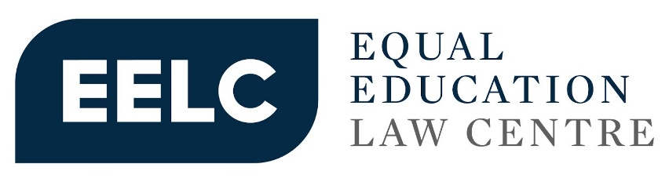

INPUT BY EQUAL EDUCATION LAW CENTRE ON HUMAN RIGHTS COUNCIL RESOLUTION 52/8 ON PROMOTING HUMAN RIGHTS AND THE SUSTAINABLE DEVELOPMENT GOALS THROUGH TRANSPARENT, ACCOUNTABLE AND EFFICIENT PUBLIC SERVICE DELIVERY

For any queries, please contact:
Katherine Sutherland (katherine@eelawcentre.org.za)

Contents
1. What are the main challenges identified in your country/region in relation to public service delivery? 2
1.1. Privatisation 2
1.2. Insufficient social spending due to austerity budgeting 2
1.3. Public Procurement & Corruption 4
2. How is the participation of private actors in public service delivery regulated and monitored in your country/region? 5

What are the main challenges identified in your country/region in relation to public service delivery?

Privatisation of Public Services
- The landscape of private schooling and non-state actor involvement is changing rapidly, both in South Africa and globally. Whereas independent schooling was once largely only an option for those who could afford to pay high fees, the increase in low-fee and middle-fee private education institutions has rapidly expanded in South Africa, now catering largely to black learners from working class and middle class communities and families. Van Der Berg et al. note that between 2000 and 2013, learner enrolment in primary and secondary independent schools doubled from 250 000 to 500 000. In 2022, independent education institutions catered to 735 000 learners. In the Gauteng province, independent education institutions make up 31% of the total number of schools in the province and cater to 357 000 learners. While the number of learners enrolled in the private sector does not nearly rival those in the public sector, independent school enrolment has grown significantly and, in line with global trends, all indications are that it will continue to grow.
- Not only has there been a rise in independent school enrolment, but in the face of budget cuts to social spending, the State is increasingly embracing non-state actor involvement in the provision of public basic education, both in policy and implementation. This has been shown through the formation of Public-Private Partnerships whereby non-state actors are given significant control over the finances and management of a public school.

Insufficient social spending due to austerity budgeting
- The South African government has implemented budget cuts to reduce public borrowing – budget cuts which are largely targeted toward decreasing social spending. 55% of South Africans live below the poverty line, and a reduction in social spending disproportionately impacts the most vulnerable, marginalised, and poor population groups in South Africa - those who rely on social grants or free public services. The inevitable consequence of this will be a widening of already vast levels of inequality.
- Basic education and early childhood development have not been immune to these austerity measures. While funding for Early Childhood Development (ECD) sector has shown some signs of improvement, it is still vastly inadequate to cater to the just under 7 million children of ECD-going age. The Department of Basic Education reports that 4.7 million of these children live in poverty are eligible for a subsidy. Learners who benefit from State ECD subsidies – only 25% of children who need it - only receive R17 per day. If the South African government used the ECD Conditional Grant to provide ECD services to all 4.7 million children living in poverty and who would likely qualify for the subsidy, the average per child spending for the next three years would only be R1.47 per day instead of the required R17.
- The per child per day subsidy, which is meant to support access to ECD services for learners from low-income families, has not increased in nominal terms since 2019, at R17 per child per day for ECD centres and R6 for non-centre based programmes. This means that in real terms, taking inflation into account, this already wholly inadequate subsidy has actually decreased. Aside from covering the costs of staff, rent and equipment, this subsidy also covers food for learners – only 50% of this subsidy can be allocated to food, which amounts to R8.50 per day. The inadequacy of this subsidy is further highlighted when considering that many learners in Early Learning Programmes (ELPs) attend centres from 7am to 6pm, and that this R8.50 subsidy is expected to cover the cost of food for learners for the entire day. According to the Budget Justice Coalition, “Erosion of its real value at a time when food inflation is as high as 13% will likely translate into reduced nutritional support for children under five years of age - the group most in need of adequate nutrition to prevent malnutrition and stunting.”
- On the other hand, basic education remains one of government’s largest spending items. While this seems promising at first glance, South Africa has a large young population and when looking at per learner spending, it is clear that South Africa’s basic education budget is comparably low and that the budget is insufficient to realise quality basic education services. Since 2016, basic education’s share of national overall spending has steadily dwindled, with COVID-19 budget cuts in 2020 creating a huge dent. Even as the sector has been slowly recovering since 2021, basic education funding has struggled to keep pace with the increasing inflation and growing learner enrolments.
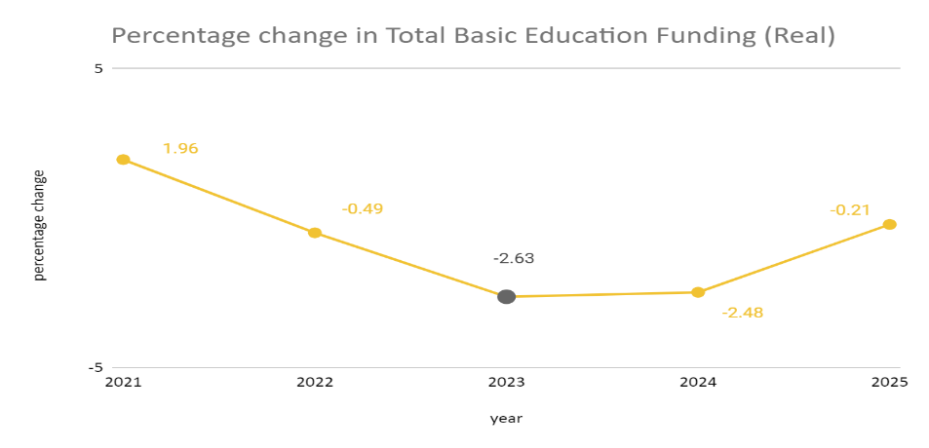
Source: Equal Education and Equal Education Law Centre joint statement: National Treasury’s budget cuts will further deepen the #EducationBlackout threatening the future of the country’s learners, 1 November 2023
- Even if the entire budget was spent with no irregular, wasteful, and fruitless expenditure, the amount of money given to the sector would still be substantially less than what is needed to address the many challenges. See the table below for the estimated costs to fix key infrastructure challenges and the proportion of these costs in relation to the yearly budget.
Issue | Department of Basic Education’s Estimated Cost to Solve the Issue | Percentage of 2023/24 Total Education Infrastructure budget  (15.6 billion)
Schools made of inappropriate materials (entirely or partially) | R16 707 992 169 | 107%
Schools with no toilets | R235 448 747 | 1.5%
Schools with no sustainable water source | R10 176 117 056 | 65%
Schools requiring sanitation upgrades | R17 953 386 864 | 115%
Schools requiring upgrading of water supply | R6 674 438 950 | 43%
Schools requiring additional classrooms | R44 498 765 853 | 286%
Schools requiring libraries | R8 646 000 000 | 56%
Total cost | R104 892 149 639 | 673%
Source: Own calculations based on information requested through the Promotion of Access to Information Act and a presentation to interested stakeholders by the Director General of the Department of Basic Education.

Public Procurement & Corruption

- Public Procurement systems are vital to transparent, accountable, and efficient public service delivery. Procurement systems handle a fifth of South Africa’s GDP and are extremely vulnerable to corruption. A confusing legal framework, made up of over 100 different legal instruments, slows down service delivery and opens up opportunities for administrators to take advantage of the system for their own benefit. In the education sector, school infrastructure is often the biggest source of irregular expenditure, particularly procurement processes involving implementing agents (IAs). IAs are middlemen in charge of managing and building schools on behalf of education departments.
- Provincial infrastructure delivery progress reports also show costly poor performance by implementing agents, with large portions of money reserved for specific projects being spent without any work being completed. For example, poor planning for a primary school in Gauteng led to a 35% (R27m) overspend.
- Government has undertaken a review of the public procurement legal framework and has published draft legislation (“the Procurement Bill”) that aims to create a more simple, unified, and effective regulatory system. The Judicial Commission of Inquiry into Allegations of State Capture, Corruption and Fraud in the Public Sector Including Organs of State (“the Zondo Commission”) conducted extensive investigations into public procurement systems and the failure to provide essential public services. The Zondo Commission also made multiple recommendations aimed at ensuring better oversight, transparency, and accountability. Unfortunately, the Procurement Bill has not adopted many of the Zondo Commission recommendations and only properly strengthens transparency with regard to high value tenders, even though there is a significant amount of maladministration and corruption in small tenders.

How is the participation of private actors in public service delivery regulated and monitored in your country/region?

- The increasing role of non-State actors in basic education combined with a lack of regulation threatens transform basic education into a commodity and parents into consumers, rather than a basic human right. The Western Cape Education Department (WCED) has developed two new models of PPPs through the Western Cape Education Amendment Act (WCEAA), specifically collaboration schools as provided for in section 12C and Donor funded public schools as provided for in section 12D.
- Modelled on the United Kingdom’s Academies and the United States’ Charter schools, donor-funded and collaboration schools are a form of public-private partnership in which non-state actors, including non-profit and for-profit actors, take up roles in the financing and management of public schools and particularly underperforming public schools. In contravention of the South African Schools Act, which requires School Governing Bodies (SGBs) to be democratically elected and representative of the school community, unelected private actors (operating partners and donors) are given significant powers in SGBs (up to 50% voting rights). Thus, non-state actors are given powers to determine parts of the curriculum, hiring and firing of educators, and the management of school affairs. The WCEAA does not explicitly provide safeguards to ensure the prioritisation of the right to basic education over profit-seeking or private interests. Similar Public School Partnerships (PSPs) are being piloted in the Eastern Cape.
- In Equal Education v Provincial Minister for Education Western Cape Province and Others, civil society organisation Equal Education represented by Equal Education Law Centre challenged the WCEAA on the grounds that, inter alia, donor-funded and collaboration schools contravened the principles of democratic school governance and accountability as prescribed in the South African Schools Act. The High Court held that the provisions were in fact in line with the law and that these schools played an important role in supplementing State financing. This judgment, if unsuccessful in appeal, sets a concerning precedent on the nature and extent of non-state actor roles in public education.
- In addition, the WCED recently announced further private sector involvement in basic education provisioning, specifically the introduction of Edu Invest - a public-private partnership initiative with Wesgro. The WCED says the purpose of Edu Invest is to attract private investment into education, specifically low-cost new private schools. He avers that, “the availability of new school places in independent schools would help to address overcrowding in public schools.” Wrenelle Stander, CEO of Wesgro, stated, “Edu Invest reflects Wesgro’s commitment to advancing the business of education.”
- There is an urgent need to develop the South African legal framework in line with the Abidjan Principles to regulate role of non-State actors in basic education. Van Der Berg et al. note that, as a consequence of ineffective regulation, there is huge variation in quality of the independent sector. This is because, inter alia, low-fee schools do not have the capacity and finances to afford to comply with the government's oversight framework or join a peer oversight body. Thus, in trying to regulate for quality oversight mechanisms, the law creates a loophole: the schools that end up receiving state subsidies and oversight are likely the schools that require it the least.
- They go further to note that “if such schools are for-profit organisations that serve parents …. [who] have little basis to choose a good school due to their own lack of exposure to quality schooling, then such loopholes may be even more worrying.” They conclude that the for-profit independent education sector urgently requires greater regulation.

Van Der Berg, S., Van Wyk, C. & Burger. R. et al. (2017) ‘The Performance of Low-Fee Independent Schools in South Africa - What Can Available Data Tell?’, RESEP University of Stellenbosch.
Draper, K. & Hofmeyr, J (2015) ‘Low-fee private schools: international experience and South African realities’, Centre for Development Studies.
Van Der Berg, S., Van Wyk, C. & Burger. R. et al. (2017) ‘The Performance of Low-Fee Independent Schools in South Africa - What Can Available Data Tell?’, RESEP University of Stellenbosch.
Department of Basic Education (2022) ‘School Realities Report 2022’.
Ibid.
Pedro, F., Leroux, G., & Watanabe, M. (2015) ‘The Privatisation of Education in Developing Countries: Evidence and Policy Implications’. UNESCO.
See, inter alia, Western Cape Education Amendment Act of 2018, Department of Basic Education’s Revised Five-Year Strategic Plan 2015/16-2019/20, the National Education Policy Act, 27 of 1996 and Donaldson, A (2023) ‘South Africa’s Budget Process and the Crisis in Public Finance Management’, UNICEF & UNWOMEN Brown Bag Series, Southern Africa Labour and Development Research Unit.
World Bank (2020) ‘Poverty & Equity Brief: Sub-Saharan Africa – South Africa’. Found at https://databankfiles.worldbank.org/public/ddpext_download/poverty/33EF03BB-9722-4AE2-ABC7-AA2972D68AFE/Global_POVEQ_ZAF.pdf.
Wills, G., Kotze, J., & Kika-Mistry, J. (2021) ‘A Sector Hanging in the Balance: Early Childhood Development and Lockdown in South Africa’. RISE Working Paper 20/055. Found at https://riseprogramme.org/sites/default/files/2020-11/RISE_WP-055_Wills_Kotze_Kika-Mistry.pdf.
For comparison, the average spending per primary school learner per day is R96.
Budget Justice Coalition, ‘FOA Submission on the 2023 MTEF’. Found at https://budgetjusticesa.org/media/bjc-foa-submission-on-the-2023-mtef/.
National Treasury, 2022 Budget Review. Found at https://www.treasury.gov.za/documents/national%20budget/2022/review/FullBR.pdf
Auditor General of South Africa report on Basic Education Spending in 2021.
Western Cape Education Amendment Act of 2018.
DG Murray Trust, in collaboration with Axiom, is piloting Public School Partnerships in the Eastern Cape for underperforming schools. More information can be found here: https://dgmt.co.za/project/public-school-partnerships .
Equal Education v Provincial Minister for Education Western Cape Province and Others (12880/2019; 4566/2019) [2023] ZAWCHC 166.
Equal Education’s media statement on the challenge to WCEAA can be found here https://eelawcentre.org.za/joint-media-statement-equal-education-and-equal-education-law-centre-in-court-today-to-challenge-the-introduction-of-collaboration-schools-donor-funded-schools-and-intervention-facilities-by-the-we/.
David Maynier (2023) ‘Western Cape Minister of Education David Maynier, and Wesgro unveil Edu Invest’. Found at https://wcedonline.westerncape.gov.za/news/western-cape-minister-education-david-maynier-and-wesgro-unveil-edu-invest.
Van Der Berg, S., Van Wyk, C. & Burger. R. et al. (2017) ‘The Performance of Low-Fee Independent Schools in South Africa - What Can Available Data Tell?’, RESEP University of Stellenbosch.
ibid.

