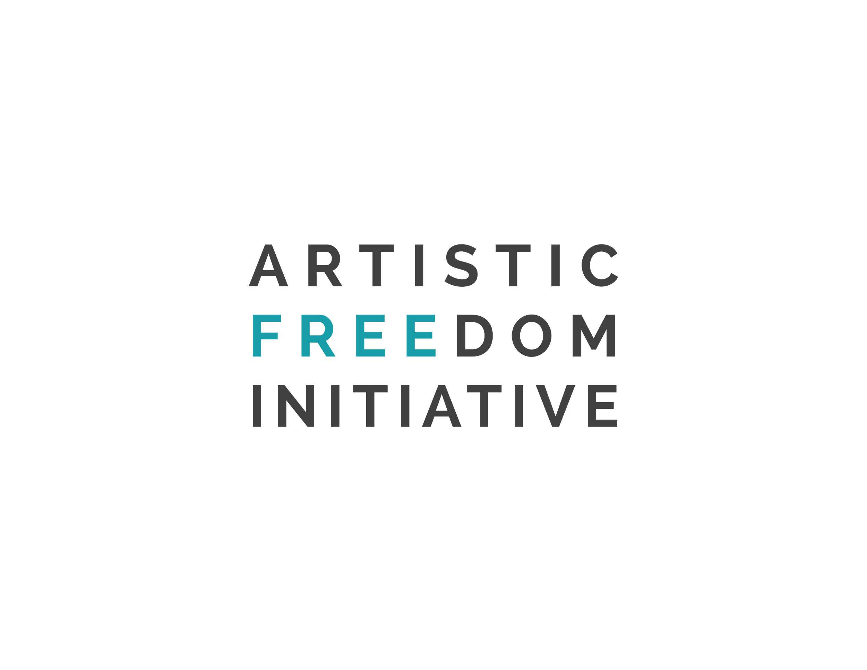  _____________________________  Artistic Freedom Initiative  77 Sands Street  Brooklyn, NY 11201  www.artisticfreedominitiative.org  _____________________________  Artistic Freedom Initiative  77 Sands Street  Brooklyn, NY 11201  www.artisticfreedominitiative.org | 23 November 2022  Author: Artistic Freedom Initiative (AFI)  Submission to the Special Rapporteur in the Field of Cultural Rights’ call for inputs for a report on Cultural Rights and Migration  Please find below AFI’s responses to questions one, nine, and ten of Special Rapporteur Xanthaki’s key questions related to migrants’ cultural rights throughout their migratory journey, with an emphasis on the periods of initial settlement and long-term integration into their host society.  - What are the issues relating to cultural rights that you see in your country’s migration processes? Please provide relevant information concerning laws and regulations, programmes and measures, services and practices that seem relevant.  Many aspects of United States immigration policies and processes impact the cultural rights of migrants. There is only one visa category that leads to lawful permanent residence in the US for artists and cultural workers (a "green card"), the EB-1, which has several issues impacting the cultural rights of migrants:  - The EB-1 has an extremely high standard of eligibility, making it a viable visa option only for the very few highly accomplished cultural workers.  - The EB-1 requires extensive documentation of an artist or cultural worker’s record of achievements and experiences, which is difficult and lengthy to compile, so the EB-1 petition doesn't provide an immediate relocation path for cultural workers in an emergency situation. The visa processing can take several months to over a year, unless an applicant pays for premium processing, which has a fee of $2,500 in addition to the regular visa application fee. This fee is extremely expensive for most cultural workers and therefore not financially feasible.  - Even if the initial I-140 petition is approved, the consular processing can take several months or longer.  Another issue that impacts the ability for migrants to practice their culture is the ability for migrants to obtain work authorization in the United States. Many migrants, such as those who apply for asylum or temporary protected status (TPS) in the United States, must go through the Employment Authorization Permit (EAD) application process, which can be expensive and lengthy. Asylum applicants are not eligible to receive EAD until their asylum application has been pending for 180 days. After an applicant has submitted their EAD application, they can wait up to 8 more months for the application to be processed and approved. For those who make a living from their cultural practices, waiting for an EAD causes financial hardship and prevents them from practicing their culture until the application has been approved. Additionally, the United States offers very few services to recent migrants to the United States, which makes it difficult for them to access affordable English language courses and cultural programs.  Since the withdrawal of the U.S. military from Kabul, Afghanistan in August 2021 and the subsequent humanitarian crisis, a number of immigration issues have emerged that specifically impact Afghans applying to come to the United States. Afghan visa applications have been challenging to process, including approved non-immigrant J-1 and O-1 visas. The Afghans our organization supports are at the top of their respective fields as artists, cultural workers, and scholars, and have been identified by leading U.S. institutions for engagements because of the benefit they would provide to the United States. However, because of the humanitarian crisis in Afghanistan, O-1 and J-1 visas are frequently flagged for immigrant intent, meaning that the government believes the applicant intends to stay permanently after arriving in the United States, thus violating the terms of the temporary visa. Some approved visa holders are either denied entry simply by virtue of their status as a displaced Afghan citizen or are placed in administrative processing for an interminable amount of time.  U.S. embassies and consulates have given considerable scrutiny to the immigrant intent of artists, cultural workers, and scholars approved for these visas. These individuals have been invited to large, renowned institutions in the United States that frequently host artists and scholars on J and O visas. While our organizations understand the need to examine the intent of those entering on non-immigrant visas, the burden of proof has created a distinction between invitees from Afghanistan and elsewhere, with Afghan artists and cultural workers are presented with a significantly higher barrier to entry.  9. What challenges do migrants face currently in practicing, maintaining, and transmitting their culture, especially when they are new and/or forced migrants?  When migrants arrive in a new country, it is often difficult for them to access the necessary resources to practice and transmit their culture. This is particularly true for forced migrants, who often leave their countries quickly and without important belongings such as musical instruments, artworks, or family heirlooms that are used to continue cultural traditions. Border control policies can forcibly separate migrants from their personal possessions in the instances when they are able to bring objects with them on these journeys.  Another major challenge faced by many forced migrants in practicing, maintaining, and transmitting their culture in the United States is their ability to legally work as artists or cultural workers upon arrival. Many artists and cultural workers who arrive in the United States after facing persecution in their home countries choose to apply for asylum. However, asylum applicants are not eligible to work legally in the United Status until they have received Employment Authorization Permits (EAD). Asylum applicants are not eligible to receive EAD until their asylum application has been pending for 180 days, after which it may take 8 more months before official authorization to work is received. This process causes financial hardship for artists and cultural workers who cannot work in the United States while they wait for EAD. It is also detrimental to the United States because migrant artists and cultural workers would enrich the cultural fabric of the U.S. by sharing their work within the country.  Beyond legal limitations, migrant artists also face financial and infrastructural barriers to continuing their creative careers in the United States. The U.S. does not provide artists with infrastructural support or safety nets, and this reality is exponentially more challenging for forced migrant artists who often come to the United States without savings or family and community ties. Across the U.S., and particularly in New York City where our organization is based, housing costs are exorbitantly expensive. Because New York City draws early-career artists from around the world, it is also a competitive market - which exacerbates the need for affordable and accessible artist housing. As a result, many migrant artists must spend their time and resources making ends meet and/or finding temporary housing solutions, and are therefore unable to restart their creative careers after arriving in the United States.  Many migrants arrive to the United States without knowledge of how or where to connect with their shared diaspora/linguistic communities. These challenges are exacerbated by language barriers, as most events, cultural opportunities, and official documentation of resources are in English. In other cases, forced migrants may feel trauma or resentment towards their home country or community. The private healthcare system in the United States can make it expensive for migrants to access mental healthcare to address this trauma or resentment. Access to mental healthcare is further inhibited by language barriers and cultural stigmas. Without mental healthcare, migrants are left to navigate the hardships of past traumatic experiences and resettlement in a new country alone.  10. Please share good practices in protecting the cultural rights of migrants to access cultural resources and services, to enjoy their heritage and that of others, to use their language in private and in public, to participate in cultural life, to freedom of artistic expression and to take part in decisions that impact their cultural life. Please focus more on new and/or forced migrants.  ​​Refugees, asylum seekers, and other migrants to the United States face significant legal, financial, professional, educational and social barriers to accessing culture in the United States. Best practices in supporting their cultural rights during initial settlement and long-term integration are outlined below.  - ​​Increasing accessibility of services and benefits necessary for artists to support themselves, including but not limited to:  - Granting asylum seekers the right to work from the day they file their I-589 application for asylum. Importantly, work permits allow artists to continue the development of their artistic practice in a sustainable way. The right to work and earn an income allows recent migrants to overcome financial barriers to arts and culture.  - Establishing and funding additional subsidized living and working spaces for low-income artists;  - Creating a need-based waiver for filing fees for talent and performance based artist visas; and  - Extending eligibility for refugee cash assistance (RCA) and refugee medical assistance (RMA) past their first eight months in the U.S. when necessary.  - Because the arts are vital to a free and democratic society, the U.S. government must take proactive steps to safeguard artistic freedom and uplift artists in the United States, particularly at-risk and exiled immigrant artists, by:  - Guaranteeing immigrant artists the capacity to continue their practice in the United States, and establishing the vocation of Artist as one that is financially viable, through measures including but not limited to:  - Increasing federal investment in arts and cultural infrastructure in the nation by:  - Creating grants, stipends, fellowships, and commissions available specifically to immigrant and non-citizen artists of any medium, awarded on the basis of need rather than merit; and  - Making immigrant and non-citizen artists eligible for currently available and future federal funding opportunities, such as the National Endowment for the Arts’ creative writing fellowship and others.  - Provide artists with access to education, training, and cultural institutions so they may continue to develop their practice, and access to education in fields outside their focus area to enhance and expand their practice, including but not limited to:  - Temporarily removing entry costs to arts and cultural museums for recent migrants. This enables migrants to connect with their culture and heritage during a particularly vulnerable period of their migration journey, and it also allows them to learn about the United States as they begin to integrate into their new host country.  - Provide artists with access to education in requisite skills that will allow them to more successfully integrate in their host society, re-enter the professional workforce, and access culture more broadly, including but not limited to:  - Offering free ESL courses allows migrants to have broader and more inclusive access to cultural opportunities, such as consuming popular media, visiting arts and cultural museums, seeking arts education, and participating in discourse on arts and culture. In particular, artists benefit greatly from free ESL courses as the education would allow them to successfully interact with buyers, professional peers, and arts institutions interested in their work.  - Provide migrants with opportunities to practice their culture by connecting them to diaspora communities, cultural centers, and places of worship linked to their country of origin. Diaspora communities are an important source of cultural preservation and connection, as communities come together to celebrate holidays, speak in a common language, and share traditions. Knowledge of cultural centers and related opportunities empowers migrants to form new communities in their host country while maintaining a meaningful connection to their country of origin.  - Promote artistic freedom by fostering a culture of appreciation for art, elevating the social status of artists in society, promoting art as a platform for social change, and encouraging artistic involvement in civil and political life. To this end, we recommend the following additional reforms:  - Develop awards to recognize and financially support artists, organizations, and institutions, doing pioneering work to advocate for artistic freedom; and  - Provide specific funding for national museums to offer programming that raises awareness about artistic freedom and cultural heritage preservation.

