[Check against delivery]

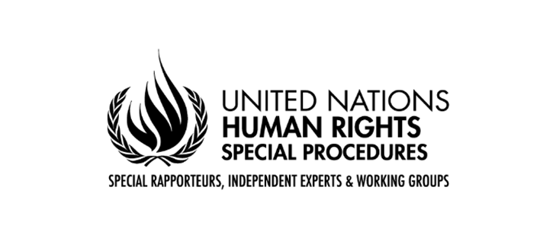

Statement by
Alexandra XANTHAKI

SPECIAL RAPPORTEUR
IN THE FIELD OF CULTURAL RIGHTS

78th session of the General Assembly
Third Committee
Item 71 (a-d): Promotion and protection of human rights

18 October 2023
New York

Mr. President,
Distinguished delegates,
Colleagues,

Good afternoon.
In the last two years, I have focused on the intersection of sustainable development and cultural rights. Today I present to you my second report on Sustainable Development and Cultural rights.
This report fills an important gap: it informs the General Assembly on the extent to which international organisations now adopt cultural rights in their sustainable development policies. It is important that States are informed on how their work as parties of such organisations fulfils or not their human rights obligations regarding cultural rights.
There can be no real development without cultural rights, in other words without allowing individuals and groups to develop their ways of life. How can gender equality be achieved if the values of the communities that perceived women as inferior do not develop in a way that women are valued as individuals equal to men? How can economic growth be achieved if measures for such growth are completely alien to the local populations’ values, even more so if they contradict their understanding of the world?
How can climate change be effectively countered? without dreaming of the future in a way that only our creativity allows us to? How can peace and justice be maintained if education promotes narratives of hatred and uses language of genocide against specific sections of the population? Look at all conflicts at the moment: they follow decades of disrespect for each other’s identities.
So, sustainable development goals cannot be achieved without cultural rights. Even more so, human beings need more than economic, social and environmental development. They need cultural development. Culture is not a mere enabler; culture is an intrinsic dimension of sustainable development.
Today I stand before you to urge you not to forget cultural rights in sustainable development decisions; and not to forget cultural development as an important dimension of sustianble development.
Wave of positive change
My report highlights the considerable progress that has been made.
In his report in July (‘Progress towards the SDGs: towards a rescue plan for people and planet’), the UN Secretary General acknowledged the importance of culture for the SDGs and also noted how culture has been side-lined. The General Assembly has recognised that cultural rights are important in the implementation of SDGs. States committed in the Mondiacult Declaration to foster an enabling environment conducive to the respect and exercise of cultural rights, both individual and collective.
Yet, yet cultural development is omitted in policies on sustainable development. We need your help in this. Only when States understand the inclusive meaning of cultural rights as ways of life, and the need to prioritise cultural rights in sustainable development, shall we see progress, within domestic contexts but also in the polices of International Organisations.
My findings are:
- Some organisations have made tremendous efforts to protect cultures in sustainable development processes. But the protection of cultural development needs more.

- Organisations need to reflect on how their policies affect the cultural rights of local populations. Their processes need to foster full respect for the various identities, aspirations and natural resource-based livelihoods. They need to protect the cultural heritage of all people in seeking development; and they need to ask the people themselves which living practices form their cultural heritage.

- Organisations need to identify the extent to which their policies disrespect cultural rights by using clear methods, expertise and by seeking the real voices of all people concerned. They need to have human rights impact assessments that include cultural rights assessment. They need to employ experts, not only economists, but experts with knowledge of cultural issues. They need to ensure that the free, prior and informed consent of the people reached with their policies is ensured. No, not mere consultation that allows for a box-ticking exercise, but really giving priority to the views of people affected by the policies.

- Organisations need to be explicit about the link between their sustainable development policies and cultural rights and the protection of cultural resources. Some organisations, like WIPO, apply cultural rights in many of their policies but do not frame them in a cultural rights manner. New policies need to be comprehensive and not adopt a piecemeal approach. General statements and policies need to ensure that the cultural dimension of sustainable development is included and acted upon.

- Organisations need to go back and interpret their existing documents in a way that is consistent with cultural rights. In this way, international conventions continue to ensure their dynamic nature and to stay relevant and reactive to the current needs and understandings of our times. I am looking forward to working with monitoring committees from all international organisations identifying how their documents can be interpreted in a way that do not violate, even more so respect cultural rights.

My report also highlights the ongoing reluctance of a few IOs to engage in a discussion on how their policies may hinder cultural development. States must work within the remit of WTO and IMF in a manner that take into account the values and aspirations of local populations in devising their policies and in their decision-making. I especially ask States to help strengthen cultural rights within the IMF policies. Economic development is not contrary to respect for local values and ways of life. In actual truth, recent history shows us that economic policies implemented by the IMF are only successful if they capture the priorities, wishes and values of the people they try to help; otherwise they are seen as imposed, alien and hostile.
Mr. President,
Distinguished delegates,
Overall, the challenges my report highlights is: The economic dimension of development still takes up all the space in international governance and the cultural dimension I still rather invisible. I was genuinely surprised that the recent SDG Summit did not include anything on culture, even though pre-meetings highlighted its importance.
I invite States to reflect on the vision they have of the international organisations as vehicles to ensure sustainable development. No one can be left behind only when States, on their own and as collectivises, ensure that the identities and the ways of life of individuals and groups are allowed to develop and flourish.
I thank you all for your kind attention.
***

