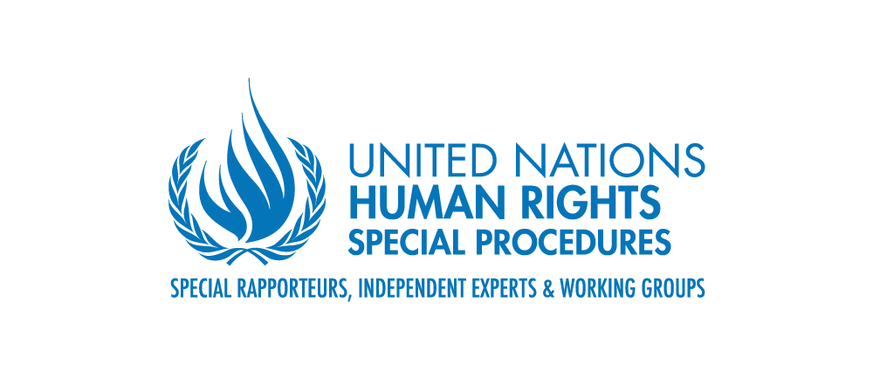

**Mandate of the United Nations Special Rapporteur**

**on the right to development**

**Consultation for the 2024 reports of the UN Special Rapporteur**

**1. Climate justice: Loss and damage**

**2. The right to development of children and future generations**

**Background**

The United Nations Special Rapporteur on the right to development, Mr Surya Deva, in his vision report to the Human Rights Council ([A/HRC/54/27](https://www.ohchr.org/en/documents/thematic-reports/ahrc5427-reinvigorating-right-development-vision-future)) highlighted climate change as one of the major disruptors to realising the right to development. He also underlined his priority to focus on the development aspirations of certain marginalised or vulnerable beneficiaries, including children, youth and future generations.

The Special Rapporteur’s 2024 reports to the Human Rights Council and the General Assembly will focus on these two themes. In 2022, States parties to the UN Framework Convention on Climate Change agreed to establish a loss and damage fund. Negotiations are currently underway to operationalise the fund. Against this context, one report will focus on the interface between the right to development and loss and damage from climate change. It will explore the impacts of loss and damage on realising the right to development, the basis of responsibility for loss and damage, the contours (both financial and non-financial components) and bearers (States and other actors) of this responsibility, and the human rights-based approach to operationalise the fund.

The other report will focus on what the right to development (economic, social, political and cultural development) means for children and future generations, how their human rights are impacted by decisions taken by the present generation, and how to ensure a meaningful participation of children and future generations in decision-making processes at all levels. This report will draw, among others, on the principle of intergenerational equity, General Comment No. 26 of the Committee on the Rights of the Child, and the Maastricht Principles on the Human Rights of Future Generations. The Special Rapporteur seeks to collect input regarding these two thematic reports of 2024.

**Specific questions/issues:**

***To inform his reports, the Special Rapporteur wishes to collect input on the following specific questions / issues during this initial (virtual) consultations:***

Climate justice: Loss and damage

1. How is the realisation of the right to development impacted by both economic and noneconomic loss and damage from climate change? How is the impact experienced differently and/or disproportionately by different individuals, groups and States?
2. What is the legal and/or moral basis for States and other actors including corporations to pay for climate change-related loss and damage?
3. What are the obligations of States and other actors such as development finance institutions and businesses to prevent, mitigate and remediate the impacts of climate change-related loss and damage on human rights, including the right to development?
4. In addition to financial contribution, what non-financial components may be relevant (e.g., transfer of green technologies and building of capacity)?
5. How should a human rights-based approach to operationalise and administer the loss and damage fund look like (e.g., integration of considerations such as non-discrimination, fair representation in decision making, gender responsiveness, and accommodation for marginalised communities and countries especially vulnerable to the adverse effects of climate change)?

The right to development of children and future generations

1. What does the right to development mean for children in line with the relevant normative instruments? What about the right to development of future generations?
2. How are the human rights of children and future generations impacted by development related decisions made by the present adult generation?
3. How to ensure a meaningful participation of children and future generations in development-related decisions at all levels?
4. How to integrate an intersectional approach to the participation of children to ensure that differentiated impacts on children due to various discriminations, exclusions or vulnerabilities are considered?
5. What measures should be taken to protect and empower child human rights defenders?

**Consultation logistics:**

Participants can [register](https://docs.google.com/forms/d/1Svp7byCNqkkY3jSUUBfDUzCtBkfKBi0BpYeBhv-R9M0/edit) and select a date and time that is most convenient for them to join one of the following consultations:

1. First option: 16 April 2024, 10:00 a.m. - 11:30 a.m. (CEST)  
2. Second option: 8 May 2024, 2:00 p.m. - 3:30 p.m. (ICT)  
3. Third option: 21 May 2024, 5:00 p.m. - 6:30 p.m. (EDT)

All consultations will be online. The joining link will be emailed to the registered participants two days before the selected session.

Due to resource constraints, all consultations will be conducted in English.

**Contact**

If you have any questions or suggestions, please contact Ms Antoanela Pavlova and Mr Suparerk Wesarat supporting the Special Rapporteur mandate at the Office of the High Commissioner for Human Rights in Geneva (+41 22 917 93 31, [antoanela.pavlova@un.org](mailto:antoanela.pavlova@un.org); [suparerk.wesarat@un.org](mailto:suparerk.wesarat@un.org) or [hrc-sr-development@un.org](mailto:hrc-sr-development@un.org)).