

**Consultation for the 2024 reports of the UN Special Rapporteur**

**Climate justice: Loss and damage**

**FIAN Uganda Submission**

**How is the realization of the right to development impacted by both economic and noneconomic loss and damage from climate change? How is the impact experienced differently and/or disproportionately by different individuals, groups and States?**

The right to development is significantly impacted by both economic and non-economic loss and damage (L&D) resulting from climate change. This right, which encompasses the ability of individuals and communities to improve their socio-economic conditions and live with dignity, is threatened by climate change's multifaceted impacts.

Here’s how this plays out, with a focus on different groups that FIAN Uganda works with such as fishers and farmers in the different parts of Uganda.

Climate change poses a significant threat to economic stability, social structures, health, and overall well-being. Rising water levels in lakes and rivers submerge villages and properties[1], while prolonged droughts lead to water shortages and crop failures, causing widespread panic among residents. These impacts underscore the urgent need for climate resilience measures and sustainable development practices to protect these vulnerable communities

**Fisheries:** Flooding of the lakes severely impacts fishing grounds, depriving fishers of their primary source of livelihood. This not only disrupts their daily activities but also threatens their economic stability. It damages infrastructure as they submerge due to rising water levels, eroding the social and cultural fabric of these communities[2]. Our recent visit to the fishing communities of Mukono and Wakiso revealed that over 12 landing sites have been severely affected by flooding, which has eroded infrastructure such as roads, houses, and safe water sources. In Mukono District, floodwaters have damaged water sources (shallow wells) and toilet facilities in the communities of Mbeya Island, Kisinsi, and Katosi landing sites. In Wakiso, the flooding of Lake Victoria has submerged Gaba market and beach and in Entebbe's Kigungu, the historical monument Catholic Church, has been submerged by the flooding of Lake Victoria. This site is not only a place of worship but also a cultural and tourist destination that attracts both local and national revenue.

Fishing, a vital source of income and revenue, has been crippled due to the loss of fish and the reduced space available for essential activities like docking, loading, and offloading fish and other goods in all these communities. Furthermore, extreme weather conditions, such as storms, have led to tragic incidents. In March 2024 a boat ferrying over 20 people with their goods from the Bussi islands in Wakiso district, to the market of Entebbe Nakiwogo, capsized due to sudden and severe storms[3]. This led to deaths and injuries to the occupants of the boat. Such events highlight the increased physical risks posed by climate change.

The loss of habitable land and productive fishing areas forces many community members to relocate, disrupting traditional ways of life and creating social and economic instability. This situation further cripples development, as local revenue collection declines and the central government provides minimal or no support. During the International Women's Day commemoration, organized by FIAN Uganda in Bussi, Wakiso, the area chairperson attributed the poor service delivery to the limited allocation of funds to the sub-county.

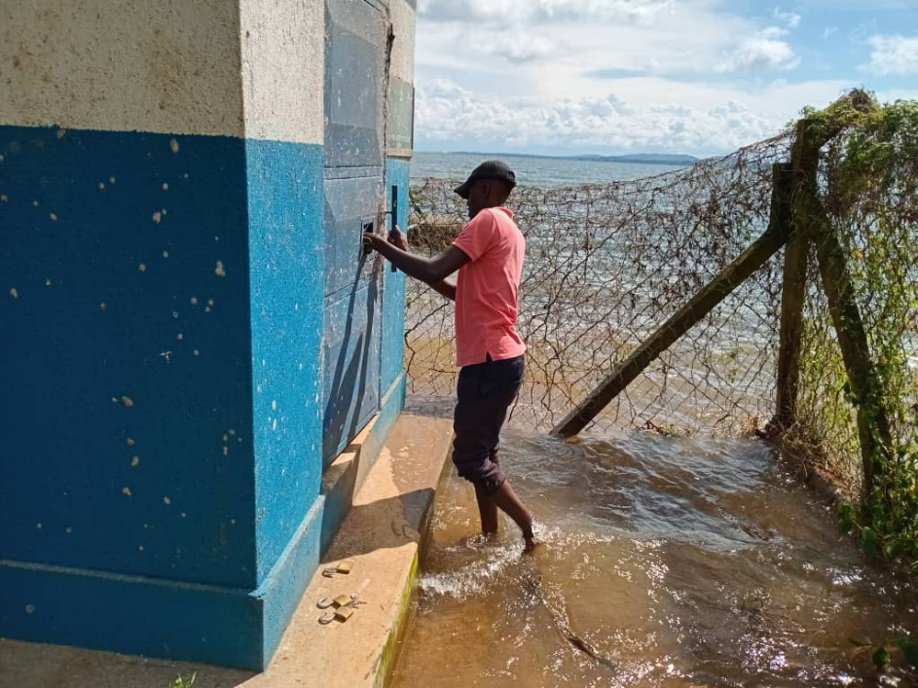

Picture 1 A water purifier in Mbeya Island sinking into floods due to rising waters from Lake Victoria

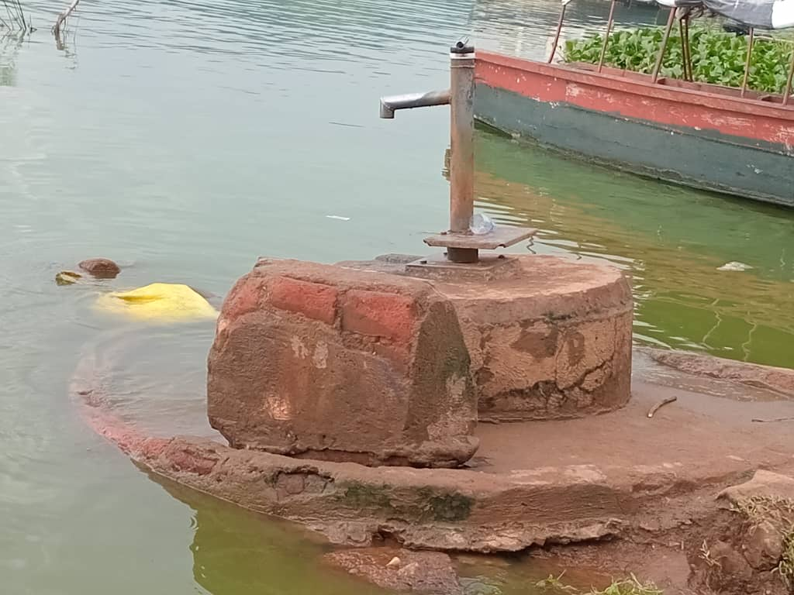

Picture A shallow well in Kisinsi fishing community destroyed by floods

* **Farmers:** Due to long dry spells, farmer communities struggle to access improved and safer water sources like boreholes because of falling water tables. As groundwater levels decline, the cost and complexity of drilling deeper boreholes increase, often beyond the financial and technical capabilities of local communities. For example, in Butoloogo, a sub-county in Mubende District of central Uganda, farmers and cattle keepers have to compete for dirty water from open water sources. Various organizations have approached the community to support them with improved water sources like boreholes and shallow wells, but this has not been possible due to the decreased water table.

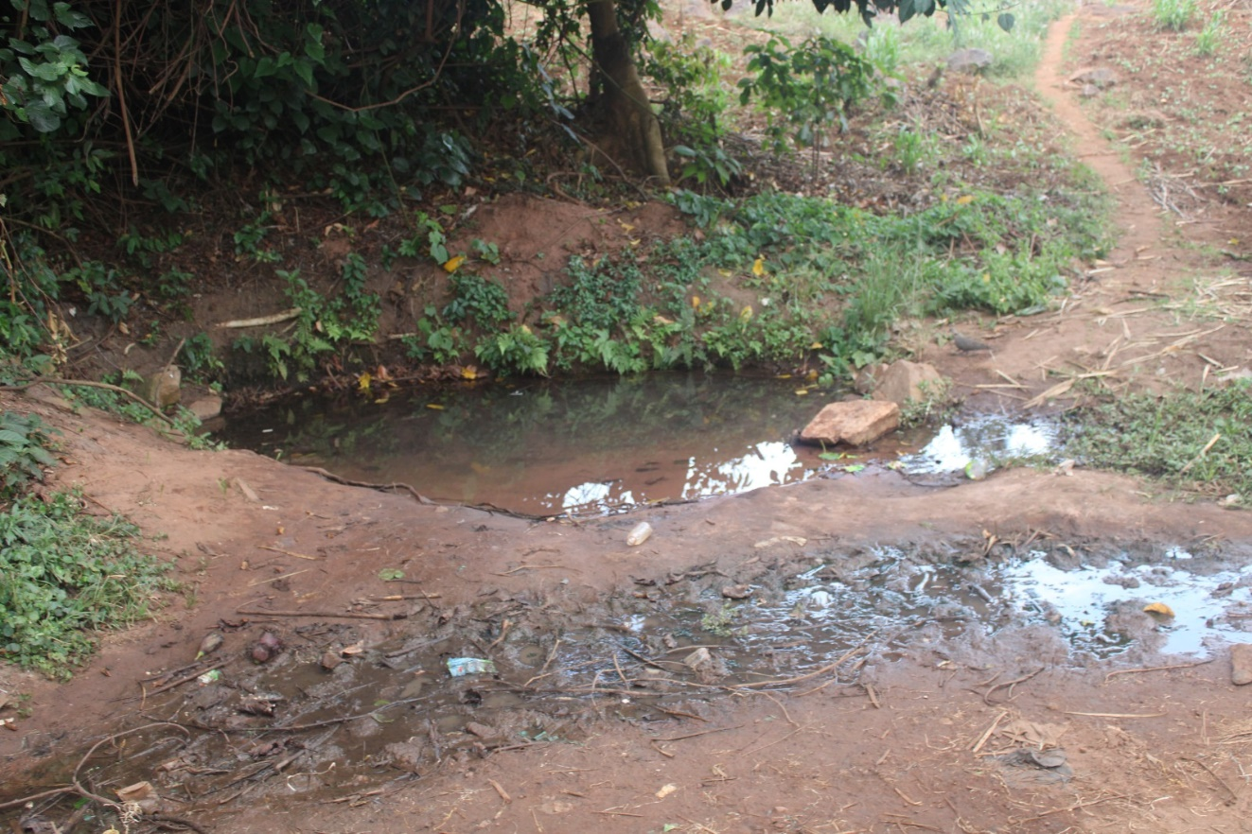

Picture 3 A water source utilized by the Butoloogo community in the Mubende District

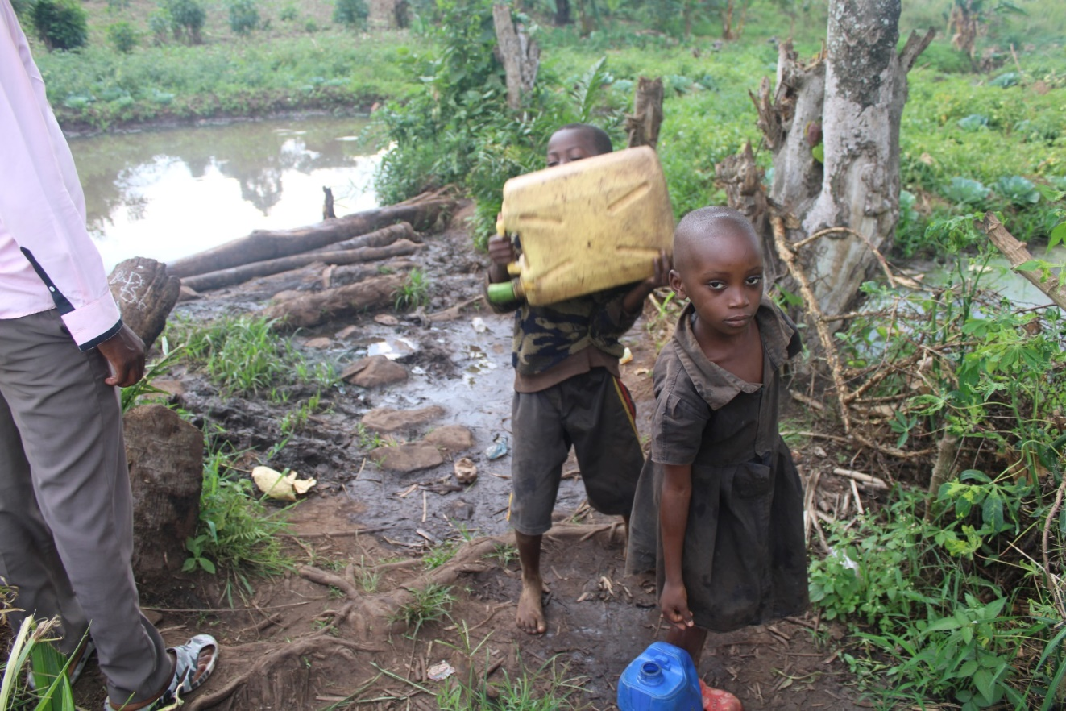

Picture 4 Children collecting water for household use from the same source where animals drink.

**What is the legal and/or moral basis for States and other actors including corporations to pay for climate change-related loss and damage?**

The legal and moral basis for compensating climate change-related loss and damage are well-established and rooted in international law, human rights principles, environmental justice, and corporate responsibility. The UNFCCC, particularly through its Paris Agreement, acknowledges the need to address loss and damage associated with the impacts of climate change. Article 8 of the Paris Agreement specifically addresses loss and damage and calls for cooperation and facilitation among parties[4].

Recognized and adopted by the UN General Assembly, a healthy environment is considered a prerequisite for the realization of the right to adequate food such as the rights to life, health, food, water and development[5]. For communities and individuals to have adequate food, a healthy environment is essential. This includes having high-quality soil, available water, and considering biodiversity in food production. Without these conditions, malnutrition and food insecurity may occur, hindering development by affecting individuals' ability to contribute to progress. State Parties therefore, have obligations to protect, respect, and fulfill these rights, which includes addressing the impacts of climate change.

States have duties to protect their populations from foreseeable harms, which include those arising from climate change. This extends to providing remedies and compensation for loss and damage. Uganda established legal frameworks such as the National Environment Act 2019[6] which try to address environmental damage, including those related to climate change. Courts are also taking in public interest cases on climate change, however the Law is silent on the a loss and damage fund and also Uganda has no independent court to handle environment related cases, resulting in the lack of prioritization for cases related to the impact of climate change on the environment. The authorities like National Environment Management Authority deny their culpability instead and accuse residents of having contributed to landslides through their poor agricultural practices, vegetation clearance, and poor cultivation.

In 2012 four minors in Uganda and their sponsors asked the Ugandan courts to develop a climate change mitigation plan and protect children from the effects of climate change and extreme weather conditions. To date, this case remains unresolved[7].

According to the National Environment Act of Uganda Corporations have legal obligations to act with due diligence in preventing harm from their operations, including environmental harm. Failure to do so can result in liability for damages. The (National Environment Act 2019) provides that corporations or business should bear the costs of damaging the environment. The Fisheries and Aquaculture Act 2022 mandates that individuals engaged in fisheries, aquaculture, or any activities involving fisheries resources must adhere to and implement environmental management principles. The Act stipulates a penalty of at least 5 years in prison, a fine of 10,000 currency points (approximately 53,000 USD), or both for those who fail to comply.[8] By establishing clear responsibilities, penalties, and adherence to environmental management principles, the legal framework demonstrates Uganda's commitment to environmental protection and therefore this commitment can be leveraged to advocate for compensation.

**What are the obligations of States and other actors such as development finance institutions and businesses to prevent, mitigate and remediate the impacts of climate change-related loss and damage on human rights, including the right to development?**

**Obligations of States**

Preventive Obligations:

Regulatory Measures: States should adopt and enforce laws and regulations regarding activities contributing to climate change, ensuring these measures are consistent with human rights standards[9].

**Remedial Obligations:**

Access to Justice: States must ensure that individuals and communities affected by climate change have access to judicial and non-judicial remedies. Provide relief, support, compensation and adequate remedy for loss and damage caused by climate impacts and support rehabilitation efforts.

**In addition to financial contribution, what non-financial components may be relevant (e.g., transfer of green technologies and building of capacity)?**

Monitoring and Evaluation; Develop and implement systems to monitor and evaluate climate policies and programs, ensuring they meet their intended goals and comply with the international human rights framework. In particular, establish mechanisms to ensure the meaningful and inclusive participation of communities and the facilitation of bottom up approaches and people-led solutions.

Establishing mechanisms for continuous feedback and learning to improve climate resilience strategies over time.

Supporting initiatives that help preserve cultural heritage and traditional knowledge that contribute to climate resilience.

Conduct awareness campaigns to educate the public about the impacts of climate change and the importance of taking action. Promote advocacy efforts to highlight the links between climate change and human rights, and to push for equitable solutions at national and international levels.

**How should a human rights-based approach to operationalize and administer the loss and damage fund look like (e.g., integration of considerations such as non-discrimination, fair representation in decision making, gender responsiveness, and accommodation for marginalized communities and countries especially vulnerable to the adverse effects of climate change)?**

Climate change adversely impacts the enjoyment of a wide range of human rights, including the right to life, adequate housing, food, and the highest attainable standard of health. Therefore, efforts in mitigation and adaptation should take a human rights-based approach to addressing the impacts of climate change.

It should ensure that climate action plans are inclusive and consider the needs and rights of vulnerable and marginalized groups, including women, indigenous peoples, and low-income communities.

Implement robust accountability measures, such as independent audits and grievance mechanisms, to address any misuse or misallocation of funds.

1. <https://www.monitor.co.ug/uganda/news/national/rising-water-levels-in-rivers-lakes-leave-trail-of-destruction-4616534>
2. <https://www.facebook.com/share/v/stafSPcssjdri3p9/?mibextid=oFDknk>
3. <https://entebbepost.com/three-confirmed-dead-as-passenger-boat-capsizes-in-lake-victoria/>
4. <https://unfccc.int/files/adaptation/groups_committees/loss_and_damage_executive_committee/application/pdf/ref_8_decision_xcp.21.pdf>
5. <https://www.undp.org/sites/g/files/zskgke326/files/2023-01/UNDP-UNEP-UNHCHR-What-is-the-Right-to-a-Healthy-Environment.pdf>
6. <https://nema.go.ug/sites/all/themes/nema/docs/National%20Environment%20Act,%20No.%205%20of%202019.pdf>
7. <https://reliefweb.int/report/uganda/uganda-when-climate-justice-becomes-climate-justice-denied>
8. <https://www.parliament.go.ug/cmis/views/c52ffe04-ce6a-4cb6-b4e0-1dd64d796f77%253B1.0>
9. <https://www.ciel.org/wp-content/uploads/2020/03/States-Human-Rights-Obligations-in-the-Context-of-Climate-Change_2020-Update.pdf>