Consultation Session Report

Impacts of Climate Change on the lives of Nepali Children

Input into the report of Special Rapporteur on the Right to Development to the Human Rights Council on Climate justice: Loss and damage
March 2024

Nepal, a landlocked country reaching from endangered floodplains up to the world's tallest mountains, contributes only 0.027 percent to the world's total global greenhouse gas emissions. It is one of the most vulnerable countries to climate disasters, which impedes Nepal’s development agenda.

Nepal currently ranks 146th on the Human Development Index, with nearly one-fourth of its population living below the poverty line. In Nepal, the impacts of climate change are deeply intertwined with the lives of children and young people. As a country vulnerable to natural disasters like floods, landslides, Glacier Lake Outbrust Flood (GLOF), avalanches and droughts, Nepal faces significant challenges in safeguarding the well-being of its youth & children population.

Moreover, the disruption to essential services such as access to education and healthcare further compounds the vulnerability of children and young people to the effects of climate change. The nexus between climate change and its impacts on children and young people in Nepal is evident across various sectors. Reduced access to clean water and sanitation facilities heightens the risk of waterborne diseases, while erratic weather patterns disrupt agricultural livelihoods, affecting food security and nutrition of low income families. Also, it has hampered the socio-cultural diversity of the people.

Additionally, the increased frequency and intensity of extreme weather events pose threats to the safety and psychological well-being of children, leading to displacement and trauma. Addressing these interconnected challenges requires holistic approaches that prioritize the protection and empowerment of Nepal's children and youth, ensuring their resilience in the face of a changing climate.

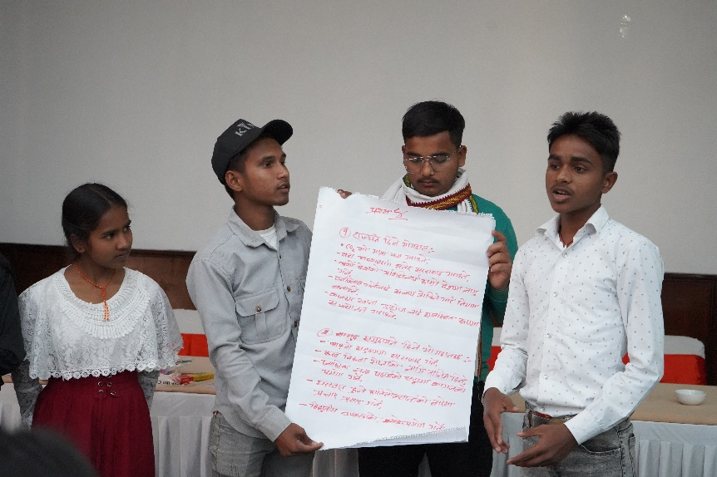
A consultation session was conducted with a group of 11 Nepali children and youth representing diverse economic and social backgrounds to understand children’s perspective on the impact of climate change in their lives. The consultation was conducted with a primary motive of informing a South Asia focused report on Loss and Damage Fund that is being prepared by United Nations Special Rapporteur on Right to Development following a direct consultation meeting between the Rapporteur and child campaigner from Nepal during the APFSD.

*Number of Participants : 11 Children ( 5 boys and 6 girls)
*Diverse Background : Dalit, Janjati, Brahmin.

Questions discussion

- How is the realisation of the right to development impacted by both economic and non-economic loss and damage from climate change? How is the impact experienced differently and/or disproportionately by different individuals (e.g., children and women), groups (e.g., Indigenous Peoples) and States (e.g., Small Island Developing States)?

Children in Nepal are facing disproportionate impacts of climate change largely affecting their health, education, wellbeing, and lives in general. The impacts are even more pronounced in children belonging to vulnerable communities who are at the frontlines of the crisis witnessing firsthand extreme weather events, disasters, and livelihood insecurities. Some of the prominent observations shared by children are documented below:

Destruction of infrastructure resulting from climate induced disasters such as flood and landslides has greatly hindered children’s access to education. When bridges are brought down by floods, children often must go weeks, sometimes even months without attending schools. In desperate attempts to reach schools, many children risk their lives climbing onto temporary bridges that are feeble and puts children’s safety at bay. Likewise, incessant rain causes leakages in school roofs, and classes shut down for days on end.

A child participant shared “since school roofs are made of cost-effective galvanized sheet, the sound of the rain hitting the roof is extremely disturbing and takes our concentration away. These roofs are comparatively more heat absorbent so during summer it is extremely difficult to spend the whole day under these roofs. The situation is even worse during summer as heatwaves causes schools to shut down for weeks.”

“Schools remain shut for weeks because of heatwaves in summer and cold waves in winter. These breaks are becoming more prolonged each year. We are out of school almost half of the academic year.” Child participant, Consultation session

Increase of hazard: Recent years have seen an increase in environmental risks brought on by climate change, such as forest fires and floods, which have forced many locals including children and youth to evacuate their homes. Along with losing their belongings, several have also lost their lives. Dehydration, dengue, and other diseases have increased because of it. Flooding often result in water contamination spreading harmful disease and putting children’s health at risk. Even mountainous and hilly regions that previously weren’t prone to such diseases have started to witness an increase in such cases.

In recent years, the air pollution level in many cities including Kathmandu has increased significantly, often resulting in multiple respiratory health issues. Only recently, all schools were advised to stay shut for almost a week because of air pollution.

Agriculture and food insecurity: Rainfall patterns have become unpredictable. Sometimes there is too much rain and sometimes there is none. Erratic rainfall has affected the quality and quantity of agriculture produce. Furthermore, the effects of climate change, such as flooding, also leads to degradation in soil quality affecting the agricultural food chain. As a result, communities are experiencing food insecurity in the family, and in many cases, the family have turned to child marriage as an indirect solution. A girl child often becomes the first to bear the brunt when family grapples with food insecurity, as they are married off to reduce the financial burden on the family.

“I am a farmer’s son myself and have experienced firsthand impact of climate change in forms of food insecurity. We haven’t been able to grow sufficient agricultural produce during in any of the harvesting season in recent years as rainfall has become erratic. This has not only impacted my family’s livelihood but also largely affected our mental wellbeing.” Child participant, Consultation Session

Scarcity in natural resources: Communities are experiencing water scarcity because of climate change. Many, including pregnant women and children, are compelled to walk long distances to collect water.

Impact on Culture and tradition: Unpredictable weather patterns have made it difficult to plan any cultural, religious, and recreational activities in advance since most activities in our communities are conducted in open spaces. One participant mentioned that severe rainfall had an impact on their culture and prevented them from carrying out their customs.

2. What are the obligations of States and other actors such as development finance institutions and businesses to prevent, mitigate and remediate the impacts of climate change-related loss and damage on human rights, including the right to development?

Governments and institutions should assess the resources available and conduct an Initial Environment Assessment and Environment Impact Assessment before beginning any developmental projects. To avoid conflict and address concerns about environmental degradation, they should also arrange for consultation with the local community including children and youth in the project's design area. If this cannot be done, the project should be closed down or its effects should be minimized by opting alternative choices.

In cases of disaster, the state should be well prepared to respond effectively and provide required assistance to the victims. For instance, when forest fire flares up, fire brigades should be accessible to minimize the impact. Proper evacuation centers for those affected by disaster, particularly children and women should be readily available.

“There are many people including children in our communities whose houses have been washed away by flooding. They are now homeless and live on the streets. The also face imminent risk of being hit by vehicles on the road.” Child participant, Consultation Session

The state international community should focus both on prevention and mitigation of such disasters. Additionally, engaging the local community right from the beginning in disaster management and reduction can be beneficial.

Since developing nations contribute least to climate change, developed countries should compensate for the losses they have incurred for the developing nations. Government should seek to establish a loss and damage fund that is dedicated towards minimizing and mitigating the impacts of climate change in communities living on the frontlines of the crisis.
The government should prioritize lowering CO2 emissions and encourage environmentally-friendly and sustainable growth.

The state, with support of the international community should introduce more projects for sanitation, plantations, and training for preparedness and response. It should formulate policies that encourage use of renewable energy sources and swap out plastic items with environmentally-friendly ones.

The Nepal government has become aware of the impacts of climate change and has begun to take steps to mitigate the situation. These efforts include awareness campaigns, sanitation initiatives, plantation initiatives, and other initiatives that are being carried out across the nation. But it must do more in analyzing the real issues climate crisis is presenting and carry out relevant initiatives. The government should conduct vulnerability sensitive Loss and Damage assessment so that needs of children are addressed.

3. What is the legal and/or moral basis for States and other actors including businesses to contribute to the Fund for climate change-related loss and damage?

Accountability: The contributor countries should be accountable for their emissions and on that basis it should provide certain share of its annual profit in loss and damage fund eg: polluters pay policy

Policy based actions: Nepal has made ambitious commitments to transition towards a cleaner and greener future. For example, Nepal has committed to replace 90 percent of its public vehicle with Electric Vehicles by 20230. However, these policies often remain confined to papers. Countries, with the support of the international community, donors and UN, along with non-state actors, should work rigorously towards translating these policies into actions.

Long term investment: Long term investment should be made to uplift the lives of climate vulnerable groups or communities to attain climate justice and for full realization of their human rights.

Solidarity: The state along with other private institutions, key stakeholders, NGOs and INGOs should forge strong collaboration and work collectively to transition to a greener economy and sustainable present and future

Inclusion and Integration: Development and other projects should be designed with an environmental lens while also ensuring inclusion, so the communities impacted the most have a say in decision making spaces.

4. In addition to making a financial contribution to the Fund, what non-financial components may be relevant from a climate justice perspective (e.g., transfer of green technologies, building of capacity and relocation pathways for climate-induced migrants)?

Promotion of Green Technology: Developed countries can support in transferring green technology as well as skills required to roll out those technologies to developing countries like Nepal. For example, Nepal is an agriculture-reliant country. However, the agricultural tools and technologies that we use are still quite primitive that makes it difficult for Nepal to produce enough for its own population, let alone competing in the international market.

Capacity building: State and non-state actors should invest in capacitating the youths, local people and community in climate change to enhance their awareness, knowledge and skills to tackle with the impacts of the climate crisis.

Sustainable infrastructure development initiation: Government and the private institutions should focus on sustainable development and promoting green economy. The state should introduce projects where development and conservation go hand in hand.

Community Engagement and Participation: the local people where the project is about to be implemented should also include the local communities and also mobilize them on the related project.

Partnerships and Collaboration: For wider outreach and to promote the project, every institution or stakeholders from NGO, INGO, government bodies, private institutions should act together and work on climate change collaboratively. Likewise local communities should be meaningfully engaged from design, implementation to closing of the projects and fund mobilization dedicated to loss and damage.

Knowledge Sharing and Education: Youth and children should have safe and accessible platform to share their knowledge and concerns for climate change openly and widely.

