**Consultation Session Report**

**Impacts of Climate Change on the Lives of Filipino Children**

***Input into the report of Special Rapporteur on the Right to Development to the Human Rights Council on Climate justice: Loss and damage***

***March 2024***

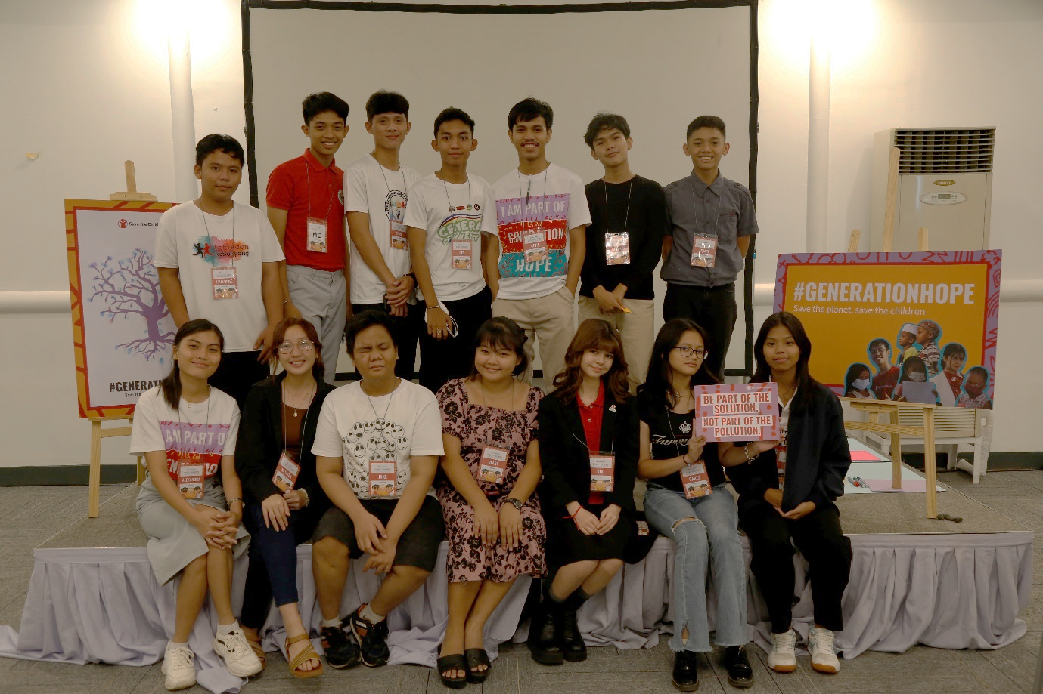

The Philippines is an archipelagic country composed of 7,641 islands, with total land area of 300,000 square kilometers.

Located in the western Pacific Ocean and north of the equator, and the western rim of the Pacific Ring of Fire, the Philippines experiences frequent seismic and volcanic activities. Due to its geographical location, the Philippines experiences more tropical cyclones each year than anywhere else in the world. On average, the country experiences around 20 cyclones annually, with 8-9 of them making landfall.[1] Consequently, heavy rains, widespread flooding, and strong winds are common occurrences, leading to significant loss of life and extensive damage to crops and property. Loss and damages from these events cost the country an average of 0.5% of its GDP annually[2].

The Philippines is among the 18 mega-biodiverse countries globally, hosting two-thirds of the planet's biodiversity. The Philippines is designated as one of the world's biodiversity hotspots, home to over 700 threatened species, establishing it as a key area for global conservation efforts. Its forest cover is only 7,226,394 hectares[3], as reported in 2020Between 2010 and 2022, the Philippines lost 62.9 kha of natural forest, equivalent to 39.8 Mt of CO₂ emissions. The Philippines emitted an average of 1.98 metric tons of carbon dioxide equivalent per capita in 2020, significantly lower than the global average of four metric tons per capita.

The Philippines has a total population of 109.04 million, of different ethno-linguistic groups, 10-20% of whom are Indigenous Peoples. While their actual number is not known, as of March 21, 2024, there are 1.7 M registered persons with disability.

Overall, children comprise 39.75 Million. Of these, 10.46 Million are poor, making them the sector with the second highest poverty incidence. There is no disaggregated data available on the actual number of Indigenous children and children with disabilities, and their poverty rate.

In 2023, the poverty incidence in the Philippines was estimated at 22.4%, affecting approximately 25.24 million individuals. The subsistence incidence, stood at 8.7%, impacting around 9.79 million Filipinos. Overall, the Philippines has an HDI of 0.710 and ranks 113 in the world.

The Philippines ranked first in the World Risk Report in 2023. Its index core of 46.86 indicates a high correlation between poverty and inequality, significant exposure to climate-sensitive risks, and complex interactions of multiple exposures, potentially leading to high intensities of impacts.

To understand the impact of climate change on Filipino children and their views on loss and damage and their right to development a consultation was conducted among 14 children who are members of Save the Children Philippines’ National Child Advisory team (NChAT) on March 16, 2024. Aged 14-17, the participants come from various provinces and represent diverse ethnicities, economic statuses, educational attainment levels, and sexual orientations, expressions, and identities. One participant is a child with a disability.

**A. Climate justice: Loss and damage**

1. ***How is the realization of the right to development impacted by both economic and non-economic loss and damage from climate change? How is the impact experienced differently and/or disproportionately by different individuals (e.g., children and women), groups (e.g., Indigenous Peoples) and States (e.g., Small Island Developing States)?***

The children emphasized that development activities have resulted in significant environmental damage, particularly biodiversity loss, which carries far reaching consequences. They discussed how this loss affects not only socio-economic and health aspects but also has profound cultural and intergenerational impacts. Additionally, they highlighted broader consequences such as the loss of human life and cultural heritage, as well as challenges related to food security and associated health issues. Moreover, they addressed rising temperatures exacerbating heat-related problems and underscored the critical importance of upholding human rights in the face of environmental degradation.

Biodiversity loss worsens climate change, causing heatwaves and health issues. Climate change affects education, as seen in government decisions to alter school calendars due to extreme heat.

Children discussed how climate change disrupts water and food access, triggering interconnected and gendered challenges in their daily lives. Additionally, compromised rights to development and leisure activities highlight multifaceted impacts on human well-being, alongside displacement of populations lacking food and water access. Moreover, the potential for child protection issues and negative impact on biodiversity emphasize, broader societal and ecological implications, underscore the need of addressing water and food scarcity in the context of climate change.

1. Top of Form
2. ***What are the obligations of States and other actors such as development finance institutions and businesses to prevent, mitigate and remediate the impacts of climate change-related loss and damage on human rights, including the right to development?***

The Philippine Constitution guarantees the right of all people to a healthy environment and is supported by robust laws promoting environmental conservation and sustainable development for future generations. These laws include a climate change law that ensures climate risk management and climate justice.

During the consultation, the children identified the following obligations:

1. Ensure carbon footprint reduction.
2. Emphasize the need for government accountability.
3. Acknowledge contributions to climate change and assign responsibility.
4. Ensure accountability from companies emitting emissions and make polluters pay.
5. Ensure efficient access to the right to health.
6. Promote holistic development.
7. Facilitate access to information and education.
8. Support meaningful child participation in decision-making and incorporate children's perspectives into recommendations.
9. Safeguard and protect activists and advocates, particularly children, amid red-tagging.
10. Prioritize impacts of climate change on present and future generations.

Additionally, the children underscored the necessity of passing a loss and damage law that considers the rights of and inputs from children after comprehensive, inclusive, and meaningful participation.

Top of Form

1. ***What is the legal and/or moral basis for States and other actors including businesses to contribute to the Fund for climate change-related loss and damage?***

A participant mentioned that in the Philippines, people have the right to a balanced and healthful ecology.

The right to a healthy environment is closely linked to our rights as children and other fundamental rights. A happy and healthy environment is characterized by the availability of food, water, and other necessities.

The environment also has its rights. The environment can defend itself just as we defend ourselves. That's why it is crucial for us to protect the environment. It entrusts us with that responsibility.[4]

1. ***In addition to making a financial contribution to the Fund, what non-financial components may be relevant from a climate justice perspective (e.g., transfer of green technologies, building of capacity and relocation pathways for climate-induced migrants)?***
2. **Manpower and Resources:**
   * Ensure sufficient manpower alongside financial resources.
   * Government assistance should include reconstruction of affected sites and ongoing monitoring.
3. **Environmental Concerns:**
   * Address the overabundance of factories in the Philippines to reduce environmental impact.
   * Government support for restoration and rehabilitation should extend beyond financial aid to include livelihood assistance. For instance, assisting families in restoring lost livestock can enhance food security and benefit children indirectly.
4. **Psychological Support:**
   * Implement holistic interventions for children, including psychological support services.
   * Establish accessible psychological support services, such as on-site psychologists in disaster-prone areas.
   * Provide psychological first aid to children affected by traumatic events, such as flooding, to alleviate anxiety and trauma.
5. **Children and Youth Education and Preparedness:**
   * Educate youth on environmental respect, including proper treatment of animals.
   * Enhance disaster preparedness among duty bearers to ensure effective response and support.
   * Ensure inclusive disaster preparedness for children with disabilities, addressing their specific needs and ensuring their active participation in drills and preparations.
6. **Legislative Action and Reflection:**

* Promote discussions on children with disabilities within the framework of existing emergency-related legislation, such as the Philippine’s law on *Children’s Emergency Preparedness and Contingency (CEPC).*
* Implement measures to memorialize lessons learned from loss and damages, including apology, and guaranteeing non-recurrence.

1. ***How should a human rights-based approach to operationalize and administer the Fund look like?***

Through commenting on the Klima Bill, a proposed legislative approach to operational and administer the funds for loss and damages in the Philippines, the following human rights-based approach to administer the fund are identified:

* + 1. **Children's Participation in Decision-Making:**
* Children should be included in the technical working group to ensure their ideas are considered in line with UNCRC principles. As a child participant said, “Participation in decision-making should be open to all ages without discrimination, with support for children's involvement."
* Children's involvement should extend beyond consultation to include monitoring.
* Emphasize that the bill is for children, and they should be actively involved in crafting it and advocating for their aspirations.
  + 1. **Government Accountability and Legislation**:
* Ensure children's inclusion in decision-making processes.
* Highlight the need for government accountability
* Recognize the contributions of both individuals and corporations to the exacerbation of climate change, and consider who bears the greatest responsibility and accountability. As one child participant emphasized, 'It is crucial to recognize that those who contribute less are often the ones most severely affected.'
* Support the bill's mandate while exploring alternative solutions during its pending approval.
* Address the gap between good laws and their effective implementation, emphasizing the need for accountability and success measurement.
  + 1. **Social Impact and Welfare**:
* Advocate for transparency in government actions.
* Stress the importance of fairness in the system and accountability among lawmakers.
* Reiterate the shared responsibility between individuals and the government in addressing climate change.

**B. The right to development of children and future generations**

***1. What does the right to development mean for children in line with the relevant policy frameworks and normative instruments? What about the right to development of future generations?***

Children have the right to sustainable development that recognizes and takes into consideration environmental health.

However, children feel that this policy is inadequately implemented as observed from various indicators that include environmental destruction and resource depletion, decreasing access to food and water, increasing importation of basic food supplies, increasing incidences of extreme weather events particularly flooding and typhoons, and increasing number of children suffering from post-traumatic stress disorder (PTSD) associated with calamities and disasters.

The children underscore it is important to view the environment holistically and implement a holistic development policy that takes into consideration intergenerational equity.

***2. How are the human rights of children and future generations impacted by development-related decisions (e.g., related to economic development or new technologies) made by the present adult generation? Please provide examples from your country or area of work.***

Participants highlighted that environmental damage and resource depletion have already limited people's access to food and resources, leading the country to rely on food importation. They discussed the socio-economic implications of environmental damage, particularly focusing on biodiversity loss, and its correlation with human health. Additionally, they emphasized its cultural significance and intergenerational repercussions. Furthermore, they discussed broader consequences such as loss of life, cultural heritage, food security challenges, and health issues, as well as the escalating temperatures contributing to heat-related problems. The children also expressed concerns about the difficulty of protecting human rights in the face of environmental degradation and climate change, especially in the aftermath of typhoons. During the discussion, a participant specifically mentioned mining, citing their experience in Samar, where it was identified as a destructive development project negatively affecting the environment, water supply, and food for present and future generations. Moreover, the increase of factories in urban areas was identified as contributing to greenhouse gas emissions and pollution.

***3. How to ensure a meaningful participation of children and future generations in development-related decisions at all levels? Are there any existing good practices or models?***

Participants emphasized that:

*“Children can do things in their everyday life. The small things that children do will make a difference and have impact.”*

*"Every individual's experience and voice are important."*

To ensure meaningful participation at all levels, they suggested:

* + 1. **Inclusive Participation of Children**
* Ensure children's presence during bill deliberations in the Senate and House of Representatives to grasp its significance.
* Seek input from children across provinces for updated perspectives.
* Provide a platform for absent children to contribute, ensuring equal opportunities with appropriate adult support.
* Enable diverse communication methods, especially for children with disabilities, to ensure meaningful participation.
  + 1. **Accessibility of Environmental Information**
* Ensure environmental information is accessible to all children, regardless of religion, color, or abilities.
  + 1. **Advocacy and Enhancement of the Bill**
* Strengthen proposed measures by soliciting stronger suggestions, facilitating bill passage.
* Incorporate suggestions from children to enhance the bill.
* Children to advocate for children's rights among lawmakers.
  + 1. **Multi-level Discussion and Education**
* Discuss the bill at various levels, from barangays to cities, and provide fact sheets for reference.
* Coordinate with Department of Education and Integrate bill in school discussions to reach and educate them on government actions.
* Engage more children through school discussions to improve the bill.
  + 1. **Engagement with Local Government Units (LGUs)**
* Inform LGUs about the bill for wider dissemination and for them to organize meetings with children.
  + 1. **Child-Centered Decision-Making**
* Ensure child-centered, inclusive decision-making, considering varying vulnerabilities to climate change.
* Adopt regular meetings like those in Malolos, Bulacan, to amplify children's voices at the barangay level and establish and maximize similar platforms.

These are the best practices that they identified to ensure children’s access to environmental information:

1. **Digital Accessibility for Children:**
   * Develop child and disability-friendly social media posts.
   * Create child-friendly applications and games focused on environmental education.
   * Develop child-friendly websites with informative content on environmental issues.
2. **Community Engagement and Awareness:**
   * Organize community gatherings and interactive sessions to raise awareness about children's ecological rights.
   * Strengthen support and implementation of the Youth for Environment in Schools Organization (YES-O).
   * Foster YES-O habits among students to promote environmental stewardship.
3. **Accessible Education Materials:**
   * Ensure that Information, Education, and Communication (IEC) materials are accessible to children with disabilities through multi-sensory experiences.
   * Enhance environmental information and education activities within school curricula.
   * Contextualize and integrate climate change lessons into school subjects.
4. **Media and Information Dissemination:**
   * Incorporate environmental education into broadcast media programs.
   * Educate adults, parents, and caregivers about the importance of environmental awareness.
5. **Resource Accessibility:**
   * Establish libraries with resources on environmental topics accessible to children.
6. **Physical Accessibility and Awareness:**
   * Install disability-friendly signages in public spaces to promote environmental awareness.
   * Organize daily, fun, and play-based activities related to climate change.
     1. ***How to integrate an intersectional approach to the participation of children to ensure that differentiated impacts on children due to various discriminations, exclusions or vulnerabilities are considered? Kindly share any good practices.***

To ensure the integration of an intersectional approach to children’s participation, participants identified the need to provide children with access to information and equip them with the necessary tools for meaningful engagement. Information, education, and communication initiatives should be conducted in collaboration with schools, local government structures, and broadcast media to ensure a broader reach.

Participation efforts should encompass diverse groups of children in terms of age, status, geographical locations, ethnic backgrounds, and educational levels. This includes the active involvement of indigenous children, children with disabilities, and children with diverse Sexual Orientation, Gender Identity, and Expression (SOGIE).

Supporting and institutionalizing child-led organizations and their adult support are essential to foster meaningful participation.

A notable example highlighted is the local government unit in Malolos, Bulacan, where children have a dedicated platform to convene regularly, discuss pertinent issues, and actively engage in local government decision-making processes.

**5. *What measures should be taken to protect and empower child human rights defenders?***

The responses of the children on how child rights defenders can be organized into five categories. Each category encompasses specific actions or measures identified by participants to safeguarding the rights and well-being of child environmental defenders.

1. **Legal Protection and Advocacy:**
   * Make laws, and adopt national and local policies to ensure the safety of child environmentalists.
   * Approve the Ecological Children's Rights Bill.
   * Abolish National Task Force to End Local Communist Armed Conflict (NTF-ELCAC).
   * Reject red-tagging.
   * Establish a party-list representative for child environmental defenders.
2. **Access to Information and Support:**

* Ensure access to information so that children can defend their rights (legal, mental, policies).
* Children should have adequate information to advocate for their rights.
* Schools should provide support.
* Raise awareness of referral pathways offline.
* Ensure the anonymity of children on sensitive issues.
* Provide psychological first aid.

1. **Engagement and Communication:**

* Ensure access to information so that children can defend their rights (legal, mental, policies).
* Children should have adequate information to advocate for their rights.
* Schools should provide support.
* Raise awareness of referral pathways offline.
* Ensure the anonymity of children on sensitive issues.
* Provide psychological first aid.

1. **Safety Measures:**

* Ensure safety and security protection.
* Establish a social media reporting page.
* Ensure the safety of journalists to prevent the spread of fear and misinformation.

1. **Policy Implementation and Collaboration:**

* Collaborate on SDG 17 between children’s groups, CSOs, and government.
* Conduct collective campaigns at the national, regional, and global levels.

1. <https://www.pagasa.dost.gov.ph/climate/tropical-cyclone-information>
2. See National Disaster Risk Reduction and Management Plan (2011)
3. See Philippine Forestry Statistics 2022 in <https://forestry.denr.gov.ph/index.php/statistics/philippines-forestry-statistics>.
4. In the Philippines, the law that recognizes the environment as having rights is the "Philippine Ecological Solid Waste Management Act of 2000" (Republic Act No. 9003). While this law primarily focuses on solid waste management, it also emphasizes the protection of public health and the environment, acknowledging the rights of the environment to be protected and preserved for the present and future generations.