

What we did to include people with disabilities in 2023
Information about our work on the United Nations plan to include people with disabilities
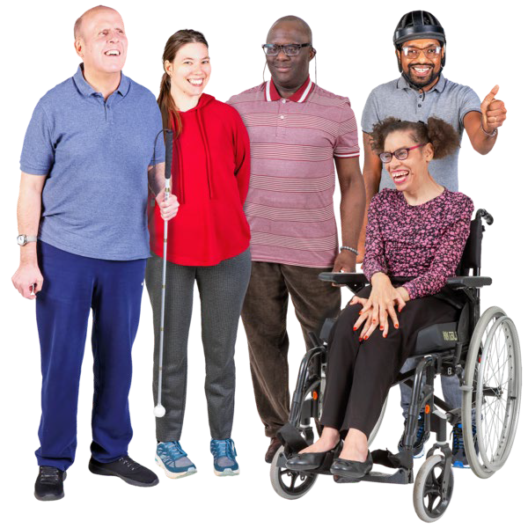
UN Disability Inclusion Strategy report

Who we are


We are the Office of the High Commissioner for Human Rights, or OHCHR for short.


We do work to support and protect the human rights of people all over the world.
Human rights are basic rights and freedoms every person should have for their whole life.

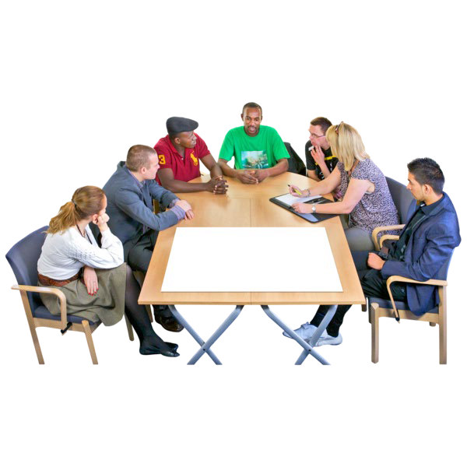
We are part of an organisation called the United Nations, or UN for short.
The UN is a group of countries that work to make the world a better and safer place.

What this booklet tells you about

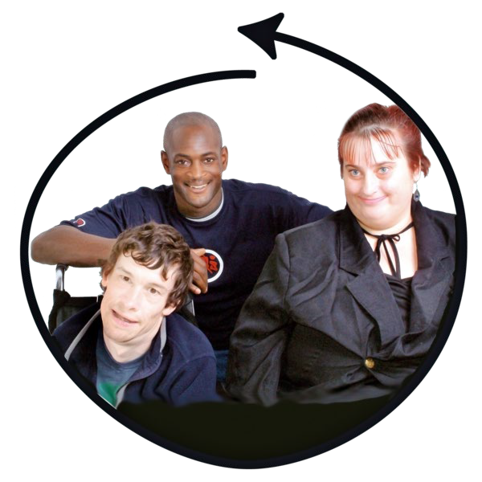
The UN wants people with disabilities to be part of everything it does.
This means people with disabilities should not be left out.

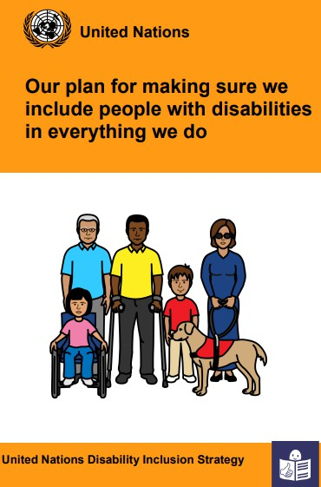
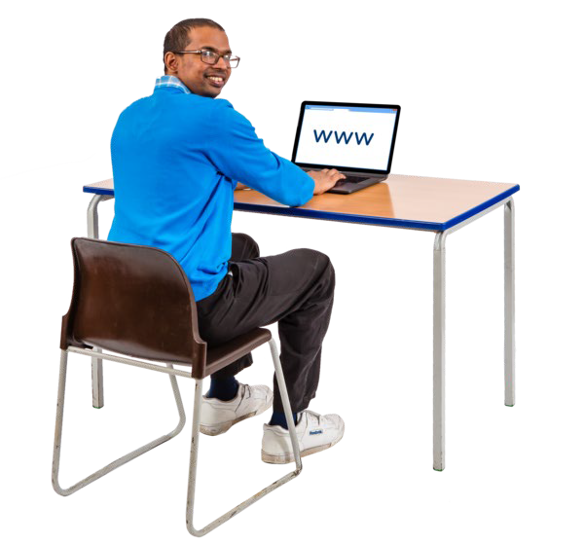
To make this happen, the UN has a plan called the UN Disability
Inclusion Strategy, or UNDIS for short.
You can go to this webpage to read an Easy Read version of the UNDIS www.un.org/en/content/disability strategy/assets/documentation/ Easy_to_Read.pdf


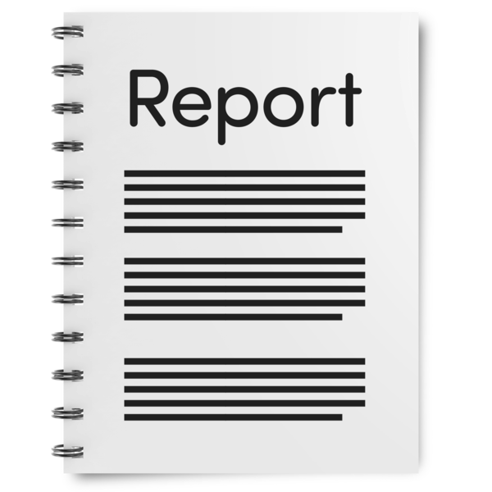
Each part of the UN must
follow the UNDIS in the work they do
write a report each year that says what they have done to follow the UNDIS.

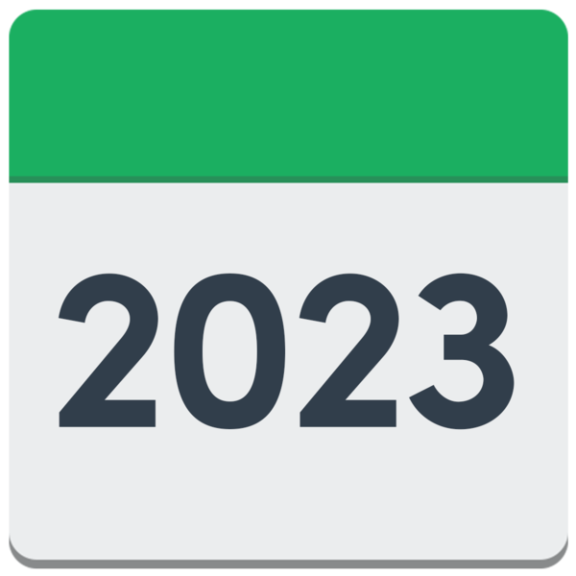
This booklet tells you about our report for 2023.

About the report
?
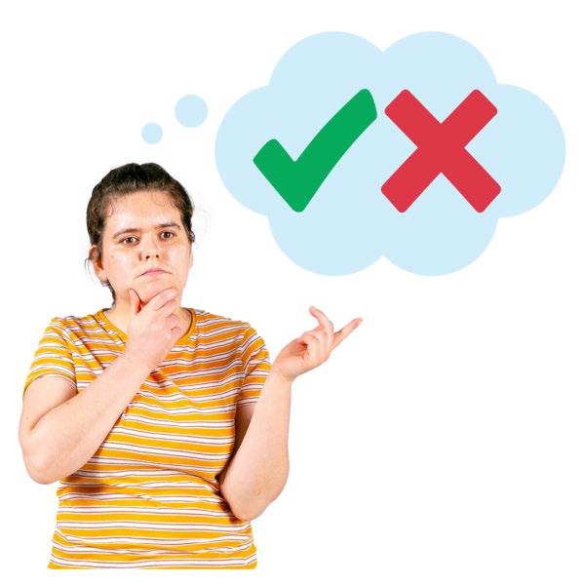
For the report we look at different areas of our work and say how well we have followed the UNDIS for each area.

Each area of work is given a rating.
A rating is a way to say how good or bad something is.

The report uses 4 ratings, called
- Exceeds Requirements
- Meets Requirements
- Approaches Requirements
- Missing

We tell you more about each rating and how well we did for each area of work in the rest of this booklet.

How we are doing so far to include people with disabilities

Exceeds Requirements

The rating Exceeds Requirements means we are doing even better than we need to.

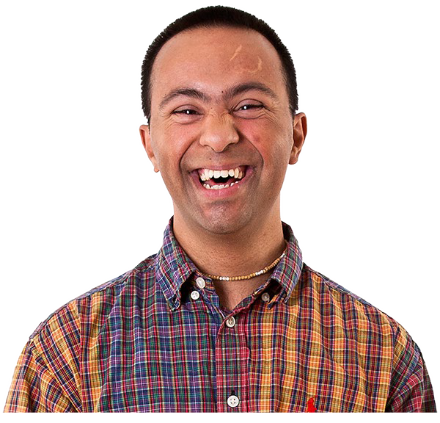
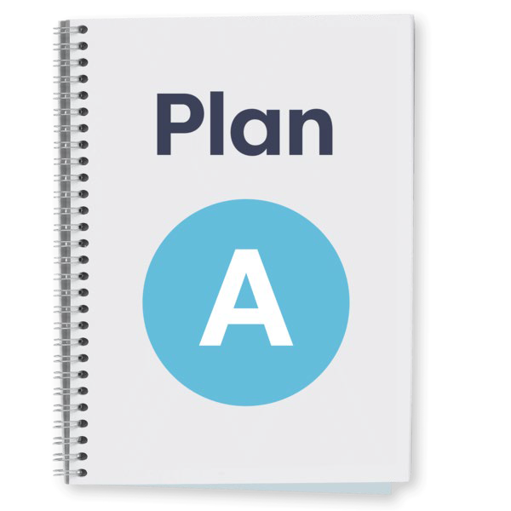
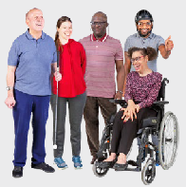
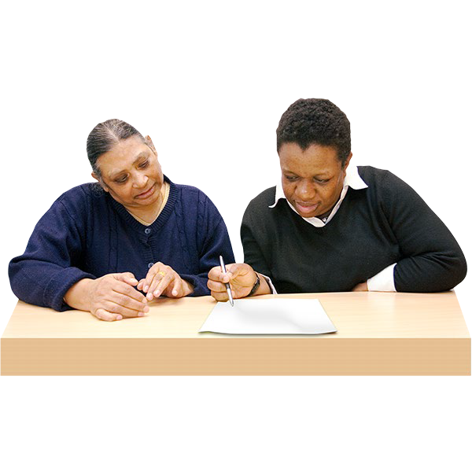
We are doing even better than we need to for the areas of work in the list below and on the next page.

  - Making sure our senior managers make the UNDIS happen.

  - Making sure we have a plan about how to include people with disabilities.

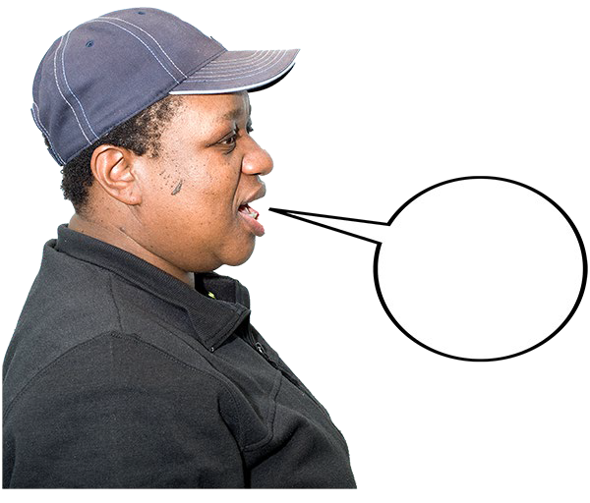
  - Making sure people with disabilities get the right support to take part and have their say.

1. Exceeds Requirements

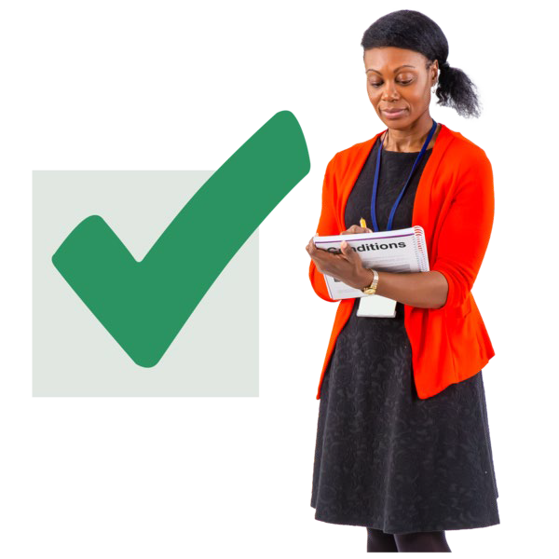
  - Making sure our projects are checked to see how they are working for people with disabilities.

  - Working with other parts of the UN to include people with disabilities.

Some examples of our work
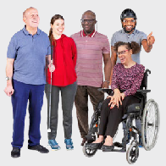
We already have a plan about how to include people with disabilities.
We made the plan in 2020.

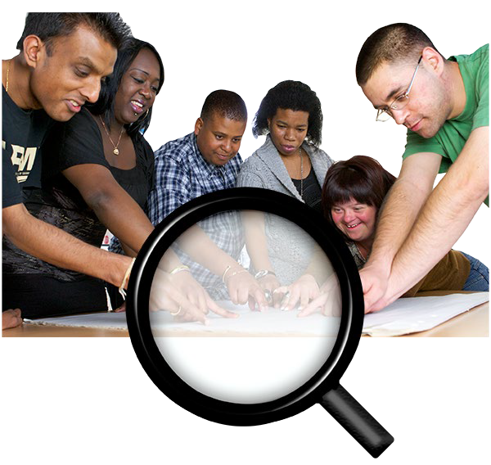
The plan includes work our senior managers have to do.

In 2023 we did a lot of work to make our plan happen and our senior managers did a lot to support this work.

For example, they met with
  - An organization called the International Disability Alliance
  - An organization called the
Icelandic Disability Association.

1. Exceeds Requirements

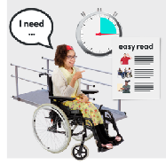
We already have a plan about how to make sure people with disabilities get the right support to take part and have their say.

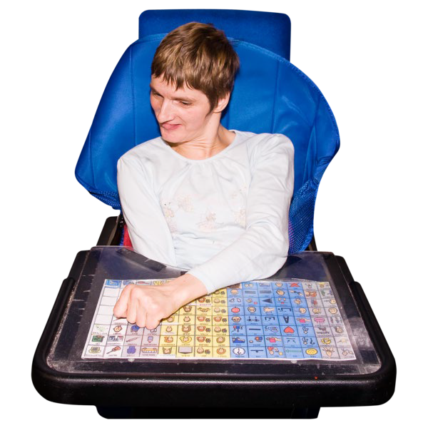
This extra support might be things like equipment or help to travel.

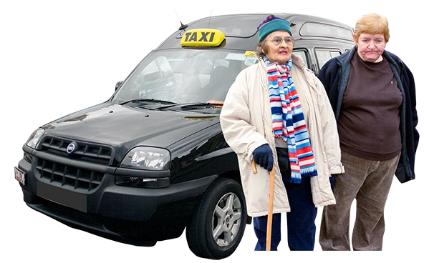
In 2021 we started a new system to give people with disabilities extra support.

In 2022 we started a pot of money to pay for extra support.

In 2023 our system for extra support was checked to make sure it works in a good way.

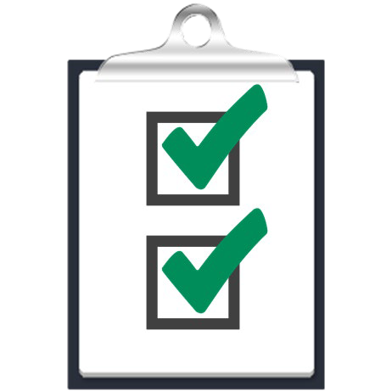
We will do more work to make sure we give extra support
  - in the best way for the people who need it
  - In a way that uses money in the best way.

1. Exceeds Requirements

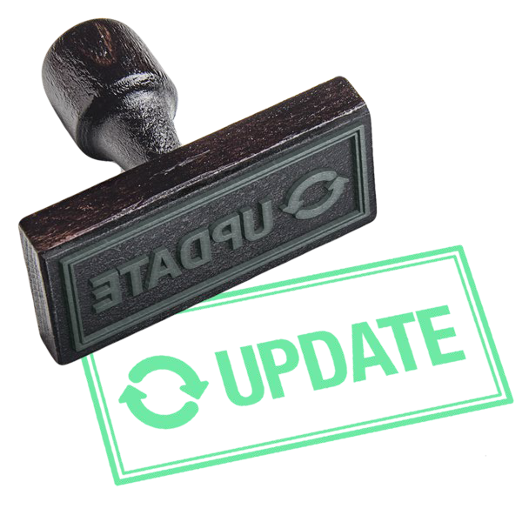
In 2022 we updated our rules about how we check projects.

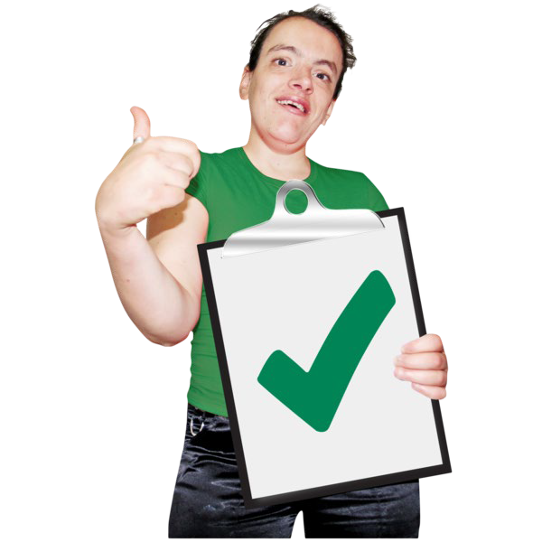
We added more information about people with disabilities and their rights.

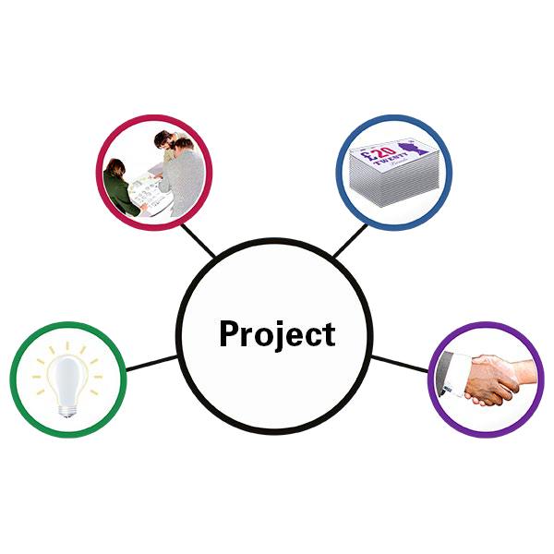
In 2023, we followed our new rules when we checked our projects.
2

We have done a lot of work with the UN and other organisations on the rights of people with disabilities.

For example, in 2023 we worked with the UN and other organisations on 2 projects.


1 project was to help people from Ukraine, and 1 project was about support and care and the rights of people with disabilities.

Meets Requirements

The rating Meets Requirements means we are doing everything we need to.

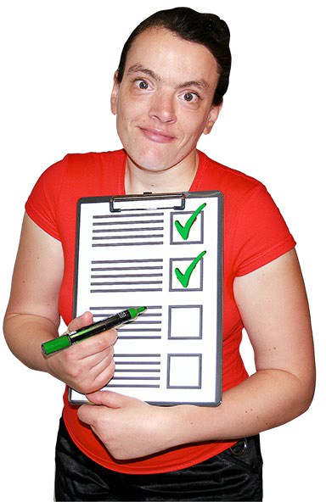
We are doing everything we need to for the areas of work in the list below.

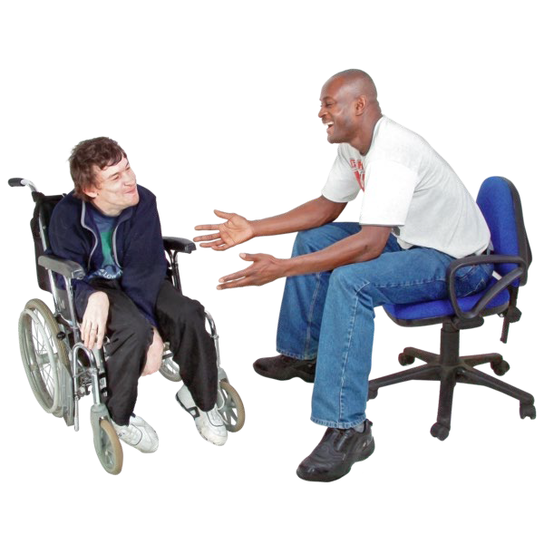
  - Making sure there are people who work for us who know about human rights and disability.
Making sure people who work for us can meet to talk about disability issues.


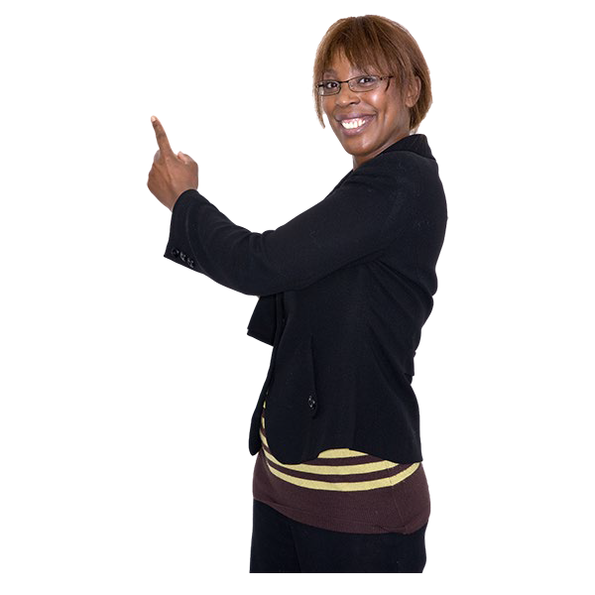
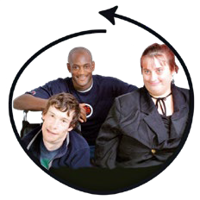
  - Making sure staff get information and training about how to include people with disabilities.

2. Meets Requirements

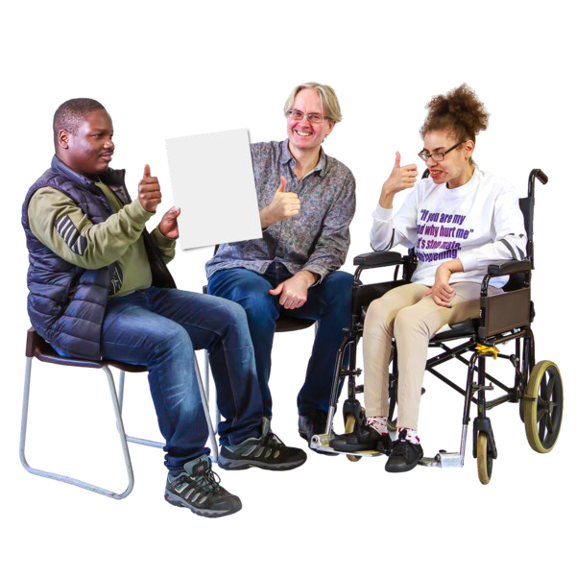
Some examples of our work
We have a Human Rights and Disability team. There are 3 people on the team.

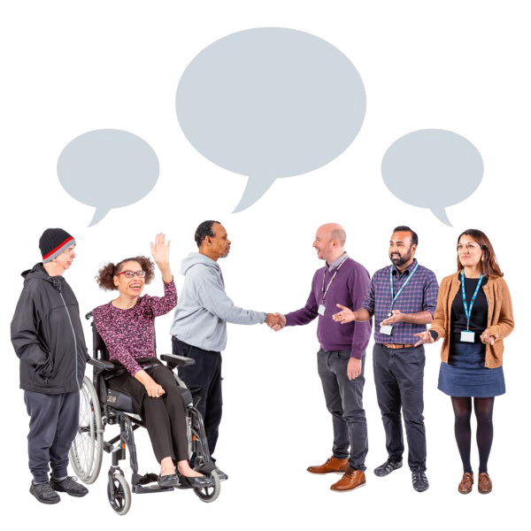
They have the right skills to help us include people with disabilities.

They work with the UN, governments, other organisations and people with disabilities.

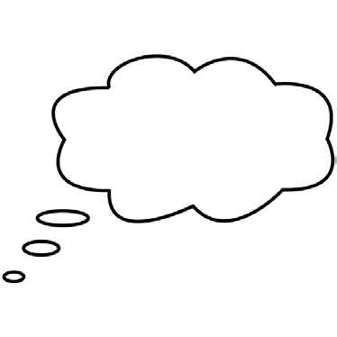

In 2021, we set up a system to help different parts of the UN work together to include people with disabilities.

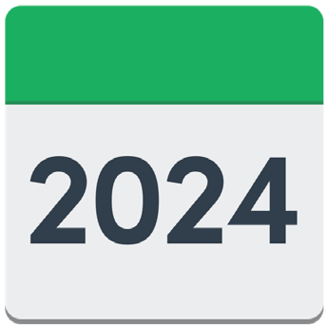

The system means people can share information and training on the rights of people with disabilities.

In 2024, we will do more work to make the system better.

2. Meets Requirements


In 2023 we looked at how some of our projects in different countries are working for people with disabilities.

In 2024, we will do more of this work.

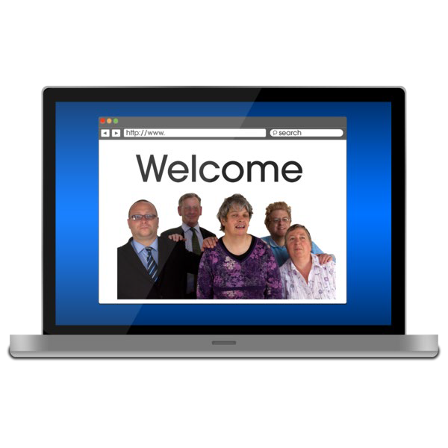
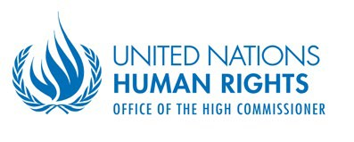
As part of our work to include people with disabilities, we made some training that says what organisations need to do.

The training is on our website.


In 2023, we made a rule that says people who work for us must do an online training course about the UNDIS.

In 2024, we will make sure everyone who works for us knows they must do the online training course and we will check it is being done.

Approaches Requirements

The rating Approaches Requirements means we are not doing everything we need to yet.

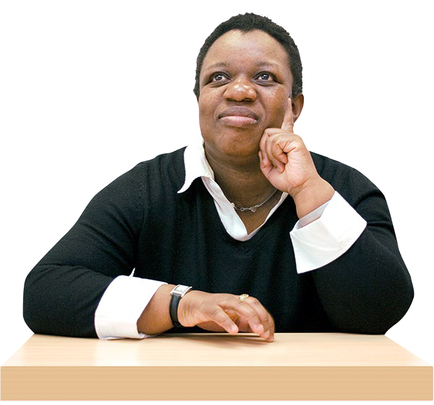
We are not doing everything we need to yet for the areas of work in the list below and on the next page.

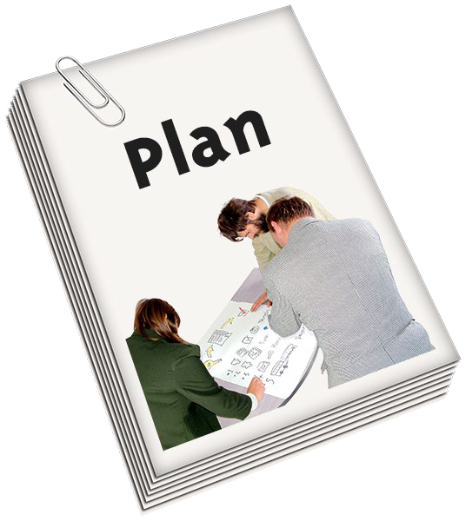
- Making sure the main plan about our work has lots of information about people with disabilities and their rights.

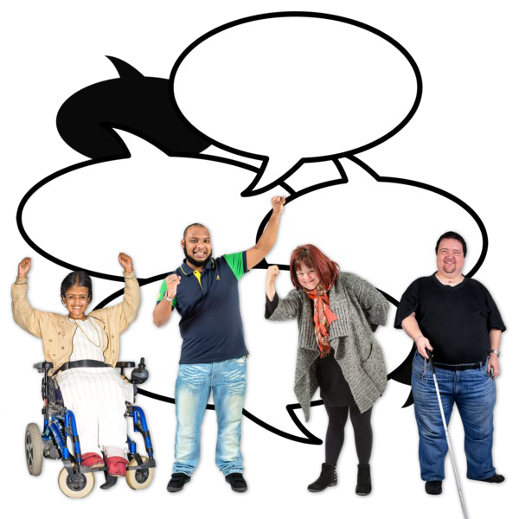
- Working with people with disabilities and making sure they can have a say.

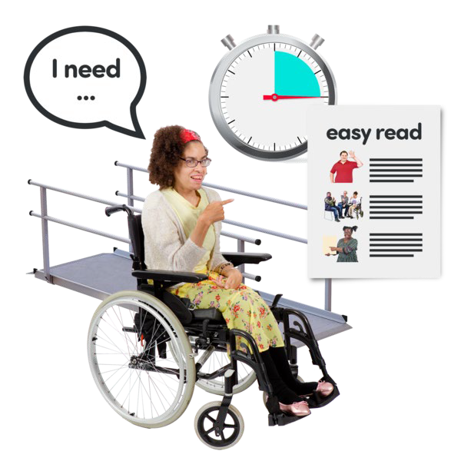
- Making sure every part of our work is accessible for people with disabilities.
Accessible means everyone can use, understand or take part in something.

3. Approaches Requirements


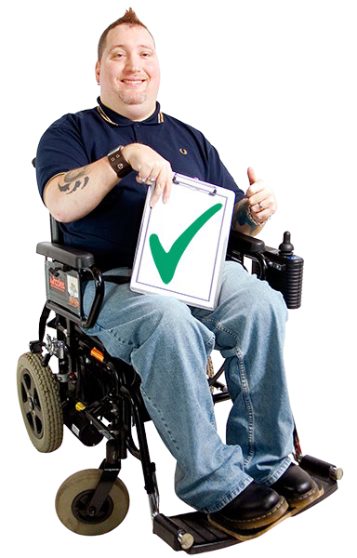
- Making sure new services and things we buy work well for people with disabilities.

- Making sure projects include people with disabilities and think about their rights and what they need.

- Making sure we include people with disabilities in our work in different countries.

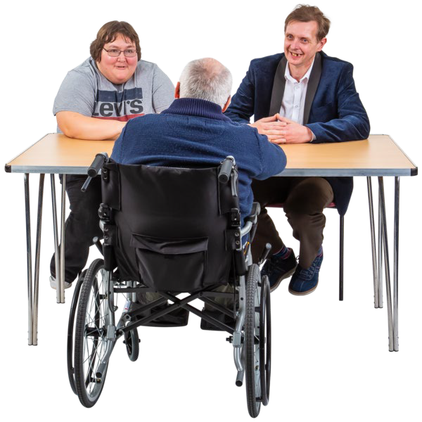
- Helping more people with disabilities to work for us and do well in their work.


- Making sure we have good communications about people with disabilities.
Communications are different ways we give out our information.

3. Approaches Requirements

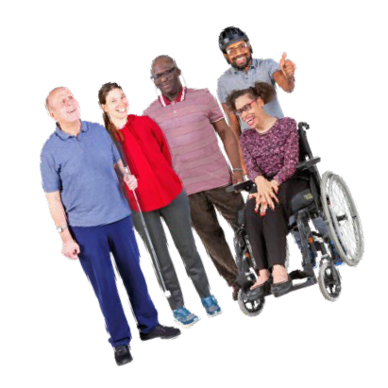
Some examples of our work
The main plan about our work has lots of information about people with disabilities and their rights.

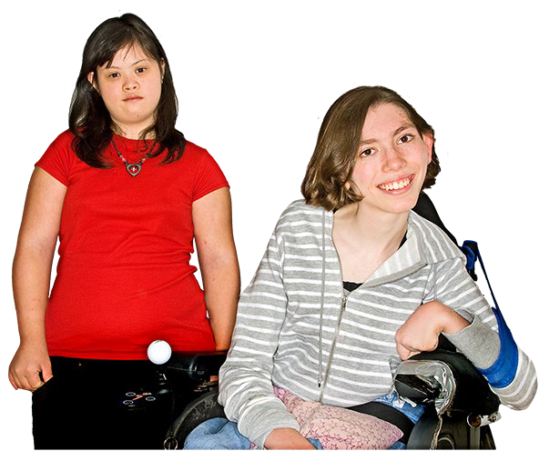
This includes information about the rights of women and young people with disabilities.

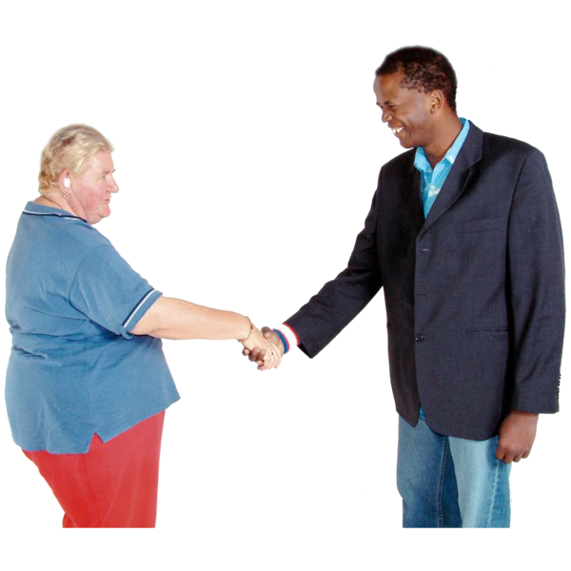
We often work with disability organisations and people with disabilities to find out what they think about things to do with disabilities.

We have done a lot of work to make some parts of what we do accessible for people with disabilities.


This includes having lots of our information online in formats that can be used by people with disabilities, like with screen readers.

3. Approaches Requirements

In 2023, 2 of our country offices were checked and given advice about how to make what they do more accessible.


We made new information about how to include people with disabilities and their rights when we ask for money for our projects.


In 2023, we made new rules about how we include people with disabilities in our work in different countries.

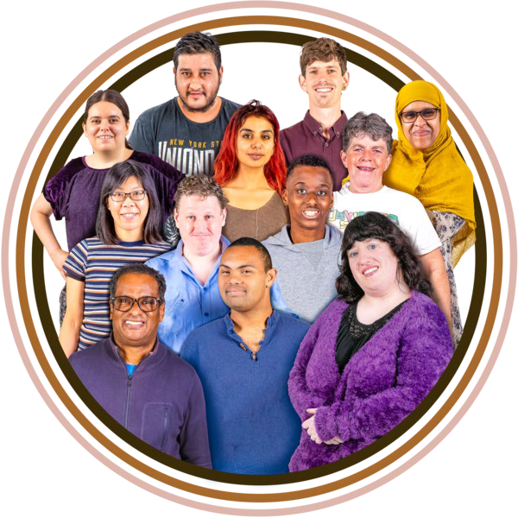
We follow UN rules to make sure we have lots of different types of people working for us, learning new skills and doing well in their work.
This includes people with disabilities.

3. Approaches Requirements




We follow information in the UNDIS to make sure we have good communications about people with disabilities.
We want to
- talk about people with disabilities in the right way
- help other people to know about people with disabilities and their rights.

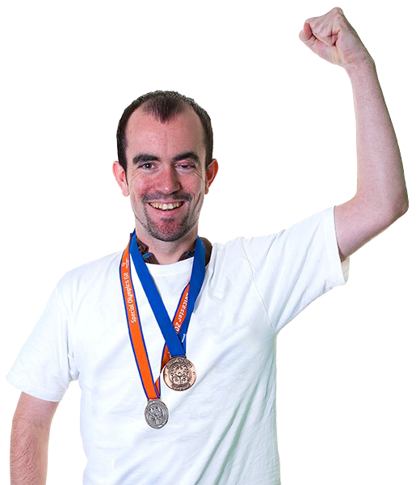
As part of our work about communications, we started a project with a big sports organisation in 2021.


In 2023, our work about communications was part of a project about the UN being 75 years old.

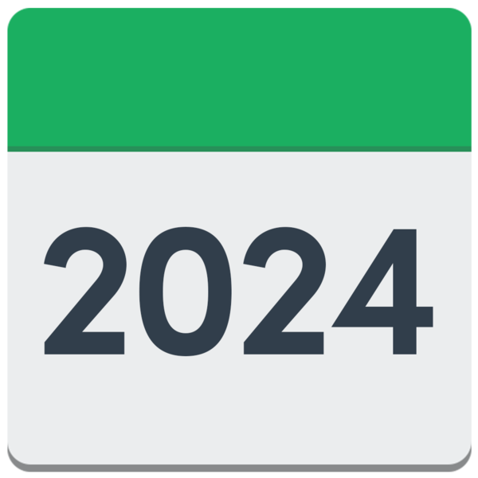
There is more we need to do in 2024
On the next page, we tell you about some of the things we will do in 2024.

3. Approaches Requirements

We will think about using a UN system to help us have better information about the work we do to include people with disabilities.

We will find a better way to check how people with disabilities are having a say in our work.

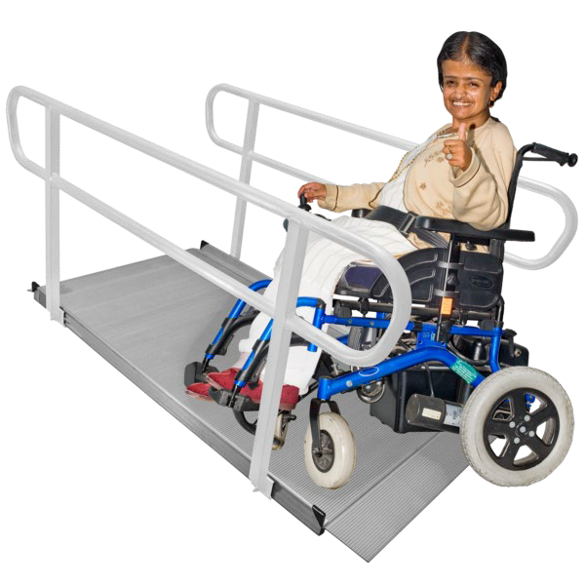

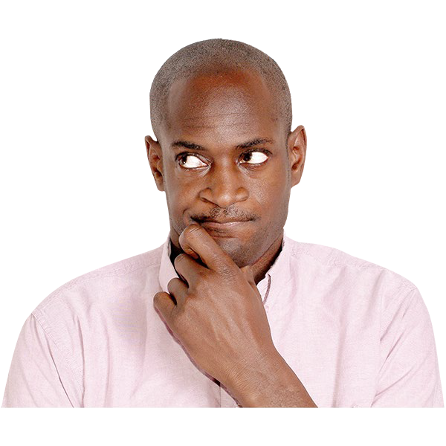
We will do work to make parts of what we do more accessible for people with disabilities, like computers, buildings and equipment.

We will think about asking organisations who care about accessibility to give us money to help make our accessibility better.

We will work hard to make sure new services and things we buy work well for people with disabilities.


We will do a check to make sure our communications about people with disabilities are good.

Missing

The rating Missing means we are not doing enough.


For 2023, the report says there are no areas of work we are not doing enough for.

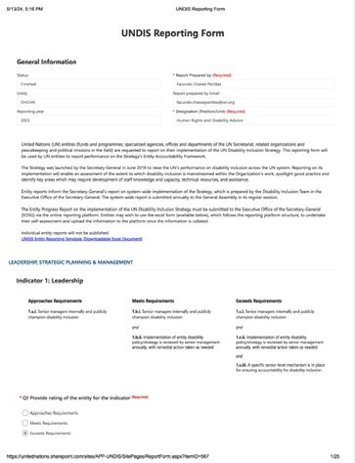

The full version of this document is called UNDIS Reporting Form.
The reporting year is 2023.

