**Call for Input: Violence and the Right to Food**

**Situation in Jordan**

**Question One: Describe the nature and degree of violence prevalent in different parts of a food system in your country or community.**

As part of an elaborate scheme by Israel to damage the agricultural sector along the Jordan River's bank on the Jordanian side, deliberate tree burning incidents erupt across the Jordan Valley nearly every year. As the first stage of the food production process and the cornerstone of national food sovereignty, Jordanian farms are being destroyed in a systematic manner, which has severe negative repercussions on the country's food security. Israel intentionally ignites the fires at the beginning of the summer season when the water level in the Jordan River is low under the guise of removing dry grass along the border which has the intended effect of accelerating their spread across the border causing substantial losses to farmers who own land adjacent to the border, including the eradication of crops and trees (e.g., citrus and olive trees), as well as infrastructure damage (e.g., equipment and irrigation lines). For example, intentional Israeli fires broke out in the northern Jordan Valley in May 2021, destroying an estimated 500 dunums of agricultural lands which resulted in huge losses incurred by Jordanian farmers. These fires are ignited by Israel as part of an old strategy looking to displace farmers and destroy farmlands in the Jordan Valley, which is considered one of the most fertile agricultural lands in the region and the “food basket” of Jordan. Due to the sensitivity of borderlines and the difficulty of civil defense cadres accessing the farms, it is difficult to control these malicious attacks, leaving the farmers to fend for themselves with no access to the resources necessary to protect themselves from the damages caused by the fires.

In addition to the arson attacks, Israel continues to expand its hydro-hegemony over Jordan’s water resources through different strategies such as claiming ownership over the northern sources of the Jordan River, including Lake Tiberias, over-pumping and diverting excess water for development projects as well as polluting the southern part of the river with agricultural waste. These actions collectively have significantly reduced the quality of the river’s water, rendering the water reaching Jordan to be unsuitable for agricultural use and exacerbating Jordan’s water crisis and food insecurity.

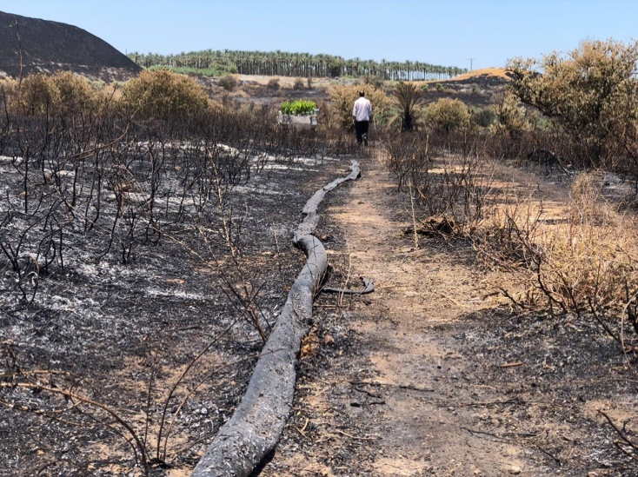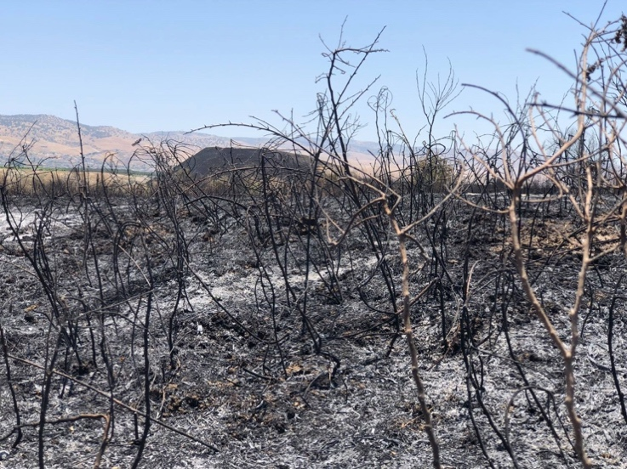

**Question Two: Provide examples of laws, policies, or campaigns that have successfully prevented or reduced violence in a food system, held perpetrators accountable, or provided reparation.**

The Jordanian government and the Jordan Farmers Union have long demanded that Israel compensates Jordanian farmers for damages they suffered as a result of these fires. However, Israel has not paid out any compensation for the May 2021 fire attacks to date. Furthermore, although the Jordanian government agreed to compensate farmers from the Agricultural Risk Fund, according to the local farmers it has yet to do so. Despite the devastating consequences of these violent attacks, farmers are left to suffer alone.

To provide protection against these attacks and prevent the spreading of the deliberate fires, we require mechanisms for accountability and compensation in addition to technical tools and resources, such as provision of equipment and capacity building. It is necessary to establish an adequate compensation structure that accounts for all costs, including fixed and recurrent expenses as well as direct and indirect losses. Furthermore, it’s crucial to raise the issue of the Jordan Valley fires before the International Criminal Court in order to pressure Israel into making reparations and prevent these atrocities from reoccurring.

**Question Three: Indicate and describe what population groups and peoples are targets of this violence?**

Although the Jordanian agricultural sector as a whole is impacted by these attacks, Jordanian farmers who own land in the Jordan Valley are affected the most. The Jordan Valley is the most fertile region in Jordan and has thousands of farm units due to its unique climate, which allows for year-round agricultural productivity. However, farmers in the region are exposed to numerous challenges that are made worse by these attacks leading to widespread poverty and youth unemployment as most families depend on agriculture for a source of income.

**Question Four: How have authorities and people created spaces of sanctuary or protection from violence within food systems?**

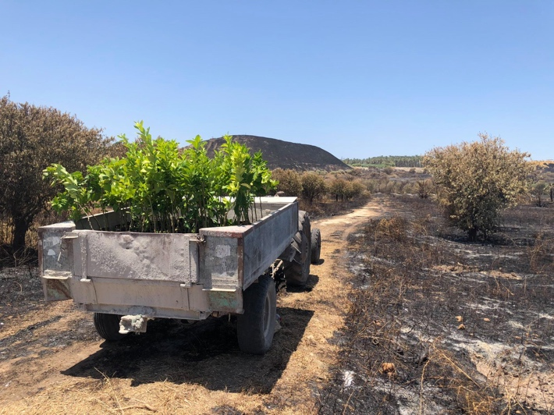Farmers have repeatedly asked for official parties to step in to provide them with compensation and find drastic solutions to tackle these frequent fires, but as was already indicated, these demands often go unmet. In response to the lack of action from official parties and civil society organizations, the Arab Group for the Protection of Nature (APN) has stepped up to address farmers’ needs and offer some form of compensation. APN has carried out many recovery and mobilization campaigns to compensate farmers in the northern Jordan Valley for losses caused by the Israeli fires. As part of the campaign, APN provided farmers with hundreds of fruit trees and contacted a number of companies working in the agricultural sector, and urged them to contribute to the installment of irrigation pipes. Moreover, APN documented these attacks and submitted an official report to public entities, and launched awareness campaigns to increase public visibility of these attacks. These efforts have helped alleviate some of the farmers' burdens and supported them in rebuilding what they have lost.

**\*note: Please contact APN (**[**gm@apnature.org**](mailto:gm@apnature.org)**/**[**advocacy@apnature.org**](mailto:advocacy@apnature.org)**) for more information and resources.**