Response to the questionnaire: “A place to live in dignity for all: Making housing affordable”
State: Thailand
Submitting entities: Ministry of Social Development and Human Security
(National Housing Authority of Thailand and Department and
Social Development and Welfare)

1. National law, policies and jurisprudence relating to affordable housing

Constitution of the Kingdom of Thailand B.E. 2560 (2017)

Section 71 states that “The State should strengthen the family unit which is an important basic element of society, provide an appropriate accommodation, promote and develop the enhancement of health in order to enable people to have good health and strong mind, as well as promote and develop excellence in sports and to maximize benefits for the people…”

Thailand’s National Strategy B.E. 2561-2580 (2018-2037)

Housing affordability are addressed within the areas of competitiveness enhancement, social cohesion and just society, and sustainable growth, in 3 master plans under the Strategy, namely, the 6th Master Plan: Smart Livable Cities, the 13th Master Plan: Well-being Promotion, and the 17th Master Plan: Social Equality and Social Protection. The Strategy also emphasizes the importance of provision and management of housing as a social protection mechanism.
Responsible authorities also aim to promote well-being of the citizens under the vision of “Stability, Prosperity, and Sustainability” by utilizing development methods based on the philosophy of Sufficiency Economy.
The strategy also emphasizes the importance of providing individuals with employment opportunities and sufficient financial resources for promoting their well-being. To achieve these goals, the strategy includes several initiatives such as Strategy 4: Creating Equal Social Opportunities, Strategy 5: Environmental Quality of Life Growth, Strategy 6: Rebalancing and Development of Public Management System, and the 17th Master Plan: Equality and Social Security for Housing and Property Safety.
The 13th National Economic and Social Development Plan B.E.2566-2570 (2023-2027)

The Plan sets out 5 major goals with 13 milestones, which include the issues of adequate and affordable housing in Goal 3: Creating a society of opportunity and equality, Milestone 8: Reducing spatial inequality in terms of economy and access to quality public services, and Milestone 9: Facilitating upward social mobility and reducing income and wealth disparities. According to the Plan, affordable housing provision is considered a mechanism to reduce social inequality and increase social welfare for all.

The 20-Year Housing Development Master Plan B.E. 2560-2579 (2017-2036);
The Plan, which is a revision of 10-Year Housing Development Plan B.E. 2559-2579 (2016-2036), was formulated with a main purpose to promote accessibility of housing with an adequate standard for all in the society on a non-discriminatory basis.
The adequate housing and housing affordability concepts from the SDG 11 and New Urban Agenda were also incorporated in the Master Plan through the vision of “Housing for All”.
The Government’s Policy Statement B.E. 2562 (2019)

The Statement includes 12 Core Policies and 12 Urgent Policies. Issues of decent and affordable housing are mentioned in the 7th core policy: Enhancing the country’s strength through a bottom-up approach, resolving housing and arable land problems to ensure livable communities by providing accommodations, and developing occupational skills and implementing comprehensive urban development plans to create resilient communities and safe societies.
Furthermore, the first urgent policy statement of solving bread-and-butter concerns focuses on, inter alia, improving tax and mortgage measures in order for people to own property in accordance with their financial capacity.

2. Data and trends on housing affordability

National Statistical Office’s measurement on housing data

The National Statistical Office (NSO) regularly conducts Household Socio-Economic Condition Survey. The 2021 survey presents data, including household income, household expenditure, household debt, indebted household: Formal and informal loan, comparison of household income, household expenditure, and household debt classified by types of occupations, and percentage of indebted household and average amount of debt per all household (2011-2021).
To enable effective housing supply to the market, National Housing Authority (NHA) developed a Criteria for Estimation of Household Income and Housing Affordability, in order to identify the target groups and their ability to pay for housing, as well as, to provide housing product relative to their income levels. The Criteria can be used as a measure of housing overburden rate, considering the housing price relative to both income and expenditure for housing of households. (see ANNEX)

Additionally, the NSO also conducts a biennial household socio-economic survey with a focus on income, collecting and monitoring data on household income, outgoings, and living requirements, suggesting housing affordability. The data collection of housing in Thailand is collected based on these following criteria;
• Rental property information is categorised as ownership of the house, rental of the house, etc.
• Types of accommodation include detached houses, row houses, townhouses, and semi-detached houses, and apartments.
• Construction materials include concrete, wood, and other locally available and used materials.
• Other expenses include dwelling rent, water costs, and energy bills.

Households, persons, or groups that are at particular risk of being exposed to housing affordability in Thailand:
According to the National Statistical Office (NSO) survey of Socio-Economic Condition of Households in 2021, Thailand has 22.624 million households, of which almost 74 per cent of the total households have housing ownership. The households who were considered possess housing ownership cover only those who had the housing and land ownership or had hire-purchase contracts with banking institutions. Those who own houses built on rented land/public lands and rental houses, as well as those who lived in welfare housing, are not included. The majority of those who have no housing ownership are the low-income (about 3.667 million households). Comparing to the previous survey in 2019, households with housing ownership increase about 1.70 per cent (from 72.17 million households to 73.90 million households).

3. Causes and Consequences of housing unaffordability

Data on the factors contributing to housing unaffordability to certain persons or groups:
According to the Analytical Study for Projection of Housing Demand after COVID-19 by the NHA and the National Institute of Development Administration (NIDA) in 2022, rapid increase of housing price has worsened housing affordability. There has been housing shortage and congested community expansion in urban areas throughout the country. Vertical housing is sub-standard. Community housings do not have basic infrastructure. The urban encroachment has been found. Reasons for housing unaffordability include (i) ability to pay for housing (measured by the relationship between household income and housing cost (ii) Lack of decent land for housing in urban areas and (iii) Continued rising of construction costs.

Percentage of land owned or otherwise controlled by the State or other public entities, as contrasted with private entities:
In Thailand, land tenure is either private or public. Private land might be owned outright or leased. Each landowner may have a title deed or a provisional land certificate over their property. According to the Land Code Promulgating Act B.E. 2497 (1954), public land is all land that is not claimed by private ownership and includes lands owned by the government such as forests and common land.

Impacts of housing unaffordability to the capacity of individuals and families to enjoy their other human rights including rights to work, health, education, and access to personal security in all its dimensions:
The urban poor households live in insecure housing and lands because they cannot afford the high housing price in the formal housing market. They also lack access to home loans from established financial institutions, as well as essential infrastructure and government services, which has a detrimental influence on health, education, income, and housing. Housing insecurity may have a multiplier effect on the nation's economic and social security.

4. Laws, policies, programmes and practices aiming to ensure that housing is affordable to all without discrimination

Department of Social Development and Welfare, Ministry of Social Development and Human Security:
Between 2021 and 2022, the Department had conducted a survey of the homeless population. The number of new homeless people increased from 2,719 to 3,534 people nationwide (1,868 in Bangkok and 1,666 in other parts of the country).
The Department has implemented the “Co-pay Rental Room Project” and used the area around Hua Lamphong Train Station in Bangkok, in which over 135 homeless people were residing, as a pilot area. The project operates by the 60:60 co-pay system, where rentees pay 60 per cent of the rental price, and the government agencies subsidize for 60 per cent of the rental price. The 20 per cent surplus is then contributed to the fund managed by the beneficiary themselves, which is used for other purposes including vocational and skill training. Homeless peoples were included in developing the project through public hearing. The Department has worked in collaboration with the Thai Health Promotion Foundation and the Institute of Asian Studies, Chulalongkorn University, and several NGOs/CSOs to implement the project.

Community Organizations Development Institute (CODI):
CODI is a public organization under the Ministry of Social Development and Human Security (MSDH) with a mission to strengthen communities and their organizations in both urban and rural areas. In addition to utilizing government budgets to operate its programmes, CODI also provides soft loans called the “revolving fund”, which are offered to communities’ cooperatives and networks in order to enable them to undertake their own development initiatives in various areas such as housing, land purchase, livelihood, and community enterprises. As a public organization, CODI has flexibility to channel government funds to facilitate development process driven by communities themselves.
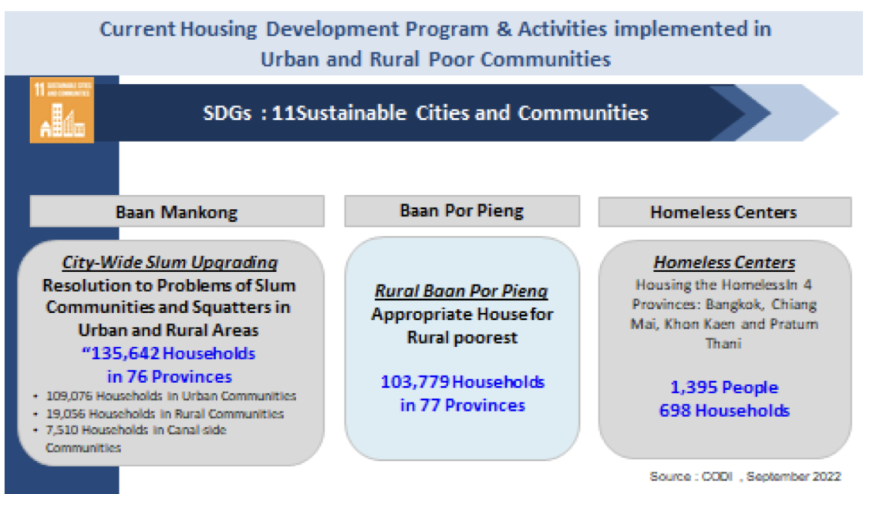
Baan Mankong Collective Housing Programme (or “Secure housing” Programme) was launched in January 2003 under the supervision of CODI, as part of its efforts to address housing problems of the country’s poorest urban citizens. The Programme finances infrastructure subsidies from government funds by providing direct soft housing and land loans for poor communities, and allows them to self-manage the loans to improve their housing conditions, environment, basic services, and tenure security. Instead of delivering housing units to individual poor families, the Programme puts Thailand slum communities (and their networked communities) at the center of a process of developing long-term, sustainable and comprehensive solutions to land and housing problems in Thai cities.
Each community works in close collaboration with local government, professionals, universities and NGOs to develop plans and projects for their own cities, and, as mentioned earlier, CODI will provide infrastructure subsidies in the form of soft housing loans directly to the communities.
CODI has also offered several other types of loans to community organizations since 1992 to support their efforts in tackling problems according to their specific needs, and to supplement the utilization of their own collective savings.
CODI currently provides 4 types of loans, namely:
(1) Loan for housing and land: The Loan is available for community organizations (both formally registered as cooperatives and informal savings groups) for a purpose of land purchasing and/or house building under the Baan Mankong Programme. The maximum loan amount per household is 360,000 THB (11,250 USD) and must not exceed 90 per cent of total house construction cost. The annual interest rate on housing loans is fixed at 4 per cent, and the maximum repayment term is 20 years.
(2) Loan for holistic development: This type of loan aims to enable communities to collectively address their economic and/or social problems. To obtain the loan, each community must submit a proposal identifying common problems its members are facing and how it will use the loan to tackle such problems. For example, a loan can be used to refinance high-interest debts community members owed to informal money lenders. Holistic development loans can also be used to support economic activities or green production of food within the community. The annual interest rate for this type of loan is 3.5per cent, and the maximum repayment term is ten years.
(3) Loan for community enterprises: The Loan is available for community organizations planning to set up community-owned businesses to generate income for their family members. Community enterprise loans can be used, for instance, to start community businesses such as retail shops, and motorcycle repair garages, and to set up production units for community product manufacture of various sorts. The annual interest rate for this type of loan is 4 per cent, and the repayment term must not exceed ten years.
(4) Revolving loan: The purpose of the revolving loan is for networks or community groups that require short-term capital for bridging finance situation while building up their internal funds, or to use as working capital for community enterprises. The annual interest rate of loans is 6 per cent, and the repayment term is 3 years.

National Housing Authority (NHA):
The National Housing Authority (NHA) is a state-owned enterprise under the supervision of the MSDHS who plays a vital role in implementing policies and programmes to address the needs of low-income earners and ensure that all individuals have access to safe, secure, and affordable housing, regardless of their financial situation. The NHA is committed to developing housing projects that align with various national policies and strategic plans, while also aiming to further advance related Sustainable Development Goals (SDGs), particularly SDG 11 (sustainable cities and communities), and working in line with the New Urban Agenda (NUA).
The NHA has collaborated with different agencies, including the Electricity Generating Authority of Thailand (EGAT) in developing the Smart and Sustainable Community (SSC) project aiming to drive sustainable development through a
four-dimensional approach that includes participation and responsibility, environmental security, economic security, and social health.
So far, NHA established 4 housing projects as follows:
(1) Ban Suk Pracha Housing Project
This project is specifically designed to address the needs of low-income communities and seeks to address the issues of housing, job availability, and income generation through a parallel community economy vision. This vision aims to raise the overall quality of life of residents by aligning with the guiding principles of the Sufficiency Economy Philosophy. One of the key aspects of this project is offering affordable rent rates, allowing residents to secure a comfortable living arrangement that meets their budgetary constraints. Additionally, the project also provides designated areas for agriculture, which allow residents to engage in sustainable activities.
The project has been established in 6 provinces across the country, namely, Samut Sakhorn, Mahasarakham, Surin, Ubon-rachathani, Lampang, and Nakhornsawan. Currently, the project has two pilot initiatives in Bangkok, with total 572 units under construction. (302 units under the Baan Suk Pracha Chalong Krung project in Nong Chok district, Bangkok, and 270 units under the Baan Suk Pracha Romklao project in Lat Krabang district, Bangkok.)
(2) Sukkasem Housing Project
The Sukkasem housing project is an initiative aimed at providing low-rent accommodation for the elderly, civil servants, and retired government officers. The five-story buildings, serviced by elevators, feature healthcare centers, common areas, event areas, and other facilities designed to cater to the overall well-being of the residents. The NHA aims to operate total 4,089 units under this initiative between 2022 and 2028, ensuring that a significant number of individuals can benefit from the project’s low-rent accommodation.
(3) Din Dang Urban Renewal Project
The Din Daeng Urban Renewal Project, according to the Din Dang Master Plan (2016-2024), is divided into four phases in a period of eight years. The development project is based on Smart City principles and ensures the involvement the Din Daeng community throughout the process by establishing a community committee. The Project aims to address diverse needs and challenges faced by the community, as well as incorporating innovative solutions to enhance the quality of life, security, and sustainability of the area while also driving overall economic development.
(4) Housing Development Project along the Mass Project Transit
This housing development project is a collaborative effort of the NHA and Mass Rapid Transit Authority (MRTA), which aligns with the government’s policy of pooling resources from state enterprise agencies. The objective is to construct housing units along the mass transit lines and develop residential areas in line with the urban development directions in order to create self-sustainable communities that are easily accessible to the mass transit system and public transportation.
In addition, the NHA has implemented the Hire-purchase programme,
to assist low-income groups and those with poor creditworthiness, such as the
self-employed or those with an irregular income. Under the programme, they were able to become homeowners by obtaining access to mortgage credit. Also, homebuyers are allowed to buy properties through hire-purchase for a period of approximately 3 - 5 years. If they can prove their creditworthiness through the ability to pay the hire-purchase monthly instalments regularly, they would then be eligible to become mortgagers. Such initiative has become one of the tools in assisting low-income earners to buy decent housing at affordable prices on the open market. So far, the NHA has rendered housing financial assistance to about 33,458 contracts under the hire-purchase programme.

**********************
ANNEX

Estimation of Household Income and Housing Affordability 2023
(National Scale)

Target Groups (Percentiles) | Income (Baht) | Ability for installment repayment (Baht/month) |  | Affordable housing prices (Baht) | Ownership
Lower low income (Congested community) (less than 20) | Less than 11,000 | 10% | ≤ 1,600.00 | ≤ 141,881 | Rent
Low income (21-40) | 11,001-16,600 | 15% | 1,615.15 -2,490.00 | 212,840 - 32,166 | Rent
Upper low income  (41-60) | 16,601-24,600 | 15% | 2,490.15 -3,690.00 | 321,186 - 475,945 | Hire-purchase/  Purchase
Lower middle income  (61-70) | 24,601-30,400 | 20% | 4,920.20 -6,080.00 | 634,620 - 784,214 | Hire-purchase/  Purchase
Middle income (71-80) | 30,401-39,300 | 20% | 6,080.20 -7,860.00 | 784,239 -1,013,803 | Hire-purchase/  Purchase
Upper middle (81-90) | 39,300-56,200 | 20% | 7,860.20 -11,240.00 | 1,013,828 - 1,449,753 | Hire-purchase/  Purchase
High income ( 91) | 56,200 | 20% | ≥ 11,240.20 | ≥ 1,447,789 | Hire-purchase/  Purchase

Notes
1. Criteria is developed by the Department of Housing Development Studies Department, NHA, 2023.
2. Assumption of interest rate of MRR 6.75% per annum for 20 years
3. NHA products are mainly for the target groups of percentile 21 - 80

https://www.krisdika.go.th/documents/67673/181643/837163_0001.pdf/3d0aab10-e61f-03a4-136a-75003ce4c625
data.opendevelopmentmekong.net/dataset/a9536973-06ad-4a26-b4d5-9f740f2433bd/resource/71078328-fac1-4cd5-a718-c342cfa49ae7/download/national-strategy-summary.pdf
The information can be accessed via www.nso.go.th.

