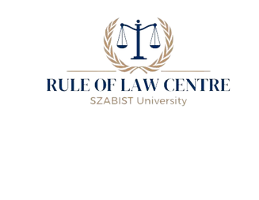



**Submission by SZABIST University for the United Nations High**

**Commissioner' s Report on**

**Resettlement as a Human Rights Issue**

KAINAAT GOHAR HAFSA JOHAR IQBAL MARIAM EEMAN ZAHID

Table of Contents

## 01.

CONTENTS

Introduction

## 02.

Project Induced Displacement

## 03.

Conflict Induced Displacement

## 05.

Nature Induced Displacement

## 06.

Humanitarian Displacement

## 08.

Conclusion

Pakistan has a long history of providing relief to internally displaced persons (IDPs), dating back to its formation in 1947 when larger numbers of people migrated and rebuilt their lives in this newly established land. The primary legal framework addressing the resettlement of IDPs in Pakistan is the Land Acquisition Act of 1894[1]. This law details procedures for land acquisition, ensuring fair compensation, and resettling of affected communities.

INTRODUCTION

The main focus of this report is to examine the effectiveness of the legal frameworks and their provisions in practice.

### It aims to determine whether these legal measures are actively implemented to provide tangible relief to IDPs or if they remain largely theoretical. The issue of resettlement is a global concern, not limited to Pakistan. According to the UNHCR, the global need for resettlement is projected to rise to 2,003,982 individuals[2]. The UNHCR also notes that this increase is observed across all regions, with the most significant rise seen in the Asia and MENA (Middle East and North Africa) regions.

**0 1**

# PROJECT INDUCED DISPLACEMENT

“*The resettlement actions are sometimes considered as being projects within projects*” (Reddy 2015)[3]. This quote highlights the significant impact of displacement caused by large-scale projects.

### Project-induced displacement, also known as involuntary resettlement, occurs when communities are forced to relocate due to large-scale initiatives such as dam construction, mining, and infrastructure development.

One notable example of project-induced displacement in Pakistan is the construction of the Tarbela Dam, which began in 1967 in the Haripur district on the Indus River in Khyber Pakhtunkhwa[4].

Tarbela Dam, the world's largest earth-filled dam, was completed in 1976 at a cost of 2.85 billion USD.

Its primary purpose was to compensate for the loss of the eastern river, and it serves multiple functions including irrigation, hydroelectric power generation, and flood control[5]. The project was in compliance with the provisions of the Land Acquisition Act and was held to be for the public purpose.[6]

This project complied with the Land Acquisition Act 1894, particularly Section 4, which outlines the publication of preliminary

notifications and the powers of officers. It also

defines "public purpose." This definition was upheld in the case of Muhammed Akbar and 7 others v. "public purpose." This definition was upheld in the case of Muhammed Akbar and 7 others v. The Commissioner, Rawalpindi Division, and 2 others.

Therefore, the construction of the Tarbela Dam complied with this Act, satisfying the

requirement of public purpose.

"

According to The Basic principle (United Nations 2007a, p. 13) ‘persons, groups or communities affected by an eviction should not suffer detriment to their human rights, including their right to the progressive realization of the right to adequate housing’[7].

During the preparation of the Ghazi-Barotha Hydropower Project in Pakistan, it was discovered that 1,440 households displaced by the Tarbela Dam had been waiting for almost 20 years to be allocated replacement lands. The Bank responded by requiring the preparation of an acceptable action plan as a condition for the project's effectiveness.

It should be noted that if compensation is not provided in a timely and appropriate manner, the resettlement would be considered a 'forceful eviction,' which goes

against international standards[8]. **0 2**

# CONFLICT INDUCED DISPLACEMENT

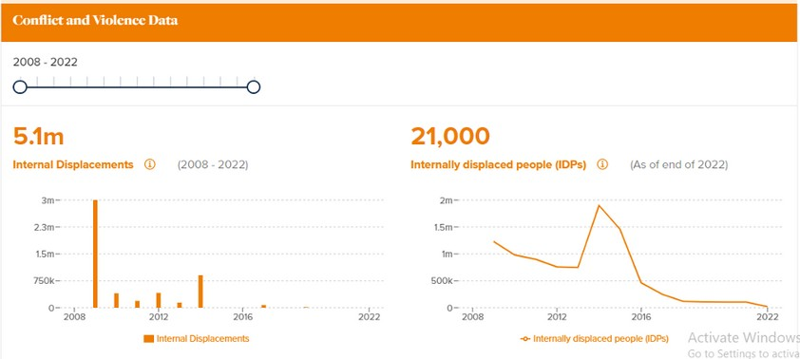

Conflict-induced displacement has resulted in approximately 5.1 million people being internally displaced in Pakistan[9]. The most affected regions are Kurram, Khyber, and South Waziristan. These areas have experienced significant atrocities, including the destruction of homes, villages, and places of worship, leading to widespread displacement.

In Kurram, militant group attacks destroyed 7,000 homes, 60 villages, and 95 places of worship, displacing 50,000 people[10]. Military operations conducted in response further exacerbated civilian displacement.

The consequences of displacement, particularly between 2009 and 2010, included lack of employment, safe drinking water, sanitation, healthcare, and education. These issues affected not only IDPs but also residents of metropolitan areas due to insufficient government resources and compensation, leading to an increase in criminal activities such as robbery and assassination[11].

However, there were steps taken to provide relief to the IDPs. The Pakistan Army issued a public apology in April 2010 for civilian casualties resulting from a military operation in the Tirah Valley of the Khyber area in FATA.

Tribesmen reported that 61 civilians were killed and 21 injured, whereas official reports initially claimed 42 insurgents were killed. In addition to the apology, the army chief promised compensation of Rs 20 million for the victims and to cover medical expenses for the injured[12]. The apology also included commitments to prevent similar incidents in the future. Furthermore, the federal government promised an additional compensation package for the victims.

The following extracts highlight the challenges faced by Internally Displaced Persons (IDPs) during conflict-induced displacement:

‘Approximately three million people were required to move from NW within three days only. The migration was very difficult for us because there is just a single route from NW to Bannu. The government should have informed us before the operation. In such an emergency, to protect our lives, we could not take anything 129 from our homes and left our animals, i.e. cows, goats, and donkeys.’ - study participant, CIPS migration.

‘We preferred to live off-camp due to our family’s purdah. In the camp, there was no proper purdah system and there was no separate washroom for females. That is why our females felt insecure and shy using the washroom during the daytime. Our female decided to

use the washroom at night due to the long mixed line of males…. They also felt insecure and wanted to leave the camp because NGOs and media channels for interviews and pictures frequently approached them.’ - study participant, CIPS migration.

These statements underscore the insufficient time allotted to citizens to evacuate their homes, revealing a lack of free, prior, and informed consent, as they were instructed to leave their homes amid the operation[13]. Living in camps posed a significant challenge, particularly due to the strong influence of purdah and conservative values deeply rooted in Khyber Pakhtunkhwa's (KPK) culture[14]. Additionally, this situation highlights that certain groups, such as pregnant females and the elderly, are at higher risk during displacement.

In South Waziristan, nearly 30,000 people returned in two phases, with promises of basic utilities such as healthcare, education, access to clean drinking water, and electricity. The majority of the returnees were children. To help restart their livelihoods, these families were promised tools and seeds. Although fulfilling such generous pledges is often rare, the distribution of 2,000 shelter kits and 8,500 cash grants was carried out by the FDMA along with a couple of UNHCR's implementing partners[15].

As data collection on internally displaced persons (IDPs) in Pakistan is inadequate, as a significant number of IDPs from the Federally Administered Tribal Areas (FATA), specifically Bajaur, Mohmand, and Orakzai agencies, are not being accounted for by the government, despite most data originating from these areas. Additionally, women face the obstacle of lacking Computerized National Identity Cards (CNICs) and registration, which hinders their ability to seek relief. While it is crucial for the government to fulfill its responsibilities, when it has the authority to evacuate people from their homes without consent, it should, at the very least, provide aid without such stringent requirements.[16]

# NATURAL DISASTER DISPLACEMENT

[17]

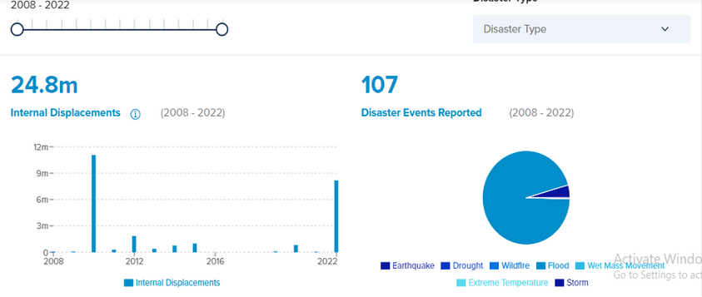

In October 2005, an earthquake in Azad Kashmir and parts of Khyber Pakhtunkhwa (KPK) resulted in approximately 73,000 deaths, 200,000 injuries, and the displacement of as many as

* 1. million people. Additionally, floods in Baluchistan displaced 300,000 people. In 2010, severe flooding triggered by heavy monsoon rains submerged 20 percent of the country, affecting around 10 percent of Pakistan's population. This disaster caused significant loss of property, infrastructure, and income. According to the Asian Development Bank (ADB), 11 million people were displaced. Many survivors experienced further flooding in the following year, accounting for 35 percent of the 4 million people displaced. By the end of the year, around 500,000 households had returned to their origins, but approximately 660,000 individuals remained displaced[18].

The 2010 floods impacted nearly every province of Pakistan, while the 2011 floods were mainly concentrated in Sindh and parts of Baluchistan. Sindh was the most affected province over the two years, with around seven million displaced individuals. At the time of registration, 90 percent of those displaced in 2010 expressed a desire to return to their homes. However, due to extensive damage to roads, schools, medical facilities, and government offices, many were displaced closer to their original locations. By the end of 2011, there was an urgent need for housing and emergency relief in Sindh villages. According to the Multi-Sector Needs Assessment (MSNA), both men and women prioritized housing and livelihoods as their greatest needs[19].

Although livelihood support may not seem like a pressing issue, the feudal culture in Sindh is strong, with the majority of the population working for landowners and agricultural landlords (waderas). As a result, some displaced households were reluctant to return to their origins for fear of being held accountable for destroyed crops due to flooding and having to repay the money received for seeds. Faced with the prospect of returning to their old lives as bonded

laborers, many decided to pursue alternative livelihoods near their homes[20]. **0 5**

# HUMANITARIAN RESETTLEMENT

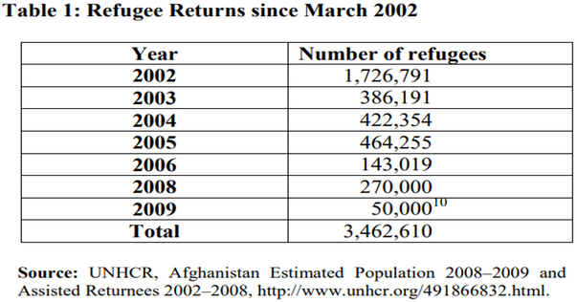

From 1980 to 2002, Afghans constituted the world's largest refugee population seeking asylum in Pakistan[21]. In 2002, the Pakistani government entered into a tripartite agreement with Afghanistan and the UNHCR to facilitate the voluntary return of Afghan refugees. However, priorities shifted in 2005 following the closure of refugee camps, which displaced around 200,000 refugees. By 2009, Pakistan's focus had shifted to addressing its own internal displacement challenges, despite having repatriated nearly 3.5 million Afghans since March 2002.

Historically, Pakistan has been generous in hosting Afghan refugees, adopting a liberal policy since the Soviet invasion in 1979. Although not a party to the Convention Relating to the Status of Refugees, Pakistan adheres to certain international laws, granting refugees basic rights such as access to healthcare and freedom of movement. However, challenges exist, including limited access to public schools for non-Afghan refugees and asylum seekers, and restrictions on refugees working in the formal sector[22].

Security and economic concerns led Pakistan to impose restrictions on Afghan refugees, including the cessation of Proof of Registration (POR) cards in 2007. The government viewed Afghan refugees as an economic burden, competing for jobs and affecting wage rates.

The situation highlighted the need for a balanced cost-benefit analysis of refugee presence, considering the significance of the informal sector. The arrival of refugees led to income distribution issues, causing tension in local communities while also incentivizing infrastructure development. Challenges such as tax revenue loss, environmental harm, and pressure on infrastructure underscore the complex nature of the Afghan refugee issue in Pakistan[23].

Social issues related to hosting Afghan refugees threatened Pakistan's national security, including narcotic smuggling and the funding of militant groups. The military operations tested the patience of both Afghan refugees and Pakistani citizens. Pakistan's strategy in the past involved using refugees and Pashtun people to achieve regional goals. Supporting the Afghan Taliban could be costly for Pakistan, potentially emboldening the Pakistani Taliban and radical groups worldwide, making them difficult to control. The Afghan refugee situation is expected to worsen due to ongoing conflicts and displacement within Pakistan, and finding a solution, as suggested by the Congressional Research Service report, may not be easy.

Pakistan has struggled to effectively manage the refugee problem, and supporting the Taliban encourages refugees to stay. International communities face challenges in funding humanitarian aid while inadvertently supporting Pakistan's actions. Balancing humane treatment with the fight against terrorism is a tough challenge.

In the previous year, the Government of Pakistan declared that all undocumented foreigners must leave by November 1st or face deportation. This announcement put nearly 1.7 million lives at risk, with police and authorities conducting mass detentions and seizing property and livestock. Approximately 300 families are returning to Afghanistan daily[24]. With winter approaching and 29.2 million people in need of humanitarian aid, the International Rescue Committee expressed serious concerns about limited resources. A director at Human Rights Watch urged authorities to end abuses and allow Afghans facing expulsion the opportunity to seek protection in Pakistan[25].

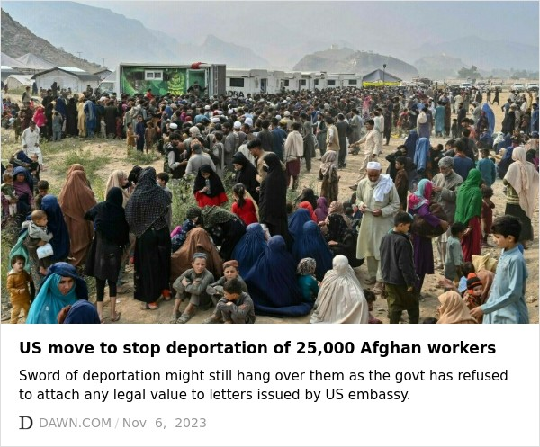

# CONCLUSION

A variety of crucial recommendations need to be taken into consideration in order to handle the complex issues of displacement in Pakistan. First and foremost, the current legislative frameworks controlling resettlement urgently require substantial change, especially as they relate to internally displaced people (IDPs). The successful application of legislation, such as the Land Acquisition Act of 1894, should be given top priority in this reform to guarantee prompt and appropriate payment and support with relocation. A concentrated effort should also be made to improve transparency and responsibility in the resettlement process, with procedures set up to handle complaints and guarantee the significant involvement of impacted communities.

Pakistan also has to further develop its ability to prepare for and respond to natural catastrophes, especially in view of the frequent occurrence of natural disasters like floods and earthquakes. This means making expenditures in community-based disaster risk reduction programmes, resilient infrastructure, and early warning systems. In order to guarantee that all impacted populations—including those from marginalized areas like the (FATA)—are appropriately accounted for and given the assistance they require, efforts should also be made to enhance data collection and management related to displacement.

Moreover, Pakistan should reaffirm its commitment to international humanitarian principles and obligations, particularly regarding the protection of refugees and asylum seekers. This includes ensuring access to essential services such as healthcare and education, as well as facilitating opportunities for livelihoods and self-reliance. Additionally, efforts should be made to address the root causes of displacement, including conflict and insecurity, through sustained peacebuilding and conflict resolution initiatives.

Overall, addressing the complex challenges of displacement in Pakistan requires a comprehensive and integrated approach, encompassing legal, policy, and institutional reforms, as well as sustained investment in disaster preparedness, humanitarian assistance, and conflict resolution efforts. By prioritizing the needs and rights of displaced populations, Pakistan can work towards building more resilient and inclusive communities, fostering sustainable development and peace for all its citizens.

[REF](https://www.internal-displacement.org/countries/pakistan/)[ERE](https://openknowledge.worldbank.org/server/api/core/bitstreams/c1454604-7bf7-534f-9530-afb8a66c9c99/content)NCES

1. Land Acquisition Act 1894

   <https://pakistancode.gov.pk/english/UY2FqaJw1-apaUY2Fqa-bJ6Z-sg-jjjjjjjjjjjjj>
2. Author: H HQ Copenhagen, UNCHR Projected Global Resettlement Needs 20023, (UNCHR, 8 June 2022)<<https://www.unhcr.org/sites/default/files/legacy-pdf/62b18e714.pdf>>accesed 24 Feb 2024
3. Author: F Frank, ‘Impact Assessment and Project Appraisal’ (2017) 35 issue 1,’Project-induced displacement and resettlement: from impoverishment risks to an opportunity for development?<<https://www.tandfonline.com/doi/full/10.1080/14615517.2017.1278671>>accessed 25 February 2024.
4. Author – Water Technology | Tarbela Dam Project, Haripur Project |<https://www.water-technology.net/projects/tarbela-dam-project/>
5. Ibid
6. Muhammad Akbar and 7 others v. The Commissioner, Rawalpindi Division and 2 others (P L D 1975 Lah 747)

   <https://advocategeneral.punjab.gov.pk/engro>
7. Author: Lidewij & Frank | A human rights based approach to project induced displacement and resettlement,2017 35 issue 1, Impact Assessment and Project Appraisal<<https://www.tandfonline.com/doi/full/10.1080/14615517.2016.1271538>>
8. Involuntary Resettlement Sourcebook Planning and Implementation in Development Projects, World Bank,2004 <<https://openknowledge.worldbank.org/server/api/core/bitstreams/c1454604-7bf7-534f-9530-afb8a66c9c99/content>>
9. Author – IDMC | Conflict and Violence Data | 2022 <<https://www.internal-displacement.org/countries/pakistan/>>
10. Internal Displacement Monitoring Centre (IDMC)|Displacement caused by conflict and natural disasters, achievements and challenges|2012 <file:///C:/Users/HP/Downloads/F_R%202.0%20(1).pdf>
11. Ibid
12. Author – N Najam U Din | Internal Displacement in Pakistan : Contemporary Challenges | 2010 | [xii] <https://www.humanitarianlibrary.org/sites/default/files/2014/02/22.pdf>
13. Author – M,A,S&F| Muhammad, Aizah, Syed & Faryal | Forced Migration and Conflict-Induced Displacement

    | 2020 |<https://pakistan.hss.de/download/publications/CIPSForced_Migration.pdf>
14. Ibid
15. Internal Displacement Monitoring Centre (IDMC)|Displacement caused by conflict and natural disasters, achievements and challenges|2012 <file:///C:/Users/HP/Downloads/F_R%202.0%20(1).pdf>
16. ibid
17. Author – IDMC | Disaster Data | 2022 <https://www.internal-displacement.org/countries/pakistan/>
18. Internal Displacement Monitoring Centre (IDMC)|Displacement caused by conflict and natural disasters, achievements and challenges|2012 <file:///C:/Users/HP/Downloads/F_R%202.0%20(1).pdf>
19. ibid
20. Ibid
21. Author – Frédéric & William F & W| The Afghan Refugees in Pakistan | 2011 <https://reliefweb.int/report/pakistan/afghan-refugees-pakistan>
22. Ibid
23. Ibid
24. Author – International Rescue Committee | 1.7 million Afghans Face Deportation from Pakistan | 2023

    <https://www.rescue.org/article/17-million-afghans-face-deportation-pakistan>
25. ibid