Report of the UN Special Rapporteur on the right to adequate housing to the
52nd session of the Human Rights Council
The right to adequate housing and climate change
Questionnaire

Impact of climate change on the right to adequate housing
In real life
- In your country, what have been the main effects of the climate crisis, on the enjoyment of the right to adequate housing? Please specify whether there have been any climate-induced impacts on the security of tenure, availability, affordability, accessibility, habitability, location and cultural adequacy of housing, including climate crisis related displacement.
About Tenants Victoria
Tenants Victoria is the peak body for Victorian renters, who number more than 2 million people. Our vision is for a safe, secure and affordable home for every Victorian renter in a fair housing system. For many renting is a permanent situation rather than a transition from the family home to home ownership. We believe all renters, including rooming house residents, should be able to afford a home that allows them to live full lives and contribute to their communities.
Each year, we assist over 10,000 renters by providing them with information, legal representation and advice, financial counselling, and outreach services. In addition, we aim to make the housing system fairer in several ways. We advocate for practices and attitudes that respect renting and for policies and laws that support the rights of renters. We increase the skills of the community workers who assist renters. We provide information that encourages rental providers and real estate agents to act responsibly.
About renters
Importantly, there is an increasingly growing wealth and hardship gap between renters and home-owners. In particular:
- Renters are increasingly poor. In 2017-18, 46.6% of Victorian renter households were considered ‘lower income’, and 43% of these were in rental hardship. A recent report from the Productivity Commission found rates of rental hardship in Australia have remained unchanged for the last 10 years.
- Victorian renters have a higher incidence of other experiences of vulnerabilities and disadvantage, as follows:
  - 51% of Victorian households including an Aboriginal person rented
  - About 33% of all renters spoke a language other than English
  - About 4.4% of renters are ‘profoundly disabled’
  - An increasing percentage of renters, or those with insecure housing, are older women
- Renters are renting for longer, as purchasing a home in Australia becomes increasingly unaffordable for many. Homeownership is dropping. There are reportedly about 100,000 people on the current social housing wait list in Victoria.
This greater likelihood of vulnerability is likely to increase sensitivity to climate change impacts such as extreme heat and flooding (i.e. those with disabilities, or older renters), increase exposure through reduced capacity to move premises, or mitigate the impacts of climate change through i.e. home modifications such as solar panels (due to relative poverty as well as reduced agency to engage in modifications due to lack of ownership) and so result in an overall reduction of ‘adaptive capacity’ of renters vis-à-vis home owners in Australia.
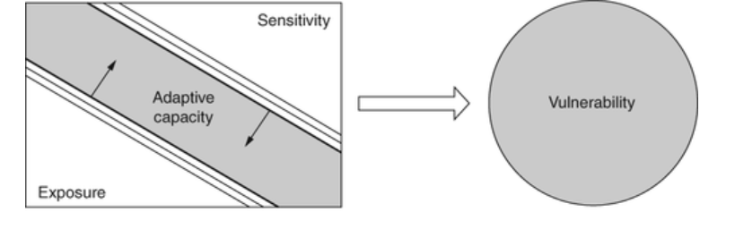
Figure 2: Vulnerability to climate events
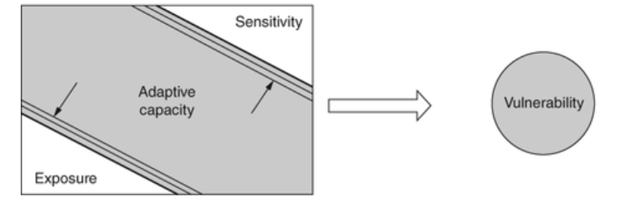
Figure 3: Higher adaptive capacity reduces exposure and sensitivity and overall vulnerability

Main impacts of climate change on renters’ enjoyment of right to adequate housing
The three key impacts on renters are as follows:
  - Reduced habitability – particularly of poorly maintained or low-quality rental stock that is impacted by extreme heat (particularly where there is insufficient insulation and/or air-conditioning) and/or mould during wet conditions. This reduced habitability has been found to have flow-on effects in relation to increased mental health episodes, family violence call outs, and other impacts on wellbeing measures – see boxed text overleaf.
  - Reduced affordability – due to increased living costs flowing from extreme heat, in particular in poorly maintained or low-quality rental stock (i.e. increased energy costs due to increased use of high-intensity energy and/or energy-inefficient appliances i.e. air-conditioners), this exacerbated when a house is poorly insulated; and/or costs for mould remediation where significant rain-fall in a year, and landlord unwilling to rectify. This has the largest impact on low-income renters, older renters, and those living with a disability; these groups are often most at risk of living in low-quality housing stock with old or inadequate appliances.
  - Disaster-related (bushfires, floods etc) impacts on rental housing in particular regional areas, impacting on availability, affordability, security of tenure, and habitability. See further detail below.

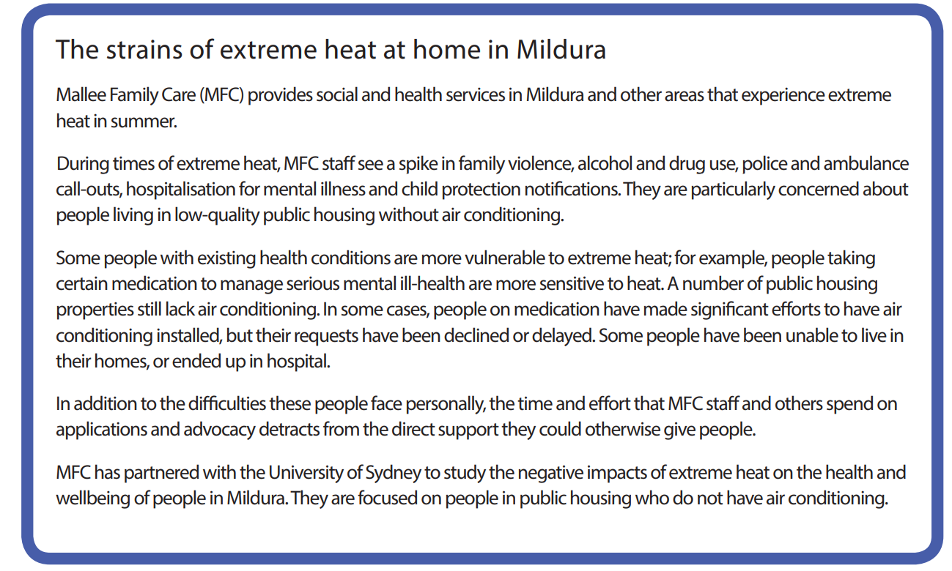

Disaster-related impacts
Victoria is in one of the most bushfire prone regions on Earth and research predicts the severity of bushfires will only increase. Two significant recent bushfire periods in Victoria were Black Saturday in 2009, and Black Summer between 2019-2020. The result of the Black Saturday bushfires was the destruction of 450,000 hectares of land, more than 2000 houses and the loss of 173 lives. During the more recent Victorian bushfire season of 2019-20, 1,507,895 hectares of land was burnt, 405 residences were destroyed, 53 residences were damaged, and 5 people lost their lives.
Tenancy Legal Need: Direct Impact of Bushfires on Renting
There is no clear data on how many rental properties were impacted by the Black Summer bushfires. Consumer Affairs Victoria lists the following common tenancy problems which arise out of bushfires with which the tenant may need legal assistance with:
- Ending the lease when the property has been destroyed: If the property is destroyed or damaged so that it is unsafe or unfit to live in, the tenant or landlord can issue a notice to end the lease immediately.
- Ending the lease when the property is still intact: If the property is still safe and fit to live in but the tenant wants to end the tenancy, they must negotiate this with the landlord. If the landlord does not consent, this may result in dispute and raise various lease breaking and costs problems for the tenant.
- Rental bonds: If the property is destroyed or damaged so that it is unsafe or unfit to live, the bond should be returned to the tenant in the normal way. Tenants should be refunded the entire bond minus any mutually agreed expenses incurred by the landlord to clean or repair the property. These expenses cannot be for damage caused by the disaster.
- Compensation: The tenant may wish to claim compensation if their possessions are destroyed or damaged in the bushfire. However, unless the landlord can be shown to be negligent, the tenant will bear the cost of damage to their possessions as a tenant is typically responsible for their own contents insurance.
- Rent: If a property is destroyed or damaged so that it is unsafe or unfit to live in, the tenant should cease paying rent immediately. If the property is damaged but remains safe to live in, the tenant can negotiate a rent reduction with the landlord.
- Maintenance and repairs: The tenant is only responsible for cleaning requirements that arise from their use of the property. It is the landlord who must clean and clear any debris caused by a disaster. If the property suffers relatively minor damage from the disaster, the tenant can serve the landlord a notice for repairs to be carried out within 14 days as usual. If repairs are urgent, the tenant should contact their landlord immediately to arrange the repairs to be fixed.
Tenancy Legal Need: Indirect Impact of Bushfires on Renting
Two indirect and interrelated impacts of bushfires on renting are the subsequent housing shortage and decrease of housing affordability. These increase the legal need of renters living in bushfire prone areas, a key example being unaffordable rents resulting in arrears, eviction and requiring subsequent legal assistance. For example, following the Black Summer bushfires of 2020, Tenants Victoria has been informed anecdotally by local services in bushfire impacted areas of rental property shortages, and the consequent unwillingness of tenants to move house, even where they may be experiencing problems, because of this. In addition, tenants living in holiday destinations such as the coastal town of Mallacoota were concerned about the risk of further shortages, or even evictions, where property owners chose to end rental leases in order to make properties available as higher-earning short-term holiday rentals over the summer-period.
While the rental housing shortage in bushfire impacted areas is caused by rental properties being damaged and destroyed, it is also due to other residential homes being impacted. This is because homeowners and other ‘bushfire affected residents will be turning to rental homes while their homes are rebuilt.’ This reduces housing supply for new and current renters seeking to move accommodation within bushfire-impacted regions, noting that those regions already had relatively low rental vacancy rates. The impacted region of the 2019-2020 Black Summer bushfires for instance included East Gippsland and Wellington Shire which already had a low had a rental vacancy rate of just 0.9% (according to the 2016 ABS census), as well as the Latrobe Valley on 1.3% rental vacancy, the Wodonga region on 1.7%, and the Goulbourn Valley on 2.5%.
Such housing shortages make the rental market increasingly unaffordable. The greater demand for rental properties from existing renters and other households who have lost their homes may result in rental increases in these regions. Rents may also increase due to owners passing on increased insurance premiums to renters, where they need to ‘upgrade their rental properties to the appropriate bushfire standard required for the zone the house is in.’
Furthermore, the Australian Housing and Urban Research Institute (AHURI) has found a longer-term impact of decreasing housing affordability in areas prone to bushfires may be that ‘many lower income households may be inhibited from moving to—or remaining in—regional, rural and remote areas, moving instead to city areas which offer greater housing options and increased and varied employment opportunities.’ This means that ‘over time, the economic advantages of lower housing and wage costs that rural and regional businesses have enjoyed (over similar businesses based in cities) will be eroded, possibly leading to reduced employment opportunities in rural and remote areas.’
Legal Sector Response
An initiative to address the significant legal need caused by the Black Saturday and Black Summer bushfires was to create a state-wide, disaster-specific legal service originally known as Bushfire Legal Help. The service is a joint initiative of Victoria Legal Aid, the Federation of Community Legal Centres, the Law Institute of Victoria, the Victorian Bar, and Justice Connect. It was formed for the 2009 Black Saturday fires as an emergency legal service providing free advice, assistance and referrals to bushfire victims. In the months following the fires, they ‘responded to over 2165 enquiries and provided ongoing legal assistance and resources to more than 800 Victorians affected by the bushfires.’ Bushfire Legal Help then evolved into Disaster Legal Help Victoria (DLHV) with a larger mandate to provide legal help to Victorians affected by disasters, not specific to bushfires. It may be useful for the special rapporteur to enquire with DLHV in relation to their impact since 2020 in relation to disaster-impacted renters.
- Are there differences how the climate crisis affects the right to adequate housing in urban and rural areas? If yes, is there an interrelationship between the two?
Yes, in particular differences between:
- Rental housing supply and affordability, as stated above – this is adversely impacted in regional areas that are prone to climate impacts, for example bushfires and flooding.
- Exposure to climate impacts, in particular bushfires, flooding, and extreme heat – regional areas are more intensely impacted.

- Are there groups distinctly affected in the enjoyment of their right to adequate housing as a result of the climate crisis? Please describe in what way.
As set out above:
- Low-income renters – due to the reduced adaptive capacity to climate change impacts, and higher likelihood of living in low-quality housing stock that has reduced capacity to
- Renters living with a disability, and older renters – due to high likely impacts of extreme heat on these groups.
- Renters in bushfire and disaster-prone areas – for the reasons set out above.

- How is the right to adequate housing ensured for persons that have been internally or internationally displaced by the climate crisis? How and under what conditions is their right to voluntarily return ensured?
NA
- When housing has been damaged or lost due to climate-induced events, what has been the related impact on the lives, health and livelihoods of the affected populations?
See above.
- How have people been able to access redress and compensation for damages to or loss of their housing as a result of the climate crisis and extreme weather events? What are the main obstacles to accessing timely redress and compensation, and what could be effective solutions?
Renters, and home-owners alike, may seek compensation for damage to housing and goods through home and/or contents insurance. Consumer Action Law Centre’s submission to the Bushfire Royal Commission sets out issues that particularly home-owners have faced in seeking adequate redress following destruction of their homes, including:
  - Significant delay in processing claims;
  - Delay in arranging quotes for work, and work (exacerbated by COVID);
  - Discovering under-insurance upon making an application to an insurer;
  - Feeling pressured to accept an inadequate cash settlement; and
  - Affordability of premiums, and issues relating to availability of cover.

- Please indicate any key rulings of national courts and tribunals protecting tenants and home owners from the impact of the climate crisis or on their right to adequate housing or related to climate induced displacement? Please also describe their outcome and impact?
We are not aware of any such rulings in Victoria.
……
Towards a just transition to a rights-compliant, climate-resilient and carbon-neutral housing
14. What specific legislation, policies, or programmes have been adopted to put in place and finance a just transition to a rights-compliant, climate-resilient and carbon-neutral housing for all, without discrimination?
In Victoria, climate change and environmental protection legislation includes the:
- Climate Change Act 2017 (Vic), and a series of Climate Change Adaptation Action Plans, including the Built Environment Climate Change Adaptation Action Plan 2022-2026 (the Plan)
- Environment Protection Act 2018 (Vic), which was amended by the Environment Protection Amendment Act 2018, implemented on 1 July 2021, including the introduction of a ‘general environmental duty’
The Plan mentions renter only twice, at page 28:
In November 2020, the government launched Victoria’s Household Energy Savings Package. The $797 million investment aims to help Victorians reduce power bills and make their homes more energy efficient. The package delivers high-efficiency heating and cooling systems for low-income households; a program of energy upgrades for social housing properties; minimum efficiency standards for rental properties, benefiting renters living in about 350,000 homes; and work to establish 7-star efficiency standards for new homes by progressing National Construction Code updates.
On 1 March 2021, there were significant amendments made to the Residential Tenancies Act 1997 (Vic), the main piece of legislation relating to renting. There were only minimal changes made relating to climate adaptation, including the introduction of:
- Rental minimum standards (s 65A, RTR r 29 and Schedule 4), which includes:
  - Adequate heating
  - Adequate ventilation
  - Free of mould and damp
  - Weather-proof and structurally sound
  - (note the absence of air-conditioning and proper insulation as a minimum standard)
- These minimum standards are enforceable through streamlined ‘urgent repairs’ process
- Energy efficiency requirements for some appliances, where they are being replaced (s 69, RTR rr 23-24)
- If appliance energy efficiency requirements are not met, the landlord is liable to pay for supply of water, gas or electricity to the property until the appliance is compliant (s 54)
- Modifications – no requirement for landlord’s consent for thermally insulating film, water efficient shower-heads (s 64, r 26)
- Removal of the ‘no reason’ Notice to Vacate – making it harder to evict someone for asking for modifications
- Provision for agreements in relation to solar panel installation (s 53AA)
There is also a Solar Panel Rebate for rental properties of $1400 in Victoria, which has been taken up by, at 8 Jul 2022, a modest 348 rental providers.
16. What adaptation strategies are needed to ensure the continued habitability of housing in the face of the climate crisis? (protection from e.g. heat, flooding, extreme weather, etc.)
We first need to have national, or state-wide a conversation about what climate just housing for renters can look like, taking into account that:
- About one-third of people are renters, and about one-third of properties are rental properties – therefore renters need to be included in this conversation
- The majority of rental home providers in Victoria own only one investment property (71.8% at 2018) – they are generally not institutional providers – and a particular approach to adapting these particular dwellings to climate change impacts much be considered
- The majority of investor-owned dwellings in Victoria (57.8%), and Australia (48.1%), are units, not stand-alone houses – therefore owners’ corporations (the manager of common property in a property development, known as ‘strata corporations’ in NSW) should also be involved – otherwise they risk operating as an obstacle for development and change
- There is a split-incentive for climate adaptation investment in rental properties – put crudely, the rental provider pays for a modification (i.e. solar panels, or insulation) but the renter receives the direct benefit (i.e. reduced energy bills) – this must be taken into account.
- Without mandating a particular level of climate adaptation for rentals, there is a risk of exacerbating climate injustice because rental providers who invest in adapting their home may increase rents, resulting in lower income renter households being less likely to find housing they can afford to both rent and heat (or cool).

Submission instructions
Deadline: 8 July 2022
Email subject line: Input for SR housing - report on climate change
Accepted File formats: Word only (supporting documents may as well be submitted in PDF)
Accepted languages: English, French and Spanish
Please include references to reports, academic articles, policy documents, text of legislation and, judgements, statistical information with hyperlinks to their full text or source or attach them to your submission (please respect total file size limit of 20 MB to ensure that it can be received)
Potential confidentiality: Please indicate on top of this questionnaire and in your e-mail if you want to have this submission or any particular attachment not to be published on the website of the Special Rapporteur and treated as confidential.
Expected presentation of the report of the Special Rapporteur: February/March 2023

Renting in Victoria Snapshot 2021.pdf (rentingcommissioner.vic.gov.au
G Housing and homelessness - Report on Government Services Productivity Commission (pc.gov.au)
Ibid 3.
Kimberley Thomas, R Dean Hardy, Heather Lazrus, Michael Mendez, Ben Orlove, Isabel Rivera-Collazo, J.Timmons Roberts, Marcy Rockman, Benjamin P.Warner, and Robert Winthrop, ‘Explaining differential vulnerability to climate change: A social science review’ (2019) 10 Wires Climate Change 565, 566.
Ibid.
Ibid.
Mallee Family Care & UNSW “Extreme heat driven by the climate emergency: impacts on the health and wellbeing of public housing tenants”: Public-Housing-Report.aspx (malleefamilycare.org.au)
See for example VCOSS ‘Feeling the Heat’ report (2021): Feeling the Heat | VCOSS; Mallee Family Care & UNSW “Extreme heat driven by the climate emergency: impacts on the health and wellbeing of public housing tenants”: Public-Housing-Report.aspx (malleefamilycare.org.au)
AHURI, ‘Building on the Bushfire Royal Commissions of the past’ (Brief, 2 March 2020) <https://www.ahuri.edu.au/research/ahuri-briefs/building-on-the-bushfire-royal-commissions-of-the-past>
Climate Council, The Facts about Bushfires and Climate Change (Web Page, 13 November 2019) <https://www.climatecouncil.org.au/not-normal-climate-change-bushfire-web/#:~:text=Climate%20change%20is%20exacerbating%20catastrophic,%3B%20The%20Australia%20Institute%202007.>
National Museum Australia, Black Saturday Bushfires (Web Page) <https://www.nma.gov.au/defining-moments/resources/black-saturday-bushfires#:~:text=The%20Black%20Saturday%20bushfires%20killed,animals%20died%20in%20the%20disaster.>
Inspector-General for Emergency Management, Phase 1 – Community and sector preparedness for and response to the 2019-20 fire season, (Summary Report, Inquiry into the 2019-20 Victorian Fire Season, October 2020).
Consumer Affairs Victoria, Renting – disaster advice (Web Page) <https://www.consumer.vic.gov.au/resources-and-tools/advice-in-a-disaster/renting>
Real Estate Institute of Victoria, ‘Bushfires may intensify housing shortage’ (Media Release, 2 January 2020) <https://reiv.com.au/policy-resources/latest-news/bushfires-may-intensify-housing-shortage>.
Real Estate Institute of Victoria, ‘Bushfires may intensify housing shortage’ (Media Release, 2 January 2020) <https://reiv.com.au/policy-resources/latest-news/bushfires-may-intensify-housing-shortage>.
AHURI, ‘Bushfires likely to increase the cost of living in regional Australia’ (Brief, 10 March 2020) <https://www.ahuri.edu.au/research/ahuri-briefs/Bushfires-likely-to-increase-the-cost-of-living>.
Ibid.
Ibid.
Ibid.
Bushfire Legal Help, Legal Assistance and Community Recovery after the 2009 Victorian Bushfires, (Report, 2010) 1.
Submission: Bushfire Royal Commission and insurance affordability - Consumer Action Law Centre
CLIMATE CHANGE ACT 2017 (austlii.edu.au)
Built-Environment-Climate-Change-Adaptation-Action-Plan-2022-2026.pdf (planning.vic.gov.au)
ENVIRONMENT PROTECTION ACT 2017 (austlii.edu.au)
RESIDENTIAL TENANCIES ACT 1997 (austlii.edu.au)
Greens call for mandatory air conditioning in Victorian rental properties (eliteagent.com)
Solar rebates for rental properties | Solar Victoria
Renting in Victoria Snapshot 2021.pdf (rentingcommissioner.vic.gov.au), page 8.
CoreLogic Investor Report_June 2016.pdf
Strata renters: have your say on renewable energy | Tenants' Union
The environmental sustainability of Australia’s private rental housing stock (ahuri.edu.au), page 29.
The environmental sustainability of Australia’s private rental housing stock (ahuri.edu.au)

