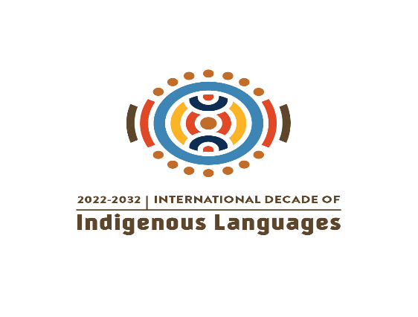
17th session of the Expert Mechanism on the Rights of Indigenous Peoples
Item 7: International Decade of Indigenous Languages (2022-2032)

Concept note
Date and venue: Thursday 11 July 2024, 11h00-13h00, Palais des Nations, Room XIX, Geneva (will be broadcasted live and archived on http://webtv.un.org)
Objectives:
Under Item 7, and under the moderation of one of the members of the Expert Mechanism, UNESCO will play a major role as lead UN Agency for the implementation of the International Decade. The discussion aims to achieve the following key objectives:
- Provide an update on the progress of implementing the Global Action Plan of the International Decade of Indigenous Languages as well as national and local action plans, including concrete measures undertaken by States, Indigenous Peoples, with the support of the United Nations system and UN mechanisms devoted to Indigenous Peoples.
- Identify challenges encountered in the implementation of the Global Action Plan, encompassing a full spectrum of human rights concerns, the legal recognition of Indigenous languages, and fostering greater usage of these languages across all socio-cultural, economic, environmental, legal, and political domains.
- Facilitate the exchange of views and experiences regarding lessons learnt and successful initiatives implemented by various stakeholders. The overarching aim is to advance the implementation of the Global Action Plan with a human rights-based approach, in alignment with the United Nations Declaration on the Rights of Indigenous Peoples and other standard setting documents.
- Foster dialogue, gather diverse insights, and identify collaborative solutions to further advance the objectives of the International Decade of Indigenous Language, including ideas for Expert Mechanism’s advice and proposals to the Human Rights Council.
- Make recommendations for including the principles of the IDIL into the roadmap for the Joint Programme of Work on the link between cultural and biological diversity.

Chair: Member of the Expert Mechanism on the Rights of Indigenous Peoples

Discussants:
- UNESCO Representative
- Indigenous Peoples’ representatives (2)
The discussion will continue following the opening of the list of speakers.

Background:
The Expert Mechanism, in its 2012 study, emphasizes the significance of languages as an important element and expression of Indigenous Peoples’ right to self-determination. Cultural and language rights are inherently included in the array of rights set out in the UNDRIP and, therefore, play a critical role in the overall implementation of the Declaration.
The Expert Mechanism has joined the efforts, led by UNESCO, in cooperation with UNDESA, OHCHR, IFAD and other relevant UN Agencies, to draw global attention to the critical situation of many Indigenous languages, following the proclamation by the General Assembly of the International Decade of Indigenous Languages (Resolution 74/135, para. 24) for the period of 2022-2032.
In its 2023 annual report, the Expert Mechanism submitted its proposals to the Human Rights Council. Proposal 7 focused on the IDIL. The Expert Mechanism proposed that the Human Rights Council encourage States to engage in fruitful and sustained dialogue with Indigenous Peoples, scholars, civil society and other public and private actors to adopt and implement the Global Action Plan of the International Decade of Indigenous Languages, taking into account the broad spectrum of human rights implicated in the promotion and fulfilment of Indigenous language rights. The Expert Mechanism invited the Council to encourage States and UNESCO to take specific measures to implement the Global Action Plan at the local and national levels in a culturally appropriate manner and in close consultation and cooperation with Indigenous Peoples. To that effect, States and UNESCO should allocate the appropriate funding. The Expert Mechanism further proposed that UNESCO establish a mechanism within UNESCO tailored for and composed of Indigenous Peoples and organize an annual session on the achievement of the International Decade of Indigenous Languages, ensuring the full and meaningful participation of Indigenous Peoples in the process of the design and subsequent implementation of strategies, initiatives, policies and legislation.
The International Decade of Indigenous Languages (IDIL) spanning 2022-2032 calls for coherent and well-coordinated approach to achieve maximum positive impact and social change with respect to the mainstreaming of Indigenous languages. The Global Action Plan of the Decade provides stakeholders with the essential principles for embarking on joint action with a vision that Indigenous Peoples will entrust their languages to future generations creating a better society for everyone. It is expected that the global priorities, international standards, and practices are translated into frameworks and actions at regional, national, and local levels.
As the Decade progresses towards the end of its first three years, it becomes crucial to take stock of the progress made in implementing the Global Action Plan of the Decade as well as national and local action plans. This juncture offers an opportunity to reflect on the broader implications of these initiatives, particularly through the lens of the human rights considerations.
Indigenous languages also offer deep ecological insights, supporting effective, culturally sensitive natural resource governance and promoting an integrated and holistic environmental stewardship, which are key for implementing the recently approved Kunming-Montreal Global Biodiversity Framework. To fully leverage these insights, the development of the roadmap for the Joint Programme of Work on the link between Cultural and Biological Diversity should incorporate the principles of the International Decade of Indigenous Language in support of biodiversity conservation efforts.
Moreover, it is essential to address the challenges encountered during implementation of the Global and National Action Plans and to develop corresponding strategies to overcome them. It must be noted that the primary responsibility for the success of these endeavours lies with the Member State and Indigenous Peoples. To ensure a comprehensive evaluation, it is crucial to incorporate perspectives from various actors, including UN agencies, National Human Rights Institutions, academia and civil society organisations.

Reference documents:
- EMRIP`s study on the role of languages and culture in the promotion and protection of the rights and identity of Indigenous Peoples: https://documents.un.org/doc/undoc/gen/g12/160/52/pdf/g1216052.pdf?token=PuJTeTc7XoLY5EytRb&fe=true
- Global Action Plan of the International Decade of Indigenous Languages, UNESCO 2021, 41 CI/INF.14.
- International Decade of Indigenous Languages, 2022-2032: Global Action Plan Note by the Secretariat: Executive summary AR | EN | ES | FR | RU | ZH (E/C.19/2022/5)
- UN DESA Policy Brief No. 151: Why Indigenous languages matter: The International Decade on Indigenous Languages 2022–2032
- The International Year of Indigenous Languages: mobilizing the international community to preserve, revitalize and promote indigenous languages / Flagship Report of the IYIL2019 (UNESCO, 2021)
- National and institutional plans developed and publicly made available for the organization of the International Decade of Indigenous Languages
- 15/22. Nature and Culture (cbd.int)
- Decision Adopted by the Conference of the Parties to the Convention on Biological Diversity (15/22. Nature and Culture): https://www.cbd.int/doc/decisions/cop-15/cop-15-dec-22-en.pdf
- Kunming-Montreal Global Biodiversity Framework: https://www.cbd.int/doc/decisions/cop-15/cop-15-dec-04-en.pdf

IDIL2022-2032 communication resources:
Official website:
https://www.unesco.org/en/decades/indigenous-languages
https://www.unesco.org/fr/decades/indigenous-languages
https://www.unesco.org/es/decades/indigenous-languages
https://www.unesco.org/ru/decades/indigenous-languages

Collaborative engagement platform:
https://idil2022-2032.org/
https://fr.idil2022-2032.org/
https://es.idil2022-2032.org/
https://ru.idil2022-2032.org/
Facebook:  @IndigenousLanguagesDecade  @UNESCO | Instagram:  @indigenouslanguages  @unesco
Twitter:  @ILDecade  @UNESCO | YouTube: International Decade of Indigenous Languages  #IndigenousLanguages #WeAreIndigenous

A/HRC/54/64, paras 34 and 35.
CBD/COP/DEC/15/22.
See A/HRC/21/53

