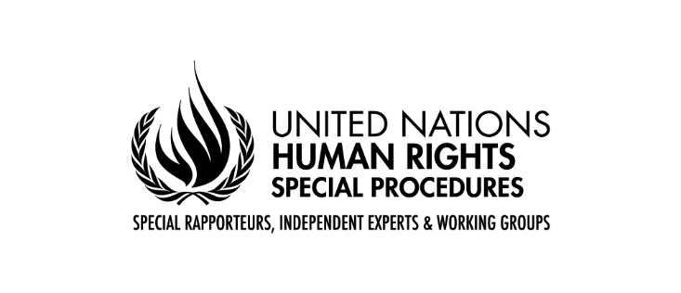

**Statement of Mr. Francisco Calí Tzay**

**Special Rapporteur on the Rights of Indigenous Peoples**

**Expert workshop on possible ways to enhance the participation of Indigenous Peoples in the work of the Human Rights Council**

**Geneva**

**21 November 2022**

Mr. High Commissioner, Mr President,

Distinguished delegates,

Indigenous peoples’ representatives,

Ladies and gentlemen,

It is an honour for me to address the Workshop dedicated to enhancing participation of Indigenous Peoples in the work of the Human Rights Council. Since making initial attempts to engage with the League of Nations in the 1920s, Indigenous Peoples have consistently sought the cooperation of the international community, including the United Nations and its agencies, funds and programmes.[1] Since then, a lot of progress has been made to enhance the participation of Indigenous Peoples in the work of the United Nations, including the Human Rights Council, but there still remain further necessary steps to be taken, in order to make such participation more effective and meaningful.

The Human Rights Committee, in its General Comment 25 recognized that the right to take part in the conduct of public affairs also includes the formulation and implementation of policy at the international and regional levels. Participation in international decision-making processes is an important element of the effective implementation of Indigenous Peoples’ right to self-determination. Indigenous Peoples have been historically excluded, and their views and needs have been inadequately addressed in decision-making processes at the national, regional and international levels. It should be acknowledged that meaningful participation requires a long-term commitment by public authorities, as well as international organizations, together with their genuine political will, an emphasis on agency and a shift in mindset regarding the way of doing things.[2]

In order to make the engagement of Indigenous Peoples in the work of the Human Rights Council more meaningful, such participation should entail not only making oral and written statements, but also actively participating in the development of resolutions and other policy decisions on matters affecting them. Indigenous Peoples’ equal participation in the formation of human rights policies contributes to redressing the asymmetries of power and the structural racial discrimination that for centuries have excluded them from public debate and the formation of public policies.

The selection criteria and mechanism for participation need to take into account that many indigenous organizations, groups and networks do not have legal recognition under national laws. This is due to a number of factors including States not recognizing or acknowledging the existence of Indigenous Peoples, barriers to registering organizations, and a lack of resources to register. Indigenous Peoples have the right to determine their own identity or membership in accordance with their customs and traditions. The UN Declaration on the Rights of Indigenous Peoples was adopted without a definition of Indigenous Peoples, relying instead on self-identification.

Indigenous women and girls-led organizations in particular face barriers to accessing funding, from local, national and international sources. Indigenous women and girls do not have the support and means to participate meaningfully in decision-making processes at the international level due to their socio-economic status, as well as cultural and political biases. Special measures must be taken to ensure indigenous women and girls’ participation through their own organizations or associations/networks. In the selection process, particular attention should be paid to increasing the participation of Indigenous women-led organizations and associations.

There is indeed further need to guarantee equal and fair participation by ensuring geographic balance, gender diversity, participation of Indigenous youth, older persons, and Indigenous persons with disabilities.  Decision-making at the international level may have a significant effect on the realization of the rights of Indigenous Peoples, as such decision-making has an impact on national legislation, policies and practices. It is thus necessary that such decisions are made in a transparent and accountable manner, with the full participation of those who will be affected, and in an environment respectful of public freedoms, which are fundamental and should also be protected at the international level. Indigenous Peoples choosing to participate in regional and international meetings must be safe and protected from acts of reprisal or intimidation[3].

And finally, States should effectively disseminate, in accessible formats and Indigenous languages, the outcomes of decisions made at international forums, including recommendations emanating from the Human Rights Council and its mechanisms in implementation of States’ human rights obligations under international human rights law.[4]

Enhancing the participation of Indigenous Peoples in the work of the Human Rights Council should be viewed as an asset to enrich its decision-making capacity and better implementation of its mandate. As the Secretary-General states in his Call to Action, “Human diversity is an asset, not a threat. We must appreciate the richness of our differences while never losing sight of our common humanity and dignity. Every community, including… Indigenous Peoples, must feel that its identity is respected and that it can fully participate in society as a whole.”[5]

I thank you for your attention.

1. A/75/255, para 4
2. [GuidelinesRightParticipatePublicAffairs_web.pdf (ohchr.org)](https://www.ohchr.org/sites/default/files/2021-12/GuidelinesRightParticipatePublicAffairs_web.pdf)
3. [GuidelinesRightParticipatePublicAffairs_web.pdf (ohchr.org)](https://www.ohchr.org/sites/default/files/2021-12/GuidelinesRightParticipatePublicAffairs_web.pdf), para 96
4. [GuidelinesRightParticipatePublicAffairs_web.pdf (ohchr.org)](https://www.ohchr.org/sites/default/files/2021-12/GuidelinesRightParticipatePublicAffairs_web.pdf), para 114
5. The Highest Aspiration: A Call to Action for Human Rights, UN, 2020, p.3