**Bridging the Gap: People Centered Policy Guidelines**

**to Minimize Relocation Failures**

Nishara Fernando, Department of Sociology, University of Colombo

**Introduction**

Displacement of people from their homes and lands, due to private and public development projects or as a disaster risk reduction method, has become a common occurrence. Although the involuntary relocation of such displaced people to unfamiliar new settlements situated far from their previous places of residence seemed to be the sole option at the given time and circumstances, such interventions have not always been very successful (Muggah, 2008) and has mainly resulted in increased impoverishment of families after relocation, due to their inability to cope with multiple risks (Cernea, 2000) and multi-dimensional stresses (physiological, psychological and social-cultural) generated by the "relocation shock" that persist through the different stages of relocation (prior to, immediately after and two years after) (Scudder, 1981; 2005). Relocation also impacts the cultural landscape and the identity of communities (Sorensen, 1996). In this context, available international and local literature on involuntary (forced) relocation emphasizes the need to reduce relocation-related risks and stresses (Oliver-Smith, 2009;2010, Modi, 2009). Careful implementation and management of the relocation process by adhering to the national and international frameworks and policies in the planning stage combined with better funding, political will, pre displacement research and long-term monitoring are interrelated vital factors to make relocated communities secure and sustainable after involuntary (forced) relocation (Fernando, 2012; Fernando and Punchihewa, 2013; Fernando et.el, 2010; Hettige et.el, 2004; Birkmann & Fernando, 2007; Birkmann et.el 2007).

Against this backdrop, the paper proposes guidelines for involuntary relocation involving 3 key stakeholders, namely the state, the development partners, and the displaced people or the beneficiaries. The past experiences in South Asian countries suggest that relocation projects have not been guided by common guidelines other than project-specific guidelines which resulted in some successes and failures. Hence, the guidelines discussed in this article attempt to respond to the emerging need for proper guidelines on the one hand and to fill a persisting gap at the policy level on the other. The proposed guidelines are generally applicable for people who are displaced because of development projects or disasters. The proposed guidelines are presented in three stages of the relocation process namely, prior to displacement (Pre- relocation), immediately after relocation, and sometime after relocation.

The corresponding author, Professor Nishara Fernando, has been extensively researching post-tsunami relocation in Sri Lanka since 2005, including as part of his PhD studies. His doctoral research focused on the impact of the 2004 Indian Ocean Tsunami on livelihoods, social capital, and social relationships between host communities and relocated communities in Akmeemana DS Division, Galle. The findings of this research were published as a book by the United Nations University Institute for Environment and Human Security in 2012. Since completing his PhD, Professor Fernando has continued his research efforts, examining the short-term and long-term impacts of relocated communities in various areas such as Galle, Lunawa, Batticaloa, Kegalle, Rathnapura, and Badulla.

**Objectives of the Policy Guidelines**

* To devise a mechanism that would enable communities to successfully cope with various risks and stresses generated by the shock of involuntary relocation.
* To make the prospective relocatees aware of the relocation process (or stages of relocation) with a time frame agreed upon to complete the successful relocation process of affected persons and implementing agencies.
* To make the relocation process participatory, transparent, and accountable.
* To assist relocatees particularly the most vulnerable groups (female-headed households, hidden female-headed households, households with disabled, chronically ill members, poor households) to successfully adapt to the new location and restore their livelihoods to improve their living standards. The programme should ensure that the displaced people improve or at least their previous standard of living is restored (Cernea, 2000).
* To ensure that the people affected due to involuntary relocation are promptly compensated and made aware of the process for redressing their grievances to facilitate easy access and quick response to resolve issues.

**The Conceptual Foundations of the Guidelines**

The main conceptual foundation for the guidelines is identified as the concept of forced relocation, including two theoretical models, namely (1). Thayer Scudder's (1981; 2005) Stress and Settlement Process and (2). Michael Cernea's (2000) Impoverishment Risks and Reconstruction Model, for resettling displaced people and the concept of vulnerability, focuses on both the external (exposure) and the internal sides (coping). The elements of the constructed analytical framework are discussed below.

Consideration of external shocks, such as natural disasters or development projects, on communities is also important. This takes two forms: the initial displacement and subsequently, the forced relocation. It highlights the challenges faced by relocated individuals, including difficulty accessing resources, lack of employment opportunities, and strained relationships with host communities. In this way, forced relocation has an impact on five types of household assets, mainly: social, financial, human, physical, and natural. External interventions, both direct and indirect, are discussed, including government support and assistance from NGOs. It also incorporates the involvement of provincial and local governments in adopting various policies, legislations, and institutions in strengthening access to assets and improving income generating activities. The outcome is to implement these strategies on the household level and gather direct feedback on the outcomes of their interventions.

***Figure 1: Analytical Framework***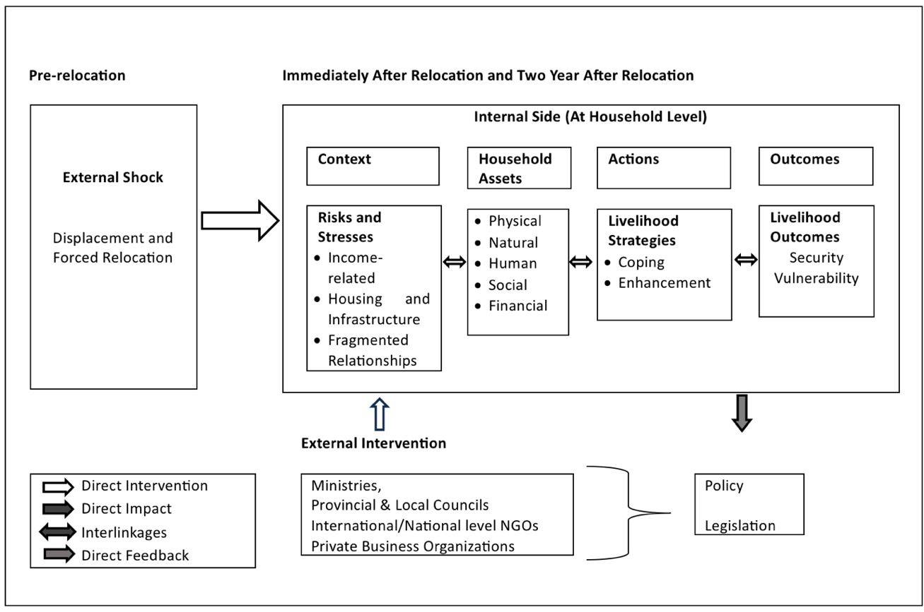

(Source: Fernando, 2013)

**Guidelines**

First and foremost, it is crucial to emphasize, as other researchers have reiterated time and again, that relocation should only be considered as a last resort. In other words, it should be viewed as a necessary evil, to be utilized only when all other alternatives have been exhaustively explored and deemed inappropriate or ineffective. The policy guidelines can be listed as prior to relocation, immediately after relocation, and sometime after (two to five years) years after relocation.

1. **Prior to relocation**

The pre-relocation phase needs to concentrate on the aspects of removing or minimizing the risks of displacement. Since displacements by disasters, either man-made or natural, and development- induced are unavoidable in certain cases, pre-planning of contingencies for relocation should be available which would contribute to minimizing adverse impacts on the social, cultural, and economic aspects of prospective relocatees.

Special attention must be paid to vulnerable communities, including children, women, female-headed households, the elderly, and people with disabilities, among others, in the displacement period. Displacement exposes these groups to specific risks and stresses, as well as to the common impacts of relocation. These impacts often have a lasting effect, significantly influencing their lives both within the relocation housing and beyond.

**1.1 Vulnerability Reduction and Early Warning**

It is necessary to minimize the number of families to be relocated by avoiding or minimizing the adverse impacts of causes of displacement, through developing proper early warning systems and other risk reduction strategies to prevent natural hazard-related displacement and relocation. This would involve:

1. well-conceived evacuation plans and programs.
2. an efficient planning process aimed at utilizing local resources to manage displacement and temporary internal migration. Consider relocation as a long-term process and resettle displaced families close to their previous location without changing sectors. For instance, it is evident from previous studies relocation of rural communities into urban areas and vice versa took more time for relocated communities to adapt to the new environment.

What is equally important is to ensure the availability of timely data. Such data could be built up as separate databases to be tapped for different types of information necessary for planning and other purposes. These can be divided into the following:

1. A resource database
2. Land database which can be used for various purposes agriculture, residential, business etc.
3. Socio-economic database of displaced people including identification of group of vulnerable families to poverty or chronic poverty.
4. Socio-economic database on host communities including identification of group of vulnerable families to poverty and chronic poverty.

**1.2 Public Information and Consultation**

1. The State authorities should provide relevant information to the prospective relocatees and the public about risks, and opportunities for future development and have continuous consultation so that public concerns can be voiced at respective levels.
2. Regular public information and consultations would complement the databases mentioned above.

**1.3 Compensating Affected Communities**

It is essential to assist the affected people in submitting their grievances and claims for compensation due to the acquisition of their land, structures, perennial crops, and economic losses. This can be implemented by establishing a Grievance Redress Committee under the chairmanship of local level government officials. Action needs to be taken by the implementing agency to establish an Inter-Ministerial committee comprising representatives from the relevant Ministries to expedite the project process. Awareness programs on existing Policies, Acts, Ordinances, rules, regulations, and other relevant material concerning relocation should be conducted for officers of implementing agencies so that they can adequately assist the communities.

1. **Immediately After Relocation**

Since disaster or development induced displacement is unavoidable in certain cases, pre-planning of contingencies for relocation should be made available to ensure the least impact on the social, cultural, and economic life of people. This section includes different approaches that can be adopted in relocating people in temporary, transitional, and permanent settlements.

* 1. **Standardization**: Nationally accepted standards should be adopted when constructing shelters. However, these standards should allow for some flexibility during implementation depending on the availability of resources.

**Participation**: Participation in the decision-making process of the prospective relocatees should be a prerequisite when making decisions pertaining to the relocation process. This would enhance the transparency and accountability of the process as well as the quality and acceptability of the shelter.

* + - Provincial Councils and Local Authorities should play a proactive role in the relocation process from the very inception of the planning process to ensure their continuing engagement in follow-up activities.
    - The host community should be involved in the relocation process as a strategy to enable the smooth integration of relocated communities with the host community. Both communities should continue to have access to adequate common property resources and infrastructure facilities.

* 1. **Infrastructure**: The informed consent of the relocated people should be obtained by donor funded projects prior to the construction of resettlement infrastructure. This information should be provided irrespective of whether houses are built by donors or by affected families using the monetary compensation they get from the organization.
     + All common infrastructure facilities should be provided before relocating the affected families to the new settlement.
     + Local councils should also be provided with the required funds to improve their services to the relocated communities.

* 1. **Land Titles**: Land that is given up should be replaced by new land of comparable value. Deeds should be granted promptly to new land. In the absence of land, cash compensation should be paid to all affected persons. Families who do not have secure land titles should receive fair and just treatment to prevent marginalization.
  2. **Options:** Relevant authorities should provide available options for relocation such as give financial assistance to purchase a land and build a house in a hazard free area (Self relocation), provide financial assistance to build a house in another land owned by the displace family or move into a planned relocated settlement built by government or any other organization.
  3. **Information**: Prospective relocatees should be given all information pertaining to the relocation process through a language they can understand. Full recovery from relocation induced stress is a need of the affected person and should be provided by the project implementers to ensure a better quality of life.
  4. **Funding**: While proper financing is important for a sound relocation project, political will is important in mobilizing the funds adequately. The absence of adequate financial compensation can lead to relocation failures.
  5. **Restoration of livelihoods**: Any disruption to household income and increased expenses that could occur due to relocation should also be considered. Local employment creation programs are vital to restore livelihoods and reduce socio-economic vulnerability.
  6. **Vulnerable groups**: Particular attention should be paid to displaced women, female headed households, children, the elderly, and people with special needs throughout the long-term process of relocation. It’s also vital to identify socio-economically vulnerable households to closely monitor them in the long run of the relocation process.

**3.Sometime (Two to five years) After Relocation**

Reviews of socio-economic, demographic, and other relevant data of the relocated families need to be carried out regularly up to five years after relocation. This can be useful in the future for project monitoring and impact evaluation purposes. Social Impact Assessment (SIA) and Environment Impact Assessment (EIA) and Vulnerability Assessment of the affected communities are useful for further improvements. These assessments will guide the implementers to efficiently assist in the relocation process, to reduce further marginalization and vulnerability of communities after relocation. Local level community-based organizations or linking the existing community-based organizations should be established in the host communities to ensure autonomy in families’ decisions related to relocation.

**Conclusion**

In conclusion, the outlined guidelines emphasize the importance of paying attention to vulnerable communities throughout the process of relocation and the need for meticulous planning and transparent decision-making. Effective early warning systems and vulnerability reduction measures are essential pre-relocation strategies. Post-relocation, immediate and long-term efforts such as standardization, participation, and livelihood restoration are vital while regular reviews and assessments are imperative for monitoring progress and addressing emerging challenges.

**Bibliography**

Amaratunga, D., Malalgoda, C., Haigh, R., Jayakody, C., Fernando, N., Senanayake, A. C., … & Witt, E. (2022). A built environment perspective on post-disaster and conflict-induced displacement. A report of the REGARD project: Rebuilding after Displacement.

Birkmann, J., & Fernando N. (2007a). Measuring revealed and emergent vulnerabilities of coastal communities to Tsunami. Disaster, vol. 32, No. 1, pp. 82-105.

Birkmann, J., Fernando, N. Hettige, S., (2007b). Rapid vulnerability assessment in Sri Lanka. Bonn: United Nations University Institute of Environment and Human Security.

Cernea, M. (2000). Risks, safeguards and reconstruction. A model for population displacement and resettlement. In Risks and Reconstruction. Experiences of Resettlers and Refugees, M. Cernea and C. McDowell, eds. Washington, D.C.: The World Bank.

Fernando, N. (2006). A sociological study on vulnerability to chronic poverty and livelihood strategies: The case of a low income settlement. "M. Phil. dissertation. Unpublished.

Fernando, N. (2012). Forced relocation after the Indian Ocean Tsunami, 2004: Case study of vulnerable populations in three relocation settlements in Galle, Sri Lanka. Publication series of UNUEHS Volume 6. Bonn: United Nations University Institute of Environment and Human Security.

Fernando, N. Birkmann Joern & Warner Koko (2010). Migration and Natural Hazards: Is relocation a secondary disaster or an opportunity for vulnerability reduction. In: Afifi, T & Jager, J (eds) “Environment, Forced migration and Vulnerability. Heidelberg: Springer.

Fernando, N., & Jayasinghe, N. (2023). Disaster-Induced relocation of vulnerable households: evidence from planned relocation in sri lanka. In Rebuilding Communities After Displacement: Sustainable and Resilience Approaches (pp. 245-268). Cham: Springer International Publishing.

Fernando, N., & Punchihewa, A. (2013). Relocating the displaced: Strategies for sustainable relocation. Colombo: Friedrich Ebert Stiftung.

Fernando, N., Amaratunga, D., Haigh, R., Wise, B., Prasanna, J., & Jayasinghe, N. (2021). Life two years after relocation: Status quo of natural hazard induced displacement and relocation in Kegalle, Sri Lanka. In Multi-Hazard Early Warning and Disaster Risks (pp. 3-25). Springer International Publishing.

Fernando, N., Senanayake, A., Amaratunga, D., Haigh, R., Malalgoda, C., & Jayakody, C. (2020). Impact of the disaster-induced relocation process on the displaced communities in Kegalle district, Sri Lanka. European Scientific Journal, 16(39), 33-53.

Gunathilake, K. L. W. I., Jayathilake, P. P. G., Fernando, N., Jayasinghe, N., Amaratunga, D., & Haigh, R. (2023). Living with landslide risks: A case of resistance to relocation among vulnerable households residing in the Kegalle district of Sri Lanka. In Rebuilding Communities After Displacement: Sustainable and Resilience Approaches (pp. 145-163). Cham: Springer International Publishing.

Hettige, S.T., Fernando, N. Mayer Markus & Noe Christiane (2004). Improving livelihoods of the urban poor - A study of resettlements schemes in Colombo, Sri Lanka. Colombo: German Technical Cooperation (GTZ).

Ministry of Land and Land Development (2013). Land acquisition and implementation of the national involuntary resettlement policy. Colombo: Ministry of Land and Land Development.

Modi, R. (2009). Beyond relocation the imperative of sustainable resettlement. India: Sage Publication.

Muggah, R., (2008). Relocation Failures in Sri Lanka A short history of internal displacement and resettlement. London: Zed Books.

Oliver-Smith, A., (2009). Development and dispossession- the crisis of forced displacement and resettlement. New Mexico: School for advanced research press.

Oliver-Smith, A., (2010). Defying displacement: Grassroots resistance and the critique of development. Austin: University of Texas Press.

Scudder, T. (1981). The development potential of new land settlements in tropics and sub-tropics: A global state of the art evaluation with specific policy implications. Binghamton: Institute for Development Anthropology.

Scudder, T. (2005). The future of large dams: Dealing with social, environmental, and political costs. London: Earthscan Publications Limited.

Sorensen, B. (1996). relocated lives: Displacement and resettlement within Mahaweli project, Sri Lanka. Amsterdam: VU University Press.