Submitted by Loss and Damage research Team (Evidence-Based Approach to Address Non-Economic Loss and Damage), International Centre for Climate Change and Development (ICCCAD)
Supported by ChristianAid

Human rights impact of planned relocations
The Manta community, known as the river gypsies of the southwest part of Bangladesh, particularly in the Barisal region, represents a unique ethnic group deeply intertwined with the water bodies of their habitat. With a rich tradition of fishing and a lifestyle revolving around boats, the Manta people have faced significant challenges due to climate change-induced displacement. Driven from their lands by riverbank erosion decades ago, they have adapted to a life on boats, facing vulnerabilities exacerbated by extreme weather events and a lack of permanent shelter. Despite their resilience, the Manta community continues to struggle with access to basic necessities such as healthcare, education, and secure livelihoods.
ICCCAD (International Centre for Climate Change and Development) has engaged with the Manta community through an evidence-based approach to address non-economic loss and damage (EBAAN). This project aims to understand and mitigate the adverse impacts of climate change on vulnerable communities like the Manta, focusing on their unique challenges and needs.
Critical Challenges and Human Rights Impacts of Planned Relocation:
In Bangladesh, planned relocation processes like those carried out under projects such as the Ashrayan project pose significant challenges and human rights impacts, especially for vulnerable communities like the Manta people. Following relocation, Manta individuals often face varied outcomes regarding their livelihoods and living standards. While some adapt successfully and explore alternative livelihood options, others struggle to regain economic stability and social integration. Access to land and property post-relocation is a major concern, affecting cultural identity and livelihoods as fishing activities may become unfeasible in new locations. Safety and security issues also arise if relocated areas are prone to climate risks or lack adequate infrastructure. Additionally, planned relocations impact host communities, potentially leading to tensions and disparities in living standards. Adequate support for host communities is crucial to prevent further marginalization and foster social cohesion. Overall, ongoing and implemented relocation processes underscore the complex challenges and human rights impacts faced by vulnerable communities like the Manta people, necessitating comprehensive approaches that prioritize the rights and needs of all stakeholders involved.
Collaboration with local governmental organizations, NGOs, and CBOs has been vital in addressing the impacts of planned relocations on the Manta community in Bangladesh. Initiatives like the Ashrayan project have aimed to relocate vulnerable families, including Manta families, providing housing and land ownership. However, challenges persist as some reject offers due to concerns about distance from traditional fishing grounds. Successful collaborations have involved engaging directly with affected communities through consultative processes outlined in Bangladesh's National Strategy on Internal Displacement Management. These approaches prioritize community voices, ensuring tailored and sustainable solutions. Collaborative efforts have gone beyond housing provision, addressing various aspects of well-being like livelihoods, education, and healthcare. Partnerships with healthcare providers and NGOs have improved access to healthcare, while initiatives to enhance educational opportunities aim to break intergenerational poverty. Moreover, efforts have recognized the communal impacts of loss of land, social cohesion, and culture, supporting community-led initiatives to preserve cultural identity amidst displacement. And these evidences are found from both of the research projects, also local led initiatives collaborated with municipalities are taking into consideration from people’s perspective and recommendations.

Legal policy and institutional frameworks
In Bangladesh, various measures and policies have been implemented at national and sub-national levels to address planned relocations and prevent arbitrary displacement, especially in response to climate change-induced events. These include:
1. National Strategy on Internal Displacement Management: Developed through community-based consultations, this strategy aims to make vulnerable communities resilient to climate change and disasters, focusing on prevention, protection, and durable solutions. However, gaps may exist in its implementation, particularly in addressing the needs of marginalized groups like the Manta community.
2. Ashrayan Project: This government initiative aims to rehabilitate the landless, homeless, and poor by providing housing and land ownership. While it has facilitated the relocation of some Manta families, concerns remain about the suitability of relocation sites and their proximity to traditional fishing grounds.
3. Legislation: Laws such as the Child Marriage Restraint Act 2017 aim to prevent early marriage among vulnerable populations like the Manta community. However, enforcement and accessibility to justice for marginalized communities may be lacking.
4. Institutional Arrangements: Coordination mechanisms among relevant ministries and agencies address climate-induced displacement, but capacity and resource gaps may hinder effective implementation, especially at the sub-national level.
5. Community Engagement: Practices like community-based consultations engage affected communities like the Manta, but gaps may exist in the meaningful inclusion of marginalized groups, potentially leading to inadequate consideration of their needs.
6. Monitoring and Evaluation: Gaps in monitoring and evaluating relocation initiatives and policy frameworks may hinder evidence-based policymaking and addressing the needs of vulnerable populations like the Manta community. Strengthening these mechanisms can help identify gaps and inform better policymaking.
Institutional and governance gaps in planned relocation processes include inadequate resources, capacity, and coordination among stakeholders, as well as limited representation of marginalized communities. Legal protections for displaced populations are insufficient, especially concerning land rights and participation in decision-making. Displacement and resettlement lack inclusivity, particularly for marginalized groups like women and indigenous peoples. Weak enforcement mechanisms hinder accountability for arbitrary displacement. Addressing these gaps requires strengthening institutional capacities, enhancing legal protections, promoting inclusive decision-making, and improving enforcement to safeguard the rights and well-being of affected communities during planned relocations and climate-induced displacement.
Legal and policy frameworks in Bangladesh provide options for persons, such as the Manta community in Barisal, who may not wish to relocate due to planned relocations. Additionally, these frameworks offer assistance and remedies for various types of losses incurred by relocated persons, including economic, non-economic, indirect, and long-term losses, as well as remedies for unanticipated losses following relocation.
1. Options for Those Not Wishing to Relocate:
- Legal provisions should ensure that individuals, including members of the Manta community, have the right to choose whether to relocate or remain in their current location. This choice should be respected and facilitated by government agencies involved in planned relocations.
- Policies may include provisions for alternative forms of support for those who opt not to relocate, such as assistance in strengthening resilience to climate hazards in their current location, access to livelihood opportunities, and support for adaptation measures.
2. Assistance and Remedies for Anticipated Losses:
- Economic Losses: Legal and policy frameworks may provide for compensation or alternative livelihood support for economic losses incurred by relocated persons, such as loss of income from traditional fishing activities.
- Non-Economic Losses: Assistance and remedies may include support for preserving cultural heritage, identity, and community cohesion, recognizing the importance of non-economic aspects to the well-being of the Manta community.
- Indirect and Long-Term Losses: Legal frameworks may outline provisions for ongoing support, including access to education, healthcare, and social services, to mitigate the indirect and long-term impacts of relocation on individuals and communities.
3. Remedies Following Relocation for Unanticipated Losses:
- Legal and policy frameworks should include mechanisms for addressing unanticipated losses that may arise following relocation, such as unforeseen disruptions to livelihoods or social networks.
- These mechanisms may involve regular monitoring and evaluation of relocation programs to identify emerging challenges and gaps in assistance, with provisions for responsive support and remedial action as needed.
- Access to justice mechanisms should be available to relocated persons, including avenues for lodging complaints, seeking redress, and accessing remedies for any adverse impacts experienced post-relocation.

Engagement of communities and regional and international actors
The process of informing, consulting, and enabling the Manta community in Barisal regarding planned relocation involved several steps aimed at ensuring their meaningful participation in decision-making. Initially, relevant governmental and non-governmental organizations likely engaged in outreach efforts to educate the community about the need for relocation due to climate-induced risks, such as riverbank erosion and extreme weather events. This educational process likely included community meetings, workshops, and consultations where information about the potential impacts of climate change and the proposed relocation plans was shared. Additionally, community leaders and representatives of the Manta were likely involved in discussions with authorities to voice their concerns, preferences, and suggestions regarding the timing, location, and modalities of relocation. These consultations would have ideally facilitated a participatory process where the Manta community had opportunities to express their perspectives, raise questions, and contribute to decision-making.
In addition to consulting with the Manta community directly affected by planned relocation, efforts were likely made to inform and involve individuals who wished to stay behind at the site of origin or those who had already moved away but expressed interest in joining the new site. This process may have involved outreach campaigns targeting individuals who had relocated earlier or those who expressed a desire to remain in their current location despite the planned relocation. Challenges to meaningful participation in the planned relocation process may have included communication barriers, lack of trust between the community and authorities, and power differentials that may have limited the ability of marginalized individuals within the Manta community to fully engage in decision-making. Additionally, logistical challenges such as access to information, language barriers, and limited resources may have posed obstacles to ensuring the comprehensive participation of all affected individuals in the planning and decision-making processes. The local led adaptation approaches are needed in this type of scenario especially for community capacity building for the overall processes and policy advocacy issues. Efforts to address these challenges also likely required targeted outreach, and transparent communication channels to empower all members of the Manta community to participate effectively in the relocation process.

Consideration of specific needs of relocated and affected populations
In the case of the Manta community in Barisal, Bangladesh, addressing their specific rights, needs, circumstances, customs, and vulnerabilities throughout planned relocation is crucial. Tailored approaches are necessary due to their marginalized status, considering socio-economic factors, health conditions, demographics, cultural customs, and social bonds within the community.
1. Socio-economic Considerations: Recognizing their economic dependence on fishing, alternative livelihood options should be explored post-relocation, along with ensuring access to basic amenities and healthcare services.
2. Health and Demographic Characteristics: Addressing prevalent health issues and providing adequate healthcare facilities are vital, given their exposure to adverse weather conditions.
3. Special Attachments to Land: Efforts should preserve their cultural heritage and traditional way of life, including access to fishing grounds and river resources.
4. Vulnerable Groups: Tailored support for women, girls, minorities, older persons, persons with disabilities, and Indigenous Peoples is essential, ensuring inclusion in decision-making processes and access to necessary services.
5. Displaced Persons and Migrants: Mechanisms should facilitate resettlement and integration into new communities, providing access to housing, livelihood opportunities, social services, and legal support.
6. Renters and Informal Settlers: Attention should also be given to safeguarding the rights of renters and informal settlers, ensuring adequate compensation, alternative housing options, and legal protections.

Data collection, analysis and availability
Based on the aforementioned case study of the Manta Community, ICCCAD, in collaboration with ChristianAid, is conducting a new initiative called ‘Evidence-Based Approach to Address Non-Economic Loss and Damage (EBAAN)’, which aims to provide valuable insights into monitoring, assessing, and evaluating the impacts of planned relocations. Similarly, other complementary initiatives are ongoing parallelly, for example the ongoing work on Building Climate Resilience Migrants Friendly Town through LLA (BCRMFT), where the overall initiative need for developing a secondary city as migrant friendly has been taken as main question for researching in the southern coastal municipal cities. These initiative collects quantitative data through statistical analysis of extreme weather events such as cyclones, floods, and droughts, which are prevalent in Bangladesh. Additionally, qualitative data is gathered through narratives and testimonials from affected communities, including the Manta community, shedding light on the socio-economic and human rights dimensions of loss and damage. Our work utilizes frameworks, mechanisms, and tools such as vulnerability assessments, participatory mapping, and community-based monitoring to engage with local communities, ensuring a comprehensive understanding of the impacts of planned relocations on relocated persons and affected communities over the long term. By employing a community-driven approach, we ensure that marginalized groups, including women, girls, minorities, older persons, persons with disabilities, Indigenous Peoples, displaced persons, migrants, renters, and informal settlers, are actively involved in the assessment and evaluation of impacts, mapping future needs given climate change forecasts.
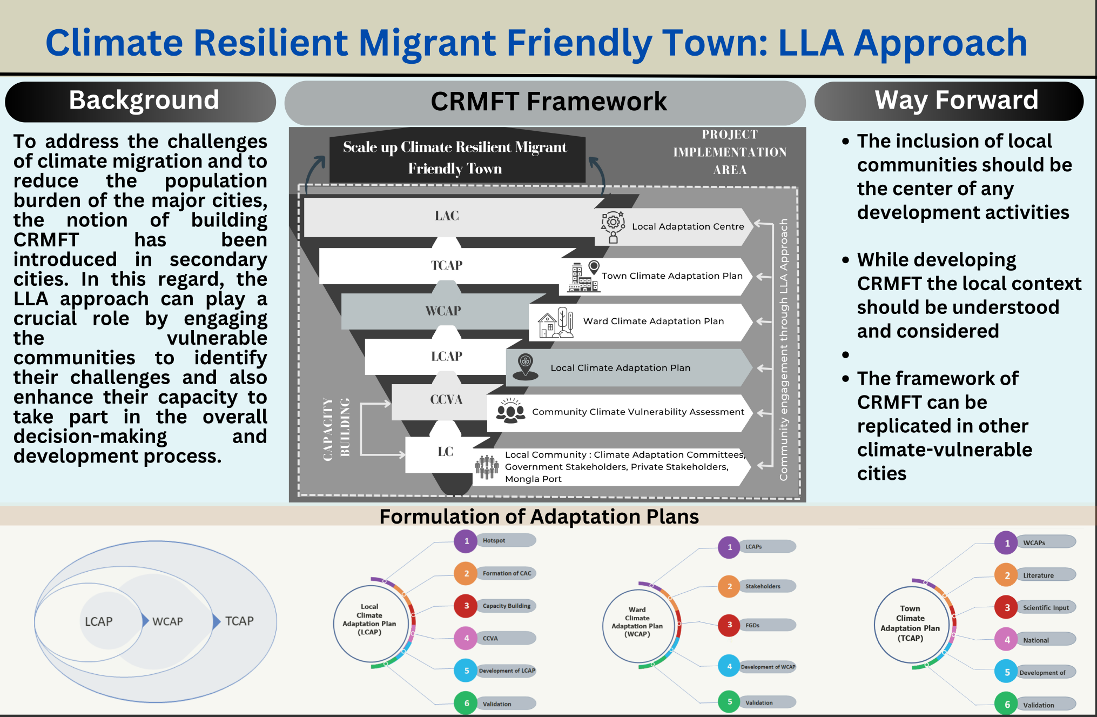

Data collected through these projects provides insights into the process and impacts of planned relocations on the Manta community and other affected groups in Bangladesh. This includes quantitative information on the frequency and intensity of extreme weather events and qualitative narratives capturing the experiences of vulnerable populations. The data highlights the differential impacts of planned relocations on members of groups in vulnerable situations, such as women, girls, minorities, older persons, persons with disabilities, LGBTI+ persons, Indigenous Peoples, displaced persons, migrants, renters, and informal settlers. These projects community-driven following LLA approaches ensure that these groups are actively involved in monitoring, assessing, and reporting on the impacts of planned relocations, enabling a more inclusive understanding of the effects on human rights and well-being. Through EBAAN, efforts are made to address the specific needs and vulnerabilities of marginalized communities, promoting resilience-building measures and rights-based approaches to adaptation and mitigation strategies in the face of climate-induced loss and damage.

Recommendation
To address the critical challenges and impacts of planned relocations on the Manta community, a people-centered approach anchored in human rights-based principles and cultural preservation is essential. At the local level, meaningful engagement with the Manta community is paramount. This includes conducting thorough consultations with community members to understand their needs, concerns, and aspirations regarding relocation. Empowering the Manta community to actively participate in decision-making processes regarding whether, when, where, and how relocation should occur is crucial. Community-led initiatives should be supported to preserve cultural identity and traditional livelihoods, ensuring that any relocation plan respects and incorporates their unique way of life.
At the national level, policy frameworks must be developed or revised to ensure that planned relocations uphold human rights standards and protect vulnerable communities like the Manta. Legislation should explicitly recognize the rights of indigenous peoples, river gypsies, and other marginalized groups, guaranteeing their right to land, livelihood, and cultural heritage. National authorities should prioritize investments in climate-resilient infrastructure and social protection programs tailored to the specific needs of riverine communities, such as access to healthcare, education, and alternative livelihood options and that need to be done by the consultation with from Local people ad local government.
Regionally and internationally, partnerships and cooperation are essential to support the Manta community and similar groups facing displacement due to climate change impacts. Regional organizations, such as the South Asian Association for Regional Cooperation (SAARC), can facilitate knowledge sharing, capacity building, and resource mobilization efforts to assist vulnerable communities in adapting to climate-induced displacement. International development agencies and financing institutions should prioritize funding projects that prioritize community-led adaptation and relocation strategies, ensuring that the voices and priorities of affected communities are central to decision-making processes.
Governments, development agencies, and financing institutions must also work collaboratively with potential host communities to address concerns and promote social cohesion. Capacity-building initiatives should be implemented to enhance the resilience of host communities and facilitate their integration with relocated populations. Efforts to promote cultural exchange and mutual understanding between host communities and the Manta community can foster positive relationships and reduce tensions. Overall, a holistic approach that prioritizes the rights, needs, and cultural identity of the Manta community is essential in ensuring that planned relocations in the context of climate change are successful and sustainable. This requires multi-level governance, community empowerment, and collaboration among diverse stakeholders to build resilience and preserve the rich cultural heritage of riverine communities like the Manta in Bangladesh.

The observation and reflections were under two of the research projects supported Christian Aid and GCA and partnered with BRAC, and these projects are ongoing and hopefully add more value and insights upon completion.

References
“আশ্রয়ণ-২ প্রকল্প.” Service.ashrayanpmo.gov.bd, service.ashrayanpmo.gov.bd/.
Gromilova, M. (2014). Revisiting planned relocation as a climate change adaptation strategy: The added value of a human rights-based approach. Utrecht Law Review, 76-95.
Mallick, B., Ahmed, B., & Vogt, J. (2017). Living with the risks of cyclone disasters in the south-western coastal region of Bangladesh. Environments, 4(1), 13.
Petz, D. (2017). Just Relocation? Planned Relocation from Climate Change, Human Rights and Justice. In Blurring Boundaries: Human Security and Forced Migration (pp. 135-160). Brill Nijhoff.
Rahman, S., & Tasnim, F. (2023). The role of NGOs in ensuring local governance in Bangladesh: from the perception of other actors of governance. Asia-Pacific Journal of Regional Science, 7(3), 1007-1034.
Shejuty, N. N. (2018). Identity in flux: A comparative study of Manta and Beday (Doctoral dissertation, BRAC Univeristy).
Rafiqul Montu. 2024. Mongla town offers new life for climate migrants. Dhaka Tribune. 13th January.https://www.dhakatribune.com/bangladesh/336605/mongla-town-offers-new-life-for-climate-migrants

GCA and BRAC host National Consultation on Climate-resilient, Migrant-Friendly Towns in Bangladesh. gca.org. Global Centre on Adaptation, https://gca.org/news/gca-and-brac-host-national-consultation-on-climate-resilient-migrant-friendly-towns-in-bangladesh/ . 10th August 2023
Sarder Shafiqul Alam , Saleemul Huq , Faisal Bin Islam , Hasan Mohammed Asiful Hoque. (2018). Building Climate-Resilient, Migrant-Friendly Cities and Towns. International Centre for Climate Change and Development. https://www.icccad.net/publications/policy-briefs/building-climate-resilient-migrant-friendly-cities-and-towns/

