**Tell us your views:**

**Children’s rights in care and support**

The United Nations is writing a report to governments about human rights, including child rights. It will tell governments how they can make sure that people in their countries have what they need to live a happy and healthy life and get all the support they need to develop. We want to hear from you!

This is a child-friendly version of the **call for input** for the **expert workshop** and **the report** on human rights and “**care and support**”.



A **call for input** is a request for information from people who are interested or know a lot about a topic, including children. We use the information we receive to prepare events or reports.

This call for input explains:

1. What kind of information they need;
2. Why the United Nations is asking for information;
3. How you can send information to the United Nations; and
4. What happens after sending the information.

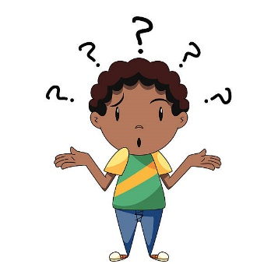

Some of the **difficult words** are in **blue** and are explained at the bottom of the document.

# What kind of information do we need?

Here are some key questions to help you in your thinking.

We would like to hear from you:

1. In your country, **how are children’s rights recognized and protected when they are giving or receiving care and support?** Please explain, with concrete examples:
   * **Rights of people caring for or supporting others**
   * **Rights of people receiving care and support**
   * **Rights relevant to taking care of yourself**

For example:

* How are these rights recognized and protected at home, at **childcare facilities** and schools, at hospitals, at work, in the community, at the court?
* Are your houses, **public transports and infrastructure**, places to get water, toilets and bathes, easy to use for people caring or supporting you, or when you care and support others, or when you need to take care of yourself?
* Do you or people caring or supporting you have access to **assistive devices** **and technologies** if they need them?
* Are children’s views heard when decisions are made on the following?
  + How to care for children
  + How to support children
  + How children should care for others
  + How children should support others
  + How children can care for themselves

1. **When do you see these rights are not recognized and protected, and why?**
2. Do you see **different groups of children are not protected equally** when giving or receiving care and support? Why? How about…
   * Girls, boys and **LGBTIQ+ children**?
   * Children with disabilities?
   * Children who do not have or do not live with families?
   * Children who are parents?
   * Children living in poverty or living in rural areas?
   * Children who belong to different ethnic groups, minority children, Indigenous children, migrant children?
   * Children who are affected by conflicts and disasters?
   * **Refugees and asylum-seeking children**?

***What are care and support?***

**“Care”** is about caring for other people and doing household work. For example, children may be cared for by their parents and family members, guardians, foster families, neighbors, teachers, nurses and doctors. Children themselves may be caring for their family members, such as sisters and brothers, parents, grandparents, and helping with household chores, such as cooking, cleaning, washing and fetching water. Children may need to take care of themselves, by resting, eating and sleeping well, playing, doing sports and cultural activities and keeping themselves clean.

**“Support”** is similar to care, but the way of helping others is different. The idea of “Support” was developed by the movements of persons with disabilities. Supporting others means supporting them with respect and helping them to participate in the society. Only being kept safe at home does not mean you are supported. When you are being supported, your views, choices and decisions are respected, and you are helped to participate in the community. For example, children with disabilities should be supported to be able to go to school and participate in school events together with other children. Children may be supporting their friends or siblings with disabilities to learn, play and join in social activities together.

# Why the United Nations is asking for information

In October 2023, the **UN Human Rights Council** asked the **United Nations Human Rights Office (UN-Human Rights)** to organize an **expert workshop** and to prepare a report on human rights and “**care and support**” to help their discussion.

The expert workshop will be held in October 2024 at the United Nations, Geneva, in Switzerland. The report will be presented at the United Nations **Human Rights Council** in March 2025.

The **United Nations (UN)** is an organization made up of many countries working together. It works to make the world a safer and better place.

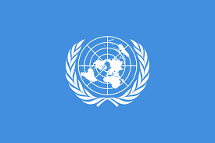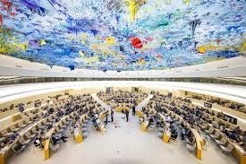

The UN **Human Rights Council** is a place where many States discuss human rights and learn how to do better to protect them.

The Council asks **UN-Human Rights** to prepare reports on various human rights issues to help States discuss these issues and make changes in their countries.

**UN-Human Rights is** an office of the UN that is working on human rights.

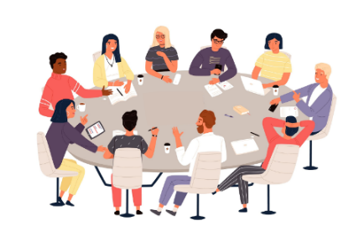An **expert workshop** is a meeting that happens at the **United Nations**, where experts, Countries and organizations talk about **human rights**, important issues and problems and how to solve them.

A **report** to the **Human Rights Council** is a document that analyses human rights issues and makes recommendations to States and others so that States and others, including children, can use such recommendations.

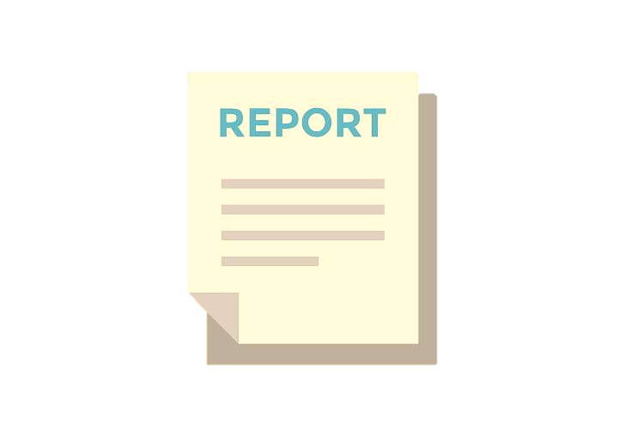

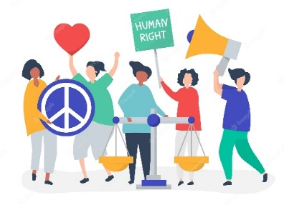

**Human rights** are the things that every person has and should be able to have, by law.[1]

# How you can send information to the United Nations

1. If you can, please write your information in English, Spanish or French.
2. Use Microsoft Word
3. Send the document by email to the **UN-Human Rights**:
   * Please copy the following text and paste it in “subject**”: Input to the study on care and support, pursuant to HRC resolution 54/6**
   * Send it to ohchr-registry@un.org and [ohchr-wohchr@un.org](mailto:ohchr-wohchr@un.org) (please add both addresses) by 13 April 2024

You can prepare the information together with child rights organizations you may be working with, or send information by yourselves.

If you have any questions, please ask Asako ([asako.hattori@un.org](mailto:asako.hattori@un.org)).

# What happens after sending the information



# The information you send to the UN will be used by experts to discuss human rights and care and support at the expert workshop.

The UN will also use the information to write a report on human rights and care and support. The report will be published online in March 2025 in 6 languages (English, French, Spanish, Arabic, Chinese, Russian) and an easy-to-read version of the report in English.

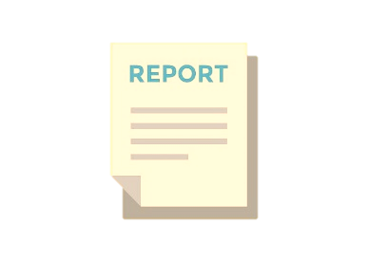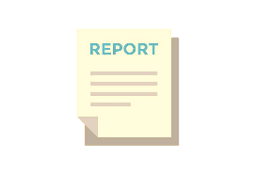

The UN and States will be able to use the report to help their decisions and their work to protect human rights of people giving and receiving care and support, and their self-care.

# What the words mean

**Human Rights** – basic rights and freedoms that should happen for every person in the world.

**Care** - caring for other people and to do household work.

**Support –** support is similar to care, but the way assisting others is different. Supporting others means treating them with respect and being helpful to do what they chose and for them to participate in the society.

**Call for input** – a request for information to events and reports the UN is preparing

**Expert workshop** – a meeting where experts get together and discuss specific issues and problems, and how to solve them.

**UN Human Rights Council** – a group of States that talk together, make decisions and write documents about the human rights of all, and learn how to do better to protect them.

**United Nations (UN) –** a group of 193 different countries that work together to try to make the world a better and safer place for everyone.

**United Nations Human Rights Office (UN-Human Rights)** – an Office of the UN that is working on human rights.

**Childcare facilities** – kindergartens, crèches, afterschool childcare, day-care centre for children

**Public transports** – Buses, trams, taxis, trains, planes and ships

**Infrastructures** – Roads, railways, stations, airports, public buildings

**Assistive devices and technologies**– Tools that help persons with disabilities, such as wheelchairs, glasses, hearing aids, computer applications that recognize your speech, that help to manage time and that do captions automatically, and automated home devices, etc.

**LGBTIQ+ children –**children who identify as lesbian, gay, bisexual, transgender, intersex or queer. The plus sign represents children who identify with other terms to describe their diverse experience of gender, sexuality or bodies other than lesbian, gay, bisexual, transgender, intersex or queer.

**Refugees and asylum-seeking children** – children who fled their countries because of war or threats and staying in other countries or requesting to stay in other countries

1. [Here](https://www.unicef.org/media/56661/file), you can find human rights relevant to children.