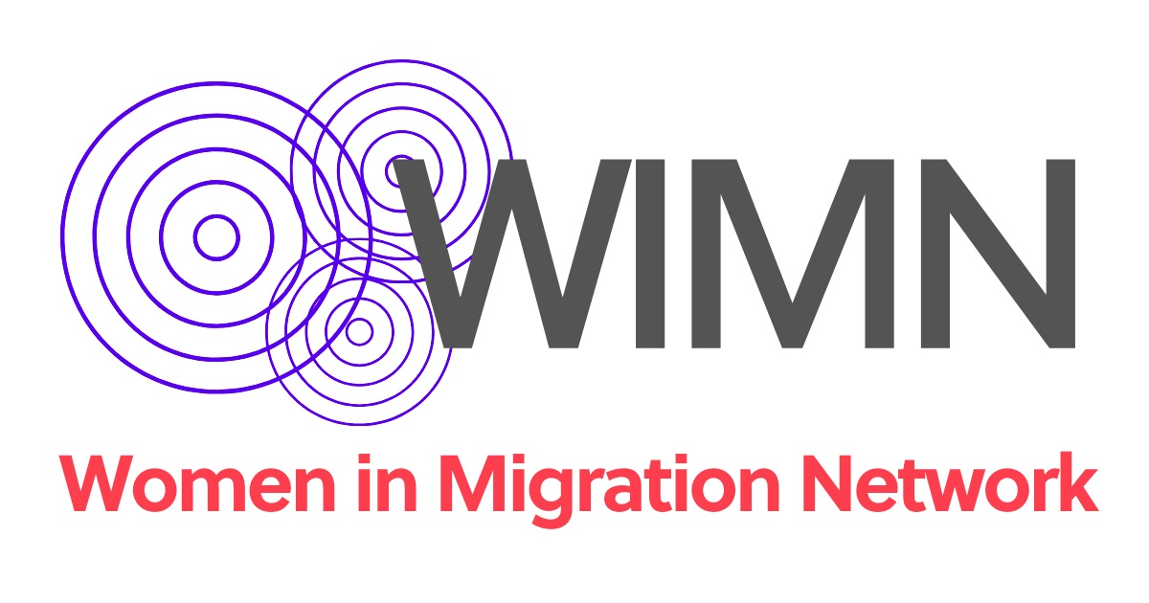

**Submission to the call for Input: Human Rights Council resolution 54/6 on the centrality of care and support from a human rights perspective**

**About WIMN**

Women in Migration Network (WIMN) is an international network focused on the rights of women in migration. We create and promote human rights-based and feminist global migration policies in an era dominated by economic, social and political inequities and hostile systems towards people in migration. We lift up and support the experiences, voices and agency of all women in migration as essential changemakers on the road to a more just world. Our members are organizations and individuals working at the national, regional and international levels, advocating for women, migrant, human rights, and labor rights.

**Introduction**

Care work provides critical support and services for individuals and communities, enabling the daily lives and functions of our social and economic systems. Yet, this essential work is defined by racial, gender, class, and geographic hierarchies within **global care chains**. Care work is generally characterized by low wages or no compensation, a lack of benefits and social protections, poor working conditions, and too often, gender-based violence and sexual harassment.

Many States do not take on the duty and the primary responsibility to provide public care services and develop a public care system. This has led to private households bearing care related responsibilities.Women all around the world are expected to pick up a disproportionate amount of care work, which is considered gendered and feminized. The burden of housework and care work falls on both adult and young women, whether they are engaged in paid employment outside of the home or not. Male members of the family are rarely seen as being equal partners in care and housework. When the burden of this work is beyond the ability of a single person, families may rely on the services of poorly paid care workers. Many of these care workers are migrant women, who may in turn depend on other women in their countries of origin to care for their families. This has become known as the ***international division of care work***, in which theglobal care chains are gendered and racialized.

The global care chains are facilitated by the existence of several factors that compel women to migrate as the solution to the existing care deficit. The first link in the global care chains is the lack of welfare and public services available for caring in both origin and destination countries, which can act as a reason to migrate. This contributes to the loss of skilled care workers in countries of the global South, and the added burden for those countries of origin of providing care for these workers in their elder years, when they return home, sometimes without pensions.

* **Main challenges faced in creating robust, resilient and gender-responsive care and support systems with full respect for human rights**

In many countries, paid care work is unregulated and not considered a part of the formal labor market. There is a high demand for migrant women’s care work, yet an unwillingness to pay living wages or to formalize women’s long-term residency and allow them access to labor rights and social security. **Circular migration schemes**—using temporary work programs—**instrumentalize migrant women's work** without opening paths to long-term residency or family unity. For women who migrate with temporary visas, the process, although regulated by governments, is mainly carried out by private recruitment and employment agencies. Since this model is based on memorandums of understanding or bilateral agreements between origin and destination countries, there is not a common international legal framework for negotiations on wages, working conditions, and other terms of employment, which tend to be obscure and without input from migrant workers.

Under these temporary migration schemes, migrant women are expected to take care of families in destination countries but have no rights to migrate with their own families. Such temporary schemes also create barriers to the full exercise of migrant women workers’ freedom of association and collective bargaining rights. In societies where unpaid work at home is not valued, there is little to no commitment to extending fair wages and working conditions to care workers. In the case of domestic workers, they are particularly often excluded from the mainstream labor laws that govern all other work sectors. Work permits and visas for domestic workers are likely to be tied to a specific employer and on a short-term or temporary basis, which greatly hinders their ability to exercise their internationally recognized labor rights.

Migrant women care workers face multiple and intersecting forms of discrimination due to their gender, race, class, and immigration status—further limiting access to rights. **Migrant care workers are also particularly at risk of exploitation due to the precarious nature of their immigration status**. For example, in GCC countries, the Kafala system makes migrant workers reliant on their employers for their legal right to live and work in a country. And temporary migration schemes in places like the United States, Canada and Europe also tie migrant care workers’ visas to their employers. As a result, migrant workers are reluctant to report abuses for fear of retaliation, blacklisting and losing their immigration status and right to work—especially after many have paid recruitment fees, which are often exorbitant and lead to debt bondage. Many migrant care workers may also be in an irregular or undocumented status due to restrictive and incoherent migration policies. Their **undocumented status** makes them even more vulnerable to **exploitation**.With the informality of much of the care sector, there is also the heightened risk of gender-based violence, labor exploitation, forced labor and human trafficking, due to a lack of labor inspections and regulation.

Migrant women care workers also face rights violations upon return home due to the stigmatization of women who migrate overseas for work. For these workers, **reintegration** and access to decent work at home is often undermined by this stigma, which can manifest as sexual and gender-based violence and gender discrimination.

Care is also an issue for migrant women who provide care for their families in destination countries. This is largely unpaid labor. Undocumented migrants have difficulty accessing many of the basic services provided by the state or non-state actors in the area of public services and social protection. Their fear of deportation, for example, may keep them from accessing needed healthcare for themselves and their children. Furthermore, women care workers may not have access to basic health care including sexual and reproductive health rights; they also may face mental health issues that emerge from isolation from family and community, violence, and exploitative working conditions. Thus, the issue of **universal access to quality public services** for all, regardless of status, is key in delivering economic and social human rights. And the need for regularization that extends long term residency and family unification are also critical to accessing those rights.

WIMN also works with women who remain in countries of origin when family members migrate. Many then assume roles as heads of household, creating intensified care demands. While it may mean more resources for those with migrant partners, for some women it may mean being the sole parent at home.When women’s family members who migrated are missing they not only shoulder the full financial and care burden for the family, but unpaid work may also involve efforts to advocate for information about their loved ones.

Migrant women who are deported or return home at the end of temporary labor contracts may face barriers in obtaining needed documentation which would enable them to access key services, while also facing stigmatization, hostility and xenophobia in some contexts. All of this may intensify the time women must allocate to unpaid work.

As a response to human rights abuses experienced by migrant care workers, several countries of origin have responded by adopting restrictions to women’s freedom of movement. For example, in the Association of Southeast Asian Nations (ASEAN) countries, several bans were put in place for certain periods in the past decade by both countries of origin and destination. Where bans exist, they fail to protect women, since many women must then migrate through informal channels to access job opportunities, thereby facing greater risk of exploitation[1].

* **How are the rights of migrant caregivers recognized and protected under international law?**

To reverse these challenges and promote decent work, care workers are organizing to fight for their labor rights.Domestic workers played an instrumental role in the drafting and the adoption of ILO Convention 189 on Domestic Work and continue to campaign for widespread ratification and implementation of the treaty. Domestic workers, including when they migrate, are organizing themselves into trade unions and associations -the International Domestic Workers Federation (IDWF) represents 670,000 domestic/household workers in 68 countries- despite limitations on freedom of association imposed in many countries either based on migration status or due to sector related limitations.

Article 5 of Convention 189 emphasizes that domestic workers, including migrant caregivers, should enjoy equal treatment with other workers in terms of working conditions, remuneration, social security, and other employment-related matters. This principle ensures that migrant caregivers are not discriminated against based on their migration status and are entitled to the same rights and protections as other workers. However, this article is jeopardized if both paid and unpaid care work are not recognized as part of national labor legal standards.

Civil society, including Global Trade Unions such as PSI, ITUC, Solidarity Center and IDWF, among others, are advocating for the ratification of ILO Convention 190 on violence and harassment in the world of work. By the ratification of ILO Convention 190 States can play a crucial role in protecting the rights of migrant care workers -formal and informal- by providing legal protections, preventive measures, support services, and holding employers accountable for ensuring safe and respectful working environments for migrant care workers.

1. Women in Migration Network, “No Borders to Equality:Global Mapping of Organizations Working on Gender and Migration”, www.womeninmigration.org/map/report