**Humanise Property:**

**Proposals for Post-Growth Development Strategy**

Submission by the research team from the Institute of Public Policy in collaboration with Centre for the Study of Social Exclusion and Inclusive Policy (CSSEIP), National Law School of India University, Bangalore, India.

Towards

Thematic report to the UN Human Rights Council "Eradicating poverty in a post-growth context: preparing for the next Development Goals" by the Special Rapporteur on extreme poverty and human rights, Olivier De Schutter, in the 56th session of the Human Rights Council.

|  |  |
| --- | --- |
| **Team of Submission Preparation** | **Respondents to the submission in the roundtable held on 13 January 2024** |
| Sony Pellissery (Lead)  Anushka Verma  Atish Padhy  Neel Lohit Pandey  Riah Rath  Shivangi Garg  Sithara Babu | Radhika Chitkare  Neel D’Souza  Sarthak Wadhwa  Sapni G. K.  V. Ashish  Saumya Singh |

**Introduction**

The reasons for search of post-growth welfare models are hugely different in the Global North and South. On the one hand, for last 40 years there been negative or zero growth in Europe. This implies search for alternative models of welfare arrangements those were made in the Golden era of welfare state ([Walker et al, 2021](https://www.sciencedirect.com/science/article/pii/S0921800921001245)). On the other hand, growth is possible and is taking place in the South. But, the outcomes of economic growth are far from desirable (e.g. inequality has increased in countries where growth has taken place in last two decades namely India and China; similarly, environmental outcomes due to growth models are discouraging). This submission is looking for alternative welfare arrangements in the light of propositions for post-growth welfare society ([Pellissery, 2024](https://papers.ssrn.com/sol3/papers.cfm?abstract_id=4671952)). The running theme through the proposal made in this submission is measures for advancing social function of property by reimagining a new relationship between work and property.

**Self-Sufficiency approaches in food production reduced quality of land and sustenance**

India’s commitment to self sufficiency in food can be traced back to the Green Revolution. The Green Revolution was India’s solution to its vulnerability to famine in 1940s. Despite the food production being consistently higher than India’s 2.14% population growth, the per capita availability of food grains had remained static till the 1990s. While the Green Revolution increased the productivity in the Northern Indian states especially Punjab and Haryana, it ushered in sharp deceleration in per hectare productivity in the southern states. During the periods 1970-73 to 1980-83, per hectare productivity declined in Tamil Nadu, Karnataka and Kerala.

With majority of the farmers belonging to small and marginal category with 86.2% of land holdings being less than 2 hectares (ha), there is a need to apply a “food system approach” which draws out the interactions between economic growth, self-sufficiency, agricultural production and nutritional outcomes.

One example of this is the nitrogen fertilizer subsidies which are subsidized nearly to 75% of their cost which has resulted in massive overuse of the nitrogen based fertilizers which in turn has reduced soil fertility while polluting the local water bodies. The self-sufficiency in agriculture has also come at the cost of our groundwater resources. Electricity subsidy provided to farmers to pump group water for production, has led to production of water intensive crops like rice and sugarcane, though the eco system in those regions primarily suited for sustainable crops like millets. An assessment done by Indian Central Ground Water Board (CGWB) which covered 6854 blocks, found that 1034 units were “over-exploited”, 253 were “critical” and 681 were “semi-critical”.

Contrasting examples are from Latin America. In the case of Colombia, the right to a balanced diet has been recognised by its constitution which has been interpreted by its court as the right to food security along with right to timely access to food adequate for meeting minimum nutritional needs. The Court’s have taken a broader understanding of food sovereignty which includes respecting and upholding the rights of local communities to forms of food production.

Both Colombia and Peru have advanced food sovereignty through peasants and indigenous organisations. The National Agrarian Confederation (CNA) has played a major role in this regard as it has shaped government policies throughout its criticism of the prioritisation given to agribusinesses and international market over local production while calling for the prioritisation of ancestral agricultural practices, land security and ensuring just access to markets. The farmers face losses due to prioritisation given to the agro-export companies, which have operated in the country as part of the Food Trade Agreement.

**Humanise the property by bringing social function upfront**

Value creation of property by holding out, is clearly anti-labour. The land titling initiatives that swept across the world in last century has intensified this process of holding out. One of the ways to humanize property is making property less exclusionary by putting it out for human flourishment purposes (Alexander 2018; Pellissery and Lodemel 2020).

India’s real estate sector is an example of loss of public interest due to nexus between the government and business firms. Regulatory capture when insiders manipulate building permits, zoning laws and land supply. The price inflation that benefits builders exclude the poorest people, leading to creation of slums / informal settlements. There are more than 11 million vacant houses in Urban India. It is exactly in these cities one finds large number of people struggling to find a place to live (Pellissery and Kaur 2022).

Increasingly, neo-liberal interpretations of courts on Rent Control Act are disproportionately favouring property owners, rather than tenents. Regulatory capture through collusion, as well as rental provisions that favour property owners, lead to holding out property for value appreciation, rather than use. This analysis suggests two indicators to ensure social function of property. First, the measures the state takes to eliminate regulatory capture. Second, imposing higher tax on holding out property, could increase the supply of housing units.

**Taking different forms of capital seriously**

Welfare policies designed as ‘tax and redistribute’ are essentially ineffective in post-growth approach since the fundamental root of inequality—wealth – remains unaddressed[1]. The accumulation and distribution of wealth itself isn’t a purely economic phenomenon insofar as largely immutable social identities, such as gender, race, ethnicity and religion, play a significant role. The centrality of ‘social capital’ holds true for other Asian, African and Latin American countries as well where one’s life’s outcomes are fundamentally influenced by one’s caste, ethnic and racial (indigenous vs white) identities.

In some ways, the approaches taken by India and Japan to deal with similar problems have been fundamentally different. The contrast offers good policy lessons. In India, 16% of population belongs to Schedule Castes (historically untouchables). In Japan, Barakumins accounts for less than two per cent of population. While India implemented its reservation policy centrally and targeted the educational and economic outcomes of individual marginalized caste members through direct reservation, Japan implemented at a municipal level and targeted the infrastructure in and around the areas where the marginalized group lived.

However, there is a lot that the Indian approach can learn from Japan as well, especially in terms of policy design. The involvement of municipal governments at the forefront of affirmative action was central to the success of the programme in Japan. India, where municipalities and rural local bodies continue to remain weak, can learn immensely from this and strengthen local bodies, which are best placed to identify the structural problems facing marginalized groups. More generally, a community-based approach that targets not just employment and education outcomes but also healthcare, housing and sanitation infrastructure will be central to transforming the symbolic successes of India’s reservation policies into more material successes.

**Dignity requires reducing knowledge inequality: Recognition is the key**

UDHR (n 2) Article 22 assures everyone, as a member of society is entitled to realization of the economic, social and cultural rights indispensable for his dignity. The dignity of the members of indigenous groups can be significantly prejudiced where the existing laws and policies for land and natural resource governance are based on external knowledge systems that are imposed in a top-down fashion, and invisibilise the indigenous groups’ local knowledge systems. This is because these knowledge systems can be an integral facet of an indigenous group’s identity.

Indian Forest Rights Act (2006) is a tremendous achievement to reduce the knowledge inequality. The Act recognizes both individual rights and community rights. Since the implementation of land, 2.2 million individual rights, and 1.1 million community rights have been granted. 18 million acres of forest land has been given for access and to pursue livelihoods.[2]

There is constant challenge against the Act from non-indigenous communities and corporations, which views forest merely as resource. This is where the recognition of conservation as development (Gupta 2021) becomes important. UNDRIP[3] (articles 19, 32, 10, 28 & 29) provides the scope of Free Prior Informed Consent (FPIC) to protect from the capture by the state and corporations. ActionAid in India has developed a manual to educate communities about FPIC principles[4], and to be vigilant when incursions take place.

Some of the existing measures, such as whether forest area have been increased/decreased, are ineffective. For example, Indian forest survey has included plantations while counting forest area to show increase of forest areas (Madhusudan and Raman 2022). These plantations are often established through land grab or sometimes denying the rights of indigenous populations.

**Disenfranchisement from natural resources leads to urban-centric growth models: Need of right to livelihood**

While the above example of recognizing the rights of forest dwellers is a positive example, many other communities which depend on natural resources are yet to realize equivalent right. Examples are fisher folk, salt workers etc. Most of these self-employed entrepreneurs self-exploit to make the ends meet. Without worker status, as the commons around the livelihood of these workers are either privatized or exhausted, they are expulsed to cities. Without conscious of these underlying reasons, facilitating migration has been a development strategy (Human Development Report 2009). One of the strategies of neo-liberal policies was to control the labour force by de-politicising it through migration, and politicizing the capital. As a result, deep and sharper inequality has emerged in the urban production hubs, where unskilled rural folks came in looking for opportunities.

On the other hand, a balanced regional development is what is required in post-growth strategy. An example of the same is found in Indian state of Tamil Nadu. Here, instead of GDP, Gross District Domestic Product (GDDP) calculates the value addition in each district. An assessment of GDDP value among all districts of Tamil Nadu during 1993-2017 shows that “only seven out 29 districts have more than one percentage point difference in the relative share of their GDDPs over the 27 years” (State Planning Commission 2022). This achievement is primarily by spreading productive activities to various locations, rather than capital investments and fund allocations primarily going to few metropolitan regions of the state. In an important way, achieving balanced regional development requires local level planning, and strengthens participation and representation in the development strategies.

Another initiative that is available at national level is promotion of products with Geographic Indicator (GI) tags. FAO started promoting GI tag as a strategy for sustainability in 2009. In India, over 500 products have been given GI tag status. While, this has given impetus to give market access to products coming from rural areas, organizing the communities around the principles of benefit sharing is yet to take place.

**Property is increasingly becoming masculine: Initiatives for transferring property to woman**

Despite of equal inheritance rights, several women have been forced to give up property rights when mutation of property is carried out in the inheritance processes.[5] Evidence shows that parents are investing in girls through other goods such as education. As a result, property in land is increasingly becoming masculine. This has twin effects. First, women’s contribution to subsistence economy is steadily decreasing. Second, girls are viewed as burdensome and economically unproductive, often increasing in infanticide (some states in India such as Haryana has female child ratio as low as 830).

An example to deal with this bias exists in the land distribution programme for the lower castes in the state of Karnataka[6]. Wherever, the state provides for land, it is made in the name of woman in the household. This could be extended to housing, credits and other welfare measures when provided by the state. Microfinance experience of Bangladesh shows that women as better custodian of resources for the household.

**References**

Alexander, A. (2018) *Property and Human Flourishing*, Oxford: Oxford University Press.

Gupta, P. (2021) ‘Conservation Is Development in the Forests of Nagarahole Tiger Reserve, India’ *Journal of South Asian Development* 16 (1) pp. 54-74.

# Madhusudan, M. D. & Raman, T R S (2022) “Is India’s forest cover really increasing? Official maps don’t tell you the whole truth”, *The Hindu* (accessible here: https://www.thehindu.com/sci-tech/energy-and-environment/is-indias-forest-cover-really-increasing-official-maps-dont-tell-you-the-whole-truth/article38412109.ece)

Pellissery, S. & [Lødemel](https://www.cambridge.org/core/search?filters%5BauthorTerms%5D=Ivar%20L%C3%B8demel&eventCode=SE-AU), I. (2020) “Property and Social Citizenship: Social Policy beyond the North”, *Social Policy and Society* 19 (2) pp.  275 – 292.

Pellissery, S. & Kaur, R. (2022) “The Social Question in Urban Centric Growth Models”, SOCIUM SFB 1342 WorkingPapers, Breman.

Pellissery, S. (2024) “Seven Propositions for Welfare State in Post-Growth Society”, Available at SSRN:  <http://dx.doi.org/10.2139/ssr.4671952>

Piketty, T. (2014) *Capital in the 21st Century*, Harvard: Belknap Press.

State Planning Board (2022) Regional Growth Patterns in Tamil Nadu (available at <https://spc.tn.gov.in/spc_reports/Regional_Imbalance.pdf> )

Valera, H., Yamana, T., Puskur, R., Veetil, P., Gupta, I., Ricarte, P., & Mohan, R. (2018) Women’s land title ownership and empowerment. ABD Economics Working Paper Series No. 559.

# Walker, C. C., Druckman, A., & Jackson, T. (2021) “Welfare systems without economic growth: A review of the challenges and next steps for the field” *Ecological Economics* Vol. 186.

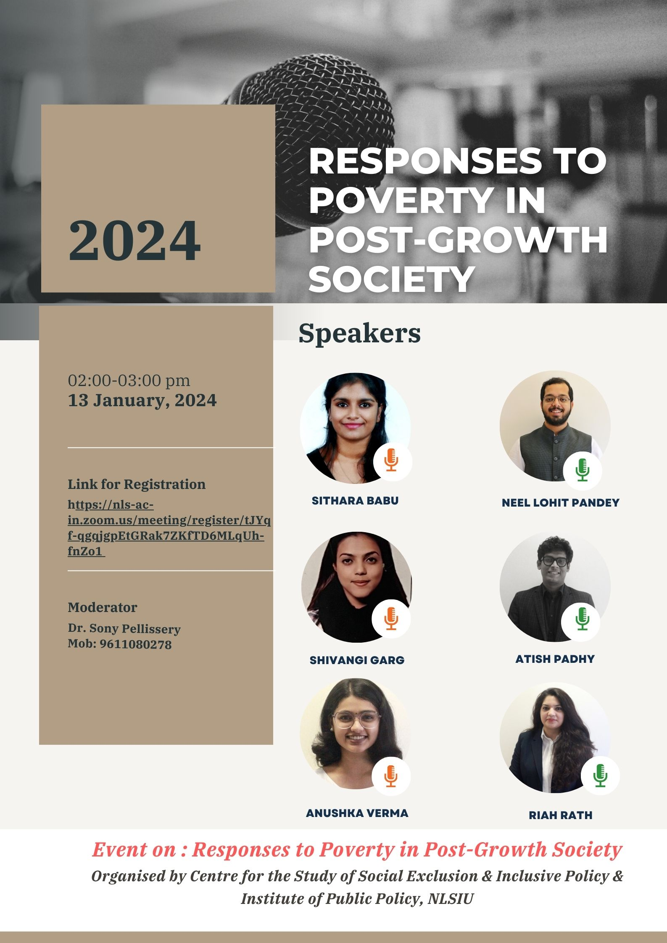

1. Piketty’s (2014) work has shown how wealth, rather than capital, is the reason for perpetuating inequality. Primarily, by showing the formula of gy < r Piketty argues that inherited wealth is likely to grow faster than outputs, when rate of return on capital exceeds rate of growth of economy.
2. Another example from Kenya is provided in the paper here: https://papers.ssrn.com/sol3/papers.cfm?abstract_id=4695291
3. The United Nations Declaration on the Rights of Indigenous Peoples (adopted 13 September 2007 UNGA Res A/RES/61/295 (UNDRIP).
4. https://www.actionaidindia.org/wp-content/uploads/2018/12/Free-Prior-Informed-Consent-English.pdf
5. Valera et al (2018) showed that only 3.1 per cent of land titles are held by women in India.
6. Details of this programme could be viewed here: https://adijambava.karnataka.gov.in/6/land-ownership-scheme/en