2. Which measures have been adopted, if any, to ensure that growth primarily benefits the bottom 40 per cent of the population, in accordance with SDG target 10.1? Have other tools to assess progress towards the reduction of inequalities been designed and implemented?

The above concern has been addressed in this note of writing based on Zambia’ s experience on SDG 10/

In 2020, Zambia undertook, assessment of the SDG indicators. This was Zambia’s first ever Voluntary National Review (VNR) towards monitoring the SDGs (Zambia Sustainable Development Goals Voluntary National Review, 2020). Quite a number of issues arose about the exercise particularly, for SDG 10 on how it is to be measured for the purpose of knowing its progress to achieving 2030 SDGs. A build up on how SDG 10 is measured was shown from the review of SDGs in 2020. The 2021 Sustainable Development Report index scored Zambia at 53.4 of the SDG progress, ranked at 141 of 165 countries. The goal on track to achieve was SDG 13 and others were making moderate progress (SDGs 3, 7 and 8), some had struggles (SDGs 2, 5, 6, 9, 11, 15, 16 and 17). However, SDG 10 had not been reported on because most of its data findings were said to have had its reflection in other goals such as SDG 1, SDG 8 and SDG 17. Therefore, gave reasons as to why the report on the SDG Index score did prove SDG 10 to have had no data indications.
The SDG 10 when enacted in 2015 was adopted to reduce inequalities for marginalized populations in all global societies who may be understood on the Goal Indicator 10.1.1 as, the “40% bottom of the population”. The UNICEF (2022) posits that quite to be understood rightly about global inequalities has to do with one’s rights at birth which reflects on the background of their parents. On the premise that an individual’s experiences of social and economic inequalities in their early childhood become responsible to their limited opportunities for them to realize their rights, ability and full potential. Therefore, forms of discrimination to people based on age, gender, ethnic or racial group, disability status, sexual orientation, migratory status, residence or other factors do stand in a way for people to exercise their rights.
In Zambia, to achieve the SDG 10, a strategic framework was designed. The strategic framework was designed as a document under the United Nations (UN). After the launch of SDGs in 2015, in 2017, the UN did launch the UN sustainable Development partnership framework (UNSDPF) and on its evaluation in 2023, another strategy was launched, the UN sustainable development cooperation framework (UNSDCF) to operate from 2023 to 2027. The UNSDCF has been designed to help achieve SDGs overall that will relate to human rights commitments in Zambia. The launched strategic framework or Cooperation Framework (CF) takes Centre stage under the UN to member states as it helps them link their development to SDGs National Development Plans (NDPs) and the Agenda 2030.
The UNSDCF is positioned to strengthen progress of Zambia towards the SDGs and other global obligations. To understand specifically SDG 10, the Goal covers 10 targets and 14 number of indicators when it was set. The targets are measured by indicators which use metrics to track achievements. In achieving SDGs and in particular, Goal 19, Zambia utilizes the current NDP to relate how to reconnect the links of progressive pathways to achieve the 2030 National Vision. The 8NDP focuses on improving the slowed down social economic conditions arising from the effects of the COVID 19 pandemic period. The SDG 10 with the rest of the goals in Zambia are consolidated in several frameworks that are anchored on the national priorities of its development policies.
The formulation of the UNSDCF is structured to help Zambia focus on four strategic priorities that is, prosperity, people, peace and planet. A complete set of 17 SDGs have in a way been represented in the four strategic priorities in the CF. When we focus on peace it requires that good governance, environment is priority to national development. The SDG 10 is aligned to the four strategic priorities that require that once a nation embraces them, it will be impacting on sustainable development goals positively including reducing inequalities. The CF aligns SDG 10 and the rest of the SDGs to the strategic priority and the Zambia 8NDP (Figure 1).

Figure 1. The relationship between UNSDCF and Z8NDP
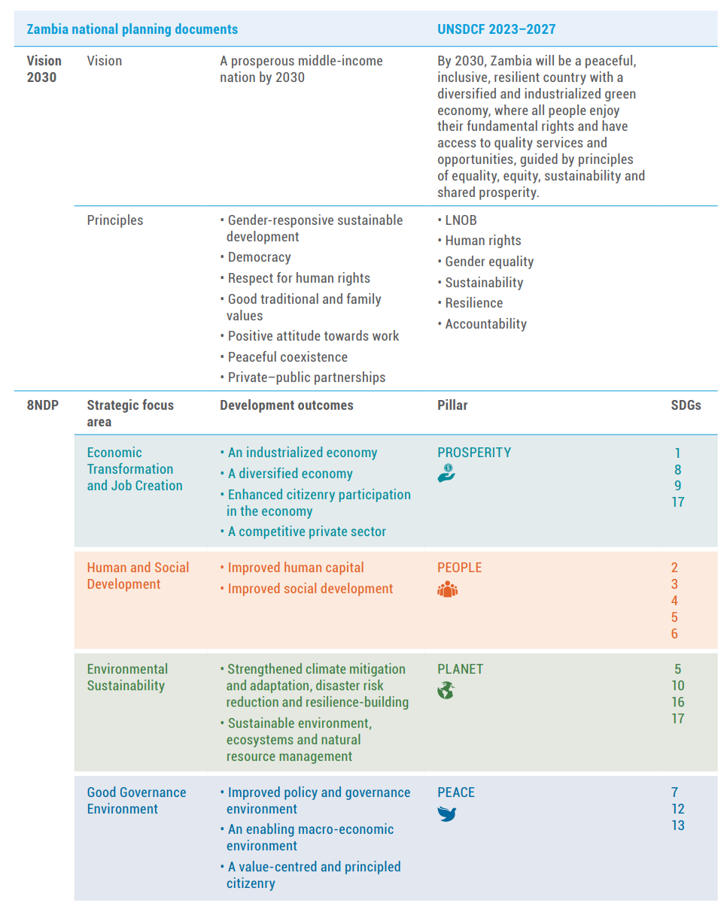
(source: Zambia UN Sustainable Development Cooperation Framework 2023-2027.pdf)

Much can be appreciated that when data was found to be unavailable for SDG 10 during the review of SDG in the 2021 SDG Index Score in Zambia, the UNSDCF helped improve measures of the goal by putting emphasis on the four strategic priorities and calling to work the principle of leaving one behind (LNOB). The leaving no one behind principle brings out challenges or difficulties to measuring SDG 10, as it had to deal with perennial issues of poverty, unemployment, access to quality services, marginalization in the population segments and several other factors.
Therefore, to that effect, change in society was identified in the UNSDCF as one form of measure needed to have impact on sustainable goals of development and a transformation process plan or approach was vital. This led to the incorporation of The Theory of change (TOC) in the CF as it rightly would help to support the strategic priorities in a transformation process of a society. The TOC is premised to help the transformation change process focused to achieve outcomes on the strategic role of the UNSDCF.
When developing the TOC, the understanding was based on how it will infuse the SDGs. The SDGs were designed on an interlinking relationship and this was the basis for the design or operation of the TOC in the framework. The TOC offers a basis to be useful to measure all SDGs understanding that sustainable development can occur if all societies adheres to the process of transformation. The TOC puts emphasis on partnership towards supportive progress on Agenda 2030. The TOC is designed based on the four pillars as strategic priorities of the UNSDCF (Figure 2).

Figure 2. Four Pillars for TOC partnerships
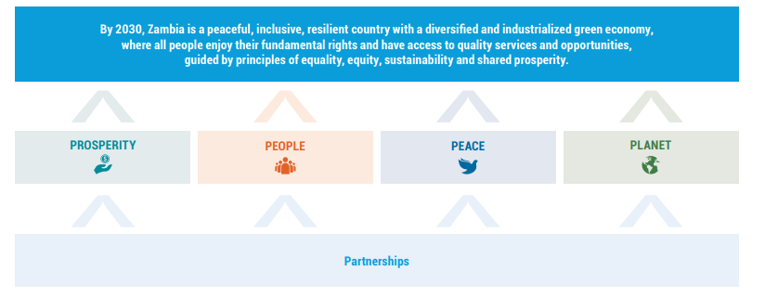
(source: Zambia UN Sustainable Development Cooperation Framework 2023-2027.pdf)

The TOC forwards emphasizes towards partnerships power which is required in a society once it is a consented effort. To achieve outcomes aspired in the UNSDCF four pillars (prosperity, people, peace and planet), need putting up effort from all players in society that have influence to social change. In this case efforts for partnering in social change is called between government and society entities. society entities include: multilateral organizations, bilateral organization, international NGO, local NGOs, Civil Society, private sector, citizens and many others. Partnerships will need to incorporate in their strategic plans how they support current National Development Plans (NDP) and Sustainable Development Goals ambitions for the greater good of society (figure 3).
In the Cooperation framework (CF) Partnerships is adopted as a cross-cutting issue that the Agenda 2030 identifies to be among its five pillars. Partnerships in the CF is well aligned to SDG 10 on the indicator to focus on reducing inequality on the 40% bottom population vulnerable groups. How are the vulnerable groups to be identified? The CF identifies a number of them to include women, children, adolescents and young people (UNSDG, 2022).
The Prosperity Pillar Unit Component
The Prosperity Pillar can be illustrated basing its focus on the wellbeing of vulnerable people. Among its components of operations, it indicates improving capabilities and strengthening social protection. The UN contribution in Zambia to the Prosperity pillar is among them economic growth focusing on how low economic groups in society may be included. This UN’s role to improve prosperity is to play a complementary task in Zambia’s economic reforms in order to balance the state and non-state actors. That will be creating a favorable enterprising environment for all groups in society either those in the informal or formal sectors. This will need economic laws and policies to show balances to human and the environment resulting into respecting rights for all living species to secure the ecosystem.
The period for economic growth during the SDGs era has had several setbacks to be understood as economic shocks that also impacted on the lives of vulnerable groups and state policies in Zambia. These shocks were caused by the Covid19 pandemic, the war in Russia and Ukraine and the economic down turn resulting thereafter. This as indicated by the UN, will need solutions to address constraints of experienced shocks. Shocks have been exacerbated due to increases in commodity prices due to weakening local currencies against international ones., upward adjustments of fuel pump prices. The vulnerable groups in society according to the CF will have to be considered by the state to improve social security issues by providing social protection schemes to reduce already existing high levels of inequality and realization of rights to social security.
Zambia's economic landscape has also been in a stimulus condition due to the gross government debt, which ranges higher than the low-income developing countries (LIDC) group average. The country’s debt crises have been ongoing since late 2020. The given financial constraints for Zambia have given options to consider such us Tax and Revenue reform, Remittances and many others (UNDP, 2023). Its growth pace has been positive and likely to contribute to poverty reduction. However, it still faces issues of income inequality or distribution. On that aspect it does requires an integrated approach which is inclusive towards poverty reduction through promotion of opportunities for the ultra-poor or marginalized

Figure 3. Six units of TOC Components
. 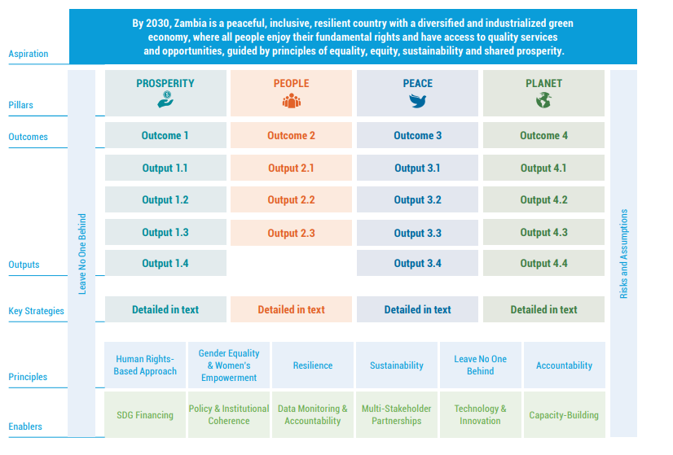
(source: Zambia UN Sustainable Development Cooperation Framework 2023-2027.pdf)

The TOC is illustrated using six unit components. It places under each component what will be reflected once operated on. The four pillars are the TOC’s basis, and under each of the four pillars, outcomes are mapped out leading to outputs, these are followed by strategies, guided by principles and enables for the process are to be identified too.

Social Protection Schemes
People’s rights especially marginalized groups of people need a critical consideration as they are a guiding principle in achieving most of the SDGs. The UNICEF’s contribution towards reaching Goal 10 centers on efforts to supporting countries enacting recommendations by the Committee on the Rights of the Child. It entails monitoring the implementation of the Convention on the Rights of the Child (CRC) through the MICS programme, the principle to Leave No One Behind is well supported by UNICEF in countries who uphold it to focus on eliminating discrimination through collection of data on the prevalence on discrimination experienced by any individuals from all groups of people in society.
When society is presented with a number of vulnerable groups, less is invested in social protection programmes or schemes. The UNICEF under Goal 10 takes an interest on investments in social protection schemes and policies to see how these address inequalities and discrimination to reduce lifelong suffering.
Programmes focusing on Social protection, have been introduced to most vulnerable groups in form of universal child grants, school feeding programmes, youth skills training programmes, social cash transfers for orphans, disabled people, elderly people and in-kind programmes. These social protection programmes have helped in connecting families with health care, nutritious food and quality education giving all children a fair to an equal entitled life.
Zambia is rightly positioned to achieving the SDGs inclusive of Goal 10 that seen interlinked in several goals. It then challenges implementers of SDGs to understand these interlinking goals, a need for an integrated approach to achieve sustainable development.

References
UNDP, 2023, SDG push Insight Report, Zambia, https://sdgpush-insights.undp.org/reports/zmb#sdg-interlinkages

UNICEF, 2022, UNICEF Data: Monitoring the situation of children and women
UNICEF Data: Monitoring the situation of children and womenhttps://data.unicef.org/sdgs/goal-10-reduced-inequalities/
UN, 2023, ZAMBIA Sustainable Development Cooperation Framework 2023–202

unsdg.un.org/2030-agenda/cooperation-framework

Zambia Sustainable Development Goals Voluntary National Review 2020 Report, https://unstats.un.org/capacity-development/UNSD-FCDO/about/

