The use of the Frisian language on government websites

Author: Jeroen Zandberg

Date: 31-10-2023

Organisation: UsNEF (Netherlands Chamber of Commerce: 84743093)

E-mail: [jeroenzandberg@underrepresentedstates.org](mailto:jeroenzandberg@underrepresentedstates.org)

Website: [www.underrepresentedstates.org](http://www.underrepresentedstates.org)

The report is focused on the provision of digital public services as mentioned in item six: *“Are public services digitalized in your country? “The* data is presented in the accompanying PDF-file.

**Objective**

This document looks into the provision of digital public services in the territories of Fryslan, Ost Friesland and Nord-Friesland where different languages are spoken, which are officially recognized by the central, regional and local authorities in the Netherlands (Fryslan) and Germany (Ost Friesland and Nord-Friesland).

**Introduction**

Many government services in the Netherlands and Germany are currently digitally available. According to the UN e-government database (<https://publicadministration.un.org/egovkb/Data-Center>) the Netherlands (rank 9) and Germany (rank 22) both have a highly developed e-government infrastructure. However, these services are only fully available in the German and Dutch language. In some areas, like education and cultural affairs, there is partial support for Frisian, but only as an online information leaflet and not as a fully transactional and seamless service. The Frisian language accessibility sits at the first stage of the e-government model, while the German and Dutch language sits at stage five. In order to bridge this digital divide, priority should be given to providing the Frisian minority the same e-government services in Frisian as in German. This would allow people who are at present excluded or at a disadvantage due to a language barrier, to be fully included.

**Frisian in the Netherlands**

Frisian is an officially recognized minority language in the province of Fryslan in the Netherlands. Through the ‘law on the Frisian language’, Frisian is protected and supported for use in education, legal procedures and governance. For more information see the links below.

<https://www.rijksoverheid.nl/onderwerpen/erkende-talen/de-friese-taal>

<https://wetten.overheid.nl/BWBR0034047/2014-01-01>

**Frisian in Germany**

The Frisians are also recognized by the German government as a national minority and their language is protected by the ‘Frisian Law’, which provides support for use in the public sphere. For more information see the links below.

<https://www.minderheitensekretariat.de/en/the-frisians/>

<https://www.minderheitensekretariat.de/en/specific-minority-legislation-and-measures/>

*“The Frisians are explicitly protected by the constitution of Schleswig-Holstein. In 2004 the Schleswig-Holstein parliament (Landtag) adopted the so-called Frisian Law that provides support for and protects the Frisian language and culture.*

*It recognises the Frisian language forms and their free use and guarantees the specific rights of the Frisians, e.g. to use Frisian in contacts with the authorities or the use of bilingual place-name signs.”*

###### [Law to support Frisian in the public sphere (Frisian Law) (German)](https://www.gesetze-rechtsprechung.sh.juris.de/jportal/portal/t/9ld/page/bsshoprod.psml?pid=Dokumentanzeige&showdoccase=1&js_peid=Trefferliste&documentnumber=1&numberofresults=1&fromdoctodoc=yes&doc.id=jlr-FriesischGSH2004rahmen&doc.part=X&doc.price=0.0&doc.hl=1#focuspoint)

###### [Overview of legal provisions relevant for the Frisian minority in Germany (German)](https://www.minderheitensekretariat.de/wp-content/uploads/2022/12/20140101_FR_rechtsgrundlagen.pdf)

**Data on the use of Frisian in e-government**

An overview of the provincial and local websites in the Frisian areas provides an insight into the use of Frisian in electronic government services. The data in the accompanying PDF-file shows that most local and provincial websites do not provide services in the minority language. However, there are several municipalities who provide partial information in the Frisian language. These local governments are marked in yellow. They provide some of the static information on their website in Frisian, but the digital services themselves can only be accessed through the national language. The provincial website of Fryslan, as well as the sites of the cities of Leeuwarden, Smallingerland and Saterland, do offer their services in the Frisian language, which shows that if the political will is present, a truly multilingual website providing all e-government services is possible.

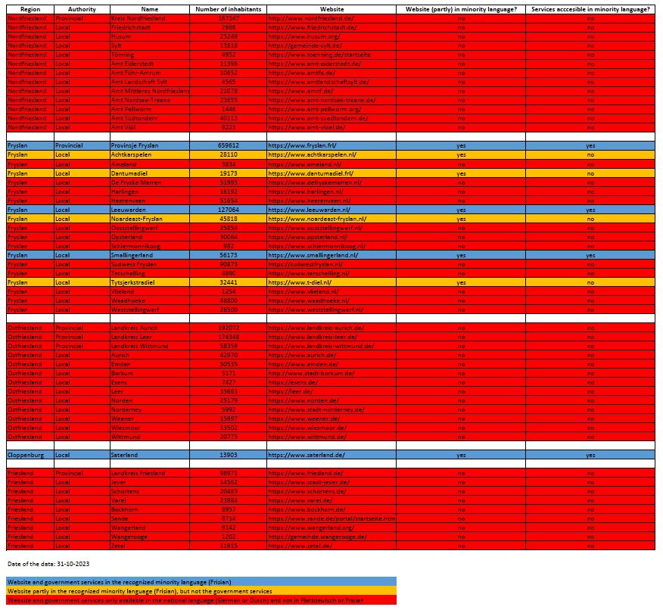

**Maps of the Frisian areas**

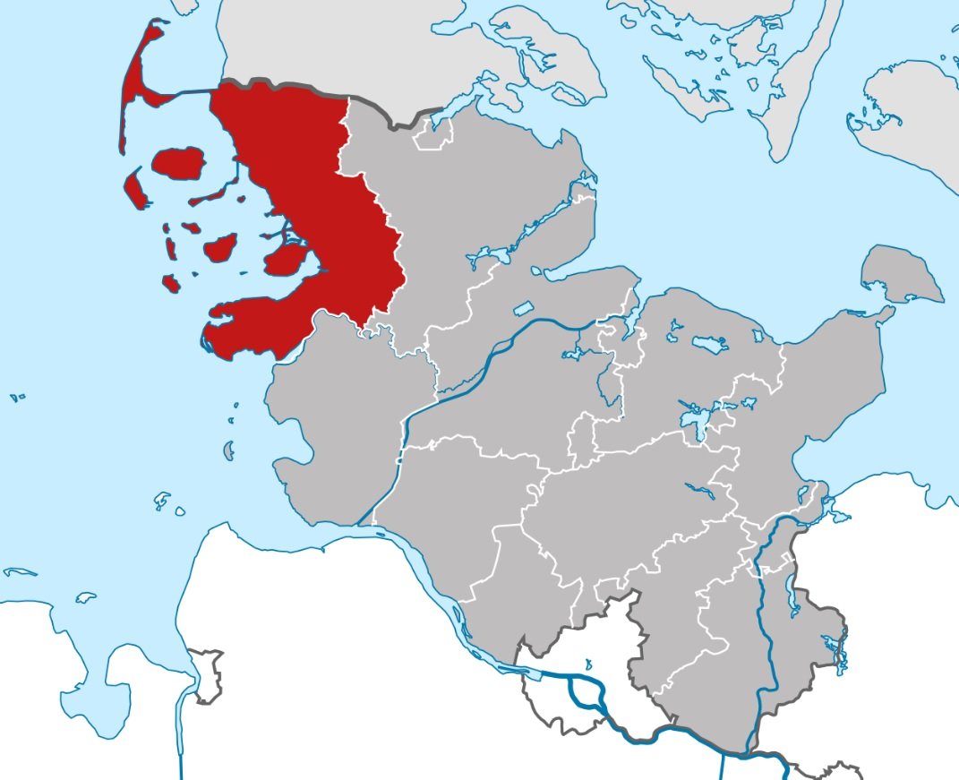

Nordfriesland

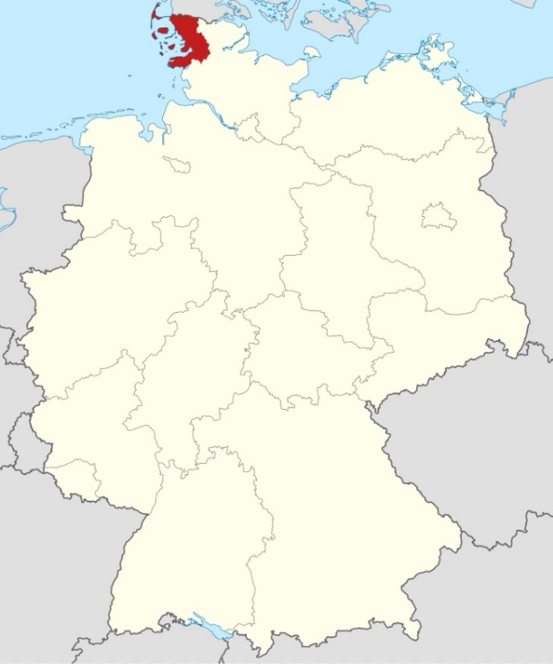

Nordfriesland

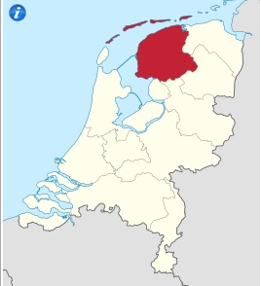

Fryslan

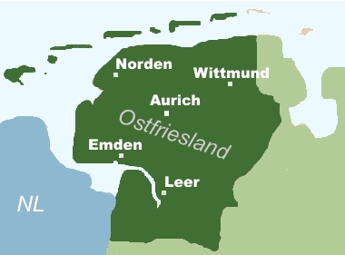

Ostfriesland

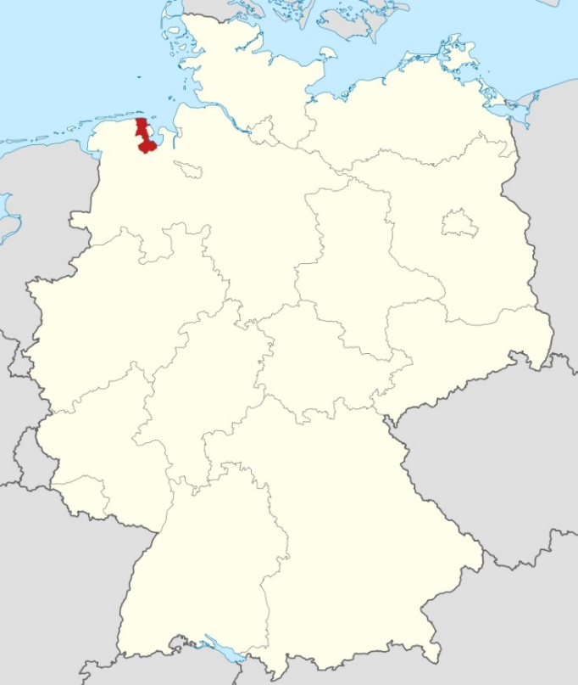

Friesland

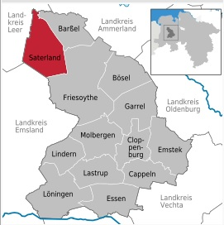

Saterland (in Cloppenburg)