**The Federation of Korean Trade Unions (FKTU), SOUTH KOREA** (29 March 2024)

**Key question 1.**

The rights of trade unions related to ILO Conventions Nos. 87 and 98 are stipulated in Article 33, Paragraph 1 of the Constitution, “Workers have the right to independent organization, collective bargaining, and collective action to improve working conditions,” and the specific contents of this are governed by ‘Trade Union and Labour Relation Adjustment Act’ (hereinafter referred to as ‘TULRAA’). On 5 January 2021, to ratify the above ILO Conventions, TULRAA and the Public Officials and Teachers' Union Act were revised. Below, the major amendments to TULRAA are as follows.

Removal of restrictions on union membership by company for laid-off workers

The qualifications for membership in a labor union are determined by the regulations, but if a union member who is an employee of the relevant company is fired and applies for relief from unfair labor practices, the employee status is recognized during the review of the case by the Central Labor Relations Commission.

Restrictions on the qualifications and union activities of non-employees as union officers and workplace representatives

The executive council members and representatives of each company's union are elected from among the union members working in the relevant business or workplace.

Non-employee union members are excluded from calculating the number of union members for purposes such as setting working hour exemption limits, decisions by the negotiating representative union, and voting for or against industrial action.

Labor union activities are permitted to the extent that they do not interfere with the employer's efficient business operation (the original regulation restricting non-employee union members from entering the workplace was deleted).

Deletion of the ban on wages for full-time union employees and reform of the working hours exemption system

Deletion of provisions banning wages for full-time union employees and prohibiting industrial action demanding payment of wages exceeding the working hours exemption limit

A collective agreement or employer agreement that exceeds the working hours exemption limit is invalid only for that part, and if the employer pays wages in excess of the time-off limit, it will be punished as an unfair labor practice.

The Working Hours Exemption Deliberation Committee was established as a special committee of the Economic, Social and Labor Committee under the Economic, Social and Labor Committee Act:

(Supplementary Provisions): Necessary procedures, such as composition of members of the Working Hours Exemption Deliberation Committee, shall be carried out before the law goes into effect, and operational conditions such as the number of union members, regional distribution of union members, and activities in union organizations for the development of sound labor-management relations shall be taken into consideration immediately upon enforcement of the law. The deliberation on working hour exemption limits also began.

Extension of the upper limit of the validity period of the collective agreement (2 → 3 years)

Labor and management set a collective agreement validity period within a 3-year period.

Prohibition of industrial action that interferes with operations by excluding employers from possession of workplaces

Reorganization of systems related to unification of negotiation channels

Declarative regulations on good faith negotiation and non-discrimination principles for all unions during individual negotiations

Establishment of new basis for integration of negotiation units: Establishment of new basis for integration of separate negotiation units, improvement of legislative insufficiencies

Obligation of national and local governments to make efforts to select various negotiation methods

Regulations on the national and local governments' obligation to make efforts to promote various negotiation methods such as negotiation by company, industry, and region

Regarding the above amendment to the Trade Union Act, organized labor, including the Federation of Korean Trade Unions, assess that it is only a minimum level of revision for ratification of the conventions, and falls far short of guaranteeing the right to unionize at an international level by specifying the three labor rights under the Constitution.

In particular, many have pointed out that it is a step backwards from the previous version as it contains content unrelated to the ratification of the conventions, such as restricting the qualifications and union activities of non-employees in each company's union as executives and representatives, and extending the upper limit of the validity period of the collective agreement.

Above all, the amendment to Articles 2 and 3 of TULRAA, which is said to be the most fundamental solution to protecting the working conditions of vulnerable workers and prohibiting forced labor (expanding the concept of employer, limiting employers' claims for damages due to industrial action, etc.) ) passed the plenary session of the National Assembly for the first time in 20 years, but was eventually abolished due to the President's veto.

In case of violation of the law related to the conventions, the TULRAA considers it to be an unfair labor practice by the employer, which mainly corresponds to refusal or neglect of collective bargaining, and imposes fines as well as related procedures for this.

**Key question 2**

Full application of the Labor Standards Act to protect the minimum working conditions for workers in workplaces with less than five employees, enactment of equal pay for equal work to prevent wage discrimination for non-regular workers such as indirectly employed workers at primary and subcontractors, and guarantee of basic labor rights for irregular workers such as platform workers and freelancers. A signature campaign was held to call for the enactment of three types of social solidarity legislation to 'enact a law to guarantee rights for working people', and a signature sheet was delivered to the chairman of the National Assembly's Environment and Labor Committee **(Picture 1,** below**)**.

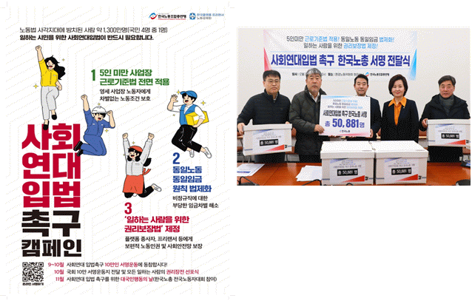

**(Picture 2)** The Federation of Korean Trade Unions is carrying out activities targeting housework and care workers vulnerable to a variety of risks limiting their labor rights

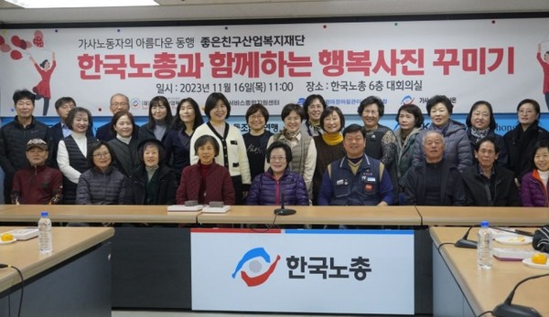

**(Picture 3)** The FKTU holds a press conference urging ratification of ILO Convention No. 190, ‘Eradication of Violence and Harassment in the World of Work’

(Related article: http://news.inochong.org/detail.php?number=5088&thread=22r07)

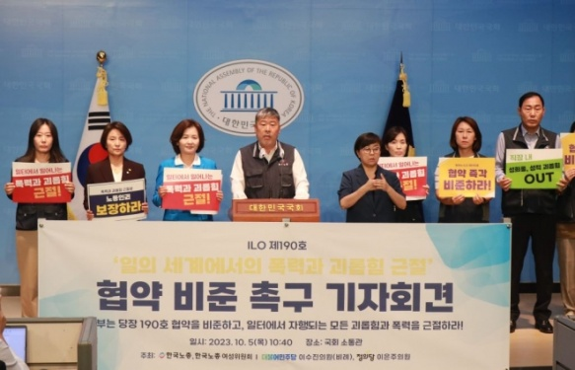

**(Picture 4)** Providing specialized legal consulting services to respond to complaints of unfairness and abuse of power against freelancers, who can be regarded as modern-day slaves.

(Related article : https://nodonggongje.org/101/?q=YToxOntzOjEyOiJrZXl3b3JkX3R5cGUiO3 M6MzoiYWxsIjt9&bmode=view&idx=18664660&t=board)

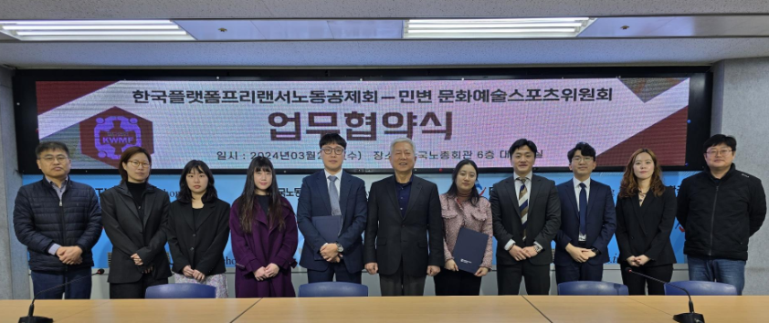

**Key question 3**

**(Picture 5)** In order to criticize Bank of Korea's review of discriminatory application of minimum wage to migrant workers, labor organizations such as the FKTU, Korean Confederation of Trade Unions (KCTU), Gonggam Public Interest Human Rights Law Foundation, Welfare State Youth Network, People's Solidarity for Participatory Democracy, Korean Federation of Women's Organizations, and Korean Women's Workers' Association and holding a joint press conference with civil society organizations.

(Related article: http://news.inochong.org/detail.php?number=5232&thread=22r07)

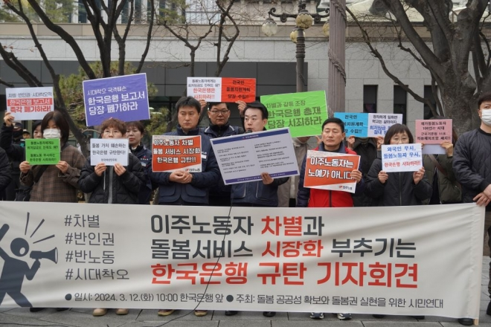

**(Picture 6)** The FKTU, the KCTU, and the National Migrant Workers' Human Rights Society held a joint press conference to condemn the government's migrant labour policies, including changes to workplaces for migrant workers and addition of regional restrictions.

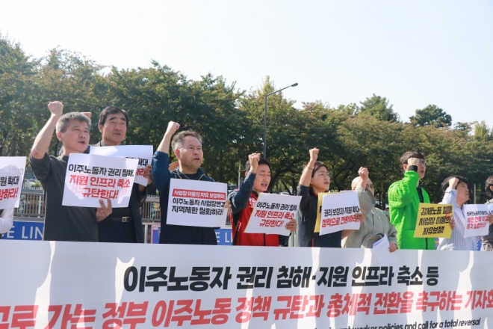

**(Picture 7)** The FKTU, the National Equal Employment Opportunity Counseling Center Network, and other civic groups held a joint press conference to condemn the government's regression in women's policies, including the abolition of the Equal Employment Opportunity Counseling Center.

(Related article: http://news.inochong.org/detail.php?number=4977&thread=22r17)

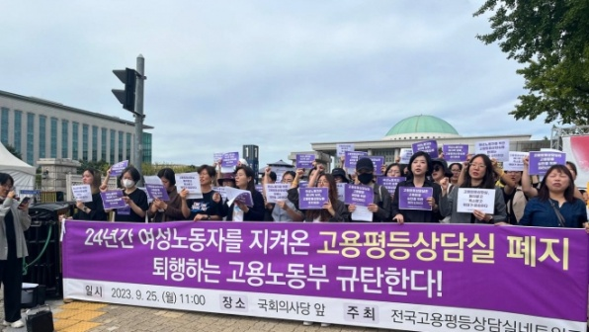

**Key question 4**

The FKTU, Good Friends Industrial Welfare Foundation, Korea Platform Freelance Labor Mutual Aid Association, Freelance Rights Center, Seoul Regional Worker Support Center, regional legal counseling centers, etc.

**Key question 5**

**Poor working environment for social service (an alternative military service) personnel(SSP)**

- SSP are a form of fulfillment of military service obligations under the Military Service Act, and cannot be considered a service for purely military purposes, which can be seen as an “exceptional form of forced or compulsory labor” in the Convention. In order to ratify the ILO Forced Labor Convention, the Korean government has granted the right to select active duty even for people with physical class 4, but in the sense that it is inevitable social service service in place of military purposes in the form of forced conscription, it is in the nature of forced or compulsory labor. It is difficult to rule out this.

- SSP under the social service system under the Military Service Act (those who have been determined to be grade 4 supplementary service and provide social service and administrative work in the private sector) are transferred to service locations (service institutions) and are restricted from moving to another service locations. Accordingly, due to the nature of compulsory service, there are frequent cases of people being harassed or forced to do unreasonable work at their place of service, and the reality is that they do not receive any legal protection.

- At the time of ratification of ILO Convention Nos. 29, the option of active duty enlistment was granted to SSP, but despite measures to amend the Military Service Act to avoid violation of the ILO Convention, there is an issue of forced or compulsory labor in that mandatory social service is inevitable in lieu of military purposes. As it is difficult to exclude, some revisions are required.

**Employment permit system that restricts the freedom of movement of migrant workers**

- The Employment Permit System, which restricts migrant workers from changing workplaces and moving around and allows employers to decide on workers’ future positions, can in fact be said to be a ‘modern-day forced slavery’

- As a result, labor exploitation, low wages and long working hours, and sexual violence against migrant workers occur frequently.

- Recently, the government is pursuing a policy that runs counter to the times by additionally introducing a ‘regional transfer system’ that allows change of workplace only within the region where the first job was obtained.

**Criminal punishment for industrial action under TULRAA**

- Since our Constitution guarantees workers' right to collective action as a basic constitutional right, and TULRAA is a law designed to realize this, excessive restrictions on industrial action and provisions on criminal punishment should be abolished.

**Discrimination against non-employee union members**

- With the revision of TULRAA in 2021, union members who are not employees of the business or workplace (non-employee union members) will only be recognized as engaged workers until the Central Labor Relations Commission come to conclusions of its labor practices reviews, and non-employee union members cannot be elected as an executive member or representative of each workspace union.

- In addition, non-employee union members are not included in the number of union members when determining the working hour exemption limit or calculating the number of union members for selecting a bargaining representative union. This effectively deprives union members who are not employees of the relevant business or workplace of their right to union activity, which violates the constitutional right to equality and the principle of prohibition of discrimination under TULRAA. It violates the ILO freedom of association principles of “workers’ right to completely freely establish and join organizations of their own choice” and “guarantee of free organization operation and activity.”

**Abuse of power by public authorities, such as forced dispersal of peaceful union protests and demonstrations**

- The freedom of assembly and demonstration inevitably entails the occupation of a certain space and the resulting inconvenience to travel and transport. However, if it is not serious, this should be permitted and the inconvenience to citizens should be minimized through proactive and proactive efforts by the police.

- On the other hand, the police used public power excessively and illegally, such as investigating the trade union's street sit-in as illegal without any legal basis, forcibly disbanding a nighttime cultural festival in front of the Supreme Court, and forcibly demolishing the place to remember Yanghoe-dong martyrs of the KCTU and Construction Workers' Union.

- The President's Office also recently attempted to have some laws revised and follow-up measures taken to reduce damage caused by ① obstruction of public transportation during commuting hours and occupation of major roads, ② noise from loudspeakers, ③ late-night and early morning rallies, and ④ rallies near residential areas and schools. By effectively ordering the Office for Government Policy Coordination and the National Police Agency to come up with an implementation plan, the freedom of assembly and demonstration, which can be considered a core value of democracy, is being suppressed.

**Narrow scope of workers and employers under TULRAA**

- The ILO Committee on Freedom of Association reminds that, in accordance with the principle of freedom of association, all workers, with the exception of soldiers and police, should have the right to form and join a labor union of their choice, and that this right must be guaranteed. It has been emphasized that the criteria for determining whether a person is eligible for relevant rights is not based on the existence of an employment relationship.

- Accordingly, in the case of agricultural workers, most self-employed workers, or independent workers, it is common for there to be no employment relationship, but the right to organize must nevertheless be guaranteed, and this principle has recently been rapidly increasing. It is necessary to revise the definition of worker under Article 2, Item 1 of TULRAA so that it can be judged to apply equally to atypical workers, that is, specially employed transport workers, platform workers, and others.

- In the case of indirect employment such as subcontracting, it is necessary to revise the definition of employer in Article 2, Paragraph 2 of TULRAA to recognize the employer status of the primary employer who has the authority to determine actual working conditions. In the case of Korea, legislation is being promoted in the National Assembly, but the Korean government is opposing the revision of the law on the grounds that it could lead to excessive expansion of negotiating parties and frequent strikes.

**Trade union establishment reporting system that suppresses union establishment**

- In Korea, the establishment of a Trade union is operated through a reporting system, but the current labor union establishment reporting system can be operated arbitrarily by administrative authorities.

- Accordingly, in order to amend in the direction of minimizing the intervention of administrative authorities in the establishment of Trade unions, Article 2, Subparagraph 4 (d) of TULRAA must be deleted to delete the provisions that serve as the basis for substantive review regarding the establishment of trade unions by administrative authorities. It is necessary to delete the provision for rejection of the establishment report in Article 12, Paragraph 3.

-- The ILO Committee on Freedom of Association states that the formalities prescribed by law for the establishment of trade unions should not be applied in a way that delays or impedes the establishment of trade unions, and that any delay caused by the authorities in registering trade unions is prohibited. Even though it was determined that it was a violation of Article 2 of Convention No. 87, it was still not corrected.

**Unified negotiation window system that infringes on autonomous labor-management bargaining**

- The current union law violates ILO standards by requiring the union organized by a majority of the total members of the unions that participated in the process of unifying the negotiation channel to have exclusive bargaining rights as the representative bargaining union. The ILO Standards Application Committee and the Freedom of Association Committee state that if there is no representative union that meets the requirements, collective bargaining rights should be granted to all unions within the relevant bargaining unit, and even minority unions should at least be able to conclude collective agreements for their members. , unions that are not granted collective bargaining rights should also be able to carry out their own activities, and it is recommended that the government take measures to ensure that unions can at least represent their members through individual objections.

- Provisions related to the unified negotiation channel system, such as Article 29 Paragraph 2 and Article 29-2 to 5 of TULRAA, need to be deleted.

**Unreasonable restrictions on collective bargaining and industrial action**

- Korean courts restrictively interpret the purpose of industrial action as being related to so-called ‘mandatory collective bargaining matters’ and matters related to determining wages and working conditions.

- Limiting the scope of negotiation to specific issues directly related to working conditions and excluding specific issues from the scope of collective bargaining is a violation of the right to collective bargaining.

- There is a need to change the jurisprudence of precedents that judge industrial action on ‘management matters’, ‘political strike’, and ‘solidarity strike’ as unjustified industrial action to comply with ILO standards.

- Legislative improvement is required to expand the scope of collective bargaining and industrial action and to expand the scope of recognition of the legitimacy of industrial action based on this.

**Administrative authorities’ authority to issue rules and resolutions for trade unions, collective agreement correction order system**

- The Korean government has conducted an extensive survey on the status of union regulations and collective agreements, including the 2009 ‘Plan for Improving Civil Service Collective Agreements’, the 2016 Wage and Collective Bargaining Guidance Direction, 2016, 2023: Corrective Orders for Public Sector Collective Agreements and Rules, etc., leading to the implementation of corrective orders for contents of collective agreements that limit the personnel and management rights of employers.

- In the case of public institutions, the product of labor-management collective bargaining and agreement is regarded as a collective agreement with unreasonable content that violates laws and government guidelines, and corrective action is taken. In terms of this, the regulations and resolutions under Article 21 of TULRAA, the administrative authorities' right to order corrections regarding collective agreements under Article 31 Paragraph 3, and the penalty provisions for violations, etc., should be abolished.