**Input to the UN’s Special Rapporteur on water rights and sanitation in response to the consultation on the thematic report “Economic values in water management from a Human Rights Perspective”**

Provided by Prof. Julia Martin-Ortega ([j.martinortega@leeds.ac.uk](mailto:j.martinortega@leeds.ac.uk)) – February 2024

***Part A. The notion of economic value***

It would be important that the report acknowledges that there are now alternative conceptualisations of water values beyond the ‘conventional’ (neoclassical) understanding of economic values as exchange values. While this concerns nature more broadly (as expressed IPBES’s, 2022), it is particularly salient in the case of water. Valuing water – that is, recognising that decision-making about water is shaped by and affects people’s plural values – is currently being formally endorsed as a new paradigm for water management by several international and national organisations (Government of the Netherlands, 2019, [Global Water Partnership, 2021](https://www.sciencedirect.com/science/article/pii/S1462901124000194#bib33), [Stockholm International Water Institute, 2021](https://www.sciencedirect.com/science/article/pii/S1462901124000194#bib92), [UN-Water, 2021](https://www.sciencedirect.com/science/article/pii/S1462901124000194#bib96)).

One way of operationalising the new *Valuing Water* paradigm, is that of the Values Landscape Approach  ([Schulz et al., 2017](https://www.sciencedirect.com/science/article/pii/S1462901124000194#bib86)a, [Schulz et al., 2018](https://www.sciencedirect.com/science/article/pii/S1462901124000194#bib87)), which brings together three types of values: fundamental, assigned and governance-related values, in a way explicitly oriented to inform decision-making processes. Fundamental values, also conceptualized as broad values, encompass people’s personal abstract goals and principles guiding their decisions (e.g. security, universalism, hedonism). Assigned values, also conceptualized as ecosystem services, are the instrumental and economic values that humans ascribe to nature (e.g. food provision, aesthetics, pollination, etc.). Governance-related values relate to the desirable characteristics of the governance system as expressed by individuals or groups (e.g. efficiency, trust, transparency, or legitimacy.). This approach helps to identify conflicting groups of values (value landscapes) across individuals, such as those arising from the tensions between conservation and development, as well as those from changing practices.

An application of the Values Landscape Approach in a global survey among water professionals across all continents (N = 293), shows how preferences among three archetypical perspectives on water management – (1) controlling water flows through engineering solutions; (2) managing water through market-based mechanisms; (3) working with natural water ecosystems – can be explained by different types of values, despite the enormous diversity among water management contexts around the world (Schulz et al. 2024). The valuing water paradigm thus has an expressly political dimension to it; applying it makes explicit how water management decisions are informed by and may reinforce some values and weaken others. As such, it can be a useful diagnostic in the context of water conflicts, to help understand how decisions about water are linked to different stakeholder groups’ values. Examples of the application of the Values Landscape Approach in country cases are also available (e.g. in Brazil with respect to the development of a waterway across the Pantanal wetland, the proliferations of dams in the Upper Paraguay River Basin, and in catchment management in Kenya (Schulz et al. 2017b, 2018, 2019, 2022– *please note that text boxes summarising further details on the global survey or these country cases can be provided if required*). Besides these research publications and policy reports, practitioners have also started to employ this framework in water decision-making. GWP have made a toolkit for its application available[1], and policy-makers in the Netherlands and Chile, among other countries, have applied it to inform development cooperation and river basin management.

* **In sum, key message for the report:** **a ‘human rights’ perspective on the economic values of water needs to acknowledge that *values* are plural, diverse and more complex than the neoclassical understanding of ‘exchange values’ measured in monetary terms. New frameworks, such as the Value Landscape Approach, provide ways of operationalising such plural values in ways that can be used to inform decision-making; so that whose values are promoted or hindered by water management decisions is made apparent, i can be identified and mitigated and conflicts can be addressed.**

***Part B. Rights and responsibilities: re-igniting kinship with water (riverkin)***

A Human Rights perspectives requires recognising both the rights and responsibilities with respect to water. While a Human Rights perspective is fundamentally anthropocentric, it does not mean it has to also be ‘instrumental’ (as inherent in the ecosystem services paradigm, Martin-Ortega et al. 2015). Other ways of conceptualising human-nature relationships are possible, ones that acknowledges the ‘relational’ nature of human-nature interactions. One of such conceptualisations is that of Riverkin (Cohen et al. 2023).

The Riverkin concept starts with the premise that human-nature relationships (specifically with rivers) were once rooted in kinship. In simple terms: rivers and people have been part of an extended family, built on relationships of mutual nurture and care. However, through history, especially in places most entangled with capitalist social structures, kinship relations have transformed from kin to thing. Fig.1 depicts this history of ‘thing-fication’, from pre-historical times, when waters and rivers were less something to be possessed and subject to human will, and more someone with whom to maintain a reciprocal relationship; to the modern understanding of water as an economic commodity, controlled through infrastructure. We argue that this evolution is largely responsible for the current water crisis globally. Business as usual in water management is not going to improve our waters, making it imperative that alternative approaches for relating to, and managing our rivers. By reigniting our relationships with rivers as kin, we can help ‘turn the tide’ and reverse this crisis.

*Fig 1. From kin to thing*

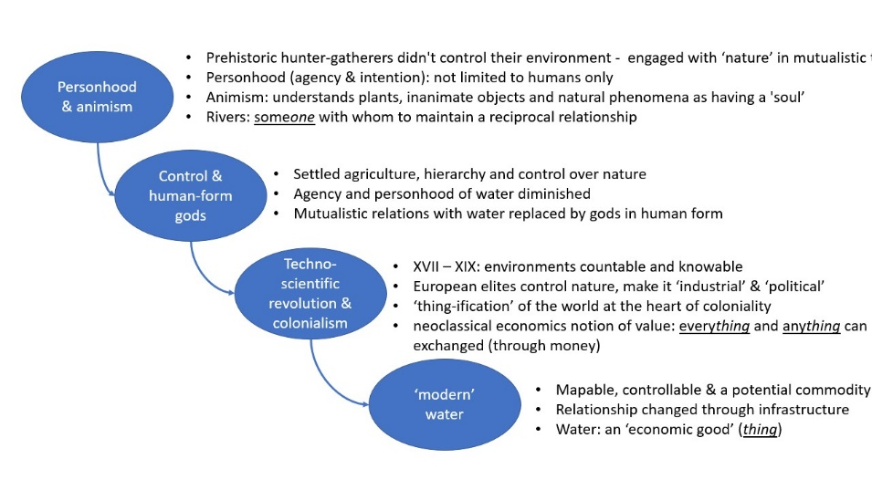

Kinship -in culturally diverse ways- is present in various contexts (e.g. in Indigenous-led struggles for there cognition of personhood of rivers in New Zealand, Australia, Canada; in Ecuador where enforceable rights of nature are recognised in the constitution; in Bolivia, which has given legal rights to Mother Earth). While this might be associated predominantly with indigenous backgrounds, the there are remaining traces of these mutualistic relationships with rivers across the globe, including the Global North, that could be activated upon for a wider water system transformation. For example, in culture and language in many countries (e.g. ‘Holywell’ town names), in the increasing trend of nature-based well-being activities (e.g. wild-swimming), within community movements (e.g. such as those having achieved bathing status to rivers in the UK) and in ‘Rights of Nature’ campaigns (e.g. legal personhood to the Mar Menor Lagoon in Spain) and in the promotion of nature-based solutions in catchment management in Europe.

* **In sum, key message for the report: A Human Rights perceptive on water values needs to acknowledge the mutual relationships of nurture, care and responsibility between humans and nature/waters. Re-igniting relationships of kinship can be critical to reverse the water global crisis. This does not have to be restricted to areas with strong indigenous backgrounds or presence, but is possible globally, including the Global North.**

***Part C. Protecting water as a public good through governance systems & the risks of nature commodification***

Explicit attention to defining and protecting public goods through governance systems is essential. Evidence suggests that market failure, weak regulation and weak commitment to ensuring access to basic services is preventing progress on fulfilling human rights to water and sanitation. Even where such rights are articulated in policy and state constitutions, when basic public goods (provision of collective water and sanitation infrastructure) are left to the markets they are failing to address the needs of the poorest and to prevent environmental pollution. The necessity to focus on solving complex political challenges in competing demands for water is essential. This was a consistent theme emerging from scoping study of the research priorities in the global water sector in 2019 which generated 4000 responses (Mdee et al. 2022).

Further, already inadequate provision of water and sanitation services are further threatened by the expected impacts of climate change. Attempts to mobilise private and public green finance appears to be driving greenwashing of business-as-usual (Hyde-Smith et al 2022)

While the issue of commodification of water has already been covered in the two previous reports from the Special Rapporteur, it might be worth updating it in the new report by acknowledging that the issue is broader than just water markets and privatisation of water supply. A more recent trend is gaining very fast traction in relation to the green financing of nature recovery, which affects ecosystems more generally (including water ecosystems) and therefore can have implications affecting the delivery of multiple ecosystem services, beyond just water supply. Private funding, including from very large corporations, is starting to be ‘called in’ for upscale nature recovery, including e.g. wetland restoration, using the argument that public funds are not enough. This is extremely important for preserving the notion of water as a public good, since without a strong regulatory arbitrage, there are serious risks of commodification including: inequities of access, ‘corruption of the mitigation’ hierarchy through off-setting and changing of motivations for conservation (conservation for profit rather than moral obligation), among other (Martin-Ortega et al. 2023). Besides the well known cases of water markets in Chile, Spain and Australia, evidence of the risks of these broader commodification of nature is starting to emerge e.g. in Scotland with ‘land grabbing’ of wetland for restoration (for carbon credits) originally intended for community purchasing (<https://www.scotsman.com/news/environment/insight-scotlands-great-net-zero-land-grab-3657133>)

* **In sum key message for the report: the governance and politics of public goods requires attention. Weak commitments to human rights are disconnected from state responsibilities to ensure public goods. Assumptions that markets and economic value will drive infrastructure to meet human rights commitments show weak progress on current challenges, let alone addressing future impacts from climate change. Risks of commodification expand now beyond water markets and water supply and are becoming all encompassing across all types of ecosystem services due to the rapid trend of involving private ‘green finance’ in nature recovery. This can have larger and broader severe consequences.**

**References**

*(Part A)*

IPBES Secretariat, Bonn (2022). Methodological Assessment Report on the Diverse Values and Valuation of Nature of the Intergovernmental Science-Policy Platform on Biodiversity and Ecosystem Services.

Global Water Partnership, 2021. Valuing Water Initiative. Available at: <https://www.gwp.org/en/we-act/campaigns/high-level-panel-on-water-valuing-water-initiative/> (Accessed: 14 August 2023).

Government of the Netherlands, 2019. Valuing Water Initiative – Better Decisions Impacting Water. Available at: <https://www.government.nl/topics/water-management/valuing-water-initiative> (Accessed: 14 August 2023).

Schulz, C.,  J. Martin-Ortega, K. Glenk, *et al. (2017a)*. The value base of water governance: a multi-disciplinary perspective. Ecol. Econ., 131 (2017), pp. 241-249, [10.1016/j.ecolecon.2016.09.009](https://doi.org/10.1016/j.ecolecon.2016.09.009)

Schulz, C., J. Martin-Ortega, A.A.R. Ioris, *et al. (2017b).* Applying a ‘Value Landscapes Approach’ to conflicts in water governance: the case of the Paraguay-Paraná Waterway. Ecol. Econ., 138 (2017), pp. 47-55, [10.1016/j.ecolecon.2017.03.033](https://doi.org/10.1016/j.ecolecon.2017.03.033)

Schulz, C., J. Martin-Ortega, K. Glenk (2018). Value landscapes and their impact on public water policy preferences. Glob. Environ. Change, 53 (2018), pp. 209-224, [10.1016/j.gloenvcha.2018.09.015](https://doi.org/10.1016/j.gloenvcha.2018.09.015)

Schulz, C., J. Martin-Ortega, K. Glenk (2019). Understanding public views on a dam construction boom: the role of values. Water Resour. Manag., 33 (14) (2019), pp. 4687-4700, [10.1007/s11269-019-02383-9](https://doi.org/10.1007/s11269-019-02383-9)

Schulz, C., J. Martin-Ortega, and K. Glenk, 2022. *Valuing Water in the Ewaso Ng’iro River Basin, Kenya*. The Hague, the Netherlands: Valuing Water Initiative (VWI). https://research-portal.st-andrews.ac.uk/en/publications/valuing-water-in-the-ewaso-ngiro-river-basin-kenya

Schulz, C., Wolf, L., Martin-Ortega, J., Glenk, K., Gischler, M (2024). Valuing water: A global survey of the values that underpin water decisions, Environmental Science & Policy. 153, 103685. <https://doi.org/10.1016/j.envsci.2024.103685>.

Stockholm International Water Institute, 2021. Seeing the Unseen: The Value of Water. World Water Week 2022. Available at: <https://www.worldwaterweek.org/programme/world-water-week-theme> (Accessed: 31 October 2022).

The United Nations World Water Development Report 2021: Valuing Water. UNESCO, Paris (2021)

*(Part B)*

Cohen, J. B., Dannreuther, C., Fraundorfer, M., Mackie, C., Martin-Ortega, J., Mdee, A., & Sutil, N. S. (2023). Riverkin: Seizing the moment to remake vital relations in the United Kingdom and beyond. People and Nature.

(Part C)

Martin-Ortega, J., Jorda-Capdevila, D., Glenk, K., & Holstead, K. L. (2015). 2 What defines ecosystem services-based approaches?. In Martin-Ortega, Ferrier and Gordon (eds). *Water Ecosystem Services*: *A Global perspective.* 3-14. Cambridge University Press.

Mdee, A., Ofori, A. Lopez-Gonzalez, G., Stringer, L., Martin-Ortega, J., Ahrari, S., Dougill, A., Evans, B., Holden, J., Kay, P., Kongo, V., Obani, P., Tillotson, M., Camargo-Valero, M.A. The top 100 global water questions: Results of a scoping exercise, *One Earth*. 2022, <https://doi.org/10.1016/j.oneear.2022.04.009>

Martin-Ortega, et al. (2023) 31 Ecosystems: ecosystem services and the commodification of nature. In Bertrand and Panitch (eds). The Routledge Handbook of Commodification. Routledge.

1. https://iwrmactionhub.org/learn/iwrm-tools/valuing-water