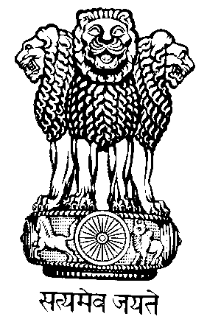
PERMANENT MISSION OF INDIA
TO THE UNITED NATIONS OFFICE
9, RUE DU VALAIS,
1202 GENEVA
Tel. : 022-9068686
Fax : 022-9068696

NV.4/12 11 January 2012

The Permanent Mission of India to the United Nations Office and other International Organizations in Geneva presents its compliments to the Office of the High Commissioner for Human Rights and has the honour to refer to the communication No.GVA-0713-ENG of 14 November 2011 of the High Commissioner for Human Rights requesting comments from State Parties on the ongoing discussion on the Treaty Body Strengthening Process.

In this context, the Permanent Mission of India to the United Nations Office and other International Organizations in Geneva has noted the report No.A/66/344 dated 7 September 2011 of the UN Secretary-General to the 66th UN General Assembly regarding “Measures to Improve Further the Effectiveness, Harmonization and Reform of the Treaty Body System” and has noted the consultations of the High Commissioner for Human Rights including meetings at Dublin, Marrakesh, Poznan, Seoul, Sion, Pretoria, Bristol and Luzern.

The Permanent Mission of India to the United Nations Office and other International Organizations in Geneva commends the High Commissioner for Human Rights for her efforts in taking the process of consultations forward for strengthening the Treaty Body System.

The Permanent Mission of India to the United Nations Office and other International Organizations in Geneva offers the following comments on the proposed Treaty Body Strengthening Process:

- For acceptability, the strengthening of the Treaty Body System should be through an inclusive process, involving consultation amongst State Parties with inputs from independent experts and other stakeholders. All options must be considered carefully before deciding the course of strengthening of the Treaty Body System. To this end, the Permanent Mission of India concurs with the suggestion of most State Parties for the creation of a Working Group to deliberate on the strengthening of the Treaty Body System that would provide an important forum, for formal Intergovernmental discussions, on this important subject. The final decision on strengthening the Treaty Body System should be based on consensus.

- The central issue is the inability of the Treaty Body System to deal with the workload, which is linked to the two key factors of resources both financial and manpower. It is, therefore, crucial that the issue of financial resources for the Treaty Body System, address maximizing existing resources through improving the efficiencies in the existing budget and through appropriately enhanced financial support solely through the regular UN budget. In this context, a separate session in Geneva exclusively on resourcing of Treaty Bodies would be salient. The background notes for such a session, needs to be circulated well in advance.

- On the issue of coherence in working methods, it is important that these methods be harmonized. Furthermore, the strengthening of the Treaty Body System requires to take care in avoiding overlap of mandates of the Treaty Bodies concerned, with the mandates of other related institutions such as OHCHR, UPR, etc. The strengthening of the Treaty Body System needs to enhance mutual trust and dialogue with the State Parties emphasizing on dialogue rather than a prescriptive and legal approach. To this end, the National Reports need to be read by the Treaty Body members, themselves rather than relying on other mechanisms to avoid the impression of premeditated outcomes. In particular, (i) advance circulation of list of questions to State Parties, (ii) allowing a break to State Parties for consultations prior to reply, (iii) limiting the number and length of concluding observations, (iv) ensuring more precise and rigorous comments would substantially strengthen the Treaty Body System.

- As the status of implementation of the recommendations can be monitored during the review of periodic reports, Treaty Bodies need to exercise caution in entering too deeply into the implementation process.

- On the issue of Treaty Body member selection, in order to reinforce the objective and impartial nature of a Treaty Body, there should be a limit on the number of tenures of an expert for a particular Treaty Body.

The Permanent Mission of India to the Offices of the United Nations and other International Organizations in Geneva avails itself of this opportunity to renew to the Office of the High Commissioner for Human Rights the assurances of its highest consideration.

Office of the High Commissioner for Human Rights,
Human Rights Treaties Division
(Kind Attention: Mr. Ibrahim Salama)
Palais des Nations
Geneva 1211
(Fax: 022-9179008)

