 | United Nations | E/C.12/PER/2-4
 | Economic and Social Council |  | Distr.: General  20 January 2011  English  Original: Spanish
Committee on Economic, Social and Cultural Rights
Implementation of the International Covenant on Economic, Social and Cultural Rights
Combined second to fourth periodic reports submitted by States parties under articles 16 and 17 of the Covenant
Peru* **
[26 May 2009]
Contents
Paragraphs Page
Abbreviations 3
I. Introduction 1–3 6
II. Part of the report relating to general provisions of the Covenant 4–10 6
A. Article 1 of the Covenant 4–6 6
B. Article 2 of the Covenant 7–10 6
III. Part of the report relating to the specific provisions of the Covenant 11–293 7
A. Article 6 of the Covenant 11–44 7
B. Article 7 of the Covenant 45–70 14
C. Article 8 of the Covenant 71–84 19
D. Article 9 of the Covenant 85 22
E. Article 10 of the Covenant 86–151 23
F. Article 11 of the Covenant 152–171 34
G. Article 12 of the Covenant 172–251 39
H. Article 13 of the Covenant 252–277 55
I. Article 15 of the Covenant 278–293 60
Annexes
I. National provisions against discrimination in the field of economic, social and cultural rights 64
II. Work 69
III. Family and standard of living 97
IV. Housing 106
V. Health 126
VI. Economic, social and cultural-health indicators 135
VII. Education 151
VIII. Economic, social and cultural-work indicators 159
Abbreviations
TRIPS Agreement on Trade-Related Aspects of International Property Rights
AFP Pension Fund Administrator
AISPED Comprehensive Health Care for Excluded and Remote Populations
APROLAB Programme in Support of Vocational Training for Integration in the Labour Market
ANR National Assembly of Rectors
APAFAS Parents’Association
BID Inter-American Development Bank
CAN Andean Community
CEDIF Centres for the Comprehensive Development of the Family f
CENFORP Vocational Training Centres
CENFOTUR Tourism Training Centre
CET Technological Efficiency Centre
CÍVICOS Communal Health Monitoring System
CLAS Local Community-Based Health Administration
CMAN High-Level Multisectoral Commission
CVR Truth and Reconciliation Commission
COFOPRI Commission for the Formalization of Informal Property
CONAM National Environmental Council
COP Persistent Organic Pollutants
CPP Peruvian Constitution
DESC Economic, Social and Cultural Rights
DESTP Directorate of Higher Technological and Techno-Productive Education
DEVIDA National Commission for a Drug-Free Life
DIGESA General Directorate of Environmental Health
DINNA Directorate for Children and Adolescents
DRTPE Regional Directorate of Labour and Employment Promotion
EA Adverse Events
ELITES Local Itinerant Extramural Health Teams
ENAHO National Household Survey
ENDES Demographic and Family Health Survey
ESNI National Immunization Strategy
ESSALUD Peruvian Health Care System
FFAA Armed Forces
FFPP Police Forces
FONCODES Cooperation Fund for Social Development
FONAVI National Housing Fund
IMARPE Marine Institute of Peru
INABIF National Family Welfare Institute
INDECOPI National Institute for the Defence of Competition and Protection of Intellectual Property
INEI National Institute of Statistics and Information Technology
INIA National Institute for Agricultural Innovation
INRENA Institute of Natural Resources
INSM National Institute of Mental Health
MAMI Child Abuse Units
MED Ministry of Education
MIMDES Ministry for Women and Social Development
MINSA Ministry of Health
MONIN National Nutritional Indicator Monitoring System
OIT International Labour Organization
OMS World Health Organization
ONG Non-Governmental Organization
OSINERGMIN Energy and Mining Investment Regulator
PAAG Programme for the Administration of Management Agreements
PAC Shared Administration Programme
PBI Gross Domestic Product
PCM Continuous Improvement Projects
PEEL Labour Statistics and Research Programme
PESEM Multi-Annual Strategic Sectoral Plan
PIR Comprehensive Reparations Plan
PNB Gross National Product
PNCS Coordinated National Health Plan
PNWW National Wawa Wasi Programme
PRONAA National Food Aid Programme
PRONAMA National Literacy Mobilization Programme
PSBPT Basic Health for All Programme
PVL “Glass of Milk” Programme
RDR Directly Raised Resources
RMV Minimum Living Wage
SCTR Complementary Insurance for Hazardous Work
SEEUS Student Eyes and Ears for University Safety – external users’ dissatisfaction index
SENAMHI National Metereological and Hydrological Service
SENASA National Agricultural Health Service
SENATI National Industrial Skills Training Service
SIS Comprehensive Health Insurance
SNA National Adoptions Secretariat
SOVIO Vocational Guidance and Employment Information Service
TUO Single Consolidated Text
UGIT Child Protection Investigation Unit
UNESCO United Nations Educational, Scientific and Cultual Organization
URSP Public Sector Remunerative Unit
I. Introduction
1. In fulfilment of its commitment in ratifying the International Covenant on Economic, Social and Cultural Rights, Peru hereby submits to the Committee on Economic, Social and Cultural Rights a consolidated report corresponding to the second to fourth periodic reports on the measures, progress and current situation concerning economic, social and cultural rights (ESCR).
2. Peru is facing enormous economic and social challenge and tackling them is therefore a priority for the Government. These efforts are yielding significant results in some spheres, an example being the current reduction of poverty levels. However, the Peruvian Government remains conscious that much remains to be done to eradicate chronic malnutrition, improve public health indicators, raise the level of education – especially state education – and further reduce poverty indicators. The Government directs much of its efforts and resources to achieving these objectives. This is the framework for the Government measures described in this report.
3. This report has been drawn up in keeping with the Committee’s guidelines for the presentation of reports and focuses on the concerns expressed by the Committee in recent years.
II. Part of the report relating to the general provisions of the Covenant
A. Article 1 of the Covenant
In what way has the right of self-determination been implemented?
4. Peru is a democratic, social, independent and sovereign Republic. Its government is unitary, representative and decentralized, being organized according to the principle of the separation of powers.
5. The 1993 Constitution recognizes the right of every person to participate in the political, economic, social and cultural life of the nation. Citizens also have the right to elect and be elected, to remove or recall officials by a legislative initiative or referendum.
6. The possibility of insurgency is likewise regulated in article 46 of the Constitution, when it states that no one owes obedience to a usurper government or to anyone who assumes public office in violation of the Constitution and the law.
B. Article 2 of the Covenant
To what extent and in what way are the rights recognized in the Covenant not granted to non-nationals? What justification is there for any differences that exist?
7. The rights recognized in the Covenant are granted to non-nationals by constitutional and legal provision. Every person has the right to equality before the law and cannot be the subject of discrimination on the basis of origin, race, sex, language, religion, opinion, economic situation or any other reason. It is also prescribed that special laws may be passed when required by the nature of things, but not because of differences between persons. The foregoing is applicable to refugees.
What rights are covered in national legislation by specific provisions against discrimination? Please attach the text of these provisions.
8. Regarding the right to work, the Peruvian Constitution recognizes equality of opportunity without discrimination as a principle in the labour field, and various legal provisions exist in this regard. The right to education also contains provisions against discrimination. Non-discrimination with regard to ethnic and cultural identity is likewise recognized in the Constitution.
9. Mention should also be made of the regulations on consumer services and the standards concerning State governance and the civil service, which overlap with the provision of services related to economic, social and cultural rights. For more details, see the description of the standards in Annex I.
10. Reference should also be made in this connection to the substantial case law of the Constitutional Court, which has ruled on many cases relating to the right of non-discrimination on the grounds of sex or sexual orientation in areas such as labour relations, pension entitlement and education.
II. Part of the report relating to the specific provisions of the Covenant
A. Article 6 of the Covenant
Please provide information on the situation, level and trends of employment, unemployment and underemployment in your country, both overall and in the way they affect particular categories of workers such as women, young people, older workers and workers with disabilities. Please compare with the corresponding situations ten and five years ago. Which persons, groups, regions or areas are considered particularly vulnerable or disadvantaged with regard to unemployment?
11. As a result of a strong increase in gross domestic product, the demand for labour by regular firms of ten or more workers in urban settings has expanded significantly (8.3 per cent in 2007) in practically all economic sectors. Nevertheless, despite the major increase in total and per capita real gross domestic product, the rate of underemployment (above all in terms of income) remained high (52 per cent of the total workforce), especially in rural areas where small subsistence farmers predominate.
12. It should be noted that some groups have greater difficulty in entering the labour market, such as disabled persons, women and young people. For example, over two thirds of disabled persons of working age are unemployed, i.e. are not working or seeking work, while unemployment rates among women (9 per cent) and young people (14 per cent) are clearly above the total unemployed rates (7 per cent) in Metropolitan Lima. On these figures and those in the previous paragraph, tables 1-12 of annex II and pages 87 to 105 of annex X are very useful.
Please describe the main policies applied and measures adopted to ensure that employment is available for all persons willing to work and seeking work.
13. The preparation of draft national employment policies was begun in 2007 by the National Directorate for Employment Promotion and Vocational Training (DPE), an organ of the Ministry of Labour and Employment Promotion. The main policies include the following:
14. The Youth Employment Action Plan 2009-201, which is currently being developed by the National Directorate jointly with the International Labour Organization. This Plan is aimed at promoting entry or re-entry in the workforce and furthering the stability and quality of employment with the emphasis on sectors strongly reliant on youth labour.
15. The National Policy Guidelines on Vocational Training, which are aimed at improving the quality of vocational training and upgrading the workforce.
16. Local and regional governments have been made responsible for implementing the national guidelines in their respective jurisdictions, in coordination with regional labour and education authorities. This involves devising regional training policies and developing a regional vocational training plan.
17. The Vocational Training Procedures Act was adopted on 24 May 2005, with the aim of: 1) promoting an appropriate and effective link between training supply and labour market demands; 2) furthering work training geared to production and service processes as a means to improving employment opportunities and labour productivity; 3) providing training that develops work capacities conducive to flexibility and adaptation to different labour situations.
18. The regulations of the Vocational Training Procedures Act cover the following: work-based apprenticeships, apprenticeships mainly at vocational training centres, vocational practice, juvenile vocational training, traineeships, internships for teachers and professors, and updating for re-entry in the labour market (for the chronically unemployed aged 45 to 65). In the period 2001-2008, there were 451,048 vocational training procedure agreements nationwide: 1,204 work-based apprenticeship agreements; 244,878 apprenticeships mainly at vocational training centres; 49,918 vocational practice agreements; 149,043 juvenile vocational training,agreements; 5,887 traineeship agreements; 4 internship agreements for teachers and professors; 5 updating agreements for re-entry in the labour market; and 6,427 SENATI dual apprenticeship contracts (2006).
19. The CIL PROEmpleo Network is the national employment service operating through a decentralized system of labour-market information, a job seekers advice service and a job placement centre. The network uses a software tool that records the effectiveness of its services. Its statistics for 2008 show that it placed 16,101 individuals in 1,883 firms and registered 39,252 job vacancies compared with 30,547 job demands. It also developed strategies for bringing firms and job seekers together through employment fairs. Five such fairs were organized in 2008.
20. All the CIL PROEmpleo Offices organized job seeker advice workshops on topics such as personal analysis for skills identification and job suitability, employment market information and drafting a résumé.
Please indicate what measures have been adopted to ensure that work is as productive as possible.
21. Occupational skills standardization is the process whereby the tasks performed by workers in the various sectors are identified, together with the criteria for evaluating these tasks and the work setting in which they are performed. This information is used to develop Occupational Skills Standards, which are those required for the successful performance of an occupational activity resulting in a quality product or service. The Ministry of Labour and Employment Promotion has in this way developed an agreed methodology for defining occupational skills standards for workers.
22. Occupational skills standards have so far been updated in the manufactures sector, these being in greatest demand by national and international markets. The tourism sector likewise has occupational skills standards, which have been developed by the Tourism Training Centre (CENFOTUR) with support from IDB (1999-2002). With resources from the European Union, skills standards have also been devised in the agricultural export sector. The business sector has participated actively in all these exercises.
23. In addition, instruments for evaluating the occupational skills of workers have been developed together with a methodology for designing curricula for the education sector, based on the aforesaid occupational skills standards.
Please indicate which provisions guarantee that there is freedom in the choice of employment and that employment conditions do not violate the individual’s basic political and economic freedoms.
24. The Peruvian Constitution stipulates that work is a duty and a right and that no one is obliged to work without pay or his/her her free consent, that is to say, everyone has the right to choose his/her work and to work freely, in accordance with the law. It should also be noted that Peru has ratified ILO Convention No. 122, which states that all Member States should declare and pursue an active policy designed to promote productive and freely chosen employment.
25. Act No. 26772 and its regulations, approved by Supreme Decree No. 002-98-TR, provides that offers of employment and access to education facilities may not contain requirements that constitute discrimination or the cancellation or impairment of equality of opportunity. For more details, see table 19 of annex II.
Please describe existing technical and vocational training programmes in your country and their operation and availability in practice.
26. The Ministry of Labour and Employment Promotion is pursuing its efforts in this regard through the Vocational Training Centres (CENFORP) and the various sectoral programmes. The centres concerned offer training designed to develop practical skills and the necessary attitudes for working in a range of occupations in the various branches of economic activity. They do so through classes and workshops separate from the state education system and sponsored by regional government and enterprises. The Vocational Training Centres serve vulnerable sectors of the provincial population, especially rural sectors, by promoting work and self-employment training for communities, households, etc.
27. According to available information, a total of 2,265 persons nationally, including 24 disabled persons, benefited from the Vocational Training Centres (Huancayo, Puno and Huaraz) between 2005 and 2007. (For more details, see table No. 13 of annex II). In the first half of 2008, the number benefiting was 706.
28. The Programme in Support of Vocational Training for Entry in the Labour Force (APROLAB) is specifically aimed at realigning vocational training with market demands,socio-economic needs and national development potential. It has been implemented in Cajamarca, La Libertad, Ica and Ayacucho, with first-stage financing of 5 million Euros by the European Union and 1 million by the Peruvian State.
29. The main purpose of the “ProJoven” Juvenile Training Programme is to facilitate access to the regular labour market by young people of limited financial means aged between 16 and 24. The programme covers Lima, Arequipa, Trujillo, Chiclayo, Piura, Cusco, Huancayo, Ica, Ayacucho, Tarapoto, Iquitos, Cajamarca, Juliaca, Huánuco and Puno. Overall gender equality is a feature of all the programme centres, which make no distinction between men and women. (Details of the recipients of the PROJOVEN programme are to be found in table 16 of Annex II).
30. With the aim of promoting greater awareness among firms of the need for proper management of human resources, the Ministry of Labour and Employment Promotion has developed and implemented the enquiry on human resource development, within the framework of the National Guidelines on Vocational Training Policy. This enquiry was undertaken for the first time in 2001 and again in 2007, when 783 firms were canvassed. The results revealed that 74 per cent of firms had trained their staff over the previous year, those with over 100 staff having provided most training (95 per cent). This figure, it should be noted, is higher than that recorded in 2001 (43 per cent).
31. With regard to future qualification and skill requirements and to the current difficulty of finding these on the labour market, the Ministry of Labour and Employment Promotion has developed and undertaken an enquiry into worker qualifications and labour skills from 2005, with the aim of gearing training more closely to labour demands. According to this enquiry, the number of students enrolled in the Technical-Productive Education Centres in 2007 was 260,570, most of them in urban areas (96.4 per cent), while the number of teaching staff was 13,180 or 19 students per teacher, compared with one teacher for every 21 students in rural areas. In the case of the Higher Technology Institutes, the number of students enrolled was 357,958, the majority in urban areas (95.7 per cent), while the teaching staff numbered 26,006 or 13 students per teacher; compared with one teacher per 19 pupils in rural areas. For more information, see table 15 in Annex II.
Please specify if you have encountered special difficulties in achieving the goals of full, productive and freely chosen employment and indicate how far these difficulties have been overcome.
32. The National Directorate of Employment Promotion and Vocational Training has qualified staff, but there is a need to train our human capital in cross-cutting management areas. Skills need to be strengthened through instruction in the tools of public administration and policy design, in methodologies for organizing consultations and workshops, in formulating and evaluating public investment projects, in occupational analysis, in the management and development of human resources, in technical drafting for researchers, in administrative law, etc.
33. There is also a need for closer links between the different areas and with the Regional Directorates of Labour and Employment Promotion, given the current institutional fragility arising from the high turnover of human resources in many cases lacking the qualifications, experience and training required and provided by the central directorate to make the processes sustainable. The reluctance of some regional and local authorities to work in a coordinated manner should also be noted.
34. This situation is reflected in the present weakness in framing and implementing strategies in pursuit of the goals of full and productive employment, one of the groups most affected being vulnerable groups such as disabled persons, women and young people.
35. In this connection, discussion forums have been created to strengthen coordination and mutual support for employment promotion. Continuous staff training is also being promoted.
Please indicate whether there exist in your country distinctions, exclusions, restrictions or preferences in legislation, administrative practice or concrete relationships between individuals or groups of individuals, on grounds of race, colour, sex, political opinion, nationality or social origin, which nullify or constitute obstacles to equality of opportunity or treatment in employment or occupation. What measures are being taken to eliminate such discrimination?
36. As mentioned in response to question “1.d”, Act No. 26772 and its regulations, approved by Supreme Decree No. 002-98-TR, provide that offers of employment and access to education facilities may not include requirements that constitute discrimination or the nullification or impairment of equality of opportunity. The Constitution likewise prohibits any kind of discrimination. In this respect, Peru has ratified ILO Conventions No. 100, on equal remuneration, and No. 111, on discrimination in respect of employment and occupation.
Please supply information on the current situation in your country with regard to vocational guidance and training, employment and occupation, by race, colour, religion and national origin.
37. The National Directorate for Employment Promotion and Vocational Training is responsible for coordinating the Vocational Guidance and Employment Information Service (SOVIO), which operates through the Regional Directorates of Labour and Employment Promotion via vocational guidance services and employment information talks. The aim is to promote the activities of SOVIO, which are focused on young people aged from 16 to 24 and designed to facilitate the choice of a professional career or occupation and to provide relevant information on the labour market.
38. The challenge is to overcome the most frequent problems facing the Regional Directorates of Labour and Employment Promotion, namely the lack of budget (22 per cent) and specialized support staff (22 per cent). This is followed by the problems of inadequate infrastructure (17 per cent) and lack of information on educational supply and labour demand (17 per cent). For more information, see table 17 in Annex II.
39. Finally, according to the data provided by the Programme of Employment Statistics and Studies (PEEL), no up-to-date information exists on employment and occupation by race, colour, religion and national origin, which is also the case with the National Institute of Statistics and Information Technology (INEI).
Please indicate the main cases in which a distinction, exclusion or preference based on one of the above-mentioned conditions is not regarded in your country as discrimination because of the specific requirements of the occupation concerned. Please indicate any problem of application, difference or controversy that has arisen in connection with these conditions.
40. The State recognizes and guarantees equality of conditions and opportunities between its nationals and foreigners. However, article 4 of Legislative Decree No. 689 -Employment of Foreign Workers Act – imposes reasonable limits on the number of foreign workers employed by a firm, with the purpose of ensuring adequate technological training
Please indicate if some members of the working population in Peru have more than one job to ensure an adequate standard of living for themselves and their families.
41. Between 2003 and 2006, the number of persons with a principal occupation who had another paid job, i.e. a secondary occupation, represented 14 per cent of the economically active population. For more details, see table 18 of Annex II.
Give a brief account of any changes affecting the right to work contained in national legislation and court decisions, as well as regulations, procedures and administrative practices, in the period 2000-2008.
42. A list of relevant legislation and rulings by the Constitutional Court will be found in tables Nos. 19, 23, 24 and 34 to 36 of annex II.
43. Under the Peruvian Constitution, the State guarantees free access to pensions through public, private or joint public-private agencies. In our country, there exist three pension systems: the private pension system, the state pension system and the Decree-Law No. 20530 system.
44. There are other special pension schemes such as the Military-Police Pension Fund (Decree-Law No. 19846), the Fishermen’s Pension Fund and other membership schemes. Peru also has a Complementary Insurance for Hazardous Work (SCTR). Finally, there is the "Insure your Pension" scheme, which is an unemployment micro-insurance.
B. Article 7 of the Covenant
Please provide information on the main methods used to set wages.
45. The single consolidated text of Legislative Decree 728, Labour Productivity and Competitiveness Act, approved by Supreme Decree No. 003-97-TR, states that: “Remuneration, for all legal purposes, is constituted by the sum of what the worker receives for his or her services, in cash or in kind, in whatever denomination, subject to their being freely rendered”.
46. With regard to wage-setting in the public sector, Legislative Decree No. 276, Civil Service (Framework) Act, provides that the remuneration of public officials and public servants consists of basic salary, allowances and benefits.
47. Act No. 28212, regulating the income of high officials and authorities of the State, develops the provisions of article 39 of the Constitution, which establishes hierarchies in the service of the Nation.
48. The private sector is governed by supply and demand in accordance with a social market economy model. The State regulates the question of minimum remuneration with the participation of organizations representing workers and employers.
Please indicate whether a minimum wage system has been established and specify the groups of wage-earners to which it applies, the number of persons included in each group and the authority responsible for determining the said groups. Is there any wage-earner still not receiving protection in law or in practice under the minimum wage system?
49. Peru possesses a minimum wage system. With regard to the scope of the minimum wage system, almost 50 per cent of wage-earners in the private sector receive salaries below the minimum, the situation being particularly critical in the microenterprise sector, where over two thirds of workers receive a salary below the minimum wage. While 68 per cent of workers in microenterprises fall into this category, the figure is lower in large firms, where 12 per cent are affected. For more details, see tables 20 to 24 and 34 to 36 of annex II, as well as pages 106 and 107 of annex X.
Do these minimum salaries have force of law and what is the guarantee against their losing value?
50. This right is guaranteed in article 24 of the Constitution. Minimum salaries are fixed by Supreme Decree issued by the President of the Republic, under his decision-making powers. The National Labour and Employment Promotion Council is designed to discuss and coordinate labour policies, employment promotion and social welfare in the context of national and regional development. It is also responsible for regulating minimum living wages. The Ministry of Labour and Employment Promotion convenes a multidisciplinary committee before the established period (biennial), for the purpose of reviewing the adjustment methodology.
How far and in what way is account taken of the needs of workers and their families, as well as economic factors, and how are the two combined to determine the level of minimum wages? What standards, goals and benchmarks are relevant in this regard?
51. The answer is contained in the reply to the next question.
Please describe briefly the mechanism adopted for setting, monitoring and adjusting minimum salaries.
52. Salary adjustments are based on the following criteria: percentage variation in the minimum wage; average inflation over the previous two years; the adjustment factor (average productivity rate over the previous five years in the commercial and services sector in relation to average productivity in the industrial and construction sectors); and the average movement in the preceding quinquennia of mean labour productivity in the non-primary sector, for the purposes of biennial adjustment.
53. The logic of taking inflation into account is to maintain the purchasing power of workers receiving an income close to the minimum wage; while the inclusion of productivity gains is to ensure that increases in the minimum wage reflect economic performance.
54. The periodicity of the adjustment of the minimum wage is every two years. The Ministry of Labour has the task of ensuring that minimum wages reflect the real situation.
Please supply information on trends in average and minimum wages over the last ten and five years compared with corresponding trends in the cost of living.
55. Throughout Peru’s history, regulation of the minimum wage has lacked an adequate institutional framework – something reflected in the repeated changes to the components, value and critria adopted for setting it. The Minimum Living Wage (RMV) was increased from 460 New Soles in 2005 to 500 New Soles with effect from 1 January 2006. It was subsequently set at 530 New Soles from 1 October 2007 and at 550 New Soles from 1 January 2008. For more details on changes to the RMV, see tables 21 and 22 of Annex II.
Please indicate whether the minimum wages system is in practice supervised effectively.
56. In 2007, the National Inspectorate issued 104 inspection orders nationally, generating 250 inspection measures. These resulted in 67 reports of infringements, which led to punitive proceedings in every case at the various regional headquarters, while in 37 other cases the inspections did not detect any infringement and final reports were issued in every instance.
57. In this regard, the National Labour Inspectorate is responsible for organizing the Labour Inspection System at national level, its duties including the management, organization, coordination, planning, monitoring and supervision of the performance and operation of the Inspection System. Its organization, operation and structure are regulated under articles 18 to 24 of Act No. 28806.
Please indicate whether there exists any inequality in remuneration for work of equal value in Peru, in particular working conditions of equal value and especially working conditions for women inferior to those for men or violations in this regard of the principle of equal remuneration for equal work.
58. In terms of statistics, no work has been done in our country on the subject of unequal remuneration for work of equal value. However, Peru has ratified ILO Convention No. 100 on equal remuneration, which inter alia makes it obligatory for each Member State to ensure the application to all workers of the principle of equal remuneration for men and women workers for work of equal value.
59. In accordance with the household survey carried out in 2006 by the National Institute of Statistics and Information Technology, it is well known that workers in urban areas receive wages that are higher on average than those paid to workers in rural areas. Similarly women tend to be paid less than men, especially in rural areas. However, the latter should not be seen as an example of less pay for similar work, but basically as reflecting the fact that women have access to work that is less productive and less well paid. It should also be noted that these differences are found mainly in the private sector. For more details, see tables 25 and 32 of annex II.
Please indicate the distribution of income among employees in the public and private sectors, taking into account both pay and non-financial benefits. Supply data, if available, on remuneration of comparable work in the public and private sectors.
60. By way of reference, income distribution among wage earners in the public and private sectors has been estimated on the basis of the INEI household enquiry, using the Gini coefficient as a measure of income distribution. The latter indicator tells us that public-sector employees (0.33) have a better income distribution than employees in the private sector (0.54). For more details, see table 26 of annex II and pages 108 to 115 of annex X.
What are the legal, administrative or other kinds of provisions that lay down minimum conditions of health and safety at work? How is compliance with these provisions ensured in practice and to which areas do they not apply?
61. With reference to minimum conditions of health and safety at work, the following standards have been issued: the Regulations on Health and Safety at Work, approved by Supreme Decree No. 009-2005-TR, provide under article 2 that they are applicable to all economic sectors and include all employees and workers, under the labour regulations governing private business nationwide. Supreme Decree No. 007-2007-TR modifies some articles of the Regulations on Health and Safety at Work, approved by Supreme Decree No. 009-2005-TR. Finally, Ministerial Decision No. 148-2007-TR approving regulation of the constitution and functioning of the Committee and the appointment and duties of the Supervisor of Health and Safety at Work, and other related documents.
62. The National Inspectorate of the Ministry of Labour and Employment Promotion, under its powers of inspection and supervision, is responsible for compliance with the above provisions.
Please indicate which categories of workers are excluded by law from the existing provisions and which do not benefit sufficiently or at all from them.
63. No information is available in this regard. However, the standards apply to all employers and workers, under the labour regulations governing private business nationwide Employers who do not comply with these obligations can be reported to the relevant authorities.
Please supply statistical or other kinds of information on the way in which the number, nature and frequency of accidents and sickness at work have evolved over time (from ten and five years ago to the present).
64. Between 2000 and 2004, the Peruvian Social Security System-ESSALUD recorded 14,137 job-related accidents, with an accident rate ranging from 0.36 to 0.83 per cent. The accidents occurred mostly in the manufacturing sector (24 per cent), the most common cause being blows and falls. For further details, see tables 27 to 31 of annex II. For its part, the Superintendency of Health Service Providers recorded 32,165 accidents among subscribers to the Complementary Work Risk Insurance (306,957 affilated workers). The accident rate was 10.48 per cent, much higher that that recorded by ESSALUD.
65. There is less information nationally on work-related illness. ESSALUD highlights acoustic trauma, contact dermatitis, abnormal results in lung-function studies and lumbago.
66. Compliance with work standards is a priority for the Peruvian State, in keeping with international treaties and agreements signed by the Peruvian Government (totalling 58 in the labour sphere).
Please provide information on the effective implementation in Peru of the principle of equality of opportunity for promotion.
Which groups of workers are deprived of equality of opportunity?
In particular, what is the situation of women in this regard?
67. The groups of workers deprived of equality of opportunity are mainly young people, women on low income, disabled persons, the elderly and people with HIV-AIDS .
What measures are taken to eliminate this inequality? Please describe the successes and failures of these measures in relation to the various underprivileged groups.
68. In keeping with Strategic Objectives 4.1 y 4.2, contained in the National Plan for Equality of Opportunity for Women and Men 2006-2010, and the National Plan for Equality of Opportunity for the Handicapped, various measures have been implemented in the course of 2007. For further details, see table 32 of annex II.
Please describe the laws and practices adopted in your country with regard to rest, leisure, reasonable limitation of working hours, periodic holidays with pay and remuneration of public holidays.
69. With regard to rest, periodic holidays with pay and remuneration of public holidays,
the following provisions are in force: paragraph 25 of the Peruvian Constitution, which stipulates that the ordinary working day is eight hours and the normal working week 48 hours; Legislative Decree No. 713, which strengthens the legislation on rest with pay for workers subject to the labour regulations governing private business; and Supreme Decree No. 012-92-TR, Regulations governing Legislative Decree No. 713
70. In addition, Peru has ratified the following ILO Conventions: No. 14, on Weekly Rest (Industry); No. 52, on Holidays with Pay; No. 67, on Hours of Work and Rest Periods (Road Transport); and, No. 106, concerning Weekly Rest (Commerce and Offices).
C. Article 8 of the Covenant
Please indicate the conditions of substance or form, as appropriate, that must be met in order to form a trade union and join the union of one’s choice.
71. Article 28 of the Peruvian Constitution recognizes the collective rights of workers, collective bargaining and the right to strike. It ensures their democratic exercise, guarantees freedom to form trade unions and encourages collective bargaining.
72. With respect to the right to join and form trade unions, the single consolidated text (TUO) of the Collective Labour Relations Act stipulates that the State recognizes the right of workers to form trade unions, without prior authorization, for the study, development, protection and defence of their rights and interests and the social, economic and moral improvement of their members. It also specifies that membership should be free and volontary. Employment of a worker cannot be made conditional upon membership, non-membership or relinquishment of membership and a worker must not be obliged to join a trade union or be prevented from doing so .
73. In order to form and maintain a trade union, the latter should have a membership of at least twenty (20) workers, in the case of unions within a firm, or fifty (50) workers in the case of other kinds of unions. In the event that the required number of workers cannot be found, the possibility exists of electing two (2) delegates to represent the workers in dealings with the employer and the Labour Authority, who should be given five working days’ notice of such a decision.
74. A meeting must be convened to form a trade union, approve its statutes and elect its representative body; all of these proceedings must be set forth in a record authenticated by a notary public or, in the absence thereof, by the local justice of the peace, specifying the place and date and containing a list of attendance. The trade union must also be entered in the appropriate register, which is kept by the Labour Authority as a formal, non-constituent instrument that cannot be declared void except in the event of non-fulfilment of the statutory requirements. For further details, please see table 6 of annex VIII.
Are any restrictions placed on the right of workers to form and join trades unions? Please describe in detail the legal provisions prescribing such restrictions and their application in practice over time.
75. Articles 42 and 153 of the Peruvian Constitution prescribe limits to the rights of members of the armed forces, national police, judges and prosecutors to form unions and strike. It should be noted that Peru has ratified ILO Convention No. 87 concerning freedom of association and the right to organize; and No. 98 concerning the right to organize and collective bargaining.
Please supply information on the way in which Peru guarantees the right of trade unions to form federations and join international trade union organizations. What legal and practical restrictions are placed on the exercise of this right?
76. A minimum of two (2) trade unions registered in the same class of activity is required to form a federation. Likewise, a minimum of two (2) registered federations is required to form a confederation. Joining or renouncing membership of federations, confederations or international trade union organizations must be agreed by General Assembly. The TUO also provides that federations and confederations are governed by the provisions of the trade unions insofar as they are applicable to them. Restrictions shall be placed on the exercise of such rights only if they compromise social peace, public security or public and private property.
Please indicate in detail what conditions or restrictions are placed on the right of trade unions to operate freely. Which unions have been adversely affected in practice by such conditions or restrictions? What measures are being taken to promote the free negotiation of collective contracts?
77. With regard to collective rights, there has been a decline in collective bargaining since the 1990s, the number of dossiers submitted having fallen from 2000 in 1990 to 500 in 2005. Only 7.24 per cent of private-sector wage-earners in our country are members of a trade union.
78. The national political agenda has therefore emphasized improvement of the quality of labour relations, unionization and peaceful ways of solving labour conflicts in Peru. On this basis, the Ministry of Labour and Employment Promotion drew up a document entitled Socio-Labour Policy Guidelines 2008-2011, setting out strategies and lines of action to combat this shortcoming.
Please provide data on the number and structure of the trade unions established in your country and on their composition.
79. According to article 44 of the single consolidated text of the Collective Labour Relations Act, unions can be organized: by enterprise, branch of activity or trade association.
80. As of 2004, the register of the Ministry of Labour and Employment Promotion included the names of 2,961 unions.
Please indicate whether the right of workers to strike is recognized in your country as a constitutional or legal right. In the contrary case, what other legal or practical criterion is used to guarantee the exercise of this right?
81. Article 28 of the Peruvian Constitution recognizes the right to strike, as previously indicated.
What restrictions are imposed on exercise of the right to strike? Please describe in detail the legal provisions that govern such restrictions and their implementation in practice over time.
82. Under article 42 of the Constitution, the right of public servants to form unions and strike is recognized. As previously stated, this right does not extend to government officials with decision-making powers, those who hold posts of trust or management, members of the Armed Forces and the National Police, judges and prosecutors. Restrictions are placed on the exercise of such rights only if it jeopardizes social peace, public security or public and private property.
Please indicate whether special legal provisions exist concerning exercise of the right to strike, how they have been applied in practice and the number of workers subject to them.
83. There are no special legal provisions.
If previous reports have been submitted, provide a brief account of any changes affecting the rights affirmed in article 8 of the Covenant that have been introduced in national legislation and judicial rulings, as well as in regulatory provisions and administrative procedures, during the period covered by the present report.
84. The corresponding report was submitted in October 1999, including an evaluation of legislation adopted in the 1990s. Changes to the situation described in this report are mainly treated in the sections relating to current levels of remuneration.
D. Article 9 of the Covenant
If your country is party to the 1952 ILO Convention on Social Security (Minimum Standards) or to subsequent Conventions (Nos. 121, 128, 130 and
168) and has submitted reports to the competent supervisory bodies concerning their provisions, please refer to these reports rather than repeating the information here. However, all questions concerning the present Covenant that were not fully covered in previous reports should be treated in this report.
85. The report on compliance with ILO Convention No. 102 on Social Security (1952) was submitted by the Peruvian Government in 2007 (under cover of Note No. 1117-2007, dated 6 November 2007). For further data on membership of health and pension schemes, see table 33 of annex II.
E. Article 10 of the Covenant
Please supply information on the ways, both official and unofficial, used in your country to provide assistance and protection to the family. In particular:
How does your country guarantee the right of men and, particularly, women to enter into marriage with their full and free consent and to establish a family? Please indicate and, where appropriate, give details of cases in which the measures adopted have been successful in abolishing practices that adversely affect enjoyment of this right.
86. Article 4 of the Peruvian Constitution makes it the duty of the State to protect the family and promote marriage, recognizing the latter as natural, fundamental institutions of society.
87. The policies guiding the actions of the State include the commitment to promote marriage and a family community that respects the dignity and rights of all its members. Another important benchmark for State policy, with which all levels of government must comply, is the National Family Support Plan 2004-2011. Within this framework, the Ministry for Women and Social Development (MIMDES) has developed and validated a training module for implementing educational measures to strengthen partner abilities and skills.
88. There are also Comprehensive Family Development Centres (CEDIF), located in INABIF premises and/or outsourced to the latter, which are situated in marginal urban and rural areas and offer services to populations subject to poverty and social risk. Services are provided in 35 Comprehensive Family Development Centres, 64 Family Care Centres and 5 Family Recreation Centres.
89. Provincial and district municipalities, and minor population centres under delegated authority, celebrate civil marriages and “collective marriages”, which involve much lower licence costs. Encouragement is also given to formalizing de facto unions, which are recognized under the Constitution.
What are the measures adopted by your country to facilitate the founding, maintenance, strengthening and protection of the family, in particular while it is responsible for the care and education of dependent children? Despite these measures, are there families that in no way benefit from this protection and assistance or that do so to significantly less that the majority of the population? Please give details of these cases. Are extended families or other forms of family organization recognized in determining the availability or applicability of these measures, in particular with respect to official benefits?
90. Supreme Decree No. 009-2006-MIMDES, published in the official gazette El Peruano on 23 August 2006, provides for the implementation of breastfeeding facilities in public-sector institutions where 20 or more women of childbearing age work. This represents the practical implementation of the public policies under the National Family Support Plan 2004-2011, which provides in Guideline No. 3 for reconciling family life with work activities in the public and private sectors alike. There are currently 124 breast-feeding facilities in Lima and 56 in the provinces, making a total of 180.
91. The Peruvian State also protects the family and promotes marriage, which are recognized under the Constitution as natural, fundamental institutions of society; it likewise protects the stable union of a man and woman free of any matrimonial impediment who establish a home, thereby giving rise to a joint estate to be governed by the system of community property where applicable.
92. In addition, under the MIMDES National Wawa Wasi Programme (PNWW), responsible parenthood is promoted by strengthening the role of the family in the provision of inclusive care to its children. It comprises information, communication and training activities on comprehensive child-rearing practices (nutrition, early stimulation, sound hygiene practices). A strategy named Wawachay (a Quechua word meaning My Boy) is currently being developed, involving exchanges of experience between fathers and sons.
93. For its part, the National Wawa Wasi Programme has been given responsibility for implementing the Q'ATARI WAWA Project, aimed at the protection and comprehensive development of boys and girls in rural Andean areas.
94. Concerning families that do not benefit in any way from this protection and assistance or that do so significantly less than the majority of the population, it should be noted that the PNWW devotes 84 per cent of its annual budget to grants, representing an average investment of $300 a month for each child supported annually. However, the demand for comprehensive care for the beneficiary population subject to poverty or extreme poverty has not been wholly satisfied, although there has been significant progress in the form of a progressive increase in the service’s coverage.
95. National child care coverage has steadily increased from 10,000 boys and girls in 1999 to 53,000 in 2007. For more information, see table I of annex III.
96. According to a study of potential demand based on data from the National Institute of Statistics and Information Technology (INEI) deriving from the National Household Survey (ENAHO), the percentage coverage in relation to demand is 14.36 per cent. However, attention is drawn to the progressive increase in the number of persons benefiting from the service, as shown in table 02 of annex III.
97. Regarding information on whether extended families or other forms of family organization are recognized in deciding whether these measures are available or applicabe, particularly with respect to official benefits, data is available on a variety of activities by suburban and rural areas and also by income quintile.
In relation to any obvious shortcomings with regard to the preceding paragraphs, what measures are being studied to remedy the situation in question?
98. Under current government policy, consideration is being given to increasing coverage in areas of extreme poverty through reorienting measures.
99. Work has begun to implement the National Family Support Plan 2004-2011, which provides under guideline 8 for the promotion of marriage and stable families through marriage preparation classes, advisory services, reduction in the high cost of civil matrimony and strengthening the oversight of marriage requirements. Efforts are also being made to revitalize the Wawa Net system in order to improve service quality and obtain relevant information for improving public administration.
Please describe the special measures to protect and assist children and young people, in particular measures to protect them from economic exploitation and prevent them from being employed in tasks presenting a moral or health risk, posing a danger to their lives and likely to impede their normal development.
What is the age limit in your country below which the paid employment of children in various ocupations is prohibited?
100. The required ages for authorization of work by adolescents are: in the case of work for a third party or as employee, 15 years for non-industrial agricultural labour; 16 years for industrial, commercial or mining work; 17 years for industrial fishery work; and 12 years for other forms of work.
101. It is presumed that adolescents are authorized to work by their parents or guardians when they live with them, except in the case of express indication to the contrary.
Please indicate how many children and in which age groups are in paid employment and to what extent.
102. In Peru, the Children’s and Adolescents’ Code classifies minors aged 0 to 12 as children and those aged 12 to 18 as adolescents. Since the minimum age of admission to employment in Peru is 14 years, and exceptionally 12 to 14 when it does not compromize their health, education and overall development, the registration, authorization and supervision of adolescent work is subject to legislation. However, some 12-year-olds are engaged in economic activities and they are the focus of policies by the Peruvian Government to protect and promote their rights.
103. The National Institute of Statistics and Information Technology (INEI) carried out the National Household Survey (ENAHO) in 2001, assembling data on the age of working minors, broken down by sex, hours of work and type of work.
104. The Ministry of Labour and Employment Promotion, on the basis of its register of adolescent work, reported a total of 497 adolescent work authorizations in the first quarter of 2008, declared in every case to be paid employment.
105. According to the statistics and report of the National Institute of Statistics and Information Technology (Source INEI-2001), 28.6 per cent of children and adolescents aged between 6 and 17 work (equivalent to some 2,000,000); 53.9 per cent are male and 46.1 per cent are female; 90 per cent are in the informal sector; they work more than 45 hours a week and 90 per cent are paid at or below the minimum wage.
106. The areas in which children between the ages of 6 and 13 work are: agriculture 81.0 per cent, family help 11 per cent, domestic help 3.7 per cent, preparing goods for sale 2 per cent, sale of goods 1.9 per cent and loading packages 0.4%.
107. The areas in which children between the ages of 14 and 17 work are: farm labouring 48.7 per cent; helper/service work 15.4 per cent; cooking, waiting and building work 11.8 per cent; commerce 11.6 per cent, domestic work 8.6 per cent and street vending 3.7 per cent.
Please indicate to what extent children are employed in the family home, farm or business.
108. There is household work that by its nature and status is considered dangerous and which minors are not therefore allowed to perform (Supreme Decree No. 007-2006-MIMDES).
109. With regard to work on farms or in family businesses, this is not registered in any way. However, it is known about as result of complaints that many minors, required by their families to care for livestock and perform farm duties, do not study and that their needs are not properly met as a result of having to contribute to the household economy
Please indicate if there are groups of children and young people in your country who do not enjoy any kind of protection and assistance or who do so significantly less than the majority. In particular, what is the situation of orphans, children whose parents are dead, small children, abandoned minors, children deprived of their family environment and physically or mentally impaired children?
110. Protection and assistance to children and adolescents is provided at two levels: firstly, through socio-educational measures designed to rehabilitate the adolescent offender, and protective measures aimed at the child or adolescent presumed abandoned.
111. The situation of orphans, abandoned children, those deprived of their family environment and physically or mentally impaired children is dealt with in the first instance by the MIMDES Protection Investigation Management Unit or the specialized family court. Following investigation of the child or adolescent, with or without physical or mental disability, the decision is made on declaration of the state of abandonment.
112. Once the state of abandonment has been declared, the child is sent to a duly accredited residential care centre, where a check is made on his or her education, food, clothing, etc. At the same time, a report has to be made on whether the abandoned child or adolescent, with or without physical or mental handicap, is suitable for adoption. This procedure is carried out by the MIMDES National Adoptions Secretariat.
113. There are approximately 300 (private) Residential Care Centres registered nationally, catering for some 6,500 resident children and adolescents. This information only covers those institutions that have registered with the MIMDES Central Register of Institutions, since there is currently a percentage that has not formally registered. The Peruvian State cannot therefore know how and in what way care is provided to the most vulnerable population in our country. The Institute of Child Care and Welfare provides accommodation for a total of 3,500 minors.
114. Currently there are some 10,000 children and adolescents aged between 0 and 18 accommodated in various State institutions and (private) Residential Care Centres.
How are the persons mentioned in the previous paragraph informed of their rights?
115. The rights of those mentioned in the previous paragraph have been publicized through campaigns, talks, forums and seminars aimed at the groups and public officials concerned, by means of a multisectoral approach. The rights of those concerned are also publicized through various teaching materials, which are featured at various events organized by the Department of Children and Adolescents (DINNA), the MIMDES Follow-Up Investigation Unit (UGIT), the National Adoptions Secretariat (SNA) and the National Comprehensive Family Welfare Programme (INABIF) – all dependent on the Ministry for Women and Social Development.
Please give details of any shortcomings or problems that have arisen. How have these situations evolved over time? What measures have been adopted to correct those situations? Please describe the consequences of these measures over time and indicate successes, problems and shortcomings.
116. Act No. 27337 – Children’s and Adolescents’ Code, published on 7 August 2000, provided that the Ministry for the Advancement of Women and Human Development – PROMUDEH (today the Ministry for Women and Social Development – MIMDES), should assume responsibility for guardianship proceedings, beginning one hundred and eighty (180) days after coming into effect, and that Family Judges should be competent in the matter in the meantime.
117. Starting in 2004, the National Adoptions Secretariat (SNA) initiated measures to remove protection investigations from the sphere of the courts. It thereby sought to accelerate the legal process, attempting in the higher interests of the child and adolescent to ensure the application of effective protection measures to avoid placing minors in institutions and to substantially guarantee their rights to develop within their biological family or, in its absence, to provide for their development in a regular family environment. These measures sought to resolve the existing problem whereby the Judiciary took from one and a half to seven years to decide on the declaration of abandonment.
118. With the adoption of Act No. 28330 published on 14 August 2004, modifying various articles of the Children’s and Adolescents’ Code, a mixed administrative-judicial system for protection investigations was created, whereby the investigative procedures are administrative and the decision on the state of abandonment of the child or adolescent is judicial, that is to say, the protection investigations are partially removed from the judicial sphere.
119. MIMDES is currently responsible for the protection investigation process, through the Protection Investigation Management Unit, which carries out the preliminary enquiries to establish the legal situation of the child or adolescent presumed abandoned, to order the relevant social protection measures and, where evidence of abandonment is found, to forward the file to the competent judge for a ruling on the matter.
120. It should be mentioned that by Supreme Decree No. 005-2007-MIMDES the Child Protection Investigation Unit (UGIT) was attached to the National Adoptions Secretariat (SNA), its functional and administrative dependency being specified in Ministerial Decision No. 413-2007-MIMDES of 27 August 2007.
121. Finally, Ministerial Decision No. 122-2008-MIMDES declared the National Adoptions Secretariat (SNA) of the Ministry of Women and Social Development (MIMDES) to be undergoing reorganization to assess, analyze, propose and implement administrative and management reforms. On completion of the reorganization, it was decided that the Protection Investigations Management Unit would be reunited with the National Family Welfare Programme – INABIF.
122. To ensure adequate and properly organized monitoring of the Residential Care Centres in Peru (catering for children and adolescents with or without physical and mental disabilities), Act No. 29174 was adopted on 23 December 2007, regulating the functioning of Residential Care Centres for Children and Adolescents.
Please provide information on the current living standards of the Peruvian population, generally and in terms of the different socio-economic, cultural and other social groups. How have the living standards of these groups varied over time (e.g. in comparison with eight years ago)? Has there been a steady improvement in the living conditions of the population as a whole or, if not, of which groups?
123. In 2001, the total poverty rate in Peru was 55.6 per cent (79.6 per cent for men and 20.4 per cent for women). Between 2006 and 2007, it fell by 5.2 percentage points, from 44.5 per cent to 39.3 per cent. This was the percentage of Peruvians whose monthly spending did not exceed 229.4 New Soles, which is the cost of the minimum food basket and also represents the total poverty line. As for the extremely poor with a monthly expenditure not exceeding 121.2 New Soles, they accounted for 13.7 per cent of the population, a fall of 2.4 percentage points since 2006. See table No. 3 of annex III.
124. In urban areas, the proportion of persons living in poverty in 2001 was 38.4 per cent, falling in 2006 to 31.2 per cent and in 2007 to 25.7 per cent. On the other hand, in rural areas the proportion remained high: in 2001, it was 78.3 per cent, reducing to 69.3 per cent in 2006 and 64.6 per cent in 2007. The departments with the highest percentage of poor people continued to be Huancavelica (85.7 per cent), Apurímac (69.5 per cent), Ayacucho (68.3 per cent), Puno (67.2 per cent), Huánuco (64.9 per cent), Cajamarca (64.5 per cent) and Pasco (63.4 per cent). These are all Andean departments, showing the discrepancy between this region and the coast and jungle areas.
125. It is however important to mention that the poverty gap has been reduced from 16.3 in 2004 to 12.8 per cent in 2007. See table 4 of annex III.
126. The average per capita monthly income by domain was 372.3 New Soles in 2004, rising to 468.6 New Soles by 2007. See table 5 of annex III.
127. Life expectancy in the Peruvian population has changed in recent years: in 1970 it was 55.52 years, whereas for those born in 2005 the average life expectancy is 71.2 years. Women have a life expectancy of 73.9 years and men of 68.7 years, and it is estimated that it will rise to an average of 75 years in 2025. In the period 1997-2001, the poverty rate among the adult population was 41.7 per cent, 17.7 per cent of whom were living in extreme poverty. See table 6 of annex III.
128. With regard to infant mortality, the rate in 2000 was 28 per cent in urban areas and 60 per cent in rural areas, while in 2006 it measured 21 per cent in urban and 36 per cent in rural areas.
129. According to the National Household Survey (ENAHO), the illiteracy rate among elderly people stood at 30.4 per cent in the first quarter of 2007. The rate was higher among women (48.5 per cent), particularly those living in rural areas where some 8 out of ten were unable to read or write, compared 3 out of 10 adult women in rural areas. While the illiteracy level in rural areas was lower among men than women, it remained significant since 37.3 per cent of males in rural areas were affected, compared with 12.1 per cent in rural areas.
130. The number of people with social security cover is 512,950 (466,942 under the National Pensions System and 46,018 under the Private Pension System). Some 2,000,000 people aged over 60 lack any kind of social security cover.
Please provide an overview of the extent to which the right to adequate food has been realized in Peru. Indicate the sources of information in this regard, in particular studies on the nutritional situation and other monitoring measures.
131. The National Food Security Strategy 2004-2015 aims to ensure that by 2015 the population as a whole can satisfy its basic food and nutritional needs. The Strategy has four main thrusts: (a) social protection for vulnerable groups; (b) improved competition in national food supply; (c) reinforced risk management capacities in the area of food security; (d) a modern institutional framework.
132. Under the Comprehensive Nutritional Programme (PIN), 85,880 expectant/breastfeeding mothers were supported by the infant subprogramme in 2007. (Source PRONAA). By March 2009, food supplements had been provided to 112,523 expectant mothers in areas of extreme poverty; 69,175 breastfeeding mothers had received monthly food supplements, and 667,266 children under 3 had enjoyed supplementary food rations.
133. Under the JUNTOS programme, families receive 100 soles if they meet three conditions: take their children under five for health checks, receive their baby food packages, and send their school-age children to school regularly. In 2007, there was over 93.4 per cent compliance. See table 7 of annex III.
134. Under the Child Food Programmes, 1,056,474 children below the age of 6 living in extreme poverty were supported in 2007. See table 8 of annex III.
Please provide detailed information (in particular, statistical data by different geographical areas) on the extent to which hunger and/or malnutrition exist in Peru. This information should cover in particular the following.
The situation of especially vulnerable or disadvantaged groups.
Significant differences between men and women in each of these groups.
Changes that have taken place over the last five years in the situation of each of the groups mentioned.
135. The national incidence of chronic malnutrition in under-five-year-olds was 36.5 per cent in 1992. WHO put the rate at 31.3 per cent in 2006 and at 29.1 per cent in 2007. See table 9 of annex III.
136. In accordance with the National Nutritional Indicator Monitoring System (MONIN), some 27 per cent of children aged 1 to 5 suffered from chronic malnutrition in 2004, the rates for rural areas (33 per cent) being higher than those for urban areas (18 per cent). These figures are similar to those of the Demographic and Family Health Survey (ENDES) for the year 2000 (26 per cent). The rate of chronic malnutrition according to the new WHO standards is 29.1 per cent (ENDES 2004-2006 – INEI). Rates of chronic malnutrition in Peru’s different departments for 2000 and 2004 will be found in table 10 of annex III.
137. The rate of anaemia nationally in children aged 6 to 59 months in the year 2000 was 57 per cent, falling to 46 per cent in 2005 and 43 per cent in 2007. See table 11 of annex III.
138. Among young children with a food intake below the minimum, 31 per cent were undersized in 2000, compared with 29 per cent in 2005 and 2007 (tables 12, 13 and 14 of annex III). As to undersized children by wealth indicator, the rate for the poorest sector in 2005 and 2007 was 54 per cent, compared with 22 per cent and 6 per cent respectively for the middle and upper sectors.
139. These problems were mainly related to the circumstances of the mother, including pregnancies among young girls and older women, short intervals between births, educational level and lack of care during pregnancy and birth.
Please indicate what measures the Peruvian Government considers necessary to guarantee access to adequate food by each of the aforementioned vulnerable or underprivileged groups and disadvantaged areas and to ensure full implementation of the right to food for men and women. Please indicate the measures adopted and specify the time targets and nutritional indicators for measuring achievements in this regard.
140. Under the National Food Security Programme, the State has implemented various programmes that come together to combat malnutrition. It has launched the Coordinated Nutritional Strategy, which addresses the multiple causes of chronic malnutrition by combining the efforts of different groups in Peru and the measures to combat malnutrition under the JUNTOS programme. In this way, it is promoting progress towards the goals of reducing malnutrition rates to 21 per cent by 2008 and to 17 per cent by 2011. The JUNTOS programme has provided food supplements to 108,499 children aged 0 to 3. Its coverage has grown and broadened in scope, benefiting 372,918 households in 14 departments. See table 15 of annex III.
141. In 2007, the National Food Aid Programme (PRONAA), together with the Child Nutrition Programmes, supported 1,056,474 children under 6, most of them in the first and second poverty quintile. See table 16 of annex III.
142. The “Glass of Milk” Programme (PVL) benefited 406,728 infants and children in 2006. Sixty per cent were aged 0 to 6, nine per cent were pregnant or nursing mothers and 20 per cent were youngsters aged 7 to 13. The Programme has an annual budget of 363 million new soles, i.e. over 40 per cent of the annual food aid budget. There was also an increase in maternal breast-feeding and the provision of solid supplements, as shown in table 17 of annex III.
Please indicate the GNP per capita of the poorest 40 per cent of the population. Is there a “poverty threshold” in Peru and, if so, what are the criteria for determining it?
143. GNP during the period has varied between US$ 4,789 in 2000 and US$ 6,177 in 2007. However, given the way in which poverty is measured by INEI, no information is available on the poorest 40 per cent of the population. On the other hand, information is available on the poverty gap and its variation in the period 2004–2007. For more information, see table 4 of annex III.
144. The National Institute of Statistics and Information Technology (INEI) is the official body in charge of the Peruvian Statistics System. It adopts a uniquely monetary and objective approach to the definition of poverty. It classifies as poor all those persons resident in private households whose expenditure per capita in monetary terms does not exceed the poverty threshold or the minimum amount needed to meet their food and non-food needs.
145. The Extreme Poverty Line is the monetary value necessary to acquire a food basket capable of meeting the minimum nutritional requirements of the persons concerned. The Total Poverty Line is the value of the Extreme Poverty Line plus the monetary value necessary to meet a set of non-food requirements considered essential (clothing and footwear, rent, fuel, furniture and fittings, health care, transport and communications, recreation, culture and other expenses).
What is the indicator of the physical quality of life in Peru?
146. Our country does not use an indicator of the physical quality of life, which is not among the variables measured by INEI. However, the variation in the Human Development Index over the period 2000-2008 was 0.620 in 2000 and 0.773 in 2007.
Have there been any changes in national policies, laws and practices in the period 2000–2008 that have adversely affected access to adequate food by these groups and sectors or among the poorest sectors of the population? If so, please describe these changes and assess their impact.
147. Contrary to the implication in the question, the period 2000-2008 has been characterized by positive changes with regard to access to adequate food. An increasing emphasis on nutrition, especially infant nutrition, has become one of the main goals of the present government.
Please indicate how measures adopted to improve methods of food production, conservation and distribution making full use of scientific and technological knowledge have furthered or impeded exercise of the right to adequate food. Please describe the impact of such measures in terms of ecological continuity and the protection and preservation of food production resources.
148. The National Food and Nutrition Centre is the technical, standard-setting agency of the National Health Institute, responsible nationally for promoting, planning, implementing and evaluating the research and development of appropriate technologies in the areas of foodstuffs, human nutrition, food hygiene control, drinks, etc.
149. Scientific research carried out by national universities and other state and private research institutions have a continuing influence on agricultural production.
Please indicate the measures adopted to make the main nutrition facts more widely known and specify if significant groups or sectors of society seem to lack such knowledge-
150. The Integrated Food Programme, developed under the National Food Aid Programme (PRONAA), has three main components, one of which is directly aimed at spreading knowledge of the principles of nutrition among specific groups. These are: firstly, mothers of children under three, parents or guardians and pregnant or nursing mothers; community leaders and officials; community agents and technical assistants; MIMDES agents; departmental and regional government officials; teachers, parents’ association (APAFAS) and the Demographic and Family Health Survey (ENDES). The contents of the Programme include healthy practices as well as the principles of nutrition – balanced diet and food supplements at 6 months and from 1 to 3 years.
Please list the agricultural reform measures adopted by your Government to ensure that your country’s agricultural system serves to increase domestic food security, without detriment to human dignity, in both rural and urban communities, having regard to the provisions of articles 6 to 8 of the Covenant. Please describe the measures adopted to: enact legislation for that purpose; apply existing legislation in that regard; promote vigilance through governmental and nongovernmenal organizations.
151. Agricultural reform took place in Peru under a military government and, while there was broad agreement on the need for such reform, the way in which it was carried out was widely criticized. Currently, the picture in Peru is not one of large estates; the problem in many cases has rather to do with smallholdings that prevent modern agricultural development. Communal lands belonging to peasant communities in the Andean region come under a special regime that grants them protection.
F. Article 11 of the Covenant
Please provide statistical information on the housing situation in your country.
152. The 11th National Population Census and 6th Housing Census carried out in 2007 revealed that there are 7,583,140 housing units in the country. Of these, 7,566,142 are private dwellings and 15,181 collective units, including 1,817 sites not intended for human habitation (bridges, parks, caves, abandoned vehicles, airports, ports, etc.) but which are used as living accommodation by some people.
153. According to the 2007 Census, private housing units in the country include 6,477,401 independent houses, representing 85.6 per cent of the total; 378,926 flats in blocks, representing 5.0 per cent; 332,121 cottages or huts, representing 4.4 per cent; and, to a lesser degree, farms, communal dwellings, makeshift accommodation and premises not intended for human or other types of habitation. For more details, see tables 1, 2 and 3 of annex IV, as well as pages 163 to 197 of annex X.
Please provide detailed information on those groups in society that find themselves in a precarious situation with regard to housing. Please indicate in particular:
The number of individuals and families who are currently inadequately housed and without access to basic services such as water, heating (where necessary), waste disposal, sanitation, electricity, postal services, etc. (insofar as these services are considered relevant in your country). Please include the number of persons living in overcrowded, damp or structurally unsafe housing or in other conditions detrimental to health.
154. Precise information on individuals and families inadequately housed and without access to basic services is not available. However, the census carried out in 2007 established that the outer walls of 2,991,627 of the 6,400,131 private dwellings whose occupants were present were constructed mainly of brick and cement blocks, representing 46.7 per cent of the housing stock; 2,229,715 were constructed mainly of adobe or mud, representing 34.8 per cent. To a lesser extent, outer walls were constructed of wood (9.7 per cent), wattle and daub (2.9 per cent), matting 2.3 per cent), stone and mud (1.7 per cent) , other materials (1.4 per cent) and stone or ashlar with lime and cement (0.5 per cent).
155. In 43.4 per cent of dwellings, i.e. 2,779,676, the floors were mainly earthen. For more details, see table 6 of annex IV.
156. Drinking water was supplied several days a week to 10.1 per cent of private dwellings (438,127) whose occupants were present. Those possessing a septic tank or latrine accounted for 28.8 per cent (1,396,402). Households using the river, irrigation ditches or canals for sanitation purposes represented 1.8 per cent (114,074), while those lacking any such service totalled 17.4 per cent (1,110,779). For more information, see tables Nos. 5 and 7 to 11 of annex IV.
The number of persons currently registered as living in “illegal” settlements or homes.
157. The 2007 Census recorded a total of 7,566,142 homes, of which 111,180 were in the nature of improvised accommodation and 10,311 were premises not designed to be inhabited. As to the tenure, 5.5 per cent of homes were acquired through invasion of State-owned land. While the State has taken steps to regularize ownership where invasions have occurred, much remains to be done in that regard. See table 4 of annex IV..
The number of people with different titles to occupancy, whether with regard to social or public housing, the private rental sector, owner occupation, the “illegal” sector or others.
158. According to type of occupancy, the number of owner-occupied, fully amortized homes is 4,241,044 (66.3 per cent) out of a total of 6,400,131 private dwellings with persons present; rented homes account for 979,657 (15.3 per cent); “squatterized” homes (5.5 per cent); other forms of occupancy (4.7 per cent); mortgaged property (4.6 per cent); and company housing and other kinds of home or institution (3.7 per cent).
Please provide information on the existence of any law that adversely affects enjoyment of the right to housing, including:
Laws that embody the essence of the right to housing, defining its content.
159. There are no legal provisions in Peru that have a negative effect on enjoyment of the right to housing. Article 2.16 of the 1993 Constitution guarantees the right to property, including the right to housing. Property is inviolable, and no one may be deprived of it, save on grounds of national security or public need determined by law and subject to payment of compensation..
Laws such as housing laws, laws on the homeless, municipal laws, etc
160. Legislation in force in the period under review:
- Act No. 26912 of 9 January 1998, on promoting access by the population to private property, housing and the promotion of savings through funding mechanisms with the participation of the private sector;
- Act No. 27972 of 6 May 2003, Organic Law on Municipalities;
- Supreme Decree No. 038-2001-MTC of 24 July 2001, creating the urban development and housing construction programme known as the MY NEIGHBOURHOOD Programme (Programa MI BARRIO);
- Legislative Decree No. 803 of 15 March 1996, on the promotion of access to formal property, and its single consolidated text, approved by Supreme Decree No. 009-99-MTC of 9 April 1999.
Laws concerning land use and distribution; assignation of land, land zoning, division of land, expropriation including provisions on compensation; land planning, including procedures for community participation-
- The Constitution provides that foreigners, whether individuals or corporations, enjoy the same rights as Peruvians concerning property. However, within a distance of 50 kilometers from the border, foreigners may not acquire or own for any reason mines, land, forests, water, fuel or energy sources. Solely for reasons of national security, the law may temporarily establish restrictions and specific bans on the acquisition, possession, use and transfer of certain types of property.
- Act No. 27972 of 6 May 2003, Organic Law on Municipalities.
- Act No. 29090 of 24 September 2007, regulating urban dwellongs and buildings.
- Supreme Decree No. 038-2001-MTC of 24 July 2001, creating the urban development and housing construction programme known as the MY NEIGHBOURHOOD Programme (Programa MI BARRIO).
- Legislative Decree No. 803 of 15 March 1996, on the promotion of access to formal property, and its single consolidated text, approved by Supreme Decree No. 009-99-MTC of 9 April 1999.
- Act No. 28579 of 27 June 2005, converting the housing mortgage fund FONDO MIVIVIENDA to FONDO MIVIVIENDA S.A. See also tables Nos. 16-18 of annex IV.
Laws relating to the right of tenants to security of tenure and protection against eviction; housing finance and rent control (or rent subsidies); availability of housing, etc.
- Civil Code;
- Legislative Decree No. 709 of 5 November 1991, on the promotion of private investment in property for rent and modifications thereto;
- Act No. 28579 of 27 June 2005, converting the housing mortgage fund FONDO MIVIVIENDA to FONDO MIVIVIENDA S.A.
Laws relating to codes, regulations and standards of construction and the provision of infrastructures.
- Act No. 27972 of 6 May 2003, Organic Law on Municipalities.
- Act No. 29090 of 24 September 2007, regulating urban dwellongs and buildings.
- Act No. 29167 of 19 November 2007, establishing special transitional procedures for building permits and for the extension or remodelling of guest accommodation.
Laws prohibiting any kind of discrimination in the housing sector that include groups not traditionally protected
161. A provision exists under article 2.2 of the Constitution, which prohibits any kind of discrimination.
Laws prohibiting any form of eviction.
162. There is no legal provision in Peru that absolutely prohibits eviction.
Laws restricting speculation in housing and property, especially when such speculation has an adverse effect on enjoyment of the right to housing by all sectors of society.
Legislative measures conferring legal title on those living in the “illegal” sector.
163. Our Civil Code (article 950) stipulates the lapse of time necessary for acquisition of ownership, which is dependent on whether the acquisition is in good faith (five years) or bad faith (ten years). The aim is to reward the person who effectively works and makes use of the land.
164. The body responsible for conferring legal title on informal property – COFOPRI – is a decentralized public agency with legal personality, attached to the Housing Sector and coming under its budget. It is responsible for devising, regulating, implementing and monitoring the formal registration of property ownership and maintenance of its legal status. It includes physical and legal conformity with sanitation standards, granting of legal title and establishment of the property register, in urban and rural areas, and the transfer of information and powers to regional and local government under the decentralization process. For more information on the regulatory framework for the activities of COFOPRI, see table 16 of annex IV.
Laws concerning environmental planning and sanitation in housing and human settlements
165. The National Plan for the Comprehensive Management of Solid Wastes was approved by Decree of the Governing Board of the National Environmental Council – CONAM No. 0047-2005-CONAM/CD of April 2005.
Please provide information on all the other measures adopted to give effect to the right to housing, in particular:
Measures adopted to encourage “facilitation strategies”, whereby local community-based organizations and the “informal” sector can construct housing and provide related services. Are such organizations free to act? Do they receive official financing?
166. Access to legal ownership is promoted in the first place through COFOPRI, which seeks solutions to the lack of title to housing.
167. Access to housing by the population has been promoted by the creation of the MIVIVIENDA programme and by the adoption of the following provisions: Act No. 26912 of 9 January 1998, on the promotion of access by the population to private property, housing and the promotion of savings through funding mechanisms with the participation of the private sector. Under this law, the Housing Mortgage Fund – MIVIVIENDA was created with resources deriving initially from the National Housing Fund (FONAVI), aimed at facilitating the acquisition of housing, especially social housing.
Measures adopted by the State to build housing units and increase other types of affordable-rent constructions.
168. Legislative Decree No. 709 of 5 November 1991, on the promotion of private investment in property for rent.
Measures adopted to ensure that international assistance for housing and human settlements is used to meet the needs of the most disadvantaged groups.
169. National policy on international cooperation in the areas of housing and human settlements is conducted and developed through various State bodies with the aim of meeting the needs of the poorest groups. In the housing field, for example, the Cooperation Fund for Social Development (FONCODES) has the strong backing of international cooperation in the form of non-reimbursable financial participation in support of various programmes and in the management of funding projects involving multilateral entities and international cooperation agencies.
Measures to promote the development of small and medium-sized urban centres, especially at the rural level.
170. The social infrastructure projects financed by FONCODES are small ventures aimed at meeting the basic needs of the rural population living in poverty. These projects have an average cost of 35,000 dollars, which finance the following: educational institutions, health centres, drinking water, latrines, footpaths, road bridges, and secondary electricity networks.
171. The projects are focused mainly on rural localities in the districts situated in quintiles I and II (those with greatest poverty) of the FONCODES Poverty Map and are implemented in conjunction with local governments. The projects must be rooted in agreed local development plans and included in participatory budgets. The relevant standards may be found in table 16 of annex IV.
G. Article 12 of the Covenant
Please provide information on the mental and physical health of the Peruvian population, in general and with regard to the different social groups, particularly members of rural and indigenous communities. How has the health situation of these groups evolved over time?
Mental health
172. The Mental Health Department of the Ministry of Health, which is responsible for questions of mental health and care for the affected population, focuses its attention on problems of violence, addiction, psychopathologies and disasters.
173. Clinical disorders: depression, anxiety and other disturbances.
174. The Epidemiological Study of Metropolitan Mental Health (National Institute of Mental Health – INSM, 2002) conducted in Peru showed a 19 per cent overall incidence of depression (14.5 per cent for men and 23.3 per cent for women). On anxiety disorders, the same study showed a 37.3 per cent incidence of psychiatric disorders in general in Metropolitan Lima and Callao. The Sogui study (1997) – focused on a single district of Lima – highlighted a 32.6 per cent incidence of depression, explaining that it appeared to affect the female population mainly during the menopause and the male population in early youth.
175. The Epidemiological Study of Mental Health in the Peruvian Sierra – Ayacucho, Cajamarca and Huaraz – (INSM, 2003) showed a 17 per cent incidence of depressive disorders, a figure similar to that already mentioned, men and women accounting for 13.5 per cent and 29.2 per cent respectively. The annual prevalence is 7.4 per cent. Most prevalent are anxiety disorders, which account for 21.1 per cent and which are observed more frequently in women (25.3 per cent) than in men (16.6 per cent). As we shall see below, substance use is more prevalent among men.
176. The Epidemiological Study of Mental Health in the Peruvian Jungle – Iquitos, Tarapoto y Pucallpa – (INSM, 2004) found that more than a third of the population of these towns (39.3 per cent) had at some time suffered from some kind of psychiatric disorder. The study showed a 21.9 per cent overall incidence of depressive disorders, men and women accounting for 13.5 per cent and 29.2 per cent respectively. On anxiety disorders, the same study showed an incidence of 18.3 per cent (14.3 per cent for men and 21.8 per cent for women).
Psychopathic aspects
177. It is important that the study carried out in the Peruvian Jungle should have included measurement of psychopathic phenomena, which because of their special nature do not feature in clinical consultations. Tendencies studied included: permissiveness in the presence of psychopathy – tolerance of criminal behaviour such as theft – and psychopathic tendencies such as frequent lying, violence and robbery. The study found an 11.6 per cent rate of permissiveness in the adult population and psychopathic tendencies in 4.7 per cent of the population.
178. It is important to point out that while permissiveness is less prevalent among the adolescent population than among the adults (9.9 per cent), psychopathic tendencies are much higher (39.4 per cent). The study mentions that the results are similar to those attested in Lima and Callao.
Suicide
179. Suicide, which figures in various tables, occupies fourth place as the cause of violent death in Lima, representing 8 per cent of such deaths (Institute of Forensic Medicine, 2001), with a 2 to 1 proportion between men and women.
180. A subsequent INSM study (2002) found a 30.3 per cent incidence of contemplation of suicide or suicidal thoughts among those questioned, such thoughts being more frequent among women (40.4 per cent) than among men (19.6 per cent), as distinct from the proportion of successful suicides. An upward generational trend in suicide indicators was observed. The incidence of contemplation of suicide or suicidal thoughts among adults, adolescents and the elderly was 30.3 per cent, 29.1 per cent and 27.8 per cent respectively. While the incidence among adults is greater than among adolescents, the annual incidence among adolescents is greater than for adults (15.3 per cent and 8.5 per cent respectively), which makes suicide and depression one of the mental health priorities during the period of childhood and adolescence.
181. In the Peruvian Sierra (INSM), 2003), among the group of women in a relationship – or previously in a relationship – the incidence of a wish to die was found to be 45 per cent. The incidence of suicidal behaviour was greater among women: 3.6 per cent compared with 1.7 per cent for men. The same study found a 34.2 per cent incidence of the wish to die among adults – slightly higher than the previous figures.
182. In the Peruvian Jungle (INSM, 2004), among the group of women with partners – or previously with partners – the number wishing to die represented 39.9 per cent. The incidence of suicidal behaviour was greater among women: 4.8 per cent compared with 2.2 per cent for men. The same study found a 32.5 per cent incidence of a wish to die among adults.
Substance consumption and abuse
183. According to the national survey on drug prevention and use, those dependent on drug consumption are mainly addicted to alcohol and tobacco (10.1 per cent and 8.1 per cent respectively of those surveyed), while dependency on marihuana, base cocaine paste, cocaine chlorohydrate, inhalers and tranquillizers accounts for 0.78 per cent.
184. According to epidemiological studies of mental health carried out by INSM, the incidence of consumption of legal non-alcoholic substances is 71.6 per cent in Lima and Callao, 66.3 per cent in the Sierra, 74.4 per cent in the jungle, and 84.9 per cent in border areas. As for non-alcoholic illegal substances, the incidence of consumption is 7.8 per cent in Lima, 2.8 per cent in the Sierra, 9.5 per cent in the jungle and 3.8 per cent in border areas
Violence
185. The above-mentioned INSM study (2002) found a 30.2 per cent incidence of violent tendencies among those surveyed (aged between 18 and 91). The study carried out in the Peruvian Sierra (2003) likewise found a 27.5 per cent incidence of violent conduct, including fights involving weapons of some kind and physical abuse of minors. The Epidemiological Study of Mental Health in the Peruvian Jungle (2004) similarly reports a 26.5 per cent incidence of violent tendencies.
Family Violence
186. According to epidemiological reports (MINSA 2000) on family violence, 84.7 per cent of victims were women, as compared with 15.2 per cent men. Sixty-one per cent were aged under 15, that is to say, those most afected were young and adolescent girls.
187. The demand for care for the victims of family violence has been growing steadily over the last ten years, registering an increase in 2007 of 96 per cent over the previous year – almost double. Since 1997, demand has increased by 46.08 per cent, i.e. caring for family violence increased 46 times during this period. However, these figures do not necessarily indicate an increase in family violence, increased complaints being an important factor in these cases. It is symptomatic that the complaints began to increase at the end of the 1990s, at a time when the State launched a major awareness campaign. For more details, see tables 4 to 6 of annex V.
Political violence, displacement and psychosocial sequels
188. According to the Final Report of the Truth and Reconciliation Commission (CVR), the most likely number of fatal victims of the political violence is 69,280, with a probability range of 95 per cent between the lower and upper limits of 61,007 and 77,552 victims respectively. Setting aside the continuing debate on the accuracy of the CVR’s figures for the number of fatalities, it is generally accepted that 85 per cent of these victims were located in 85 per cent of what are regarded as the poorest departments in the country – Ayacucho, Junín, Huánuco, Huancavelica, Apurímac and San Martín. Over 40 per cent of the deaths and disappearances reported by the CVR were concentrated in the department of Ayacucho.
Physical health
189. The health system comprises two subsectors: the public system (MINSA, Essalud, and the Health Service of the Armed Forces and the Police) and the private sector (health service providers, clinics, etc.).
190. Generally speaking, doctors, nurses, obstetricians and dental surgeons are concentrated in the most developed departments and regions. The Ministry of Health administers 84.7 per cent of the establishments in the sector. The regions with the greatest availability of health establishments are Madre de Dios, Pasco and Amazonas.
191. For ten years, vaccination coverage for all the main diseases has been over 85 per cent. Pre-natal care coverage (4 or more tests) is 87 per cent, while the figure for institutional births is 70.4 per cent. The use of contraceptives is high in the country. 70.5 per cent of women of childbearing age with partners use some form of contraception (46.7 per cent use a modern method, 22 per cent traditional methods and 1.8 per cent folk methods)
192. Since its introduction, coverage under the Comprehensive Social Security Scheme has been increasing, with some 3.5 million joining it in 2005. Membership is greater in rural areas and among the poorest quintile.
Please indicate whether Peru has a national health policy. Indicate whether it has adopted the WHO approach to primary health care as part of its health policy. If so, what measures have been adopted to provide primary health care?
193. Peru has a Coordinated National Health Plan (PNCS), drawn up on the basis of a broad participative process, which sets the objectives and health goals in the medium and long term for the period 2007-20011.
194. In this Plan, the country’s health problems are grouped under three main headings: hygiene problems, problems concerning the functioning of the health service and problems relating to the determinants of health. It also emphasizes that problems relating to water and sanitation, food security, education, public safety, safety of the working environment, lifestyles and poverty necessitate the participation of other government sectors.
195. Various experiments and technical and social processes attempting to identify the the country’s main health problems have been matched in Peru by political cooperation initiaves and agreements aimed at directing efforts and resources to overcome them. These problems may be summarized thus:
- High rate of maternal mortality. This occurs mainly in the poorest regions excluded from the rest of the country, and is due to the high rate of pregnancy among adolescemts, to pregnancy, childbirth and postnatal complications and to lack of access to family planning methods.
- High rate of child mortality. This is caused mainly by perinatal problems, acute diarrhoea and acute respiratory problems occurring mainly in the poorest and most excluded parts of the country.
- High percentage of chronic child malnitrition (proteins, calories and micronutrient deficiencies) – mainly in the poorest and most excluded parts of the country
- High prevalence of transmissible diseases (malaria, tuberculosis, HIV, AIDS).
- High incidence of regional transmissible diseases (dengue, bartonellosis, Chagas disease, leishmaniosis, plague).
- High rate of cancer mortality (neck of the uteris, breast, prostate, stomach, lung, skin and mouth).
196. Peru also works in close collaboration with the Pan American Health Organization and the Regional Office of the World Health Organization. In this connection, it has developed the Primary Care Services Portfolio, which is a set of measures aimed at the different population groups (children, adolescents, women, pregnant mothers, adults and the elderly), responding to the needs and demands of the insured population.
197. The ESSALUD Primary Care School has also been established, further to the recommendation to invest in the development of institutional human capital. It is designed as a functional organization responsible for the skill development and training of ESSALUD staff.
Please indicate what percentage of GNP, and of national and/or regional budgets, is devoted to health. What percentage of these resources goes to primary health care? Compare this situation with that existing five and ten years ago.
198. Expenditure on health at the national level represents 4.4 per cent of GDP, the contribution of the state health budget being 1.3 per cent, while in relation to the general budget of the Republic it is 5.38 per cent. For more details, see table 29 of annex IV.
Please supply, if available, the WHO indicators in relation to the following:
Rates of infant mortality (as well as the national rate, please indicate the rate by sex, by urban and rural areas and also, where possible, by socioeconomic and ethnic groups and geographical areas. Please include the national definitions of urban and rural areas and other subdivisions).
199. Infant and child deaths per thousand births fell from 43 (urban 28 per cent and rural 60 per cent) and 59 respectively in 1996 to 21 and 29 per thousand births (urban 17 per cent and rural 27 per cent) in 2004-2006, that is to say, there was a reduction of just over 51 per cent as a result of improvements in health service coverage in rural areas, narrowing the traditional gap between urban and rural health indicators. For more details of the causes of death, see tables Nos. 7 to 11 of annex VI.
Access to adequate water supply (please distinguish between the urban and rural population).
200. The Peruvian Government, through the Ministry of Housing, Building and Sanitation, approved the National Sanitation Plan “Water is Life” 2006-2015. The 2007 Census revealed that 3,504,658 private residences with occupants present had a domestic connection to the public network, representing 54.8 per cent nationally; 568,800 had access to the public network outside the home but within the place of residence (8.9 per cent) and 243,241 had access to drinking water through a public standpipe. At the other extreme, 16.0 per cent of homes (1,024,654) used water from rivers, irrigation channels or springs and 8.1 per cent (515,589) obtained their supply from wells. For more details, see tables 7 to 9 of annex IV.
Access to adequate sewage services (please distinguish between the urban and rural population).
201. The 2007 Census revealed that 3,073,327 (48.0 per cent) of private homes with occupants possessed sanitation connected to the public sewage system, representing 48 per cent; and 1,396,402 homes (21.8 per cent) had a cesspool or latrine. Households using rivers, irrigation channels or canals for sanitation purposes totalled 114,074 (1.8 per cent), and homes lacking such a service numbered 1,110,779 (17.4 per cent). For more information, see tables 10 and 9 of annexes IV and V.
Children immunized against diphtheria, whooping cough, tetanos, measles, polio and tuberculosis (with a breakdown by urban and rural areas and by socioeconomic group and sex).
202. According to the most recent figures available, the following percentage coverages were achieved in 2002:94.5 for polio; 94.8 for whooping cough; 95.2 for measles and 92.1 for tuberculosis. For more information, see tables 10 to 12 in annex V.
Life expectancy (with a breakdown by urban and rural areas and by socioeconomic group and sex).
203. Since 1950 the gross mortality rate in Peru has tended to fall, which is largely attributable to the decline of infant mortality. For more details, see tables 13 and 14 of annex V. The average age of death of a Peruvian is 52 years, while half the deaths in the country occur before the age of 63 – figures that vary in the interior of the country.
204. Acute respiratory infections, disorders of the urinary system and circulatory diseases are the main causes of death, with rates of 83.5, 28.0 and 25.9 per 100,000 inhabitants respectively. Deaths by cirrhosis, events of undetermined cause (mainly traffic accidents), HIV/AIDS and tuberculosis are more prevalent among men than among women
205. In the rural environment, deaths produced by events of undetermined cause, respiratory disorders among newborn children and emergency surgery pathologies such as apendicitis have mortality rates above the national average.
Proportion of pregnant women with access to trained staff during pregnancy and the proportion assisted by such staff at childbirth. Please give figures on maternal mortality rates, both before and after childbirth.
206. In the case of women with access to trained personnel during pregnancy, there has been an increase in maternal care: prenatal care and institutional births, particularly in rural areas. For more information, see tables 21 to 26 of annex VI.
207. In 1997, the number of recorded maternal deaths was 769, compared with 513 in 2007. For more information, see tables 17 to 19 of annex VI.
Proportion of children with access to health care by trained staff. (Please give a breakdown of data by urban and rural areas and by socio-economic groups).
208. On this question, see tables 14 to 16 of annex IV.
Is it possible to say from the breakdown of any of the indicators used or by any other means whether there are some groups in the country whose state of health is considerably worse than that of the majority of the population? Please define these groups as precisely as possible, giving details. Which geographical areas of Peru, if any, are in a worse situation with regard to the health of the population?
209. The priority areas include the jungle, where the population is sparse and subject to many serious health problems because of climatic conditions favouring all kinds of tropical diseases. Responding to them is difficult because of the inaccessible nature of the areas where the native communities are located. The Sierra, for its part, contains scattered populations subject to extreme poverty, who are assisted sporadically and with great difficulty because of the financial cost of the operation.
Please indicate what measures Peru considers necessary to improve the state of mental and physical health of these vulnerable and disadvantaged groups or those living in these underprivileged areas.
210. The measures adopted by Peru that are identified as necessary in the Coordinated National Health Plan (2007) include: reduction of infant mortality by strengthening the National Immunization Strategy so as to ensure the financing of inputs and maintenance of the cold chain; adequate training for the treatment of transmissible diseases; and the inclusion of mental health benefits in the Universal Health Plan.
211. At the same time, the Ministry of Health is providing care for children and adolescents who are the victims of violence, sexual abuse and child commercial sexual exploitation. Its approach involves training health-care workers, according to the levels of care: the primary level consists in the prevention, detection and referral of cases when required; the secondary level has involved implementing the Child Maltreatment Care Modules strategy, of which there are twelve nationwide.
212. A Reparations Plan embodying the recommendations of the CVR exists to provide support to the victims of political violence. In the area of mental health, priority has been given to ten regions where implementation of the relevant provisions in the Plan takes place through mental health teams responsible for treating the victims of political violence.
213. With regard to highly impoverished sectors, the National Programme of Direct Support to the Poorestc– JUNTOS has identified three priority regions for mental health care, which is being provided through teams of mental health workers (nurses, psychologists and psychiatrists).
214. Other measures being implemented include: expansion and distribution of health service staff to the most needy sectors; information campaigns on generic medicines; involvement of regional and local government in expanding and improving health provision; redirecting public health spending towards the poorest areas, particularly rural ones; introducing educational measures within the community in the areas of food, nutrition, hygiene and the environment, using tested methods based on exchanges of practice (including the washing of hands by mothers and children, demonstrations of food preparation and support groups for breast-feeding mothers); promoting civic awareness of food and nutritional safety issues.
Please set out the political measures taken by Peru, within its available resources, to bring about this improvement. Please indicate the time targets and criteria for measuring achievements in this field.
Child abuse
- Establishment of 6 child abuse units to care for child and adolescent victims of violence, sexual abuse and commercial sexual exploitation;
- A technical directive is being prepared to integrate these units in health facilities and provide them with their own budgets;
- Also being prepared is a technical directive providing for comprehensive care for child and adolescent victims of violence, sexual abuse and sexual exploitation, designed to be of national scope and to complete the whole caring process (referral centres).
Addiction
- The Rapid Addiction Response Plan has been drawn up and implemented, with the aim of strengthening networks for dealing with addiction in the various regions and facilitating access by alcohol consumers, and those consuming harmful levels of alcohol, to timely comprehensive care.
- Rapid Addiction Response Units have been set up in various parts of the country to provide specialized care and serve as referral centres for their respective regional networks. In 1998, the first projects were established to cater for the remote communities on the edge of the basins of the Huallaga Central and Alto Bravo rivers in San Martín and the basins of the Ene and Tambo rivers in Junín. The aim was to provide community health care by a team made up of technical and professional staff, linking up with existing local health providers
Comprehensive Health Care for Excluded and Remote Populations (AISPED)
215. In 1998, the first projects launched were focused on the remote populations located on the edge of the basins of the Huallaga Central and Alto Bravo rivers in San Martín and in the basins of the Ene and Tambo rivers in Junín. The aim was to provide community health care through a team consisting of technical and professional staff, linking up with existing local health providers.
216. In 1999, on the basis of the results of these pilot measures, the experiment was extended to 16 Health departments. In 2000, special attention was paid to organizing, developing and systematizing the experiment, strengthening monitoring and supervisory links.
217. In 2001, the Programme for the Administration of Management Agreements (PAAG) consolidated and operationalized the work of the Itinerant Local Extramural Health Teams (ELITES) as part of the strategy for improving the access, social service cover and wellbeing of the poorest sectors of the population. The ELITES are organized along standard lines and were introduced progressively throughout the Health Department’s networks or micro-networks of primary-care health facilities.
218. As of December 2004, 152,946 new users had been enrolled at an average cost of 30 new soles for 2.15 treatments at 14.00 new soles per treatment.
219. In 2006, the number of AISPED teams was increased to 124. For more information, see tables 15 to 17 of annex V.
Please list the measures adopted by Peru to reduce still-births and infant mortality and foster child development.
220. It is clear that, despite the progress made, the gaps relating to levels of urbanization, age and education of mothers have not yet been bridged and are greater in rural than in urban areas. The Peruvian State is working on the basis of the following strategies and measures:
- Strengthening the National Immunization Strategy (ESNI) and ensuring the financing of its inputs and the cold chain;
- Adequate and timely monitoring of child growth and development using health service inputs and standards;
- Psychological and emotional stimulation of the child during the first three years of life;
- Expanding and developing the prevention and treatment of illnesses common among children (acute diarrhoeal diseases, acute respiratory infections, perinatal disorders) through an integrated community focus at all levels and by all service providers;
- Strengthening the capacity for problem solving at the level of primary paediatric care and ensuring competent human resources and adequate infrastructure and equipment for the comprehensive care of children;
- Promotion of hand-washing by mothers and children, associated with a reduction in the incidence of acute diarrhoea;
- Improvement of child-raising practices and better use of family and community resources for adequate growth and early development;
- Access by remote communities to comprehensive health care through the Comprehensive Health Care for Excluded and Remote Communities teams (AISPED).
Please list the measures adopted by Peru to improve all aspects of environmental and industrial hygiene.
221. The Peruvian State is working on the basis of the following strategies and measures: finalizing and integrating the overall framework of enviromental monitoring; finalizing the definition of pollution standards; improving management, monitoring and supervision of solid waste, polluting gases, chemical substances and ionizing and non-ionizing radiations; coordination of planning, preventive action and response to emergencies and natural disasters; involving the public in monitoring activities.
222. With regard to enviromental air quality, Act No. 28817 of July 2006 provides that the National Environment Council (CONAM), in its capacity as National Environmental Authority, is responsible drafting, revising and progressively adopting air quality standards and that the Department of Environmental Health of the Ministry of Health is charged with monitoring air quality and carrying out emission checks and epidemiological studies in coordination with the Technical Environmental Studies Groups.
223. With regard to solid waste pollution, the National Solid Waste Management Plan requires the investment of a minimum of 100 million dollars, mainly in infrastructures, to ensure adequate collection and final disposal of solid waste at the national level.
224. Concerning Persistent Organic Pollutants (COPs), Peru has recently drawn up a National Plan for Implementation of the Stockholm Convention. Imports of pesticide COPs for agricultural use have been banned.
225. While not prohibited for public health activities and for industrial, domestic and other uses, they have not ben employed for over ten years in keeping with the reports of the customs and other authorities. There is a problem of pesticide COPs entering through the northern border and Bolivia.
226. In Peru, the registration, import and use of DDT for agricultural purposes has been expressly forbidden since 1991, and DDT has not been used for vector control for over ten years.
227. With regard to laboratory infrastructures, we have three public laboratories in SENASA, DIGESA and IMARPE, as well as certain universities such as the Universidad Nacional Mayor de San Marcos, the Pontificia Universidad Católica of Peru, the National Engineering University as well as 6 private laboratories that analyze pesticide COPs and PCBs. There are no more laboratories analyzing dioxines and heterocyclic compounds.
Hydrocarbons and mines
228. On 24 January 2007, in accordance with articles 1, 2 and 18 of Act No. 28964, the Energy and Mining Investment Regulator (OSINERGMIN) was established to regulate, supervise and oversee the activities of public or private law corporations and individuals in the electricity, hydrocarbons and mining sectors.
229. Any natural or legal person, private or public, who has incurred environmental liabilities in the hydrocarbons subsector will be responsible for the corresponding environmental compensation, on pain of sanction, and will be obliged to submit a clean-up plan to the Department of Environmental Energy Affairs of the Ministry of Energy and Mines.
230. On 14 May 2008, the Ministry of the Environment was established under Legislative Decree No. 1013 to be the national governing body for environmental affairs, with responsibility for coordination at the local, regional and national government levels. The Ministry has merged with organizations such as CONAM and INRENA and is linked to bodies such as the National Meteorological and Hydrological Service – SENAMHI.
Please describe the measures adopted nationally to prevent, treat and combat epidemic, endemic, professional and other kinds of ailments.
231. The Peruvian State is working on the basis of the following strategies and measures:
- Development of preventive strategies aimed at reducing the risk factors associated with diabetes mellitus, arterial hypertension, ischemic heart disease and stroke in the adult population.
- Development of strategies for early diagnosis, treatment and effective monitoring of patients with diabetes mellitus, arterial hypertension, ischemic heart disease and stroke in the adult population.
- Specific prenatal care for monitoring glycemia in diabetic women of childbearing age.
- Promotion of healthy lifestyles, avoidance of sedentary habits, obesity and stress, and participation in regular physical activity.
- Promotion of organized groups (help groups) for the prevention of chronic degenerative diseases, particularly diabetes mellitus.
- Inclusion in the universal insurance plan of health care for diabetes mellitus, arterial hypertension, ischemic heart disease and stroke.
232. In the case of cancer deaths:
- Promoting knowledge of the benefits of prevention, and tests and early diagnosis of cancer of the breast, neck of the uterus, prostate, lung and stomach.
- Training of primary health-care workers in Papanicolaou testing, mamography checks and guidance/counselling for prevention, detection and treatment, particularly in rural coastal, Sierra and jungle areas.
- Strengthening of radiodiagnostic services in medium and high treatment complexity hospitals.
- Strengthening of quality control in centralized cytology laboratories in departmental capitals.
- Training and provision of logistics for the early diagnosis of prostate cancer by strengthening hospital laboratories and for PSA analysis by the ELISA method.
- Designing and implementing protocols for prevention of cancer of the neck, breast, stomach, prostate and lung.
- Involvement of all sectors (public and private) required for an integrated approach to problems.
- Allocation of resources for the introduction of teams to detect cancerogenous processes at strategic regional points (mamographies, coloscopies) together with training for the management of those teams.
- Improving the system of prevention and early intervention, through an adequate system of referral and counter-referral.
233. In the sphere of occupational health and safety at work:
- Review and coordinate updating of health and safety at work regulations
- Closer monitoring of compliance with occupational health regulations.
- Increased human resources specialized in occupational health and safety at work.
- Promoting worker awareness of occupational health rights and risk prevention in the working environment.
- Promoting the introduction of occupational health topics in the educational system for the training of health professionals.
Please describe the measures adopted to ensure medical care and medical services for all in case of illness.
234. The Peruvian State is working on the basis of the following strategies and measures.
235. Extension of health services:
- Creation of labour incentives for rural and less developed areas, with a view to ensuring the provision of suitable personnel.
- Introduction of the shared use of services through the exchange of services between Essalud, MINSA and the health services of the FFAA and FFPP as well as private services.
- Standardization of procedures and protocols for the interchange of services.
- Organization of itinerant health-care teams for remote population centres in the Sierra and the Jungle.
- Establishment of referral mechanisms between levels I, II and III.
- Provision for specialized treatment (the commonest forms of treatment and elective surgery where feasible) at the primary-care level in rural areas.
- Programme to reduce the risks of accidents (identification, registration, report, notification, processing, analysis and accident reduction system) in public hospitals.
- 100 per cent of the blood units to be certified as Safe Blood and 30 per cent to come from volonteer donors.
236. Strengthening the infrastructure of the health service networks and micro-networks:
- Classification of public and private health facilities.
- Formulation of a master plan for investment in hospitals, networks and micro-networks – one that specifies the need for expansion or new health infrastructure for the department as a whole and that includes a budget for the maintenance of equipment.
- Formulation of regional pre-investment profiles, specification of institutional arrangements and agreements regarding investments with other levels of government, and management of investment projects.
- Legal overhaul of priority establishments.
- Structure health facilities in terms of complexity levels and establish referral and transport routes.
- Implement an equipment maintenance programme.
237. Implementation of the National Health Service Quality Guarantee System:
- Accreditation of health facilities and support medical services.
- National Plan for Patient Security and the Reduction of Adverse Events.
- Continuous Improvement Projects (PCM) in health facilities;
- Audit of health-care quality.
- Measurement of the index of dissatisfaction of external users – SEEUS, and measurement of the satisfaction of internal users-organizational climate.
- Measurement of standardized management.
238. Supreme Decree No. 077-2006-PCM issued on 31 October 2006 established that from January 2007 the management of primary health care would be transferred to local government through pilot projects to be undertaken in all departments and the Constitutional Province of Callao . Also issued was Supreme Decree No. 027-2007-PCM, which adopted the priority projects with regard to decentralization.
Please indicate the measures adopted in Peru to ensure maximum increased community participation in the planning, organization, operation and monitoring of primary health care.
239. The Law on the Coordinated and Decentralized National Health System provides for the training and operation of the National Health Council, the Regional Health Councils and the Provincial and Local Health Systems. These forums for coordination are consultative in nature and are composed in the main of representatives of health service provider bodies. Civil society in the health sector and grass-roots social organizations are also represented on the basis of one representative for every seven or nine participants.
240. With regard to benefits, Supreme Decree No. 01-94-SA regulates on the basis of the Shared Administration Programme (PAC) the constitution and operation of the Local Health Administration Communities (CLAS), which currently administer 35 per cent of the primary health-care facilities nationwide. The PAC decentralized, for the first time in the sector, the allocation and management of health-service resources, and has contributed in general to an improvement in quality and better use of public resources in establishments administered under this arrangement.
241. In recent decades, existing local organization and representation machinery has been developed in some regions, as in the case of the Community Health Monitoring System – SIVICOS, the Communal Health Monitoring System – SIVICs, and health and development committees. In many cases, this machinery still needs to develop its capacities and achieve better links with central levels of political representation.
Please indicate if the Ministry of Health has a national physical or mental health plan and, if so, what degree of progress it has made to date in implementing it.
242. Under its National Mental Health Plan, Peru has set itself the target for 2008 of treating 360.000 persons with mental health problems and training 160 primary health-care workers in the promotion and management of clinical guidelines for the prevention and treatment of mental health problems.
243. In the first half of 2008, a total of 176.868 patients were treated for mental health problems (49 per cent progress towards the target). Seven workshops have also been held, providing training in the management of mental health problems for 661 professionals at the primary-care level (56.9 per cent of the total target).
244. The approaches adopted include: the Multi-Annual Sectoral Strategic Plan (PIR); the Rapid Impact Plan; treatment for depression and other pathologies; and disaster relief measures.
245. With regard to activities under the Comprehensive Plan for Reparations with Respect to Mental Health and Violence, in the first half of 2008 eleven mental health teams made up of doctors, psychologists and nurses treated 70,745 cases (64 per cent progress) among the population affected by political violence .
246. In February 2008, the results of the project “Reinforcing Comprehensive Health Care for Persons affected by Violence and the Violation of Human Rights” were evaluated. The results were: 14,546 victims of violence identified and 13,832 treated. With the aim of implementing this Plan in the area affected by the 2007 earthquake (Ica Regional Health Department – Chincha Health Network – Pisco), the following results were obtained in the period January to March 2008: 80 primary-level health professionals trained in post-disaster relief; likewise 40 health promoters, community leaders, ONG representatives, and 90 primary- and secondary-school teachers
247. Exchange of experience between the Child Abuse Units – MAMI, involving 78 participants from the regions of Cuzco, Ayacucho, Madre de Dios, Loreto and Ica. Another positive step was the signing of a letter allocating budgetary support for the functioning of the Child Abuse Units.
248. Reports have been submitted to the High-Level Multisectoral Commission (CMAN) on activities in the sphere of mental health, together with the Results of the National Plan to Combat Violence against Women 2005-2007. A draft Guide for the Supervision of Rehabilitation Centres has also been drawn up with the participation of coordination meetings on its implementation, together with technical standards for the provision of comprehensive care to child and adolescent victims of violence and sexual abuse, and a technical directive for the functioning of the Child and Adolescent Abuse Units.
Addiction – Rapid Impact Plan.
249. The Operational Plan under the Rapid Impact Plan for Combating Drugs -2008 has been drawn up in coordination with the National Commission for Development and Life without Drugs (DEVIDA), entitled “Strengthening and implementing programmes to care for persons consuming or dependent on alcohol, tobacco and other drugs at the national level”.
250. In addition, 6 addiction units have been set up at: Tumbes (Zarumilla Health Centre), Andahuaylas (Talavera Local Health Committee) and Arequipa (Paucarpata, Zamacola, Edificadores Misti and Víctor Raúl Hinojosa Extension Health Centres) which will serve a population of 138,798 children, adolescents and young adults.
Physical aspect
251. Peru possesses an Agreed National Health Plan, approved by Ministerial Decision No. 589-2007-MINSA of 20 July 2007.
H. Article 13 of the Covenant
With a view to achieving full realization of the right of everyone to education:
How does Peru comply with the obligation to provide compulsory primary education available free to all?
252. Education in Peru is compulsory for pupils at the initial, primary and secondary levels. Coverage in the educational system is currently nearly universal among those aged 6 to 11 (96.5%), with no great disparities by gender, area or poverty level. In 2007, the net coverage level in primary education reached 93.6 per cent.
How far is access to higher education general in our country? What is the cost of this higher education? Has free education been established or is it being introduced?
253. State education is free, and the Higher Technological Institutes in the public sector therefore provide free education. Efforts are being made to broaden the coverage of State education, especially in rural areas. Thus anyone can apply for entry to a State university. Access to private universities is also common. Completion of secondary education is the requirement for admission to higher education. It should be added that the State covers the expenses of poor students throughout their degree course, subject to continuous satisfactory performance, thereby guaranteeing access to higher education free of charge to persons of limited means, in accordance with article 17 of the Peruvian Constitution.
254. Educational expenditure per student in the public sector includes current expenditure in educational establishments, plus the management costs of the executive units, plus a percentage for depreciation of fixed assets. In non-university higher education, the main cost reflects the fact that each section is staffed, on average, by 1.6 teachers working 40 hours, not forgetting the involvement of administrative staff. The gross teaching load of 14.5 pupils per teacher is largely explained by the fact that each teacher working a 40-hour week is only responsible for 22 hours of classes on average.
What efforts have been made to establish a system of basic education for those who have not received primary education or who have not completed it entirely?
255. The National Literacy Mobilization Programme – PRONAMA (MED) has the task of developing activities aimed at eradicating illiteracy in the country. Its purpose is to provide reading, writing and basic maths skills to young people aged 15 and above who have not had proper access to education or who have lost those skills as a result of not using them. In the period 2006-2011, it is planned to reach two and a half million Peruvians in the hope that some 75 per cent will attain the skills in question. By achieving this target, it is hoped to keep the illiteracy rate in the country below 4 per cent.
What are the difficulties encountered in realizing the right to education as defined in question 1? What time frame and what points of reference has our government fixed in that regard?
256. The main difficulty is the lack of financial resources to extend educational cover to all those persons who have not completed basic education. The aim is to provide literacy training for some 2,500,000 people and to integrate a significant percentage of them (an estimated 65 per cent of those graduating from literacy programmes) in Alternative Basic Education, so that they complete their primary education as a minimum.
Statistical data on literacy training, enrolment in basic education with information on rural areas, adult education and continuing education, dropout rates at all educational levels (with a breakdown, if possible, by sex, religion, etc.). Please also supply information on measures adopted to promote literacy training, with data on the scope of the programmes, the target population, financing and enrolment, as well as statistics on graduation, by age, sex, etc.
257. The percentage of students aged 15 or over who have successfully studied one year or more in higher education is 31.1 per cent, representing an increase of 112 per cent compared with the figures reported in the 1993 Census. The number of persons with secondary education increased to 49.8 per cent, compared with 35.5 per cent in 1993 and 38.2 per cent in 2007. (Socio-demographic profile of Peru, 2007 Census, table 2.1, page 87 et seq. of annex IX).
258. Concerning place of residence, 37.9 per cent of the urban population gained entry to higher education, compared with only 6.2 per cent in rural areas. Again, 40.7 per cent of the urban population have secondary education, while the figure in rural areas is 28.9 per cent (Socio-demographic profile of Peru, 2007 Census, table 2.1, page 87 et seq. of annex IX).
259. By sex, 32 per cent of men gained entry to higher education in 2007, compared with 21.6 per cent in 1993. Women have also progressed since the proportion of women aged 15 or over with higher education has increased from 19.3 per cent in 1993 to 30.2 per cent. Finally, while 17.6 per cent of women and 6.7 per cent of men were without education in 2003, the percentages had been reduced to 10.8 per cent and 3.9 per cent in 2007 (Socio-demographic profile of Peru, 2007 Census, table 2.1, page 98 of annex IX).
260. In Peru there are 1,359,558 persons aged 15 or over who cannot read or write, which is equivalent to 7.1 per cent of this age group. Compared with 1993, this constitutes a reduction of 5.7 per cent. In absolute terms, the illiterate population has been reduced by 424,723. Gender disparities remain, since illiteracy among men stands at 3.6 per cent, compared with 10.6 per cent among women. However, in the period 1993 to 2007 between censuses, the rate of female illiteracy fell from 18.3 per cent to 10.6 per cent, that is to say, a decrease of 7.7 per cent compared with a 3.5 decrease in the rate for men, which fell from 7.1 to 3.6 per cent (Socio-demographic profile of Peru, 2007 Census, table 2.12, page 101 of annex IX).
261. Illiteracy affects 19.7 per cent of the population aged 15 or over in rural areas and 3.7 per cent in urban areas. Compared with the 1993 census, the reduction of 10.1 per cent in rural areas is greater than in urban areas, where it is 3.0 per cent.
262. The elder population is more affected, with 26.7 per cent of persons aged 65 and above compared with 2.2 per cent in the 20 to 29 age group and 1.3 per cent in the 15 to 19 age group. A comparison with the 2003 census shows a reduction in all age groups, particularly those aged between 40 and 69, with an incidence of 11.6 per cent (Socio-demographic profile of Peru, 2007 Census, table 2.14, page 103 of annex IX).
263. The 2007 census moreover reveals that 8,169,236 persons aged 3 to 24 attend an educational establishment. In the period 1993-2007 between censuses, the rate of school attendance among the population aged from 6 to 11 and from 12 to 16 increased by 7.6 per cent and 9.4 per cent respectively (Socio-demographic profile of Peru, 2007 Census, table 2.4, page 93 of annex IX).
Please provide information on the percentage of the budget (or, where necessary, regional budgets) devoted to education. Please describe your school system, your activity in the construction of new schools, the proximity of schools, above all in rural areas, as well as school lists
264. The education sector received 3 per cent of the gross domestic product (GDP) in 2007, corresponding to 18.6 per cent of the national budget. For more information, see table 9 of annex VII.
265. The education budget allocated by the Government to state universities in 2008 amounted to 1,960,572.107 new soles (Act No. 29142 on the Public-Sector Budget for the Fiscal Year 2008), slightly more than triple that in 1995. This represnts a substantive increase in the funding sources that the universities are auto-generating, according to the National Assembly of Rectors (ANR). Thus, whereas in 1995 state universities operated with 85 per cent of their income deriving from the public purse and 15 per cent raised directly (RDR), en 2007 participation by the State had declined to 69 per cent and RDR had increased to 31 per cent.
How far is equal access to the different levels of education and to measures to promote literacy enjoyed in practice? For example:
What is the proportion of men and women benefiting from the different levels of education and participating in these measures?
266. At the higher education level (23 years on average), the number of beneficiaries in 2006 was 597,759 (52.97 per cent men and 47.03 per cent women). According to ANR figures, 290,516 students were attended public universities, compared with 307,243 attending private ones. This indicates that there is no gender gap excluding women. In 2007, the number of people studying at university was 604,197 (estimated figure). For information on other educational levels, please see table 2 of annex VII.
With regard to practical realization of the right to these educational levels and to measures to promote literacy, are there any specially vulnerable or disadvantaged groups? Please indicate, for example, how far young people, children from low-income groups, children in rural areas, young people who are physically or mentally handicapped, children of immigrants and migrant workers, children belonging to linguistic, racial, religious or other kinds of minorities, and children of Indian peoples enjoy the right to literacy and education as set out in article 12.
267. Especially vulnerable groups include women in rural areas who have failed to complete basic education and adolescents aged 9 to 18 sent out to work or mistreated.
268. To promote the literacy process, the following key native languages are used, in addition to Spanish, among vulnerable groups and linguistic minorities: Quechua Ayacucho-Chanka; Quechua Cusco-Collao; Aymara; Ashaninka; Shipibo; Aguaruna; Huambisa y Quechua Huanca.
269. However, according to the 2007 Census data, populations that have learned a native language in their childhood show high rates of illiteracy unlike those who have learned Spanish. 21.8 per cent of those who learned Quetchua in their childhood, 27.6 per cent of those who learned Ashaninka and 14.6 per cent of those who learned Aymara are illiterate, whereas the incidence is 4.3 per cent among those who learned Spanish. In rural areas these percentages increase. Educational opportunities are likewise more accessible to those who have learned Spanish in childhood since the 35.2 per cent studied in higher education as compared with 10.6 per cent of those who learned Quechua and 12.8 per cent who learned Aymara
What measures have been adopted or are due to be adopted to introduce or guarantee equality of access to all educational levels in your country – for example, in the form of antidiscriminatory measures or financial incentives, study grants and positive or affirmative measures? Please describe the effects of those measures.
270. Public policies of inclusion are gradually being developed with the aim of eliminating the gaps that can limit those affected for some reason. For example, consideration is being given under the Comprehensive Reparations Plan for Victims of Terrorism to awarding grants to recipients included in the unified register of victims.
271. In the realm of financial incentives, as noted previously, provision was made under the JUNTOS programme for families to receive 100 soles, subject to their sending their children of school age to school regularly, a condition with which there was 93.4 per cent compliance in 2007.
Please describe the linguistic facilities provided in this regard, such as mother-language teaching.
272. With the aim of providing linguistic facilities, mother-language teaching includes, besides Spanish, the following major languages: Quechua Ayacucho – Chanka; Quechua Cusco – Collao; Aymara; Ashaninka; Shipibo; Aguaruna; Huambisa and Quechua Huanca.
Please describe the material conditions of teachers at all levels in our country, having regard to the Recommendation concerning the Status of Teachers, adopted on 5 October 1966 by the Special Intergovernmental Conference on the Status of Teachers convened by UNESCO.
273. In higher technological education, there is no plan at national level for the technological training or updating of teachers. The Department of Higher Technological Education, in experimenting with a new Basic Curricular Design for Higher Technological Education, has been training teachers in the higher technological institutes participating in the experimental process. Through agreements with other institutions (such as the National Institute of Agricultural Innovation – INIA) and projects under the responsibility of DESTP (such as APROLAB), provision has been made for the training of teachers in higher technological institutes and techno-productive education centres. However, this is insufficient to meet the great demand for both higher technological education and technical-productive education
What measures has your country adopted or is intending to adopt to improve the living conditions of teachers?
274. Measures to train and professionalize teachers are being adopted through the following programmes: National ‘New Teacher’ Scholarship Programme; National Lifelong Training Programme – 2008; “Twenty-First-Century Teacher” Programme, under which 100,000 Peruvian teachers and school heads are receiving a laptop; Teacher Training Programme for other university graduates; and the Prtogramme of Specialized Academic Training for Teachers.
What proportion of schools in our country have not been established and administered by the Government? Have those wishing to establish these schools or obtaining access to them encountered any difficulties?
275. Sevent-seven per cent of regular basic education schools are within the public sector. Anyone wishing to establish these schools or obtain access to them has had no difficulties. The adoption of Legislative Decree No. 882 (November 1996) on the promotion of private investment in education opened the legal possibility for educational establishments to exist on a profit-making basis, administered by their promoter or founder and basically subject to the law of the market.
What progress has been made to date with the National Education Plan?
276. Evaluation of the Multi-Annual Sectoral Strategic Plan – PESEM 2007–2011 has highlighted the main results of the educational management carried out in 2007 through the PESEM-approved indicators. The indicators showing significant fulfilment of targets include Net Coverage Rate at the Primary Level with an implementation rate of 93.6 per cent, Rate of Completion of Primary Education at the Official Age (11 to 13 years) with 77.6 per cent and Net Coverage Rate at the Secondary Level with 74.7 per cent.
During the period covered by the report, have there been changes in the national policies, laws and practices that adversely affect the right affirmed in article 13? If so, please describe these changes and evaluate their impact.
277. During the period covered by the report, there have been no changes in the national policies, laws and practices that adversely affect the right embodied in article 13.
I. Article 15 of the Covenant
Please describe the legislative and other measures adopted by your Government to realise the right of all to take part in the forms of cultural life they consider relevant and to express their own culture. In particular, please provide information on the following:
Any other measure adopted to preserve, develop and disseminate culture.
278. Relevant institutions include the National Music Conservatory, the National School of Fine Arts, the National School of Dramatic Arts and the National School of Ballet of Peru. These public institutions of higher education are academically, financially and administraively autonomous and train professional artists and teachers in the different artistic disciplines.
Please describe the legislative and other kinds of measures adopted to realise the right of everyone to enjoy the benefits of scientific progress and its applications, including those necessary for the conservation, development and diffusion of science. In particular, please provide information on the following:
Measures adopted to promote the dissemination of information on scientific progress.
279. Given that it is the duty of the State to promote Peru’s scientific and technological development, the competitive scholarship "Haya de la Torre" has been created by Supreme Decree No. 008-ED-2007 to enable young professionals to pursue their university studies in those scientific and technological subjects considered priorities for the development of the country, including agricultural research, metallurgical and genetic processing and systems engineering.
What measures has your Government adopted to conserve, develop and diffuse science and culture? Please describe in particular:
The legislative and other measures adopted to realize the right of anyone to enjoy protection of the moral and material interests resulting from any scientific literary or artistic production of which he is the author, including facilitating the necessary conditions for scientific, literary and artistic activities and protection of the intellectual property rights resulting from those activities. What difficulties have affected the degree to which these rights have been realised?
280. The Law on Copyright grants protection to any intellectual production in the literary or artistic sphere that has the characteristics of originality and is able to be disseminated or reproduced by any means or procedure, known or to be discovered. Under Legislative Decree No. 822 the legislation on copyright was modernised so as to make it comply with Decision No. 351 of the Andine Community and new international trends, as well as to take account of the impact of the new technologies and the digital age. Legislative Decree No. 822 was modified by Legislative Decree No. 1076. At the same time, various penalties were introduced, targeting those who infringe copyright standards.
281. In the area of criminal law, a special chapter was incorporated in 1991 in the new Criminal Code under Copyright Offences (arts. 216 a 221), providing among other penalties for deprivation of freedom and fines for anyone wholly modifying a work, reproducing it totally or partially, by whatever means or procedure, distributing it for sale, hire or public loan, communicating or disseminating it publicly by any means or procedure, or reproducing, distributing or communicating it in a greater number of copies than that authorized in writing.
282. Peru also has a Strategic National Plan to Combat Customs Offences and Piracy 2005–2009, which replaces the Strategic National Plan to Combat Contraband and Customs Fraud 2002-2006. Under this strategy, regional teams to combat customs offences and piracy have been set up in various parts of the country with the aim of furthering joint planning and prior coordination in the conduct of operations to be carried out by institutions within their sphere of competence at regional level.
283. There is currently a major trade in Peru in copies of disks and books on which copyright duties have not been paid, so-called pirate works, giving rise to constant seizure operations by the police.
Please describe the legal, administrative and judicial system of your country aimed at respecting and protecting the freedom indispensable for scientific research and creative activity, in particular:
Measures designed to promote enjoyment of this freedom including creation of all the conditions and facilities necessary for scientific research and creative activity
284. Consistent with the undertakings deriving from adherence to international agreements, as well as the entry into force of Andine Decision No. 351 of the Andine Community of Nations, among other factors, the various legislative reforms have been introduced, adapting standards to modern international trends.
285. Promotion of the scientific and technological development of the country is stipulated in article 14, paragraph 2, of the Constitution. Likewise, subparagraph 8 of article 2 provides for freedom of creation and access to culture.
286. Since 1 December 2000, Decision No. 486 of the Commission of the Andine Community has come into force in Peru as a supranational provision establishing a common system of industrial property for the member countries of the Andine Community of Nations – CAN, which has agreed to incorporate the standards contained in the Agreement on Trade-Related Aspects of Intellectual Property Rights – TRIPS
The measures adopted to guarantee freedom of exchange of scientific, technical and cultural information, opinions and experience among scientists, writers, creative workers, artists and other creative persons and their respective institutions.
287. The National Copyright Department, forming part of the National Institute for the Defence of Competition and Protection of Intellectual Property (INDECOPI), has been furthering and promoting nationally, through various campaigns with the private sector and with the associations of the various cultural industries and societies of authors, composers, artists, etc., a culture of respect for intellectual property rights in general.
288. At the same time, the Department of Inventions and New Technologies, with the aim of furthering the development of inventions, has published bibliographical information on the Internet about the delivery of patents on inventions, as well as the complete text of the decisions on the granting of such patents and the rest of the Department's decisions.
Measures adopted to support cultural societies, scientific academies, professional associations, trade unions and other organizations and institutions dedicated to scientific research and creative activities.
289. The National Copyright Department, as the sole responsible body, authorizes collective rights management bodies and oversees their management activities.
290. Collective rights management societies, which defend the fundamental principles of copyright, have today become essential entities for establishing, monitoring, collecting and distributing the rights of representation and public performance, television broadcasting and mechanical reproduction. Peruvian law accordingly authorizes the holders of copyright and related rights to create such societies.
Have there been any changes in national policies, laws and practices over the last eight years that adversely affect the rights affirmed in article 15? If so, please describe these changes and assess their repercussions.
291. Legislative reforms on intellectual property rights seek to ensure effective protection of those rights, as well as to provide an incentive to creative activity, which includes combating piracy, that is to say, the reproduction and sale of creative works (generally books or records) without authorization or payment of the appropriate dues. It should be noted that combating this offence, as well as other criminal activities such as smuggling and counterfeiting, has today been declared of public interest.
292. Specialized courts have been created for customs and intellectual property offences, bringing such illegal activities under the jurisdiction of the National Criminal Court for Offences against Human Rights and Crimes against Humanity. In addition, the Public Prosecutor’s Department has established Special Prosecutors’ Offices.
293. As indicated, no changes in national legislation have been prejudicial to any of the rights affirmed in the aforementioned legal provisions.
Annexes
Annex I
National provisions against discrimination in the field of economic, social and cultural rights
1. Constitutional framework
1. Article 2, paragraph 2, of the Peruvian Constitution establishes the right to non-discrimination in the terms set forth in the Convention:
“Every person has the right: … to equality before the law. No person shall be discriminated against on the basis of origin, race, sex, language, religion, opinion, economic situation or any other reason.”
2. Article 2, paragraph 19, on the fundamental rights of individuals, guarantees the right to ethnic and cultural identity and expresses the State’s acknowledgement and commitment to the protection of the ethnic and cultural diversity of the nation.
3. The Constitution also provides guarantees for the effective protection of human rights by means of procedures that may be initiated by any citizen. To protect the right to non-discrimination, article 200, paragraph 2, provides for amparo proceedings as a guarantee against any act or omission by any authority, official or person which violates or threatens fundamental human rights.
4. The Constitutional Court has succeeded in establishing important judicial precedents concerning the protection and respect of human rights in Peru. In its judgement in case No. 0261-2003-AA/TC, the Court develops the concepts of equality, equality before the law and differentiation, noting that “the notion of equality should be viewed as existing on two converging planes. On the first, it constitutes a guiding principle for the organization and action of a democratic State operating under the rule of law. On the second, it constitutes a fundamental right of the individual”.
5. In numerous executory judgements, the Constitutional Court has defined its judicial approach to the right to equality and has established that it is a principle and a right that places people, under identical conditions, on an equivalent footing. This entails conformity or identity based on a matching nature, circumstance, quality, quantity or form such that no exceptions or privileges are granted that would deny one person access to the rights conferred upon another within the same time frame or for the same reason.
2. Legal framework
Legal provisions governing access to educational institutions
6. Article 8 of the General Education Act (No. 28044) provides that people are the “centre of and major stakeholder in the educational process” and is based, inter alia, on the principle of inclusiveness, which “embraces persons with disabilities and excluded, marginalized and vulnerable social groups, especially in rural areas, regardless of ethnic identity, religion, sex or other cause of discrimination, thereby contributing to the elimination of poverty, exclusion and inequalities”. Article 18 instructs the State to develop and implement education projects having objectives, strategies, measures and resources directed towards reversing situations of inequality and/or inequity based on origin, ethnic group, gender, language, religion, opinion, economic status, age or any other such factor.
7. Article 14 of the Code on Children and Adolescents, adopted by Act No. 27337, requires education authorities to take the necessary steps to prevent any form of discrimination.
Legal provisions governing employment and labour relations
8. Act No. 26772, on the prevention of discrimination in employment and access to education and training, provides that vacancy announcements may not contain any requirement that would constitute discrimination or that would negate or affect equality of opportunity or treatment. Under the Act, any requirements for employment or for enrolment in technical and professional training courses that are based on race, sex, religion, opinion, social origin, economic status, marital status, age or any other such factor are considered as discriminatory. The Ministry of Labour and Employment Promotion is authorized to investigate such cases, identify the responsible parties and impose the corresponding administrative sanctions.
9. While it may seem that this limits employers’ decision-making power, by requiring them to base their decisions on, essentially, criteria related to job qualifications, the law’s objective is not to do away with an employer’s freedom of contract but simply to reconcile it with the right to equality by seeking to ensure that staff selection is reasonable and is justified by the merits and aptitudes of job-seekers.
10. The implementing regulations for Act No. 26772 state that the prohibition of discrimination in employment and access to education and training applies to employers, education and training providers, and employment agencies and other employment intermediaries. The regulations also make it obligatory for media that advertise vacancies and educational or training opportunities to furnish the necessary information to the administrative labour authority and to facilitate any investigation undertaken by that authority. They also cite certain situations that do not constitute discriminatory practices because they have an objective and reasonable basis. People may therefore report instances of discrimination to the administrative labour authority and submit the relevant evidence, which, in the case of discriminatory materials distributed through the media, will be a copy of the advertisement alleged to contain a discriminatory personnel selection criterion.
11. Article 30 (f) of the consolidated amended text of Legislative Decree No. 728, on labour competitiveness and productivity, classifies acts of discrimination based on sex, race, religion, opinion or language as hostile acts that can be equated with dismissal.
12. The regulations implementing the General Act on the Labour Inspectorate authorize the Labour Inspection Directorate of the Regional Labour and Employment Directorate for Lima and Callao to investigate discrimination in job advertisements and in labour relations, and empower the directorates for dispute prevention and settlement of the labour and employment directorates, or the equivalent body, as appropriate, to do so in the other departments of Peru.
13. Article 31.3 of these regulations classifies the following acts as very serious violations of employment and recruitment rules: the advertisement and publication, through any medium, of vacancy announcements that contain discriminatory elements based on origin, race, colour, sex, age, language, religion, opinion, nationality, social origin, economic status, the exercise of freedom of association, disability, infection with HIV or any other such factor. Article 48 contains provisions concerning the severity and application of the corresponding penalties.
Legal provisions on consumer relations
14. Although a consumer protection law does exist (Legislative Decree No. 716), the consolidated amended text adopted in Supreme Decree No. 039-2000-ITINCI contains the most comprehensive provisions on consumer and user rights. The decree establishes a number of consumer rights, including the right to access to a variety of competitively priced goods and services and the right to protection of consumers’ pecuniary interests through fair and equitable treatment in all commercial transactions. To this end, it establishes the right of consumers to be free of discrimination on the basis of race, sex, socio-economic status, language, disability, political preferences, religious beliefs or any other such factor in connection with the acquisition of goods and services made available in establishments open to the public.
15. Act No. 27049 adds article 7-B to Legislative Decree No. 716, which states that consumers may not be the object of discrimination on the basis of race, sex, socio-economic status, language, disability, political preferences, religious beliefs or any other such factor in connection with the acquisition of goods and services made available in establishments open to the public. An objective rationale relating to the safety of the establishment or clients’ tranquillity or other duly substantiated reasons must be given for any instance of exclusion.
16. The burden of proof concerning unequal treatment is borne by the consumer in question or by his or her representative. Precedents have been set in regard to penalties for establishments employing discriminatory practices. Cases of discrimination may be reported to the Consumer Protection Commission of the National Institute for the Defence of Competition and Protection of Intellectual Property (INDECOPI) by any natural or legal persons who feel that their right as a consumer to be treated fairly and equitably has been infringed upon.
17. In the area of consumer protection in advertising, Legislative Decree No. 1044, on unfair competition, has recently entered into force. The decree seeks to put a stop to advertisements that may give rise to acts of discrimination and to safeguard the educational role of commercial advertising.
Legal provisions prohibiting discrimination in the civil service
18. Under the framework law on the modernization of the State, Act No. 27658, the Government of Peru has set about modernizing its various agencies, offices, entities, organizations and procedures to improve governance and build a democratic, decentralized State at the service of its citizens. It has also established principles, measures, mechanisms and tools for doing so.
19. In keeping with these goals and as befits a democratic State, all civil servants must respect the Constitution and applicable laws, specifically the Civil Service Ethics Code set forth in Act No. 27815 and its accompanying regulations, in the performance of their duties. Any civil servant who engages in a discriminatory act will thus be violating both the Constitution and the Code, thereby incurring occupational liability for a sanctionable act.
Other efforts
20. Regional and local governments have been introducing regulations that contribute to the progressive development of human rights. Specific mention may be made of a number of initiatives relating to discrimination. Ordinance No. 002-2008-A-MPA of the provincial municipality of Abancay, which prohibits discrimination in all areas, is a landmark statute because it is the first of its kind in the country. This provision recognizes the equality of human beings and bans all forms of discrimination by reason of race, sex, religion, activity, health status, disability, place of origin or residence, age, language or any other factor.
21. Attention should be drawn to the work of the regional government of Apurímac, which has issued Regional Ordinance No. 017-2008-CR-APURÍMAC in order to prevent and eliminate all forms of discrimination. The particular importance of this regulation lies in the fact that it makes non-discrimination a cross-cutting issue in all human rights initiatives undertaken by that government and its various institutions.
22. Other local governments have been working along the same lines and have issued ordinances prohibiting discrimination. Examples include the district municipality of San Juan Bautista in Ayacucho, the provincial municipality of Huamanga in Ayacucho and the district municipality of Miraflores in Lima.
Criminal Code
23. Discrimination is characterized as a criminal offence under article 323, chapter IV, title XIV-A: Crimes against humanity, of the Criminal Code:
“Any person who directly or indirectly discriminates against one or more individuals or group of persons, or who publicly incites or promotes acts of discrimination by reason of race, religion, sex, genetic factors, parentage, age, disability, language, ethnic or cultural identity, clothing, political or other opinion, or economic status for the purpose of nullifying or impairing the recognition, enjoyment or exercise of their rights shall be sentenced to imprisonment for a term of no less than two and no more than three years or to the performance of from 60 to 120 days of community service.
If the agent is a civil or public servant, the sentence shall be no less than two and no more than four years, in addition to disqualification as provided for under article 36, paragraph 2.
The same term of imprisonment shall be imposed if the act of discrimination has been carried out by means of physical or mental violence.”
Annex II
Work
A. Statistical data
Article 6 of the Covenant
Employment trends
1. As a result of the strong increase in gross domestic product, the demand for labour by regular firms of 10 or more workers in urban areas expanded significantly (8.3 per cent in 2007) in practically all economic activities.

Table 1
Urban Peru: Employment patterns in firms of 10 or more workers
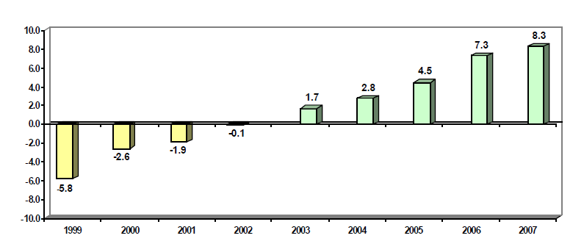
Source: National Survey of Monthly Employment Patterns. MTPE.

Table 2
Urban Peru: Employment patterns in the extractive sector
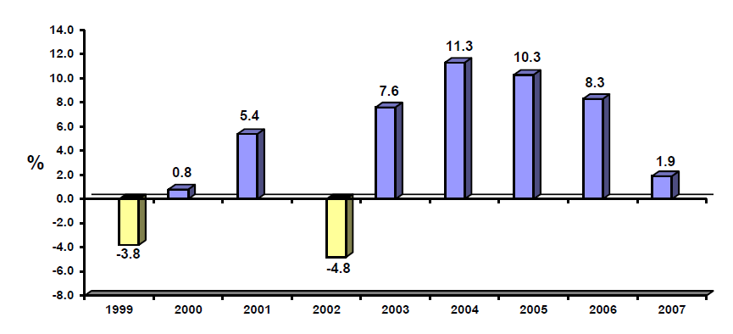
Source: National Survey of Monthly Employment Patterns (firms of 10 or more workers). MTPE.

Table 3
Urban Peru: Employment patterns in the industrial sector
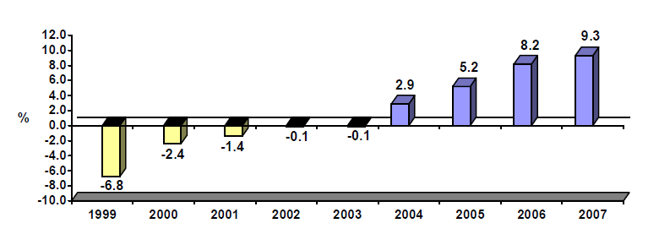
Source: National Survey of Monthly Employment Patterns (firms of 10 or more workers). MTPE.

Table 4
Urban Peru: Employment patterns in the electricity, gas and water sectors
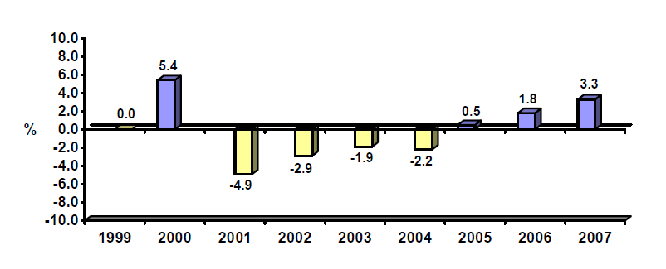
Source: National Survey of Monthly Employment Patterns (firms of 10 or more workers). MTPE.

Table 5
Urban Peru: Employment patterns in the commerce sector

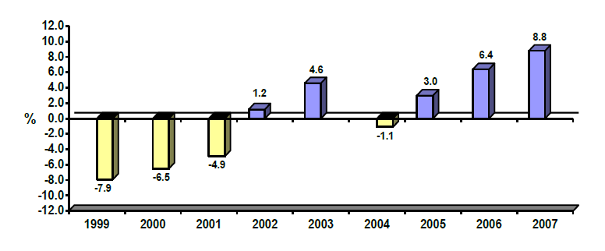
Source: National Survey of Monthly Employment Patterns (firms of 10 or more workers). MTPE.

Table 6
Urban Peru: Employment patterns in the transport, storage and communications sectors

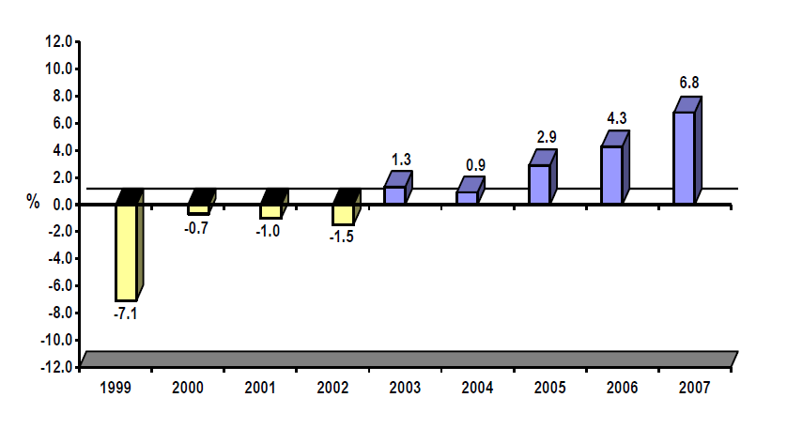
Source: National Survey of Monthly Employment Patterns (firms of 10 or more workers). MTPE.

Table 7
Urban Peru: Employment patterns in the services sector
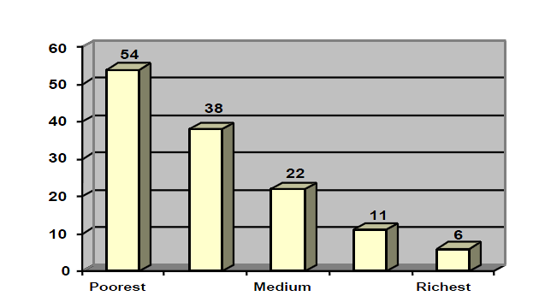
Source: National Survey of Monthly Employment Patterns (firms of 10 or more workers). MTPE.
Demand for labour

Table 8
Urban Peru: Monthly employment index by size of firm,
October 1997-July 2008
(Base May 2004 = 100)
Month | 1997 | 1998 | 1999 | 2000 | 2001 | 2002 | 2003 | 2004 | 2005 | 2006 | 2007 | 2008
10 and more workers
January | - | 106.0 | 101.9 | 96.8 | 94.4 | 92.2 | 95.0 | 96.6 | 100.0 | 105.8 | 115.0 | 125.1
February | - | 105.2 | 100.5 | 96.1 | 93.7 | 91.9 | 93.7 | 95.7 | 99.3 | 105.6 | 114.5 | 124.9
March | - | 105.3 | 100.1 | 96.5 | 94.2 | 92.7 | 94.1 | 96.0 | 100.1 | 106.4 | 116.1 | 126.2
April | - | 106.2 | 100.2 | 97.4 | 95.3 | 94.9 | 95.9 | 99.0 | 101.9 | 109.0 | 117.8 | 128.1
May | - | 106.7 | 100.5 | 97.6 | 96.1 | 95.6 | 97.4 | 100.0 | 103.9 | 110.0 | 118.8 | 130.6
June | - | 106.6 | 100.4 | 98.7 | 96.4 | 96.4 | 98.1 | 100.4 | 105.0 | 111.6 | 120.3 | 131.7
July | - | 107.0 | 100.0 | 98.7 | 96.3 | 96.8 | 98.1 | 100.5 | 105.6 | 112.9 | 121.4 | 132.7
August | - | 107.0 | 99.2 | 97.8 | 95.9 | 96.0 | 96.8 | 99.6 | 104.7 | 112.5 | 122.0
September | - | 107.0 | 99.0 | 97.6 | 96.1 | 96.3 | 98.2 | 100.9 | 106.2 | 114.5 | 124.1
October | 107.3 | 106.9 | 99.4 | 97.4 | 96.3 | 97.5 | 99.1 | 102.7 | 107.6 | 117.2 | 126.5
November | 108.1 | 105.9 | 99.7 | 97.6 | 96.6 | 98.1 | 99.8 | 103.3 | 108.4 | 118.4 | 127.8
December | 108.3 | 105.4 | 99.9 | 97.3 | 96.2 | 98.5 | 100.2 | 103.8 | 109.6 | 119.2 | 129.9
10 to 49 workers
January | - | 127.8 | 117.8 | 105.8 | 99.4 | 94.9 | 96.3 | 96.3 | 94.4 | 98.0 | 104.3 | 109.7
February | - | 127.5 | 116.0 | 104.8 | 98.4 | 94.5 | 96.3 | 94.4 | 93.9 | 97.7 | 105.0 | 110.8
March | - | 126.9 | 114.5 | 104.8 | 98.6 | 95.0 | 96.8 | 95.0 | 95.8 | 98.8 | 107.8 | 113.5
April | - | 127.3 | 113.8 | 105.7 | 100.1 | 98.2 | 99.7 | 99.7 | 98.6 | 102.7 | 108.4 | 114.9
May | - | 127.4 | 113.9 | 105.8 | 101.0 | 99.3 | 100.7 | 100.0 | 101.3 | 102.6 | 109.7 | 117.0
June | - | 126.5 | 113.4 | 107.1 | 100.7 | 100.2 | 101.2 | 100.2 | 101.1 | 103.3 | 111.1 | 117.7
July | - | 128.3 | 112.5 | 106.7 | 100.1 | 99.9 | 100.7 | 99.4 | 101.6 | 104.9 | 111.2 | 119.5
August | - | 128.0 | 111.9 | 105.2 | 100.5 | 99.5 | 99.9 | 98.2 | 100.6 | 103.8 | 112.5
September | - | 127.2 | 111.5 | 105.1 | 100.6 | 100.0 | 100.2 | 98.7 | 100.5 | 104.9 | 113.2
October | 129.1 | 125.8 | 110.6 | 104.3 | 100.5 | 100.1 | 100.7 | 98.8 | 101.1 | 107.0 | 114.3
November | 130.1 | 123.3 | 110.5 | 103.9 | 100.0 | 100.6 | 101.1 | 99.3 | 102.1 | 108.5 | 115.2
December | 130.8 | 122.3 | 110.3 | 103.2 | 99.1 | 100.6 | 101.1 | 99.5 | 103.0 | 108.5 | 115.9
50 and more workers
January | - | 97.2 | 95.3 | 93.0 | 92.4 | 91.2 | 94.5 | 96.7 | 102.1 | 108.7 | 119.7 | 131.5
February | - | 96.3 | 94.1 | 92.5 | 91.7 | 90.8 | 92.6 | 96.2 | 101.3 | 108.5 | 118.4 | 130.9
March | - | 96.7 | 94.2 | 93.0 | 92.4 | 91.8 | 93.1 | 96.3 | 101.7 | 109.2 | 119.2 | 131.4
April | - | 97.6 | 94.6 | 94.0 | 93.3 | 93.7 | 94.5 | 98.7 | 103.1 | 11.3 | 121.3 | 133.6
May | - | 98.3 | 95.0 | 94.1 | 94.0 | 94.2 | 96.1 | 100.0 | 104.8 | 113.0 | 122.2 | 136.3
June | - | 98.5 | 95.0 | 95.2 | 94.7 | 95.0 | 96.9 | 100.5 | 106.4 | 115.0 | 124.0 | 137.6
July | - | 98.4 | 94.8 | 95.4 | 94.8 | 95.6 | 97.2 | 100.9 | 107.1 | 116.1 | 125.7 | 138.1
August | - | 98.5 | 94.0 | 94.7 | 94.1 | 94.7 | 95.7 | 100.1 | 106.3 | 116.2 | 125.9
September | - | 98.8 | 93.9 | 94.5 | 94.4 | 94.9 | 97.4 | 101.8 | 108.4 | 118.5 | 128.6
October | 98.6 | 99.2 | 94.7 | 94.5 | 94.6 | 96.5 | 98.5 | 104.1 | 110.1 | 121.5 | 131.6
November | 99.2 | 98.7 | 95.3 | 95.0 | 95.2 | 97.2 | 99.4 | 104.8 | 110.8 | 122.6 | 133.1
December | 99.2 | 98.5 | 95.6 | 94.9 | 95.1 | 97.7 | 99.9 | 105.4 | 112.1 | 123.8 | 135.8
Source: National Survey of Monthly Employment Patterns. Ministry of Labour and Employment Promotion – Directorate of Employment and Vocational Training (MTPE-DNPEFP)

Table 9
Other Urban: Original and seasonally adjusted trends in the employment index in private firms of ten or more workers, January 2000-July 2008
(Base May 2004 = 100)
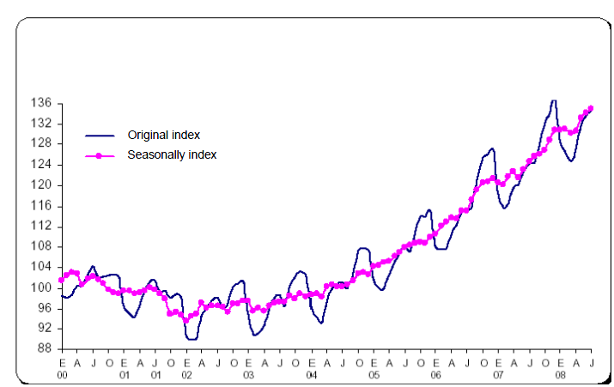
Note: Seasonally adjusted using the X12-ARIMA programme
Source: National Survey of Monthly Employment Patterns. MTPE – DNEFP
Trends in underemployment

2. Despite the significant increase in the total and per capita real gross domestic product, the underemployment rate (particularly by income) has remained high (52 per cent of total workers), especially in rural areas, where small subsistence agricultural producers predominate.

Table 10
Peru: Trends in the underemployment rate by geographical area
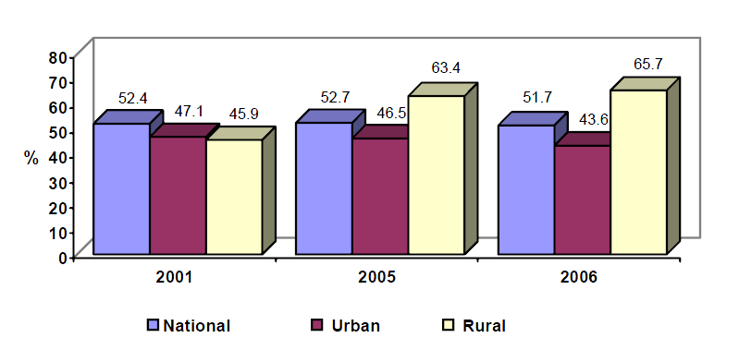
Source: National Household Survey. INEI.
Vulnerable groups
3. Some population groups cost more to integrate in the labour market, such as the disabled, women and young people. Over two thirds of disabled persons of working age are inactive, i.e. are neither working nor seeking work; while unemployment rates among women (9 per cent) and young people (14 per cent) are markedly higher than the overall rate (7 per cent) in metropolitan Lima.

Table 11
Metropolitan Lima: Distribution of disabled persons of working age, 2005 | Metropolitan Lima: Distribution of economically active persons with disability, 2005
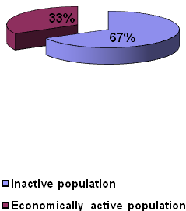 | 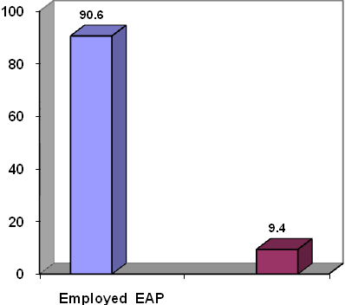
Source: Household Survey on Disability in Metropolitan Lima, 2005. INEI – CONADIS.

Table 12
Unemployment rate in Metropolitan Lima
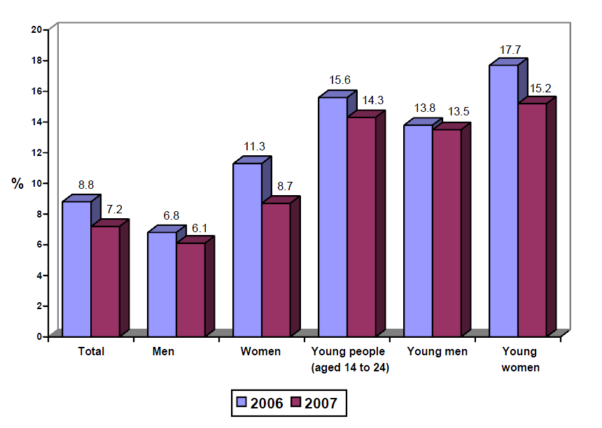
Source: Specialized Household Survey of Employment Levels. 2006 and 2007. MTPE.

Table 13
CENFORP trainees at Huancayo, Taraco-Puno and Huaraz, 2005-2007
Year | Trainees | Disabled | Total
2005 | 443 | 11 | 454
2006 | 621 | 0 | 621
2007 | 1 177 | 13 | 1 190
Total | 2 241 | 24 | 2 265
Source: Annual Report of the Vocational Training Centres (CENFORP) at national level.
4. The Vocational Training Centres provide training aimed at developing the practical skills and necessary attitudes for working in a set of occupations in the different branches of economic activity. They offer classroom and workshop teaching, are not usually part of the state education system and may be sponsored by the government or private enterprise. These Centres serve the vulnerable sectors of the provincial population, especially rural sectors, providing work and self-employment training for communities, settlements, etc.
Technical and vocational training

Table 14
Peru: economically active population (EAP) by sex and level of employment according to educational level, 2005-2006
(Percentages)
 | 2005
Educational level | Men |  |  |  | Women
 | Unemployed | Subemployed | Adequate  employment | Total Men | Unemployed | Subemployed | Adequate employment | Total Women | Expanded figures
Up to secondary completed | 4.3 | 58.2 | 37.6 | 100.0 | 4.5 | 58.2 | 37.3 | 100.0 | 10 793 160
Higher non-univ.incomplete | 6.2 | 47.7 | 46.1 | 100.0 | 10.5 | 47.1 | 42.4 | 100.0 | 450 153
Higher non-univ. completed | 4.9 | 31.5 | 63.6 | 100.0 | 7.1 | 39.7 | 53.2 | 100.0 | 1 061 661
Higher univ. incomplete. | 8.5 | 32.8 | 58.7 | 100.0 | 7.5 | 45.4 | 47.1 | 100.0 | 493 732
Higher univ. completed | 6.1 | 17.2 | 76.7 | 100.0 | 9.3 | 25.6 | 65.2 | 100.0 | 1 009 187
Total | 4.7 | 51.8 | 43.6 | 100.0 | 5.3 | 53.7 | 41.0 | 100.0 | 13 807 892

 | 2006
 | Men |  |  |  | Women
Educational level | Unemployed | Subemployed | Adequate  employment | Total Men | Unemployed | Subemployed | Adequate employment | Total Women | Expanded figures
Up to secondary completed | 3.6 | 57.1 | 39.3 | 100.0 | 4.1 | 58.9 | 37.0 | 100.0 | 11 658 813
Higher non-univ.incomplete | 6.0 | 37.6 | 56.3 | 100.0 | 8.9 | 53.8 | 37.3 | 100.0 | 563 506
Higher non-univ. completed | 4.0 | 27.0 | 69.1 | 100.0 | 7.9 | 38.7 | 53.4 | 100.0 | 1 161 260
Higher univ. incomplete. | 6.6 | 31.2 | 62.3 | 100.0 | 11.8 | 35.6 | 52.6 | 100.0 | 543 099
Higher univ. completed | 2.9 | 16.7 | 80.4 | 100.0 | 5.9 | 24.3 | 69.8 | 100.0 | 1 124 559
Total | 3.8 | 49.9 | 46.3 | 100.0 | 4.9 | 53.8 | 41.2 | 100.0 | 15 051 237
Source: INEI – ENAHO. Living conditions and poverty, 2005-2006.

Table 15
Peru: enrolments, teachers and techno-productive centres and higher institutes, 2007
 | Enrolments |  |  |  | Teachers |  |  |  | Centres or programmes
Stages and educational level | Total | Urban | Rural |  | Total | Urban | Rural |  | Total | Urban | Rural
Techno-productive | 260 570 | 251 312 | 9 258 |  | 13 620 | 13 180 | 440 |  | 2 185 | 2 047 | 138
Higher non-univ. | 357 958 | 342 744 | 15 214 |  | 27 326 | 26 006 | 1 320 |  | 1 092 | 1 023 | 69
Teacher training | 71 872 | 67 370 | 4 502 |  | 7 327 | 6 892 | 435 |  | 345 | 326 | 19
Technological | 279 336 | 269 040 | 10 296 |  | 18 746 | 17 936 | 810 |  | 703 | 656 | 47
Artistic | 6 750 | 6 334 | 416 |  | 1 253 | 1 178 | 75 |  | 44 | 41 | 3
Note: The number of teachers can include double entries since the data collection unit is the number of teachers working in each education centre or programme.
Source: Ministry of Education. Educational Statistics Unit – 2008.

Table 16
History of the participants in the pro-youth programme 1997-2008
Meeting | Men | Women | Total | Percentage  Men | Percentage Women
1ª Meeting | 666 | 839 | 1 505 | 44.3 | 55.7
2ª Meeting | 792 | 1 015 | 1 807 | 43.8 | 56.2
3ª Meeting | 982 | 1 261 | 2 243 | 43.8 | 56.2
4ª Meeting | 1 131 | 1 540 | 2 671 | 42.3 | 57.7
5ª Meeting | 1 363 | 1 712 | 3 075 | 44.3 | 55.7
6ª Meeting | 1 673 | 1 978 | 3 651 | 45.8 | 54.2
7ª Meeting | 1 979 | 2 199 | 4 178 | 47.4 | 52.6
8ª Meeting | 2 378 | 2 779 | 5 157 | 46.1 | 53.9
9ª Meeting | 2 808 | 3 134 | 5 942 | 47.3 | 52.7
10ª Meeting | 845 | 950 | 1 795 | 47.1 | 52.9
11ª Meeting | 1 115 | 1 197 | 2 312 | 48.2 | 51.8
12ª Meeting | 1 261 | 1 419 | 2 680 | 47.1 | 52.9
13ª Meeting | 2 570 | 2 642 | 5 212 | 49.3 | 50.7
14ª Meeting | 4 664 | 6 406 | 11 070 | 42.1 | 57.9
Total | 24 231 | 29 070 | 53 298 | 45.5 | 54.5
Note: More information is available at www.projoven.gob.pe.
Current situation of the country regarding vocational guidance and training

Table 17
Problems common to the Regional Directorates of Labour and Employment Promotion
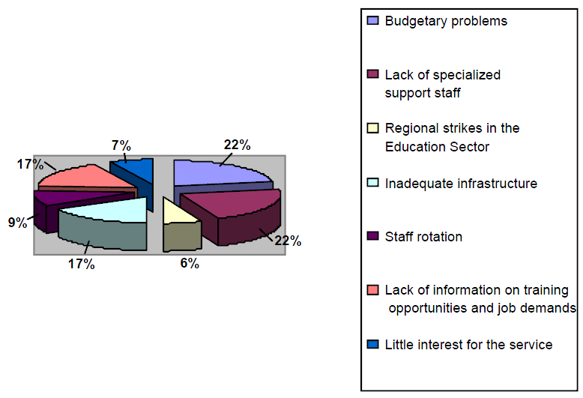
Source: Qualitative report submitted by the DRTPE (January-December 2007).
Working population of Peru with more than one occupation

Table 18
Peru: Annual distribution of the economically active population with a secondary occupation, 2003–2006
(In percentages)
Secondary occupation | 2003–2004 | 2005 | 2006
Absolute total | 13 013 298.0 | 13 728 585.0 | 14 403 932.0
Relative total | 100.0 | 100.0 | 100.0
Yes | 14.3 | 13.5 | 14.3
No | 85.7 | 86.5 | 85.7
Source: INEI – National Household Survey on Living Conditions and Poverty, continuous 2003-2004; 2005 and 2006. Compiled by: MTPE – PEEL.
NB: Workers with a secondary occupation are those who in the reference week as well as having a main occupation had another job to obtain income.
Changes affecting the right to work

Table 19
General provisions | - Act N° 28518, on training for work arrangements.  - Supreme Decree N° 007-2005- TR, regulating Act N° 28518.  - Act N° 27626, regulating the activity of special services companies and workers’ cooperatives.  - Supreme Decree N° 003-2002- TR, regulating Act N° 27626.
Non-discrimination mandate | - Act N° 27270, prohibiting discriminatory acts.  - Act N° 27942, on the prevention and punishment of sexual harassment.  - Supreme Decree N° 010-2003-MIMDES, regulating Act N° 27942.
Workers’ rights: provision and protection | - Act N° 27409, granting leave from work in the case of adoption.  - Act N° 27403, specifying leave entitlements for breastfeeding.  - Act N° 28048, providing for protection of pregnant mothers from work endangering the health and/or normal development of the embryo and foetus.  - Supreme Decree N° 009-2004-TR, regulating Act N° 28048.
Remuneration and social benefits | - Act N° 28951, on food aid for workers subject to the private-sector labour regime.  - Supreme Decree N° 013-2003-TR, regulating Act N° 28951.  - Act N° 27735, regulating special payments for public holidays and Christmas for workers subject to private-sector labour regime.  - Supreme Decree N° 005-2002- TR, regulating Act N° 27735.  - Act N° 27700, specifying the rights of workers who fail to maintain their life insurance.  - Supreme Decree N° 024-2001- TR, specifying and regulating the provisions of the law consolidating social benefits.  - Act N° 28461, authorizing the use of 80 per cent of compensation for time worked for acquiring housing or land under the programmes promoted by the Ministry of Housing and Construction or by the private sector.
Worktime | - Supreme Decree N° 007-2002- TR, single consolidated text of the law on the working day, hours worked and overtime.  - Supreme Decree N° 008-2002- TR, regulating the single consolidated text of the law on working hours, work schedule and overtime.  - Supreme Decree N° 012-2002- TR, modifying articles of Supreme Decree N° 008-2002- TR.
Health and safety at work | - Supreme Decree N° 009-2005- TR, regulating health and safety at work.  - Ministerial Decision N° 148-2007- TR, approving the regulation on the constitution and functioning of the Committee and appointment and duties of the Supervisor of Health and Safety at Work and other related documents.
Collective labour relations | - Supreme Decree N° 010-2003-TR, the single consolidated text of the law on collective labour relations.  - Act N° 27556, creating the register of public service trade unions.  - Supreme Decree N° 003-2004-TR, establishing the register of public service trade unions.
Labour Inspectorate | - General Labour Inspectorate Act N° 28806.  - Supreme Decree N° 019-2006-TR, regulating Act N° 28806.
Judgements of the Constitutional Court | - Case No. 3330-2004-AA/TC y N° 10287-2005-AA/TC.- Amparo proceedings ruling on the essential content of the right to work.  - Case No. 09272-2005-PA/TC.- Amparo proceedings on arbitrary dismissal.  - Case No. 2252-2003-AA/TC y No. 3710-2005-PA/TC.- Amparo proceedings on dismissal without due cause.  - Case No. 0206-2005-PA/TC.- Amparo proceedings on invalid dismissal.  - Case No. 2371-2004-AA/TC.- Amparo proceedings on prohibition of arbitrary dismissals.  - Case No. 4058-2004-AA/TC, N.º 2802-2005-PA/TC y N° 01535-2006-PA/TC.- Amparo proceedings on the right to work.  - Case N° 01564-2005-PA/TC y 0206-2005-PA/TC.- Amparo proceedings on fraudulent dismissal.  - Case No. 4635-2004-AA/TC.- Amparo proceedings on cumulative atypical working hours in the mining industry, rest days and leisure in the case of the miner’s working day and the eight-hour working day.  - Case No. 3012-2004-AA/TC and No. 2040-2004-AA/TC.- Amparo proceedings on the content of the work contract.  - Case No. 0008-2005-PI/TC.- Unconstitutionality proceedings on the right to strike (scope, essential content, notice, limitations and entitlement).  - Case N° 00005-2006-AI/TC.- Unconstitutionality proceedings on pensions.  - Case No. 1412-2005-PA/TC.- Amparo proceedings on the essential content of the right to pension.  - Case No. 0050-2004-AI/TC and others (accumulated). Amparo proceedings on the essential content of the right to pension.  - Case No. 1417-2005-PA/TC and No. 05189-2005-AA/TC . Amparo proceedings on the minimum pension.
Article 7 of the Covenant
Compliance with minimum wage provisions
5. Concerning compliance with minimum wage provisions, almost 50% of wage earners in the private sector receive salaries below the minimum, the situation being especially critical in the micro-enterprise sector, in which over a third of workers receive incomes below the minimum wage.

Table 20
Peru: Percentage of wage-earners with salaries below the minimum wage
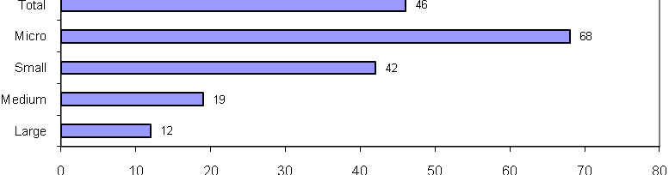
Source: National Household Survey, continuous 2006. INEI.
Trends in the purchasing power of average wages and the minimum wage
6. Over the last 10 years, the average real wages of salaried employees and manual workers has remained practically static, despite the strong economic growth in the current decade.

Table 21
Urban Peru: Trends in gross real salaries in firms of 10 or more employees,
1996–2007
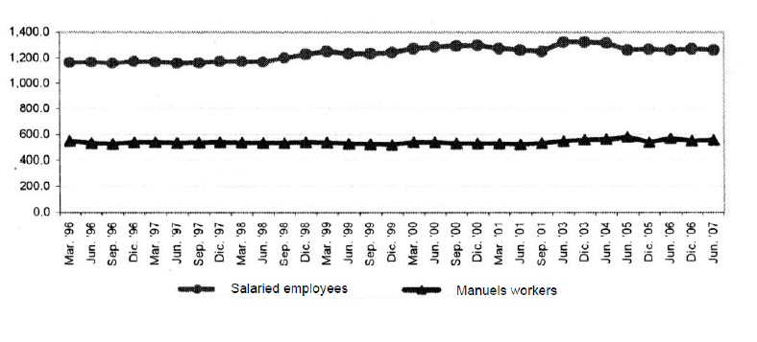
Soles, 1994
Source: National Survey of Wages and Salaries in private firms of 10 or more workers.
7. However, the real minimum wage showed a significant recovery from the middle of the 1990s, while not achieving the levels observed in the 1970s.

Table 22
Peru: Trends in the Minimum Wage, January 1962-April 2008
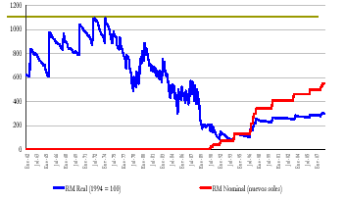
Real minimum wage (1994 = 100)

Nominal minimum wage (new soles)

Source: Ministry of Labour and Employment of Promotion, Office of Statistics and Information Technology
Compiled by: National Labour Inspectorate.

Table 23
Number of offences by category
Category of offence | Number of offences | Percentage
Compensation for time worked | 2 734 | 21.0308
Payroll | 2 633 | 20.2538
Obstruction of labour inspector | 2 419 | 18.6077
Wages | 2 218 | 17.0615
Working day. rest days and hours worked | 2 174 | 16.7231
Profit sharing | 220 | 1.6923
Social security | 164 | 1.2615
Work contracts | 73 | 0.5615
Worker risk insurance | 64 | 0.4923
Personal protection teams | 45 | 0.3462
Internal management of health and safety at work | 31 | 0.2385
Collective labour relations | 31 | 0.2385
Safety conditions. workplaces and civil installations | 27 | 0.2077
Client firms | 22 | 0.1692
Work hygiene | 19 | 0.1462
Work certificate | 17 | 0.1308
Life insurance policy | 16 | 0.1231
Subcontractor firms | 14 | 0.1077
Training and information on health and safety at work | 12 | 0.0923
Fire prevention and protection | 11 | 0.0846
Privacy and dignity | 8 | 0.0615
Adolescent work permit | 7 | 0.0538
Communication. enrolment and registration | 7 | 0.0538
Safety-at-work teams | 6 | 0.0462
Private employment agencies | 6 | 0.0462
Training | 5 | 0.0385
Discrimination in the workplace | 4 | 0.0308
Specific groups | 3 | 0.0231
Work- risk prevention plans and programmes | 2 | 0.0154
Employment and placement | 2 | 0.0154
Internal rules | 1 | 0.0077
Checking of facts | 1 | 0.0077
Work equipment | 1 | 0.0077
Dangerous work | 1 | 0.0077
Work by under-18-year-olds | 1 | 0.0077
Conciliation and mediation | 1 | 0.0077
Total | 13 000 | 100.0000
Source: Ministry of Labour and Employment Promotion, Office of Statistics and Information Technology.
Compiled by: National Labour Inspectorate

Table 24
Number of offences by category of inspection, 2007
Categories of inspection
Work by under-18-year olds

Workplaces

Internal rules

Work risk prevention plans and programmes

Discrimination in the workplace

Private employment agencies

Communication, enrolment and registration

Privacy and dignity

Health and safety-at-work training and information

Life insurance policy

Hygiene in the workplace

Safety conditions, workplaces and civil installations

Internal management of health and
safety at work

Worker risk insurance

Social security

Working days, rest days and hours worked

Obstruction of labour inspector

Length-of-service compensation
Source: Ministry of Labour and Employment Promotion, Office of Statistics and Information Technology
Compiled by: National Labour Inspectorate
Unequal remuneration
8. Workers in urban areas receive a higher average income than their counterparts in rural areas. Moreover, women tend to be less well paid than men, especially in rural areas.

Table 25
Average monthly earned income by sex and geographical region, 2006
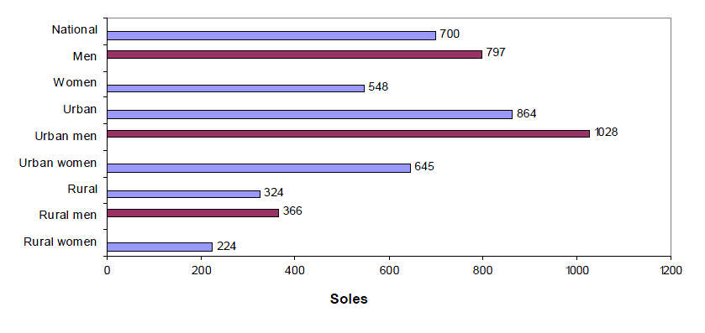
Source: National Household Survey, continuous 2006. INEI
Income of employees in the public and private sectors

Table 26
Peru: Distribution of earned income by type of worker and by quintile, 2006
(In percentages)
Quintile of the working population | Total | Private sector | Public sector
Gini coefficient | 0.55 | 0.54 | 0.33
Relative total | 100.0 | 100.0 | 100.0
20 per cent poorest | 17.6 | 22.7 | 7.4
2nd quintile | 20.8 | 26.8 | 8.8
3rd quintile | 20.0 | 18.2 | 23.6
4th quintile | 18.0 | 10.2 | 33.6
20 per cent richest | 23.6 | 22.1 | 26.7
NB: Earned income is monetary and non-monetary. For the purpose of calculation, only wage-earners have been taken into account
Source: INEI – National Household Survey on living conditions and poverty, continuous 2003-2004; 2005 and 2006
Compiled by: MTPE – PEEL
9. According to the above table, public-sector employees have a better income distribution when measured by the Gini coefficient. However, when disaggregating by quintiles we see that 20 per cent of the poorest public-sector employees account for 7.4 per cent of total income while their counterparts in the private sector account for 22.7 per cent. At the same time, the richest 20 per cent of private- and public-sector workers account for 22.1 per cent and 26.7 per cent of total income respectively. The most significant figure to emerge is that 40 per cent of public-sector workers receive no more than 16.2 per cent of total income.
Work-related accidents and illnesses

Table 27
Work accidents by economic activity
Economic activity | 1997 | 1998 | 1999 | 2000 | 2001 | 2002 | 2003 | 2004 | 2005
Construction | 7 | 14 | 10 | 10 | 9 | 8 | 10 | 10 | 15
Mining |  |  | 3 | 8 | 4 | 6 |  | 6 | 4
Industry | 43 | 38 | 58 | 26 | 22 | 28 | 20 | 30 | 44
Fishing |  |  |  | 4 | 9 | 4 |  | 7 | 1
Services | 15 | 22 | 24 | 37 | 19 | 16 | 12 | 8 | 17
Other | 9 | 15 |  |  | 4 | 14 | 4 | 6 | 23
Total | 74 | 89 | 95 | 85 | 67 | 76 | 46 | 67 | 104
Source: MTPE Health and Safety at Work Inspectorate

Table 28
Types of work accident
Type of accident | 1997 | 1998 | 1999 | 2000 | 2001 | 2002 | 2003 | 2004 | 2005
Vehicle accidents | 4 | 4 | 5 | 4 | 3 | 4 |  | 5 | 4
Imprisonment | 38 | 40 | 29 | 22 | 18 | 25 | 12 | 21 | 49
Falls | 19 | 17 | 5 | 14 | 7 | 16 | 10 | 12 | 25
Electric shocks | 3 | 0 | 0 | 5 | 1 | 2 | 2 | 3 | 3
Cuts | 0 | 0 | 28 | 6 | 2 | 0 | 3 | 2 | 28
Explosions | 0 | 0 | 0 | 5 | 2 | 2 | 4 | 5 | 2
Building collapse | 0 | 0 | 0 | 7 | 3 | 2 | 1 | 3 | 8
Blows by object | 2 | 17 | 3 | 9 | 15 | 16 | 7 | 5 | 14
Burns | 3 | 9 | 10 | 2 | 2 | 2 | 0 | 6 | 5
Other | 5 | 2 | 15 | 11 | 14 | 7 | 7 | 10 | 13
Total | 74 | 89 | 95 | 85 | 67 | 76 | 46 | 72 | 152
Source: MTPE Health and Safety at Work Inspectorate

Table 29
Nunber of work accident reports recorded by ESSALUD (2000-2005)
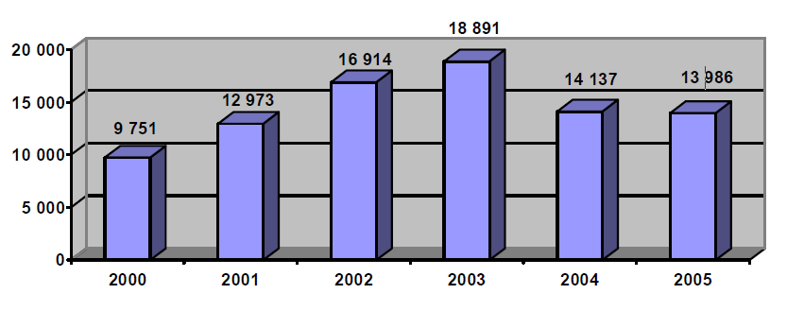
Source: Work Accident Reporting System – ESSALUD.

Table 30
Work accidents reported by MINSA, (495 cases)
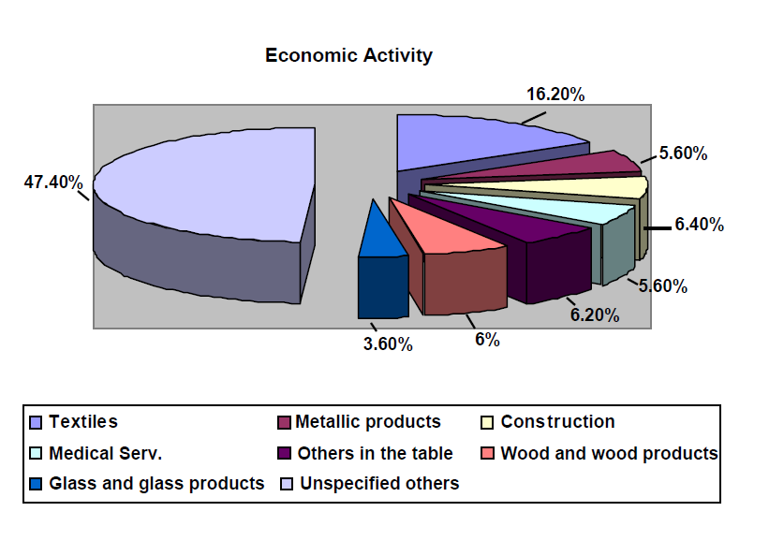
Source: Ministry of Health.

Table 31
Work-related accidents, Type of accident
Source: Ministry of Health.
Measures to eliminate inequality

Table 32
Measures adopted by the State to eliminate inequality
National Plan for Equality of Opportunity for Women and Men, 2006-2010
CIL – PROEMPLEO Network | - 46,575 job-seekers (59.3 per cent men and 40.7 per cent women) successfully entered the job market through the PROEmpleo Offices nationally.  - Extension and decentralization of the CIL PROEmpleo Network, and the creation of 27 new CIL PROEmpleo Offices nationally.
Juvenil – PROJOVEN Work Training Programme | - 11,070 young trainees (6,302 women and 4,768 men) in the cities of Lima, Callao, Trujillo, Chiclayo, Arequipa, Huancayo, Piura and Cusco.  - Contract with 70 training centres.  - Intensive use of information technology in all ProJoven’s activities.
National Plan for Equality of Opportunity for the Disabled
- The Cil Proempleo Network has included 124 Disabled Persons on its register and found jobs for 16.
- The Constructing Peru programme has provided temporary work for 5,614 disabled persons nationwide, including 3,097 men and 2,517 women.
- Measures to publicize the employment programmes and to promote greater sensitivity to disabled persons:

- Expansion of the “Constructing Peru”, “Pro Joven” and “Mi Empresa” programmes to accommodate 79 disabled persons.
- Awareness-raising and training for 52 Cil ProEmpleo employees.
- Training and awareness-raising with regard to Act N° 27050, on disabled persons; 65 sectoral work inspectors.
- Dissemination of Act N° 27050 to disabled persons and their families, employers’ organizations, trade unions, public-sector workers, private firms, public and private institutions, public-service transport personnel, etc.
- Guidance, information and distribution of material on applicable labour standards to 450 disabled persons (Directorate of Labour Relations).
- Priority given to disabled persons for conciliation, legal defence, mediation and free legal advice services (3 253 beneficiaries).
- Other activities by the Ministry of Labour and Employment Promotion:
- Managing the establishment of the Consultative Committee on the employment of disabled persons, with the participation of employers’ organizations, trade unions, associations representing the disabled, representatives of the public sector and private institutions.
- 44 inspections of firms to check compliance with labour standards applicable to the disabled.
- Participation of the sector, through the Inspectorate of Labour Relations, in the Multisectoral Commission for drafting the Equal Opportunities for the Disabled Plan 2007–2016.
Article 9 of the Covenant
10. In Peru, no more than one third of wage-earners in the private sector have social security cover, including health and pension insurance – a situation that is particularly critical in the micro-enterprise sector where 88 per cent of workers are not members of a pension system and 95 per cent have no form of health insurance.

Table 33
Peru: Percentage of wage-earners affiliated to a health and pensions scheme, by type of enterprise
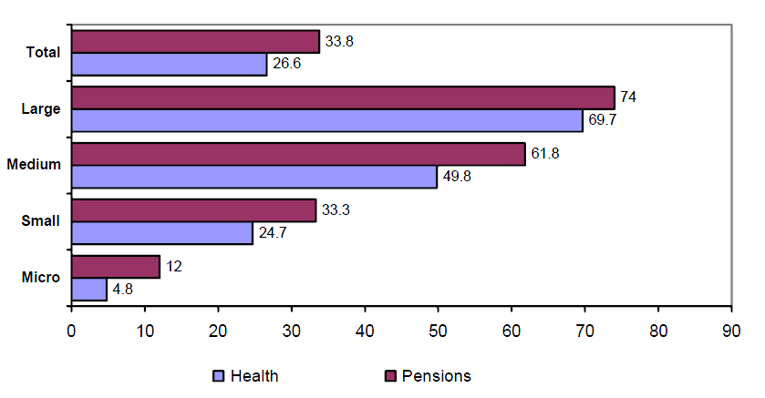
Source: National Household Survey, continuous 2006. INEI

B. Labour supervision

Table 34
Lima
Headquarters
Inspection orders by month and measures taken, 2007
(Computerized Labour Inspection System – SIIT)
Inspection orders/actions | January | February | March | April | May | June | July | August | September | October | November | December | Total
I. Inspection orders from outside source
- Inspection orders registered | 1 035 | 1 049 | 966 | 897 | 1 131 | 1 033 | 1 142 | 717 | 996 | 923 | 982 | 843 | 11 714
- Inspection orders in progress | 46 | 32 | 61 | 86 | 50 | 60 | 64 | 54 | 80 | 114 | 101 | 196 | 944
- Inspection orders completed | 989 | 1 017 | 905 | 811 | 1 081 | 973 | 1 078 | 663 | 916 | 809 | 881 | 647 | 10 770
II. Inspection orders from internal source
- Inspection orders registered | 332 | 635 | 355 | 39 | 306 | 212 | 4 192 | 149 | 14 | 40 | 692 | 470 | 7 436
- Inspection orders in progress | 21 | 69 | 22 | 7 | 34 | 69 | 1977 | 26 | 11 | 18 | 215 | 110 | 2 579
- Inspection orders completed | 311 | 566 | 333 | 32 | 272 | 143 | 2 215 | 123 | 3 | 22 | 477 | 360 | 4 857
III. Workers concerned
- Men | 15 606 | 9 571 | 7 768 | 6 230 | 18 272 | 20 453 | 63 471 | 6 207 | 9 140 | 5 364 | 22 191 | 8 719 | 192 992
- Women | 4 591 | 3 531 | 3 982 | 1 702 | 7 300 | 3 393 | 22 629 | 3 775 | 4 129 | 1 603 | 10 143 | 4 178 | 70 956
- Minors | 2 | 1 | 1 | 4 | - | - | 11 | - | 15 | 12 | - | 1 | 47
- Disabled | - | 1 | - | - | - | - | - | - | - | - | - | - | 1
- Foreigners | 4 | 1 | - | 6 | - | - | 29 | - | - | 4 | - | 4 | 48
IV. Inspection actions
- Onsite inspections | 1 734 | 2 907 | 2 965 | 2 174 | 2 504 | 2 434 | 2 873 | 1 764 | 1 100 | 3 978 | 3 264 | 1 927 | 29 624
- Attendance order | 164 | 424 | 566 | 550 | 794 | 740 | 964 | 825 | 23 | 650 | 677 | 370 | 6 747
V. Inspection measures
- Warning | 111 | 209 | 160 | 87 | 78 | 164 | 337 | 61 | 45 | 10 | 200 | 39 | 1 501
- Compliance notice | 1 016 | 1 544 | 1 374 | 1 293 | 2 078 | 1 298 | 2 437 | 1 104 | 1 727 | 1 115 | 854 | 438 | 16 278
VI. Subject of inspection
- Work |  |  |  |  |  |  |  |  |  |  |  |  | 19 809
Arbitrary dismissal | 1 138 | 966 | 922 | 826 | 896 | 729 | 1 056 | 835 | 971 | 1 079 | 993 | 832 | 11 243
Work contracts | 122 | 196 | 116 | 230 | 114 | 60 | 91 | 91 | 63 | 66 | 133 | 109 | 1 391
- Health and safety at work | 546 | 185 | 69 | 111 | 278 | 261 | 86 | 65 | 77 | 57 | 54 | 71 | 1 860
- Adolescent labour | 11 | 11 | 39 | 24 | 5 | 9 | 19 | 103 | 53 | 100 | 260 | 269 | 903
- Employment | 25 | 450 | 310 | 16 | 269 | 192 | 27 | 15 | 8 | 22 | 53 | 7 | 1 394
Source: Ministry of Labour and Employment Promotion. SIIT – Lima Headquarters.
Compiled by: Office of Statistics and Information Technology / Statistics Office.

Table 35
Callao
Inspection orders by month and measures taken, 2007
Inspection orders/actions | January | February | March | April | May | June | July | August | September | October | November | December | Total
I. Inspection orders from outside source
- Inspection orders registered | 91 | 104 | 123 | 120 | 92 | 73 | 122 | 113 | 118 | 85 | 60 | 81 | 1 182
- Inspection orders in progress | - | - | - | 10 | 13 | 75 | 98 | 53 | 57 | 42 | 52 | 41 | 441
- Inspection orders completed | 91 | 104 | 123 | 110 | 79 | 16 | 42 | 60 | 61 | 43 | 60 | - | 789
II. Inspection orders from internal source
- Inspection orders registered | - | 43 | 25 | - | 5 | - | 40 | 1 | 3 | - | 63 | - | 180
- Inspection orders in progress | - | - | - | - | - | - | 40 | 1 | 3 | - | 36 | - | 80
- Inspection orders completed | - | 43 | 25 | - | 5 | - | - | - | - | - | 27 | - | 100
III. Workers concerned
- Men | 134 | 87 | 675 | 90 | 705 | 43 | 270 | 162 | 121 | 57 | 66 | 186 | 2 596
- Women | 10 | 27 | 31 | 30 | 34 | 9 | 11 | 11 | 11 | 15 | 17 | 12 | 218
- Minors | - | - | - | - | - | - | - | - | - | - | - | - | -
- Disabled | - | - | - | - | - | - | - | - | - | - | - | - | -
- Foreigners | - | - | - | - | - | - | - | - | - | - | - | - | -
IV. Inspection actions
- Onsite inspections | 133 | 187 | 236 | 204 | 161 | 122 | 156 | 168 | 166 | 264 | 296 | 168 | 2 261
- Attendance orders | 53 | 168 | 142 | 119 | 180 | 127 | 109 | 105 | 110 | 53 | 37 | 20 | 1 223
- Data verification
V. Inspection measures
- Warning  - Recommendation | - | - | - | - | - | - | - | - | - | - | - | - | -
- Compliance notice | 2 | 1 | 2 | 3 | 2 | 7 | 6 | 4 | 1 | - | - | 15 | 43
VI. Subject of inspection
Work
- Arbitrary dismissal | 90 | 62 | 68 | 91 | 60 | 42 | 56 | 46 | 51 | 93 | 69 | 78 | 806
- Work contracts | - | - | - | - | - | - | - | - | - | - | - | - | -
- Actual situation | - | - | - | - | - | - | - | - | - | - | - | - | -
- Forced labour and discrimination | - | - | - | - | - | - | - | - | - | - | - | - | -
- Other | 36 | 37 | 47 | 26 | 30 | 29 | 181 | 162 | 70 | 132 | 119 | 188 | 1 057
Health and safety at work
- Health and safety at work | 1 | 5 | 8 | 3 | 7 | 2 | 2 | 2 | 15 | 11 | 4 | 5 | 65
- Work risk insurance | - | - | - | - | - | - | - | - | 15 | 11 | 4 | 5 | 35
Adolescent labour
- Adolescent labour permit | - | - | - | - | - | - | - | - | - | - | - | - | -
- Child labour | - | - | - | - | - | - | - | - | - | - | - | - | -
Employment
- Training facilities | - | - | - | - | - | - | - | - | - | - | - | - | -
- Employment | - | - | - | - | - | - | - | - | - | - | - | - | -
Source: Ministry of Labour and Employment Promotion. Callao Regional Office.
Compiled by: Office of Statistics and Information Technology/ Statistics Office.

Table 36
National level*
Inspection orders by month and measures taken, 2007
Inspection orders/actions | January | February | March | April | May | June | July | August | September | October | November | December | Total
I. Inspection orders from external source
- Inspection orders registered | 1 571 | 1 065 | 1 265 | 1 017 | 1 120 | 923 | 1 395 | 1 212 | 1 224 | 1 176 | 1 185 | 1 105 | 14 258
- Inspection orders in progress | 526 | 435 | 483 | 423 | 421 | 465 | 644 | 489 | 622 | 683 | 624 | 585 | 6 400
- Inspection orders completed | 884 | 631 | 862 | 615 | 710 | 543 | 644 | 671 | 611 | 447 | 681 | 548 | 7 847
II. Inspection orders from internal source
- Inspection orders registered | 543 | 635 | 1 093 | 598 | 847 | 732 | 1 146 | 770 | 874 | 863 | 1 054 | 999 | 10 154
- Inspection orders in progress | 188 | 236 | 492 | 319 | 416 | 322 | 506 | 390 | 480 | 428 | 535 | 367 | 4 679
- Inspection orders completed | 317 | 343 | 697 | 394 | 590 | 522 | 667 | 480 | 391 | 475 | 502 | 625 | 6 003
III. Workers concerned
- Men | 9 334 | 8 007 | 13 188 | 12 054 | 16 997 | 17 733 | 15 519 | 11 660 | 9 837 | 16 886 | 16 886 | 16 767 | 161 785
- Women | 1 703 | 2 889 | 2 674 | 1 069 | 1 538 | 2 700 | 3 228 | 2 827 | 2 261 | 1 713 | 2 394 | 2 420 | 27 416
- Minors | 1 | 3 | 4 | - | 64 | 4 | 6 | - | 4 | 8 | 16 | 24 | 134
- Disabled | - | 8 | - | - | 7 | - | - | - | - | - | - | - | 15
- Foreigners | - | 1 | - | - | - | - | - | - | - | - | - | - | 1
IV. Inspection actions
- Onsite inspections | 1 820 | 1 460 | 2 098 | 1 488 | 1 686 | 1 490 | 1 907 | 1 672 | 1 866 | 1 935 | 2 202 | 1 898 | 21 522
- Attendance orders | 550 | 677 | 1 018 | 694 | 1 065 | 1 076 | 1 313 | 1 192 | 1 167 | 1 065 | 1 480 | 1 106 | 12 403
- Data verification | 700 | 538 | 688 | 653 | 593 | 624 | 2 269 | 527 | 589 | 675 | 1 097 | 697 | 9 650
V. Inspection measures  - Warnings | 25 | 12 | 34 | 27 | 33 | 49 | 34 | 53 | 82 | 98 | 75 | 42 | 564
- Recommendations | 89 | 79 | 56 | 43 | 63 | 127 | 73 | 37 | 31 | 36 | 54 | 13 | 701
- Compliance notice | 406 | 320 | 462 | 272 | 260 | 373 | 490 | 472 | 560 | 616 | 596 | 440 | 5 267
VI. Subject of inspection
Work
- Arbitrary dismissal | 798 | 430 | 451
- Work contracts | 268 | 289 | 228 | 187 | 248 | 284 | 290 | 294 | 404 | 364 | 345 | 416 | 3 617
- Actual situation | 162 | 86 | 61 | 73 | 126 | 121 | 106 | 109 | 124 | 180 | 80 | 160 | 1 388
- Forced labour and discrimination | - | - | - | - | - | - | 39 | 37 | 114 | 14 | 55 | 31 | 290
- Other | 482 | 569 | 791 | 940 | 1 293 | 1 535 | 1 208 | 1 279 | 996 | 1 768 | 1 219 | 751 | 12 831
Health and safety at work
- Health and safety at work | 20 | 145 | 176 | 246 | 36 | 187 | 48 | 43 | 57 | 64 | 82 | 39 | 1 143
- Work risk insurance | 7 | 35 | 41 | 33 | 27 | 65 | 11 | 30 | 26 | 28 | 71 | 28 | 402
Adolescent labour
- Adolescent labour permit | 39 | 33 | 11 | 12 | 10 | 10 | 5 | 23 | 8 | 7 | 7 | 7 | 172
- Child labour | 1 | 2 | - | - | - | - | - | 2 | - | 7 | - | 1 | 13
Employment
- Training facilities | 267 | 65 | 100 | 107 | 75 | 133 | - | 7 | - | - | - | 1 | 755
- Employment | - | - | - | - | 2 | - | - | - | - | 8 | 3 | - | 13
Source: Ministry of Labour and Employment Promotion. Regional Directorates/Areas of work.
Compiled by: Office of Statistics and Information Technology/Statistics Office.
* Lima information (Headquarters – SIIT) not included.

Annex III
Family and standard of living

Table 1
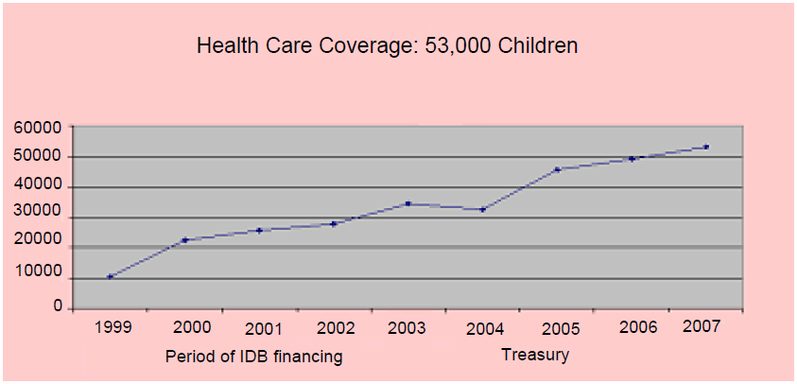

Table 2
Potential demand for WAWA WASIS – Peru by department
(Children aged between 6 and 47 months)
Department | Potential child demand | Users in 2008 | Percentage coverage
Amazonas | 9 127 | 576
Ancash | 16 027 | 3 176
Apurimac | 9 923 | 2 888
Arequipa | 12 458 | 3 696
Ayacucho | 13 888 | 2 130
Cajamarca | 28 179 | 2 784
Callao* | 0 | 0
Cusco | 26 597 | 2 282
Huancavelic | 13 785 | 2 896
Huanuco | 19 253 | 1 654
Ica | 5 650 | 1 456
Junin | 17 390 | 1 768
La Libertad | 16 957 | 1 026
Lambayeque | 15 472 | 1 848
Lima | 67 865 | 10 582
Loreto | 15 873 | 1 920
Madre de Dios | 1 016 | 160
Moquegua | 927 | 1 104
Pasco | 4 264 | 1 000
Piura | 22 890 | 1 912
Puno | 27 827 | 3 606
San Martín | 11 365 | 720
Tacna | 2 456 | 1 320
Tumbes | 1 802 | 1 248
Ucayali | 8 091 | 1 248
Total | 369 083 | 53 000 | 14,36
* Included under Lima.
Sources: INEI, Statistical Compendium 2002; INEI, Poverty Profile 2002; ENAHO 2004; Fourth Population Census and Fifth Housing Census.
Parameters for assessing potential demand
1. Poor or extremely poor population.
2. Maternal heads of household.
3. Households with working fathers and mothers.
4. Male household heads lacking partner.
5. Households lacking a person aged over 12.
Compiled by:
Jorge Shiga Meza – National Wawa Wasi Programme (PNWW)

Table 3
Population living in extreme poverty, by geographical location, 2004–2007
(Percentage relative to total population by year and geographical location)
Geographical location | 2004 | 2005 | 2006 | 2007
Total country | 17.1 | 17.4 | 16.1 | 13.7
Metropolitan Lima | 1.3 | 2.0 | 0.9 | 0.5
Rest of the country | 23.5 | 23.6 | 22.3 | 19.1
Residential area
Urban | 6.5 | 6.3 | 4.9 | 3.5
Rural | 36.8 | 37.9 | 37.1 | 32.9
Natural region
Coast | 4.0 | 3.8 | 3.0 | 2.0
Sierra | 33.2 | 34.1 | 33.4 | 29.3
Jungle | 25.0 | 25.5 | 21.6 | 17.8
Department
Amazonas | 28.3 | 25.1 | 20.0 | 19.6
Áncash | 23.3 | 25.0 | 20.8 | 17.2
Apurímac | 28.0 | 34.7 | 39.7 | 29.7
Arequipa | 6.5 | 3.8 | 3.4 | 3.7
Ayacucho | 27.8 | 38.6 | 41.3 | 35.8
Cajamarca | 29.5 | 30.8 | 29.0 | 31.0
Cusco | 23.5 | 22.3 | 22.8 | 27.8
Huancavelica | 64.6 | 76.2 | 72.3 | 68.7
Huánuco | 48.8 | 44.5 | 48.6 | 31.7
Ica | 1.7 | 1.0 | 1.3 | 0.3
Junín | 16.5 | 18.7 | 16.5 | 13.4
La Libertad | 18.6 | 14.8 | 18.2 | 12.4
Lambayeque | 9.5 | 7.5 | 9.5 | 7.0
Lima¹ | 2.5 | 2.5 | 1.4 | 1.1
Loreto | 38.0 | 41.2 | 33.9 | 23.8
Madre de Dios | 6.3 | 9.4 | 4.3 | 1.8
Moquegua | 10.9 | 5.4 | 3.9 | 4.3
Pasco | 28.5 | 32.0 | 31.0 | 31.5
Piura | 17.0 | 19.4 | 13.1 | 13.3
Puno | 43.8 | 44.1 | 41.6 | 29.9
San Martín | 20.9 | 20.8 | 17.2 | 16.9
Tacna | 3.8 | 3.7 | 3.3 | 3.9
Tumbes | 1.3 | 1.3 | 0.4 | 0.5
Source: INEI

Table 4
Population | Poverty gap 2004 | Poverty gap 2007
Urban | 10.6 | 6.5
Rural | 26.6 | 24.4
Total | 16.2 | 12.8
Source: INEI.

Table 5
Peru: average monthly income per capita, by area 2004-2007
(In new soles)
Deciles of expenditure | 2004 | 2005 | 2006 | 2007 | Variation
 |  |  |  |  | Percentage 2007-2006 | New soles 2007-2006
National | 372.3 | 370.4 | 412.5 | 468.6 | 13.6 | 56.1
Metropolitan Lima¹ | 643.7 | 625.3 | 709.3 | 789.7 | 11.3 | 80.4
Urban other | 362.5 | 371.2 | 408.3 | 482.6 | 18.2 | 74.3
Rural | 158.4 | 159.6 | 171.4 | 187.6 | 9.4 | 16.2
Source: INEI – National Household Survey 2007.
¹ Includes the Constitutional Province of Callao.

Table 6
Percentage of the population aged 60 or over, by poverty status
 | Total poverty | Poor |  | Not poor
 | Total poverty | Extreme | Not extreme | Not poor
Total National | 49.80 | 19.50 | 30.30 | 50.20
Elderly | 41.70 | 17.50 | 24.20 | 58.30
60 to 69 | 41.66 | 17.58 | 24.08 | 58.34
70 to 79 | 41.50 | 16.74 | 24.76 | 58.50
80 and more | 42.50 | 19.30 | 23.20 | 57.50
Source: National Household Survey, 1997–2001.

Table 7
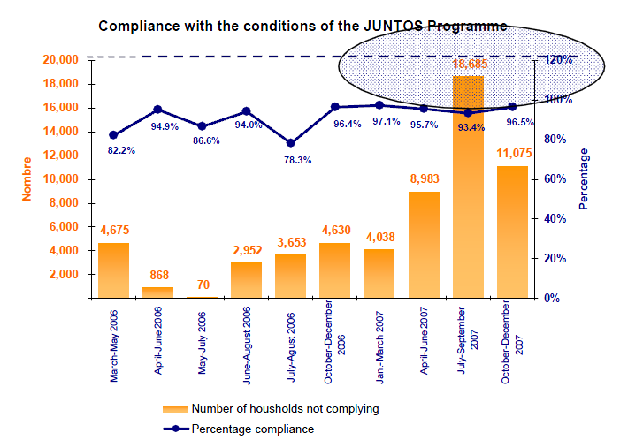
Source: PRONAA.

Table 8

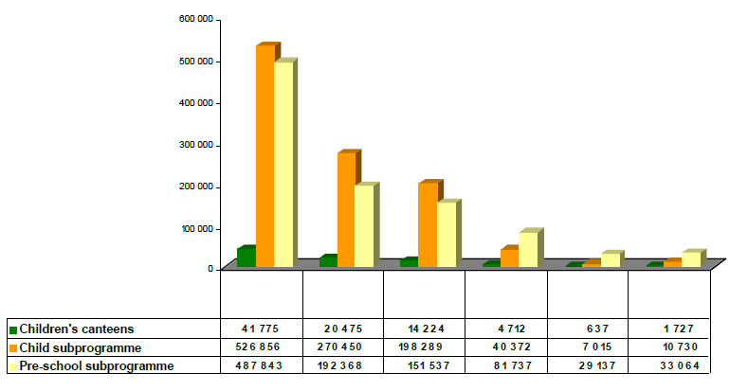
Total
beneficiaries
2nd
Quintile
5th
Quintile
4th
Quintile
3rd
Quintile
1st
Quintile
Source: PRONAA.

Table 9
Prevalence of chronic malnutrition in children under five, Peru 2005, 2007
Location | Reference | 1992 | 1996 | 2000 | 2005 | 2007
National | NCHS  WHO 2006 | 36.5 | 25.8  31.6 | 25.4  31.3 | 23.9  29.3 | 23.5  29.1
Urban | NCHS  WHO 2006 | 25.9 | 16.2  20.9 | 13.4  18.2 | 10.1  13.7 | 11.5  15.7
Rural | NCHS  WHO 2006 | 53.4 | 40.4  47.8 | 40.2  47.3 | 39  46.3 | 36.1  43.5
Source: ENDES continuous.

Table 10
Prevalence of chronic malnutrition in children under five, by department and according to ENDES 2000 and MONIN 2004
Department | ENDES 2000 |  | MONIN 2004
Department | Number | Percentage | Number | Percentage
Amazonas | 180 | 36.0 | 386 | 22.9
Ancash | 488 | 34.5 | 642 | 26.9
Apurimac | 208 | 43.0 | 459 | 33.2
Arequipa | 323 | 12.3 | 786 | 17.2
Ayacucho | 240 | 33.6 | 430 | 40.2
Cajamarca | 657 | 42.3 | 680 | 36.0
Cusco | 595 | 43.2 | 511 | 37.9
Huancavelica | 269 | 53.4 | 455 | 48.5
Huanuco | 400 | 42.8 | 649 | 40.7
Ica | 258 | 12.1 | 535 | 12.5
Junín | 532 | 31.3 | 743 | 39.1
La Libertad | 574 | 27.9 | 706 | 31.9
Lambayeque | 469 | 23.6 | 592 | 39.9
Lima | 2 649 | 8.3 | 492 | 16.9
Loreto | 471 | 32.4 | 415 | 25.2
Madre de Dios | 30 | 18.7 | 441 | 20.5
Moquegua | 38 | 9.3 | 683 | 19.9
Pasco | 110 | 26.4 | 343 | 30.0
Piura | 518 | 24.1 | 545 | 25.0
Puno | 556 | 29.7 | 583 | 29.9
San Martín | 284 | 19.9 | 497 | 20.7
Tacna | 83 | 5.4 | 419 | 9.0
Tumbes | 81 | 12.9 | 449 | 12.2
Ucayali | 165 | 33.6 | 521 | 29.5
National | 10 478 | 25.4 | 12 972 | 26.7
Table 11
Anaemia
(Children aged 6 to 59 months)
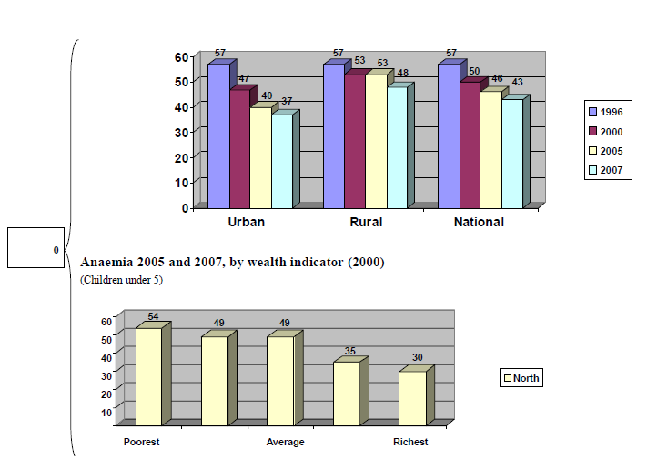
Percentage of children under 5
Source: ENDES continuous.

Table 12
Proportion of the population with below minimum food intake and underweight children under 5
(Undersized children under 5)
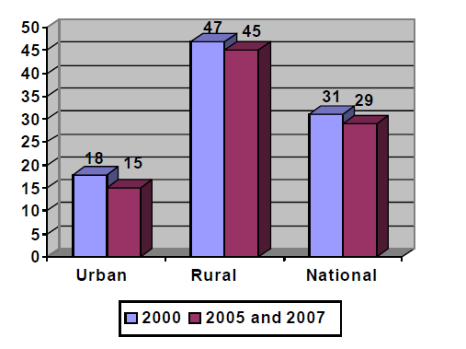
Source: ENDES continuous.

Table 13
Undersized children under 5, 2005 and 2007, by wealth indicator (2000)
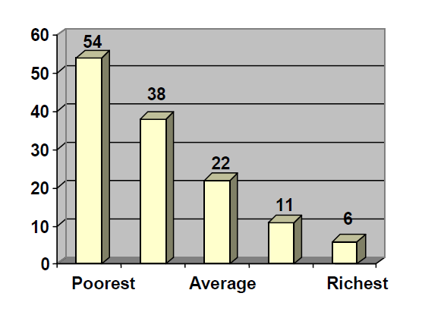
Source: ENDES continuous.

Table 14
Undersized children by age, 2005 and 2007
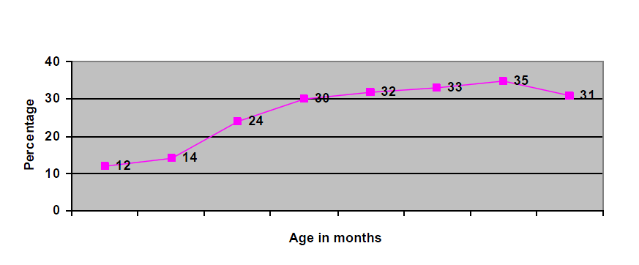
Source: ENDES continuous.

Table 15
Trends in the coverage of the JUNTOS Programme
Measure | Year
Measure | 2005 | 2006 | 2007
Departments | 4 | 9 | 14
Provinces | 26 | 67 | 115
Districts | 70 | 320 | 638
Recipient households | 22.55 | 163.74 | 372.92
Source: Office of the President of the Council of Ministers.

Table 16
PRONAA Child Nutrition Programmes – PIN
Programmes | Recipients
Children’s canteens | 41 775
Child subprogrammes | 526 856
Pre-school subprogrammes | 487 843
Total | 1 056 474
Source: PRONAA, 2007.

Table 17
Breastfeeding and nutrition
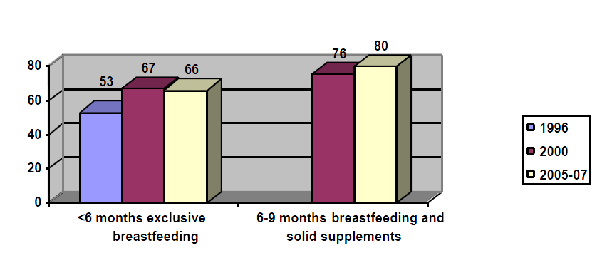
Source: ENDES continues.
Annex IV
Housing
Housing situation in Peru
Census of private and collective housing

Table 1
Census of private, collective and other types of housing
Name of Department | Private | Collective | Other type | Total
Dept. Amazonas | 112 680 | 205 | 31 | 112 916
Dept. Ancash | 314 221 | 762 | 102 | 315 085
Dept. Apurimac | 148 069 | 183 | 28 | 148 280
Dept. Arequipa | 343 631 | 948 | 228 | 344 807
Dept. Ayacucho | 222 831 | 384 | 86 | 223 301
Dept. Cajamarca | 412 375 | 685 | 55 | 413 115
Constitucional Prov. Callao | 212 608 | 236 | 12 | 212 856
Dept. Cusco | 358 498 | 968 | 126 | 359 592
Dept. Huancavelica | 156 819 | 199 | 52 | 157 070
Dept. Huanuco | 226 367 | 368 | 41 | 226 776
Dept. Ica | 197 493 | 466 | 44 | 198 003
Dept. Junin | 348 571 | 645 | 131 | 349 347
Dept. La Libertad | 416 064 | 726 | 122 | 416 912
Dept. Lambayeque | 268 235 | 407 | 74 | 268 716
Dpto. Lima | 2 123 751 | 3 625 | 234 | 2 127 610
Dept. Loreto | 183 634 | 707 | 52 | 184 393
Dept. Madre de Dios | 30 201 | 231 | 40 | 30 472
Dept. Moquegua | 57 549 | 187 | 17 | 57 753
Dept. Pasco | 77 677 | 395 | 49 | 78 121
Dept. Piura | 408 419 | 823 | 63 | 409 305
Dept. Puno | 498 658 | 632 | 118 | 499 408
Dept. San Martín | 191 032 | 397 | 56 | 191 485
Dept. Tacna | 99 665 | 296 | 20 | 99 981
Dept. Tumbes | 55 348 | 147 | 7 | 55 502
Dept. Ucayali | 101 746 | 559 | 29 | 102 334
Total | 7 566 142 | 15 181 | 1 817 | 7 583 140
Source: INEI – CPV2007.
State of occupancy of private housing
1. Depending on its status of occupation, private housing is classified as occupied or unoccupied. According to the 2007 Census, there are 7,122,197 occupied private premises, representing 94.1 per cent of the total private housing stock. Of this total, 6,400,131 are occupied with the occupants present (84.6 per cent), while 430,062 are occupied with the occupants absent (5.7 per cent), and 292,204 are occupied for occasional use (3.9 per cent).

Table 2
Status of occupation of housing
Name of department | Occupied with persons present | Occupied with persons absent | Used occasionally | Unoccupied, rented | Unoccupied, under construction or repair | Abandoned, closed | Other cause | Total
Dept. Amazonas | 89 030 | 6 363 | 9 861 | 432 | 1 402 | 5 316 | 276 | 112 680
Dept.. Ancash | 248 398 | 17 297 | 21 031 | 719 | 4 404 | 21 172 | 1 200 | 314 221
Dept.. Apurimac | 104 787 | 11 852 | 14 007 | 342 | 2 960 | 13 489 | 632 | 148 069
Dept.. Arequipa | 286 291 | 22 329 | 9 472 | 1 126 | 3 754 | 19 291 | 1 368 | 343 631
Dept.. Ayacucho | 158 261 | 23 084 | 18 329 | 438 | 3 462 | 17 653 | 1 604 | 222 831
Dpto. Cajamarca | 325 399 | 21 990 | 33 333 | 875 | 4 640 | 25 092 | 1 046 | 412 375
Constitutional Prov.  of Callao | 198 682 | 7 192 | 499 | 439 | 432 | 4 975 | 389 | 212 608
Dept.. Cusco | 293 584 | 23 523 | 18 553 | 652 | 4 275 | 17 052 | 859 | 358 498
Dept.. Huancavelica | 111 275 | 14 312 | 14 437 | 339 | 2 342 | 13 464 | 650 | 156 819
Dept.. Huanuco | 175 534 | 16 443 | 16 768 | 788 | 3 411 | 12 282 | 1 141 | 226 367
Dept.. Ica | 167 923 | 15 300 | 1 903 | 352 | 2 089 | 8 397 | 1 529 | 197 493
Dept.. Junin | 287 035 | 22 047 | 15 605 | 1 398 | 3 998 | 16 878 | 1 610 | 348 571
Dept.. La Libertad | 364 226 | 16 582 | 12 389 | 1 705 | 4 577 | 15 471 | 1 114 | 416 064
Dept.. Lambayeque | 241 271 | 8 951 | 3 246 | 1 156 | 3 544 | 9 463 | 604 | 268 235
Dept.. Lima | 1 921 949 | 97 946 | 25 925 | 8 118 | 11 446 | 50 131 | 8 236 | 2 123 751
Dept.. Loreto | 170 831 | 6 380 | 1 055 | 441 | 1 204 | 3 376 | 347 | 183 634
Dept.. Madre de Dios | 26 516 | 1 854 | 224 | 155 | 426 | 939 | 87 | 30 201
Dept.. Moquegua | 47 557 | 3 842 | 1 776 | 170 | 417 | 3 435 | 352 | 57 549
Dept.. Pasco | 64 782 | 5 507 | 2 707 | 290 | 1 437 | 2 752 | 202 | 77 677
Dept.. Piura | 372 187 | 11 402 | 5 494 | 880 | 3 358 | 14 250 | 848 | 408 419
Dept.. Puno | 353 838 | 48 873 | 57 380 | 1 020 | 4 856 | 31 274 | 1 417 | 498 658
Dept.. San Martín | 167 587 | 12 517 | 4 271 | 696 | 1 407 | 4 118 | 436 | 191 032
Dept.. Tacna | 80 251 | 8 088 | 2 973 | 337 | 1 232 | 6 442 | 342 | 99 665
Dept.. Tumbes | 48 638 | 2 181 | 547 | 298 | 906 | 2 609 | 169 | 55 348
Dept.. Ucayali | 94 299 | 4 207 | 419 | 283 | 501 | 1 899 | 138 | 101 746
Total | 6 400 131 | 430 062 | 292 204 | 23 449 | 72 480 | 321 220 | 26 596 | 7 566 142
Source: INEI – CPV2007.

Table 3
Types of private housing
Name of Department | Independent house | Flat in block | Housing on estate | Apartment building | Cottage or cabin | Improvised  housing | Not intended for housing | Other type of private housing | Total
Dept. Amazonas | 95 775 | 314 | 1 512 | 2 031 | 12 836 | 115 | 74 | 23 | 112 680
Dept. Ancash | 298 798 | 2 024 | 1 357 | 1 708 | 6 090 | 3 984 | 232 | 28 | 314 221
Dept. Apurimac | 136 210 | 607 | 310 | 3 535 | 7 150 | 148 | 82 | 27 | 148 069
Dept. Arequipa | 305 147 | 9 889 | 4 470 | 5 435 | 10 343 | 7 693 | 525 | 129 | 343 631
Dept. Ayacucho | 195 343 | 850 | 2 549 | 2 240 | 21 137 | 495 | 173 | 44 | 222 831
Dept. Cajamarca | 385 950 | 3 124 | 5 214 | 3 021 | 14 396 | 323 | 252 | 95 | 412 375
Constitutional Prov.  of Callao | 179 695 | 17 020 | 5 750 | 3 664 | 0 | 6 057 | 408 | 14 | 212 608
Dept. Cusco | 299 881 | 6 780 | 6 201 | 19 545 | 24 589 | 909 | 348 | 245 | 358 498
Dept. Huancavelica | 142 202 | 177 | 1 023 | 2 837 | 10 211 | 129 | 121 | 119 | 156 819
Dept. Huanuco | 196 711 | 2 869 | 2 541 | 2 102 | 21 584 | 354 | 155 | 51 | 226 367
Dept. Ica | 165 581 | 2 704 | 2 207 | 1 869 | 4 007 | 19 832 | 286 | 1 007 | 197 493
Dept. Junin | 292 085 | 7 261 | 8 052 | 8 842 | 30 549 | 1 008 | 489 | 285 | 348 571
Dept. La Libertad | 389 970 | 11 234 | 4 690 | 3 469 | 4 014 | 2 122 | 502 | 63 | 416 064
Dept. Lambayeque | 250 285 | 8 203 | 2 365 | 2 632 | 2 718 | 1 697 | 302 | 33 | 268 235
Dept. Lima | 1 676 030 | 289 603 | 65 802 | 29 136 | 6 734 | 45 901 | 4 698 | 5 847 | 2 123 751
Dept. Loreto | 144 980 | 646 | 4 862 | 548 | 31 248 | 1 053 | 222 | 75 | 183 634
Dept. Madre de Dios | 23 683 | 182 | 982 | 2 548 | 2 340 | 305 | 96 | 65 | 30 201
Dept. Moquegua | 49 947 | 2 261 | 120 | 263 | 1 923 | 2 947 | 61 | 27 | 57 549
Dept. Pasco | 65 302 | 1 010 | 1 804 | 1 966 | 7 241 | 185 | 114 | 55 | 77 677
Dept. Piura | 394 241 | 3 663 | 638 | 692 | 4 098 | 4 755 | 273 | 59 | 408 419
Dept. Puno | 410 762 | 2 184 | 1 356 | 10 328 | 71 808 | 1 501 | 249 | 470 | 498 658
Dept. San Martín | 161 170 | 620 | 6 182 | 1 639 | 20 042 | 1 016 | 270 | 93 | 191 032
Dept. Tacna | 81 590 | 4 593 | 464 | 728 | 4 744 | 7 350 | 163 | 33 | 99 665
Dept. Tumbes | 52 621 | 540 | 1 423 | 184 | 158 | 200 | 69 | 153 | 55 348
Dept. Ucayali | 83 442 | 568 | 3 371 | 731 | 12 328 | 1 101 | 147 | 58 | 101 746
Total | 6 477 401 | 378 926 |  | 111 693 | 332 288 | 111 180 |  | 9 098 | 7 566 142
Source: INEI – CPV2007.

Table 4
Status of occupancy
Name of department | Occupancy of the premises – The housing occupied is:
Name of department | Rented | Squatted  property | Owned with mortgage | Fully owned | Provided  by firm | Other type | Total
Dept. Amazonas | 13 399 | 831 | 1 841 | 64 620 | 6 309 | 2 030 | 89 030
Dept. Ancash | 22 524 | 17 524 | 7 814 | 173 082 | 10 673 | 16 781 | 248 398
Dept. Apurimac | 15 042 | 1 292 | 1 603 | 79 086 | 3 688 | 4 076 | 104 787
Dept. Arequipa | 42 653 | 12 014 | 25 160 | 176 679 | 13 398 | 16 387 | 286 291
Dept. Ayacucho | 20 070 | 3 722 | 4 312 | 117 778 | 4 389 | 7 990 | 158 261
Dept. Cajamarca | 41 520 | 3 943 | 4 777 | 261 661 | 5 680 | 7 818 | 325 399
Prov. Constitucional del Callao | 35 173 | 18 463 | 10 068 | 121 197 | 5 154 | 8 627 | 198 682
Dept. Cusco | 54 274 | 4 677 | 7 212 | 204 082 | 10 577 | 12 762 | 293 584
Dept. Huancavelica | 11 294 | 1 769 | 1 540 | 81 283 | 6 142 | 9 247 | 111 275
Dept. Huanuco | 23 304 | 6 811 | 4 145 | 127 619 | 7 083 | 6 572 | 175 534
Dept. Ica | 17 841 | 12 301 | 10 914 | 105 482 | 11 508 | 9 877 | 167 923
Dept. Junin | 55 931 | 5 195 | 9 546 | 181 436 | 16 438 | 18 489 | 287 035
Dept. La Libertad | 45 511 | 23 489 | 11 367 | 251 863 | 16 707 | 15 289 | 364 226
Dept. Lambayeque | 33 653 | 12 628 | 9 890 | 162 193 | 14 639 | 8 268 | 241 271
Dept. Lima | 399 251 | 107 591 | 124 436 | 1 133 639 | 58 823 | 98 209 | 1 921 949
Dept. Loreto | 11 367 | 8 980 | 6 649 | 131 981 | 4 341 | 7 513 | 170 831
Dept. Madre de Dios | 7 294 | 488 | 903 | 14 474 | 1 150 | 2 207 | 26 516
Dept. Moquegua | 5 466 | 3 428 | 5 590 | 28 766 | 1 897 | 2 410 | 47 557
Dept. Pasco | 12 331 | 1 794 | 1 362 | 38 696 | 5 201 | 5 398 | 64 782
Dept. Piura | 24 073 | 71 148 | 13 469 | 237 164 | 12 635 | 13 698 | 372 187
Dept. Puno | 38 173 | 5 419 | 6 914 | 279 300 | 10 373 | 13 659 | 353 838
Dept. San Martín | 26 304 | 5 014 | 6 794 | 123 186 | 2 910 | 3 379 | 167 587
Dept. Tacna | 8 805 | 7 373 | 8 005 | 50 084 | 2 784 | 3 200 | 80 251
Dept. Tumbes | 5 289 | 8 788 | 3 549 | 27 875 | 1 260 | 1 877 | 48 638
Dept. Ucayali | 9 115 | 4 733 | 5 191 | 67 818 | 2 885 | 4 557 | 94 299
Total | 979 657 | 349 415 | 293 051 | 4 241 044 | 236 644 | 300 320 | 6 400 131
Source: INEI – CPV2007.
Housing construction material
2. The 2007 Census contains information on the main materials used in the construction of the exterior walls and floors of the premises. This section presents the results in the form of data on private housing with its occupants present.

Table 5
Main materials used in the external walls
Name of Department | Brick or cement block | Adobe  or mud | Wood | Wattle and daub | Matting | Stone and mud | Stone or ashlar with lime or cement | Other | Total
Dept. Amazonas | 10 563 | 49 909 | 18 575 | 5 518 | 168 | 922 | 108 | 3 267 | 89 030
Dept. Ancash | 81 643 | 142 584 | 3 150 | 2 613 | 15 150 | 1 587 | 201 | 1 470 | 248 398
Dept. Apurimac | 8 636 | 91 707 | 385 | 326 | 159 | 3 085 | 59 | 430 | 104 787
Dept. Arequipa | 200 397 | 22 497 | 2 885 | 7 057 | 12 843 | 10 280 | 25 609 | 4 723 | 286 291
Dept. Ayacucho | 24 675 | 108 648 | 8 216 | 1 406 | 1 579 | 11 697 | 399 | 1 641 | 158 261
Dept. Cajamarca | 46 810 | 249 578 | 5 114 | 12 278 | 438 | 10 247 | 157 | 777 | 325 399
Prov. Constitucional del Callao | 136 430 | 6 765 | 46 640 | 3 353 | 3 383 | 96 | 254 | 1 761 | 198 682
Dept. Cusco | 38 161 | 223 575 | 14 024 | 986 | 517 | 12 818 | 1 247 | 2 256 | 293 584
Dept. Huancavelica | 5 845 | 96 258 | 346 | 311 | 208 | 7 631 | 163 | 513 | 111 275
Dept. Huanuco | 35 917 | 107 753 | 25 638 | 1 556 | 356 | 2 561 | 130 | 1 623 | 175 534
Dept. Ica | 74 409 | 50 044 | 2 157 | 4 713 | 28 439 | 210 | 79 | 7 872 | 167 923
Dept. Junin | 103 721 | 125 529 | 40 631 | 9 163 | 442 | 2 179 | 311 | 5 059 | 287 035
Dept. La Libertad | 127 913 | 224 802 | 1 439 | 1 879 | 4 452 | 2 128 | 389 | 1 224 | 364 226
Dept. Lambayeque | 108 583 | 121 605 | 852 | 6 964 | 2 141 | 236 | 159 | 731 | 241 271
Dept. Lima | 1 505 535 | 171 766 | 153 375 | 14 671 | 41 765 | 3 393 | 2 751 | 28 693 | 1 921 949
Dept. Loreto | 49 406 | 1 242 | 113 829 | 829 | 1 918 | 148 | 114 | 3 345 | 170 831
Dept. Madre de Dios | 8 541 | 155 | 16 484 | 71 | 66 | 7 | 70 | 1 122 | 26 516
Dept. Moquegua | 25 869 | 13 796 | 1 130 | 449 | 4 900 | 995 | 72 | 346 | 47 557
Dept. Pasco | 18 310 | 28 923 | 13 772 | 773 | 136 | 1 250 | 186 | 1 432 | 64 782
Dept. Piura | 152 528 | 121 128 | 17 171 | 58 632 | 12 986 | 944 | 383 | 8 415 | 372 187
Dpto. Puno | 79 390 | 229 548 | 4 076 | 343 | 549 | 32 641 | 408 | 6 883 | 353 838
Dept. San Martín | 52 193 | 27 720 | 51 440 | 30 671 | 501 | 906 | 333 | 3 823 | 167 587
Dept. Tacna | 58 905 | 8 865 | 661 | 647 | 9 869 | 527 | 107 | 670 | 80 251
Dept. Tumbes | 20 336 | 4 621 | 2 618 | 18 199 | 325 | 267 | 129 | 2 143 | 48 638
Dept. Ucayali | 16 911 | 697 | 73 134 | 454 | 1 221 | 68 | 121 | 1 693 | 94 299
Total | 2 991 627 | 2 229 715 | 617 742 | 183 862 | 144 511 | 106 823 | 33 939 | 91 912 | 6 400 131
Source: INEI – CPV2007.
Main materials used in the flooring
3. According to the 2007 Census, 43.4 per cent of the housing with occupants present has predominantly earth flooring, which means in absolute terms 2,779,676 premises; 38.7 per cent have predominantly cement, or 2,441,844 premises; in 9.3 per cent, the main material used is floor tiles, terrazzo, pottery or similar (4.5 per cent), or 579,734 premises; and, to a lesser extent, parquet or polished wood (4.5 per cent), wood (3.4 per cent), asphalt, vinyl or similar sheets (0.7 per cent) and other materials (0.5 per cent).

Table 6
Main construction material used in flooring
Name of Department | Earth | Cement | Floor tiles or terrazzo | Parquet or polished wood | Wood, planking | Asphalt sheets | Other | Total
Dept. Amazonas | 61 125 | 24 101 | 956 | 214 | 2 482 | 39 | 113 | 89 030
Dept. Ancash | 148 405 | 81 483 | 14 342 | 1 306 | 693 | 459 | 1 710 | 248 398
Dept. Apurimac | 85 784 | 15 821 | 1 071 | 500 | 1 404 | 131 | 76 | 104 787
Dept. Arequipa | 81 708 | 157 829 | 21 685 | 13 140 | 2 253 | 7 867 | 1 809 | 286 291
Dept. Ayacucho | 123 349 | 29 329 | 3 571 | 322 | 1 144 | 151 | 395 | 158 261
Dept. Cajamarca | 241 413 | 69 824 | 7 955 | 1 797 | 3 794 | 174 | 442 | 325 399
Constitutional Prov. of Callao | 32 150 | 106 768 | 37 519 | 13 603 | 2 211 | 2 478 | 3 953 | 198 682
Dept. Cusco | 195 222 | 56 964 | 9 176 | 10 419 | 20 317 | 697 | 789 | 293 584
Dept. Huancavelica | 97 388 | 9 835 | 509 | 439 | 2 649 | 357 | 98 | 111 275
Dept. Huanuco | 118 652 | 41 636 | 4 789 | 857 | 8 991 | 356 | 253 | 175 534
Dept. Ica | 68 736 | 79 145 | 15 803 | 1 749 | 487 | 745 | 1 258 | 167 923
Dept. Junin | 152 681 | 96 541 | 9 679 | 6 889 | 19 750 | 901 | 594 | 287 035
Dept. La Libertad | 182 686 | 141 011 | 26 984 | 9 625 | 1 348 | 1 010 | 1 562 | 364 226
Dept. Lambayeque | 102 864 | 103 648 | 30 175 | 2 605 | 331 | 598 | 1 050 | 241 271
Dept. Lima | 320 107 | 977 720 | 359 788 | 211 726 | 19 525 | 23 662 | 9 421 | 1 921 949
Dept. Loreto | 53 171 | 48 973 | 4 931 | 920 | 61 992 | 133 | 711 | 170 831
Dept. Madre de Dios | 6 901 | 12 722 | 784 | 242 | 5 767 | 23 | 77 | 26 516
Dept. Moquegua | 20 907 | 20 800 | 3 624 | 371 | 144 | 1 612 | 99 | 47 557
Dept. Pasco | 24 265 | 14 864 | 1 018 | 2 506 | 21 447 | 180 | 502 | 64 782
Dept. Piura | 219 783 | 124 263 | 24 275 | 614 | 1 289 | 587 | 1 376 | 372 187
Dept. Puno | 258 573 | 73 088 | 3 187 | 5 281 | 11 565 | 757 | 1 387 | 353 838
Dept. San Martín | 96 981 | 63 312 | 4 033 | 203 | 2 288 | 111 | 659 | 167 587
Dept. Tacna | 31 873 | 36 652 | 6 745 | 2 131 | 329 | 2 312 | 209 | 80 251
Dept. Tumbes | 20 702 | 24 352 | 3 013 | 158 | 160 | 53 | 200 | 48 638
Dpto. Ucayali | 34 250 | 31 203 | 2 122 | 1 086 | 25 187 | 100 | 351 | 94 299
Total | 2 779 676 | 2 441 884 | 597 734 | 288 703 | 217 547 | 45 493 | 29 094 | 6 400 131
Source: INEI – CPV2008.
Domestic services
Type of water supply
4. The 2007 Census showed that 3,504,658 individual homes with occupants present are connected directly to the public network, representing 54.8 per cent of the national total. There are also 568,800 premises connected to the public network outside the home but within the building (8.9 per cent) and 243,241 with access to drinking water through a public drinking fountain. At the other extreme, 16 per cent of households (1,024,654) use water from a river, irrigation channel or spring and 8.1 per cent (515,589) obtain it from a well.

Table 7
Domestic water supply
Name of Department | Public supply in the home  (drinking water) | Public supply outside the home | Public drinking fountain | Water  tanker | Well | River, irrigation channel | Neighbour | Other | Total
Dept. Amazonas | 26 717 | 9 573 | 1 377 | 98 | 9 248 | 37 869 | 2 134 | 2 014 | 89 030
Dept. Ancash | 151 733 | 19 345 | 6 895 | 1 236 | 15 597 | 43 138 | 8 152 | 2 302 | 248 39E
Dept. Apurimac | 33 832 | 20 473 | 2 430 | 47 | 2 896 | 37 955 | 4 495 | 2 659 | 104 787
Dept. Arequipa | 194 147 | 17 562 | 16 638 | 16 539 | 8 097 | 26 968 | 4 316 | 2 024 | 286 291
Dept. Ayacucho | 63 842 | 17 222 | 6 527 | 1 488 | 5 670 | 52 993 | 7 456 | 3 063 | 158 261
Dept. Cajamarca | 119 547 | 61 152 | 7 712 | 251 | 51 253 | 69 887 | 11 387 | 4 210 | 325 399
Constitutional Prov. of Callao | 133 785 | 11 001 | 14 544 | 32 739 | 2 573 | 118 | 2 999 | 923 | 198 682
Dept. Cusco | 120 159 | 59 738 | 9 751 | 427 | 8 962 | 84 045 | 7 318 | 3 184 | 293 584
Dept. Huancavelica | 24 167 | 8 840 | 4 533 | 89 | 6 004 | 61 993 | 3 521 | 2 128 | 111 275
Dept. Huanuco | 48 354 | 11 503 | 6 285 | 1 412 | 16 167 | 86 742 | 3 989 | 1 082 | 175 534
Dept. Ica | 107 598 | 15 210 | 6 032 | 8 998 | 12 202 | 4 415 | 10 847 | 2 621 | 167 923
Dept. Junin | 146 165 | 24 236 | 4 980 | 564 | 12 514 | 87 227 | 7 840 | 3 509 | 287 035
Dept. La Libertad | 206 433 | 22 194 | 7 044 | 7 305 | 47 317 | 55 544 | 14 541 | 3 848 | 364 226
Dept. Lambayeque | 144 225 | 11 162 | 13 083 | 4 303 | 42 533 | 12 358 | 10 876 | 2 731 | 241 271
Dept. Lima | 1 412 156 | 142 583 | 74 108 | 162 632 | 48 357 | 34 757 | 37 888 | 9 468 | 1 921 949
Dept. Loreto | 52 930 | 5 732 | 5 841 | 3 864 | 35 432 | 55 926 | 6 810 | 4 296 | 170 831
Dept. Madre de Dios | 11 104 | 5 236 | 1 156 | 196 | 3 617 | 4 413 | 406 | 388 | 26 516
Dept. Moquegua | 27 921 | 5 571 | 3 049 | 344 | 434 | 8 850 | 976 | 412 | 47 557
Dept. Pasco | 15 168 | 7 192 | 2 702 | 301 | 3 340 | 33 142 | 1 932 | 1 005 | 64 782
Dept. Piura | 199 127 | 17 622 | 18 908 | 14 934 | 21 457 | 68 500 | 23 630 | 8 009 | 372 187
Dept. Puno | 88 892 | 41 302 | 9 072 | 3 177 | 112 565 | 79 711 | 12 708 | 6 411 | 353 838
Dept. San Martín | 67 482 | 17 879 | 2 839 | 255 | 18 303 | 52 233 | 4 415 | 4 181 | 167 587
Dept. Tacna | 53 869 | 2 887 | 11 641 | 1 895 | 2 777 | 5 643 | 922 | 617 | 80 251
Dept. Tumbes | 29 218 | 4 033 | 2 402 | 2 104 | 1 023 | 2 459 | 6 296 | 1 103 | 48 638
Dept. Ucayali | 26 087 | 9 552 | 3 692 | 1 461 | 27 251 | 17 768 | 5 961 | 2 527 | 94 299
Total | 3 504 658 | 568 800 |  | 266 659 | 515 589 | 1 024 654 | 201 815 | 74 715 | 6 400 131
Source: INEI – CPV2007.
Number of days when drinking water is available
5. The drinking water supply in the country does not reach all inhabited private homes. Drinking water is available (through the public network within and outside the home and public drinking fountains) to 4,316,699 dwellings, i.e. 67.4 per cent. Within this group, drinking water is available on a daily basis in 3,878,572 homes, representing 89.9 per cent.

Table 8
Domestic water supply service – daily
Name of Department | Daily water supply | No daily water supply | Total
Dept. Amazonas | 31 633 | 6 034 | 37 667
Dept. Ancash | 161 691 | 16 282 | 177 973
Dept. Apurimac | 51 562 | 5 173 | 56 735
Dept. Arequipa | 210 896 | 17 451 | 228 347
Dept. Ayacucho | 78 694 | 8 897 | 87 591
Dept. Cajamarca | 167 181 | 21 230 | 188 411
Constitutional Prov. of Callao | 147 173 | 12 157 | 159 330
Dept. Cusco | 171 194 | 18 454 | 189 648
Dept. Huancavelica | 33 364 | 4 176 | 37 540
Dept. Huanuco | 60 337 | 5 805 | 66 142
Dept. Ica | 91 734 | 37 106 | 128 840
Dept. Junin | 156 627 | 18 754 | 175 381
Dept. La Libertad | 179 242 | 56 429 | 235 671
Dept. Lambayeque | 159 573 | 8 897 | 168 470
Dept. Lima | 1 537 116 | 91 731 | 1 628 847
Dept. Loreto | 58 186 | 6 317 | 64 503
Dept. Madre de Dios | 15 392 | 2 104 | 17 496
Dept. Moquegua | 27 164 | 9 377 | 36 541
Dept. Pasco | 16 344 | 8 718 | 25 062
Dept. Piura | 184 618 | 51 039 | 235 657
Dept. Puno | 129 973 | 9 293 | 139 266
Dept. San Martín | 78 220 | 9 980 | 88 200
Dept. Tacna | 64 991 | 3 406 | 68 397
Dept. Turnbes | 28 239 | 7 414 | 35 653
Dept. Ucayali | 37 428 | 1 903 | 39 331
Total | 3 878 572 | 438 127 | 4 316 699
Source: INEI – CPV2009.

Table 9
Name of department | Domestic water supply – some days of the week only
Name of department | 1 day | 2 days | 3 days | 4 days | 5 days | 6 days | Total
Dept. Amazonas | 708 | 571 | 2 808 | 1 548 | 291 | 108 | 6 034
Dept. Ancash | 2 052 | 2 413 | 5 797 | 3 688 | 1 588 | 744 | 16 282
Dept. Apurimac | 1 008 | 703 | 1 423 | 806 | 857 | 376 | 5 173
Dept. Arequipa | 3 164 | 2 613 | 4 547 | 1 885 | 3 054 | 2 188 | 17 451
Dept. Ayacucho | 1 714 | 1 195 | 2 879 | 1 390 | 1 127 | 592 | 8 897
Dept. Cajamarca | 3 955 | 3 291 | 6 305 | 3 667 | 2 460 | 1 552 | 21 230
Prov. Constitucional del Callao | 2 085 | 1 312 | 4 324 | 3 240 | 790 | 406 | 12 157
Dept. Cusco | 3 759 | 2 075 | 5 030 | 3 194 | 2 804 | 1 592 | 18 454
Dept. Huancavelica | 904 | 539 | 1 123 | 654 | 644 | 312 | 4 176
Dept. Huanuco | 1 100 | 1 100 | 2 053 | 991 | 544 | 239 | 5 805
Dept. Ica | 4 455 | 7 461 | 15 966 | 6 465 | 1 388 | 1 371 | 37 106
Dept. Junin | 2 807 | 2 093 | 4 820 | 3 814 | 2 868 | 2 352 | 18 754
Dept. La Libertad | 5 133 | 3 138 | 26 871 | 19 661 | 1 252 | 374 | 56 429
Dept. Lambayeque | 2 109 | 996 | 2 577 | 1 264 | 1 324 | 627 | 8 897
Dept. Lima | 25 844 | 17 100 | 25 372 | 12 585 | 6 425 | 4 405 | 91 731
Dept. Loreto | 1 943 | 804 | 1 878 | 771 | 679 | 242 | 6 317
Dept. Madre de Dios | 458 | 351 | 440 | 271 | 326 | 258 | 2 104
Dept. Moquegua | 610 | 4 823 | 3 180 | 266 | 270 | 228 | 9 377
Dept. Pasco | 1 796 | 1 955 | 3 672 | 673 | 269 | 353 | 8 718
Dept. Piura | 6 504 | 10 174 | 22 364 | 8 811 | 1 643 | 1 543 | 51 039
Dept. Puno | 1 967 | 1 584 | 2 284 | 1 382 | 1 407 | 669 | 9 293
Dept. San Martín | 1 663 | 1 135 | 3 286 | 1 804 | 1 172 | 920 | 9 980
Dept. Tacna | 817 | 263 | 353 | 389 | 582 | 1 002 | 3 406
Dept. Tumbes | 1 444 | 1 459 | 2 756 | 1 266 | 319 | 170 | 7 414
Dept. Ucayali | 692 | 266 | 421 | 265 | 150 | 109 | 1 903
Total | 78 691 | 69 192 | 152 529 | 80 750 | 34 233 | 22 732 | 438 127
Source: INEI – CPV2007.
Sanitation service
6. According to the 2007 Census, a total of 3,073,327 private homes with occupants present (48 per cent) have domestic sanitation connected to the public sewage system; 1,396,402 (21.8 per cent) have a cesspool or latrine. Homes using the rivers, irrigation channels or canals for sanitation purposes number 114,074 (1.8%), while 1,110,779 (17.4 per cent) have no such service.

Table 10
Name of Department | Domestic sanitation facilities
Name of Department | Public sanitation in the home | Public sanitation outside the home | Septic tank | Cesspool | River, irrigation | None | Total
Dept. Amazonas | 20 720 | 7 655 | 3 229 | 42 034 | 2 353 | 13 039 | 89 030
Dept. Ancash | 114 145 | 9 055 | 7 927 | 48 455 | 2 909 | 65 907 | 248 398
Dept. Apurimac | 19 417 | 8 648 | 3 600 | 41 570 | 1 204 | 30 348 | 104 787
Dept. Arequipa | 172 082 | 14 514 | 11 728 | 53 302 | 1 988 | 32 677 | 286 291
Dept. Ayacucho | 39 967 | 7 794 | 6 415 | 47 291 | 3 311 | 53 483 | 158 261
Dept. Cajamarca | 74 418 | 14 044 | 7 037 | 162 568 | 3 186 | 64 146 | 325 399
Constitutional Prov.  of Callao | 135 468 | 11 511 | 15 546 | 28 002 | 1 403 | 6 752 | 198 682
Dept. Cusco | 91 000 | 40 104 | 17 588 | 50 167 | 7 398 | 87 327 | 293 584
Dept. Huancavelica | 12 252 | 4 024 | 3 518 | 24 243 | 1 875 | 65 363 | 111 275
Dept. Huanuco | 40 610 | 8 209 | 14 275 | 62 405 | 5 626 | 44 409 | 175 534
Dept. Ica | 89 589 | 6 526 | 5 934 | 38 278 | 2 284 | 25 312 | 167 923
Dept. Junin | 107 328 | 21 645 | 23 402 | 66 216 | 6 847 | 61 597 | 287 035
Dept. La Libertad | 180 120 | 13 724 | 10 783 | 91 203 | 5 854 | 62 542 | 364 226
Dept. Lambayeque | 136 830 | 8 746 | 4 923 | 62 956 | 1 771 | 26 045 | 241 271
Dept. Lima | 1 393 858 | 142 661 | 99 908 | 169 856 | 17 996 | 97 670 | 1 921 949
Dept. Loreto | 49 446 | 7 968 | 8 953 | 52 749 | 11 976 | 39 739 | 170 831
Dept. Madre de Dios | 6 300 | 3 340 | 3 709 | 8 191 | 512 | 4 464 | 26 516
Dept. Moquegua | 26 306 | 3 271 | 1 871 | 6 997 | 325 | 8 787 | 47 557
Dept. Pasco | 13 179 | 6 276 | 2 299 | 10 328 | 7 435 | 25 265 | 64 782
Dept. Piura | 144 418 | 8 729 | 17 951 | 81 347 | 4 018 | 115 724 | 372 187
Dept. Puno | 69 869 | 26 585 | 13 392 | 103 331 | 15 596 | 125 065 | 353 838
Dept. San Martín | 41 829 | 7 330 | 10 388 | 85 960 | 2 214 | 19 866 | 167 587
Dept. Tacna | 52 372 | 2 617 | 5 108 | 9 724 | 1 098 | 9 332 | 80 251
Dept. Tumbes | 22 888 | 2 426 | 3 076 | 8 882 | 371 | 10 995 | 48 638
Dept. Ucayali | 18 916 | 6 104 | 9 483 | 40 347 | 4 524 | 14 925 | 94 299
Total | 3 073 327 | 393 506 | 312 043 | 1 396 402 | 114 074 | 1 110 779 | 6 400 131
Source: INEI – CPV2007.
Availability of electric lighting
7. According to the 2007 Census, a total of 4,741,730 homes with occupants present have electric lighting connected to the public grid, while 1,658,401 do not yet have this service. In relative terms, 74.1 per cent of homes possess this service, which is a significant increase since 1993, when the figure was 54.9 per cent. The number of homes without electric lighting has accordingly decreased from 45.1 per cent in 1993 to 25.9 per cent in 2007.

Table 11
Name of Department | Homes with electric light
Name of Department | Have | Have not | Total
Dept. Amazonas | 43 162 | 45 868 | 89 030
Dept. Ancash | 181 804 | 66 594 | 248 398
Dept. Apurimac | 59 295 | 45 492 | 104 787
Dept. Arequipa | 241 142 | 45 149 | 286 291
Dept. Ayacucho | 81 010 | 77 251 | 158 261
Dept. Cajamarca | 130 871 | 194 528 | 325 399
Constitutional Province of Callao | 185 007 | 13 675 | 198 682
Dept. Cusco | 188 985 | 104 599 | 293 584
Dept. Huancavelica | 62 142 | 49 133 | 111 275
Dept. Huanuco | 75 723 | 99 811 | 175 534
Dept. Ica | 128 004 | 39 919 | 167 923
Dept. Junin | 210 544 | 76 491 | 287 035
Dept. La Libertad | 261 911 | 102 315 | 364 226
Dept. Lambayeque | 183 557 | 57 714 | 241 271
Dept. Lima | 1 787 542 | 134 407 | 1 921 949
Dept. Loreto | 104 661 | 66 170 | 170 831
Dept. Madre de Dios | 18 102 | 8 414 | 26 516
Dept. Moquegua | 38 168 | 9 389 | 47 557
Dept. Pasco | 44 673 | 20 109 | 64 782
Dept. Piura | 247 246 | 124 941 | 372 187
Dept. Puno | 203 412 | 150 426 | 353 838
Dept. San Martín | 98 914 | 68 673 | 167 587
Dept. Tacna | 65 443 | 14 808 | 80 251
Dept. Tumbes | 39 458 | 9 180 | 48 638
Dept. Ucayali | 60 954 | 33 345 | 94 299
Total | 4 741 730 | 1 658 401 | 6 400 131
Source: INEI – CPV2007.
Number of rooms per home
8. The number of rooms in the home is very importance to its inhabitants, since it shapes the living conditions affecting their daily activities.
9. According to the 2007 Census, 68.4 per cent of private homes in Peru with occupants present (4,377,692 homes) have less than 4 rooms. Of these, 1,475,430 (23.1 per cent) consist of a single room.
10. The homes offering the best living conditions and degree of comfort, i.e. those with 6 or more rooms, constitute 9.7 per cent of the housing stock, or 622,831 homes.

Table 12
Name of Department | Number of inhabitants per home
Name of Department | 1 | 2 | 3 | 4 | 5 | 6 | 7 | 8 or more | Total
Dept. Amazonas | 31 643 | 26 501 | 13 712 | 8 383 | 3 955 | 2 260 | 1 012 | 1 564 | 89 030
Dept. Ancash | 36 241 | 68 181 | 53 093 | 43 698 | 19 832 | 12 784 | 5 366 | 9 203 | 248 398
Dept. Apurimac | 29 175 | 34 143 | 15 194 | 14 181 | 4 225 | 3 678 | 1 308 | 2 883 | 104 787
Dept. Arequipa | 72 906 | 68 755 | 51 465 | 36 895 | 21 775 | 14 093 | 8 060 | 12 342 | 286 291
Dept. Ayacucho | 48 720 | 53 983 | 23 729 | 16 634 | 5 914 | 4 157 | 1 723 | 3 401 | 158 261
Dept. Cajamarca | 122 371 | 100 207 | 40 783 | 29 734 | 11 316 | 9 304 | 3 723 | 7 961 | 325 399
Constitutional Prov.  of Callao | 32 025 | 45 312 | 46 209 | 34 894 | 17 856 | 9 866 | 5 163 | 7 357 | 198 682
Dept. Cusco | 80 975 | 77 534 | 46 117 | 39 219 | 18 654 | 12 502 | 6 218 | 12 365 | 293 584
Dept. Huancavelica | 24 215 | 38 877 | 17 715 | 18 487 | 4 434 | 4 260 | 1 105 | 2 182 | 111 275
Dept. Huánuco | 57 824 | 55 521 | 24 525 | 20 291 | 6 675 | 4 893 | 1 930 | 3 875 | 175 534
Dept. Ica | 48 317 | 38 807 | 31 517 | 23 021 | 12 496 | 6 619 | 3 025 | 4 121 | 167 923
Dept. Junín | 73 310 | 77 682 | 50 059 | 41 024 | 18 146 | 12 060 | 5 379 | 9 375 | 287 035
Dept. La Libertad | 54 505 | 81 686 | 76 553 | 68 889 | 35 495 | 21 856 | 9 713 | 15 529 | 364 226
Dept. Lambayeque | 32 826 | 57 963 | 61 060 | 42 378 | 23 332 | 11 537 | 5 282 | 6 893 | 241 271
Dept. Lima | 358 948 | 406 089 | 404 088 | 321 161 | 177 798 | 103 452 | 55 537 | 94 876 | 1 921 949
Dept. Loreto | 50 351 | 51 888 | 32 915 | 19 484 | 9 000 | 3 794 | 1 611 | 1 788 | 170 831
Dept. Madre de Dios | 11 088 | 6 741 | 3 826 | 2 396 | 1 134 | 549 | 258 | 524 | 26 516
Dept. Moquegua | 13 263 | 13 202 | 9 181 | 5 369 | 3 043 | 1 621 | 816 | 1 062 | 47557
Dept. Pasco | 23 630 | 19 827 | 8 755 | 6 242 | 2 643 | 1 659 | 735 | 1 291 | 64 782
Dept. Piura | 57 447 | 108 938 | 97 128 | 58 057 | 27 787 | 11 900 | 4 966 | 5 964 | 372 187
Dept. Puno | 98 830 | 113 281 | 65 161 | 38 020 | 16 857 | 9 336 | 4 398 | 7 955 | 353 838
Dept. San Martín | 49 458 | 49 860 | 32 087 | 18 872 | 8 498 | 4 000 | 1 957 | 2 855 | 167 587
Dept. Tacna | 22 456 | 20 472 | 15 298 | 10 375 | 5 206 | 2 773 | 1 446 | 2 225 | 80 251
Dept. Tumbes | 10 368 | 13 059 | 12 500 | 7 507 | 3 135 | 1 173 | 439 | 457 | 48 638
Dept. Ucayali | 34 538 | 23 801 | 17 282 | 10 642 | 4 549 | 1 862 | 710 | 915 | 94 299
Total | 1 475 430 | 1 652 310 | 1 249 952 | 935 853 | 463 755 | 271 988 | 131 880 | 218 963 | 6 400 131
Source: INEI – CPV2007.
Population
11. According to the results of the 11th National Population Census, the population on 21 October 2007 numbered 27,412,157. The male population totalled 13,622,640, or 49.7 per cent, and the female population 13,789,517, or 50.3 per cent.

Table 13
Name of Department | Population covered by the census, by sex
Name of Department | Men | Women | Total
Dept. Amazonas | 192 940 | 183 053 | 375 993
Dept. Ancash | 529 708 | 533 751 | 1 063 459
Dept. Apurimac | 200 766 | 203 424 | 404 190
Dept. Arequipa | 567 339 | 584 964 | 1 152 303
Dept. Ayacucho | 304 142 | 308 347 | 612 489
Dept. Cajamarca | 693 195 | 694 614 | 1 387 809
Constitutional Prov. Callao | 430 582 | 446 295 | 876 877
Dept. Cusco | 584 868 | 586 535 | 1 171 403
Dept. Huancavelica | 224 906 | 229 891 | 454 797
Dept. Huanuco | 384 424 | 377 799 | 762 223
Dept. Ica | 353 386 | 358 546 | 711 932
Dept. Junin | 610 745 | 614 729 | 1 225 474
Dept. La Libertad | 799 101 | 817 949 | 1 617 050
Dept. Lambayeque | 541 944 | 570 924 | 1 112 868
Dept. Lima | 4 139 686 | 4 305 525 | 8 445 211
Dept. Loreto | 456 962 | 434 770 | 891 732
Dept. Madre de Dios | 59 499 | 50 056 | 109 555
Dept. Moquegua | 82 887 | 78 646 | 161 533
Dept. Pasco | 144 145 | 136 304 | 280 449
Dept. Piura | 835 203 | 841 112 | 1 676 315
Dept. Puno | 633 332 | 635 109 | 1 268 441
Dept. San Martín | 382 517 | 346 291 | 728 808
Dept. Tacna | 144 528 | 144 253 | 288 781
Dept. Tumbes | 103 703 | 96 603 | 200 306
Dept. Ucayali | 222 132 | 210 027 | 432 159
Total | 13 622 640 | 13 789 517 | 27 412 157
Source: INEI – CPV2007.

Table 14
Population by main age groups
Name of Department | Population covered by the census, by main age groups
Name of Department | 0-14 | 15-64 | 65 and more | Total
Dept. Amazonas | 142 230 | 214 024 | 19 739 | 375 993
Dept. Ancash | 335 040 | 646 825 | 81 594 | 1 063 459
Dept. Apurimac | 151 684 | 222 202 | 30 304 | 404 190
Dept. Arequipa | 304 769 | 762 605 | 84 929 | 1 152 303
Dept. Ayacucho | 221 844 | 346 599 | 44 046 | 612 489
Dept. Cajamarca | 484 904 | 813 572 | 89 333 | 1 387 809
Constitucional Prov. Callao | 235 281 | 585 564 | 56 032 | 876 877
Dept. Cusco | 402 695 | 695 977 | 72 731 | 1 171 403
Dept. Huancavelica | 180 578 | 245 597 | 28 622 | 454 797
Dept. Huanuco | 285 469 | 435 817 | 40 937 | 762 223
Dept. Ica | 204 910 | 458 321 | 48 701 | 711 932
Dept. Junin | 404 363 | 746 243 | 74 868 | 1 225 474
Dept. La Libertad | 502 338 | 1 005 989 | 108 723 | 1 617 050
Dept. Lambayeque | 340 295 | 698 969 | 73 604 | 1 112 868
Dept. Lima | 2 145 822 | 5 719 577 | 579 812 | 8 445 211
Dept. Loreto | 344 347 | 513 029 | 34 356 | 891 732
Dept. Madre de Dios | 34 423 | 72 229 | 2 903 | 109 555
Dept. Moquegua | 40 897 | 109 115 | 11 521 | 161 533
Dept. Pasco | 92 596 | 174 544 | 13 309 | 280 449
Dept. Piura | 552 866 | 1 019 194 | 104 255 | 1 676 315
Dept. Puno | 404 058 | 772 304 | 92 079 | 1 268 441
Dept. San Martín | 251 881 | 444 999 | 31 928 | 728 808
Dept. Tacna | 76 881 | 197 284 | 14 616 | 288 781
Dept. Tumbes | 60 776 | 129 678 | 9 852 | 200 306
Dept. Ucayali | 156 586 | 259 680 | 15 893 | 432 159
Total | 8 357 533 | 17 289 937 | 1 764 687 | 27 412 157
Source: INEI – CPV2007.
Households
12. The 2007 Census recorded the presence of 6,771,072 households nationally.

Table 15
Name of department | Total number of households
Dept. Amazonas | 90 881
Dept. Ancash | 260 951
Dept. Apurimac | 106 656
Dept. Arequipa | 311 068
Dept. Ayacucho | 163 617
Dept. Cajamarca | 334 051
Constitutional Prov. Callao | 216 500
Dept. Cusco | 305 068
Dept. Huancavelica | 113 068
Dept. Huanuco | 181 140
Dept. Ica | 181 338
Dept. Junin | 303 994
Dept. La Libertad | 385 690
Dept. Lambayeque | 254 969
Dept. Lima | 2 078 950
Dept. Loreto | 176 805
Dept. Madre de Dios | 27 765
Dept. Moquegua | 49 303
Dept. Pasco | 67 333
Dept. Piura | 390 571
Dept. Puno | 364 182
Dept. San Martín | 174 099
Dept. Tacna | 85 135
Dept. Tumbes | 50 159
Dept. Ucayali | 97 779
Total | 6 771 072
Source: INEI – CPV2007.

Table 16
Legislative framework of COFOPRI
Regulations | Summary | Date of publication
Legislative Decree No. 803 | Act on the Promotion of Access to Formal Property | 22/03/99
Eighth Complementary Provision of Decree Law No. 25902 | Approving the Organic Law of the Ministry of Agriculture. | 29/11/92
Sixth Complementary Provision of Act No. 26366 | Declaring the Special Project for Title of Lands and Rural Real Estate – PETT – to be a Special Investment Project of the Ministry of Agriculture. | 16/10/94
Act No. 26505 | Law on private investment in the development of economic activities in the national territory and of agrarian and native communities; and regulation of the Act, approved by Supreme Decree No. 011-97-AG; and regulation of the Second Complementary Provision, approved by Supreme Decree No. 026-2003-AG. | 18/07/95
Act No. 26845 | Awarding title to the lands of the agrarian communities of the Coast. | 26/07/97
Act No. 27046 | Complementary Law on the Promotion of Access to Formal Property. | 05/01/99
General Management Decision No. 080-98-COFOPRI/GG | Approving the regulation of the Organization and Functions – ROF – of the Agency for the Formalization of Informal Property –COFOPRI.
Supreme Decree No. 013-99-MTC | Approving the regulation of the formalization of informal property under the authority of COFOPRI. | 06/05/99
Act No. 27136 | Law on access to credit for formalization of ownership | 13/06/99
Act No. 27161 | Law amending and expanding the provisions of the law on registration of rural property. | 05/08/99
Supreme Decree No. 025-99-MTC | Approves the regulation of the law on access to credit for formalization of ownership. | 10/07/99
Act No. 27304 | Law assigning State-owned land occupied by markets. | 12/07/00
Act No. 27313 | Complementary law on the formalization of ownership under State housing programmes. | 20/07/00
Supreme Decree No. 038-2000-MTC | Approving the regulation of the law on the assignment of State-owned land occupied by markets, under the authority of COFOPRI. | 04/08/00
Act No. 27628 | Law facilitating the implementation of public road works. | 09/01/02
Supreme Decree 006-2004-JUS | Approving the procedure for the legal examination and physical reorganization of the immovable property constituting the cultural heritage of the Nation under the responsibility of COFOPRI. | 25/06/04
Act No. 27887 | Law providing for the sale of lands assigned to Special Hydroenergy and Irrigation Projects funded by the Treasury and/or with international cooperation; and establishing its regulatory provisions approved by Supreme Decree No. 002-2004-VIVIENDA. | 18/12/02
Act No. 28294 | Law establishing the integrated national system of real estate information and its links with the real estate register, and its regulatory provisions, approved by Supreme Decree No. 005-2006-JUS. | 21/07/04
Act No. 28667 | Law on restitution to the State of rural properties purchased for agricultural purposes and occupied by human settlements, and its regulatory provisions, approved by Supreme Decree No. 018-2006-AG. | 12/01/06
Title I of Act No. 28687 | Law developing and supplementing provisions on the formalization of informal property, informal access to the land and the provision of basic services and other regulatory standards, and its regulation, approved by Supreme Decree No. 006-2006-VIVIENDA. | 17/03/06
Supreme Decree No. 011-2005-JUS | Specifying the aims and functions of COFOPRI. | 02/09/05
Supreme Decree No. 016-2006-VIVIENDA | Providing for the attachment of the Agency for the Formalization of Informal Property – COFOPRI. | 23/07/06
Act No. 28923 | Special temporary regime for formalizing and assigning ownership of urban real estate, and its regulation, approved by Supreme Decree No. 008-2007-VIVIENDA. | 08/12/06
Supreme Decree No. 021-2006-VIVIENDA | Modifying article 9 of the regulation of Act No. 28867 concerning the transfer, in return for compensation, of housing plots. | 20/08/06
Supreme Decree No. 018-2006-AG | Approving the regulation of Act No. 28667 on restitution to the State of rural properties purchased for agricultural purposes and occupied by human settlements. | 11/04/06
Supreme Decree No. 010-97-AG | Approving the procedures applicable to complaints concerning uncultivated land submitted prior to the adoption of Act No. 26505. | 10/06/97
Act No. 28259 | Law on restitution to the State of rural properties granted for free; and its regulation approved by Supreme Decree No. 035-2004-AG. | 26/06/04
Legislative Decree No. 667 | Law on the registration of rural property | 13/09/91
Act No. 28685 | Law regulating the declaration of legal abandonment of the lands of the agricultural communities of the Coast occupied by AAHH and other informal possessions. | 14/01/06
Decree Law No. 22175 | Law on the rural communities and agrarian development of the Jungle and Jungle Rim. | 10/05/78
Decree Law No. 25891 | Transfers the functions and activities contained in the General Law on Rural Communities and the Law on Rural Communities and Agrarian Development of the Jungle and Jungle Rim. | 09/12/92
Supreme Decree No. 005-2007-VIVIENDA | Approves the merging of the Special Project for the Granting of Title to Lands and Rural Property – PETT – with the Agency for the Formalization of Informal Property - COFOPRI. | 22/02/07
Supreme Decree No. 012-2007-VIVIENDA | Specifies the scope of the fusion by absorption stipulated in Supreme Decree No. 005-2007-VIVIENDA. | 21/04/07
Supreme Decree No. 025-2007-VIVIENDA | Approves the Regulations for the organization and functions of the Agency for the Formalization of Informal Property - COFOPRI. | 28/07/07
Regulatory provisions
13. The following provisions were formulated and approved in the period 2007-2008.

Table 17
Legislative provision | Summary | Publication | Subject
Supreme Decree No. 003-2008-VIVIENDA | Regulation of Law No. 29033, Creation of a good payer bonus | 09/02/2008 | GOOD PAYER BONUS
Supreme Decree No. 004-2008-VIVIENDA | Regulation of Act No. 29080, Creation of the Register of Estate Agents | 16/02/2008 | ESTATE AGENT
R.D. No. 006-2008-VIVIENDA-VMVU/DNV | Approves for publication the curriculum and registration forms | 16/04/2008 | ESTATE AGENT
Supreme Decree. No. 030-2007-VIVIENDA | Regulation of the Property Formalization Bonus – BFI | 06/10/2007 | PROPERTY FORMALIZATION BONUS
Ministerial Decision. No. 685-2007-VIVIENDA | Operating Regulations of the BFI | 22/12/2007 | PROPERTY FORMALIZATION BONUS
Ministerial Decision No. 453-2007-VIVIENDA | Operating Regulations of the Family Housing Bonus for Single-Rate Acquisition of New Housing | 08/09/2007 | FAMILY HOUSING BONUS
Ministerial Decision. No. 454-2007-VIVIENDA | Operating Regulations of the Family Housing Bonus concerning credit arrangements for Building on Your Own Site and Housing Improvement | 19/09/2007 | FAMILY HOUSING BONUS
Ministerial Decision No. 578-2007-VIVIENDA | Operating Regulations of the Family Housing Bonus concerning credit arrangements for building on one’s own site and home improvement | 15/09/2007 | FAMILY HOUSING BONUS
Supreme Decree No. 020-2008-VIVIENDA | Regulation of Law No. 29167 | 05/07/2008 | CONSTRUCTION LICENCES FOR HOTELS
Act No. 29090 | Law regulating urban housing and buildings | 24/09/2007 | URB.HOUSING AND BUILDINGS.
Emergency Decree No. 019-2008 | Declaring of national interest the implementation and use of the alternative heating technology “Passive system of indirect solar energy collection called Muro Trombe”. | 05/06/2008 | “FREAK FREEZE” IN THE HIGH ANDES
Concerning the earthquakes of 15 August 2007

Table 18
Legal provision | Summary | Publication | Subject
Emergency Decree (E.D.) No. 032-2007 | Authorizing VIVIENDA to provide and install temporary housing in areas where an emergency has been declared and to provide economic and social assistance to the disaster-affected families | 27/09/2007 | EARTHQUAKES
E.D. No. 006-2008 | Authorizing VIVIENDA to hire and acquire the goods and services necessary to ensure continuity in the provision and installation of temporary housing for those affected by the earthquake of 15 August 2007 | 24/01/2008 | EARTHQUAKES
E.D. No. 091-2007-PCM | Approving the regulations for the granting of economic and social assistance under article 2 (b) of I D U No. 023-2007- Grants for material losses. | 16/11/2007 | EARTHQUAKES
E.D. No. 001-2008-VIVIENDA | Approving special conditions for applying for the Family Housing Bonus in areas where a state of emergency has been declared as a result of the earthquake | 18/01/2008 | EARTHQUAKES
E.D. No. 515- 2007- VIVIENDA | Approving the regulations for granting economic and social assistance to those affected by the earthquake of 15 August 2007 | 11/10/2007 | EARTHQUAKES
E.D. No. 561-2007-VIVIENDA | Exonerating the provinces of Cañete, Chincha Pisco and Ica from the selection process for acquiring the housing units to be distributed there given the emergency situation | 06/11/2007 | EARTHQUAKES
E.D. No. 559-2007- VIVIENDA | Inviting the owners of property or its surrounds to meet the regulatory requirements for the granting of socio-economic assistance for the creation of a register of property or its surrounds suitable for letting. | 01/11/2007 | EARTHQUAKES
E.D. No. 560-2007-VIVIENDA | Modifying the regulations for the granting of socio-economic assistance approved under E.D. No. 515-2007-VIVIENDA | 01/11/2007 | EARTHQUAKES
E.D. No. 001-2008-JUS | Approving preferential registration rates for those affected by the earthquakes of 15 August 2007. | 25/01/2008 | EARTHQUAKES
E.D. N° 004-2008-JUS | Modifying E.D. No. 001-2008-JUS | 06/03/2008 | EARTHQUAKES
Law No. 29208 | Extending the territorial jurisdiction of public notaries for material and legal rehabilitation in the areas affected by the earthquakes of 15 August 2007 | 03/04/2008 | EARTHQUAKES
Supreme Decree No. 010-2008-PCM | Amendments to the regulations governing Bono 6000 compensation for material losses with the aim of streamlining the procedure for granting such compensation | 09/02/2008 | EARTHQUAKES
Supreme Decree No. 043-2008-PCM | Amendments to the regulations governing Bono 6000 compensation for material losses with the aim of streamlining the procedure for granting of such compensation | 26/06/2008 | EARTHQUAKES
Emergency Decree No. 033-2008 | Authorizing the Ministry of Housing, Construction and Rehabilitation together with public bodies and enterprises in the relevant sectors, in the context of the state of emergency declared under Supreme Decree No. 068-2007-PCM, to hire and acquire goods and services and to make financial transfers in keeping with current rules and regulations for acquiring and installing fences, earth-moving activities and clearance |  | EARTHQUAKES
Annex V
Health

Table 1
Lifetime, annual, six-month and current incidence of all kinds of psychiatric disturbance – Metropolitan Lima, Sierra and Peruvian Jungle
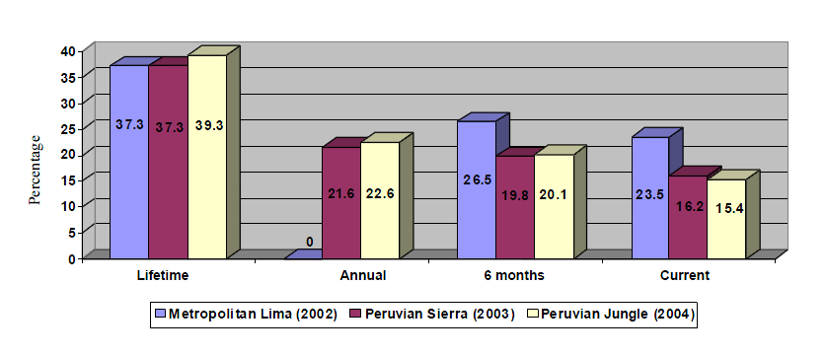
Source: Epidemiological Study of Merntal Health – Metropolitan Lima (INSM 2002); Epidemiological Study of Mental Health – Peruvian Sierra (INSM 2003); Epidemiological Study of Mental Health – Peruvian Jungle (INSM 2004).

Table 2
Lifetime incidence of depression and anxiety disturbances – epidemiological studies of mental health in Metropolitan Lima, the Sierra and the Jungle
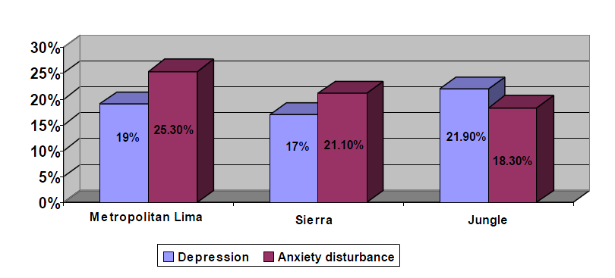
Source: Epidemiological Study of Merntal Health – Metropolitan Lima (INSM 2002); Epidemiological Study of Mental Health – Peruvian Sierra (INSM 2003); Epidemiological Study of Mental Health – Peruvian Jungle (INSM 2004).

Table 3
Incidence of some kind of psychological disturbance in Lima, the Sierra and the Jungle, by city
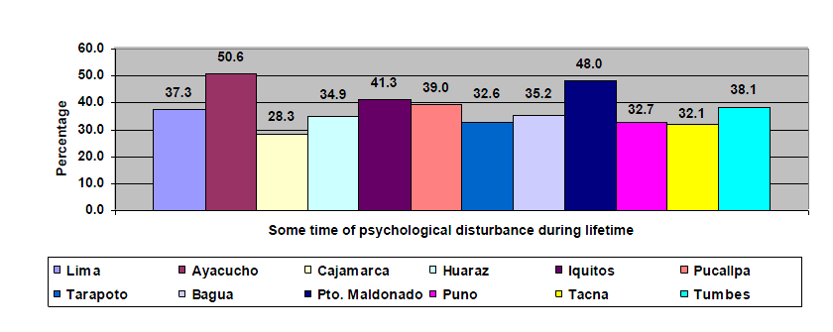
Source: Epidemiological Study of Mental Health – Metropolitan Lima (INSM 2002); Epidemiological Study of Mental Health – Peruvian Sierra (INSM 2003); Epidemiological Study of Mental Health – Peruvian Jungle (INSM 2004).

Table 4
Trends in the demand for assistance (level 1) concerning family violence, Ministry of Health – Peru 2007
Years | 1997 | 1998 | 1999 | 2000 | 2001 | 2005 | 2006 | 2007
Assistance | 4 889 | 11 710 | 30 386 | 68 381 | 77 355 | 92 340 | 114 832 | 225 319
Source: Office of Statistics and Information Technology of the Ministry of Health.

Table 5
Assistance concerning family violence, by year – 2005, 2006 and 2007
Source: Office of Statistics and Information Technology of the Ministry of Health. Victims of family violence are most often found in the 20-39 age-group, the 10-19 age-group also being frequent concerned.

Table 6
Lifetime incidence of abuse or ill-treatment involving the current partner
Lima (2002), Sierra (2003), Jungle (2004) and border areas (2005)
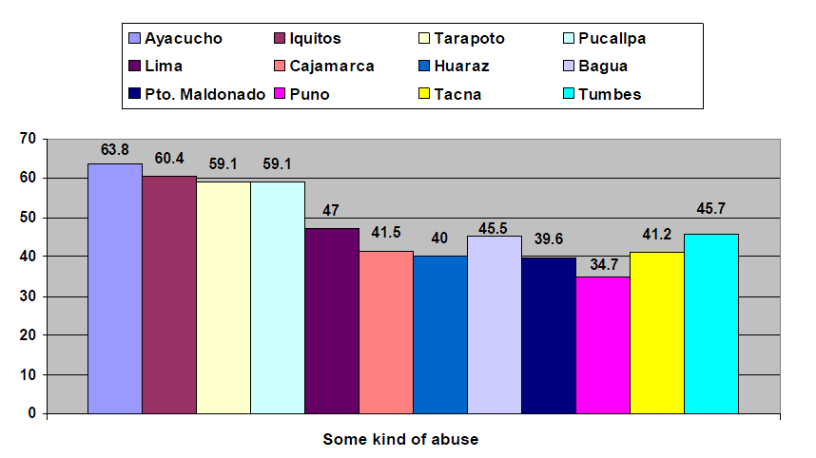
Source: Epidemiological Study of Mental Health – Metropolitan Lima (INSM 2002); Epidemiological Study of Mental Health – Peruvian Sierra (INSM 2003); Epidemiological Study of Mental Health – Peruvian Jungle (INSM 2004); Epidemiological Study of Mental Health – border areas (INSM 2005).
1. INSM epidemiological studies of mental health in recent years show that the cities with the highest incidence of all kinds of abuse involving the current partner are Ayacucho (63.8 per cent), Iquitos (60.4 per cent), Tarapoto (59.1 per cent) and Lima (47 per cent). However, in the case of systematic violence, the highest figures over the last year concerned: Lima (21.2 per cent), Puerto Maldonado (14.2 per cent), Tumbes (13.6 per cent), Ayacucho (13.6 per cent) and Iquitos (13.2 per cent). The lowest figure corresponded to the town of Huarez with 5.2 per cent.

Table 7
Peru: Coverage rate for water supply and sanitation, 2004
 | Population | Population with access to drinking water |  | Population with access to sanitation
Area | Millions | Millions | Percentage | Millions | Percentage
Urban | 19.6 | 15.9 | 81 | 13.4 | 68
SEDAPAL | 8.0 | 7.1 | 89 | 6.7 | 84
Large EPS (water companies) | 5.4 | 4.5 | 82 | 3.7 | 68
Medium EPS | 3.0 | 2.4 | 79 | 1.8 | 61
Small EPS | 0.7 | 0.4 | 71 | 0.3 | 51
Other administrations | 2.5 | 1.5 | 60 | 0.8 | 33
Rural | 7.9 | 4.9 | 62 | 2.4 | 30
Total coverage | 27.5 | 20.8 | 76 | 15.7 | 57
Source: National Plan for the Sanitation Subsector 2005-2015. National Sanitation Authority.
2. The above table shows a firm resolve to reverse a highly critical situation. In 2004, only 76 per cent of the population had access to drinking water services and barely 54 per cent to sanitation services, adding up to a sizeable gap with respect to the Millennium Development Goals. The Government recently created the Water for All Programme (PAPT) designed to help reduce by half over the next five years the number of people without access to drinking water. The investment shock in the water and sanitation sectors represents a great opportunity to attend to the backlog of social demands and help resolve the country’s health problems.

Table 8
Types of water supply in private homes by geographical area
Departments | Type of supply
Departments | Domestic public supply | Public supply outside thee home but within the building,
Amazonas | 41.9 | 7.5
Áncash | 75.6 | 2.3
Apurímac | 53.2 | 7.7
Arequipa | 72.5 | 7.1
Ayacucho | 56.5 | 5.1
Cajamarca | 49.5 | 2.8
Cusco | 49.5 | 17.7
Huancavelica | 36.4 | 5
Huánuco | 36.4 | 5.7
Ica | 79.4 | 1.5
Junín | 60.4 | 8.9
La Libertad | 69.7 | 1.9
Lambayeque | 66.2 | 2
Lima (includes metropolitan Lima) | 79.4 | 4.1
Loreto | 29.9 | 0.4
Madre de Dios | 43.1 | 16.9
Moquegua | 80.7 | 1.2
Pasco | 26.5 | 6.4
Piura | 59.2 | 0.4
Puno | 40.7 | 8.1
San Martín | 55.2 | 5.2
Tacna | 74.3 | 5.1
Tumbes | 61.2 | 1.3
Ucayali | 33.7 | 2.6
Source: INEI – Continuous National Survey – ENCO, 2006.

Table 9
Types of sewage elimination in private homes by geographical region
Departments | Forms of elimination
Departments | Cesspool or latrine | Septic tank | Public sanitation  in the home | Pubic sanitation, outside the home but in the building
Amazonas | 41.8 | 7.8 | 25.6 | 3.5
Áncash | 21.8 | 1.2 | 49.1 | 1
Apurímac | 33.3 | 7.3 | 22.3 | 4.8
Arequipa | 19.7 | 1.5 | 63 | 6.6
Ayacucho | 20.3 | 12.6 | 25.6 | 4.5
Cajamarca | 48.2 | 3 | 23.7 | 2.1
Cusco | 18.8 | 5.8 | 28.4 | 16.5
Huancavelica | 18.4 | 3.3 | 10.8 | 3.1
Huánuco | 26 | 7.2 | 24.5 | 4.2
Ica | 25.9 | 2.1 | 60.8 | 1
Junín | 22.9 | 6.8 | 39.5 | 8.2
La Libertad | 22.5 | 4.2 | 53.3 | 1.3
Lambayeque | 15.3 | 10.9 | 58.6 | 2
Lima (includes metropolitan Lima) | 8.2 | 4.8 | 77.3 | 4.4
Loreto | 27.8 | 3.9 | 29.1 | 0.4
Madre de Dios | 45.5 | 4.1 | 18.1 | 11.6
Moquegua | 15.8 | 6 | 59.7 | 0.5
Pasco | 12.9 | 3.6 | 24.9 | 6.6
Piura | 24 | 3.8 | 40.6 | 0.3
Puno | 31.4 | 0.7 | 24.6 | 7.2
San Martín | 42.4 | 13.8 | 26.4 | 3.4
Tacna | 12.1 | 1.8 | 71.6 | 5
Tumbes | 21.6 | 8 | 50.3 | 0.9
Ucayali | 53.2 | 2.6 | 23.9 | 1.5
Source: INEI – Continuous National Survey – ENCO, 2006.

Table 10
Immunization coverage in infants aged 1 or less, Peru, 1987-2002
Years | Polio | DPT | Anti-measles | BCG
1987 | 44.7 | 42.6 | 32.5 | 61.3
1988 | 60.8 | 60.9 | 52.0 | 70.0
1989 | 59.8 | 58.3 | 52.1 | 61.8
1990 | 69.0 | 67.1 | 59.8 | 78.4
1991 | 74.4 | 71.0 | 59.7 | 78.5
1992 | 84.6 | 82.9 | 83.3 | 85.2
1993 | 87.8 | 86.9 | 76.2 | 88.5
1994 | 87.4 | 87.4 | 75.1 | 92.1
1995 | 92.9 | 94.8 | 98.9 | 96.2
1996 | 100.0 | 100.0 | 86.6 | 96.9
1997 | 97.0 | 98.6 | 91.9 | 98.5
1998 | 98.6 | 99.6 | 94.4 | 96.2
1999 | 95.9 | 98.9 | 92.5 | 96.9
2000 | 93.1 | 97.7 | 97.2 | 93.2
2001 | 91.7 | 91.3 | 97.3 | 88.3
2002 | 94.5 | 94.8 | 95.2 | 92.1
Source: MINSA – Office of Statistics and Information Technology.
NB: Coverage of the anti-measles vaccine administered to under-one-year-olds corresponds to the period up to 1996 and from 1997 onwards to children aged one.

Table 11
Coverage of the main vaccines (18 to 29 months), Peru 2005-2007
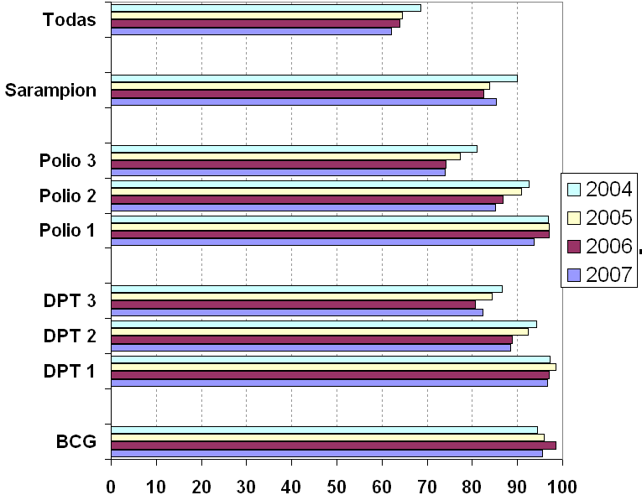
All

Measles
Source: ENDES: 2004, 2005, 2006, 2007.

Table 12
Coverage of the main vaccines (18 to 29 months), Peru 2005-2007
All

Measles
Source: ENDES: 2004, 2005, 2006, 2007.

Table 13
Trends in life expectancy and gross mortality rates in Peru
(Rate per 1000 inhabitants)
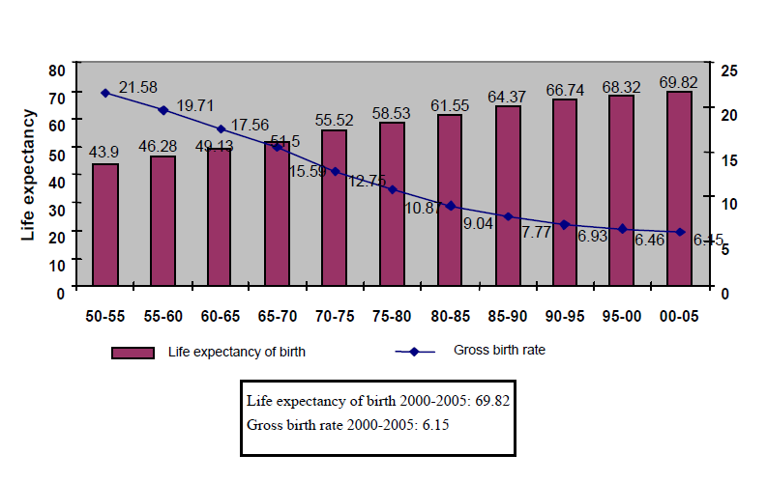
Source: INEI.

Table 14
Trends in life expectancy by gender in Peru
(EVN = life expectancy at birth)
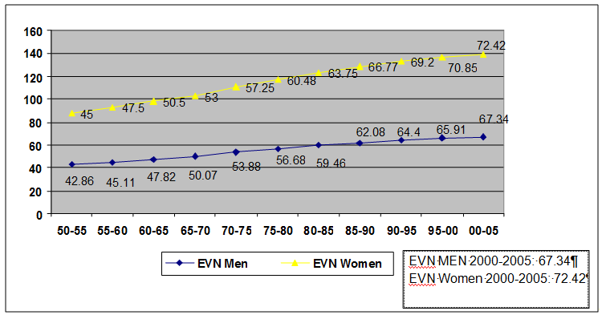
Source: INEI, Compendium 2000 and population projections.

Table 15
Essential public health functions (FESP), results of measurements 2001, 2006
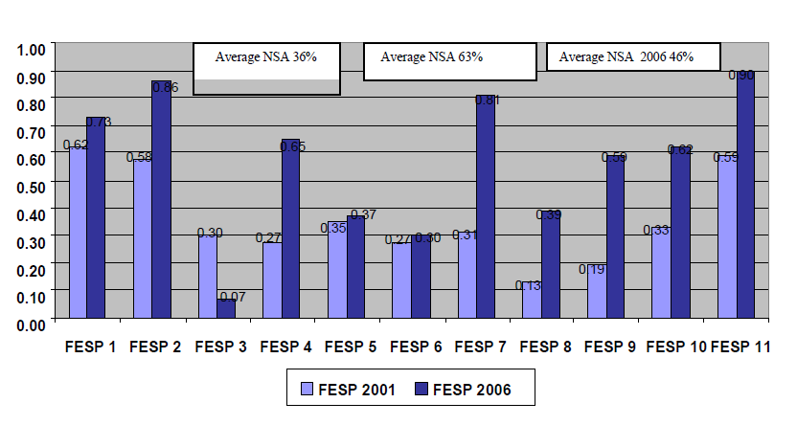
Source: INEI, Evaluation of Essential Public Health Functions (FESP), Health Authority.
3. The Peruvian Ministry of Health carried out the first Essential Functions exercise in 24 regions of Peru in 2005. It also undertook an initial measurement of FESP performance through the National Sanitary Authority in 2001 and a second one in June 2006.
4. In the evaluation of the FESP by the National Sanitary Authority (NSA), the NSA increased its performance in nine out of eleven functions (82 per cent) and in 2 its increase was minimal (18 per cent), especially in tables 16 and 17, highlighting the need to strengthen oversight of the public health function, having regard to the various sub-sectors

Table 16
Development of planning and management policies and institutional capacity in the public health sector
Indicators:
1. National and subnational definition of public health objectives
2. Development, monitoring and evaluation of public health policies.
3. Development of institutional managerial capacity in public health.
4. Management of international cooperation in public health. l
5. Asesoría y apoyo técnico a los niveles subnacionales en desarrollo de políticas, planificación y gestión de la salud pública.
0.39
0.22
0.42
0.41
0.39
0.00
0.10
0.20
0.30
0.40
0.50
0.60
0.70
0.80
0.90
1.00
Indicators
Scale
Source: FESP Evaluation of the Sanitary Authority.
5. The development of planning and management policies and institutional capacity in the public health sector achieved a performance rating of 37% (low average). All the indicators show below-standard performance (50%), indicator 5 having the lowest rating. The first four FESP indicators recorded a low-average performance, with symmetrical growth.

Table 17
Strengthening of institutional capacity for regulation and supervision in the public health sector
Indicators::
1. Periodic review, evaluation and modification of the regulatory framework.
2. Compliance with health standards.
3. Knowledge, skills and mecanisms for revising, improving and complying with the regulatory framework.
4. Advice and technical support at the subnational public health levels in the production and supervision of laws and regulations.
0.13
0.50
0.11
0.47
0
0.1
0.2
0.3
0.4
0.5
0.6
Indicators
Scale
Source: FESP Evaluation of the Sanitary Authority.
6. Strengthening of institutional capacity for regulation and supervision in the public health sector achieved a performance rating of 30% (low average). The rating for indicators 1,2 and 4 was below average (50%) while indicator 3 recorded a standard rating.
Annex VI
Economic, social and cultural-health indicators
Information on the standards of living of the population, which should cover at least five years and should be broken down by sex, age and main population groups, in particular:
- Proportion of (family) expenditure on health;
Proportion of the population whose food intake is below the minimum and children under five who are underweight

Table 1
Children under five who are small in stature
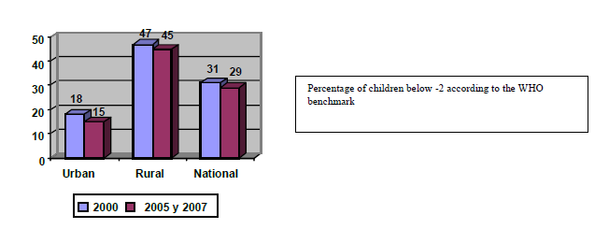

Table 2
Children under five who are small in stature 2005 and 2007, by wealth indicator (2000)
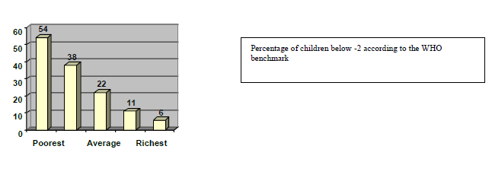
Source: Demographic and Family Health Survey.

Table 3
Children under 5 small in stature, by age, 2005 y 2007.
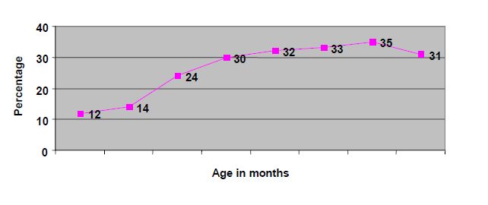
Source: Continuous ENDES.

Table 4
Incidence of chronic malnutrition in children under 5, Peru 2005, 2007
Area | Benchmark | 1992 | 1996 | 2000 | 2005 | 2007
National | NCHS | 36.5 | 25.8 | 25.4 | 23.9 | 23.5
 | WHO 2006 |  | 31.6 | 31.3 | 29.3 | 29.1
Urban | NCHS WHO | 25.9 | 16.2 | 13.4 | 10.1 | 11.5
 | 206 |  | 20.9 | 18.2 | 13.7 | 15.7
Rural | NCHS WHO | 53.4 | 40.4 | 40.2 | 39 | 36.1
 | 2006 |  | 47.8 | 47.3 | 46.3 | 43.5
Source: Continuous ENDES

Table 5
Anaemia, infants 6 to 59 months
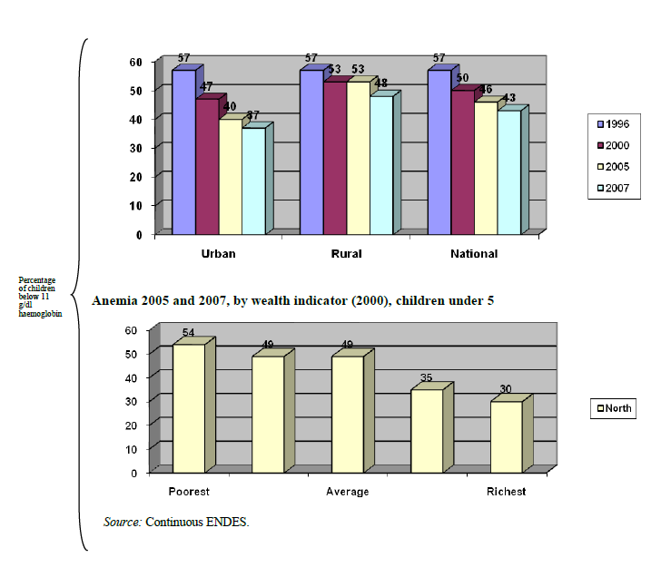

Table 6
Breastfeeding and food
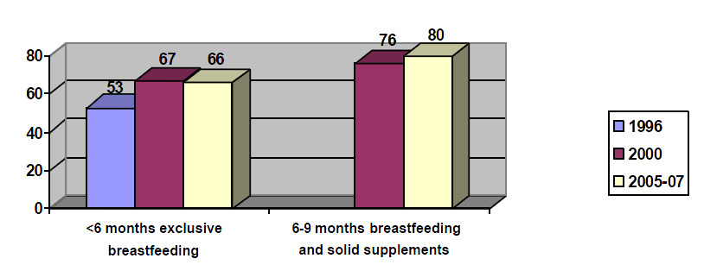
Source: Continuous ENDES.

Postnatal, infant and maternal mortality

Table 7
Most frequent causes of post-natal mortality
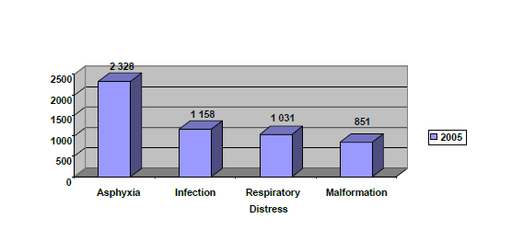
Source: OGEI 2005.
1. These problems are for the most part related to the state of the mother, including advanced age, short intervals between births, educational level, lack of care during pregnancy and inadequate care during childbirth.

Table 8
Rate of child mortality for the years 1992–2004–05
Mortality rates among children (x 1 000 children born alive)
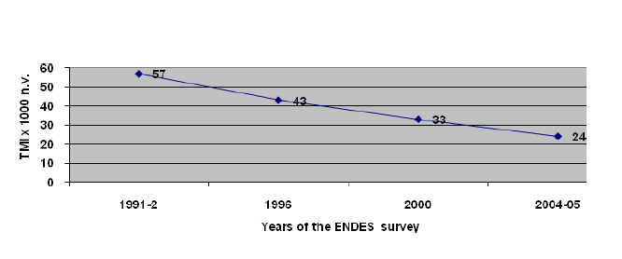
Source: ENDES 92, ENDES 96, ENDES 2000, continuous ENDES 2004-2005.
2. The trends in infant and child mortality between 1992 and 2005 have occurred despite the fact that levels of poverty and extreme poverty have not declined significantly over the same period. It may be concluded that the reduction in the mortality rate among infants and children under 5 is closely related to the development of health policies, including massive immunization campaigns, greater access to health services, extension of strategies such as oral rehydration, growth monitoring and an increase in the presence of trained personnel at childbirth.

Table 9
Child mortality among under-five-year-olds, in relation to family purchasing power Peru 1996-2000
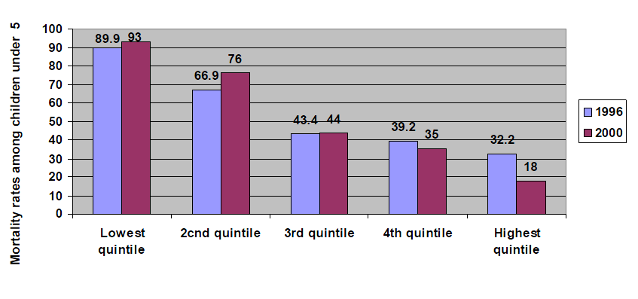
Source: ENDES.

Table 10
Distribution by cause of child mortality, Peru 2004
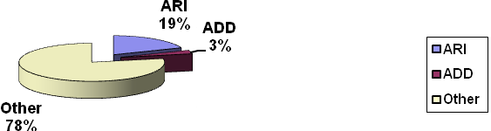
ARI – Acute respiratory infections; ADD – Acute diarrhoeal diseases
Source: OEI-MINSA 2001 Death certificate.
3. In recent years, comprehensive health insurance has helped to lower the economic barrier to access to health services by under-five-year olds, contributing to a reduction in mortality, especially through illnesses to which infants are prone such as acute respiratory infections (IRA) and acute diarrhoeal diseases. Control of these conditions has been the key factor in gains in the life expectancy of Peruvian children.
4. Thus, of all the deaths among under-five-year-olds in 2004, 18.6 per cent were due to pneumonia and 3.2 per cent to dehydration caused by diarrhoea .

Table 11
Mortality rates among infants and children under 5
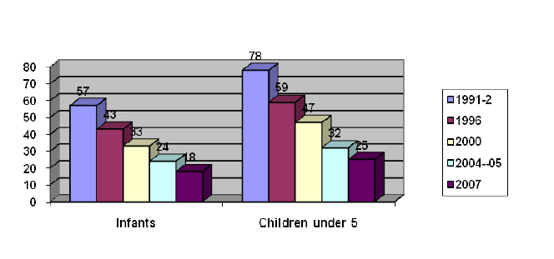
Source: continuous ENDES.
5. In 2000, thirty-three out of every 1000 children born alive in Peru died before completing their first year of life. 14 departments had higher rates than the national average, the highetst rates being found in Puno, Huancavelica, Apurímac, Cuzco, Ucayali and Ayacucho.

Table 12
Morbidity, percentage of children under 60 months with acute respiratory infection, fever or diarrhoea
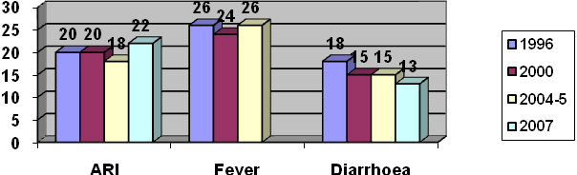
Source: Continuous ENDES.

Table 13
Morbidity, percentage of children under 60 months with acute respiratory infection, fever or diarrhoea (by poverty level)
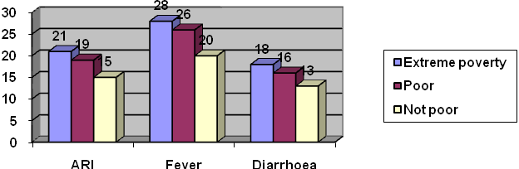
Source: Continuous ENDES, 2007.

Table 14
Treatment of ARI, percentage of children under 60 months with ARI taken to health providers
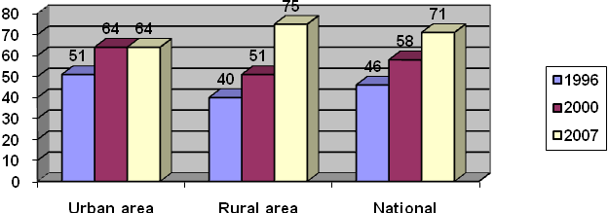
Source: Continuous ENDES.
Table 15
Treatment of diarrhoea, percentage of children under 60 months with diarrhoea taken to health providers
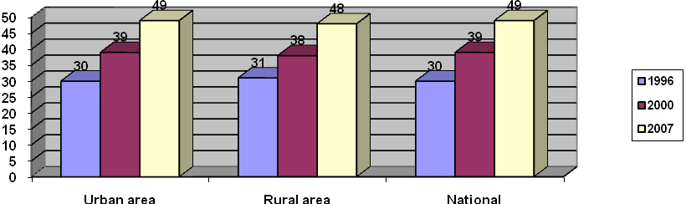
Source: Continuous ENDES.
Table 16
Use of health service for ADD and ARI. Peru 2005, 2007
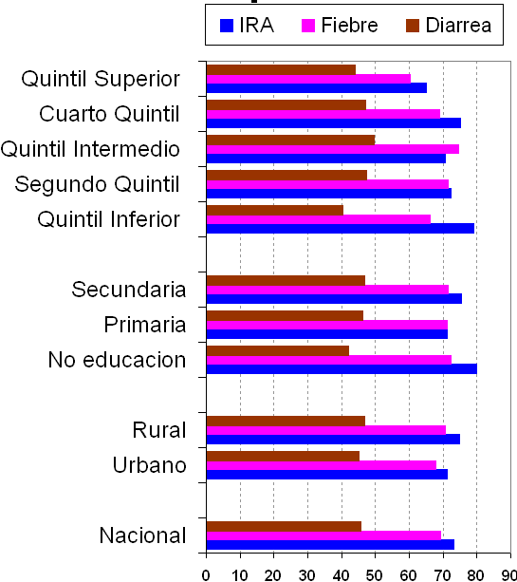
Top quintile

Fourth quintile
Intermediate quintile
Second quintile
Bottom quintile

Secondary

Primary

No education

Rural

Urban

National
ARI
Fever
Diarrhoea
Source: Continuous ENDES.

Table 17
Maternal mortality in Peru, 1955-2000

Rate per 1 000 live births
Source: MINSA and ENDES II, III, IV.

Table 18
Number of maternal deaths recorded 1997-2007
Number of maternal deaths
Source: MINSA and ENDES II, III, IV.

Table 19
Maternal deaths by cause, 1997-2006
Source: DGSP-OGE-OEli.
Percentage of women of childbearing age who use contraceptives or whose partners use contraceptives

Table 20
Use of contraceptives by married women or common-law spouses, by type of method
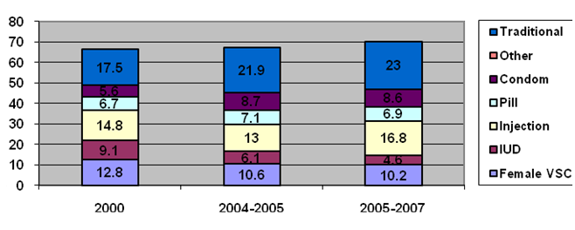
Source: ENDES 2000, 2004-2005, 2005-2007.
6. An increase was observed in the use of contraceptives by married women or common-law spouses, from 66.5 per cent in 2000 to 70.1 per cent in 2007.

Table 21
Maternal care by health professionals
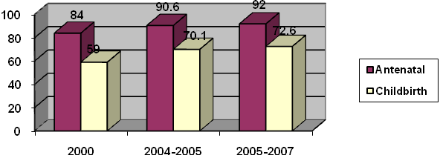
Source: ENDES (2000, 2004-2005, 2005-2007).
Table 22
Antenatal monitoring
92
97
97.3
72
81.6
85.1
72
84
90.7
92
0
10
20
30
40
50
60
70
80
90
100
Urban area
Rural area
National
1996
2000
2004-05
2005-2007
Source: ENDES (2000, 2004-2005, 2005-2007).

Table 23
Care during childbirth by health professional
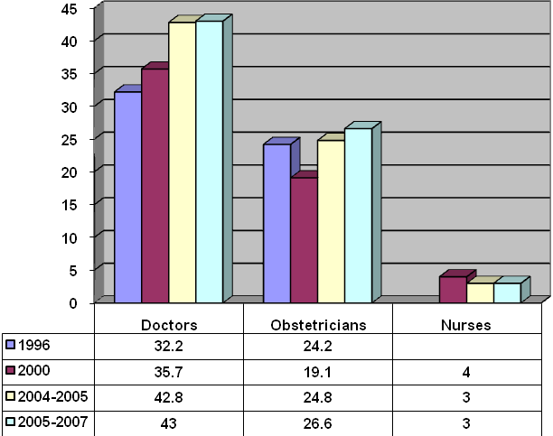
Source: ENDES (2000, 2004-2005, 2005-2007).

Table 24
Care during childbirth by health professional, by geographical region
Jungle

Sierra

Coastal Region

Metropolitan
Lima

 | Doctor |  | Obstetrician |  | Nurse

Source: ENDES (2000, 2004-2005, 2005-2007).

Table 25
Births in health facilities
Source: ENDES (2000, 2004-2005, 2005-2007).
7. A 100 per cent increase in births in hospitals and clinics was observed between 2000 and 2007.

Table 26
Homes for expectant mothers at national level

¹
Amazonas | 8
Ancash | 14
Arequipa | 8
Ayacucho | 25
Apurímac | 42
Cajamarca (Chota, Cutervo Jaén) | 13
Cuzco | 133
Huancavelica | 25
Huánuco | 56
Ica | 0
Junín | 9
Lambayeque | 1
La Libertad | 4
Lima | 3
Loreto | 2
Madre de Dios | 0
Moquegua | 6
Pasco | 8
Piura | 1
Puno | 30
San Martín | 1
Tacna | 0
Tumbes | 0
Ucayali | 1
Total | 390
Medical abortions as a percentage of live births

Table 27
Care following incomplete abortions
Year | Adolescents | Infected cases | Total
1997 | 1 904 |  | 21 232
1998 | 1 841 |  | 29 091
1999 | 2 003 |  | 28 736
2000 | 4 677 |  | 34 653
2001 | 4 765 |  | 35 000
2002 | 5 498 |  | 38 851
2003 | 4 247 |  | 41 993
2004 | 5 380 |  | 42 558
2005 | 6 309 |  | 40 912
2006 | 6 031 | 1 808 | 41 363
2007 | 7 467 | 2 239 | 44 685
Source: DIRESAS.
8. The number of cases increased from 34,653 (absolute figures) in 2000 to 44,685 in 2007.
Rates of infection by HIV/AIDS and the main transmissible diseases
9. The first case of HIV/AIDS in Peru was diagnosed in 1983. To date, according to the data of the Office of Epidemiology (as of October 2008), there are 32,932 cases of HIV and 22,549 cases of AIDS. The HIV epidemic in our country is produced in 97 per cent of cases by sexual transmission, with a greater incidence of infection among men having sex with men, followed by mother-child transmission (2 per cent) and transmission through blood (1 per cent). The man/women ratio, i.e. the number of men with HIV in relation to women with HIV, has declined from 24/1 in 1987 to 3.3/1 in 2007, reflecting the progression of the epidemic from the vulnerable population (men having sex with other men) to the population in general, resulting in an increasing incidence among the female population. It is also calculated that the average age at which people are becoming
infected is 25.
².
10. The World Bank has described the situation in Peru, with regard to HIV/AIDS, as a concentrated epidemic characterized by men having sex with men, which represent over 5 per cent of cases while the general incidence is less than 1 per cent of the population. In our country, according to data deriving from the monitoring exercise carried out by the Office of Epidemiology in 2005 and 2006, it is estimated that the incidence among men having sex with other men is 10.1 per cent, compared with 0.23 per cent among pregnant women (representing the general population).
11. Regarding the response of the Peruvian State to reduce the impact of HIV among the affected groups, there are currently 72 distribution points nationally providing high antiviral activity treatment (TARGA). As of March 2008, 13,849 persons had benefited from TARGA nationally. Of these, 71 per cent (9,810 persons) received their treatment in Ministry of Health facilities (including private institutions in Lima City that deliver antiviral medication distributed by the Peruvian State), while 3,836 persons (28 per cent) were treated by ESSALUD (public health insurance system) and 213 (1 per cent) by the Commission for the Prevention and Control of HIV/AIDS (COPRECOS) of the Armed Forces.
Ten main causes of death

Table 28
Main causes of death, 2000
Causes of death | Percentage
Acute respiratory infections | 11.6
Septicemia, except neonatal | 2.6
Tuberculosis | 2.4
HIV (AIDS) -related illness | 1.4
Infectious intestinal disease | 1.2
Neoplasias (Tumours) | 17.5
Diseases of the circulatory system | 18.2
Certain post-natal infections | 3.7
Accidents | 5.7
Accidental poisoning due to exposure to harmful substances | 0.1
Urinary system illnesses | 4.4
Nutritional deficiencies and nutritional anaemias | 2.3
Other illnesses | 28.9
Total | 100.0
Source: MINSA – Office of Statistics and Information Technology.
12. One of the limitations facing the Ministry of Health, in order to carry out a proper analysis of the health situation in terms of mortality, is directly related to the system for collecting information on vital statistics
13. The mortality rate nationally is calculated using the number of deaths registered by the Office of Statistics and Information Technology on the basis of the estimates of the National Institute of Statistics and Information Technology (INEI) for a given year.
14. Analysis of the mortality rate reveals a substantial improvement compared with rates achieved in the 1980s, reaching a peak of 59.4 per cent in 1998. In the year 2000, the rate continued to be unsatisfactory, above all for calculating the overall mortality rate and specific rates. However, the information registered is widely used for analysing the characteristic of mortality.
15. There has been a notable improvement with regard to registered deaths accompanied by a medical certificate since these increased from 79.4 per cent in 1998 to 87.7 per cent in 2000. In terms of medically certified information by geographical region, the highest percentages were those achieved by Lima, Madre de Dios, Moquegua, Tacna and Tumbes, while the lowest corresponded to the departaments of Puno, Apurímac, Pasco, Huánuco and Huancavelica, which happen to have poverty status.

Social expenditure (health) as a proportion of total public expenditure and GDP
Table 29
Social expenditure on priority programmes*
(in millions of soles)
 | 2001 | 2002 | 2003 | 2004 | 2005 | 2006
Initial education | 425 | 511 | 553 | 552 | 591 | 656
Primary education | 1 859 | 2 027 | 2 177 | 2 389 | 2 580 | 2 772
Secondary education | 1 453 | 1 657 | 1 823 | 2039 | 2 328 | 2 453
Social and community promotion and assistance | 1 207 | 1 213 | 990 | 1 609 | 1 920 | 1 925
Collective health | 554 | 588 | 290 | 285 | 313 | 377
Individual health | 1 832 | 2 058 | 2 140 | 2 458 | 2 662 | 2 913
Total | 7 330 | 8 055 | 7 972 | 9 331 | 10 394 | 11 096
Source: Ministry of the Economy and Finance.
* Includes administrative expenses.
16. According to the Ministry of the Economy and Finance, total public expenditure in combating poverty expressed as a percentage of GDP amounted to 5.4 per cent in 2003. However, this figure does not reflect the actual public expenditure on financing social programmes, since it includes transfers to local governments to cover their current expenses.
Annex VII
Education

Table 1
Literacy
 | Illiteracy rates
 | Percentage of ages  15 to 24 years |  |  | Percentage of ages  15 years and over
 | 2003 | 2006 | 2007 | 2003 | 2006 | 2007
Peru | 3.1 | 2.2 | 2.6 | 11.8 | 10.9 | 10.5
Sex
Female | 4.1 | 2.9 | 3.3 | 17.0 | 15.9 | 15.5
Male | 2.1 | 1.4 | 2.0 | 6.3 | 5.5 | 5.1
Area and sex
Urban | 1.1 | 0.8 | 1.4 | 5.5 | 5.5 | 5.1
Female | 1.2 | 0.9 | 1.4 | 8.1 | 8.2 | 7.7
Male | 1.0 | 0.7 | 1.3 | 2.8 | 2.5 | 2.3
Rural | 7.6 | 5.0 | 5.2 | 25.6 | 22.6 | 22.1
Female | 11.4 | 7.6 | 7.2 | 37.8 | 34.0 | 33.2
Male | 4.4 | 2.9 | 3.3 | 13.7 | 11.7 | 11.0
Poverty level
Not poor | 0.9 | ... | 1.2 | 6.4 | ... | 6.0
Poor | 2.5 | ... | 3.8 | 13.0 | ... | 15.3
Extremely poor | 10.5 | ... | 8.1 | 16.0 | ... | 28.2
Source: National Household Survey – INEI.
Compilation: Education Statistics Unit (UEE) – MED.

Table 2
Rate by educational level
 | Rate by educational level
 | Initial  (percentage of ages.  3 to 5 years) |  |  | Primary  (percentage of ages,  6 to 11 years) |  |  | Secondary  (percentage of ages,  12 to 16 years)
 | 2003 | 2006 | 2007 | 2003 | 2006 | 2007 | 2003 | 2006 | 2007
Peru | 53.2 | 59.5 | 64.2 | 92.5 | 93.1 | 93.7 | 69.8 | 72.6 | 74.6
Sex
Female | 53.0 | 59.4 | 63.4 | 92.1 | 92.3 | 93.6 | 68.1 | 71.9 | 74.1
Male | 53.5 | 59.6 | 65.0 | 93.0 | 93.9 | 93.7 | 71.4 | 73.3 | 75.0
Area and sex
Urban | 61.6 | 69.4 | 72.4 | 94.3 | 93.8 | 93.6 | 80.9 | 83.4 | 82.0
Female | 59.8 | 68.6 | 71.7 | 94.0 | 92.8 | 93.5 | 79.5 | 84.4 | 81.4
Male | 63.6 | 70.2 | 73.1 | 94.7 | 94.8 | 93.6 | 82.4 | 82.4 | 82.6
Rural | 42.5 | 47.0 | 52.8 | 90.2 | 92.2 | 93.7 | 52.6 | 56.4 | 63.5
Female | 43.6 | 47.6 | 52.2 | 89.7 | 91.8 | 93.7 | 49.3 | 52.8 | 63.3
Male | 41.3 | 46.5 | 53.4 | 90.7 | 92.7 | 93.7 | 55.6 | 59.9 | 63.6
Poverty level
Not poor | 66.5 | ... | 74.6 | 93.9 | ... | 94.0 | 83.4 | ... | 83.7
Poor | 54.8 | ... | 60.5 | 93.4 | ... | 93.2 | 71.3 | ... | 70.1
Extremely poor | 35.7 | ... | 47.4 | 90.0 | ... | 93.5 | 47.9 | ... | 52.9
Source: National Household Survey – INEI.
Compiled by: Education Statistics Unit (UEE) – MED.

Table 3
Adult population rate
 | Adult rate by level
 | Primary  (percentage of ages, 15 to 19 years  without complete primary) |  |  | Secondary  (percentage of ages, 20 to 24 years  without complete secondary)
 | 2003 | 2006 | 2007 | 2003 | 2006 | 2007
Peru | 14.7 | 18.6 | 13.2 | 8.9 | 7.1 | 5.5
Sex
Female | 11.7 | 14.0 | 11.8 | 7.7 | 6.9 | 5.0
Male | 18.7 | 24.6 | 15.1 | 9.9 | 7.2 | 6.0
Area
Urban | 21.7 | 25.3 | 9.0 | 11.4 | 9.2 | 6.0
Rural | 11.8 | 15.8 | 15.4 | 6.3 | 4.9 | 5.0
Poverty level
Not poor | 25.7 | ... | 8.9 | 11.2 | ... | 7.2
Poor | 13.1 | ... | 12.0 | 7.8 | ... | 4.1
Extremely poor | 11.4 | ... | 18.4 | 7.2 | ... | 4.3
Source: National Household Survey – INEI.
Compiled by: Education Statistics Unit (UEE) – MED.

Table 4
Completion of primary education
 | Completion rate for primary education
 | Percentage of ages  (12 to 14 years) |  |  | Percentage of ages  (15 to 19 years)
 | 2003 | 2006 | 2007 | 2003 | 2006 | 2007
Peru | 72.5 | 75.4 | 77.6 | 91.8 | 93.4 | 93.9
Sex
Female | 73.2 | 76.2 | 78.4 | 90.4 | 92.4 | 92.7
Male | 71.8 | 74.7 | 76.8 | 93.2 | 94.5 | 95.1
Area and sex
Urban | 82.8 | 85.7 | 86.2 | 96.3 | 96.9 | 96.7
Female | 83.0 | 86.6 | 86.8 | 96.3 | 96.8 | 96.1
Male | 82.6 | 84.8 | 85.6 | 96.3 | 97.1 | 97.4
Rural | 58.5 | 60.7 | 65.7 | 83.2 | 87.4 | 88.6
Female | 59.3 | 61.1 | 67.1 | 78.0 | 83.9 | 86.1
Male | 57.8 | 60.2 | 64.3 | 87.6 | 90.3 | 90.9
Poverty level
Not poor | 86.5 | ... | 88.0 | 96.5 | ... | 96.9
Poor | 73.1 | ... | 72.9 | 93.1 | ... | 91.9
Extremely poor | 53.7 | ... | 55.9 | 78.5 | ... | 82.9
Source: National Household Survey – INEI.
Compiled by: Education Statistics Unit (UEE) – MED

Table 5
Completion of secondary education
 | Completion rate for secondary education
 | Percentage of ages  (17 to 19 years) |  |  | Percentage of ages  (20 to 24 years)
 | 2003 | 2006 | 2007 | 2003 | 2006 | 2007
Peru | 51.3 | 56.0 | 60.3 | 65.7 | 71.2 | 71.0
Sex
Female | 52.0 | 57.3 | 61.5 | 65.0 | 69.5 | 69.8
Male | 50.6 | 54.8 | 59.0 | 66.4 | 72.7 | 72.2
Area and sex
Urban | 64.2 | 68.5 | 72.0 | 78.4 | 81.6 | 81.3
Female | 66.9 | 70.1 | 74.4 | 78.7 | 81.1 | 81.2
Male | 61.7 | 66.9 | 69.6 | 78.0 | 82.0 | 81.4
Rural | 24.3 | 32.6 | 36.0 | 34.9 | 44.2 | 45.5
Female | 19.6 | 30.0 | 33.0 | 29.5 | 37.5 | 39.0
Male | 28.4 | 34.8 | 38.8 | 40.1 | 50.1 | 51.3
Poverty level
Not poor | 68.0 | ... | 72.0 | 80.6 | ... | 82.3
Poor | 45.0 | ... | 46.2 | 55.8 | ... | 54.2
Extremely poor | 17.4 | ... | 21.7 | 26.6 | ... | 27.4
Source: National Household Survey – INEI.
Compiled by: Education Statistics Unit (UEE) – MED.

Table 6
Basic education of young people
 | Successfully completed basic education  (percentage distribution of ages, 20 to 24 years) |  |  |  |  | Successfully completed basic education  (percentage distribution of ages, 20 to 24 years) |  |  |  |  |  | Average years of basic schooling (number of years)
 | Initial or no level | Incomplete primary | Primary completed | Incomplete secondary | Secondary completed |  | Initial or no level | Incomplete primary | Primary completed | Incomplete secondary | Secondary completed
 | 2006 |  |  |  |  |  | 2007 |  |  |  |  | 2003 | 2006 | 2007
Peru | 0.9 | 6.5 | 7.5 | 14.0 | 71.2 |  | 0.9 | 6.6 | 7.5 | 14.0 | 71.0 | 9.6 | 9.8 | 9.8
Sex
Female | 1.3 | 8.5 | 8.0 | 12.7 | 69.5 |  | 1.3 | 7.8 | 7.8 | 13.3 | 69.8 | 9.4 | 9.6 | 9.7
Male | 0.4 | 4.5 | 7.0 | 15.3 | 72.7 |  | 0.6 | 5.3 | 7.3 | 14.6 | 72.2 | 9.6 | 9.9 | 9.9
Area and sex
Urban | 0.3 | 2.8 | 3.4 | 12.0 | 81.6 |  | 0.5 | 3.2 | 3.6 | 11.4 | 81.3 | 10.2 | 10.3 | 10.3
Female | 0.5 | 3.5 | 4.0 | 10.9 | 81.1 |  | 0.6 | 3.5 | 3.5 | 11.2 | 81.2 | 10.2 | 10.3 | 10.3
Male | 0.1 | 2.1 | 2.8 | 13.0 | 82.0 |  | 0.4 | 2.9 | 3.7 | 11.6 | 93.0 | 10.2 | 10.4 | 10.3
Rural | 2.3 | 16.0 | 18.2 | 19.3 | 44.2 |  | 2.0 | 14.9 | 17.2 | 20.3 | 45.5 | 7.8 | 8.3 | 8.5
Female | 3.7 | 22.3 | 19.1 | 17.4 | 37.5 |  | 3.1 | 19.6 | 19.3 | 19.0 | 39.0 | 7.3 | 7.7 | 8.0
Male | 1.0 | 10.5 | 17.3 | 21.0 | 50.1 |  | 1.0 | 10.7 | 15.4 | 21.5 | 51.3 | 8.2 | 8.8 | 8.9
Poverty level
Not poor | ... | ... | ... | ... | ... |  | 0.5 | 3.0 | 3.9 | 10.3 | 82.3 | 10.3 |  | 10.3
Poor | ... | ... | ... | ... | ... |  | 1.2 | 11.3 | 11.7 | 21.7 | 54.2 | 9.1 |  | 9.0
Extremely poor | ... | ... | ... | ... | ... |  | 3.5 | 22.0 | 24.5 | 22.6 | 27.4 | 7.3 |  | 7.4
Source: National Household Survey – INEI.
Compiled by: Education Statistics Unit (UEE) – MED

Table 7
Continued attendance annually
Percentage of withdrawals
(percentage of total enrolment at the level)
 | Initial  (3 to 5 five) |  |  | Primary |  |  | Secondary
 | 2001 | 2005 | 2006 | 2001 | 2005 | 2006 | 2001 | 2005 | 2006
Peru | 6.5 | 4.3 | 5.5 | 7.2 | 5.7 | 5.3 | 5.7 | 5.6 | 5.5
Grade
First | a | a | a | 12.8 | 10.2 | 9.8 | 6.7 | 6.3 | 6.2
Second | a | a | a | 7.0 | 5.8 | 5.4 | 5.7 | 5.6 | 5.5
Third | a | a | a | 6.3 | º5.0 | 4.8 | 5.7 | 6.0 | 5.6
Fourth | a | a | a | 5.9 | 4.5 | 4.2 | 5.2 | 5.6 | 5.5
Fifth | a | a | a | 6.0 | 4.6 | 4.2 | 4.6 | 4.3 | 4.3
Sixth | a | a | a | 4.8 | 3.8 | 3.5 | a | a | a
Sex
Female | 6.4 | 4.2 | 5.3 | 7.3 | 5.6 | 5.2 | 5.1 | 5.1 | 4.9
Male | 6.6 | 4.4 | 5.6 | 7.2 | 5.7 | 5.4 | 6.3 | 6.1 | 6.0
Area and sex
Urban | 6.0 | 4.0 | 5.5 | 4.7 | 4.0 | 4.0 | 4.6 | 4.7 | 4.7
Female | 6.0 | 3.9 | 5.4 | 4.6 | 3.8 | 3.8 | 4.1 | 4.2 | 4.2
Male | 6.1 | 4.1 | 5.7 | 4.8 | 4.1 | 4.2 | 5.1 | 5.3 | 5.2
Rural | 7.7 | 5.4 | 5.3 | 11.0 | 9.0 | 7.9 | 11.4 | 10.6 | 9.8
Female | 7.5 | 5.2 | 5.2 | 11.3 | 9.1 | 8.0 | 11.2 | 10.6 | 9.6
Male | 7.8 | 5.5 | 5.5 | 10.7 | 8.9 | 7.9 | 11.5 | 10.5 | 9.9
Poverty level
Not poor | 5.3 | 3.9 | 5.3 | 4.4 | 3.8 | 4.1 | 4.0 | 4.4 | 4.6
Poor | 7.6 | 5.4 | 5.9 | 9.0 | 7.7 | 7.5 | 7.1 | 9.3 | 8.3
Extremely poor | 8.9 | 5.0 | 5.6 | 12.5 | 10.3 | 8.8 | 11.1 | 12.7 | 11.0
Source: National Household Survey – INEI.
Compiled by: Education Statistics Unit (UEE) – MED.
a = not available.

Table 8
Continued attendance from year to year
Rate of school dropout
(Percentage of enrolments in year t that it was hoped would enrol again in t+1)
 | Primary |  |  | Secondary
 | 2002 | 2006 | 2007 | 2002 | 2006 | 2007
Peru | 3.9 | 3.8 | 2.6 | 6.8 | 7.5 | 6.1
Sex
Female | 4.1 | 3.9 | 2.7 | 6.5 | 6.7 | 5.1
Male | 3.6 | 3.7 | 2.5 | 7.1 | 8.3 | 7.1
Grade
First | 5.0 | 5.1 | 3.5 | 7.7 | 8.6 | 7.5
Second | 3.5 | 3.7 | 2.4 | 5.9 | 6.4 | 4.7
Third | 3.2 | 3.2 | 1.9 | 6.0 | 7.4 | 5.6
Fourth | 3.4 | 3.2 | 2.0 | 5.2 | 6.9 | 5.4
Fifth | 4.2 | 4.0 | 2.6 | 9.6 | 8.3 | 5.4
Sixth | 4.2 | 3.8 | 3.5 | a | a | 7.4
Source: School census of the Ministry of Education-Educational Statistics Unit.
Compiled by: Education Statistics Unit (UEE) – MED.

Table 9
Percentage of the budget devoted to education
 | 2004 | 2005 | 2006 | 2007
Education Sector/GDP | 3.81% | 3.60% | 3.28% | 3.0%
Education Sector/State budget | 20.17% | 19.18% | 19.66% | 18.6%
Source: Budget Unit – MED.
Compiled by: PLANMED.

Table 10
Dissemination activities on patents organized by the Directorate of Inventions and New Technologies, 2006-2007
Details | 2006 | 2007
Number of talks | 22 | 19
Persons trained to give talks | 600 | 1 120
Number of workshops on patent applications | 8 | 15
Persons trained in workshops on patent applications | 152 | 643
Talks and workshops in universities and institutes | 11 | 24
Talks and workshops in the provinces | 6 | 14
Provinces visited | 4 | 6

Table 11
Population aged 3 to 24, by literacy status and by to department, province, district, urban and rural area, sex and standard educational age groups
Department, province, district, urban and rural area, sex and standard study age | Total | Literacy status
 | Total | Able to read and write | Unable to read or write
Peru | 12 018 046 | 10 129 592 | 1 888 454
From 3 to 5 years | 1 646 438 | 162 894 | 1 483 544
From 6 to 11 years | 3 313 391 | 3 009 028 | 304 363
From 12 to 16 years | 2 913 715 | 2 882 527 | 31 188
From 17 to 24 years | 4 144 502 | 4 075 143 | 69 359
Men | 6 071 051 | 5 119 950 | 951 101
From 3 to 5 years | 839 082 | 82 722 | 756 360
From 6 to 11 years | 1 687 353 | 1 531 056 | 156 297
From 12 to 16 years | 1 474 393 | 1 460 215 | 14 178
From 17 to 24 years | 2 070 223 | 2 045 957 | 24 266
Women | 5 946 995 | 5 009 642 | 937 353
From 3 to 5 years | 807 356 | 80 172 | 727 184
From 6 to 11 years | 1 626 038 | 1 477 972 | 148 066
From 12 to 16 years | 1 439 322 | 1 422 312 | 17 010
From 17 to 24 years | 2 074 279 | 2 029 186 | 45 093
Urban | 8 816 751 | 7 624 632 | 1 192 119
From 3 to 5 years | 1 145 896 | 135 164 | 1 010 732
From 6 to 11 years | 2 303 616 | 2 159 694 | 143 922
From 12 to 16 years | 2 115 530 | 2 101 998 | 13 532
From 17 to 24 years | 3 251 709 | 3 227 776 | 23 933
Men | 4 419 765 | 3 811 533 | 608 232
From 3 to 5 years | 584 978 | 68 725 | 516 253
From 6 to 11 years | 1 171 796 | 1 096 723 | 75 073
From 12 to 16 years | 1 059 418 | 1 052 654 | 6 764
From 17 to 24 years | 1 603 573 | 1 593 431 | 10 142
Women | 4 396 986 | 3 813 099 | 583 887
From 3 to 5 years | 560 918 | 66 439 | 494 479
From 6 to 11 years | 1 131 820 | 1 062 971 | 68 849
From 12 to 16 years | 1 056 112 | 1 049 344 | 6 768
From 17 to 24 years | 1 648 136 | 1 634 345 | 13 791
Rural | 3 201 295 | 2 504 960 | 696 335
From 3 to 5 years | 500 542 | 27 730 | 472 812
From 6 to 11 years | 1 009 775 | 849 334 | 160 441
From 12 to 16 years | 798 185 | 780 529 | 17 656
From 17 to 24 years | 892 793 | 847 367 | 45 426
Men | 1 651 286 | 1 308 417 | 342 869
From 3 to 5 years | 254 104 | 13 997 | 240 107
From 6 to 11 years | 515 557 | 434 333 | 81 224
From 12 to 16 years | 414 975 | 407 561 | 7 414
From 17 to 24 years | 466 650 | 452 526 | 14 124
Women | 1 550 009 | 1 196 543 | 353 466
From 3 to 5 years | 246 438 | 13 733 | 232 705
From 6 to 11 years | 494 218 | 415 001 | 79 217
From 12 to 16 years | 383 210 | 372 968 | 10 242
From 17 to 24 years | 426 143 | 394 841 | 31 302
Source: INEI – National Censuses 2007: XI Population and VI Housing.
- The populations of the district of Carmen Alto, the province of Huamanga and the Department of Ayacucho were not registered.
Annex VIII
Economic, social and cultural-work indicators
Rate of unemployment
1. While there is a low rate of unemployment nationally (4.3 per cent), the rate is higher (6.4 per cent) if one focuses on urban areas, although it has been decreasing in recent years.

Table 1
Peru: Trends in unemployment rates, 2001-2006
Source: National Household Survey, INEI.
2. For example, the unemployment rate in urban Lima fell from 11 per cent to 7 per cent between 2004 and 2007. However, the level of unemployment among women continues to be above that for men and for the total.

Table 2
Metropolitan Lima: Trends in the unemployment rate
Total unemployment
(In percentages)
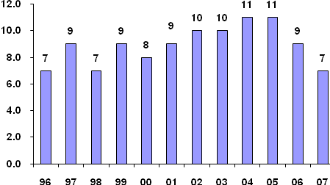
Unemployment by sex
(In percentages)
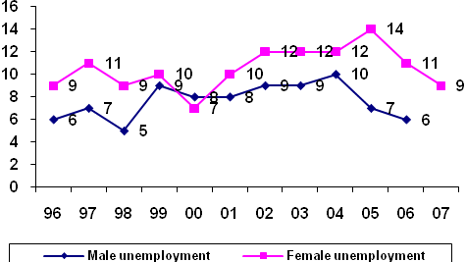
Source: Agreement MTPE – INEI. National Household Survey, 3rd quarter 1996-2001.
MTPE – DNPEFP. Specialized Household Survey of Employment Levels, October 2002, July 2003, August 2004, September 2005, September 2006 and September 2007.
Labour participation rate
3. Participation in the labour market by persons of working age has remained around 71 per cent, although with a clear gap between men and women.

Table 3
Peru: Activity and employment indicators among the working-age population
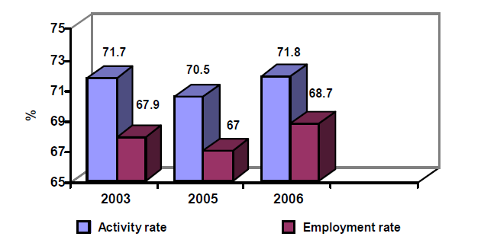

Peru: Activity and employment indicators among the working-age population
according to sex 2006
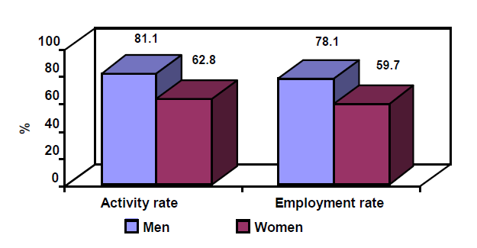
Source: National Household Survey. INEI.
* Economically active population/working-age population.
** Economically active employed population/working-age population.
Employment in the main economic activities
4. The majority of the economically active employed population in Peru is concentrated in the agricultural sector (36.7 per cent), services sector (28.7 per cent) and commercial centre (16.9 per cent), which are in turn those registering the lowest productivity levels.

Table 4
Peru: Distribution of the economically active employed population by economic activity
Source: National Household Survey, Continuous 2006, INEI.
5. Furthermore, if we classify the economically active employed population according to market structure we find that 72 per cent are made up of self-employed workers engaged in non-professional activities (33.8 per cent), micro-enterprises (19.9 per cent) and non-remunerated family workers (18.2 per cent).

Table 5
Peru: Distribution of the economically active employed population according to market structure
Source: National Household Survey, Continuous 2006. INEI.
Rate of unionization
6. From 2001, the rate of unionization showed a slight upward trend, reaching 8.6 per cent in 2005; however, this situation seems to have been reversed over the last two years.

Table 6
Peru: Trends in the proportion of unionized workers in the private formal sector, 2000–2007
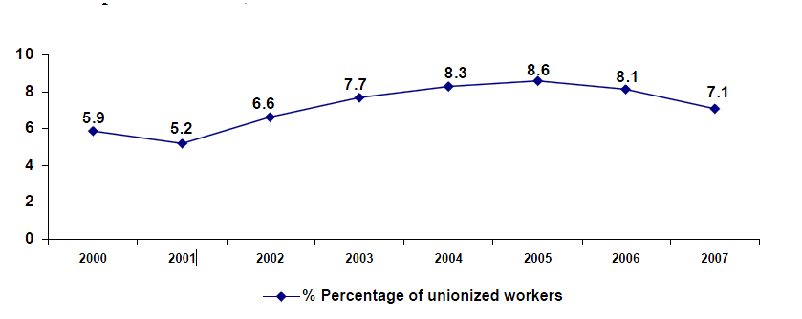
Source: Staffing-table sheet (firms of over 5 workers), Office of Statistics and Information Technology – MTPE.
Per capita gross domestic product
7. As a result of the major economic growth recorded in recent years, the real gross domestic product per capita has followed a clear upward path, increasing by 31 per cent in the period 2000-2007. However, this has not involved a significant reduction in inequality of income distribution

Table 7
Peru: Trends in real gross domestic product per capita
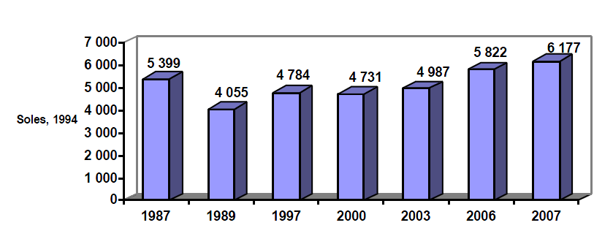
Source: INEI y BCR.
Trends in gross domestic product
8. Real gross domestic product also registered sustained growth from the beginning of the present decade as a result of the strong expansion of the mining and agricultural-export sectors initially and subsequently of the commercial, industrial and construction sectors.

Table 8
Peru: Variations in the real gross domestic product
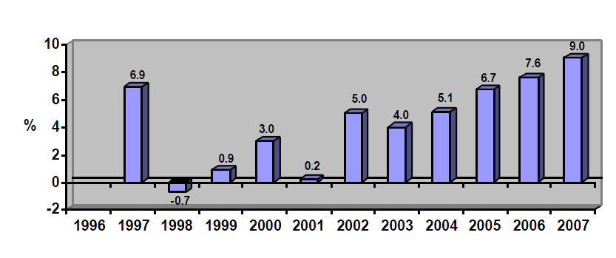
Source: INEI and Central Reserve Bank of Peru (BCR).

* * In accordance with the information transmitted to States parties regarding the processing of their reports, the present document was not formally edited before being sent to the United Nations translation services.
* ** Annexes IX and X may be consulted in the Secretariat archives.
? Article 43 of the 1993 Constitution (http://web.parliament.go.th/parcy/sapa_db/cons_doc/ constitutions/data/Peru/peru.pdf).
? Article 2, paragraph 17, of the 1993 Constitution.
? Articles 2, paragraph 2, and 103 of the 1993 Constitution.
? See Law No. 26772 prohibiting discrimination in offers of employment and access to educational training, the single consolidated text of Legislative Decree No. 728 on work productivity and competitivity, and the Regulation on Labour Inspection and Defence of the Worker. Similarly, Law No. 27270, published in the official gazette El Peruano on 29 May 2000, incorporating chapter IV in title XIV-A of the Criminal Code and characterizing discrimination as a crime under article 323.
? Act No. 28044, General Education Act, and the Children’s and Adolescents’ Code approved by Act No. 27337.
? The following rulings may be cited by way of example: 05652-2007-PA/TC, 1417-2005-AA/TC, 4232-2004-AA/TC. The rulings of the Constitutional Court (TC) may be found at: www.tc.gob.pe.
? The DPE’s draft national employment policies draw on the ILO’s Hemispheric Agenda in recognizing the need to establish stable public policies that guide decisions in the short, medium and long term and promote decent and productive work.
? These national policies received new inputs in the first half of 2008 from areas under the National Directorate, consultants, employment experts, regional directors of labour and employment promotion, and those responsible for employment promotion, vocational training and micro and small enterprises (MYPE) in the country’s 25 regions. A validation process is currently in progress with a view to arriving at an agreed draft at national level.
? Approved on 28 July 2006 in Supreme Decree No. 021-2006-ED, they are the result of a joint effort to arrive at agreed solutions through national consultative mechanisms (2004) involving relevant government departments and civil society stakeholders.
? The four main policy lines are: 1) promoting, institutionalizing and strengthening forums for social dialogue, coordination and negotiation among the main stakeholders and other agents concerned with vocational training; 2) encouraging quality vocational training with an emphasis on values, on a competitive and participative approach and on systemic equity in keeping with local and regional characteristics and demand in the framework of decentralization and improvement of the quality of life of the population; 3) ensuring the production and provision of relevant, timely and quality data, implementing the system of labour market and training information and facilitating decision-making by social stakeholders and other agents concerned with vocational training at the national, regional and local nevels; 4) guaranteeing policy stability in the legislative, administrative, economic, social and institutional spheres and environmental sustainability of the efforts in the field of vocational training and employment promotion.
? In 2007 and July 2008, twenty-four regions were visited and informed about the implementation process; 23 regions received transfer of the methodological data for framing regional policies and developing a regional vocational training plan. In the current financial year, technical assistance and training visits have taken place in the regions of Lambayeque, La Libertad, Puno, Cajamarca, Pasco, Tumbes, Piura, Ucayali and Arequipa.
? Act No. 28518.
? Supreme Decree No. 007-2005-TR of 19 September 2005.
? It is currently compulsory for the firm to provide employees with health insurance. Leave is also granted if the training period lasts for more than a year, with an extra proportional leave allowance every six months.
? The computer software used is SILNET and the website located at www.empleosperu.gob.pe.
? It is one of the specific tasks of the National Directorate of Employment Promotion and Vocational Training to investigate and evaluate the employment dynamics of Peru and to coordinate rules and regulations concerning labour standardization and certification.
? These centres provide training based on a curriculum developed by each Regional Directorate of Labour and Employment Promotion (DRTPE) to meet the training needs of the region. They also provide short-term training courses in technical specialities, preference being given to young people from poor backgrounds who are helped in obtaining food and lodging (CENFORP Huaraz and Taraco-Puno).
? Preliminary data.
? The achievements of APROLAB include: organization of the national training workshop for transfering sectoral skills to regional governments, with the participation of 103 technical and operational officials; provision of training in enterprise management and other specific areas for 160 micro-enterprises in the regions of Cajamarca and Ayacucho; development of a draft plan for continuing education and assessment of educational workers; analysis of the regional labour market and rural training for the regions of Ayacucho and Cajamarca; a draft plan for teacher training and management for the four regions; support for the labour sector in implementing socio-economic labour observatories in Ayacucho, Cajamarca, Ica and La Libertad; implementation of 17 projects for modifying the vocational training curriculum of teacher training colleges and technical education centres located in Ayacucho 04, Cajamarca 04, Ica 04 and la Libertad 05; preparation of various studies and analyses.
? Training has mainly been in the form of specific courses on work activities (84 per cent), followed by updating courses (44 per cent) and new management techniques (36 per cent). Seventy-five per cent of firms reported that the training had been mainly directed towards administrative staff and to a lesser extent top management and clerical staff. Most firms focus their training on company services (17.8 per cent), wholesale trading (15.2 per cent) and the consumer goods industry (14.1 per cent.
? The enquiry has served to show how far the education received is adapted to the work carried out by the employed workers and to provide information on the present and future demand for qualified personnel. The aims of the enquiry are: (i) to provide information to vocational training personnel on company requirements with regard to worker qualifications and skills; characterize the qualifications of the workers by economic sector and size of the firms concerned; raise awareness among vocational training providers of the importance and necessity of using information on supply and demand.
? The sectors analyzed to date are: 2005 – textile, plastics and pharmaceutical sectors; 2006 – agriculture and tourism sectors; 2007 – fisheries sector; 2008 – manufacturing sector, food and drinks production subsector, cocoa, coffee, chocolates and confectionary production subsectors, construction inputs subsector, furniture manufacture subsector and jewelry and related manufactures subsector.
? The Vocational Guidance and Employment Information Service (SOVIO) operates through the Regional Directorates of Labour and Employment Promotion and nationally through the Directorates of Employment Promotion and Vocational Training, Micro- and Small Enterprises and Labour and Employment Promotion Areas.
? The Private Pension System was established in 1992 and has a membership of over 4 million workers, including more than 72,000 persons drawing (retirement) benefits. It is a volontary system in which the member contributes a fixed amount to a personal account administered by the Pension Fund Administrators (AFPs) with the aim of accumulating a personal pension fund and benefiting from it when he or she retires. The National Pension System, regulated by Decree Law No. 19990 and coming under the authority of the State, has over 1,559,227 members (compulsory and volontary) coming from both the private and public sectors. Four hundred and forty-two thousand persons are currently drawing retirement benefits under this system. Members do not contribute to a personal account but to a joint fund (mutual benefit system). The State sets upper and lower pension limits and a fixed contribution (minimum amount).The Decree Law No. 20530 Scheme is closed to new participants. Its main feature is that pensions are calculated in such a way as to enable them to be adjusted to the salaries of active members. Responsibility for assessment, recognition and payment of the pension under this system rests with the entities from which the worker originates.
? Established by Act No. 26790, this scheme is governed by the technical standards of Supreme Decree No. 003-98-SA, applicable from 16 May 1998. It provides work accident and occupational illness cover for workers, employees and labourers in high-risk employment, i.e. those engaged in one of the activities listed in Supreme Decree No.009-97-SA. It is compulsory and is chargeable to the employer.
? This is reserved for workers who are compulsory contributors to the National Pensions System and guarantees continuity of payment of the contributions necessary for paid retirement in the event of loss of employment on grounds not attributable to the worker’s conduct (DS No. 003- 97-TR). Membership is open to all workers who have previously made compulsory contributions to the National Pension System for a minimum of 18 calendar months.
? Article 43 of the Decree states in this regard:"The remuneration of public officials and public servants consists of basic salary, allowances and benefits. In the case of public officials, basic salary is fixed according to each post and, in the case of public servants, according to career level. In both cases, basic salary is the same for each post and each level. Allowances are: personal, corresponding to seniority in the service, calculated by five-year periods; family, corresponding to family responsibilities; and differential, which cannot be greater than the percentage paid annually to the public sector as a whole on a single and uniform basis. The benefits are those established by the relevant laws and regulations, and are uniform throughout the civil service”. The basic salary of public servants is also regulated annually in proportion to and as a percentage of the Public Sector Remunerative Unit (URSP). The amount of the URSP is fixed by Supreme Decree, with the approval of the Council of Ministers, and is updated periodically in accordance with government policy and the availability of funds.There are fourteen career levels in the civil service. The lowest level corresponds to a basic salary equivalent to one (1) URSP. The proportion corresponding to the highest level, calculated on the basis of a whole number of remunerative units, is fixed annually. The intermediate levels are distributed proportionately between the two extremes. The remuneration of public officials is fixed according to specific posts, within an eight-grade structure. The highest level corresponds to the President of the Republic.
? “Article 24. The worker has a right to fair and adequate pay that will provide material and spiritual well-being for him and his family. Payment of the worker’s wages and social benefits has priority over any other obligation of the employer. Minimum wages are regulated by the government with the participation of organizations representing workers and employers”.
? Headed by the Minister of Labour and Employment Promotion, the Council is composed of representatives of workers and employers (including representatives of small and micro- enterprises) as well as representative of social organizations linked to ministerial sectors.
? The National Inspectorate, under its ex officio powers to verify compliance with social and labour regulations (article 8.b of the regulations of Act No. 28806, approved by Supreme Decree No. 019-2006-TR), undertook in the course of 2007 operations in various socio-economic sectors where it was reported that workers’ rights were being widely violated. These operations were carried out nationally in the jurisdictions of the Regional Directorates of Labour and Employment Promotion as well as in metropolitan Lima and Callao and included supervision of the application of the minimum living wage. More details are to be found in the Inspectorate’s Annual Report for 2007, prepared by the Ministry of Labour and Employment Promotion and available at the following Internet website: http://www.mintra.gob.pe/contenidos/archivos/inspecciones/ informe_anual_inspecciones-2007.pdf. The number of infringements by category at the national level totalled 13,000, bearing in mind that an infringement may entail more than one fine because of the different breaches of labour regulations that may have been committed. The categories involving the greatest number of fines were: compensation for periods of service (2,734 infringements); staffing tables and pay slips (2,633 infringements); obstruction of the labour inspection (2,419 infringements); wage payments (2,218 infringements); and work days, rest periods and working hours (2,174 infringements). For further details, see tables 23 to 27 of annex II.
? Articles 18 and 19 of the regulations in question provide that firms with 25 or more workers must form a health and safety at work committee, while firms with less than 25 workers must train and appoint, from among their production workers, at least one health and safety at work supervisor. Articles 24 and 25 stipulate that firms with 25 or more workers must establish internal health and safety at work regulations and that the employer must provide a copy of those regulations to every worker.
? In accordance with the Ninth Complementary and Transitory Provisions of Supreme Decree No. 009-2005-TR, the following instruments were approved as annexes to this Decision at its time of issue: Regulations on the Setting-up and Operation of the Committee and the Appointment and Functions of the Supervisor of Health and Safety at Work; Model Internal Rules on Health and Safety at Work; Basic Guide to Management of the System of Health and Safety at Work; and Technical Guide to Registers.
? Inspectors currently have a new health and safety at work inspection form under the Plan RETO (compulsory worker registration), which will help improve their operations in this regard. The form may be consulted at the following website: http://www.mintra.gob.pe/documentos/ FORMATO_01_FISCALIZACION_ACT_ECONOMICAS.xls.
? ESSALUD. Accident rate among insurance holders. Statistics of the Central Insurance Management, 2000-2004.
? The Occupational Health Monitoring System (SIVISO) of the Department of Environmental Health (DIGESA) of the Ministry of Health reported 80 work accidents in 2004, 1,350 in 2005 and 2,156 in 2006. The main causes were work tools (26 per cent), machines (12 per cent) and transport vehicles (8 per cent).
? The replies to these questions have been illustrated with reference to the report: "Results of the specialized household survey on employment levels in the districts of Independencia, Los Olivos and San Martín de Porres districts". This report, published in July 2008, has been taken as a sample of the situation in Peru, together with the report on Employment in Metropolitan Lima - 2007 and the Updated Statistics on Micro- and Small Enterprises - 2007, compiled by the Department of Micro- and Small Enterprises of the Ministry of Labour and Employment Promotion.
? For more details concerning HIV-AIDS, see annex VI, page 13.
? Strategic Objective 4.1 "Women and men shall have access to, remain in and progress within the labour market on the basis of gender equality, that is to say, equality of opportunity” and 4.2 "Guarantee equality of economic opportunity for income generation and improvement by women and men in urban and rural areas”.
? The National Plan for Equality of Opportunity for Women and Men 2006-2010 includes the CIL – PROEMPLEO Network programmes and the Youth Work Training Programme - PROJOVEN. The National Plan for Equality of Opportunity for the Handicapped adds the programmes Constructing Peru and My Enterprise.
? Article 25 of the Constitution states that: “The regular work schedule is eight hours a day or 48 hours a week maximum. In the case of cumulative or atypical schedules, the average number of hours worked during an equivalent period may not exceed that maximum. Workers have the right to weekly and annual paid vacations. This benefit and compensation for it are regulated by law or agreements”.
? Article 28 of the Constitution states that: “The government recognizes the right to form unions, to engage in collective bargaining, and to strike. It ensures their democratic exercise: 1. It guarantees trade union freedom. 2. It fosters collective bargaining and promotes the peaceful solution of labour disputes. Collective agreements are binding in the area for which they are made. 3. It regulates the right to strike so that it will be exercised in keeping with the social interest”.
? This regulation is contained in articles 2 and 3 of the single consolidated text (TUO) of the Collective Labour Relations Act, approved by Supreme Decree No. 010-2003-TR. Article 4 establishes that the State, employers and the representatives of either must abstain from any action tending to coerce, restrict or diminish in whatever form the right of workers to form unions and from intervening in any way in the creation, administration or maintenance of the trade unions they constitute.
? Article 14 and 15 of the TUO.
? Articles 16 and 17 of the TUO.
? According to article 42, “The right of public servants to form unions and strike is recognized. This right does not extend to government officials with decision-making powers, those who hold posts of trust or management, or members of the Armed Forces and the National Police”. Article 153 states that “Judges and prosecutors may not engage in politics, join unions, or strike”.
? Articles 22 (d), 36 and 38 of the TUO.
? The result of a fixed leadership, politicization of violent political marches, little capacity for dialogue and extreme paralysis is the loss of union power.
? See the document Socio-Labour Policy Guidelines 2008-2011 at the following website: http://www.mintra.gob.pe/contenidos/portal_de_transparencia/transparencia_2008/lineamientos_ politico_sociolaboral_2008_2001.pdf.
? For more information, see the following link: http://www.mintra.gob.pe/contenidos/estadisticas/ sindicatos/sindicatos_2004.pdf.
? Also Legislative Decree No. 346, on the national population policy (article V (2) and article 2).
? State Policy No. 16 under the National Agreement.
? Approved by Supreme Decree No. 005-2004-MIMDES, which through its 12 policy guidelines seeks to strengthen families so that they can play their proper role and are regarded as the key to implementing policies for overcoming poverty and exclusion through promotion, protection and assistance measures. Guideline 8 provides for the promotion of marriage and stable families, through marriage preparation courses, advisory services, reducion of the cost of civil marriage and strengthening the machinery for monitoring the requirements for getting married.
? Report No. 01-2008-MIMDES-DGFC-DAFF-IVVC.
? These centres provide the following: day care, adolescent promotion service, seniors club, occupational workshops and services related to the judiciary, police and local government. There are also comprehensive family development centres: Family Recreation Centres, located in INABIF premises and offering sports, recreational and cultural activities aimed at children, adolescents, young people, adults and older people in the community; and Community Care Centres providing an extension service in very poor areas removed from the Comprehensive Family Development Centres. The latter are premises belonging to the community, situated in areas of poverty and extreme poverty in both Lima and the provinces, which provide food and socio-educational activities for children and adolescents aged from 2 to 14, and which may be extended where necessary to old people.
? The breastfeeding facility is an area specially equipped to provide working mothers with a hygienic, private and dignified environment where they can sit to breastfeed their babies.
? The National Family Support Plan 2004-2011, approved by Supreme Decree No. 005-2004-MIMDES, seeks to strengthen families so that they can play their proper role and are regarded as key to the implementation of policies to overcome poverty and exclusion through promotion, protection and assistance measures.
? The introduction of these breastfeeding facilities has its legal basis in various standards and international commitments, including the Peruvian Constitution, the National Action Plan for Children and Adolescents 2002-2010, the National Family Support Plan 2004-2011, the Regulations on Child Nutrition, the Children’s and Adolescents’ Code and the Ministry of Health’s Sectoral Policy Guidelines 2002-2010.
? Article 3 of the Peruvian Constitution.
? Cf. Article 5 of the Peruvian Constitution.
? Wawa wasi: a Quechua term meaning children’s home.
? The wawa wasi serve to: a) promote a permanent dialogue with families through advisory activities and participatory meetings to reflect with parents on their role, child-rearing practices and their attitudes to the all-round development of their children, having due regard for cultural diversity; b) help prevent child malnutrition and growth deficits by providing children with adequate nutrition and promoting healthy practices, open spaces and the necessary stimulus to enable them to develop their potential to the full. Parents are informed about the growth and development of their children and are given practical information on how best to respond where there is a risk of malnutrition; c) furnish opportunities for strengthening the affective links between members of the household through experience-sharing workshops that foster communication between parents and children, maternal breastfeeding and play activities; d) promote the development of family support networks within the community.
? Q'atari Wawa has been adopted by the National Wawa Wasi Programme (PNWW) as a strategy for promoting comprehensive care for children from gestation to the age of 47 months so that they enjoy a favourable environment for their optimum growth and development. Q'atari Wawa is based on the strengthening of family capacities (fathers, mothers, elder brothers and sisters and other family members) to assume responsibility for the care of the child and/or infant in the home, adopting an intercultural, rights-based and gender equity approach. Age-old Andean practices of healthy child-rearing are thus recognized and promoted and new practices are incorporated in a consensual, participative and progressive manner to serve the children’s development.
? It is important to highlight these elements as integral to the PNWW’s approach, which is based on recognition of our country’s ethnic cultural diversity and reflected in a responsiveness to demand, including the provision of appropriate toys, use of materials adapted to place and recipe books featuring local ingredients.
? Regulated by article 51 of the Children’s and Adolescents’ Code.
? Adolescent work may take the form of independent work, household work for a third party or family work. In the first two cases, registration, authorization and supervision come under the municipality, the penultimate case being the responsibility of the Ministry of Labour and Employment Promotion, while family work is not subject to any form of registration.
? No statistical data are available on registration by the municipalities since there is no agency responsible for centralizing local statistical reports, this being a matter for the revisory commission for the Children’s and Adolescents’ Code.
? The protective measures are: care in the family home, in which case the parents or guardians will be instructed in complying with their obligations, with support and temporary monitoring by child protection institutions; participation in the official or community child protection programme with educational, health and social care; integration in a substitute or placement family; comprehensive care in a duly accredited special protection institution; and delivery for adoption, subject to the child having been declared abandoned by a specialized judge.
? Source: Central Register of Institutions Data Base – MIMDES.
? The Central Register of Institutions in the MIMDES Department of Children and Adolescents is responsible for accrediting private organizations offering care to children and adolescents.
? Subsequently, the National Adoptions Secretariat prepared the draft regulations for the law, which were approved by Supreme Decree No. 011-2005-MIMDES published on 15 November 2005 and entitled regulation of Chapters IX and X of Title II, Book 4, of the Children’s and Adolescents’ Code, modified by Act No. 28330, currently in force. Ministerial Decision No. 177-2006-MIMDES of 18 March 2006 stipulated that from 22 March 2006 MIMDES would be responsible for instituting child protection investigations through the National Comprehensive Family Welfare Programme – INABIF. It was also given responsibility for the child protection courts of the Lima Supreme Court of Justice, and from 2 October 2006 of the Supreme Courts of Justice of Lima North and Callao. It was also established that from 2007 MIMDES would progressively assume responsibility for child protection investigations at national level. Finally, Supreme Decree No. 005-2007-MIMDES of 5 May 2007 provided, among other things, that the Management Unit responsible for child protection investigations should be attached to the National Adoptions Secretariat, a process that was completed in September 2007. Currently (August 2008), the Management Unit has been reintegrated with the National Comprehensive Family Welfare Programme – INABIF. Until 1998, the adoption process in Peru was a mixed procedure, that is to say, evaluation of the adoptive parents and assignment of the children was the responsibility of the administrative authority, which was at the time the Ministry for the Advancement of Women and Human Development – PROMUDEH, while the judicial authority was responsible for issuing the adoption decisions, which because of the excessive case load of the judges were much delayed. In 1998, the Peruvian Government accordingly promulgated Act No. 26981 on administrative procedures for the adoption of minors declared judicially abandoned, designed to ensure a suitable match between the child and the adoptive family. Given the need for the National Adoptions Programme to be properly organized, as a specialized and independent entity, the National Adoptions Secretariat (SNA) was set up in December 2002 as a decentralized agency of the Ministry for Women and Social Development – MIMDES, coming under the Vice-Ministry for Women. The National Adoptions Secretariat thus became the authority responsible for administrative adoption procedures, these being governed by Act No. 26981 and its regulatory provisions approved by Supreme Decree No. 010-2005-MIMDES.
? This legal instrument stipulated in its Final Provision that the Act in question would be regulated by the Executive within a period of one hundred and eighty calendar days of its coming into force. In report No. 042-2008/MIMDES/DGFC/DINNA/RCI of 8 May 2008, the Central Register of Institutions of the MIMDES Department of Children and Adolescents submitted the corresponding draft regulation of Act No. 29174 prescribing the operation of the Residential Care Centres for Children and Adolescents.
? Approved by Supreme Decree No. 066-2004-PCM of 2 September 2004. In charge of the strategy are MINDES (with PRONAA, the National Wawa Wasi Programme and INABIF), the Office of the President of the Council of Ministers (with the Technical Secretariat of the Interministerial Social Affairs Commission and the Round Table on Combating Poverty), the Ministry of Health (with the National Institute of Health and the Office of Environmental Health), the Ministry of Agriculture (with the Office of Agricultural Planning and the Department of Agricultural Promotion, as well as the Programme for the Management of River Basins and Soils), the Ministry of Production, the Ministry of Labour and Employment Promotion and the Vice-Ministry of Foreign Trade.
? Since 1996, the figures produced by the National Centre for Health Statistics (NCHS) have been 5.5 points lower than those of WHO. Thus in 2007 NCHS established that the rate of chronic malnutrition in children under five was 23.1 per cent.
? This statistical information was based on the height-for-age and weight-for-height standards applicable up to 2006, when WHO published new reference standards. In terms of the previous standards, the rate of chronic malnutrition registered by the ENDES enquiry in 2004-2006 was 24 per cent while according to the new standards it would approach 30 per cent. It should also be noted that the 27 per cent figure was based on the earlier methodology, although on the basis of information collected by CENAN using the National Monitoring of Nutritional Indicators (MONIN). While there is a difference of a number of points, it is to be hoped that the error margins in both estimates balance out and that the figures are therefore statistically equivalent.
? Some figures: the National Wasa Wasi Programme provided comprehensive care to 51,672 children. The incidence of chronic malnutrition in the Wasa Wasi Programme was 22.1 per cent in 2007 compared with 23 per cent in 2006. Ninety-four per cent of children who remained a minimum of six months in the programme developed adequately in the areas of motor skills, social personality and language. In 2007, the service retrained its sights on rural areas, extending its coverage to 35.8 per cent or 12,664 children aged from six months to 3 years 11 months, compared with 9,323 children in 2006. In 2008, it is planned to double the percentage increase in 2007, targeting in particular districts in quintiles 1 and 2 under the Growth Strategy. At the same time, 116,501 families were included in the "Healthy Families and Homes" programme in the 34 Regional Health Offices (food, healthy nutrition, hygiene, environment and sexual and reproductive health); 244,844 children under hild Protection Investigation Unit the age of three, 153,971 preschool children and 855,375 school children benefited from the Child Subprogramme of the Comprehensive Nutrition Programme (PIN) in January-October 2007 under the Growth Strategy; 59.9 per cent of the initial education programmes in areas of extreme poverty received food assistance in 2006. Seven hundred and ninety-nine municipalities were included in the Healthy Municipalities Programme and 21 regional municipal networks were set up.
? Monetary poverty is so called because it does not take into account other non-monetary dimensions of poverty, such as malnutrition, unsatisfied basic needs, social exclusion, capacities, etc and not in the sense that the factors taken into account derive exclusively from expenditure or monetary income. It is said to be objective because it is deduced from a whole set of procedures. Poverty is absolute because measured in terms of a value assigned to the poverty line that does not depend on the distribution relative to the well-being of households (as in the case of a poverty line based on half of average expenditure or income). Two kinds of poverty line are used: extreme poverty and total poverty.
? Manuals and guides have been produced on this topic including publications on child nutrition, care for pregnant mothers, a guide for female educators and a food guide.
? Article 70 of the Constitution.
? Articles 71 and 72 of the Constitution.
? Article 2.2 states that every individual has the right to equality before the law. No one may be discriminated against because of his origin, race, sex, language, religion, opinion, economic status, or any other reason.
? CONAM was created under Act No. 26410 of 22 December 1994, with the objective of promoting conservation of the environment by furthering a balance between socioeconomic development, the sustainable use of natural resources and conservation of the environment.
? Drinking water and sanitation projects have been financed under the National Water and Rural Sanitation Project - PRONASAR, implemented through the Ministry of Housing, Construction and Sanitation. The Cooperation Fund for Social Development (FONCODES) provides technical assistance and training to audited district municipalities that choose to implement their projects (financed with their own resources) by means of “action groups”.
? See tables 1 to 3 of annex V.
? National Institute of Mental Health (INSM), "Honorio Delgado-Hideyo Noguchi". Epidemiological Study of Mental Health in Metropolitan Lima 2002. In: Anales de Salud Mental, Vol. XVII, Nos. 1 and 2, 2002.
? INSM "Honorio Delgado-Hideyo Noguchi". Epidemiological Study of Mental Health in the Peruvian Sierra 2003. In: Anales de Salud Mental, Vol. XIX, Nos. 1 and 2, 2003.
? INSM "Honorio Delgado-Hideyo Noguchi". Epidemiological Study of Mental Health in the Peruvian Jungle 2004. In: Anales de Salud Mental, Vol. XXI, Nos. 1 and 2, 2005.
? The motives most frequently associated with suicide are: 29.6 per cent, conjugal conflicts; 27.6 per cent, family conflicts; 22.1 per cent, sentimental conflicts; 17.6 per cent, psychopathologies; 2.2 per cent, work/economic problems; 0.8 per cent, physical ailments. Three-quarters of suicides were related to some form of depression: major depressive disturbance (39.4 per cent), and reactive disturbance with depressive symptoms (35.5 per cent), alcohol and substance abuse (23.8 per cent) VÁSQUEZ, Freddy. Monitoring of patients presenting suicidal tendencies treated in the emergency service of the INSM Honorio Delgado-Hideyo Noguchi. In: Anales de Salud Mental, 1998 XIV: 65-76.
? Ibíd. In: Anales de Salud Mental, 2002.
? Ibid.
? Combating Drugs. National Enquiry into Drug Prevention and Consumption 2002. Lima, 2003.
? This trend persists according to the National Enquiry carried out by the National Commission for a Drug-Free Life – DEVIDA (National Enquiry into Drug Prevention and Consumption 2002 Lima, 2003), which showed that 94.2 per cent of those surveyed had consumed alcohol, 68 per cent had consumed tobacco and 5.8 per cent had consumed marijuana - followed by base cocaine paste (2.1 per cent), cocaine chlorohydrate (1.8 per cent), inhalants (1 per cent), and tranquillizers (6.5 per cent). While these percentages do not indicate dependency, they highlight consumption trends and public preference.
? The most widely consumed non-alcoholic legal substance remains tobacco (69.5 per cent in Lima, 57.7 per cent in the Sierra, 72.5 per cent in the Jungle and 71 per cent in border areas), while the most widely consumed illegal substance is marihuana (6.3 per cent in Lima, 2 per cent in the Sierra, 6.1 per cent in the Jungle and 2.8 per cent in border areas). These are followed by cocaine (3.9 per cent in Lima, 1.3 per cent in the Sierra, 5.7 per cent in the Jungle and 2 per cent in border areas. Consumption last month of non-alcoholic legal substances totalled 30.8 per cent in Lima, 23 pe cent in the Sierra, 27.9 per cent in the Jungle and 35.7 per cent in border areas.
? Ministry of Health. General Office of Epidemiology 2000. In: Anales de Salud Mental, vol. XIX, year 2003, Nos.1 and 2.
? The information assembled by the Women’s Emergency Centres (CEM) show that 16 per cent of cases treated were children and adolescents under 17. Of these, 73.1 per cent reported psychological violence, 43 per cent physical violence and 23 per cent sexual violence. Those treated for family violence were preponderantly in the 20-39 age-group, with a high frequency too in the 10-19 age-group.
? Conclusions of the Truth and Reconciliation Commission (CVR), Final Report, Volume VIII.
? The Epidemiological Study of Mental Health in the Peruvian Sierra (INSM, 2003) found that about one third of the population of Ayacucho, Cajamarca y Huaraz had at least one experience of personal loss during the years of violence. The incidence of some kind of psychiatric disturbance in this group is 50 per cent, very much greater than that reported in other groups, the most common form being anxiety disturbance.
? Adopted by Ministerial Decision No. 589-2007/MINSA of 20 June 2007.
? Regional and local governments and organized and informal civil society groups participated, and account was taken of the inputs of cooperation agencies such as the Pan American Health Organization, CARE-Peru and UNICEF.
? Other priority health problems are: the increase in chronic degenerative diseases (diabetes mellitus, arterial hypertension, myocardial ischemia, stroke, cataract blindness); increase in immuno-preventable diseases (hepatitis B, yellow fever, TBC, pertussis, diphtheria and neonatal tetanus); increase in illnesses from external causes (accidents and intentional wounds); increase in mental or physical disability or handicap; high incidence of diseases of the buccal cavity.
? Technical documents: Decision by the Management of the Benefits Division No. 246-GDP-ESSALUD-2004 (Primary care services portfolio); Decision by the Management of the Benefits Division 051-GDP-ESSALUD-2005 (Guides to the portfolio of services for comprehensive care of the child) (a) /Adolescent, Guides to the portfolio of services for comprehensive care of the mother- mother-to-be, Guides to the portfolio of services for comprehensive care of the adult, Guides to the portfolio of services for comprehensive care of the elderly.
? The services portfolio is a dynamic tool, flexible in time and geographical scope, which can be modified in keeping with the institution and specific regional needs and which defines the work of ESSALUD primary health-care professionals. It covers the following activities: services to the child/adolescent; prevention and treatment of oral diseases in the child and adolescent; checks on the healthy child aged 0-9; health education in education centres; prevention and treatment of oral diseases in the child and adolescent; care for adolescents. Services for women/mothers to be: identification and initial consultation/care for pregnant mothers; preparation for childbirth; care at childbirth; consultation or care in the first months following childbirth; contraceptive information and monitoring; early diagnosis of cervical cancer; early diagnosis of endometrial cancer; early diagnosis of breast cancer; care for menopausal women. Services for adults/the elderly: adult consultations; tetanus vaccination; hepatitis B vaccination of groups at risk; prevention of cardiovascular diseases; care for chronic patients (arterial hypertension); care for chronic patients (diabetes); care for chronic patients (asthma); care for chronic patients (obesity); care for chronic patients (hypercholesterolemia); care for patients with HIV-AIDS; health education for groups of chronic patients (diabetes); health education for other groups; home care for immobilized patients; care for patients with terminal illnesses; prevention and detection of problems in the elderly.
? General Management Decision No. 400–GG-ESSALUD-2005. July 2005.
? Supreme Decree No. 007-2006-VIVIENDA of 14 March 2006.
? In the regions of Pasco, Huánuco, Ucayali and Madre de Dios, the average age of death is under 45 and 50 per cent of deaths occur before the age of 50.
? Reduction of infant mortality: access by remote communities to comprehensive health care for children through teams offering Comprehensive Health Care to Excluded and Remote Populations (AISPED); promotion of coordinated action by national, regional and local governments with the participation of civil society in the implementation of programmes to combat malnutrition; furthering local production and consumption in the region; encouraging and promoting access to the media on food and nutrition topics. Transmissible diseases: training health personnel in primary care for the management of sexually transmitted diseases and HIV/AIDS, TBC and malaria through guidance/advice on prevention, detection and treatment of cases; coordinated action by national, regional and local governments and civil society in addressing their main factors and measures to control transmissible diseases. Mental health: inclusion of medication for the most common problems; strengthening the supply of primary-care mental health services; supporting intersectoral action and creating social support networks for people experiencing the sequel of political violence in affected areas; devising and applying mechanisms, instruments and procedures for continuous improvement of services for the care, recuperation and reintegration of women victims of violence.
? Plans exist to implement 6 more modules in regions such as Loreto, Madre de Dios, Ayacucho, Cuzco and Lima.
? The team consisted of a doctor, nurse, obstetrician, dentist, nursing technician and laboratory technician, with the support of a motorcyclist/driver. One of these was a person with experience of extramural work and control of outbreaks and knowledge of the area concerned. The team remained in the area for 21 days, five of which were spent drawing up and dispatching the mission report.
? The programme had three sources of financing: 46 teams were funded by regular resources, 48 by the JUNTOS programme and 30 by the Food Security Support Programme (PASA).
? The National Meteorological and Hydrological Service (SENAMHI) is to carry out meteorological studies that will provide additional monitoring of air quality.
? It is difficult for our country to contemplate this basic environmental investment. According to the DIGESA register of solid waste disposal facilities, there are no more than ten landfill sites nationwide, which is a measure of the scale of the challenge.
? Only a small quantity of pesticide COPs have been found, in total some 100 kg and 50 tons in disuse (2006), in the warehouses of the Ministry of Agriculture, SENASA and, in lesser amounts, MINSA. Concerning dioxins and heterocyclic compounds, five of the ten sources examined represent 98.4 per cent of the release of these substances, open-air combustion and the production of ferrous and non-ferrous being the major ones representing 60.1 per cent of the total. The other three relevant sources are energy and heat generation, final disposal/landfill sites and waste incineration, which represent 38.3 per cent. There are cleaner production initiatives including the CET, Responsible Care promoted by the Chemical Industry Committee, COATINGS Care, Environmental Management based on ISO 14001 and the COPs Environmental Management Pilot Project in the Valle del Mantaro.
? As of March 2009, there exists a draft regulation on Environmental Liabilities in the Hydrocarbons Subsector, published on the web page of the Ministry of Energy and Mines (MINEM) to canvass opinions prior to its adoption by supreme decree. This provision will be applied to remedy environmental shortcomings in the hydrocarbons subsector nationally.
? See tables 15 to 17 of annex V.
? The Ministry of Health finalized the rules and regulations governing this process in Ministerial Decision No. 1204-2006-MINSA, defining the management of primary health care; and Ministerial Decision No. 366-2007-MINSA, approving the technical document on the development of the health function in local government.
? Civic participation understood as participation by the population in all phases of public management - planning, design, implementation and evaluation – is provided for in the 1993 Constitution. The State Modernization Act also provides for participative democracy (art. 8) and civic control by conferring on the citizen the right to participate in the processes of budget formulation and the supervision, implementation and monitoring of the management of the State (art. 9).
? SIVICOS is a management strategy for community participation l the different social stakeholders and health facilities defined through mechanisms that interact dynamically. This exercise in corresponsibility is aimed at monitoring and promoting self-help in health matters by the individual, family and community.
? Adopted by Ministerial Decision No. 943-2006/MINSA of 6 October 2006.
? Some regions have been prioritized in accordance with the provisions of the CVR: Apurímac, Ayacucho, Cuzco, Huancavelica, Huánuco, Junín, Pasco, Puno, Ucayali and San Martín. Eleven Interinstituional Mental Health Regional Committees attached to the Regional Health Board have also been formed in the areas affected by political violence. These committees have enabled mental health activities to be coordinated more effectively, avoiding duplication of effort.
? Other results of the project were: 2,815 persons referred to health workers, establishment of mental health and other community organizations/institutions; 392 health professional attended a diploma course; 4,591 participants in repeat training; and 192 health promoters trained.
? Signed on 22 May 2008, the Interinstitutional Agreement between the Ministry of Health and DEVIDA is aimed at creating and implementing the infrastructure to provide comprehensive care to consumers dependent on alcohol, tobacco and other drugs. It is designed to serve 25 health regions prioritized for their high rates of consumption (Apurímac I, Apurímac II, Arequipa, Ayacucho, Cajamarca, Cuzco, Huánuco, Ica, Junín, Lambayeque, La Libertad, Loreto, Moquegua, Amazonas, Piura, Puno, San Martín, Tacna, Tumbes, Ucayali, Madre de Dios, Huancavelica, Health Department (DISA) I Callao, DISA V Lima ciudad and DISA IV East Lima).
? General Education Act No. 28044 (article 12).
? Source: Evaluation of the Strategic Medium-Term Sectoral Plan 2007 – PESEM Education 2007-2011.
? Source: Office of Higher and Technical-Vocational Education.
? The Executive Board of the National Literacy Mobilization Programme, created by Supreme Decree No. 022-2006-ED, is the governing body of PRONAMA and is composed of the Ministry of Education (as president), Ministry of Defence, Ministry of Economy and Finance, Ministry of Health, Ministry of Women’s Affairs and Social Development and the National Decentralization Council.
? Source: National Literacy Mobilization Programme – PRONAMA.
? Source: Department of Alternative Basic Education.
? Of this total, 861,213 (10.5 per cent) are aged between 3 and 5 (equivalent to 60.6 per cent of children in urban areas and 33.4 per cent in rural areas); 3,143,247 (38.5 per cent) between 6 and 11, 2,572,208 (31.5 per cent) between 12 and 16 and 1,592,568 (19.5 per cent) aged between 17 and 24.
? Children between 6 and 11 must attend the different grades of primary education.
? Source: Budget Unit - MED
? Source: Office of Higher and Technical-Vocational Education.
? "University Statistical Summary 2006" - National Assembly of Rectors (ANR) - University Planning Office - Department of Statistics and Information Technology. Lima, April 2008.
? Ibíd.
? This measure was adopted pursuant to Act No. 28592 and in the framework of the recommendations of the Truth and Reconciliation Commission. The body responsible for awarding compensation to the victims of violence is the High-Level Multisectoral Commission (CAN), chaired by the President of the Council of Ministers representing the President of the Republic.
? Those involved are applicants from EBR public and private secondary-school leavers in 2005, 2006 and 2007, who must sit a national exam.
? It comprises 250 hours of further training for 74,589 teachers, with the emphasis on four components: development of communication abilities, mathematical logic, mastery of the academic speciality and school curriculum.
? It is financed by the National Bank, with additional government funding of 465 new soles; the remainder takes the form of a loan to be paid back over four years.
? Specialized teacher-training programmes for other university graduates, enabling then to develop their skills to assume the role of secondary-school teachers.
? Specialized academic training for secondary-school teachers in the fields of communication, mathematics, science, technology, environment and the social sciences.
? According to the MED Educational Statistics Unit.
? Annual Evaluation 2007 of the Strategic Medium-Term Sectoral Plan - PESEM Educación 2007-2011.
? The first Virtual Course on Teaching for Understanding (EpC1) took place in the Graduate School of the Harvard University Faculty of Education with the participation of 301 primary and secondary school teachers from the different regions of Peru including Cajamarca, Ayacucho, Pasco, San Martín, Apurímac and Loreto. In charge of the course was a team of teachers who engaged in reflection, analysis, discussion and metacognition as well as thinking on classroom applications.
? Legislative Decree No. 822 - Copyright Act, published on 24 April 1996, abolished Copyright Act No. 13714 of 1961 and unified legal provisions on copyright found in various parts of Peruvian legislation.
? The penalties are: warnings, fines up to 180 tax units (equivalent to 630,000 new soles or US$ 212,121), temporary closure of premises for up to 90 days, confiscation of equipment, as well as various precautionary measures ordered by the competent National Office.
? The maximum custodial sentence can be as much as eight year’s imprisonment and in accordance with Act No. 28289 the minimum legal sentence is from 2 to 4 years.
? Approved under Agreement No. 20-2005 of the 16th session of the Commission to Combat Customs Offences and Piracy. The new Strategic National Plan provides for the broadest possible participation by public and private-sector institutions.
? The Regions in which they have been set up are: Tacna (28 October 2004), Puno (December 2004), Tumbes (19 January 2005), Piura (20 January 2005), Arequipa (30 September 2005), Lambayeque (10 February 2006) and Moquegua (19 April 2006). The Regional Commands are made up of the Provincial Criminal Procurator specialized in customs offences or, in the absence of the latter, the Senior Procurator at the regional headquarters of the circuit jurisdiction, the Customs Commissioner, the Head of the INDECOPI decentralized office, the regional Chief of the Armed Forces, the regional Police Chief, the Maritime Authority, all of them authorities in the Region, as well as a representative of the private sector duly accredited by the Technical Secretariat of the Commission.
? In Peru, the inviolability of intellectual property rights has its origin in the 1823 Constitution. 1849 saw the enactment of the first copyright act (No. 13714), regarded as one of the most modern in Latin America.
? In accordance with article 2 of the Constitution, every individual has the right to to freedom of intellectual, artistic, technical, and scientific creation, as well as ownership of such creations and the profits derived therefrom. The government provides access to culture and promotes its development and dissemination.
? The National Copyright Office’s dissemination work forms an important part of training strategies and activities on copyright, which are carried out under the authority of the Public Prosecutor’s Department, the Judicial Authorities, the National Police, Local Governments, etc.
? The “Computerized Patent Platform” project, financed by the Korean Fund for Innovation and the Inter-American Development Bank, is in the process of being developed and implemented. It is aimed at providing a computerized service that will facilitate access to and dissemination of patent documents and the information they contain to local innovation system agents. The project will be implemented between 2008 and 2010.
? Legislative Decree No. 1033.
? The Copyright Office also includes in dissemination work bodies such as the Peruvian Musicians Union and other representative groups concerned with intellectual copyright.
? The efforts of the Peruvian Government to defend the rights of creators has been recognized by international organizations such as the International Intellectual Property Organization (IIPA), which brings together cultural property industries in the United States of America, as well as the Motion Pictures Association, representing the main producers of audiovisual works.
? With the exception of the right to individual freedom and related rights, which are protected by the writ of habeas corpus, and the right to information and the right to privacy, which are protected by the writ of habeas data.
? The Court discharges its duty of verifying the constitutionality of the nation’s laws through constitutional reviews and, in terms of the direct protection of human rights, through the extraordinary remedies of habeas corpus, amparo, habeas data and mandamus, which constitute constitutional guarantees.
? The Constitutional Court’s rulings on the right to equality are binding upon judges at the national level. This is established in article VII of title 1 of the Constitutional Code of Procedure (Act No. 28237), which states that the judgements of the Constitutional Court that take on the authority of res judicata constitute binding precedents when this is so stated in the judgement, which should also stipulate the domain in which they are to apply.
? Constitutional Court judgement in the amparo application brought by the Peruvian Chamber of Commerce against the Ministry of Labour and Social Promotion (case No. 261-2003-AA/TC).
? Constitutional Court judgement in the amparo application brought by the Peruvian Chamber of Commerce against the Ministry of Labour and Social Promotion (case No. 261-2003-AA/TC); the judgement in the application filed by over 5,000 citizens for the constitutional review of Decree-Laws Nos. 25475, 25659, 25708 and 25880, together with the corresponding supplementary and related regulations (case No. 010-2002-AI/TC); and the judgement in the applications filed by the Association of Notaries of the Lima Notarial District for the constitutional review of the second and fourth paragraphs of article 7 and article 13 of Act No. 27755 and by the Associations of Notaries of the Callao and Arequipa Notarial Districts for the constitutional review of the second paragraph of article 7 of Act No. 27755 (joined cases Nos. 0001/0003-2003-AI/TC).
? Of 28 July 2003.
? Of 7 August 2000.
? Act No. 26772 was published in the Official Gazette (Diario Oficial El Peruano) on 17 April 1997 and was amended by the Anti-Discrimination Act (No. 27270). Article 2 of Act No. 27270, published on 29 May 2000, amends articles 1–3 of Act No. 26772.
? Adopted by Supreme Decree No. 002-98-TR and published in the Official Gazette on 1 February 1998.
? Supreme Decree No. 002-98-TR defines education or technical and vocational training providers as institutions within the formal educational system and the vocational training programmes listed under title I of the consolidated amended text of the Vocational Training and Labour Promotion Act approved by Supreme Decree No. 002-97-TR.
? Adopted by Supreme Decree No. 003-97-TR of 27 March 1997.
? Adopted by Supreme Decree No. 019-2006-TR and published in the Official Gazette on 29 October 2006.
? Of 7 November 1991.
? Published on 11 December 2000.
? Of 6 January 1999.
? The provision concerning the types of evidence that may be advanced as proof that discrimination has been practised in an establishment open to the public states that circumstantial and other indirect evidence may be adduced.
? As demonstrated by the cases cited earlier.
? Of 29 January 2002.
? Of 12 August 2002.
? Adopted by Supreme Decree No. 033-2005-PCM of 19 April 2005.
? The implementing regulations of the Civil Service Ethics Code state that penalties for infractions of the Code may take the form of censure, suspension, fines, termination of contract or dismissal. They also provide that the penalties are to be recorded in the National Registry of Sanctions and Dismissals.
? Through their policymaking and deliberative organs, the regional councils and the municipal councils respectively.
? Of 25 February 2008.
? Of 19 August 2008.
? Municipal Ordinance No. 010-2008-MDSJB/AYAC of 28 May 2008.
? Municipal Ordinance No. 021-2008-MPH/AYAC of 5 June 2008.
? Municipal Ordinance No. 294-MM of 25 August 2008.
? Analysis of the housing stock and the national housing profile are based on official information deriving from the 2007 National Censuses: XI on Population and VI on Housing, compiled by INEI.
1 These are maternity homes equipped to provide temporary accommodation for pregnant women or post-partum mothers having difficulty in gaining access to health facilities. The first of these homes was established in Ilave – Puno in 1997, by the year 2000 their number had increased to 99 and there are currently 390 such maternity homes nationwide.
2 For more details, see descriptive tables on the following ling: http://www.dge.gob.pe/vigilancia/ vih/Boletin_2008/nacional.pdf.

