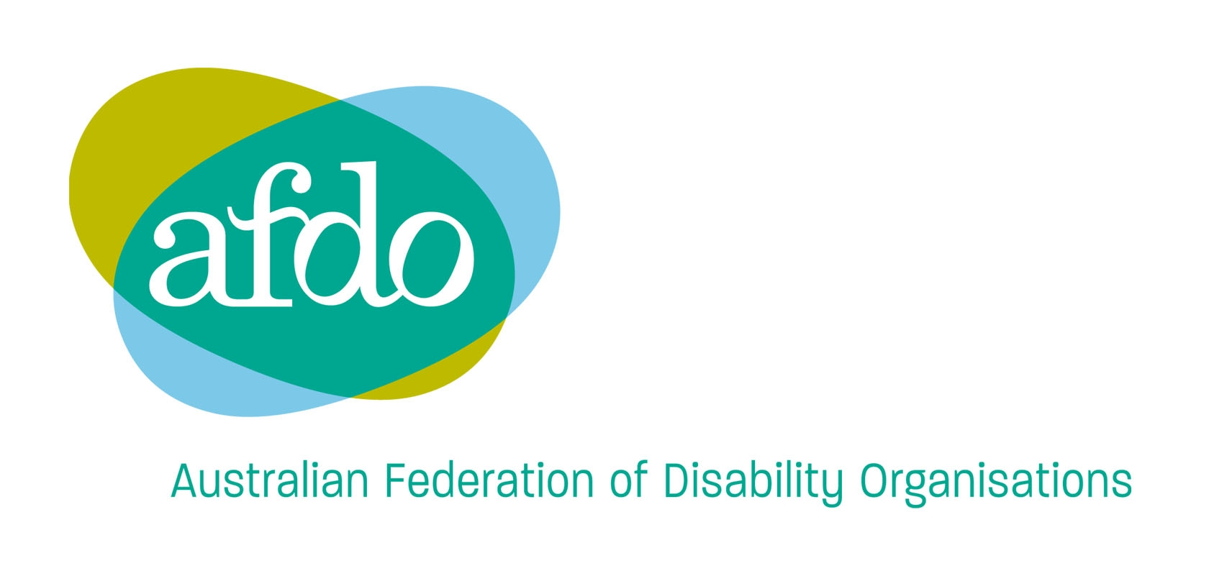
247 Flinders Lane
Melbourne VIC 3000
AUSTRALIA
Phone: 03 9662 3324
TTY: 03 9662 3374
Fax: 03 9662 3325
Email: office@afdo.org.au
Web: www.afdo.org.au

15th October 2010

Submission to OHCHR study on
CRPD Article 32, International Cooperation.

The Australian Federation of Disability Organisations is the National voice of People with Disability formed in 2003 and we represent the interests of all people with disability across Australia. The mission of AFDO is to champion the rights of people with disability in Australia and help them participate fully in Australian life.
We are a cross-disability human rights organisation and comprise of key National diagnostic and State disabled peoples organisations.
- Blind Citizens Australia
- Brain Injury Australia
- Deaf Australia
- Deafness Forum Limited
- National Association of People living with HIV/Aids
- National Council on Intellectual Disability
- National Ethnic Disability Alliance
- Physical Disability Australia
- Women with Disabilities Australia
- Disability Resources Centre
- People with Disabilities (Western Australia)
- Access for All Alliance
The Australian Federation Disability Organisations (AFDO) believe that Article 32 International Cooperation is one of the key articles of the Convention as it requires States, UN Agencies and International Organisations to involve disabled peoples organisations (a disabled peoples’ organisation is run and controlled by a majority of persons with disabilities) as equal partners in all areas of international development both internally and externally. The CRPD requires all States and International Agencies to implement a human rights agenda so that no longer will persons with disabilities and our organisations be dominated by the medical model with professionals and bureaucrats running our lives.
AFDO and our predecessors, Disabled Peoples’ International (Australia) and Disability Australia have worked throughout both the Asian and Pacific Regions as well as at a world level to promote and skill disabled peoples’ organisations for the last thirty years. During this time we have worked directly with people with disabilities in developing countries to help strengthen and resource their organisations.

However since 1981 we have fought to change the mind set of governments, UN Agencies, International Aid Organisations and Disabilities Service Providers from old institutional practices based in the medical model and concentrating on prevention and rehabilitation to strengthening disabled peoples’ organisations.

There have been many United Nations strategies to energise countries to improve the services and rights of people with disabilities including the International Year of Disabled Persons (IYDP) 1981, the World Program of Action (WPA) 1982, the World and Regional Decades of Persons with Disabilities and the Standard Rules on the Equalization of Opportunities for Persons with Disabilities 1993. While there has been a gradual shift from prevention and rehabilitation to a greater recognition of empowering disabled peoples’ organisations, non-disabled medical and rehabilitation professionals were still the major influences on the policies of the United Nations.

Since the work to develop the Convention on the Rights of Persons with Disabilities began in 2001, International and national disabled peoples’ organisations have seized the opportunity to be key participants in the development of the Convention. This occurred by our organisations directly attending the CRPD Adhoc meetings in New York and Regional meetings both in our own right and as part of Government Delegations. The strength and quality of disabled peoples’ organisations participation at the International, Regional and National levels has resulted in a mark shift in the involvement of persons with disabilities in international and national policy development. However this has often resulted in the process of Governments cherry picking individuals who are unaligned to disabled peoples’ organisations.

Some countries including Canada, Sweden, Norway, Finland and Denmark have very long history of constantly funding international disabled peoples’ organisations for over thirty years, in particular Disabled Peoples’ International. While others have only began to reform their International Aid policies to include specific programs for people with disabilities since the adoption of the Convention on the Rights of Persons with Disabilities by the UN General Assembly in 2006.

In Australia, AusAID began a process of international consultation with disabled peoples’ organisations in 2008 following a change of national government and intense lobbying by disability aid organisations and national disabled peoples’ organisations. The consultations actively sought the views and opinions to disabled peoples organisations from around the world but in particular the Pacific, Asian and African Regions where Australian Aid is distributed. AusAID Officers also met directly with disabled peoples’ organisations at Regional meetings in both the Pacific and Asia. AusAID have setup an advisory structure the Disability-Inclusive Development Reference Group including organisations working on disability issues. http://www.ausaid.gov.au/keyaid/disability.cfm

Unfortunately this reference group does not include the national disabled peoples’ organisation, the Australian Federation of Disability Organisations which is the Australian member of Disabled Peoples’ International. Despite two formal requests from AFDO the department believe there is no need for our involvement as they don’t see a need to hear from Australian disabled peoples’ organisations other than Aid organisations working in disability.

Another concern is that the majority of the $30.2 million of the four year budget is allocated to prevention issues such as road safety, avoidable blindness etc which we believe are not specifically disability issues but should be funded through Health Programs.

Having made the above criticisms we believe the other Core Outcomes of the Program;
* Improved quality of life of people with a disability
* Effective leadership on disability and development
* AusAID skilled and confident in disability-inclusive development
* Improved understanding of disability and development
are of merit and we support their ongoing implementation.

A final criticism we would make is that since the CRPD Adhoc meetings where the Australian Government included AFDO in their delegation, except in one instance they no longer include AFDO in their delegations, nor do they resource AFDO to attend International forums where disability issues must advocated to ensure the full implementation of the Convention and to achieve an inclusive society.
Frank Hall-Bentick
International Portfolio
AFDO Board

