Memorandum on the role of international cooperation in support of national efforts for the realization of the rights of persons with disabilities BY G3ict

Background on ICT accessibility

The role of international cooperation is particularly important in matters of accessibility to information and communication technologies and assistive technologies. Indeed, there is no need to demonstrate that information technologies products and services are driven by global market forces, global vendors and international standards. In such context, States Parties can achieve little in isolation. In fact, by adopting national standards inconsistent with international standards, States Parties can unwillingly fragment the market which in turn can cause dis-economies of scale and increase costs for end-users, including persons with disabilities. Such result would in fact contradict the disposition of the Convention on the Rights of Persons with Disabilities (CRPD) calling for States Parties to make available affordable solutions to persons with disabilities. Equally important in terms of promoting global standards is the need to ensure global interoperability between information infrastructure and assistive technologies. Finally, one of the challenges and opportunities which States Parties need to tackle is that, while solutions exist to make ICT accessible and many free open source assistive solutions are available, few disabled persons benefit from those around the world.
In order to address those issues and anticipating the adoption of the Convention by many countries, the United Nations Global Alliance for ICT and Development, in cooperation with the Secretariat for the Convention at UNDESA, staged the creation of G3ict – the Global Initiative for Inclusive ICTs. G3ict was designed since inception as a multi-stakeholders advocacy initiative exclusively focused on issues related to accessible and assistive technologies. Since inception, all research and capacity building programs produced by G3ict have involved an international network of industry, disabled persons and public sector organizations in order to take into account their input and address issues with a global perspective.

The e-Accessibility Policy Toolkit for Policy Makers jointly produced by G3ict with the ITU www.e-accessibilitytoolkit.org is an example of such cooperation with over 60 experts from industry, NGOs, governments and academia from around the world contributing their expertise in a collaborative on-line environment.
While the attached note sent to the Committee on the Rights of Persons with Disabilities for its October 7, 2010 Discussion Day on Accessibility includes information about G3ict activities, this memorandum focuses on existing and potential international cooperation programs in the field of ICT accessibility.

International Cooperation mechanisms
Based upon G3ict experience over the last four years, there are four strategies for international cooperation which States Parties should contemplate:
- Participation to standards activities. Currently the main organizations dealing with ICT accessibility standards are ISO and its regional standards development affiliated organizations (ANSI, ETSI etc.); ITU, W3C-WAI. While those organizations have produced considerable standards work, they remain largely unknown from policy makers and even from industry. It is also worth mentioning that developed countries are over -represented and developing nations under - represented in the various accessibility committees of those standardization organizations. However, the CRPD stipulated that States Parties shall promote accessibility standards. Hence a significant gap between guidelines and practice.

- Enforcing accessibility standards via public procurement. Government’s purchases of ICTs represent a very large portion of ay national IT market. Governments, by applying accessibility standards in their lists of specifications can influence industry behavior, help build national expertise in support services and lead by example. While there is no mention of public procurement in the CRPD itself, the reporting guidelines issued by the United Nations SG do include such question. Existing coordination of public procurement has been informally established by the U.S. Access Board which invited international participants to its TEITAC sessions, a multi-stakeholder committee charged with the definition of public procurement ICT standards including the EC, Japan, Canada and Australia.

- Exchanging policies and good practices among regulatory authorities overseeing mobile and fixed phones operators and broadcasters. Aligning requirements for accessible broadcasting and telecommunications services can be a relatively simple task within the context of each major family of global equipment standards. Solutions exist which are proven for television, mobile phones, fixed phones and web sites. The International Telecommunication Union (ITU), in cooperation with G3ict, is promoting such approach through systematic capacity building programs on all continents. This sector represents the greatest opportunity for short term results for persons with disabilities since one single entity controls in most countries a few operators serving the entire population. It is also worth noting that regulatory authorities exist in most countries today:

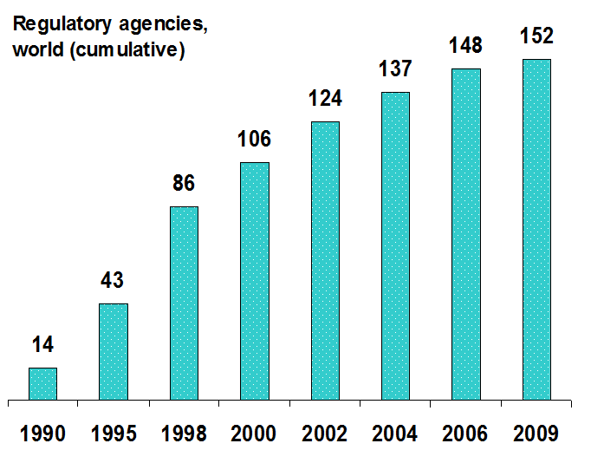

- Promotion of Assistive Technologies
International cooperation in the field of assistive technologies is a more complex challenge. Assistive technologies require a very strong training and support “ecosystem” to deliver results for persons with disabilities. Governments typically intervene via three main channels to promote assistive solutions for persons with disabilities: national education systems, workplace accommodation and rehabilitation services. Current international cooperation in those three areas can be summarized as follows:
  - Education
Today, most ratifying countries do have programs in place to provide reasonable accommodations to students with disabilities in schools and universities, including ICTs, systems and contents. Little cooperation exists however in this field and exchanges of experiences are simply not happening in any significant way internationally. G3ict entered into a partnership agreement with UNESCO to develop ministerial level policy and programmatic exchanges starting in 2011. It is also organizing in cooperation with WIPO, ITU, UNESCO and Indian NGOs a workshop on this topic in October 2010 in New Delhi, the results of which will serve to identify capacity building priorities for future programs. UNESCO is involved since many years in promoting education for students with disabilities and its programs have reached a large number of countries in including in matters of technology. UNESCO’s constituents include government department overseeing education in most countries and is therefore well positioned to develop capacity building programs and foster international cooperation.
  - Workplace
There is little cooperation in matters of ICT accessibility for the workplace in the world today. ILO is currently launching a network of companies and institutions to promote the employment of persons with disabilities. It is likely that such program will include a component on reasonable accommodation with ICT accessibility and assistive technologies good practices sharing.
  - Rehabilitation Centers
Exchanges in the field of rehabilitation are occurring through well-established professional organizations. Promoting assistive technologies is critical when providing support services to persons who acquired a disability following an injury of disease and who are trying to rejoin the workforce or other regular activities. Because of the close association with medical professions, rehabilitation services do have a tradition of exchanging technical and good practices information. There is however no formal systematic international cooperation program on assistive technologies in place as of today among UN agencies – to our knowledge.
One of the common challenges among countries promoting assistive technologies is the weak support and services “ecosystem” which they can rely on. In addition, frequent technology changes, a highly fragmented industry, a lack of interoperability and non-coordinated government initiatives among agencies make this entire field a very difficult to improve upon.
- Participation to WIPO negotiations on copyrights exemptions
One important area of international cooperation is the current negotiation of a new treaty led by WIPO on copyrights exemptions to allow access to copyrighted contents by persons with disabilities via digital means. Unlike in the case of standardization bodies, developed and developing countries both anticipate actively to those discussions. It is worth noting that the negotiation was actually initiated by several Latin American countries.

International Cooperation developments

G3ict’s will continue to pursue its mission in cooperation with United Nations affiliated agencies in order to reach out appropriate government agencies in each country: telecom regulators with ITU, education agencies with UNESCO, workplace accommodation with ILO, possibly rehabilitation centers with WHO, if such cooperation is possible. In addition, the World Bank, regional development organizations such as UNESCAP and other agencies like UNICEF, do offer excellent venues for international cooperation in the field of accessible and assistive technologies policies and programs.
In parallel, G3ict continues its close involvement with leading standards development organizations including ITU-T, ISO and W3C-WAI, IT professional organizations as well as disabled person’s organizations.
One important aspect of any capacity building program is the need to associate multiple stakeholders and disabled person’s organizations in particular. ICT accessibility is an area which cannot be promoted effectively without the full participation of all parties concerned. G3ict also observed that the active participation of disabled person’s organizations in capacity building programs for government officials and private sector leaders is a critical factor of success, notably by building the necessary momentum of the dialogue required to develop policies and programs.
Finally, G3ict believes that without standardized measurement of accessibility in various domains, driving change through policies will remain illusory. Several governments have proven the effectiveness of measuring accessibility of various services such as e-government web sites and publishing results. The attached presentation summarizes the key findings of the first G3ict progress report. G3ict plans to develop in coordination with ITU, UESCO and ILO a first attempt to develop a benchmarking tool by utilizing aggregated country data from annual surveys conducted by those agencies, in addition to G3ict own data collection process. G3ict will reconvene the same Research Committee which had helped design the first survey and included participants from international institutions, disabled persons, industry, academia and observers from the OHCHR.

