
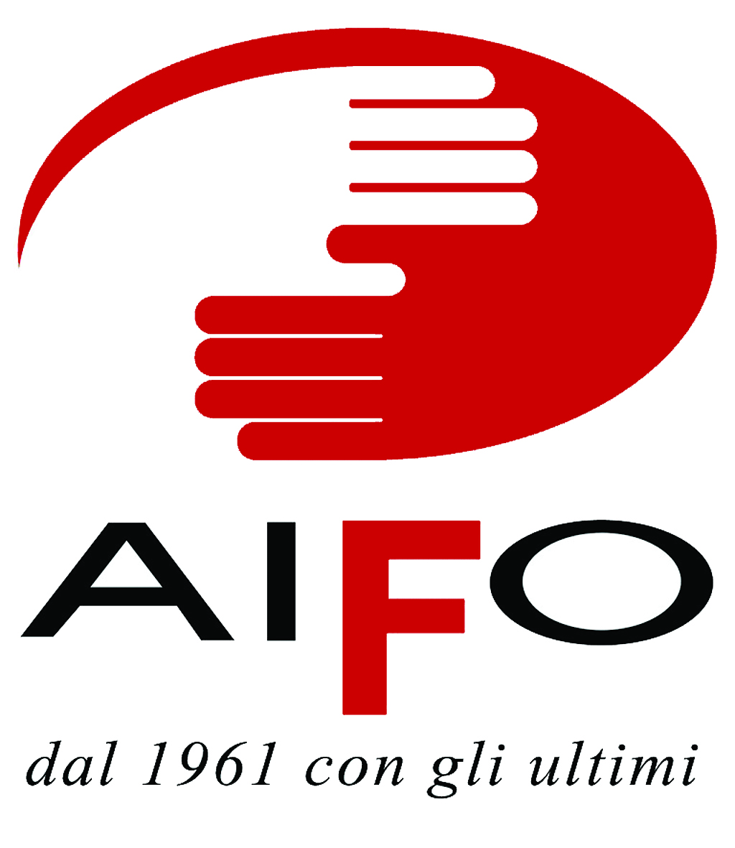

AIFO - Associazione Italiana Amici di Raoul Follereau

DPI - Disabled Peoples International Italia

Submission for the study to be prepared by the Office of the United Nations High Commissioner for Human Rights implementing Human Rights Council resolution 13/11 on the role of international cooperation in support of national efforts for the realization of the rights of persons with disabilities

drafted by

Simonetta Capobianco, Sunil Deepak, Giampiero Griffo, Francesca Ortali, Simona Venturoli

September 2010

- Key measures adopted at national level to implement the Convention on the Rights of Persons with Disabilities, and relative budgetary allocations

a.1 National Observatory on the condition of persons with disabilities
Italy has ratified the UN Convention on the rights of persons with disabilities on March 3rd, 2009 with law no. 18/09. Ratification law, which delegates the Government to ensure the full compliance of the national law to the Treaty, also includes the institution of a National Observatory on the condition of persons with disabilities. Such Observatory is composed by 40 members amongst central administrations involved in defining and implementing disability-related policies, Regions and local autonomies, Social Security Institution, National Statistics Institute, major representative organizations of workers, retired persons and employers, major national associations of persons with disabilities end third sector organizations operating in the disability field as well as experts. Among other tasks, the Observatory will promote the implementation of the CRPD together with the Inter-ministerial Committee on Human Rights; develop two-year national plan of action on disability implementing national and international legislation; promote the development of statistics-based studies and researches with the aim of identifying propriety areas of action. Mostly, “within two years of the ratification, and every four years thereafter, the Observatory will issue a detailed report on the measures that were taken to ensure that the provisions mandated by the Convention are implemented and progress is achieved in related areas”. The Observatory is financed through the National Fund for Social Policies with 500.000€ per year, from 2009 to 2014. Notwithstanding the provision of establishing the Observatory within three months after the entry into force of law n. 18/09, as of today it has yet to be established.

- Challenges and obstacles to the full implementation at national level of the Convention on the Rights of Persons with Disabilities

b.1 Insufficient funding for International Development Cooperation
In 2009, Italy’s contribution to Development Cooperation amounted to the 0,16% of GDP, about 3,3 billion dollars, against the European average of 0,44%. Compared to 2009, funds were reduced by 34%. For the period 2011-2012 the European Commission estimates that Italy’s contribution will go down to 15%. Reduced investment in development cooperation equals to lesser attention devoted to disability. (Also see data on disability)

b.2 Intellectual disability and complex dependency needs are not included
Intellectual disability and complex dependency needs are largely excluded in development cooperation activities: they are not among the direct target groups nor the issues related to their rights and needs are being discussed or included in training and awareness raising activities. When they do, they most often fall under the social health programs heading. In fact, frequently in developing countries institutionalization is the only form of support available however the condition of segregation that persons with disabilities live is often reported by DPOs and, in east and central Europe, by the Human Rights Commissioner of the Council of Europe. Direct participation, thus, is still an issue that need to find its way into the agenda.
b.3 Gender is not a priority issue
“Six projects target women as specific beneficiaries. This is not consistent with the Italian Cooperation
guidelines for persons with disabilities which specifically indicate “gender equality” as an element
that needs specific focus”. Also from the mapping report done by the EU-financed project “mainstreaming disability in development cooperation”, out of 107 projects mapped, only 11 included a gender perspective.

b.4 Poor national activity
Only 1% of the total amount of disability related project mapped by the Italian Cooperation are being implemented in Italy. With reference to the emancipatory research approach and, more widely, to the human rights based approach, such figure is not in line with the principle of mainstreaming disability as, by way of example, training of national development cooperation as well as awareness raising among international development cooperation implementation of funding entities, is a key element for sustainability.
b.5 Undue delay of the establishment of the National Observatory and lack of clear role
As mentioned, the delay in the establishment of the National Observatory on the condition of persons with disability unavoidably hinders the full implementation of the provisions contained in the UN Convention and article 32. In addition, law n. 18/09 does not clearly state that the Italian MFA should be among the Observatory’s permanent members. This is particularly important as the Observatory will produce the periodic government reports to the CRPD committee.

- The existence, scope and content of policies and/or guidelines adopted at national level to guide international cooperation in support of the Convention

c.1 Italy’s approach to development cooperation and the role of the Italian MFA
Starting with the Ad Hoc Committee developing the draft text, Italy has actively participated to the development of the UN CRPD. Its presence, in coordination with the EU delegation, was ensured by a consistent number of delegates, mainly from the MFA. Throughout the negotiation process, the delegation has strongly advocated for the introduction of as specific article on international development cooperation and provided valuable inputs to this regard. At national level, mainstreaming of disability in a human rights approach in development cooperation activities has taken a sharp turn starting from 2000 when a group of NGOs and Disabled Peoples Organizations (DPOs) started to cooperate in developing policies and strategies including the disability perspective, thus influencing the work of the MFA itself. Such cooperation at theoretical level evolved into the development of joint projects based on the twin track approach of mainstreaming: disability-specific activities and inclusive development cooperation activities.
Italian Cooperation operates through what is called “System Italy”: a network of entities that collaborate with the MFA in development activities comprising NGOs, universities, national and local agencies and private enterprises.

Development cooperation actors are, besides NGOs: Italian MFA, Regions, Provinces, Local autonomies, Universities. Technical support institutions to this end are: Permanent Forum among the Government and Regions, the Interregional Observatory on International Cooperation, the Union of Italian Provinces, the National Association of Italian Municipalities.

c.2 Guidelines for the inclusion of disability within Italian Cooperation policy and activities
In 2002 the Italian MFA issued the first Guidelines on disability in development cooperation which were based on the social model of disability. In may 2010, the Italian MFA finalized the updated version called “Guidelines for the inclusion of disability within Italian Cooperation policy and activities” mainly based on a human rights approach and, mostly, take into account art 32 of the CRPD. The working group in charge to develop the document included persons with disabilities, institutions, associations and single experts. Although not legally binding for the moment (recently adopted, in november 2010), they encompass years of collaboration and debate so as to reach a point where the Italian Cooperation felt the need to harmonize its approach to disability with the standards set by common practice and, for all, the UN Convention.
Among others, the 2010 Guidelines include provisions regarding:
- Training of Italian MFA staff on disability, including DPOs as trainers;
- Priority funding for inclusive development cooperation projects based on the twin track approach;
- Italian Cooperation’s infrastructures to follow universal design criteria;
- Particular attention to emergency situations, referring to the Verona Charter on the rescue of persons with disabilities in case of disasters;
- Data collection according to OCSE-DAC categories;
- Suggestions to tie up Italian funding to the EU and International Agencies to include disability.

c.3 Guidelines and Program Objectives 2009-2011
In 2008, the Italian Cooperation approved the document, entitled The Italian Cooperation for 2009-2011: Guidelines and Program Objectives (“La Cooperazione Italiana allo Sviluppo nel Triennio 2009-2011. Linee Guida e Indirizzi di Programmazione”), which lists priority areas including the cross-sector theme of disability.

c.4 Training on International cooperation and persons with disabilities in the Universities
DPOs and NGOs working in the field of inclusion of persons with disabilities in International cooperation have influenced various universities into including specific training on persons with disabilities in masters courses on development. At the moment, the University of Modena and Reggio Emilia (Master on international cooperation), University of Bologna (Master on inclusive education), University La Sapienza of Rome – CIRPS (Master in development) provide specific training modules on this issue.

- Forms of international cooperation that, at bilateral and multilateral level, as a complement to national efforts, can play a key role in assisting the realization of the Convention at national level

d.1 MFA’s Guidelines on decentralized cooperation
With regards to decentralized cooperation, the Italian MFS is progressively recognizing the important contribution it brings to root national strategies at local level, especially with the stricter involvement of civil society. To this end, and to better harmonize national and local strategies, the guidelines on decentralized cooperation were issued in 2010.

d.2 “Mainstreaming disability in international cooperation”, an EU co-financed project
A number of examples can be made, however the most relevant is a 2006-2008 EU co-financed project called “Mainstreaming disability in development cooperation” which put together 12 European NGOs and DPOs. Based, in fact, on a twin-track approach, it made possible to survey the number of project, implemented by NGOs, DPOs, local entities and the Italian MFA on disability and collect relevant data so as to create an accessible database to serve as the basis for re-thinking the approach to disability in development cooperation. This has also allowed to better identify the actors in the development cooperation field, highlighting, for instance, the emerging and ever more incisive role of the local autonomies (Regions, Provinces, Municipalities) and the need for better coordination. The involvement of the Italian MFA in this survey has played an important role as it consolidated and structured the collaboration with NGOs and DPOs. The follow-up of this project has been recently financed by the EU for the period 2010-2012. The new project is run by 11 partners, among European NGOs and DPOs, and it aims at promoting consistent implementation of UNCRPD in member states development cooperation. Among the project's activities, a specific one-day workshop will be organized in Italy by AIFO with the involvement of the MFA and other Italian development cooperation actors about Italian commitment on CRPD articles 11 and 32.

d.3 Awareness raising in the European Commission and EU ratification of the CRPD
Commitment of public and private donors to finance international development cooperation projects that acknowledge the CRPD and article 32 in particular. By way of example, given that degree of understanding and awareness of disability concerns, how to address them specifically and how to mainstream, is still limited among staff in EU Delegations, the European Commission is carrying out a “Study of Disability in EC Development Cooperation”. With the main objective of having the CRPD be the benchmark for inclusive development programs (the EU will probably ratify the CRPD by the end of 2010), the study focuses on identifying indicators to monitor the effectiveness and assess the impact of EU development cooperation activities on persons with disabilities in a mainstreaming perspective. In fact, treating persons with disabilities as one of the target vulnerable group “often triggers focused responses of assistance and protection rather than a cross-cutting issue”. Such initiative is quite important as 2-5% of EU funds are destined to disability-specific projects. On this note, the International Disability and Development Consortium – IDDC - and the European Disability Forum –EDF – have been lobbying the EU on updating its Guidance Note on Disability (dating 2003) and other European instruments, including its approach to the MDGs, to be in line with the Convention.

d.4 Recommendations
- Including disability the Millennium Development Goals as a priority and transversal target, as foreseen by UN General Assembly Resolutions: Realizing the Millennium Development Goals for persons with disabilities A/RES/64/131) and Inclusion of persons with disabilities in realizing the Millennium Development Goals (A/C.3/64/L.5). In particular, it is extremely important to develop a specific indicator for the evaluation of the poverty level persons with disabilities assess on, especially in developing countries. The International Disability and Development (IDDC) campaign “Include everybody” provides essential data proving why, by not including disability, the MDGs cannot be met.
- Lobbying donors’ networks as well as International institutions engaged in development cooperation, including the European Union, to acknowledge the principles set forth in the CRPD.
- Strengthen the engagement of UN agencies in mainstreaming disability in their work, including the training for staff members both in headquarters and on the field. Italian Multilateral Cooperation operates through Human Development Programs; strengthening the inclusion of disability in such framework
- Fill the gap on statistical data. Lack of data on the condition of persons with disabilities appears to be particularly difficult as no International standards are set yet on which data to collect, based on art. 31 of the CRPD. However, it appears that no action is being taken for coordinating efforts to collect data on International agencies’ financing and funds devoted to disability.
- Develop a training manual on how to develop development cooperation projects respecting articles 11 and 32 of the CRPD.
- Support the collaboration between DPOs and NGOs in project on development
- Foster debate on shifting from humanitarian projects to human rights-based activities and on inclusive development, that does not exclude anybody
- Encourage DPOs in engaging in development cooperation activities, including support in strengthening collaboration with NGOs and other Agencies.
- Organize an international conference, including National agencies, private donors, NGOs and DPOs, to set up a statement on International cooperation and persons with disabilities.
- Build a strong alliance between DPOs and NHRIs on the CRPD ratification, implementation and monitoring.

- Examples of engagement in international cooperation and assessment of their impact on promoting the realization of the convention;

Although quite few NGOs working in the human rights field do so with taking into account persons with disabilities.

e.1 Training course for persons with disabilities to become junior experts in development cooperation
Persons with disabilities and their families in development cooperation represents a fundamental added value to foster empowerment processes. In fact, sustainability of the CRPD application depends on the presence on state parties f persons with disabilities having a strong role and able to become Institutions’ reference points. This presupposes the development of methodologies, instruments and competencies allowing CRPD’s article 32 concretely applicable and too few NOGs chose to take action to guarantee the promotion and protection of the rights of persons with disabilities. To this point, AIFO and DPI are organizing a course aiming at creating a stable group of persons with disabilities trained to be future junior development cooperation experts as a starting point to become future experts in this field. The first training course will take place on December 18 2010 in Bologna.

e.2 Inclusion of CRPD in Community Based Rehabilitation projects
Community-based rehabilitation (CBR) projects are increasingly adopting human rights approach as their basic philosophy to guide their activities. In this direction, AIFO and DPI together have taken some actions. For example, in February 2009 at the first Asia Pacific CBR congress, AIFO, DPI together with IDDC, UNESCAP and some other international organizations organized three international workshops for CBR program managers on “CRPD and CBR”, “CRPD and Leprosy” and “CRPD and Mental Health”. Discussions in CBR programs supported by AIFO in countries like Liberia, Guyana, India, have focused on introducing CRPD at grassroots level in communities, promoting and strengthening local DPOs in rural and isolated areas, and monitoring of implementation of CRPD at field level by collaborating with national CRPD monitoring systems.. In effect the CBR matrix does not include all norms including in the CRPD and the role of DPOs, as defined in the CRPD itself; it must be reinforced the CBR programmes.

e.3 AIFO and MFA projects on empowerment of DPOs as guarantee for the sustainability of CRPD implementation
Mongolia
The respect of the human rights of persons with disabilities and implementation of the CRPD depend especially from the capacity of the movement of persons with disabilities in all countries to be partner of the national and local authorities, in particular in the developing countries, where the attention on the rights of these citizen is very low and the standard of democracy frequently weak. It is important to build a strong relationship between NHRIs and DPOs, that often do not have enough knowledge respectively on disability issue and Human Rights. The real sustainability of the CRPD and respect of Human Rights of persons with disabilities is the empowerment of the DPOs, through capacity building, appropriate support and management capacity. Aifo and DPI-Italy developed a specific attention on this issue in two project in Mongolia. The first project (2006-2007), financed by UNDESA and Aifo, developing various activities on empowerment of DPOs at national and local level, producing a training manual of Human Rights, disability and CRPD, that has been translated in English, French, Spanish, Portuguese, Italian and Mongolian (this is a case where the South supported the North). The second project (2008-2010), financed by European Commission, continues the training of DPOs at national and local level, building an alliance between DPOs and National Commission on Human Rights, that nominated an officer in this area and developed activities included in the national programme on Human Rights. The project extends Community Based Rehabilitation programmes in all Mongolian areas and take in account the CRPD in the activities of empowerment the DPOs in rural and remote areas.

Mandya research (India)
Apart from promotion of CRPD in specific CBR programmes, AIFO and DPI have together promoted different specific activities for strengthening and empowerment of national and local level DPOs. A significant example of such initiatives is a research project looking at impact of 10 years of two CBR programs in Mandya district of India, covering 1.8 million population and reaching out to more than 22,000 persons with disabilities. This research involves DPOs, federations, university academics as well as local communities and adopts complementary approaches. Thus, on one hand, it has a quantitative and qualitative research done by researchers; on the other hand, it has “emancipatory research” where persons with disabilities and local groups control and decide the research priorities and look at impact of CBR from their own point of view, with technical support from DPI and disabled university academics.
Kosovo
The MFA, through the directorate on international cooperation (DGCS), has financed a project (2008-2009) in the Republic of Kosovo, to support the elaboration and approval of the National Disability Action Plan (NDAP), developed with a fully participation of DPOs. The NDAP was approved in April 2009 and MFA-DGCS has financed an other project (2010-2011) to support the monitoring system to check the progress of the implementation of NDAP. To support the implementation of Human Rights of persons with disabilities, it is important define the instruments to promote policies on disability. One of the more important strategy is to define and approval of the NDAP, with the full participation of the DPOS.

In the near future, AIFO in collaboration with DPI-Italy, will develop new projects, financed by European Commission, in Vietnam and Liberia as well as a research on intellectual and psycho-social disability in the field of CBR.

e.4 More on sustainability
In the development and implementation of legislation and policies to implement the present Convention, and in other decision-making processes concerning issues relating to persons with disabilities, States Parties shall closely consult with and actively involve persons with disabilities, including children with disabilities, through their representative organizations (CRPD, art. 4.3).

- AIFO (an NGO) and DPI Italy (a DPO) have signed an agreement that includes cooperation for a number of activities, including collaboration in international cooperation projects. Aifo have signed a similar agreement with DPI-Asia Pacific, to utilize the experts from the DPI network in project in Asia Pacific continent.
- Empowerment of persons with disabilities and their organization in all project on development is a prerogative for effective CRPD sustainability and implementation. The sustainability of the CRPD application in all countries is the strong and participative role of the DPOs in the decision concerning issues relating to persons with disabilities. AIFO and DPI collaborate on many projects in developing countries, for building new tools and methodologies useful to be transferred in other projects and countries.
- Develop appropriate working instruments such as Human Rights capacity building; training manuals; explore the “emancipatory research” relying on unlocking the complex web of discrimination faced by persons with disabilities through knowledge and life experience of persons with disabilities themselves and strengthen processes rather than single projects.

AIFO was founded by Raoul Follereau in 1961 to fight leprosy and all forms of discrimination. AIFO has chosen to focus its activities in supporting leprosy affected persons and persons with disabilities, guided by principles of respect of Human Rights of all, social justice, dignity and equality of all peoples. It expresses its mission through inclusive development projects focusing on leprosy, community and primary health care, disability and rehabilitation, and vulnerable children and in Italy, where activities are linked to development education. It has working relationship with the World Health Organization.

AIFO - Associazione Italiana Amici di Raoul Follereau
Via Borselli 4-6
40135 Bologna
Italy
Tel. +39.051.433402
Fax +39.051.434046
www.aifo.it/english
Contact person: Francesca Ortali
francesca.ortali@aifo.it

DPI Italia Onlus Italian section of Disabled Peoples' International, an international organization, present in 135 countries and recognized by the principal agencies and international and European institutions. Made up of 19 Italian organizations, DPI works for the promotion and safeguarding of human and civil rights of persons with disabilities.
DPI is also a movement of social and cultural nature, whose constitutive principle is based fundamentally on the direct self promotion of persons with disabilities. The movement believes that the latter are the real experts of the multiple problems and difficulties that, they encounter everyday in society. Therefore they deem extremely important that they take an active part in all the processes, contexts and solutions that regard their own personal and social sphere.

Disabled Peoples International Italia
Via dei Bizantini, 97
88046 Lamezia Terme (CZ)
Italy
Tel.+39.0968.463499
Fax +39.0968.463568
www.dpitalia.org
Contact person: Giampiero Griffo
giambatman@tin.it

Disability, International Cooperation and Development, the experience of the Italian Cooperation 2000-2008; Italian Cooperation and the world Bank, June 2010, page 17
On October 23, the Regulation on the functioning of the National Observatory on the condition o persons with disabilities entered into force. Full text available here (in Italian): http://www.lavoro.gov.it/NR/rdonlyres/09A35E99-355E-4AEE-B89D-2FB32B1F78F7/0/20100706_DI_167.pdf
Action Aid Annual report “L’Italia e la lotta alla povertà nel mondo. 2010: cala il sipario”, June 2010; http://www.actionaid.it/filemanager/cms_actionaid/images/Cosa_facciamo_pdf/Governance_pdf/ILAP_2010_11.pdf
For data related to previous years, please refer to Disability, International Cooperation and Development, the experience of the Italian Cooperation 2000-2008; page 27 table 1
Disability, International Cooperation and Development, the experience of the Italian Cooperation 2000-2008; page 24
See reports form MDRI and Human Rights Watch
See also: Mental health and development: targeting people with mental health conditions as a vulnerable group available at http://www.who.int/mental_health/policy/mhtargeting/en/index.html
Disability, International Cooperation and Development, the experience of the Italian Cooperation 2000-2008; p. 41
http://www.make-development-inclusive.org/toolsen/aifomai08.pdf
It is also worth noting that Italy has yet to establish a Human Rights Institution.
Linee Guida della Cooperazione Italiana sulla tematica dell’handicap, Italian MFA, July 2002 http://www.cooperazioneallosviluppo.esteri.it/pdgcs/italiano/LineeGuida/pdf/Linee_Guida2010-2012_engl.pdf
Available at http://www.eena.org/ressource/static/files/Verona%20Charter%20approved.pdf
See http://www.cooperazioneallosviluppo.esteri.it/pdgcs/italiano/Pubblicazioni/pdf/Programmazione%202009-2011.pdf .
Linee Guida sulla Cooperazione Decentrata, Italian MFA, March 2010 http://www.cooperazioneallosviluppo.esteri.it/pdgcs/italiano/LineeGuida/pdf/Linee_guida_Decentrata.pdf
For more information: www.makedevelopmentinclusive.org
For more information: http://www.iddcconsortium.net/joomla/index.php/component/content/article/38-news-and-events/361-100629-mdi-proj-launch
For more information: www.aifo.it
See attached IDDC EDF letter to EC Commissioner for development 2010
http://www.un.org/disabilities/documents/gadocs/a_res_64_131.doc
http://www.un.org/disabilities/documents/gadocs/a_c3_64_l5.doc
See the report Disability poverty in the UK by G. Parckar. London, Leonard Cheshire disability, 2008.
http://www.includeeverybody.org/. For more info on including disability in the MDGs please refer to the third sessions of the UN CRPD committee documents: http://www.un.org/disabilities/default.asp?id=1470; International Disability Alliance’s “Overcoming invisibility: Making the MDGs inclusive of and accessible For persons with disabilities” available at http://www.internationaldisabilityalliance.org/wp-content/uploads/2010/06/MDGs-IDA-paper-final-print.doc.
Disability, International Cooperation and Development, the experience of the Italian Cooperation 2000-2008; page 23
Some training tools have been developed by the “mainstreaming disability in development cooperation” project http://make-development-inclusive.org/tools.php?spk=en
As shown in the Italian Cooperation document as well as by the results of the mapping done within the “Mainstreaming disability in development cooperation” http://www.make-development-inclusive.org/toolsen/aifomai08.pdf, national DPOs directly involved in implementing development cooperation projects amounts to just 1 while out of the 51 projects mapped by the Italian Cooperation, only 5 have DPOs as local partners involved in the mapping.
For more information see ww.aifo.it
For the report of the workshop see the web site www.aifo.it.
Griffo, G., Ortali F. Training manual on Human Rights of persons with disabilities. The participation of the Disabled People Organization in the process of ratification, monitoring and implementation of the UN CRPD. Bologna, 2007.
For more information on Mandya CBR research see http://www.aifo.it/english/proj/research/sparkcbr/index.htm
Ministry of Foreign Affairs – Dept. of International Cooperation (2009): Technical assistance project for the National Disability Action Plan in Kosovo. Final report. Ministry of Foreign Affairs – Dept. of International Cooperation, 2009.

